Additional File 1
This protocol is a detailed step-by-step guide to preparing QSAR models using free and open-source tools. The main tools used are the OCHEM platform as a molecular descriptor calculator and PyQSAR as a tool for creating the QSAR model. The data used to prepare the antioxidant QSAR model presented in the article is used as a case study during the protocol. All data needed is available as Additional File 3. This protocol was tested in Windows OS and Linux OS and is divided into 3 parts:
Part 1. Obtaining Molecular Descriptors through OCHEM
Part 2. Construction of a QSAR Model using PyQSAR
Part 3. Requirements and Installation of PyQSAR
PART 1 – PyQSAR requirements and installation

The following steps outline the requirements needed to install and use PyQSAR successfully.
1 – Installation of the CONDA package and environment management system
You can find everything you need to install CONDA at: https://docs.conda.io/projects/conda/en/latest/user-guide/install/index.html
2 – Installation of PYTHON language
You can find all available versions and how to install them at: https://www.python.org/downloads
3 – Installation of PIP
Step 1 – Open the Command Prompt
Step 2 – Write the command python -m ensurepip
Step 3 – Upgrade PIP with the latest version by writing the command pip install –upgrade pip
4 – Installation of PyQSAR
Step 1 – Open the Command Prompt
Step 2 – Write the command conda install -c rdkit rdkit
Step 3 – Write the command pip install pyqsar
5 – Installation of Jupyter Notebook
Step 1 – Open the Command Prompt
Step 2 – Write the command pip install jupyterlab
6 – Installation of PYTHON packages needed to run PyQSAR
The following packages should be already installed with PyQSAR. However, the version should be updated to at least the following versions: numpy >=1.12.0 / setuptools >=27.2.0 / pandas >=0.24.2 / scikit-learn >=0.18.1 / matplotlib >=2.0.2 / ipywidgets >=6.0.0 / ipython >=5.3.0 / bokeh >=0.12.5 / joblib >=0.11 / xlwt >= 1.3.0 / openpyxl >= 3.0.9
NOTE: As OCHEM is a web-based platform, installation or specific requirements are not necessary. You only need to create a free account.
PART 2 – Obtaining molecular descriptors through the OCHEM platform
The Online Chemical Modeling Environment is a web-based platform that aims to automate and simplify the typical steps required for QSAR modeling. To use this platform, just access https://ochem.eu/home/show.do and create a free account. After that, you can start using this platform, which has several features for building QSAR models.

1 – Creation of the input file with the compounds we want to use
OCHEM's tool for calculating molecular descriptors can read input files in various formats, such as SDF, Mol2, SMILES or even an Excel file. There is also a feature for drawing structures within this platform. An Excel file was built with the Code of the compound, its SMILE and the experimental pIC₅₀ value. The excel file used for this article is available as Supplementary Material 3.
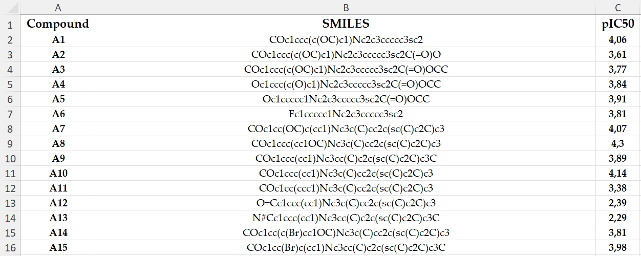

2 – Calculation of the molecular descriptors for the compounds
Step 1 – Log in to your OCHEM account, click "Models", and then "Calculate descriptors".
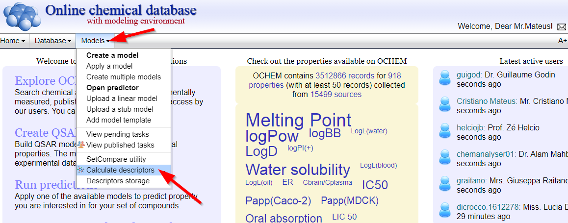

Step 2 – Upload the file with the compounds to be tested.

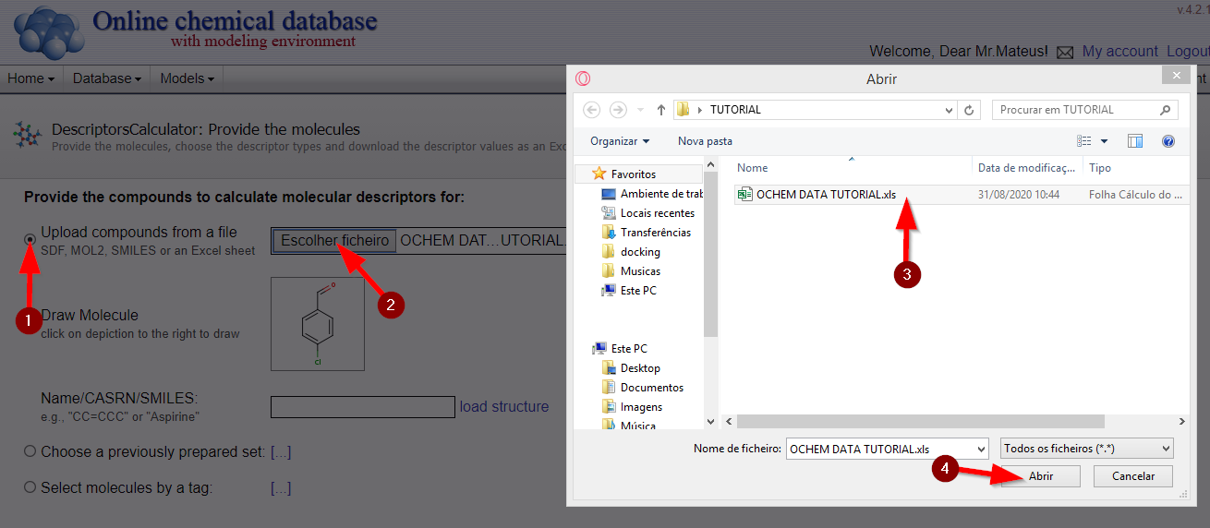
Step 3 – Select from the list of molecular descriptors the ones you want OCHEM to calculate.
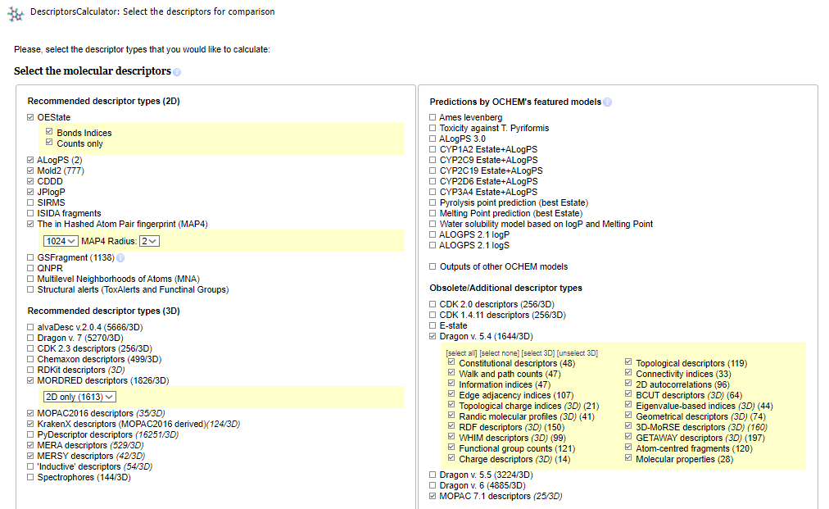
Step 4 – Choose the molecule structures optimization tool. For this study, we used the Corina optimization.
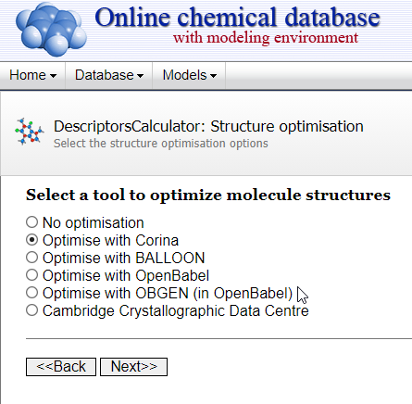

Step 5 – Wait for the calculation of molecular descriptors. This can take some time depending on the number of molecular descriptors selected, the computer parameters and the number of tasks the OCHEM server is processing.
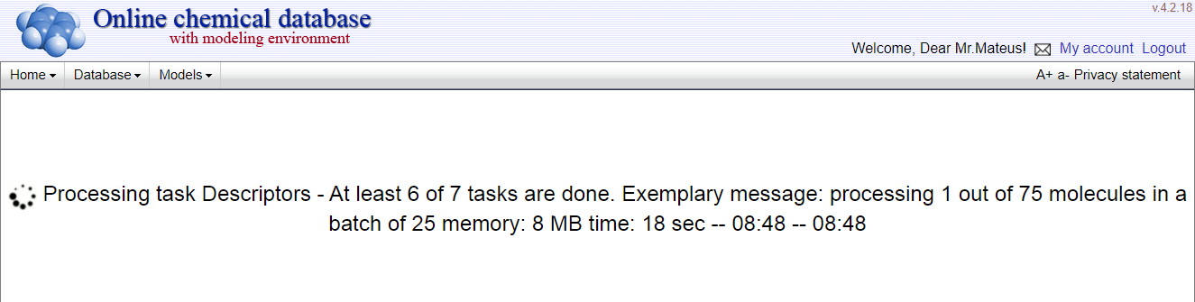

Step 6 – Collect the results. Analyze if the molecular descriptors were correctly calculated, and download the file with the results.
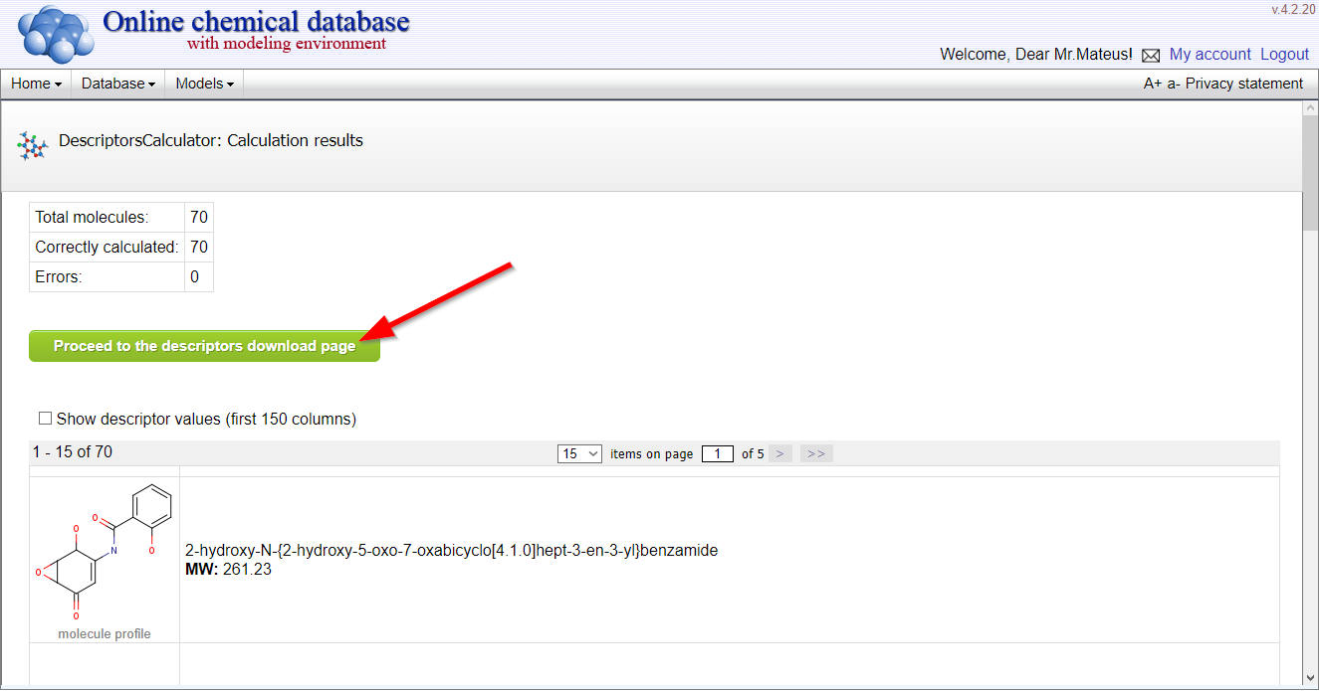

Step 7 – Select the items and the format in which you want the results.
NOTE: For PyQSAR, using CSV or Excel files is preferable, so the results export must be done in one of these formats.
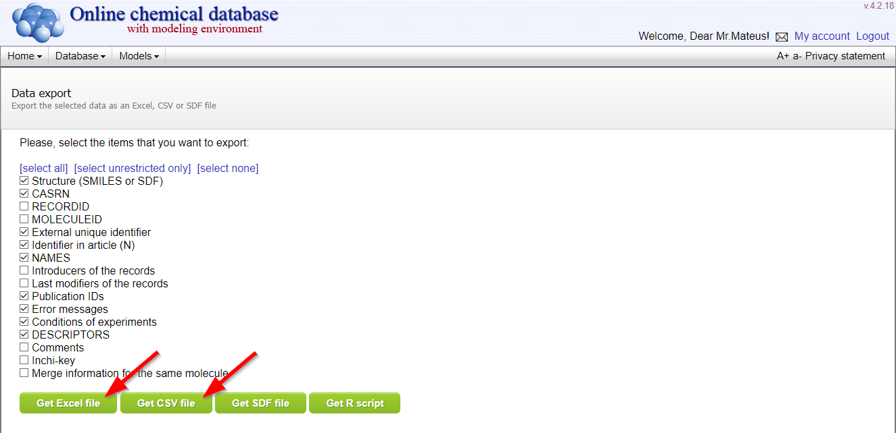

Step 8 – Save the downloaded file in the desired directory.
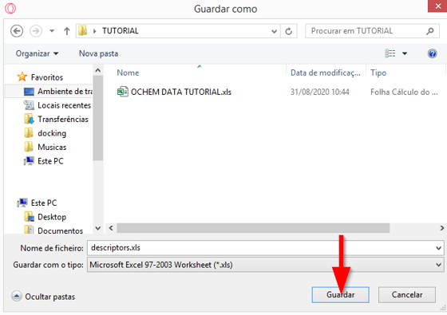

Step 9 – Finally, the file with the molecular descriptors is available and can be opened to check the content.
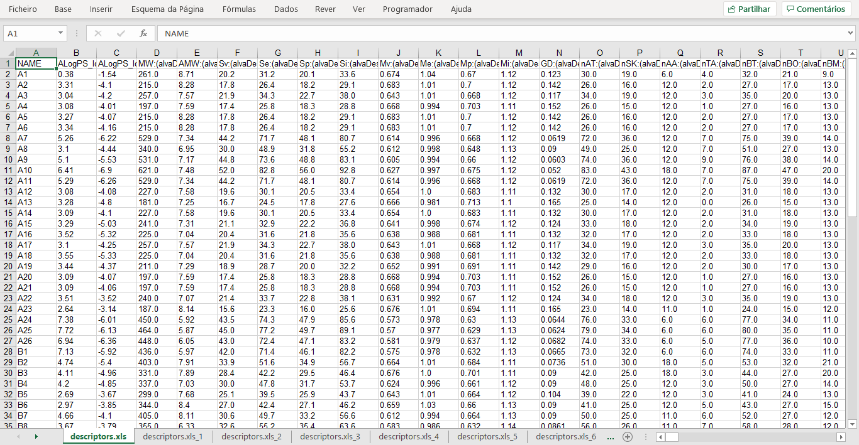
PART 3 – Construction of the QSAR model using the PyQSAR package
PyQSAR is an integrated standalone PYTHON package that combines all QSAR modeling steps in one workbench. This tool can be used like any other package of any language. It can be used by opening the PYTHON language IDLE and importing the package. However, some tools are more appealing than PYTHON's IDLE, making reading and obtaining different graphics easier. One such tool is the Jupyter Notebook, which is featured in the web-based Jupyter Lab software.
NOTE: This tutorial demonstrates how to obtain a QSAR model using PyQSAR using the web-based Jupyter Notebook software. However, the entire process can be replicated in any Notebook that uses the PYTHON language and in PYTHON's own IDLE.

1 – Open and create a Jupyter Notebook (Optional)
Step 1 – Open the Command Prompt.
Step 2 – Use the command cd and insert the desired directory where you want to create the Notebook.
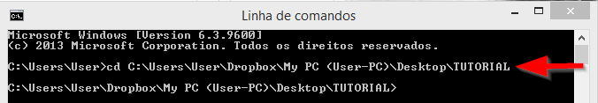

Step 3 – Write the command jupyter notebook (A web page should open with the Notebook).
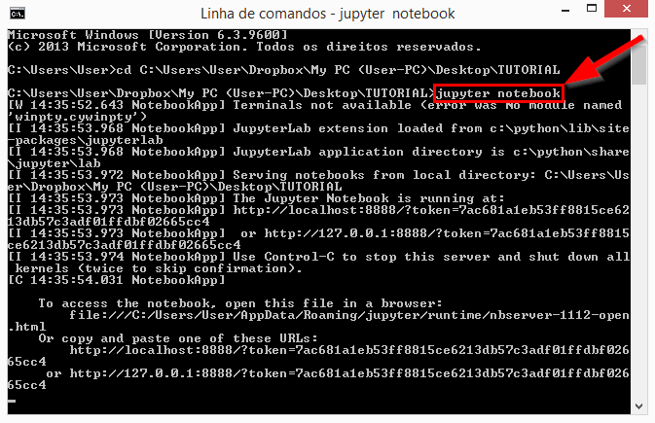
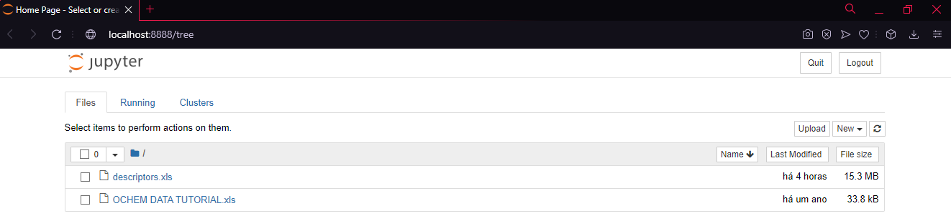
Step 4 – Create the Notebook for Python 3.
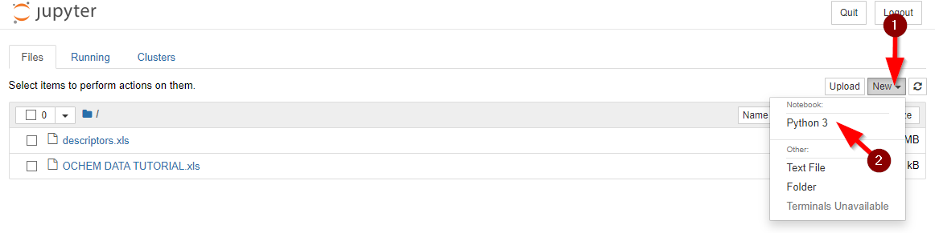
Step 5 – Finally, a clean sheet for PYTHON should appear.
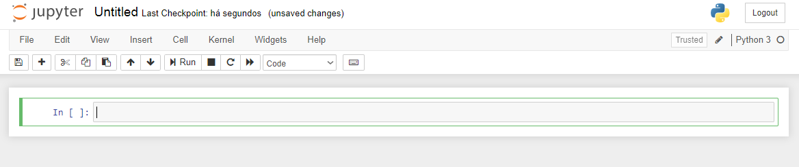

2 – QSAR model construction
Step 1 – Import and read the descriptors file, and write the following commands:
NOTE: The descriptor Excel file obtained from OCHEM was converted into CSV format as it is a more general format that guarantees that different systems and notebooks can read it.
Step 2 – Define the columns and rows for our Descriptors (X_data) and the biological activity of each compound (y_data)
Step 3 – Verify the descriptors and biological activity data with the commands .head() and .shape
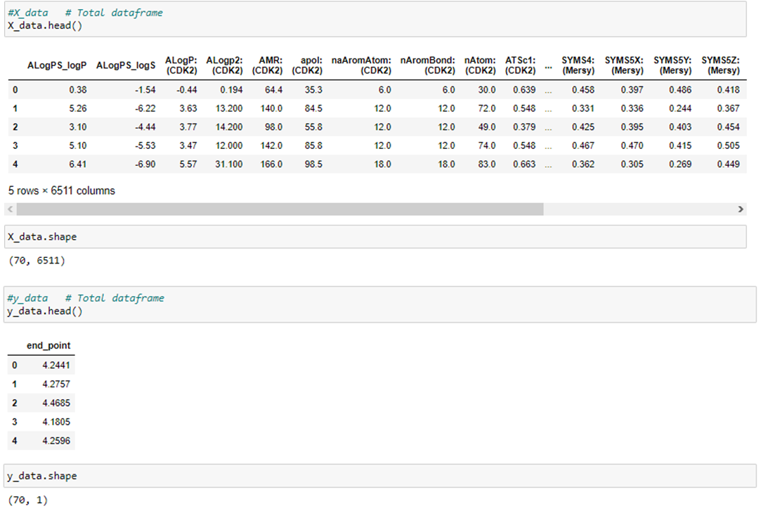

NOTE: A column with the biological activity values must be added in the Excel file resulting from the calculation of molecular descriptors. This column should have the name end_point, as shown in the image.

Step 4 – Import the PyQSAR package and data_tools.

Step 5 – Remove the empty feature and NaN from the descriptors data and verify the shape again.
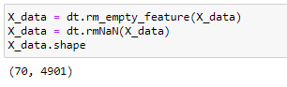
Step 6 (OPTIONAL) – In case of the need to search for a particular descriptor or perform a scatter matrix, you can use the following codes:

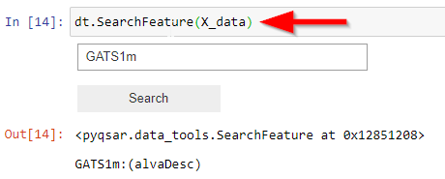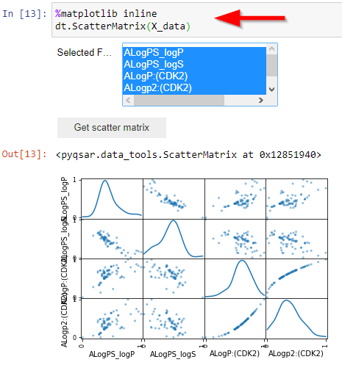
Step 7 – Transform the molecular descriptor data into a specific scale to treat these data. Verify the changes using the command .head()
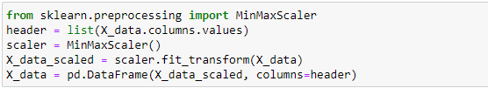
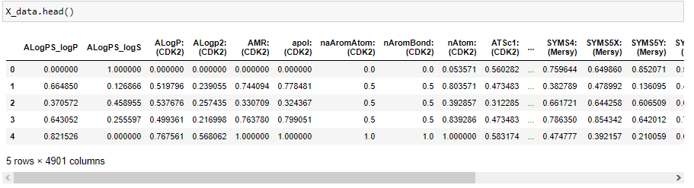
Step 8 – Create a .xlsx file with the descriptors data after the PyQSAR adjustments.
NOTE: This is the descriptors file that can be used to search the descriptors values and substitute them in the final equation to predict the biological activity values.
Step 9 – Calculate the cophenetic correlation coefficient.
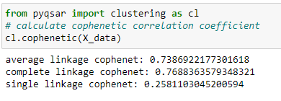
Step 10 – Perform the Clustering
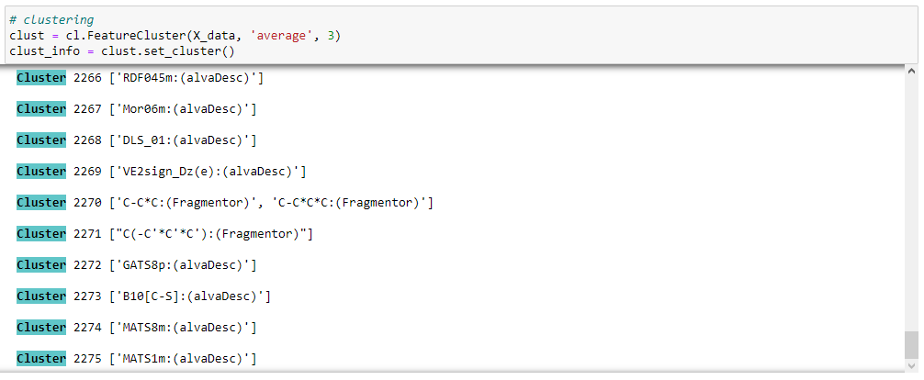

Step 11 (OPTIONAL) – Obtain the Clusters distribution graph.
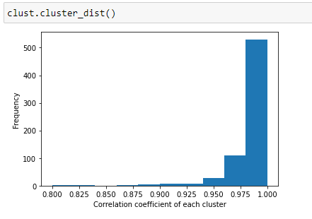
Step 12 – Perform the descriptors selection algorithm for a single selection.
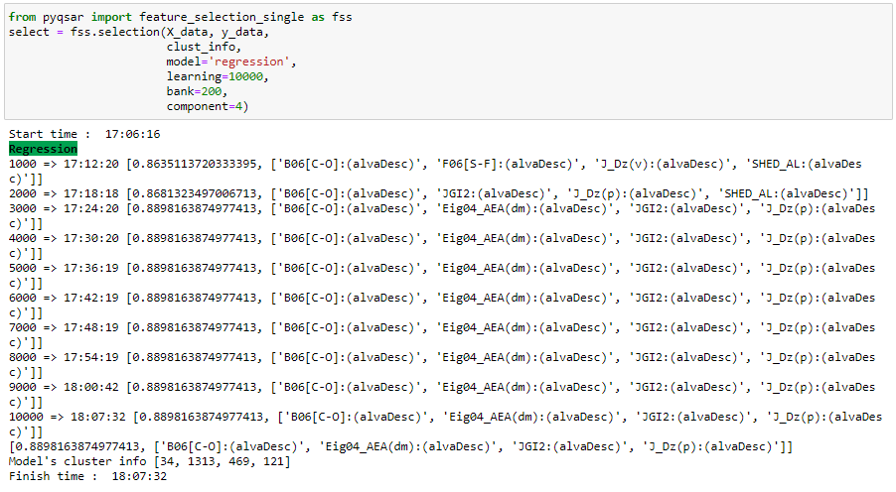
Step 13 – Write the command select to see which descriptors were chosen by the single selection.
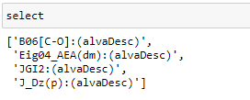

Step 14 – Build the QSAR model with the Multiple linear regression method.
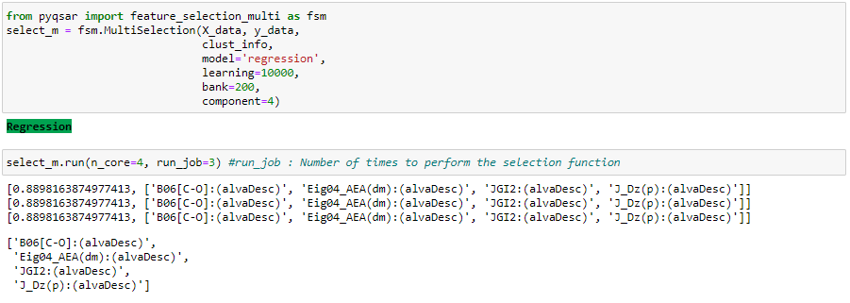
Step 15 – Finish and Export the QSAR model to validate and see the results.
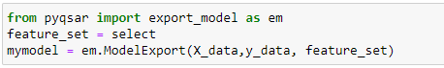

3 – QSAR model Results and Validation
Step 1 – Write the command .features_table() to access your selected descriptors and their values for each compound.
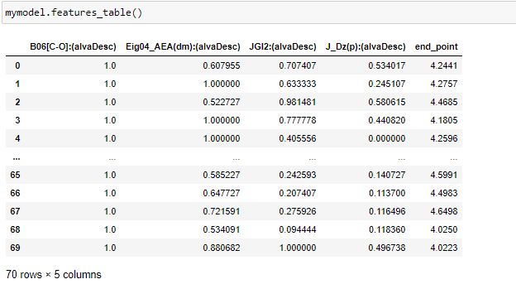

Step 2 – Write the command .model_corr() to get the table correlating descriptors-descriptors and descriptors-biological activity. It will also perform a scatter matrix for the selected descriptors and biological activity.
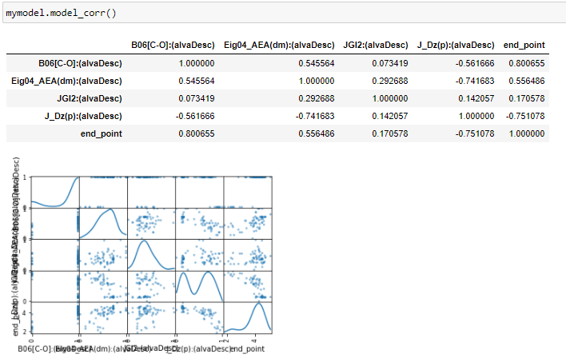
Step 3 – Use the command .mlr() to get the coefficients of the molecular descriptors and be able to build the final equation for the predictive model.
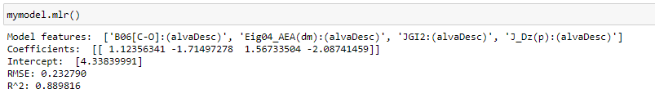
Step 4 – Write the command .train_plot() to draw a regular chart or use the command .train_plot_inter() to build an interactive chart which relates the Experimental values (Actual Y) with the Predicted values (Predicted Y) of the biological activity.
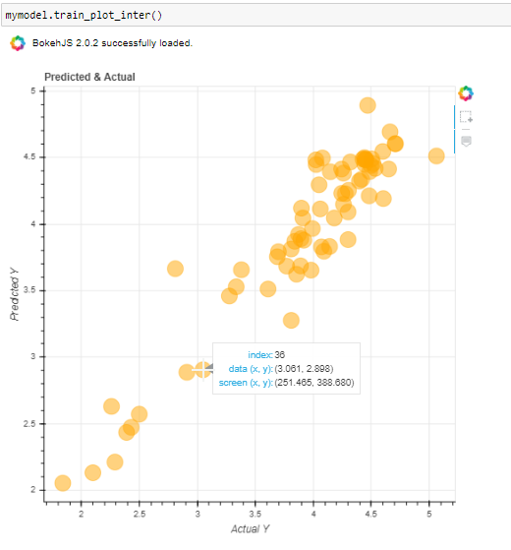

Step 5 – Validate the model using Cross-validation method.
