Supplementary Information for

Folate-conjugated organic CO prodrugs: Synthesis and CO release kinetic studies
Shameer M. Kondengadan, Shubham Bansal, Xiaoxiao Yang, and Binghe Wang*
Department of Chemistry and Center for Diagnostics and Therapeutics, Georgia State University, Atlanta, Georgia 30303, USA
*Correspondence: wang@gsu.edu

Supplementary Figures

Cell imaging experiment

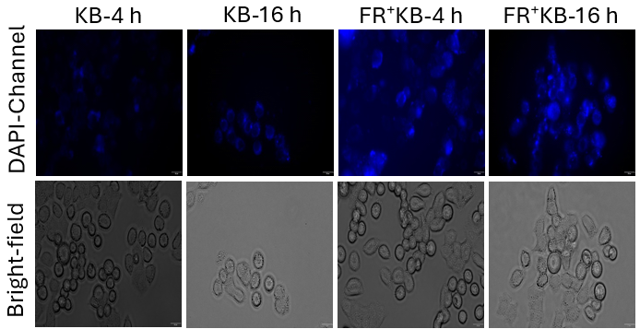
Fig. S1 Fluorescence imaging studies of the click reaction between folate conjugated CO prodrug partners 11 and 19b (10 µM each) in KB cells and FR⁺ KB cells at 4 h and 16 h timepoint.
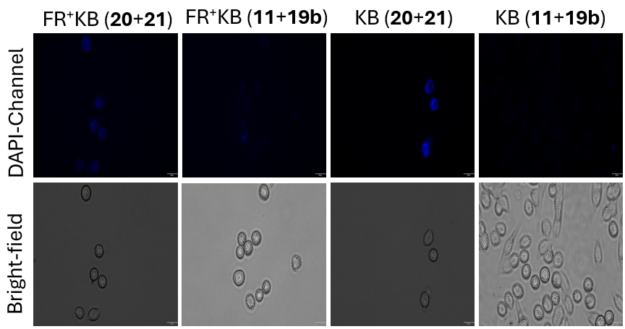

Fig. S2 Fluorescence imaging studies of the click reaction between folate conjugated CO prodrug partners 11 and 19b (10 µM each), and control compounds 20 and 21 in KB cells and FR⁺ KB cells at 4 h timepoint.

NMR Spectra of Final Compounds and Key Intermediates

Compound 8 ¹H-NMR
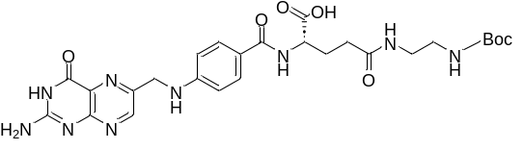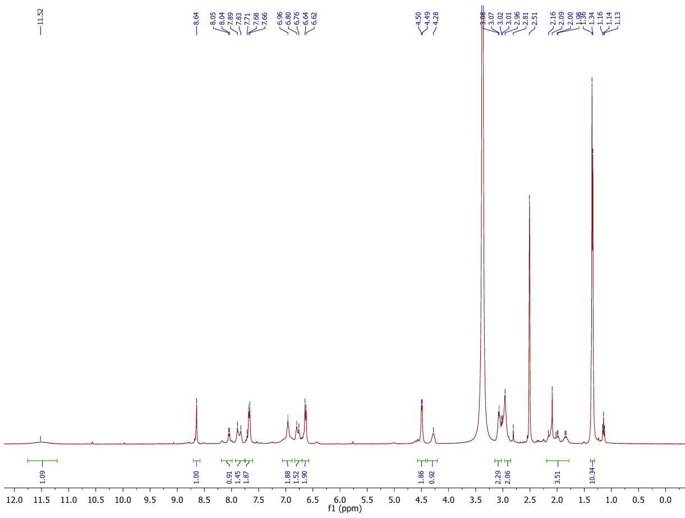
Compound 9 ¹H-NMR
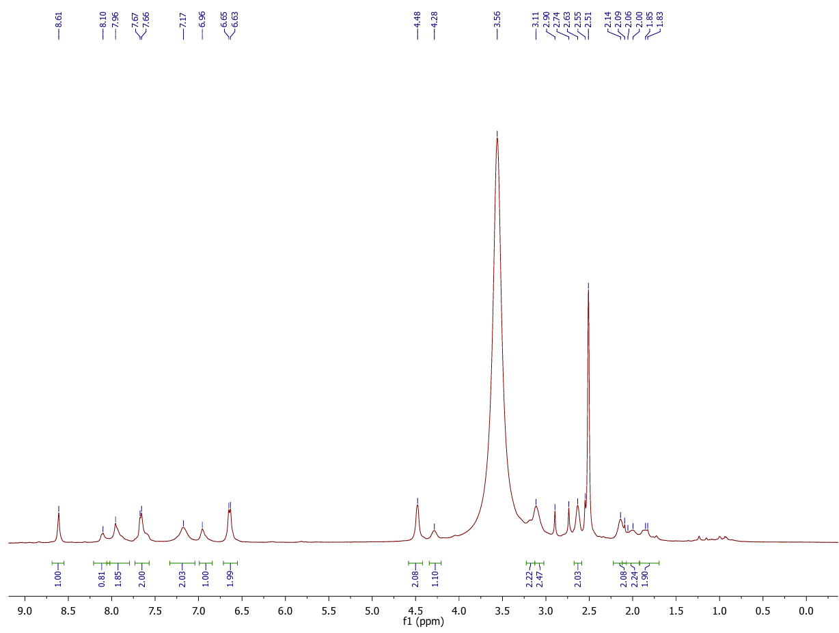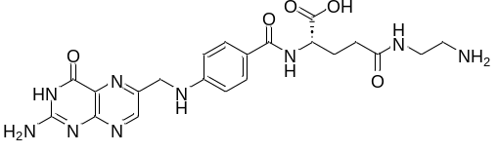
Compound 10 ¹H-NMR
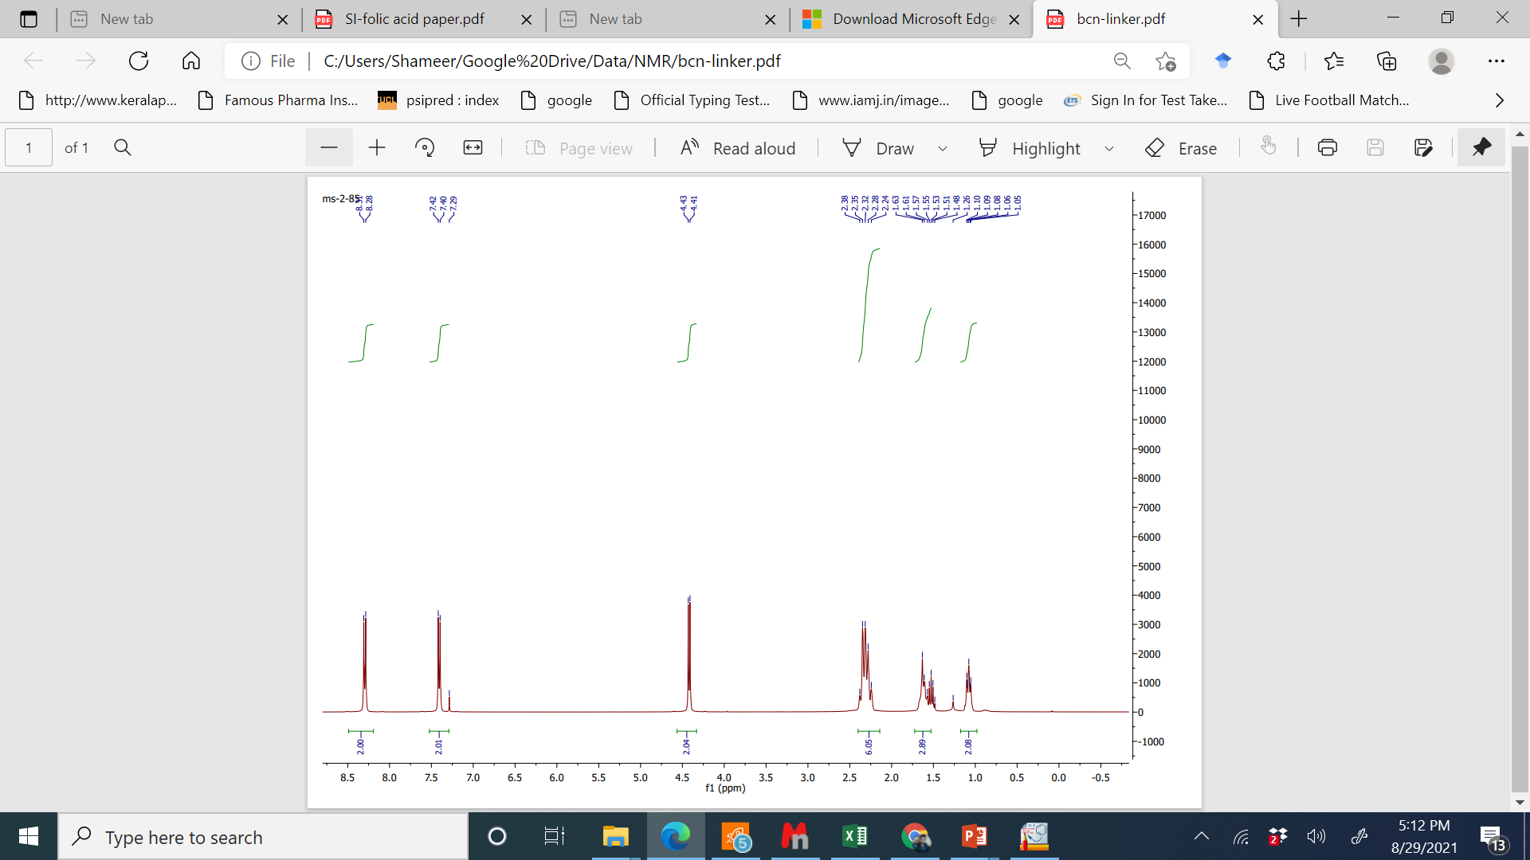

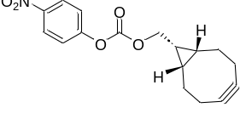

Compound 11 ¹H-NMR
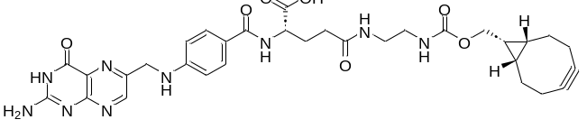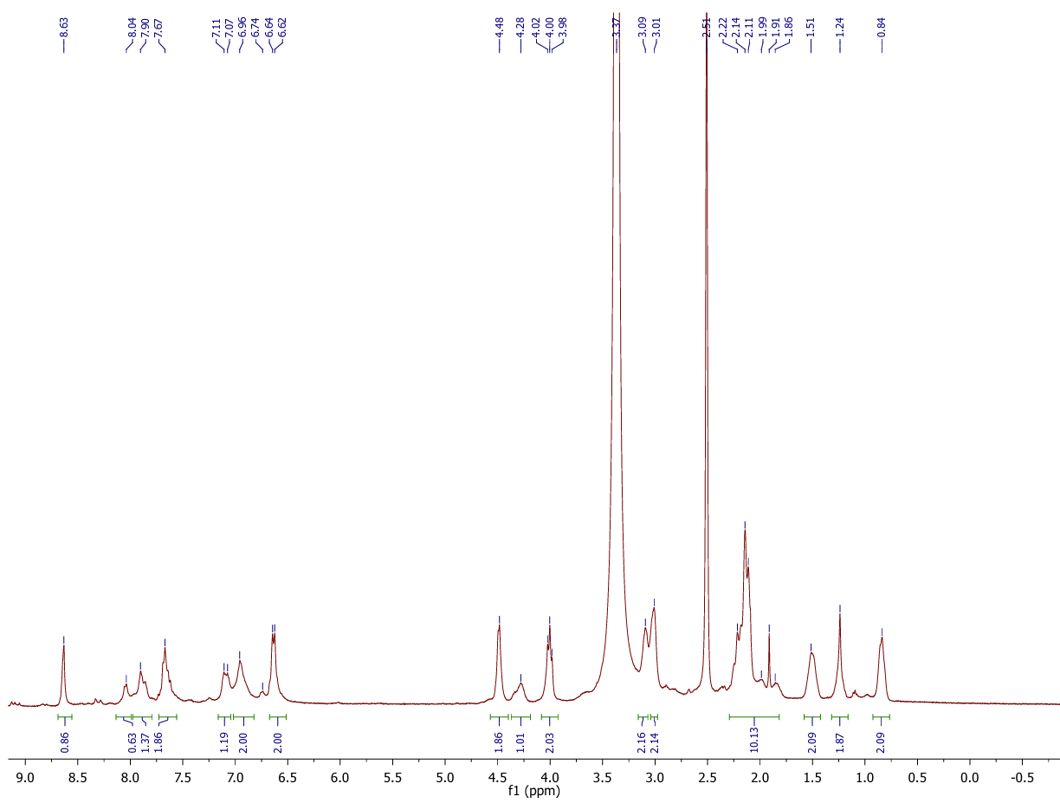

Compound 14a ¹H-NMR
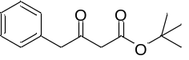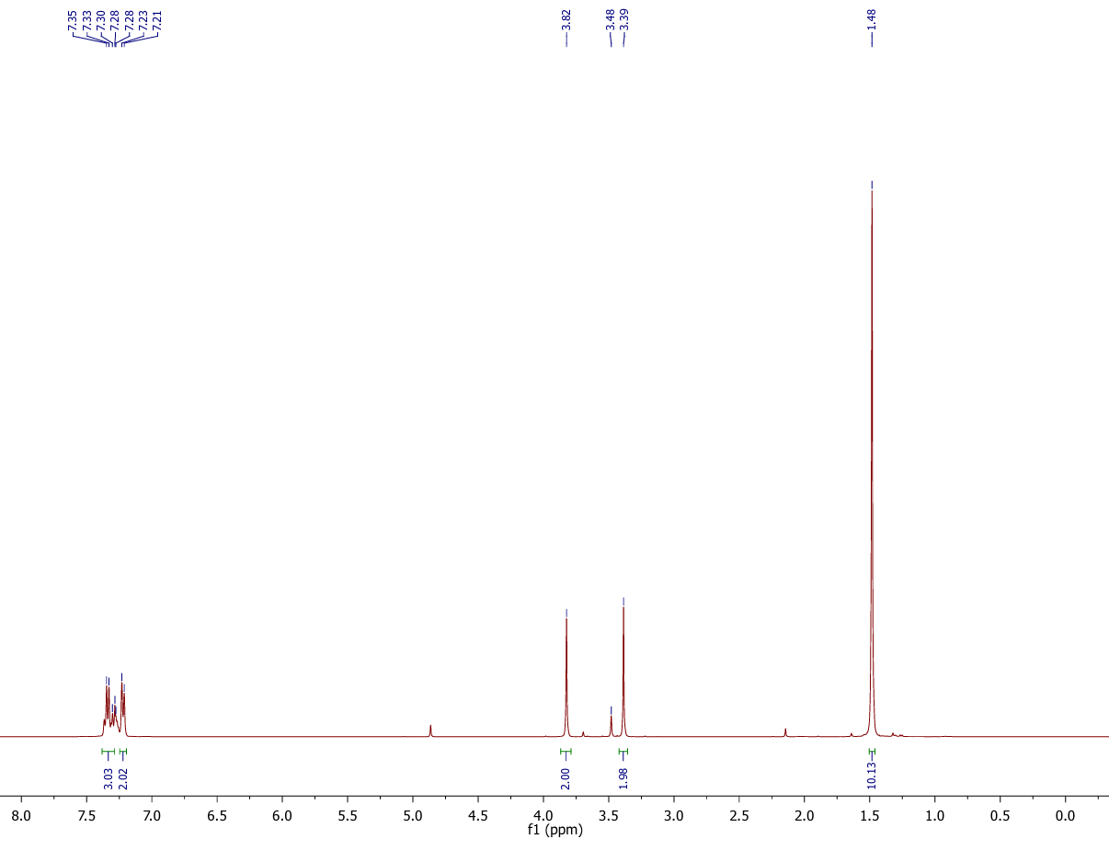
Compound 14a ¹³C-NMR

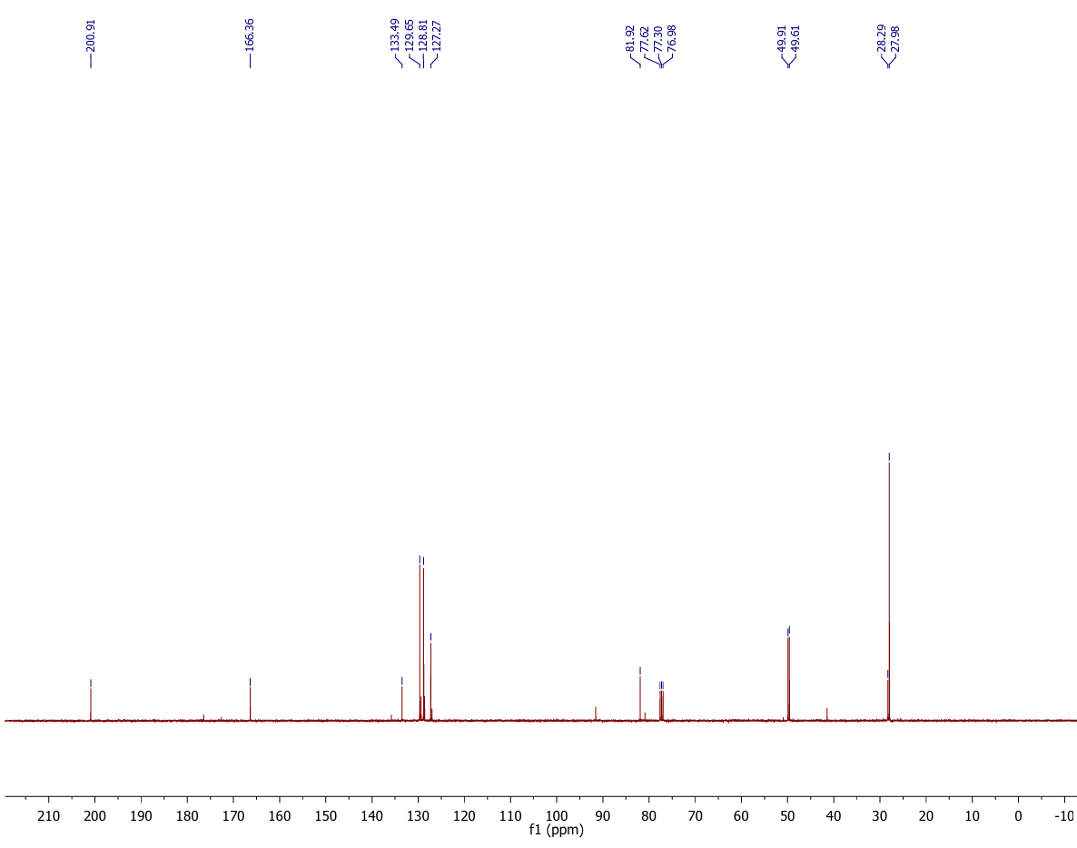
Compound 15a ¹H-NMR
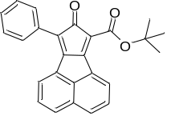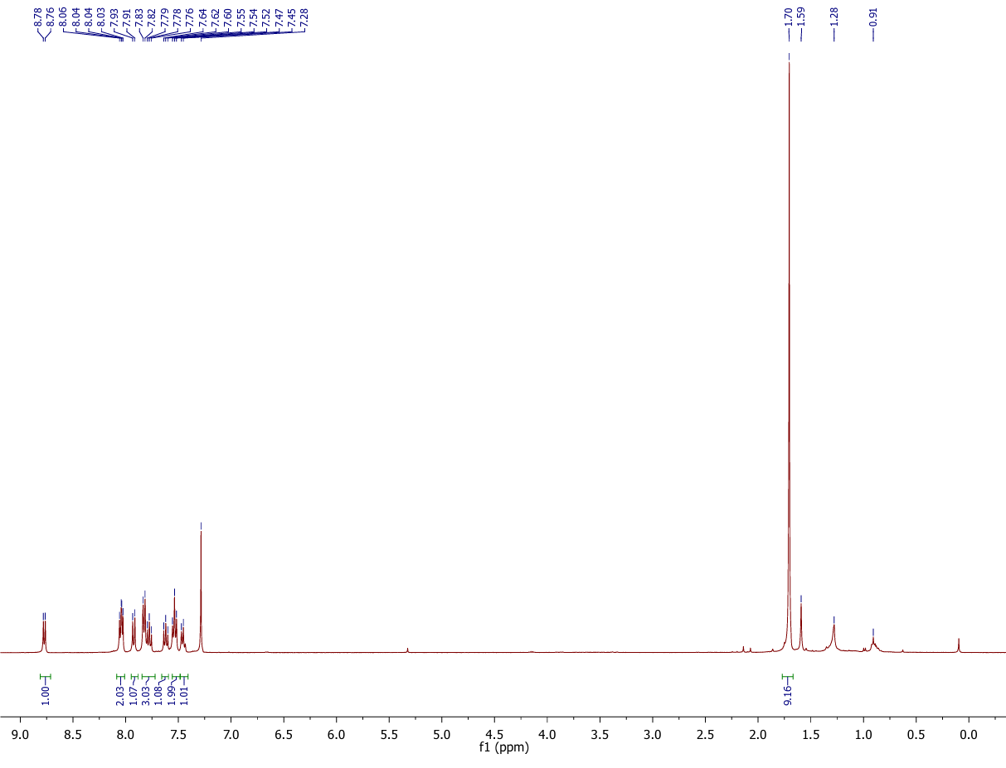
Compound 15a ¹³C-NMR

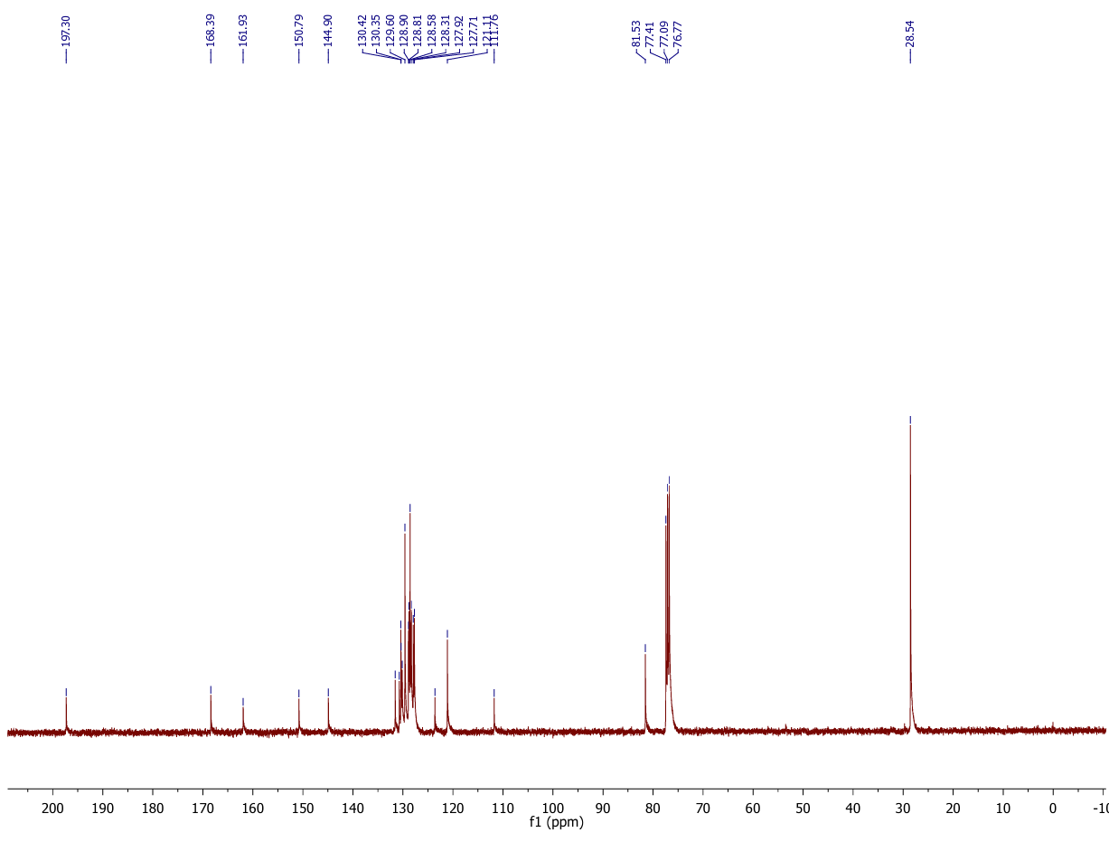
Compound 17a ¹H-NMR
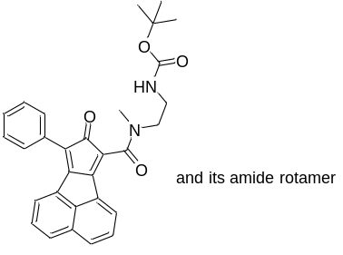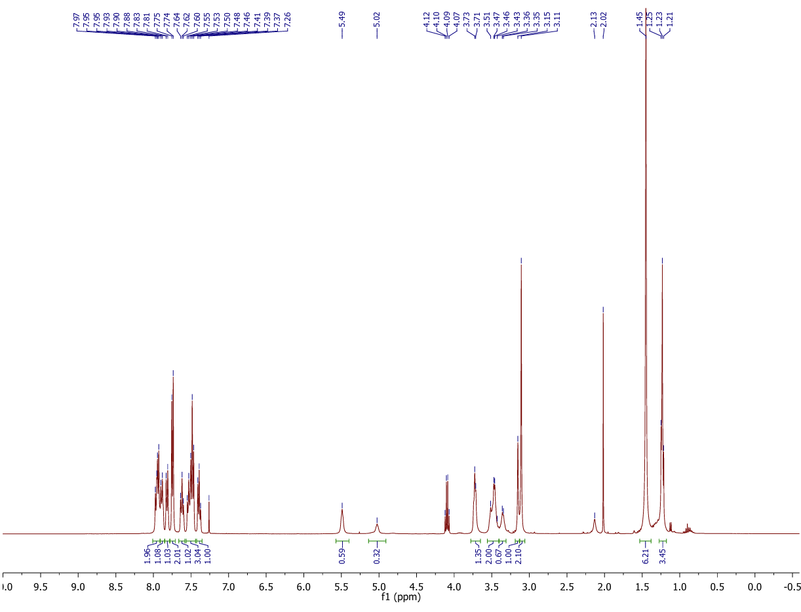
Compound 17a ¹³C-NMR
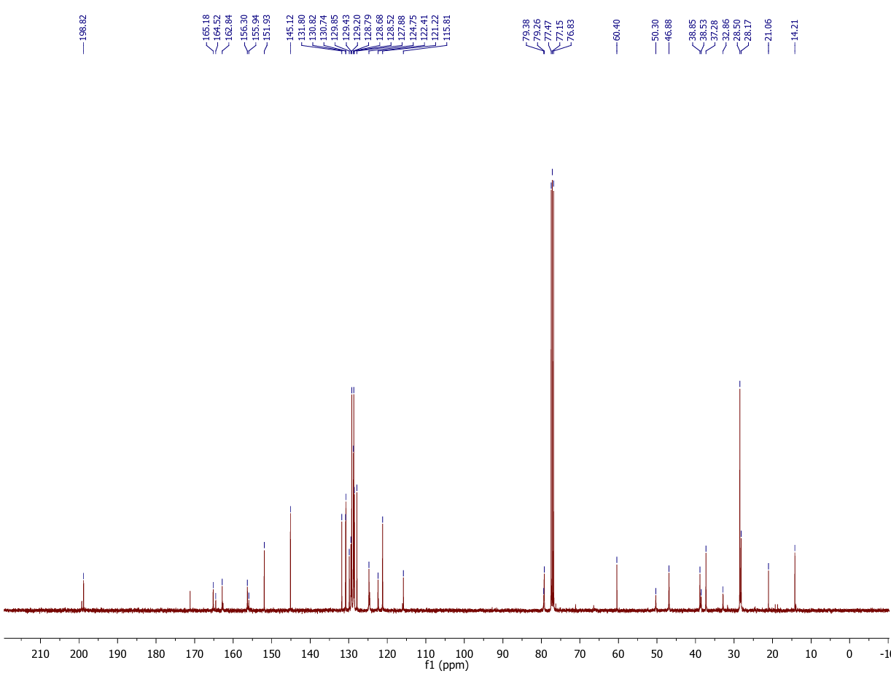
Compound 13b ¹H-NMR
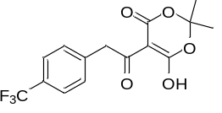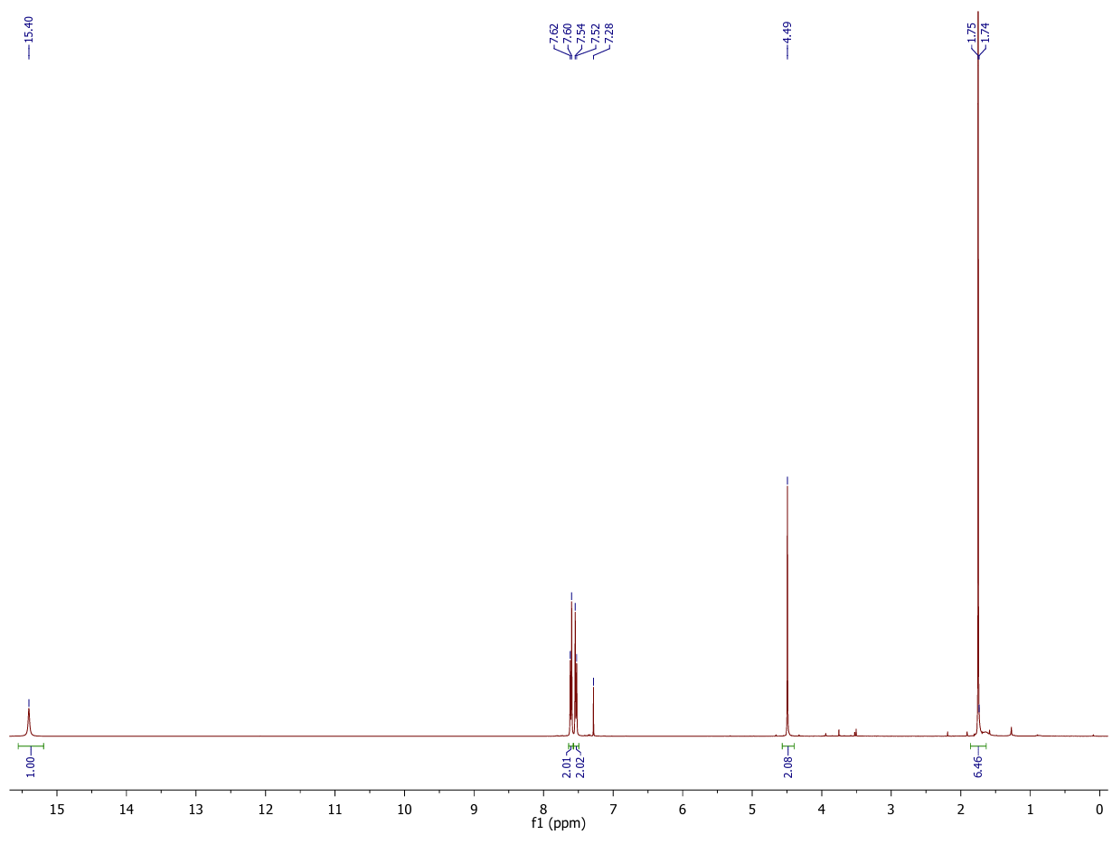
Compound 13b ¹³C-NMR
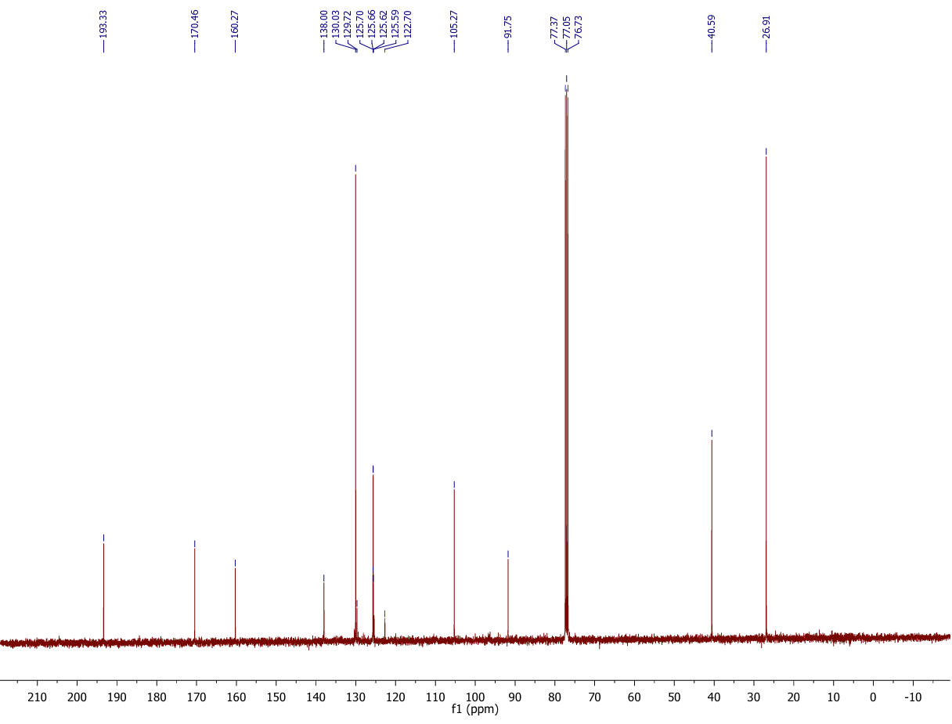
Compound 14b ¹H-NMR
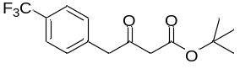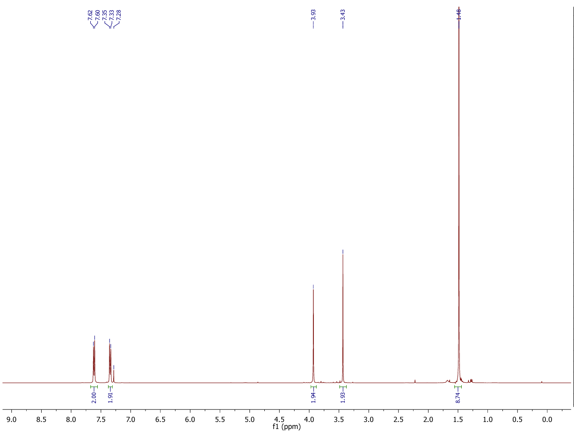
Compound 14b ¹³C-NMR
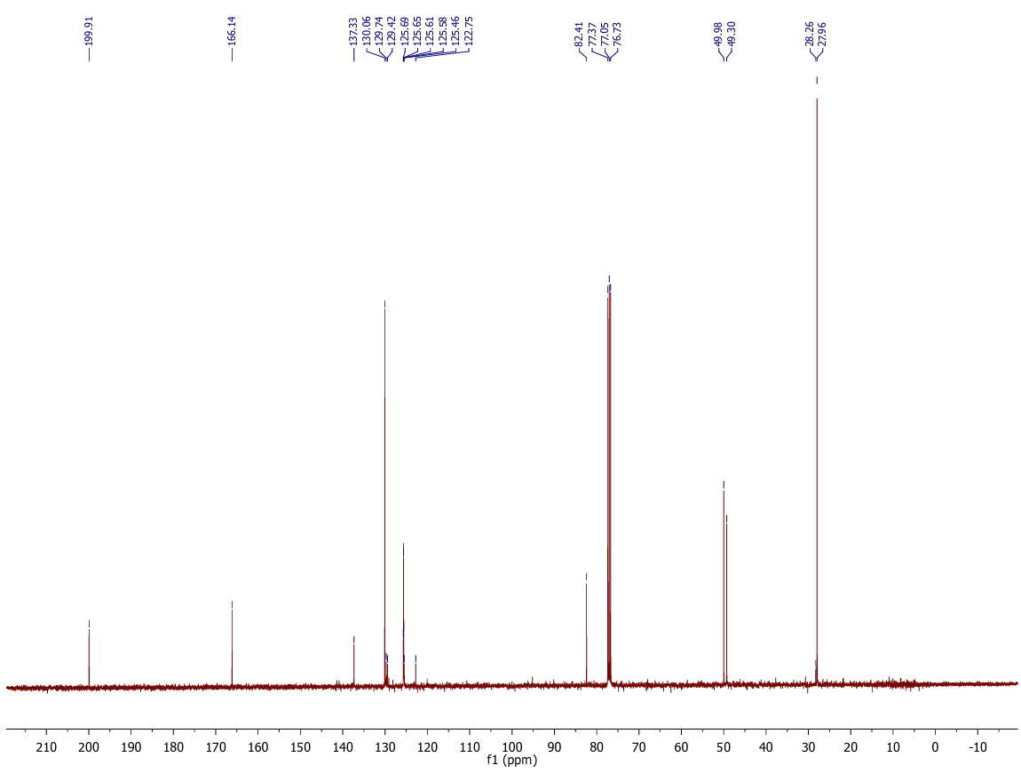
Compound 15b ¹H-NMR
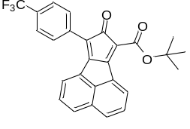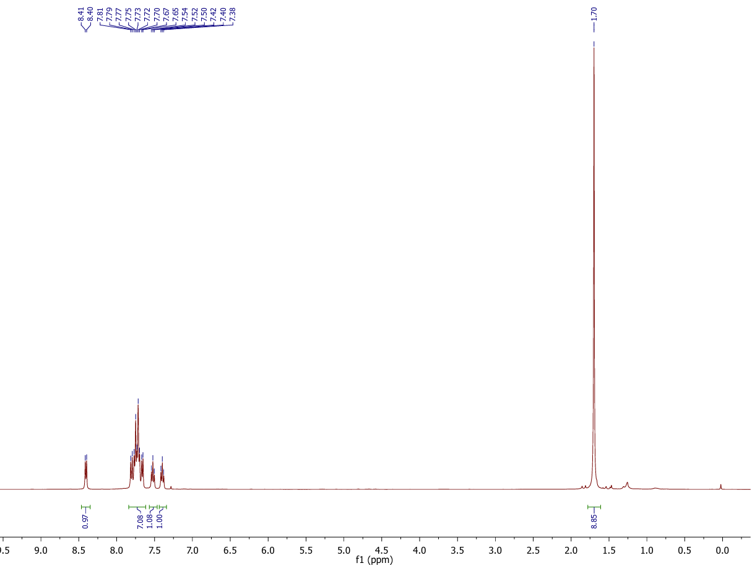
Compound 15b ¹³C-NMR
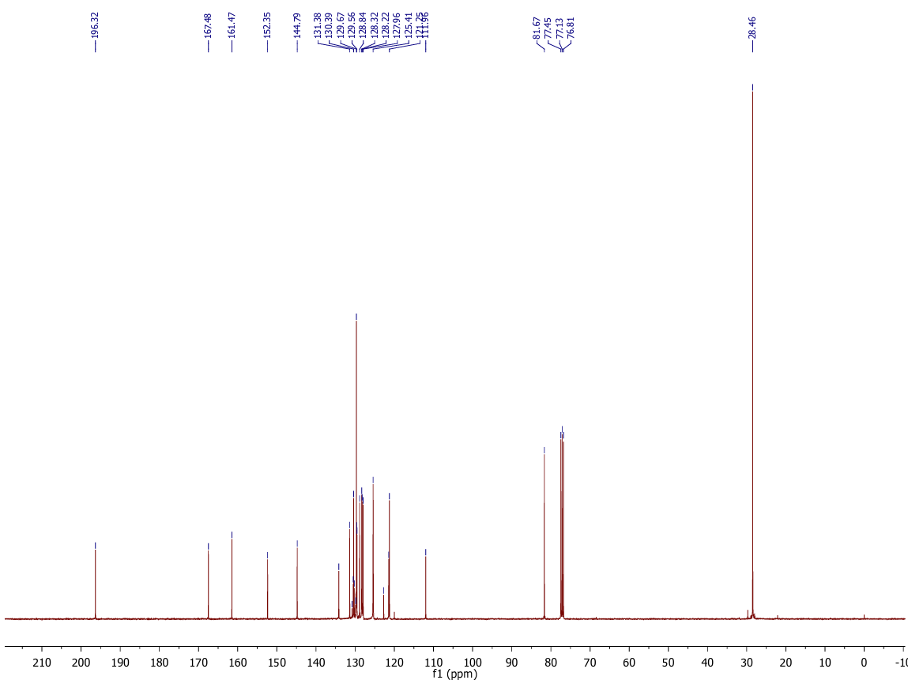
Compound 17b ¹H-NMR
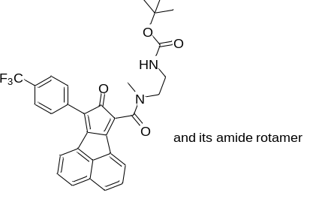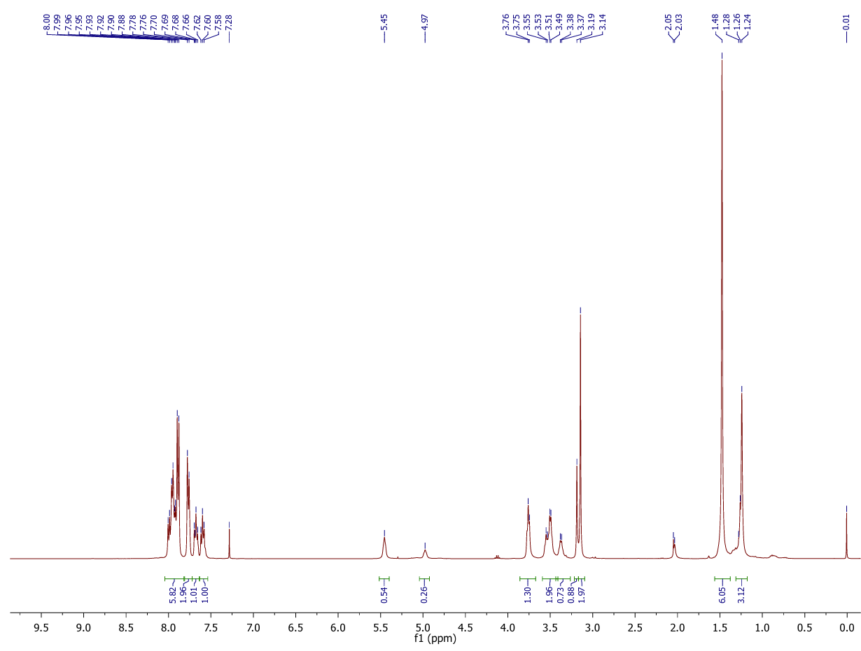
Compound 17b ¹³C-NMR
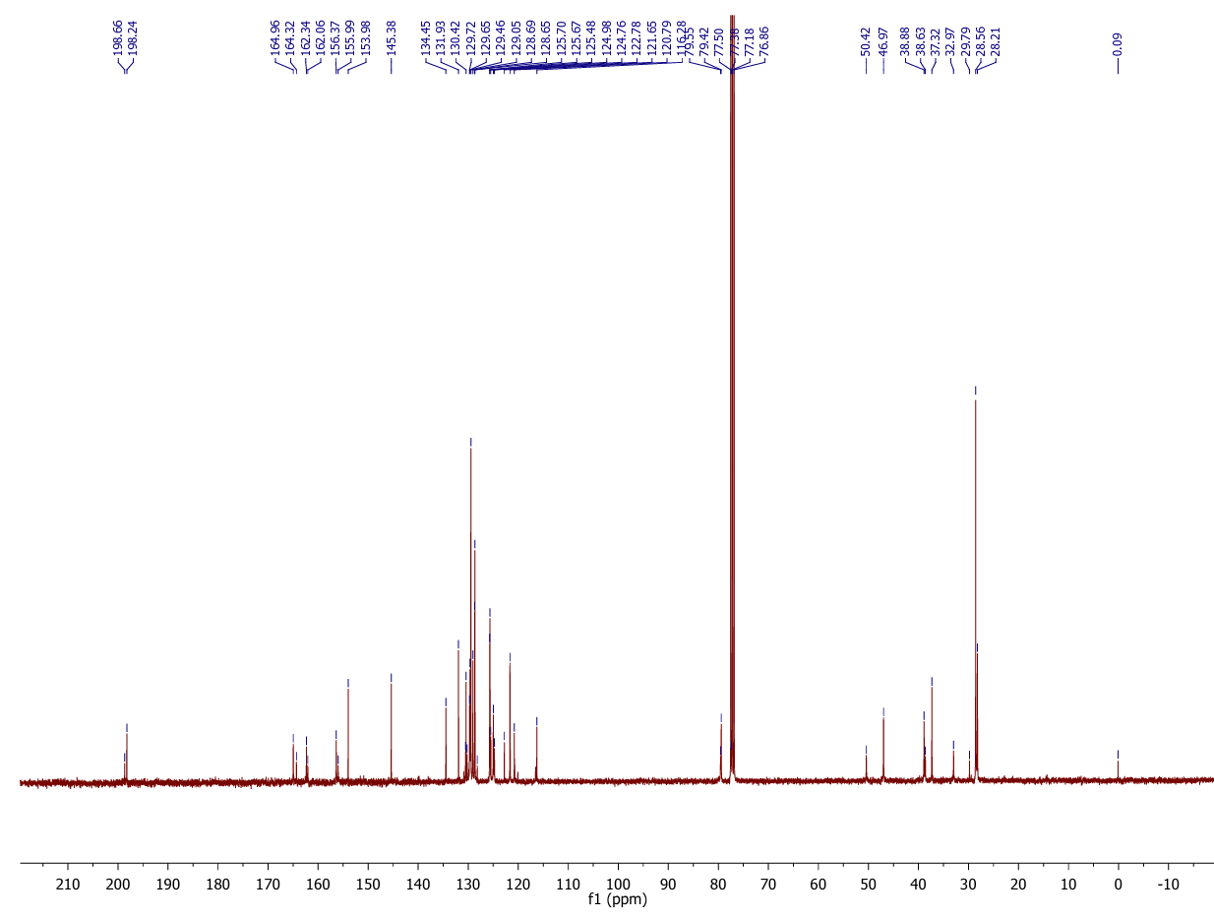

Compound 17b HRMS&LC-MS

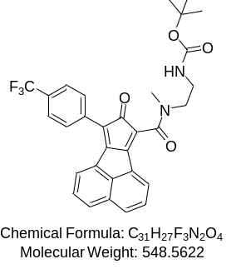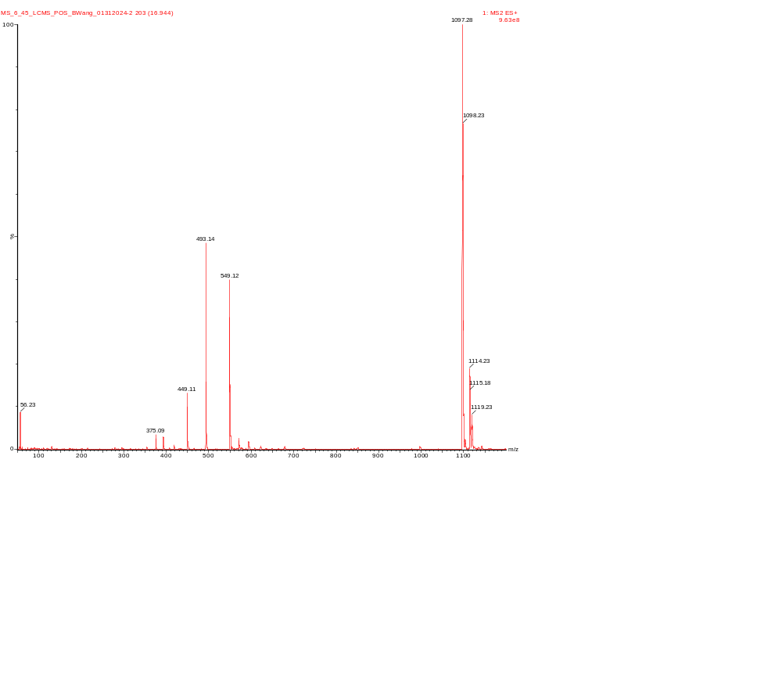
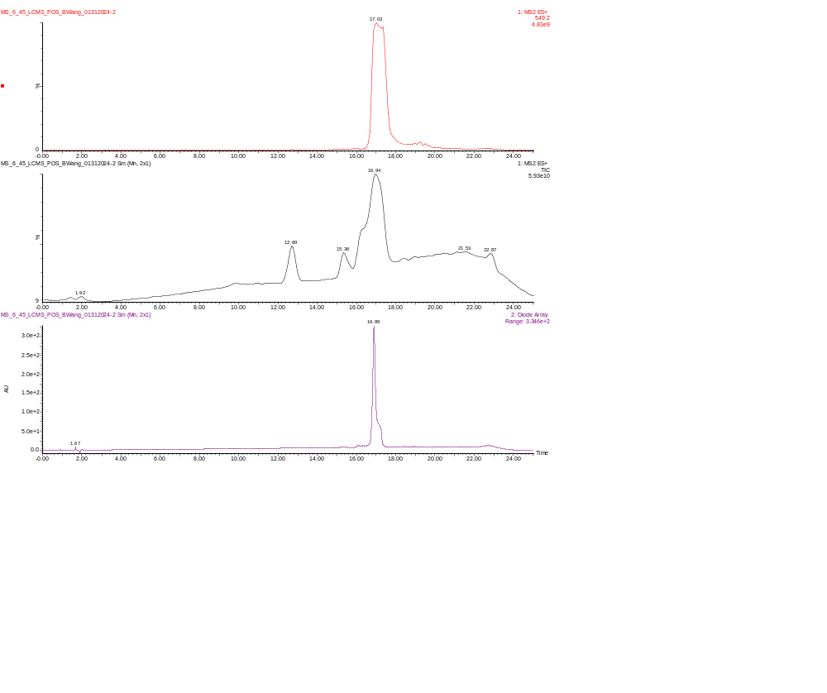

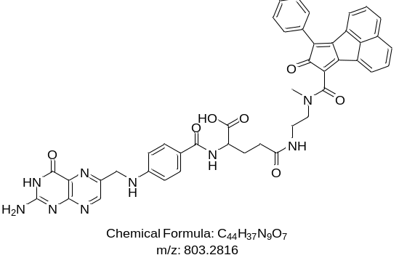Compound 19a HRMS& LC-MS
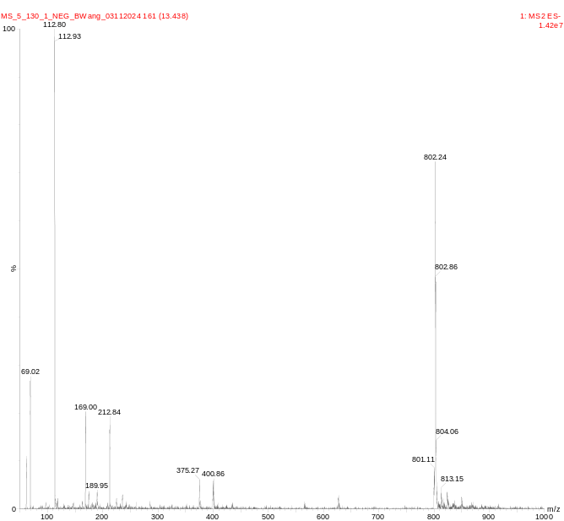
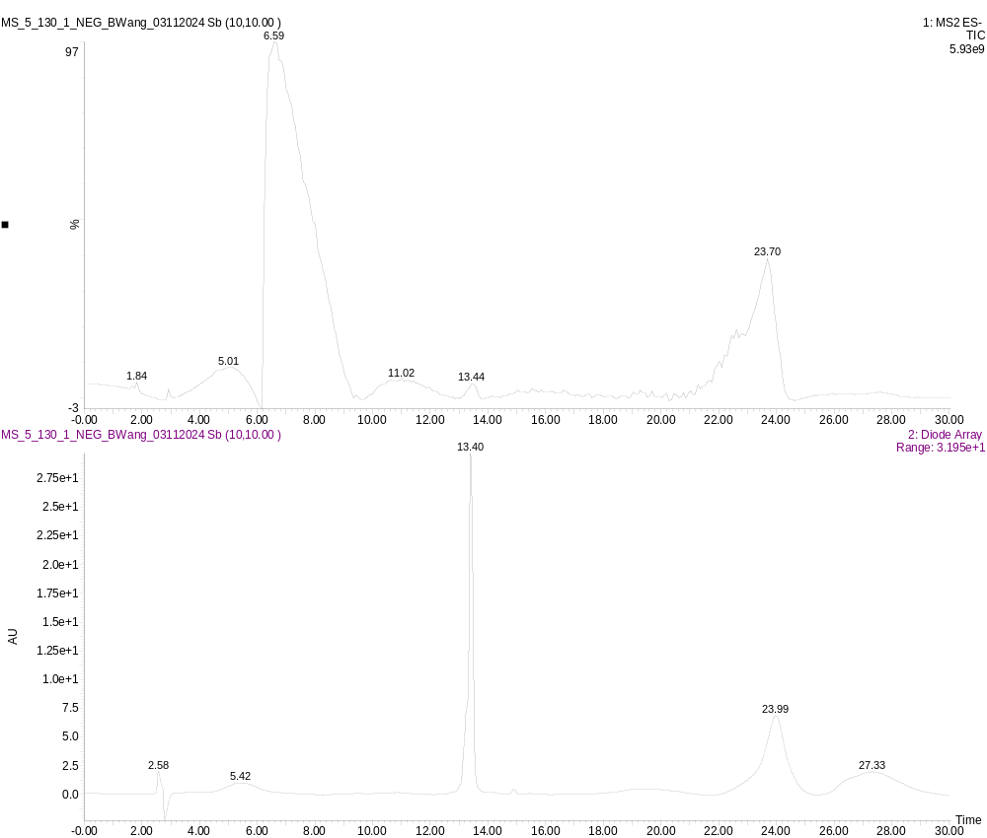

Compound 19b HRMS& LC-MS
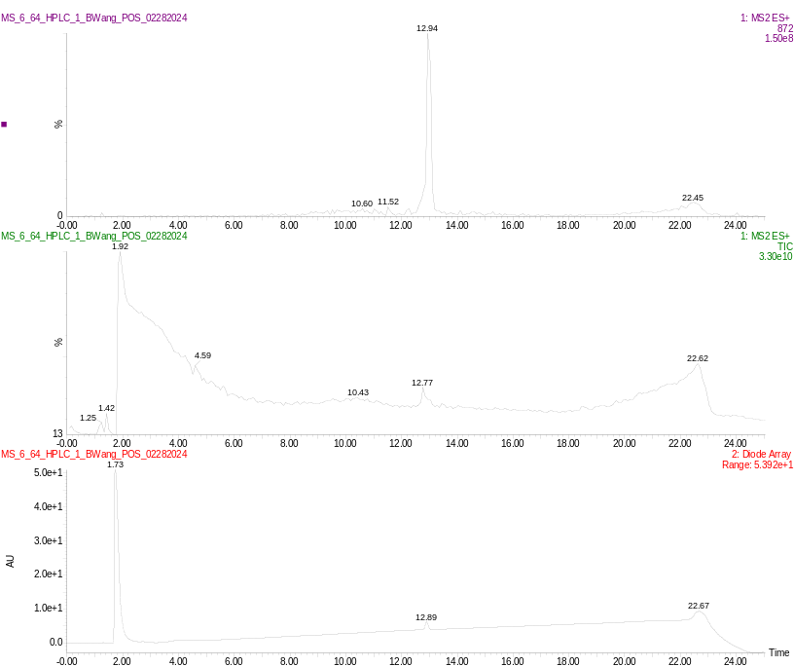

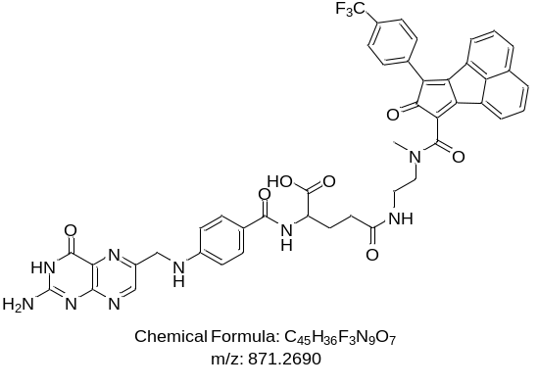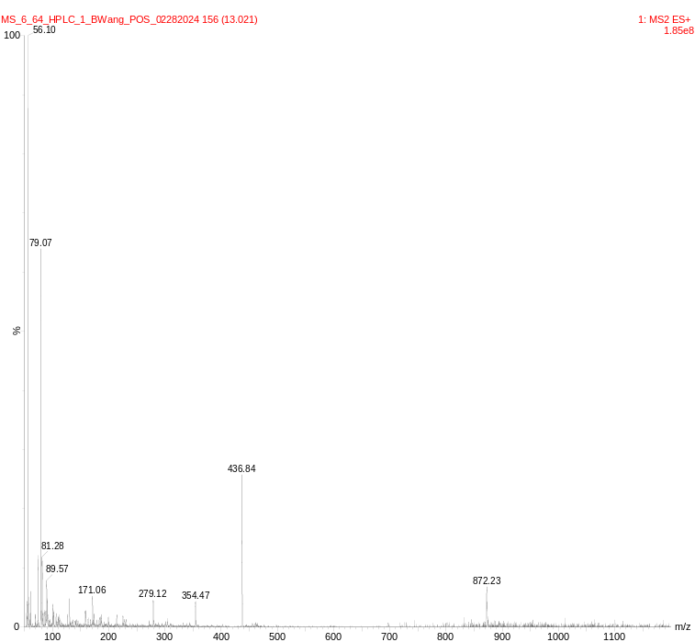
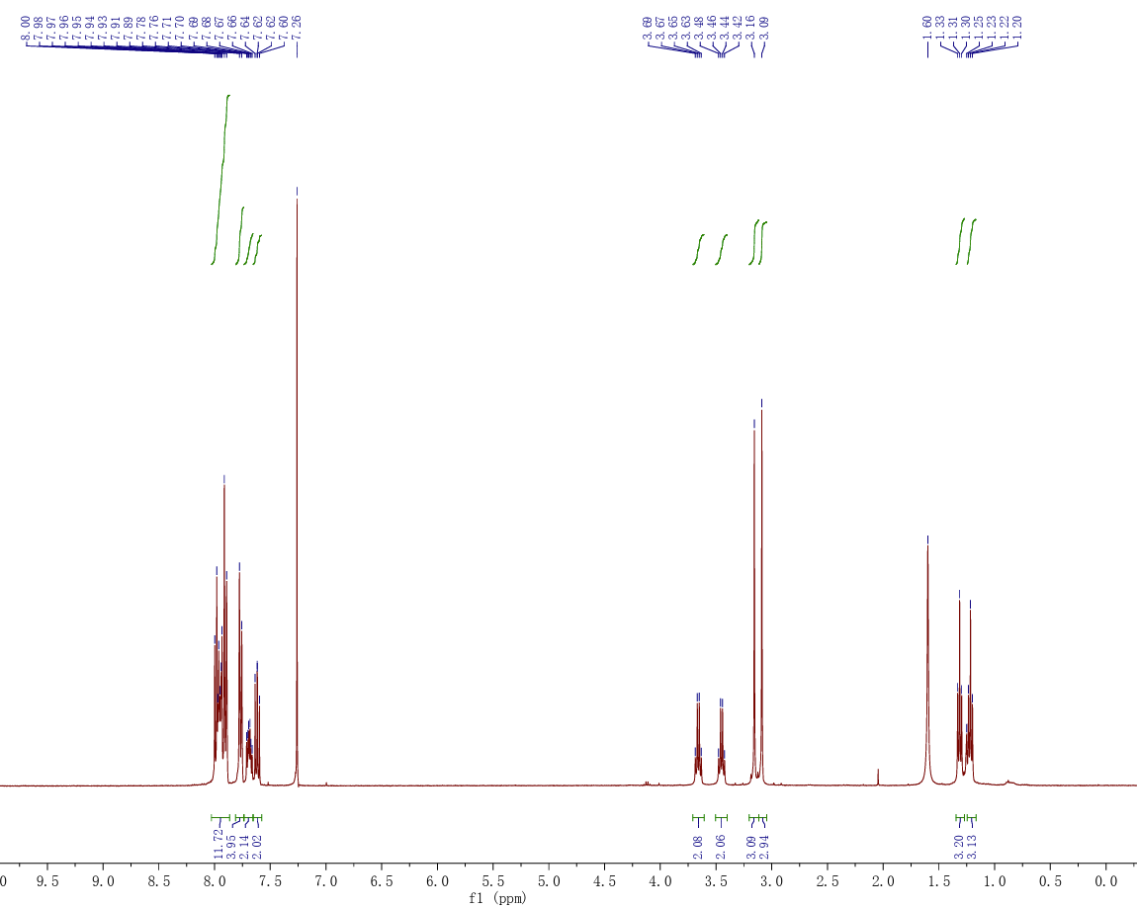
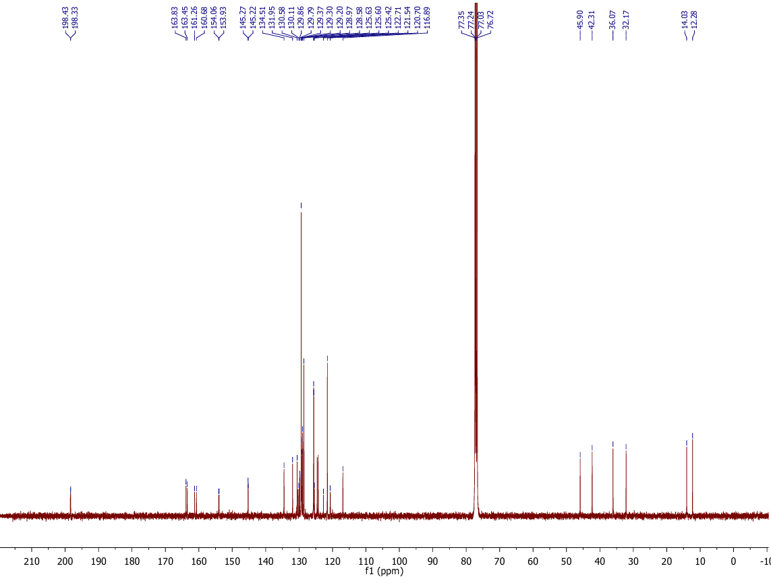
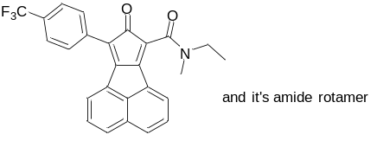 Compound 20 ¹H-NMR

Compound 20 ¹³C-NMR

