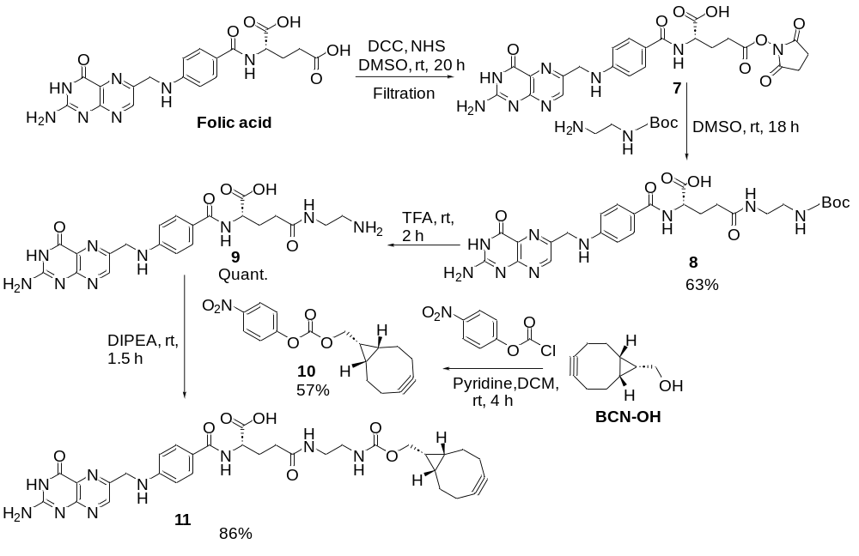
Scheme 1 Synthesis of folate conjugated BCN.
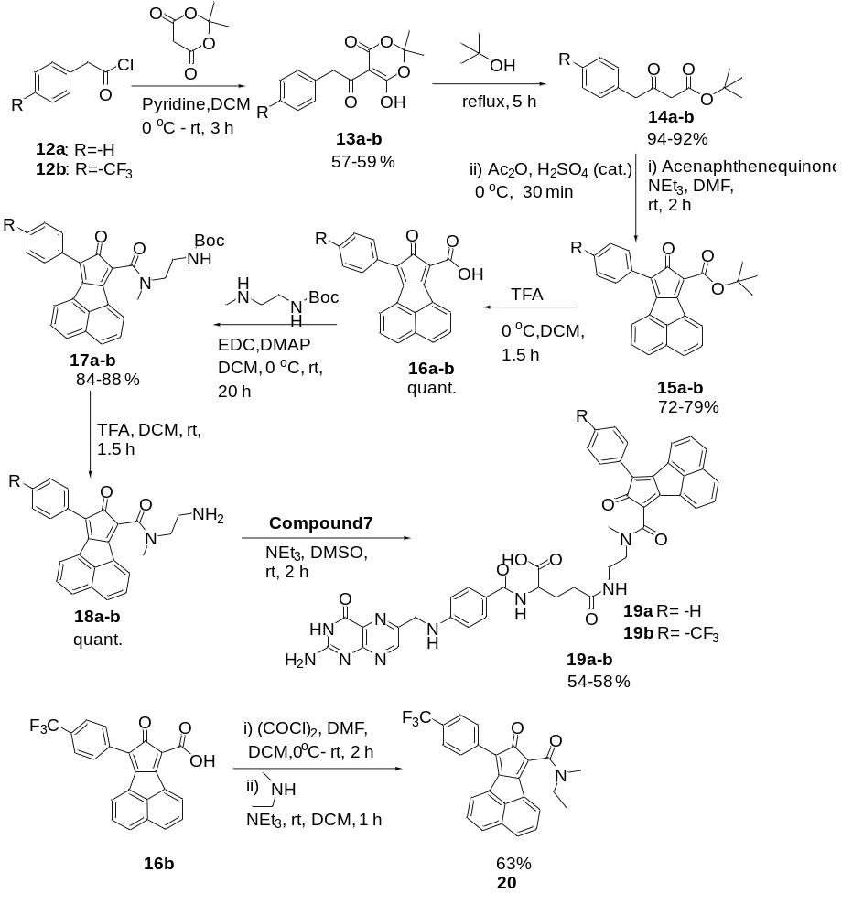
Scheme 2 Synthesis of folate-conjugated cyclopentadienones and control compound.

