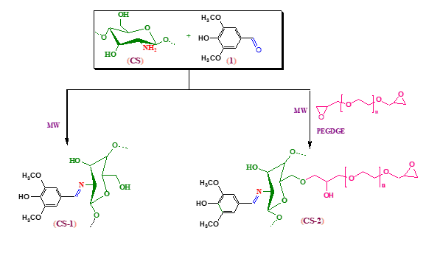
Scheme 1. Synthesis of (CS-1), (CS-2) derivatives.

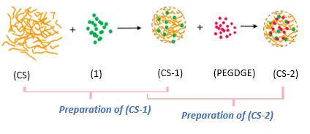
Fig 1. Synthesis of (CS-1), (CS-2) derivatives.

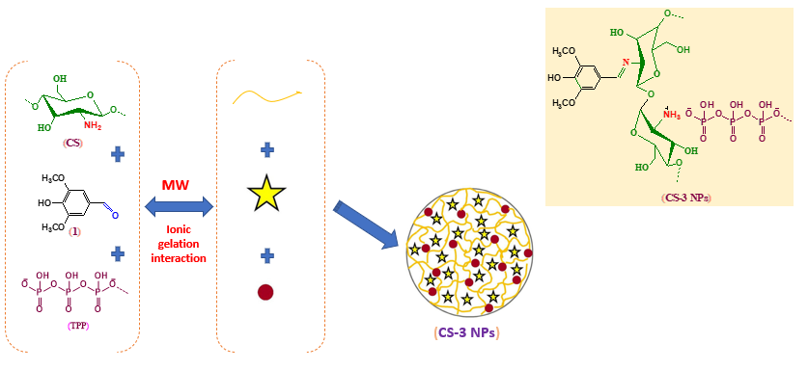
Fig 2. Synthesis of (CS-3NPs) nanoparticle.

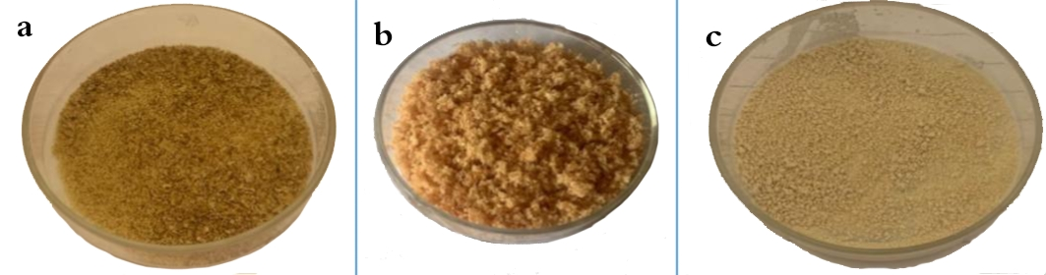

Fig 3. Modified (CS) derivatives. a) (CS-1), b) (CS-2), c) (CS-3NPs).

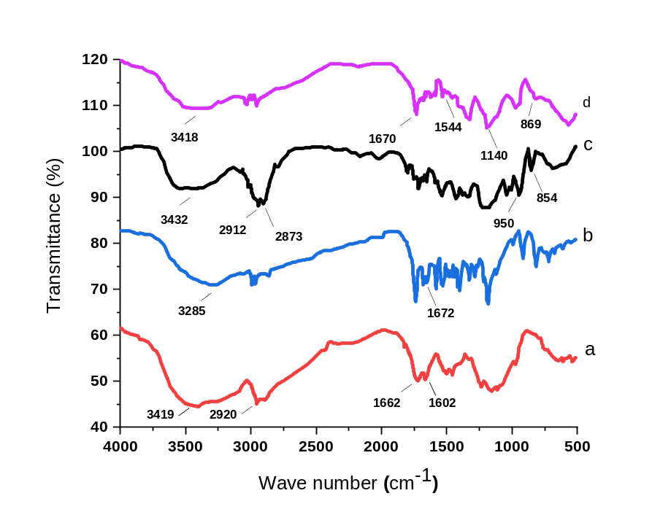
Fig. 4. FTIR of a) (CS), b) (CS-1), c) (CS-2) and d) (CS-3NPs).
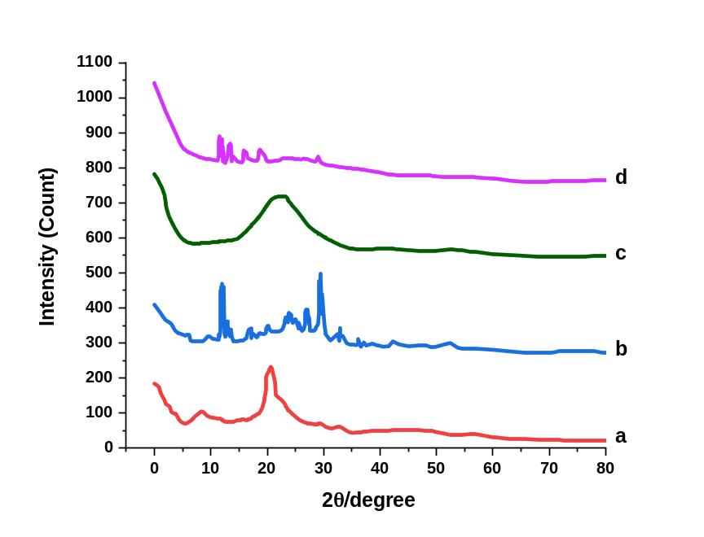
Fig. 5. XRD diffraction pattern of a) (CS), b) (CS-1), c) (CS-2) and d) (CS-3NPs).

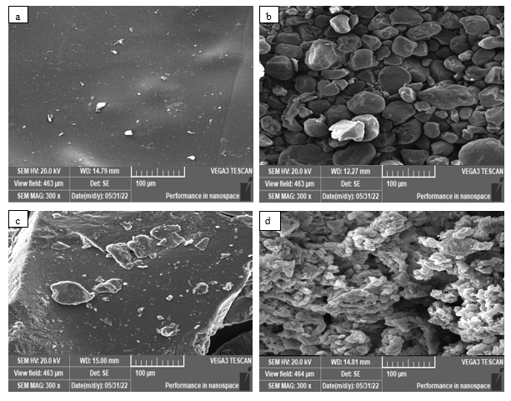
Fig. 6. SEM of a) (CS), b) (CS-1), c) (CS-2) and d) (CS-3NPs).

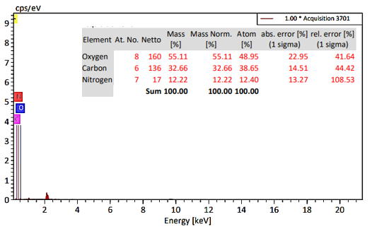
Fig. 7a. EDX of chitosan (CS).
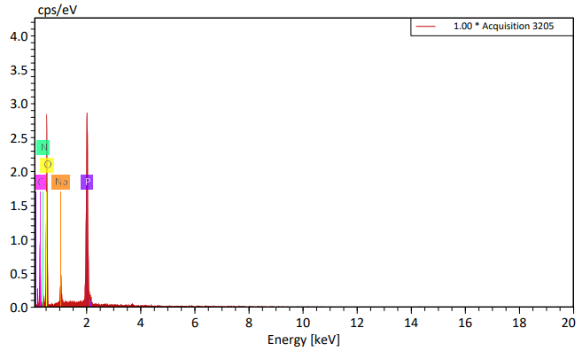
Fig. 7b. EDX of modified chitosan nanoparticle (CS-3NPs).
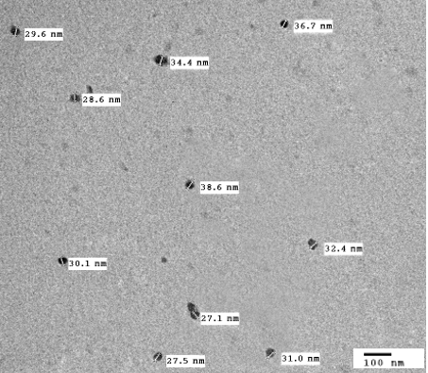
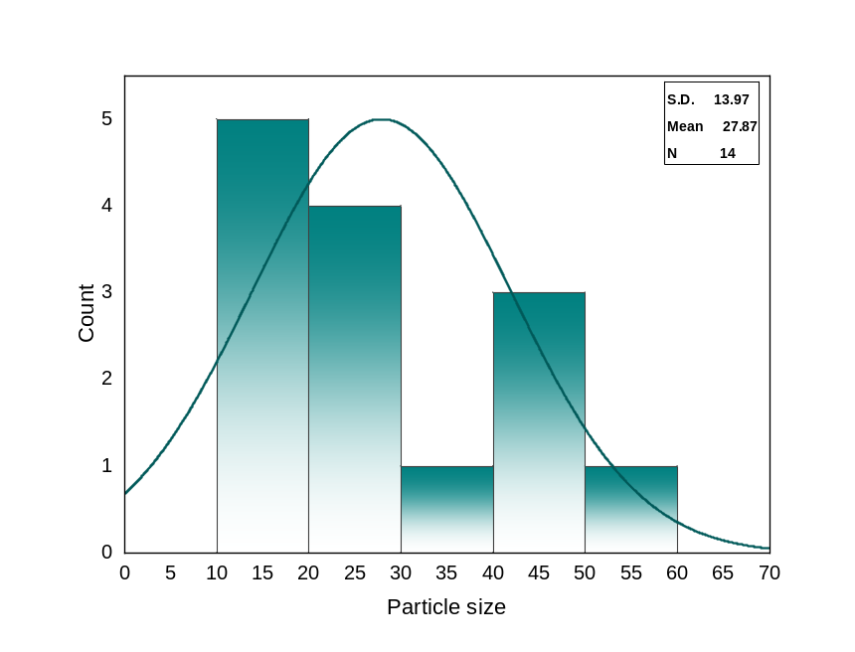

Fig. 8. TEM of modified chitosan nanoparticle (CS-3NPs) at 100 nm and particle size distribution diagram.
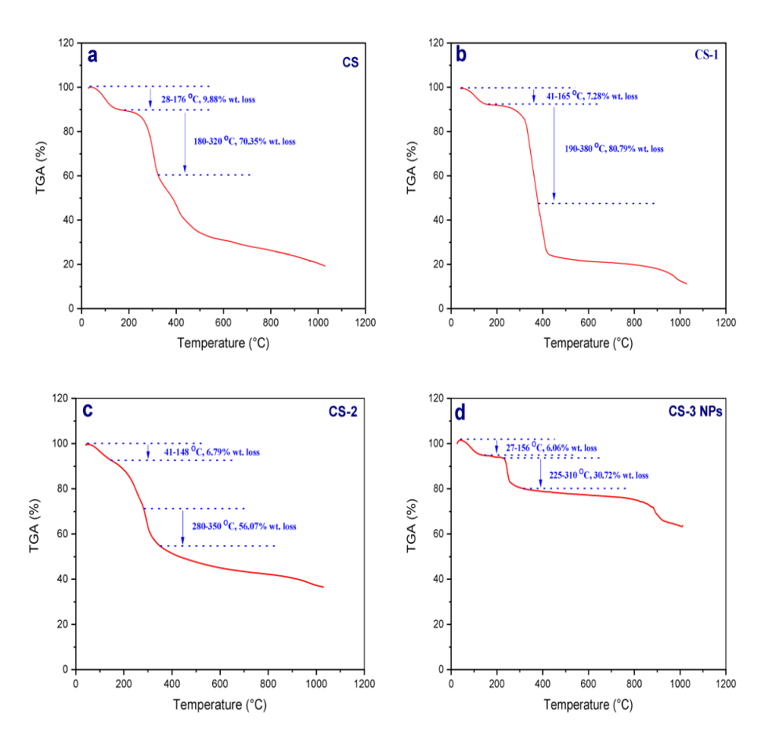
Fig. 9. TGA of a) (CS), b) (CS-1), c) (CS-2) and d) (CS-3NPs).

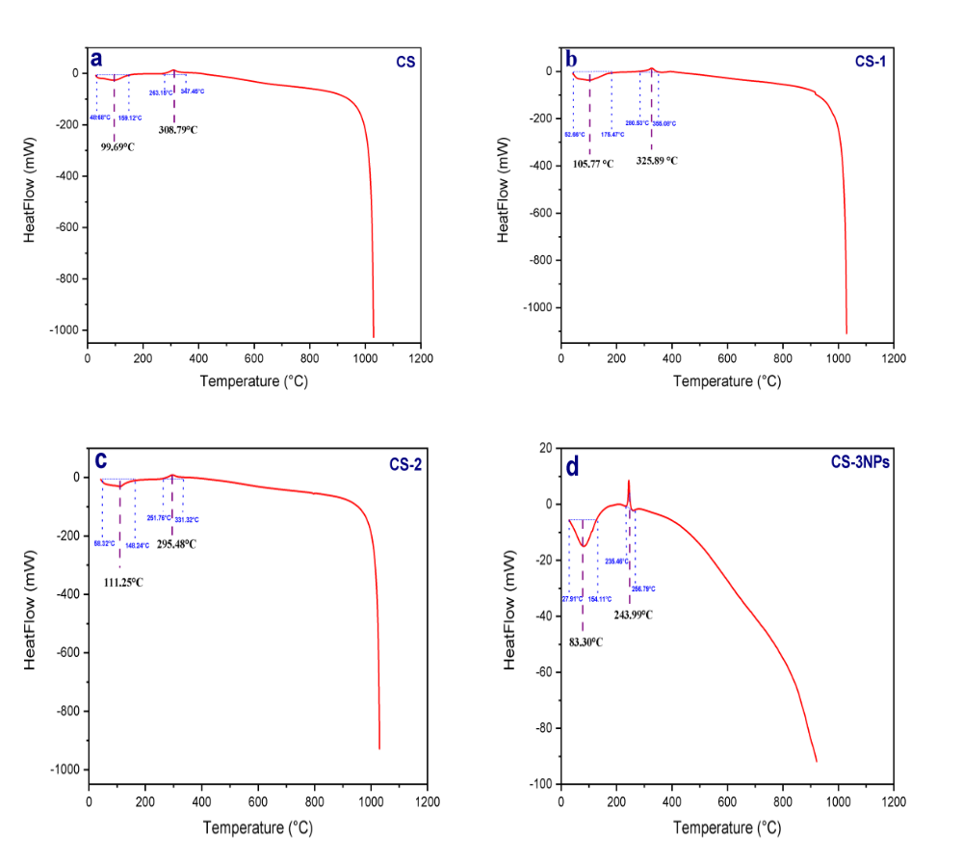

Fig. 10. DSC of a) (CS), b) (CS-1), c) (CS-2) and d) (CS-3NPs).

Fig. 11. The antitumor activity of (CS), (CS-1), (CS-2), and (CS-3NPs) against HeLa cells. Data were demonstrated as a means of standard deviation (±SD).

Fig. 12. The antitumor activity of (CS), (CS-1), (CS-2), and (CS-3NPs) against Hep-2 Data were demonstrated as a means of standard deviation (±SD).

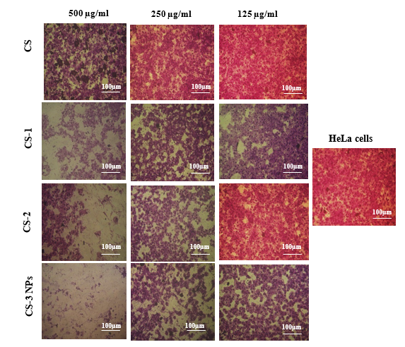

Fig. 13. Morphological changes of HeLa cells for (CS), (CS-1), (CS-2), and (CS-3NPs).

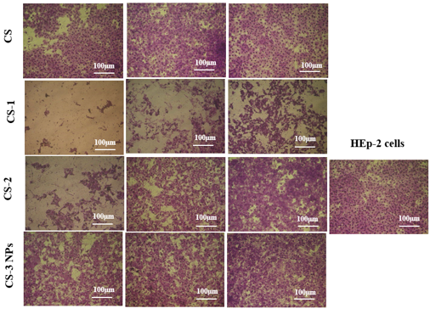
Fig. 14. Morphological changes of HEp-2 cells for (CS), (CS-1), (CS-2), and (CS-3NPs).

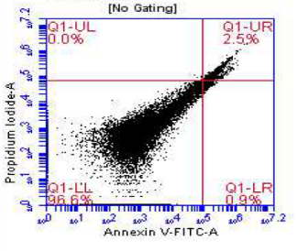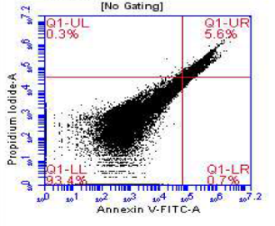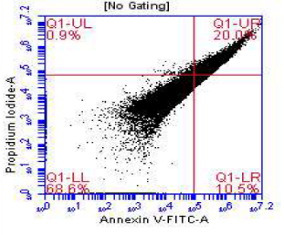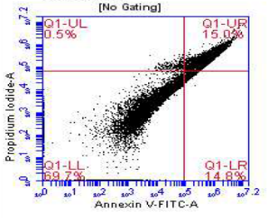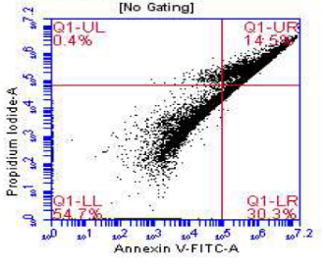
E
A
B
D
C

Fig. 15. Flow cytometric analysis of treated HeLa cells with 125µg of different derivatives.
(A). Control, (B). Chitosan (CS), (C). (CS-1), (D).(CS-2), and (E). (CS-3NPs). The lower left (LL) quadrant (Q1) (annexin V-/PI-) is regarded as the population of live cells, the lower right quadrant (Q2) (LR) (annexin V+/PI-) is considered as the cell population at the early apoptotic stage, the upper right (UR) quadrant (Q3) (annexin V+/PI+) represents the cell population at the late apoptotic stage, and upper left (UL) quadrant (Q4) (annexin V-/PI+) is considered as necrotic cell population.

Table 1
Elemental analysis, (MW), (DD) and (DS) of (CS) and (CS) derivatives.
Sample code | C% | H% | N% | C/N | MW  KDa | DD% | DS
CS | 40.72 | 7.47 | 7.68 | 5.30 | 60 | 91 | -
CS-1 | 48.57 | 5.80 | 3.41 | 14.24 | - | - | 0.9
CS-2 | 55.29 | 7.39 | 2.78 | 19.88 | - | - | 0.8
CS-3NPs | 35.26 | 5.28 | 3.79 | 9.30 | - | - | 0.4

Table 2.
Thermal stability TGA and DSC of (CS), its derivatives (CS-1), (CS-2) and (CS-3NPs).
Sample code | temperature | Weight loss (%) | temperature | Weight loss (%) | temperature | Weight loss (%) | Tg | Tc
CS | 65.4 | 9.88 | - | - | 250 | 70.35 | 99.69 | 308.79
CS-1 | 82 | 7.28 | - | - | 285 | 80.79 | 105.77 | 325.89
CS-2 | 95.26 | 6.79 | - | - | 315 | 56.07 | 111.25 | 295.48
CS-3NPs | 89 | 6.06 | - | - | 295 | 30.72 | 83.30 | 243.99

Table 3.
IC₅₀ values of (CS), (CS-1), (CS-2), and (CS-3NPs) against HeLa cells and HEp-2 cells
Sample code | IC₅₀ (µg/ml)
Sample code | Hela cell lines | HEp-2 cell lines
CS | 424.89±12.37ª | ≥500^{b}
CS-1 | 194.44±6.58^{c} | 108.05±2.31^{d}
CS-2 | 228.51±3.97^{b} | 348.65±4.11^{c}
CS-3NPs | 108.01±3.94^{d} | ≥500ª

