Table S1: The snow leopards display nine distinct behaviors involving scent marking, body rubbing, and investigation based on camera trap video imagery.
Type | Behaviour | Definition | references
Scent Marking | Scraping | Raking their hind feet through the substrate and then occasionally urinating and/or defecating on the scraped mound of material/or sands | Ahlborn and Jackson 1986
Scent Marking | Urine Spraying | spraying urine backwards onto overhanging rocks or other vertical surface of rocks
Scent Marking | Faecal Deposition | Defecating; also called “faecal marking” in some studies/scats marks
Body Rubbing | Cheek Rubbing | Rubbing their cheek on a rock surface /snags, tree trunks | Wolf, M. & Ale, S 2009
Body Rubbing | Claw Marking | Raking, gouging, or gripping a bushy vegetation or rocks with their claws | Ahlborn
Body Rubbing | Rolling | Rolling posterior and onward on the ground; also called “vegetation flattening” in some studies
Body Rubbing | Tail Wrapping | Wrapping their tail around a vertical rock surface
Vocalization | vocalization | Making breeding calls or other sounds during mating seasons /non-mating seasons | Hill et al., 1976
Investigating | Olfaction | Sniffing to examine cues and signals, distinguished by the snow leopard’s nose within one head length of a scrape or other cue; also called “sniffing” in some studies | Li, J. et al.,2013
Investigating | Flehmen Response | Lifting their head and curling back their upper lip, sometimes arching its neck backwards, in order to expose their vomeronasal organ | Allen etal.,2014

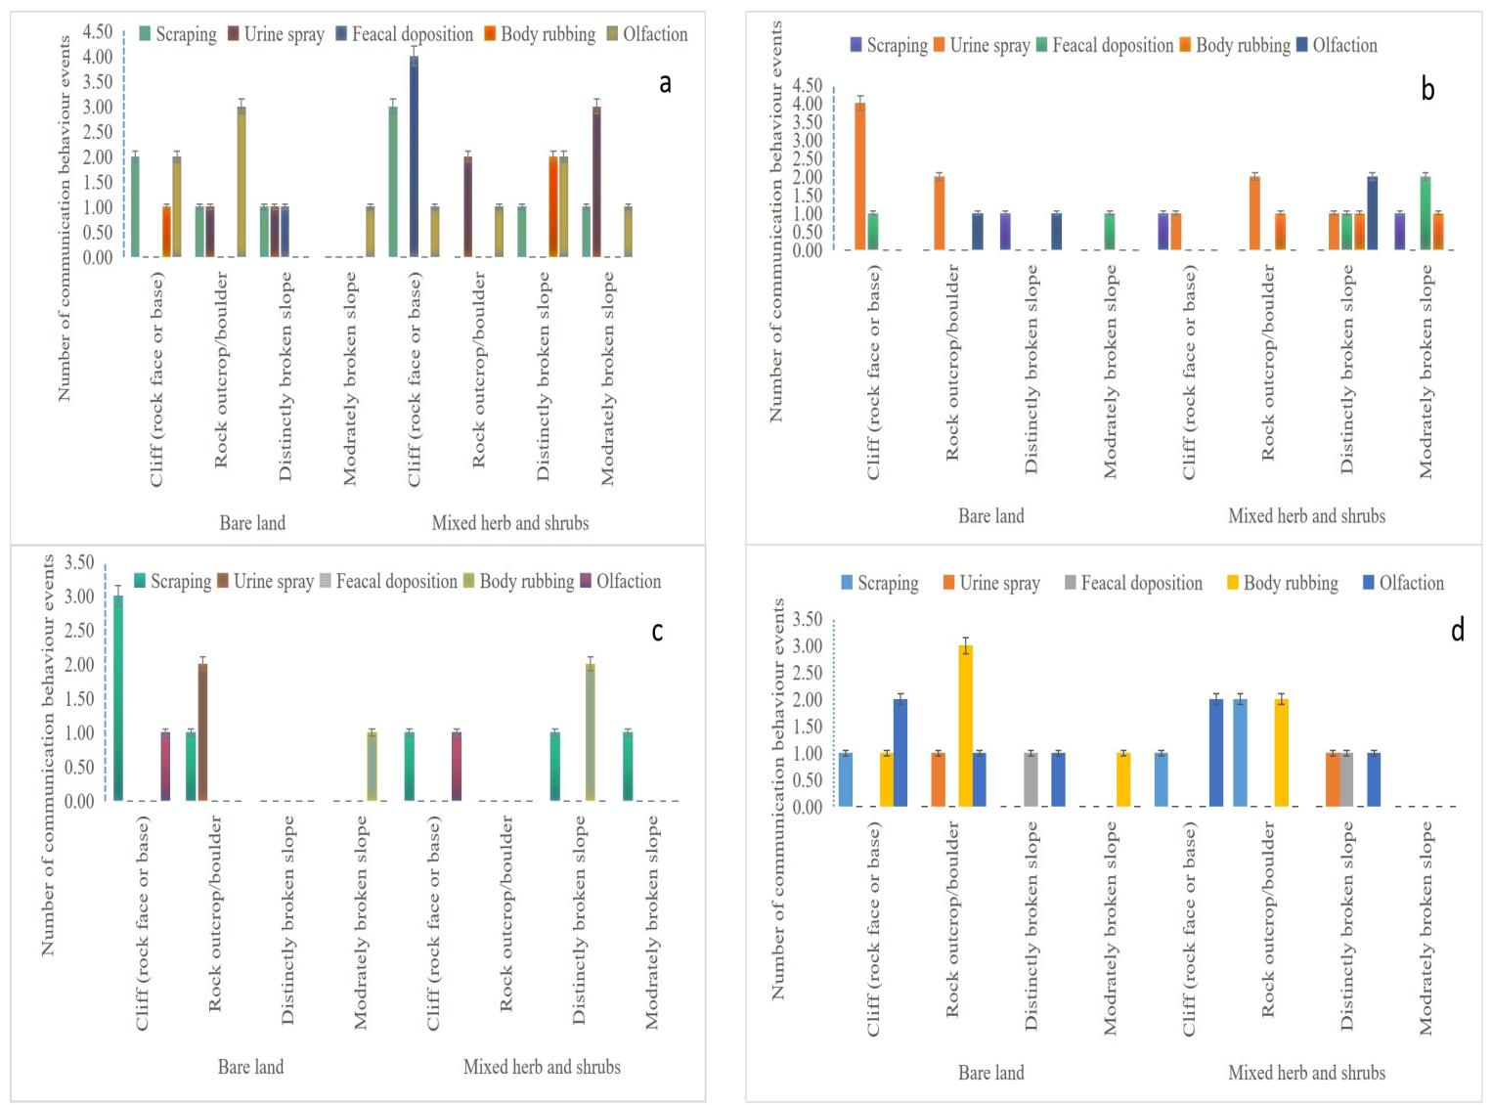
Figure s1.The figure depicts Snow leopard communication behavior events related to feature marks such as cliffs, rock outcrops, distinctly broken slopes, and moderately broken slopes during the absence of snow for (a) nighttime and (b) daytime, and in the presence of snow for (c) nighttime and (d) daytime.

Table s2.The study compared snow presence/absence and marking behaviors of snow leopards in different habitats using the Mann-Whitney Test (U), z-test. Significance levels were determined based on marking activities during snowy and snow-free conditions.
Grouping variable presence or absences of snow day vs night | Type of marking behaviours | U | Z | Sig.
a)Absence of snow night vs daytime | Scent Marking | 111.00 | -0.17 | 0.85
- | Body Rubbing | 108.00 | -0.73 | 0.46
- | Investigating | 108.00 | -0.65 | 0.51
b) Presence of snow night vs day | Scent Marking | 529.00 | -1.83 | 0.06
 | Body Rubbing | 647.00 | -0.05 | 0.95
 | Investigating | 611.00 | -1.26 | 0.20
C)snow absence vs presence day | Scent Marking | 689.00 | -3.35 | 0.00
 | Body Rubbing | 100.00 | -0.33 | 0.73
 | Investigating | 961.50 | -1.03 | 0.30
- Snow absence vs presence night | Scent Marking | 581.00 | -1.43 | 0.15
 | Body Rubbing | 660.00 | -0.94 | 0.34
 | Investigating | 585.00 | -2.19 | 0.02

Table s3. The camera-trapped observations of snow leopard cubs with their mother in northern Pakistan
Serial number /camera id | Habitat types | Videos captured date/year | Time of captured | location | Number of cubs | Age class | behaviors
01 (121 sokyo) | bareland | 12-29-2021 | 3:01 pm | CCHA,S  rondo | 3 | Sub-adult with mother | playing
02 (138 hushe) | shrubs land | 3-11-2022 | 12:10pm | CCHA Hushe | 1 | Sub-adult with mother | walking
03 (188 krba) | Bare land | 3-20-2022 | 10:02am | CCHA,s Rondo | 1 | Sub-adult without mother | walking
04 (199sokyoB) | shrubs land | 2-16-2015 | 18:26 pm | CCHA,s Rondo | 1 | Sub-adult with mother | walking
05(199 sokyo) | Mixed herb/ shrubs | 12-12-2021 | 5:44am | CCHA,s Rondo | 3 | Sub -adult with mother | running
06 (109 kraba) | Bare land | 1-14-2022 | 06:12pm | CCHA,s Rondo | 3 | Adult with mother | walking
07 (109 krba) | Bare land | 1-22-2022 | 02:04am | CCHA,s Rondo | - | Adult with mother | watching
08 (121 skb) | Shrubs land | 1/19/2018 | 8:16pm | Rondo | 3 | Adults with mother | watching
09 (118 skb) | Mixed herb/shrubs | 1/31/2021 | 5:17pm | CCHA,s Rondo | 3 | Adults with mother | walking
10 (240 skb) | Mixed herb/shrubs | 1-19-2018 | 7:47 pm | CCHA,s Rondo | 3 | Adults with mother | walking

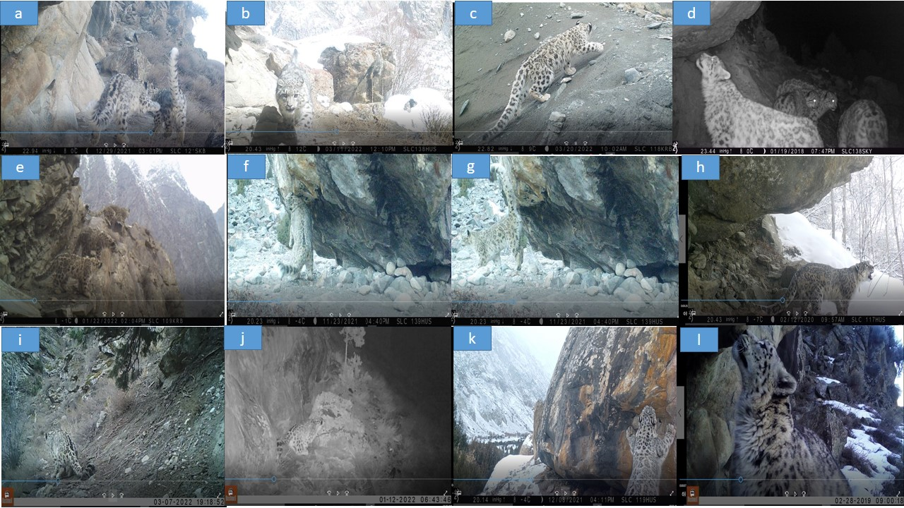
Figure s2. The first photographic evidence showcasing various communication behaviors and the observation of snow leopard cubs with their mother in northern Pakistan has been documented. (a) Three sub-adult cubs were observed in the Skoyo valley. (b) One sub-adult cub was spotted in the Hushe valley. (c) Another sub-adult cub was documented at Trabathang. (d) A female with three cubs was recorded in Rundo. (e) An adult with three cubs was also seen in Rondo. (f) An adult snow leopard exhibited cheek rubbing behavior in Hushe. (g) Another adult snow leopard displayed urine spraying behavior in Hushe. (h) Various vocalization behaviors were observed in Hushe. (i) The scat deposition and defecation behaviors of snow leopards were studied. (j) An adult leopard demonstrated scraping behaviors in Rondo. (k) Snow leopards exhibited olfaction or sniffing and claw marking behavior in Hushe. (l) Sniffing behavior to observe cues and signals was documented in Rondo.

