Supporting Information

Facility green electrocatalyst: Sulfur-modified N-doped Durian Shell derived Graphene-like Porous Carbon for N₂ fixation

Jin Wang ª, Xianglong Liu ª, Zhicheng Liu ª, Liangliang Xin ª, Dan Li ª, Ziwei Wang ^{b, *} and Shuang Wang ^{c, *}

- Advanced Energy Materials and Systems Institute, North University of China, Taiyuan 030051, Shanxi, P.R. China.
E-mail: 20210089@nuc.edu.cn
- College of Mechanical Engineering, North University of China, Taiyuan 030051, Shanxi, P.R. China.
E-mail: 20140083@nuc.edu.cn
- College of Environmental Science and Engineering, Taiyuan University of Technology, Jinzhong 030600, Shanxi, P.R. China.
E-mail: wangshuang@tyut.edu.cn

Materials
Durian shells were recycled from fruit supermarket. Potassium hydroxide (KOH), urea (CH₄N₂O), ammonium chloride (NH₄Cl), salicylic acid (C₇H₆O₃), sodium citrate dehydrate (C₆H₅Na₃O₇·2H₂O), pdimethylamino-benzaldehyde (C₉H₁₁NO), sodium nitroferricyanide dehydrate (C₅FeN₆Na₂O·2H₂O), sodium hypochlorite solution (NaClO), sodium sulfate (Na₂SO₄) were purchased from Aladdin Ltd. (Shanghai, China). Nafion (5 wt%) solution was purchased from Sigma-Aldrich Chemical Reagent Co., Ltd. Hydrochloric acid, sulfuric acid, hydrogen peroxide, hydrazine monohydrate (N₂H₄·H₂O) and ethyl alcohol (C₂H₅OH) were purchased from Sinopharm Chemical Reagent Co., Ltd, China. Methanesulfonic acid was purchased from Damao chemical reagent factory. The ultrapure water used throughout all experiments was purified through a Millipore system. The high-purity nitrogen and argon gases used in the experiment came from Anxuhongyun technology development co. LTD. All reagents were analytical reagent grade without further purification.
Characterization
SEM images were collected from the tungsten lamp-equipped SU8010 scanning electron microscope at an accelerating voltage of 20 kV (HITACHI, Japan). The crystal structure of the synthesized samples was analysed on a Rigaku Mini Flex II benchtop powder X-ray diffractometer (PXRD) with Cu-Kα radiation (40 kV, 40 mA, λ = 0.15418 nm) in the 2θ range of 5 – 80 ° with a scanning rate of 8 ° min⁻¹. Morphologies of the samples were observed by scanning electron microscopy (Hitachi, SU8010). Transmission electron microscopy (TEM) was tested on JEM-2100F. The X-ray photoelectron spectroscopy (XPS) measurements were performed on a Thermo Fisher Scientific K-Alpha spectrometer with Al Ka (1486.6 eV) as the X-ray excitation source. Thermogravimetric analysis was carried out with a heating rate of 5 K/min from 303 K to 1273 K in N₂ on STA 449 F5 from NETZSCH company. Nitrogen adsorption isotherms of powder samples were measured with a Micromeritics ASAP 2020 adsorption apparatus at 77 K up to 1 bar. Before starting the adsorption measurements, each sample was activated by heating under vacuum at 493 K for 5 h unless otherwise noted. The pore textural properties including Brunauer-Emmett-Teller (BET) surface area, pore volume, and pore size were obtained by analyzing nitrogen adsorption and desorption isotherms with Micromeritics ASAP 2020 built-in software. The absorbance data of spectrophotometer were measured on PerkinElmer Lambda 650 ultraviolet-visible (UV-Vis) spectrophotometer. The ion chromatography data were collected on Thermo Dionex aquion rfic.
Nafion 117 pretreatment
The Nafion 117 membrane was boiled in 3% H₂O₂ solution for 30 min to remove organic impurities. The membrane surface of Nafion 117 was repeatedly cleaned with deionized water, and then boiled in 0.5 M H₂SO₄ solution for 1 h. The Nafion membrane is stored in deionized water for later use. After each electrochemical reaction, the membrane was placed in deionized water for 30 seconds each time for 3 times to remove residual impurities and contaminants on the surface to avoid affecting the results of the next experiment.
Ar and N₂ pretreatment
Before the gas enters the electrolytic cell, 0.10 M H₂SO₄ was used to remove the possible impurities in the gas to achieve the purpose of purifying the gas.
Electrode preparation
5 mg of catalyst was dispersed in 960 µL (V_{water}: V_{ethanol} = 1:2) mixed solution and 40 μL Nafion solution (5 wt %) were sonicated for at least 20 min to form a homogeneous ink. Then, 50 µL of catalyst ink was drop-casted onto carbon paper with a loading mass of 0.20 mg. The area of carbon paper electrode is 1.0×1.5 cm² and the practically immersing area in the electrolyte was 1.0×1.0 cm². Let dry naturally and leave to dry under a baking lamp for 1 h. Then dip in the prepared electrolyte for 1 h. The working electrode was ready to be used.
Electrochemical Measurements
The electrorhemical tests were carried out in a three electrode system on an electrochemical workstation (VERSASTAT3) at room temperature. Electrochemical reduction of N₂ to ammonia was performed in a two-compartment cell at room temperature, and the cells were separated by a Nafion 117 membrane. An Ag/AgCl (saturated KCl solution) electrode was used as the reference electrode, and a Platinum foil electrode was used as the counter electrode. The electrolyte volume in the two parts of H-cell is 70 mL. For electrocatalytic N₂ reduction, potentiostatic tests were conducted in N₂-saturated 0.05 M H₂SO₄ for 2 h, which was purged with N₂ for 30 min before the measurement. Pure N₂ was continuously fed into the cathodic compartment with a properly positioned sparger during the experiments.

Figure S1 SEM images of (a) DSPC 9-4-1 (b) DSPC 9-4-2 (c) DSPC 9-4-3 and (d) DSPC 9-4-4

Figure S2 SEM image of N-DSPC
Figure S3 TEM images of N-DSPC

Figure S4 N₂ sorption-desorption isotherms at different condition: (a) Temperature, (b) Carbon base ratio and (c) Calcination time
Figure S5. N₂ sorption-desorption isotherms and Pore size distributions (inset) of (a) DSPC 9-4-1, (b) DSPC 9-4-2, (c) DSPC 9-4-3 and (d) DSPC 9-4-4

Figure S6. XPS spectra of DSPC (a) survey and (b) C 1s regions.
Figure S7. XPS spectra of N-DSPC (a) survey, (b) C 1s and (c) N 1s regions.
Figure S8. XPS spectra of S/DSPC, (a) survey, (b) C 1s and (c) S 2p regions.

Figure S9. XPS spectra of S/N-DSPC treated with CS₂, (a) survey, (b) C 1s (c) N 1s and (d) S 2p regions.

Table S1 Contents of C, O, N, S in DSPC, N-DSPC, S/DSPC and S/N-DSPC.
 | DSPC | N-DSPC | S/DSPC | S/N-DSPC
C | 82.69 | 83.15 | 48.46 | 46.23
H | 0.79 | 0.73 | 0.69 | 0.68
N | 0.57 | 5.48 | 0.54 | 4.01
S | 0.24 | 0.17 | 37.32 | 36.88

Figure S10. TGA and Differential Thermal Analysis (DTA) curves of (a) DSPC and (b) S/N-DSPC.

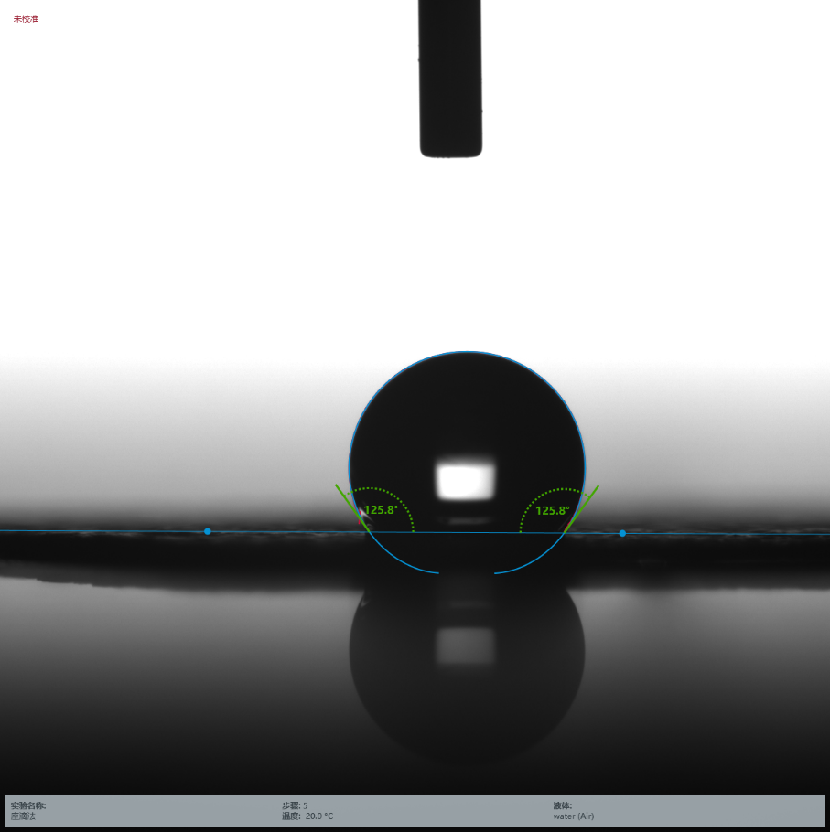
Figure S11. Water contact angle on the surface of carbon paper.
Figure S12. (a) Ion chromatogram curves of the standard solution with NH₄⁺ concentrations in 0.05 M H₂SO₄. (b) Calibration curve used for estimation of NH₄⁺. (y=5.62151x+0.58742, R²=0.999)

Figure S13. UV-vis curves (a) and (b) concentration-absorbance curve of NH₄⁺ ions solution with a series of standard concentration. The absorbance at 655 nm was measured by UV-vis spectrophotometer. The standard curve showed good linear relation of absorbance with NH₄⁺ ion concentration (y = 0.3235x +0.0087, R² = 0.999).

Figure S14. UV-vis curves (a) and (b) concentration-absorbance curve of N₂H₄ solution with a series of standard concentration. The absorbance at 455 nm was measured by UV-vis spectrophotometer. The standard curve showed good linear relation of absorbance with N₂H₄ concentration (y = 0.74227x + 0.00505, R² = 0.999).

Figure S15. Ion chromatogram for the electrolytes at a series of potentials after electrolysis for 2 h.

Figure S16. (a) LSV curves of S/DSPC in Ar- and N₂-saturated in 0.05 M H₂SO₄, respectively. (b) NH₃ yields and corresponding FEs of S/DSPC at different selected potentials. (c) Chronoamperometric curves of S/DSPC at different selected potentials for 2 h. (d) NH₃ yields of after 2 h electrolysis under different conditions: Carbon paper, Open circuit S/DSPC in Ar, DSPC and S/DSPC at -0.4 V.
Figure S17. (a) UV-vis absorption spectra of the H₂SO₄ electrolyte after electrolysis on the S/DSPC electrode stained with indophenol indicator after charging six times for 2 h under the same conditions. (b) NH₃ yields and corresponding FEs of S/DSPC during the recycling test 6 times.

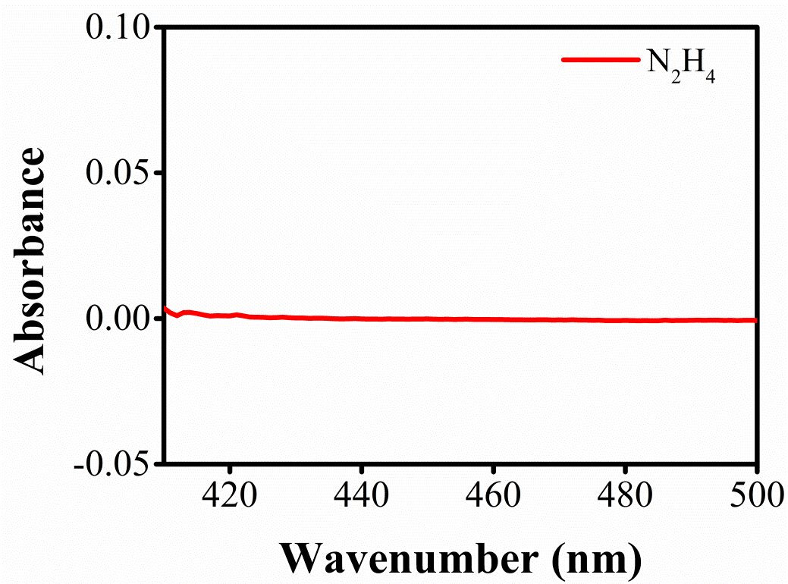
Figure S18. UV-Vis absorption curves of electrolytes stained with p-C₉H₁₁NO indicator for 30 min after NRR of S/N-DSPC at -0.4 V.

Table S2 Contents of C, O, N, S in S/N-DSPC after 72 h.
 | C | H | N | S
S/N-DSPC | 47.15 | 0.72 | 3.89 | 37.42

