Table S1. Comparison of maximum likelihood tree (RAxML tree) and Bayesian tree
source | ref | E.size | nRF | RF | maxRF | src-br+ | ref-br+ | subtre+ | treekoD
Bayesian tree | RAxML tree | 117 | 0.03 | 7.00 | 227.00 | 0.99 | 0.98 | 1 | NA

The reported values are (from http://etetoolkit.org/documentation/ete-compare/):
source target tree used
ref reference tree used to compare with
eff.size Effective tree size used for comparisons (after pruning not shared items)
nRF Normalized Robinson-Foulds distance (RF/maxRF)
RF Robinson-Foulds symmetric distance
maxRF maximum Robinson-Foulds value for this comparison
%src_br frequency of edges in target tree found in the reference (1.00 = 100% of branches are found)
%ref_br frequency of edges in the reference tree found in target (1.00 = 100% of branches are found)
subtrees Number of subtrees used for the comparison (applies only when duplicated items are used to decomposed target trees)
treekoD Average distance among all possible subtrees in the original target trees to the reference tree

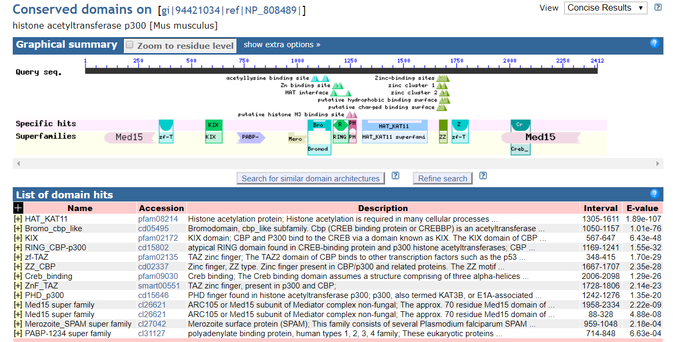
Fig. S1 CDD search result of M. musculus EP300.

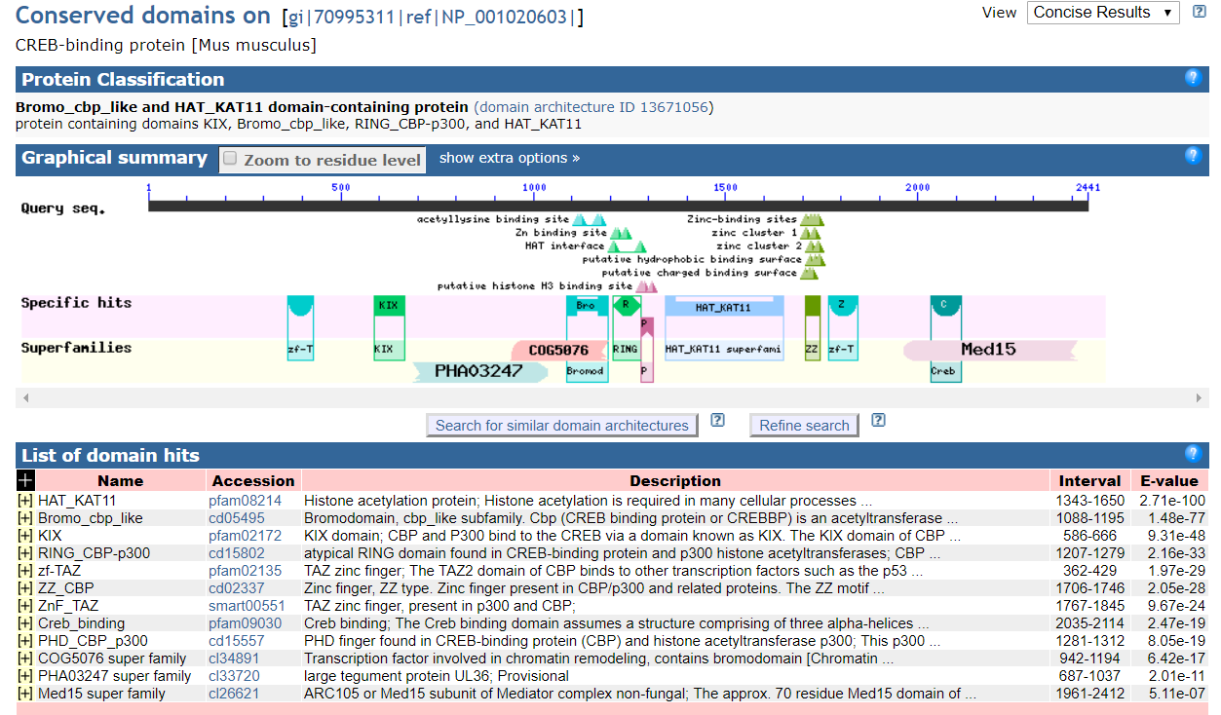
Fig. S2 CDD search result of M. musculus CREBBP

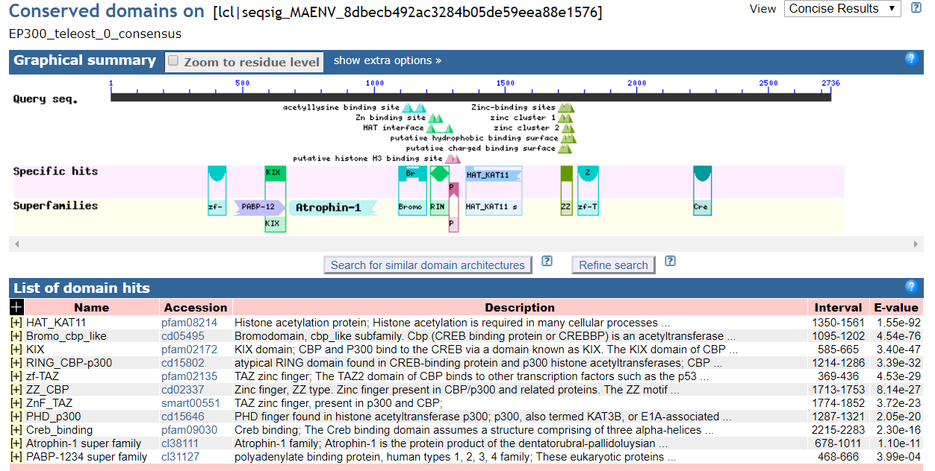
Fig. S3 CDD search result of teleosts’ Ep300a consensus sequence

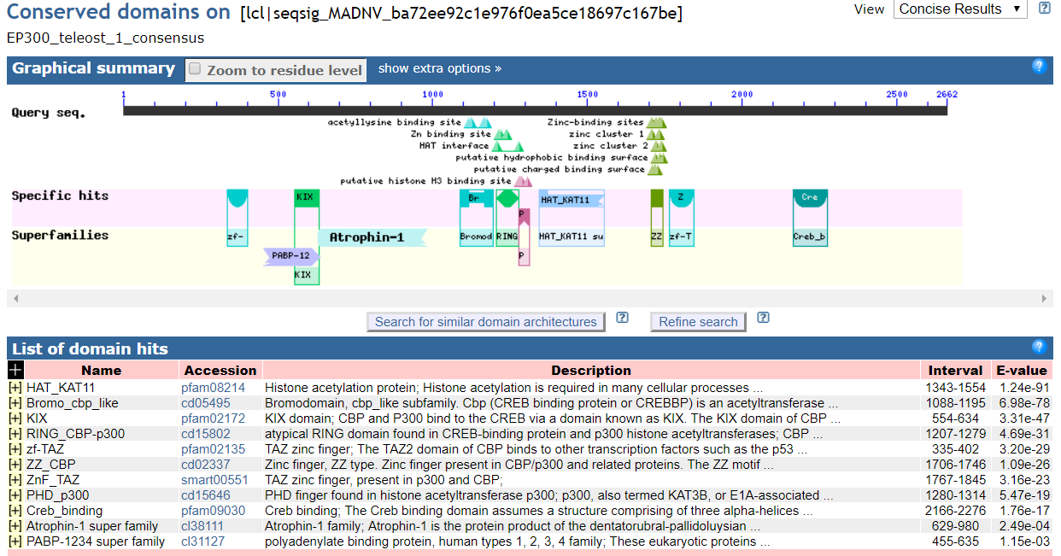
Fig. S4 CDD search result of teleosts’ Ep300b consensus sequence.

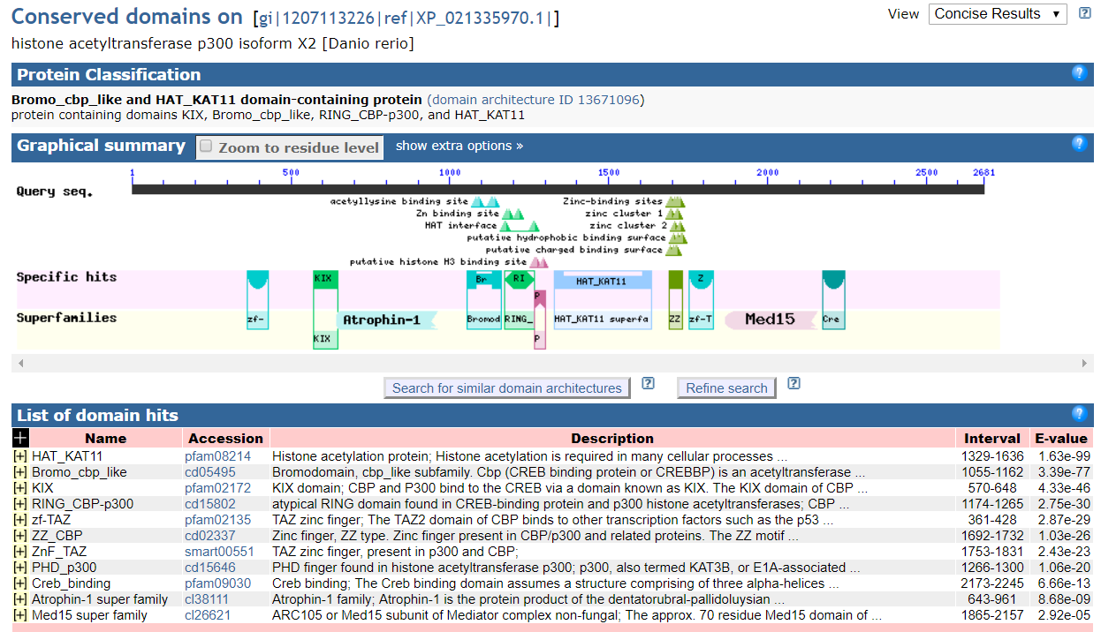
Fig. S5 CDD search result of D. rerio Ep300a.

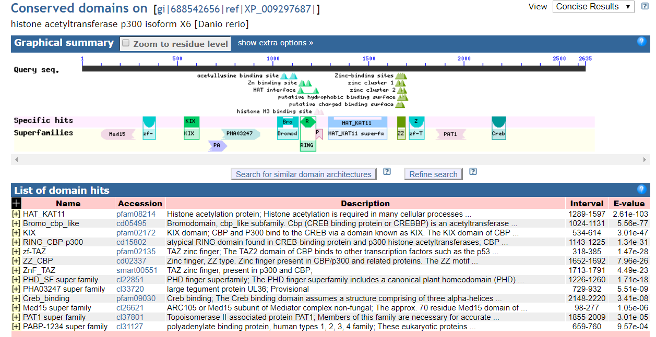
Fig. S6 CDD search result of D. rerio Ep300b. Note that in Ep300a there is a specific hit named PHD_p300 while in p300b there is not such a specific hit, but a PHD_SF super family instead. We checked all other isoforms of the Ep300b (gene id 565612) and found that none of them has a PHD_p300 domain either.

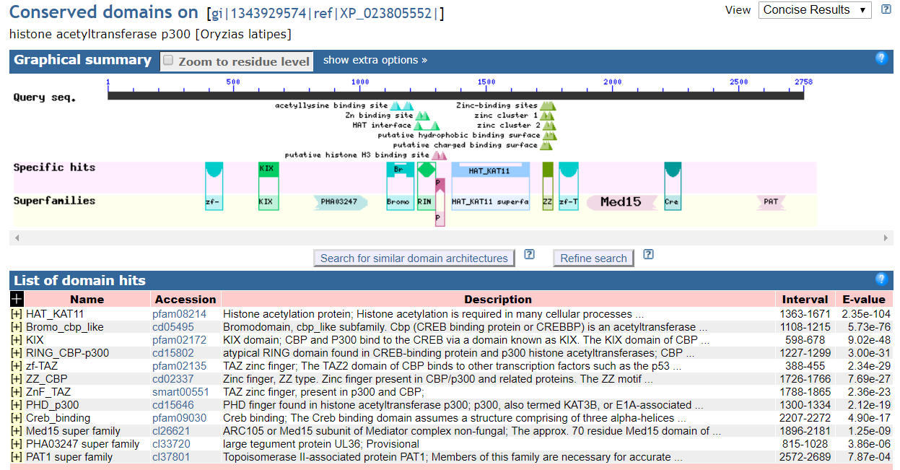
Fig. S7 CDD search result of O. latipes Ep300a.

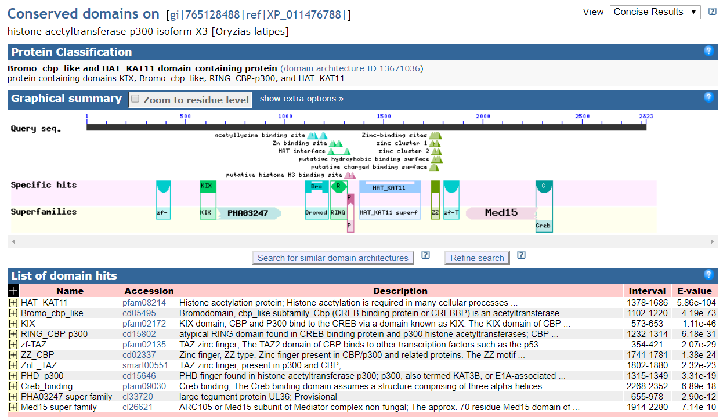
Fig. S8 CDD search result of O. latipes Ep300b.

Table S2. Comparisons of proportions of positively selected branches in different clades
Clade A | positively  selected  branches | total  branches | Clade B | positively  selected  branches | total  branches | p value
Ep300a | 22 | 55 | Ep300b | 21 | 57 | 0.846
Ep300a | 22 | 55 | mammals | 5 | 59 | 0.000117
Ep300a | 22 | 55 | sauropsid | 4 | 49 | 0.000207
mammals | 5 | 59 | sauropsid | 4 | 49 | 1.0
EP300b | 21 | 57 | mammals | 5 | 59 | 0.00029
EP300b | 21 | 57 | squropsid | 4 | 49 | 0.000516

Table S3. Estimated accuracy of models of zf-TAZ domain and its flanking regions
Sequence | Model# | C-score | Estimated |  | Clusters (N=11295)
Sequence | Model# | C-score | TM-score | RMSD | #decoys | density
Ep300a of D. rerio | model1 | -1.41 | 0.54+-0.15 | 10.6+-4.6 | 2259 | 0.080
Ep300a of D. rerio | model2 | -2.45 |  |  | 753 | 0.028
Ep300a of D. rerio | model3 | -3.79 |  |  | 370 | 0.007
Ep300a of D. rerio | model4 | -4.05 |  |  | 216 | 0.006
Ep300a of D. rerio | model5 | -3.74 |  |  | 185 | 0.008
Ep300b of D. rerio | model1 | -1.70 | 0.51+-0.15 | 11.4+-4.5 | 2259 | 0.056
Ep300b of D. rerio | model2 | -2.46 |  |  | 753 | 0.026
Ep300b of D. rerio | model3 | -2.19 |  |  | 753 | 0.034
Ep300b of D. rerio | model4 | -4.10 |  |  | 234 | 0.005
Ep300b of D. rerio | model5 | -4.22 |  |  | 190 | 0.005
Ep300a of O. latipes | model1 | -2.50 | 0.42+-0.14 | 13.7+-4.0 | 1704 | 0.026
Ep300a of O. latipes | model2 | -2.53 |  |  | 753 | 0.025
Ep300a of O. latipes | model3 | -3.41 |  |  | 733 | 0.011
Ep300a of O. latipes | model4 | -3.63 |  |  | 659 | 0.008
Ep300a of O. latipes | model5 | -3.42 |  |  | 713 | 0.010
Ep300b of O. latipes | model1 | -1.42 | 0.54+-0.15 | 10.7+-4.6 | 3462 | 0.071
Ep300b of O. latipes | model2 | -3.35 |  |  | 581 | 0.010
Ep300b of O. latipes | model3 | -3.30 |  |  | 554 | 0.011
Ep300b of O. latipes | model4 | -3.37 |  |  | 472 | 0.010
Ep300b of O. latipes | model5 | -3.73 |  |  | 406 | 0.007
C-score is a confidence score of the I-TASSER predictions which is typically in [-5,2]. TM-score and RMSD measure how close the model is to the native structure and both are estimated based on the C-score. TM-score is in [0,1] with a value >0.5 implying the model of correct topology.

Table S4. Estimated accuracy of models of N-terminal side flanking regions of zf-TAZ domain
Sequence | Model# | C-score | Estimated |  | Clusters (N=20200)
Sequence | Model# | C-score | TM-score | RMSD | #decoys | density
Ep300a of D. rerio  (1-360 aa) | model1 | -1.52 | 0.53+-1.15 | 10.1+-4.6 | 3041 | 0.062
Ep300a of D. rerio  (1-360 aa) | model2 | -2.16 |  |  | 2363 | 0.033
Ep300a of D. rerio  (1-360 aa) | model3 | -1.90 |  |  | 2362 | 0.043
Ep300a of D. rerio  (1-360 aa) | model4 | -2.86 |  |  | 694 | 0.016
Ep300a of D. rerio  (1-360 aa) | model5 | -3.38 |  |  | 647 | 0.010
Ep300b of D. rerio  (1-317 aa) | model1 | -2.26 | 0.45+-0.14 | 11.6+-4.5 | 4208 | 0.035
Ep300b of D. rerio  (1-317 aa) | model2 | -3.57 |  |  | 797 | 0.009
Ep300b of D. rerio  (1-317 aa) | model3 | -2.54 |  |  | 704 | 0.026
Ep300b of D. rerio  (1-317 aa) | model4 | -2.04 |  |  | 703 | 0.043
Ep300b of D. rerio  (1-317 aa) | model5 | -4.30 |  |  | 595 | 0.004
Ep300a of O. latipes  (1-387 aa) | model1 | -0.31 | 0.67+-0.13 | 7.4+-4.3 | 4725 | 0.158
Ep300a of O. latipes  (1-387 aa) | model2 | -1.62 |  |  | 695 | 0.043
Ep300a of O. latipes  (1-387 aa) | model3 | -3.80 |  |  | 353 | 0.005
Ep300a of O. latipes  (1-387 aa) | model4 | -3.93 |  |  | 316 | 0.004
Ep300a of O. latipes  (1-387 aa) | model5 | -4.29 |  |  | 307 | 0.003
Ep300b of O. latipes  (1-353 aa) | model1 | -0.50 | 0.65+-0.13 | 7.6+-4.3 | 12860 | 0.185
Ep300b of O. latipes  (1-353 aa) | model2 | -2.07 |  |  | 1464 | 0.038
Ep300b of O. latipes  (1-353 aa) | model3 | -2.21 |  |  | 778 | 0.033
Ep300b of O. latipes  (1-353 aa) | model4 | -2.77 |  |  | 648 | 0.019
Ep300b of O. latipes  (1-353 aa) | model5 | -3.77 |  |  | 642 | 0.007

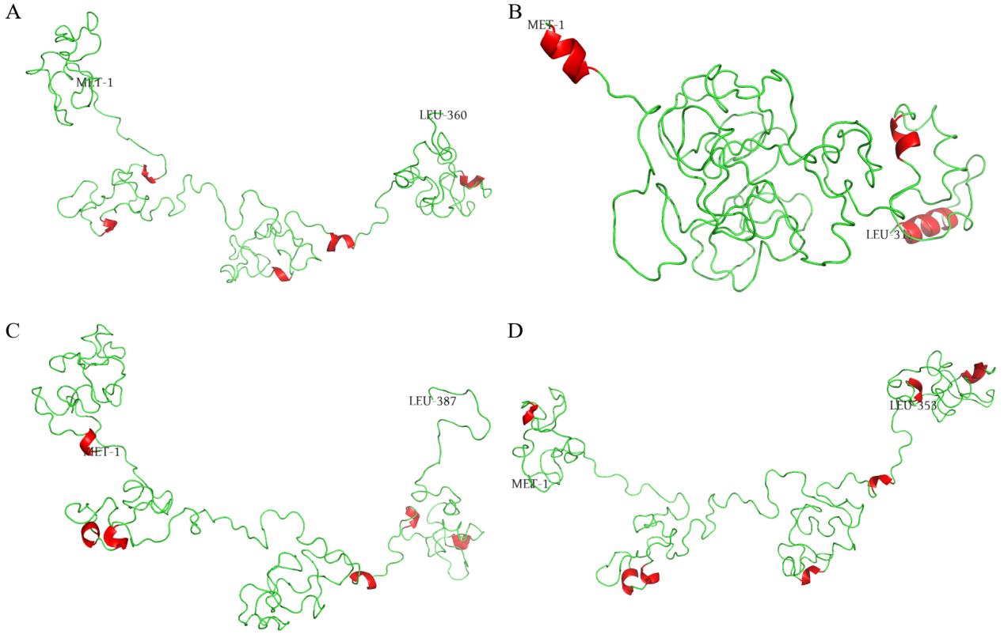
Fig. S9 Structures of N-terminal side flanking region of zf-TAZ domain. The source sequences were Ep300a of D. rerio (A), Ep300b of D. rerio (B), Ep300a of O. latipes (C) and Ep300b of O. latipes (D). The first (always MET-1) and last residue of each sequence used for modeling are labeled; α-helixes are colored red. For Ep300a and Ep300b of D. rerio, the best models (model 1, as shown in Table S4) were selected. For Ep300a and Ep300b of O. latipes, however, the best models are not the best choices: their C-scores and TM-scores were too high to be credible. Actually, model 1 of Ep300a of O. latipes contained a number of β-sheets, which are not expected to appear in flanking region of zf-TAZ domain. Therefore, model 2 of Ep300a and Ep300b of O. latipes were selected. For Ep300b of D. rerio, the α-helixes look longer; however, it should be noted that TM-score of the model 1 was below 0.5.

Table S5. Quality of sequencing data of four fishes
Species | Number of assembled contigs | Number of bases used for assembly | N50 | N90 | Mean depth | Source link
Danio rerio | 48157 | 135089951 | 3655 | 1488 | 59.79 | http://phylofish.sigenae.org/ngspipelines/#!/NGSpipelines/Danio%20rerio
Oryzias latipes | 42186 | 116128086 | 3654 | 1437 | 47.29 | http://phylofish.sigenae.org/ngspipelines/#!/NGSpipelines/Oryzias%20latipes
Esox lucius | 48567 | 148174033 | 3959 | 1636 | 37.31 | http://phylofish.sigenae.org/ngspipelines/#!/NGSpipelines/Esox%20lucius
Lepisosteus oculatus | 41396 | 124732602 | 4057 | 1602 | 68.5 | http://phylofish.sigenae.org/ngspipelines/#!/NGSpipelines/Lepisosteus%20oculatus

Table S6. Tissue expression profiles of ep300a/ep300b based on NCBI SRA study ERP12186
Organism | Tissue | TPM |  | Relative abundance in accordance with PhyloFish data (yes or not)
Organism | Tissue | ep300a | ep300b
Danio rerio | brain | 12.44 | 18.04 | yes
 | gill | 8.25 | 11.32 | not
 | heart | 4.77 | 2.82 | yes
 | liver | 1.66 | 1.54 | yes
 | muscle | 2.38 | 1.70 | yes
 | eye | 9.11 | 9.04 | -
 | gut | 2.62 | 2.66 | -
 | skin | 6.70 | 8.21 | -
Oryzias latipes | brain | 18.48 | 30.99 | yes
 | gill | 8.95 | 17.28 | yes
 | heart | 2.64 | 1.85 | not
 | liver | 2.05 | 2.14 | yes
 | muscle | 1.90 | 3.02 | yes
 | eye | 10.31 | 15.99 | -
 | gut | 5.21 | 6.00 | -
 | skin | 3.68 | 6.64 | -
Methods: Raw RNA-seq reads were downloaded by SRA Run and dumped into fastq format by fasterq-dump in sratoolkit. RefSeq RNA and genome sequences of D. rerio and O. latipes were downloaded from NCBI FTP site. The links of respective directories are https://ftp.ncbi.nlm.nih.gov/genomes/refseq/vertebrate_other/Danio_rerio/latest_assembly_versions/GCF_000002035.6_GRCz11/ and https://ftp.ncbi.nlm.nih.gov/genomes/refseq/vertebrate_other/Oryzias_latipes/latest_assembly_versions/GCF_002234675.1_ASM223467v1/. RNA and genome sequences were used to build SAF genome index for respective species by salmon index, following tutorials listed on the page https://github.com/COMBINE-lab/salmon. Abundances of transcripts of the two species were quantified per tissue by salmon quant. From the gene2accession file (downloaded from https://ftp.ncbi.nlm.nih.gov/gene/DATA/) we obtained a full collection of accession numbers of transcript variants of ep300a/ep300b genes of the two species. For each gene, TPMs (transcripts per million) of all transcript variants were added to get the gene TPM.

