Supporting information

Interactive effects of natural and anthropogenic factors on heterogenetic accumulations of heavy metals in surface drinking water sources in the upper Huaihe River Basin in China

Tong Liu¹, Mingya Wang¹, Chunhui Zhang¹, Shili Yang¹, Fan Zhang¹, Luhao Jia¹, Wanqi Ma¹, Shaobo Sui¹,Qingwei Liu¹, Mingshi Wang^{1, *}
¹ College of Resource and Environment, Henan Polytechnic University, Jiaozuo, 454003, China;

* Corresponding author. E-mail address: mingshiwang@hpu.edu.cn (M. Wang).
8 Tables 5 Fig
Table S1 WQI water quality classification.
Table S2 EI value of standards at all levels.
Table S3 SF and RfD values of each factor.
Table S4 Exposure factors and values used in health risk assessment model to evaluate exposure risks with Mote Carlo simulator.
Table S5 Concentration statistics of various indicators in drinking water source areas.
Fig S1 WQI water quality index during wet, dry, and normal seasons.
Fig S2 Calculation results of WQI values in different periods.
Fig S3 Calculation of trophic state EI values.
Fig S4 Correlation analysis between EI and various factors.
Table S6 Carcinogenic risk values of various heavy metals.
Table S7 Non carcinogenic risk values for various heavy metals.
Fig S5 Correlation analysis of heavy metals.
Table S8 The first three terms of factor interaction and their explanatory power q values.

Table S1 WQI water quality classificationª
Range | WQI＜25 | 25≤WQI≤70 | 50＜WQI≤70 | 70＜WQI≤90 | WQI＞90
Water quality level | very good | good | medium | poor | very poor
ªform: (Zhu et al.2021)

Table S2 EI value of standards at all levels^{b}
Level | EI
Level 1 (oligotrophic) | 20
Level 2 (medium nutrition) | 39.42
Level 3 (eutrophic) | 61.29
Level 4 (heavy eutrophication) | 76.28
Level 5 (extremely nutritious) | 99.77
^{b}from: (Li et al.2010)

Table S3 SF and RfD values of each factor^{c}
 | As | Hg | Cd | Cr⁶⁺ | Pb
SF | 1.5 |  | 0.5 | 0.5 | 0.0085
RfD | 0.0003 | 0.0003 | 0.0005 | 0.003 | 0.0014
^{c}from: (Zhang et al.2022)

Table S4 Exposure factors and values used in health risk assessment model to evaluate exposure risks with Mote Carlo simulator
Parameters | Unit | Probabilistic Distribution | Children | Adult | References
C | mg/L | Normal | Measured | Measured | This study
IR (Intake rate) | L/day | Normal | 50th :0.6,  95th :1.3 | 50th :1.5,  95th :3.7 | (Shi et al.2022)^{d}
EF (Exposure frequency) | Day/year | Triangular | 350 (180,365) | 350 (180,365) | (Shi et al.2022)^{d}
ED (Exposure duration) | year | Point | 6 | 30 | (USEPA,2011)
BW (Average body weight) | kg | Lognormal/Normal | (37.0,2.98) | (60.3,3.46) | (Wang et al.2022)^{e}
AT (Average time of exposure) | day | Point | 2190 (non-carcinogenic)  25550 (carcinogenic) | 10950 (non-carcinogenic)  25550 (carcinogenic) | (Wang et al.2022)^{e}

Table S5 Concentration statistics of various indicators in drinking water source areas
Index | Minimum value (mg/L) | Maximum value (mg/L) | Average value (mg/L) | Median  (mg/L) | Standard deviation (mg/L) | Coefficient of variation (%)
pH | 6.88 | 8.90 | 7.70 | 7.67 | 0.46 | 6.01
DO | 5.00 | 12.2 | 8.14 | 8.20 | 1.56 | 19.19
COD_{MN} | 0.70 | 5.90 | 3.32 | 3.30 | 1.19 | 35.85
BOD₅ | 0.50 | 3.90 | 2.51 | 2.70 | 0.86 | 34.40
NH₃-N | 0.03 | 0.85 | 0.24 | 0.21 | 0.14 | 58.89
TP | 0.01 | 0.19 | 0.04 | 0.03 | 0.02 | 65.86
TN | 0.06 | 2.5 | 0.72 | 0.71 | 0.28 | 39.40
As | 0.0003 | 0.003 | 0.00032 | 0.0003 | 0.0003 | 69.25
Hg | 0.00004 | 0.0001 | 0.000045 | 0.00004 | 0.000015 | 33.99
Cd | 0.0001 | 0.004 | 0.0005 | 0.0005 | 0.0005 | 90.99
Cr⁶⁺ | 0.004 | 0.04 | 0.005 | 0.004 | 0.0039 | 71.99
Pb | 0.00009 | 0.02 | 0.0045 | 0.0025 | 0.0043 | 96.15
NO₃-N | 0.004 | 3.08 | 0.28 | 0.21 | 0.31 | 112.61

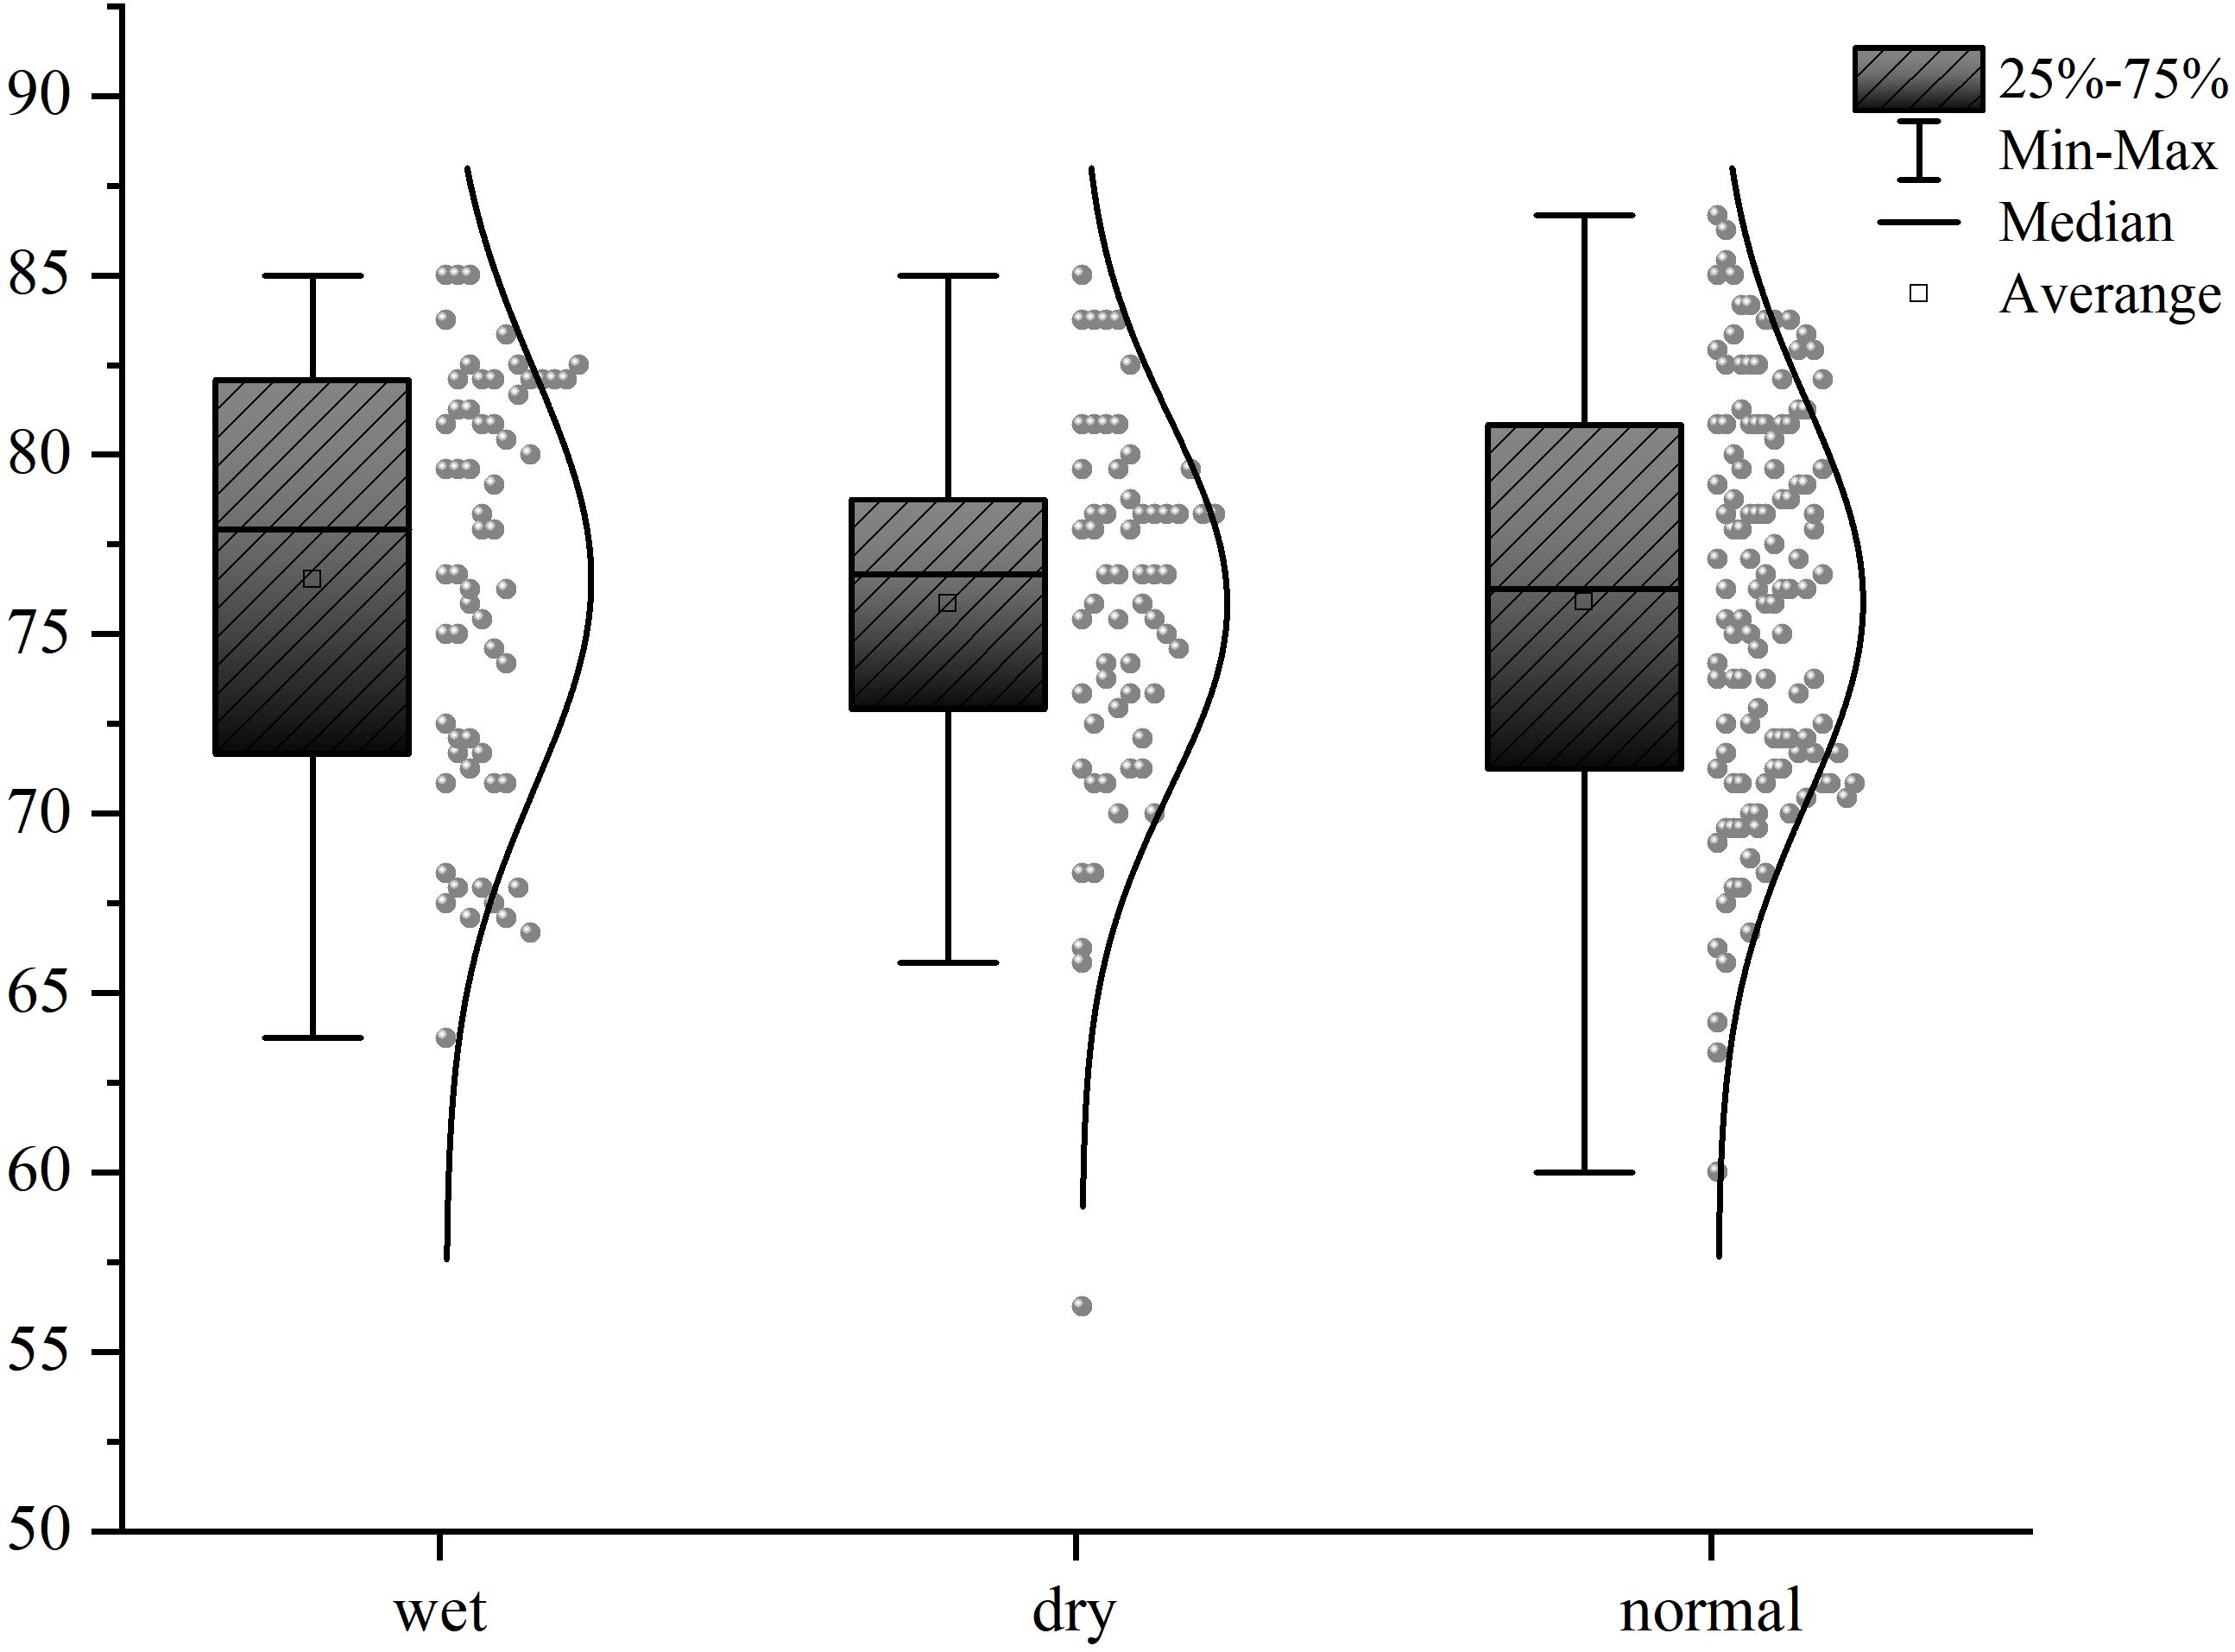
Fig S1 WQI water quality index during wet, dry, and normal seasons

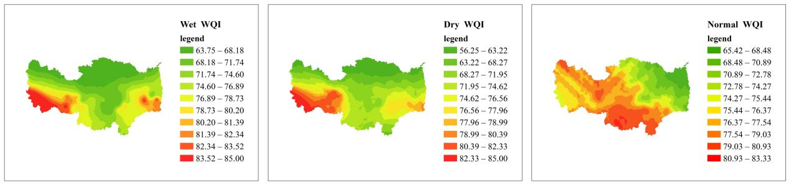
Fig S2 Calculation results of WQI values in different periods

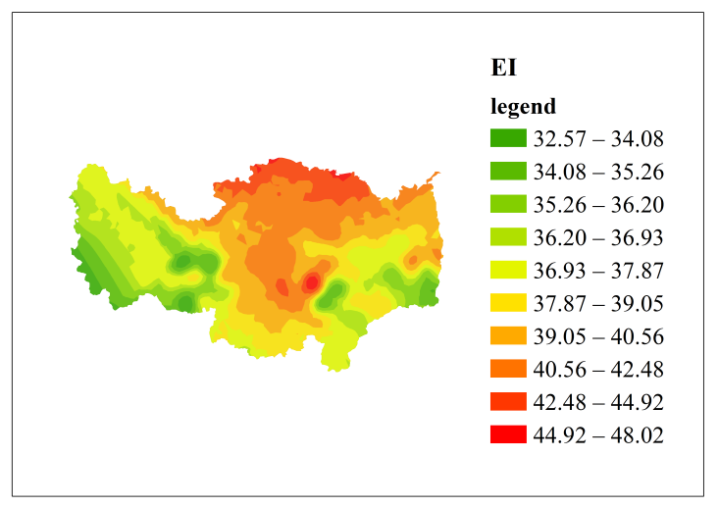
Fig S3 Calculation of trophic state EI values

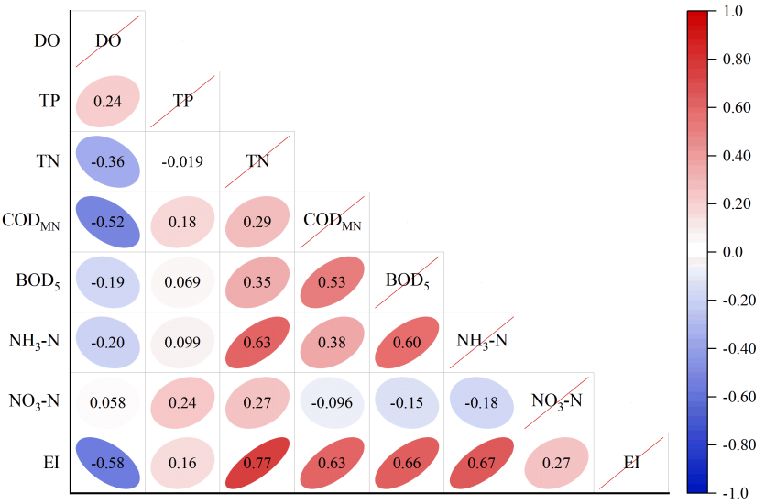
Fig S4 Correlation analysis between EI and various factors

Table S6 Carcinogenic risk values of various heavy metals
 |  | Average value | Average Standard Error | Minimum Value | Maximum Value | Median
As | Children | 1.94E-06 | 9.92E-09 | 8.63E-08 | 9.92E-06 | 1.76E-06
As | Adult | 7.98E-06 | 3.44E-08 | 1.36E-06 | 3.91E-05 | 7.36E-06
Cd | Children | 7.75E-07 | 8.67E-09 | 3.20E-12 | 1.37E-05 | 4.94E-07
Cd | Adult | 3.17E-06 | 3.28E-08 | 9.98E-12 | 3.58E-05 | 2.14E-06
Cr⁶⁺ | Children | 6.74E-06 | 3.97E-08 | 2.61E-09 | 3.68E-05 | 6.24E-06
Cr⁶⁺ | Adult | 2.76E-05 | 1.41E-07 | 1.14E-08 | 9.48E-05 | 2.67E-05
Pb | Children | 1.07E-07 | 1.51E-09 | 1.12E-09 | 3.61E-06 | 6.09E-08
Pb | Adult | 4.42E-07 | 6.08E-09 | 4.43E-09 | 1.35E-05 | 2.59E-07

Table S7 Non carcinogenic risk values for various heavy metals
 |  | Average value | Average Standard Error | Minimum Value | Maximum Value | Median
As | Children | 5.04E-02 | 2.57E-04 | 2.24E-03 | 2.57E-01 | 4.55E-02
As | Adult | 4.14E-02 | 1.78E-04 | 7.05E-03 | 2.03E-01 | 3.82E-02
Hg | Children | 4.93E-03 | 1.85E-05 | 2.28E-04 | 1.62E-02 | 4.72E-03
Hg | Adult | 4.04E-03 | 1.10E-05 | 1.56E-03 | 9.83E-03 | 3.89E-03
Cd | Children | 3.62E-02 | 4.05E-04 | 1.50E-07 | 6.37E-01 | 2.31E-02
Cd | Adult | 2.96E-02 | 3.06E-04 | 9.32E-08 | 3.34E-01 | 2.00E-02
Cr⁶⁺ | Children | 5.24E-02 | 3.09E-04 | 2.03E-05 | 2.86E-01 | 4.86E-02
Cr⁶⁺ | Adult | 4.29E-02 | 2.19E-04 | 1.78E-05 | 1.47E-01 | 4.15E-02
Pb | Children | 1.05E-01 | 1.48E-03 | 1.10E-03 | 3.54E+00 | 5.97E-02
Pb | Adult | 8.66E-02 | 4.72E-03 | 8.69E-04 | 2.64E+00 | 5.09E-02

Fig S5 Correlation analysis of heavy metals

Table S8 The first three terms of factor interaction and their explanatory power q values
 | Leading factor | interaction1 | q value | interaction2 | q value | interaction3 | q value
TN | Precipitation | X₅∩X₉ | 0.543 | X₃∩X₅ | 0.504 | X₅∩X₈ | 0.499
TP | GDP | X₅∩X₈ | 0.480 | X₂∩X₇ | 0.478 | X₅∩X₇ | 0.461
As | Precipitation | X₂∩X₇ | 0.678 | X₃∩X₇ | 0.673 | X₁∩X₇ | 0.647
Hg | GDP | X₇∩X₈ | 0.763 | X₇∩X₉ | 0.607 | X₁∩X₈ | 0.567
Cd | GDP | X₃∩X₇ | 0.616 | X₇∩X₈ | 0.594 | X₃∩X₈ | 0.553
Cr | DEM | X₁∩X₃ | 0.786 | X₁∩X₈ | 0.735 | X₁∩X₂ | 0.701
Pb | Precipitation | X₃∩X₈ | 0.625 | X₁∩X₇ | 0.614 | X₁∩X₃ | 0.530
(X₁₋₉ represents DEM, NDVI, Precipitation, Temperature, Soil Type, Land Use, Road Network Density, GDP, Population Density)

Reference
Changjun Z, Fangxing Z, Budong L, et al. Water quality evaluation of Daheiting reservoir based on principal component analysis and WQI_{min}[J]. Journal of Henan Normal University(Natural Science Edition), 2021,49(03):52-58.
Zuoyong L, Jiayang W, Chun G. A universal index formula for eutrophic evaluation using a logarithmic power function[J]. Acta Scientiae Circumstantiae, 2010,30(03):664-672.
Zhang L, Tan X, Chen H, et al. Effects of Agriculture and Animal Husbandry on Heavy Metal Contamination in the Aquatic Environment and Human Health in Huangshui River Basin[J]. WATER, 2022,14(4).
Shi H, Zeng M, Peng H, et al. Health Risk Assessment of Heavy Metals in Groundwater of Hainan Island Using the Monte Carlo Simulation Coupled with the APCS / MLR Model[J]. INTERNATIONAL JOURNAL OF ENVIRONMENTAL RESEARCH AND PUBLIC HEALTH, 2022,19(13).
Wang W, Chen C, Liu D, et al. Health risk assessment of PM2.5 heavy metals in county units of northern China based on Monte Carlo simulation and APCS-MLR[J]. SCIENCE OF THE TOTAL ENVIRONMENT, 2022,843.

