SM1: Clinical trials
ATTAIN
The ATTAIN trial, registered under EUDRACT number 2021-001489-40 and CCMO number NL77310.029.21, known under the full title: “A clinical imaging study using [¹⁸F]F-AraG PET to visualize Tumor infiltrating T-cell Activation in Non-small cell lung cancer”, is a single arm imaging study where 10 resectable early-stage NSCLC patients receive 2 dynamic [¹⁸F]F-AraG PET scans prior to their routine tumour resection. The main objective of this trial is to perform full kinetic modelling on [¹⁸F]F-AraG uptake in tumor lesions, to assess the test-retest variability of the scans and to correlate the relation between [¹⁸F]F-AraG uptake and number of CD8⁺ T-cells and other immune cells measured by immunohistochemistry and gene expression. Primary inclusion criteria is a histologically confirmed NSCLC, ≥ 2 cm, scheduled for resection. Primary exclusion criteria are the use of immunosuppressive medications within 14 days of screening, pregnancy and psychiatric or substance disorders that would interfere with cooperation with the requirements of the trial.
SHARP
The SHARP trial, registered under EUDRACT number 2021-003986-36 and CCMO number NL78588.029.21, known under the full title: “A clinical imaging Study of the changes in [¹⁸F]F-AraG uptake following anti-PD-1 therapy in Non-small cell lung cancer”, is a single arm imaging study where 15 advanced stage NSCLC patients, scheduled to receive anti-PD-1 therapy, receive 3 dynamic [¹⁸F]F-AraG PET scans at baseline, at 2 weeks and at 6 weeks after the start of their treatment. The main objective of this trial is to assess relative change in [¹⁸F]F-AraG uptake in tumor lesions upon anti-PD-1 therapy and to assess the relation between baseline [¹⁸F]F-AraG uptake, change in uptake and response to anti-PD-1 therapy. Primary inclusion criteria is a histologically confirmed stage IIIB-IV NSCLC, planned to receive anti-PD-1 monotherapy. Primary exclusion criteria are the use of immunosuppressive medications within 14 days of screening, pregnancy and psychiatric or substance disorders that would interfere with cooperation with the requirements of the trial.

Supplemental Fig. S1: Comparisons between venous and arterial blood sampling in six patients: for activity concentrations in whole-blood (A) and plasma (B) (first sample excluded because differences between venous and arterial activity concentrations are expected due to time delay), for whole-blood/plasma fractions (C) and for parent fractions (D). The dashed lines represent the line of identity. Strong positive correlations were found for figures A r(36)=0.99, p<0.001; B r(36)=0.99, p<0.001; C r(36)=0.98, p<0.001; and D r(24)=0.87, p<0.001.

Supplemental Table S1: Correlation of simplified uptake measure versus 2T3k-derived K_{i.}
Measure | Time interval (min p.i.) | Slope | Intercept | r
SUV_{BW} | 20-30 | 35.9 | 0.46 | 0.74**
SUV_{BW} | 30-40 | 33.3 | 0.53 | 0.74**
SUV_{BW} | 40-50 | 32.3 | 0.46 | 0.74**
SUV_{BW} | 50-60 | 29.9 | 0.57 | 0.73**
SUV_{BW} | 60-70 | 32.1 | 0.33 | 0.78**
SUV_{BSA} | 20-30 | 0.91 | 0.01 | 0.72**
SUV_{BSA} | 30-40 | 0.84 | 0.01 | 0.71**
SUV_{BSA} | 40-50 | 0.82 | 0.01 | 0.72**
SUV_{BSA} | 50-60 | 0.76 | 0.01 | 0.70**
SUV_{BSA} | 60-70 | 0.82 | 0.01 | 0.76**
SUV_{LBM} | 20-30 | 29.3 | 0.21 | 0.72**
SUV_{LBM} | 30-40 | 27.2 | 0.27 | 0.71**
SUV_{LBM} | 40-50 | 26.5 | 0.22 | 0.71**
SUV_{LBM} | 50-60 | 24.6 | 0.30 | 0.70**
SUV_{LBM} | 60-70 | 25.6 | 0.18 | 0.74**
TBR | 20-30 | 220.5 | 0.24 | 0.84**
TBR | 40-50 | 226.9 | 0.68 | 0.84**
TBR | 60-70 | 238.7 | 0.24 | 0.87**
TPR | 20-30 | 611.2 | 4.84 | 0.83**
TPR | 40-50 | 744.5 | 10.9 | 0.89**
TPR | 60-70 | 1063.0 | 4.71 | 0.89 **
Patlak K_{i} | From 20 | 0.77 | 0.008 | 0.92**
* p-value <0.05, ** p-value <0.01, SUV_{BW} = standardized uptake value corrected for body weight, SUV_{BSA} = standardized uptake value corrected for body surface area, SUV_{LBM} = standardized uptake value corrected for lean body mass, TBR = tumour-to-blood ratio, TPR = tumour-to-plasma ratio.
Supplemental Fig. S2: Correlation between 3T3k-derived K_{i} and simplified uptake measures with test and re-test scans showing in color. Scatter plots showing tumour lesion [¹⁸F]F-AraG uptake (A) expressed in SUV_{BW} at 60-70 min p.i. against 2T3k-derived K_{i,} and (B) expressed in TBR at 60-70 min p.i. against 2T3k-derived K_{i}.
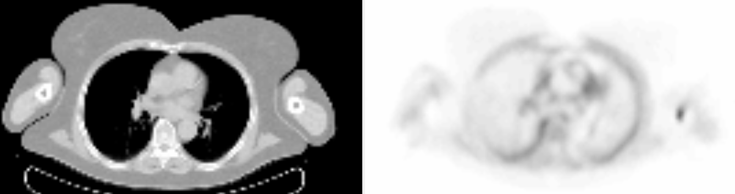
Supplemental Fig. S3: Axial view of ldCT (left) and PET scan (right) of patient ATT03 scan 1 showing the low [¹⁸F]F-AraG uptake in adipose tissue.

