Supplementary Table S1 The primer sequences used for quantitative real-time PCR

Gene | Forward or Reverse | Sequences (5’-3’)
GLI1 | Forward | AGCGTGAGCCTGAATCTGTG
 | Reverse | CAGCATGTACTGGGCTTTGAA
PPIA | Forward | ATGGTCAACCCCACCGTGT
 | Reverse | TCTGCTGTCTTTGGGACCTTGTC
PTCH1 | Forward | CCAGAAAGTATATGCACTGGCA
 | Reverse | GTGCTCGTACATTTGCTTGGG

Supplementary Table S2 The primer sequences used for short hairpin RNA

Gene | Forward or Reverse | Sequences (5’-3’)
shKIF3A | Forward | CCGGGCAACTAATATGAACGAACATCTCGAGATGTTCGTTCATATTAGTTGCTTTTTG
 | Reverse | AATTCAAAAAGCAACTAATATGAACGAACATCTCGAGATGTTCGTTCATATTAGTTGC
shIFT88 | Forward | CCGGGAACAAGTTACAACTCCAGAACTCGAGTTCTGGAGTTGTAACTTGTTCTTTTTG
 | Reverse | AATTCAAAAAGAACAAGTTACAACTCCAGAACTCGAGTTCTGGAGTTGTAACTTGTTC
shVHL | Forward | CCGGTAGGATTGACATTCTTACAGTTCTCGAGAACTGTAGAATGTCAATCCTATTTTTG
 | Reverse | AATTCAAAAATAGGATTGACATTCTTACAGTTCTCGAGAACTGTAGAATGTCAATCCTA
shGLI1 | Forward | CCGGCGTGAGCCTGAATCTGTGTATCTCGAGATACACAGATTCAGGCTCACGTTTTTG
 | Reverse | AATTCAAAAACGTGAGCCTGAATCTGTGTATCTCGAGATACACAGATTCAGGCTCACG

Supplementary Table S3 The primer sequences used for mutations of PTCH1/2
Gene | Forward or Reverse | Sequences (5’-3’)
PTCH1, c.109G>C, p.Gly37Arg | Forward | CGCAGACGGACGCGGGGGCTGCGCCGTGCT
PTCH1, c.109G>C, p.Gly37Arg | Reverse | GCGTCCGTCTGCGCCTCCCGCCTCCAGCCG
PTCH1, c.1398G>C, p.Gln466His | Forward | CTCCAAGTCCCAGCATGCCGTGGGGCTGGCT
PTCH1, c.1398G>C, p.Gln466His | Reverse | TGCTGGGACTTGGAGCAGTCCCAGCGCAGC
PTCH1, c.3944C>T, p.Pro1315Leu | Forward | CTTGTGGCCACCCCTCTACAGACCGCGCAG
PTCH1, c.3944C>T, p.Pro1315Leu | Reverse | AGGGGTGGCCACAAGCCTTCTCTGGGGGGGT
PTCH2, c.620G>A, p.Gly207Asp | Forward | GCCTACCTGCCCGACCGCCCGGATATCCAG
PTCH2, c.620G>A, p.Gly207Asp | Reverse | TCGGGCAGGTAGGCGGAGCCCCCTTGGA
PTCH2, c.311T>C, p.Leu104Pro | Forward | CACCAAGGAGAAGCCGGGGGAGGAGGCTGCATA
PTCH2, c.311T>C, p.Leu104Pro | Reverse | GGCTTCTCCTTGGTGTAATGCAGCTCCTGGCTCAC

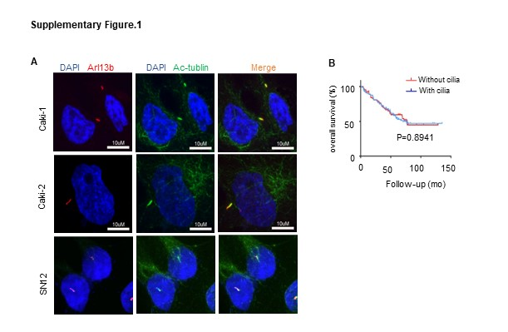
Supplementary Figure 1.
(A) VHL wild type (VHL-wt) ccRCC cell lines (Caki-1, Caki-2, SN12-PM6) were double-stained with antibodies for Arl13b (red) and Ac-tublin to mark cilia, and DAPI (blue) to mark DNA. Scale bar = 10 μm.
(B) Kaplan-Meier analysis indicated that there was no significant difference between ccRCC with primary cilia or without primary cilia. (P >0.05).

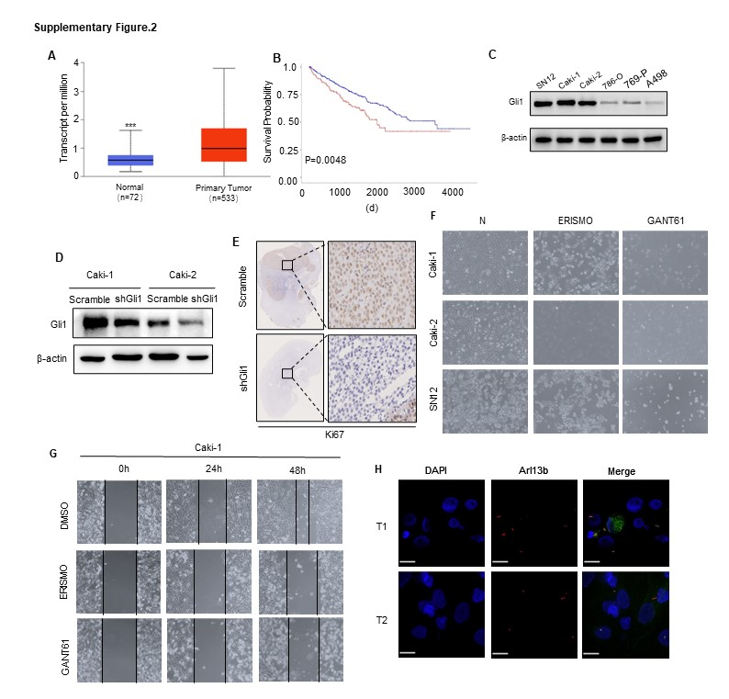

Supplementary Figure 2.
(A) TCGA database analyze showed expression of GLI1 is higher in tumor than normal tissue, p<0.01.
(B) TCGA database analyze showed high expression of GLI1 is associated with poor survival, p<0.01.
(C) Western blot assay showed GLI1 protein levels in VHL wild-type cell lines Caki-1, Caki-2, SN12-PM6 cells and VHL mutated cell lines 786-O, 769-P, A498.
(D) Western blot assay showed GLI1 protein levels in Caki-1 and Caki-2 with knockdown of GLI1.
(E) IHC staining showed the level ki67 in the tumor of nude mice.
(F) Cell numbers and morphology depicted the effect of GLI1 inhibitors Erismodegib and GANT61 in ccRCC cell lines (Caki-1, Caki-2, and SN12-PM6).
(G) Wound healing assay depicted the effect of GLI1 inhibitors Erismodegib and GANT61 on the migration ability of caki-1.
(H) Primary ccRCC tumor cells were stained with antibodies for Arl13b (red) to mark cilia, and DAPI (blue) to mark DNA. Scale bar = 10 μm.

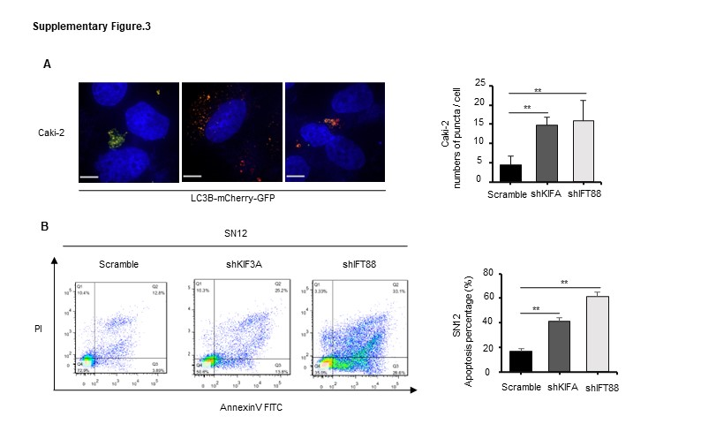

Supplementary Figure 3.
(A) Caki-2 cells were transfected with mCherry-GFP-LC3B. After knockdown of KIF3A and IFT88, representative images of LC3-positive puncta were obtained with a confocal fluorescence microscope. Quantification of puncta numbers of each group was shown in the fight panel. Scale bars = 10 μm. Error bars represent SD.
(B) Flow cytometry showed the percentage of apoptosis cell of SN12 after transfected with vectors of shKIF3A, shIFT88 and scramble. Quantification of apoptosis percentage of each group was shown in the fight panel. Error bars represent SD.

