Supplementary Files

Supplementary Table 1. Univariate logistic regression analyses for A-PCE

 | Score | Degree | p-value
Age | 0.648 | 1 | 0.421
Sex (male=0, female=1) | 1.447 | 1 | 0.229
Hypertension (1) | 1.696 | 1 | 0.193
Cardiac disease history (1) | 0.386 | 1 | 0.535
Smoking (1) | 0.389 | 1 | 0.533
Diabetes mellitus (1) | 1.124 | 1 | 0.289
Alcohol (1) | 3.542 | 1 | 0.060
PS | 0.451 | 2 | 0.798
PS (1) | 0.176 | 1 | 0.675
PS (2) | 0.429 | 1 | 0.512
Pericardium volume | 2.135 | 1 | 0.144
Clinical stage (I vs. II-IV) | 0.944 | 1 | 0.331
2D-plan/3D-CRT | 4.969 | 1 | 0.026
Radiation dose 60 Gy (1) | 3.599 | 1 | 0.058
Heart average dose | 31.293 | 1 | 0.000
Heart V10 | 19.621 | 1 | 0.000
Heart V20 | 24.251 | 1 | 0.000
Heart V30 | 27.368 | 1 | 0.000
Heart V40 | 37.236 | 1 | 0.000
Heart V50 | 33.776 | 1 | 0.000
Heart V60 | 16.272 | 1 | 0.000
Pericardium average dose | 32.788 | 1 | 0.000
Pericardium V10 | 24.019 | 1 | 0.000
Pericardium V20 | 30.026 | 1 | 0.000
Pericardium V30 | 30.812 | 1 | 0.000
Pericardium V40 | 34.595 | 1 | 0.000
Pericardium V50 | 28.748 | 1 | 0.000
Pericardium V60 | 13.259 | 1 | 0.000
Lt Atrium average dose | 23.854 | 1 | 0.000
Lt Atrium V10 | 16.615 | 1 | 0.000
Lt Atrium V20 | 18.129 | 1 | 0.000
Lt Atrium V30 | 19.252 | 1 | 0.000
Lt Atrium V40 | 24.291 | 1 | 0.000
Lt Atrium V50 | 26.266 | 1 | 0.000
Lt Atrium V60 | 5.312 | 1 | 0.021
Rt Atrium average dose | 25.347 | 1 | 0.000
Rt Atrium V10 | 17.167 | 1 | 0.000
Rt Atrium V20 | 18.871 | 1 | 0.000
Rt Atrium V30 | 19.507 | 1 | 0.000
Rt Atrium V40 | 25.216 | 1 | 0.000
Rt Atrium V50 | 20.61 | 1 | 0.000
Rt Atrium V60 | 9.720 | 1 | 0.002
Lt Ventricle average dose | 12.244 | 1 | 0.000
Lt Ventricle V10 | 9.048 | 1 | 0.003
Lt Ventricle V20 | 11.677 | 1 | 0.001
Lt Ventricle V30 | 12.337 | 1 | 0.000
Lt Ventricle V40 | 13.462 | 1 | 0.000
Lt Ventricle V50 | 9.488 | 1 | 0.002
Lt Ventricle V60 | 1.808 | 1 | 0.179
Rt Ventricle average dose | 20.667 | 1 | 0.000
Rt Ventricle V10 | 13.567 | 1 | 0.000
Rt Ventricle V20 | 14.871 | 1 | 0.000
Rt Ventricle V30 | 16.272 | 1 | 0.000
Rt Ventricle V40 | 27.984 | 1 | 0.000
Rt Ventricle V50 | 12.364 | 1 | 0.000
Rt Ventricle V60 | 4.965 | 1 | 0.026
Lt Lung average dose | 8.498 | 1 | 0.004
Lt Lung V10 | 5.034 | 1 | 0.025
Lt Lung V20 | 4.919 | 1 | 0.027
Lt Lung V30 | 5.467 | 1 | 0.019
Lt Lung V40 | 7.155 | 1 | 0.007
Lt Lung V50 | 6.464 | 1 | 0.011
Lt Lung V60 | 4.320 | 1 | 0.038
Rt Lung average dose | 6.641 | 1 | 0.010
Rt Lung V10 | 3.342 | 1 | 0.068
Rt Lung V20 | 7.048 | 1 | 0.008
Rt Lung V30 | 4.391 | 1 | 0.036
Rt Lung V40 | 4.733 | 1 | 0.030
Rt Lung V50 | 2.507 | 1 | 0.113
Rt Lung V60 | 3.023 | 1 | 0.082
 | 96.584 | 69 | 0.016

2D-plan: two-dimensional treatment plan; 3D-CRT: three-dimensional conformal radiotherapy; A-PCE: pericardial effusion of any grade; Degree: degree of freedom; Lt: left; PS: performance state;
Rt: right.

Supplementary Table 2. Univariate logistic regression analyses for S-PCE

 | Score | Degree | p-value
Age | 2.762 | 1 | 0.097
Sex (male=0, female=1) | 1.246 | 1 | 0.264
Hypertension (1) | 5.986 | 1 | 0.014
Cardiac disease history (1) | 0.007 | 1 | 0.934
Smoking (1) | 1.655 | 1 | 0.198
Diabetes mellitus (1) | 2.093 | 1 | 0.148
Alcohol (1) | 2.598 | 1 | 0.107
PS | 0.631 | 2 | 0.729
PS (1) | 0.589 | 1 | 0.443
PS (2) | 0.531 | 1 | 0.466
Pericardium volume | 0.000 | 1 | 0.998
Clinical stage (I vs. II-IV) | 2.932 | 1 | 0.087
2D-plan/3D-CRT | 9.250 | 1 | 0.002
Radiation dose 60 Gy (1) | 3.320 | 1 | 0.068
Heart average dose | 18.847 | 1 | 0.000
Heart V10 | 11.858 | 1 | 0.001
Heart V20 | 13.555 | 1 | 0.000
Heart V30 | 17.217 | 1 | 0.000
Heart V40 | 20.217 | 1 | 0.000
Heart V50 | 18.691 | 1 | 0.000
Heart V60 | 15.472 | 1 | 0.000
Pericardium average dose | 20.387 | 1 | 0.000
Pericardium V10 | 13.437 | 1 | 0.000
Pericardium V20 | 15.293 | 1 | 0.000
Pericardium V30 | 19.598 | 1 | 0.000
Pericardium V40 | 19.429 | 1 | 0.000
Pericardium V50 | 23.143 | 1 | 0.000
Pericardium V60 | 15.094 | 1 | 0.000
Lt Atrium average dose | 9.082 | 1 | 0.003
Lt Atrium V10 | 4.910 | 1 | 0.027
Lt Atrium V20 | 5.533 | 1 | 0.019
Lt Atrium V30 | 6.770 | 1 | 0.009
Lt Atrium V40 | 8.998 | 1 | 0.003
Lt Atrium V50 | 13.191 | 1 | 0.000
Lt Atrium V60 | 1.717 | 1 | 0.190
Rt Atrium average dose | 11.55 | 1 | 0.001
Rt Atrium V10 | 7.255 | 1 | 0.007
Rt Atrium V20 | 5.334 | 1 | 0.021
Rt Atrium V30 | 8.800 | 1 | 0.003
Rt Atrium V40 | 11.056 | 1 | 0.001
Rt Atrium V50 | 15.350 | 1 | 0.000
Rt Atrium V60 | 7.517 | 1 | 0.006
Lt Ventricle average dose | 13.178 | 1 | 0.000
Lt Ventricle V10 | 11.089 | 1 | 0.001
Lt Ventricle V20 | 12.640 | 1 | 0.000
Lt Ventricle V30 | 13.239 | 1 | 0.000
Lt Ventricle V40 | 14.807 | 1 | 0.000
Lt Ventricle V50 | 4.887 | 1 | 0.027
Lt Ventricle V60 | 4.079 | 1 | 0.043
Rt Ventricle average dose | 13.022 | 1 | 0.000
Rt Ventricle V10 | 7.937 | 1 | 0.005
Rt Ventricle V20 | 9.369 | 1 | 0.002
Rt Ventricle V30 | 11.416 | 1 | 0.001
Rt Ventricle V40 | 16.701 | 1 | 0.000
Rt Ventricle V50 | 5.943 | 1 | 0.015
Rt Ventricle V60 | 4.108 | 1 | 0.043
Lt Lung average dose | 10.265 | 1 | 0.001
Lt Lung V10 | 4.893 | 1 | 0.027
Lt Lung V20 | 7.342 | 1 | 0.007
Lt Lung V30 | 9.299 | 1 | 0.002
Lt Lung V40 | 10.195 | 1 | 0.001
Lt Lung V50 | 14.653 | 1 | 0.000
Lt Lung V60 | 15.853 | 1 | 0.000
Rt Lung average dose | 6.674 | 1 | 0.010
Rt Lung V10 | 4.940 | 1 | 0.026
Rt Lung V20 | 5.341 | 1 | 0.021
Rt Lung V30 | 4.883 | 1 | 0.027
Rt Lung V40 | 4.088 | 1 | 0.043
Rt Lung V50 | 7.144 | 1 | 0.008
Rt Lung V60 | 1.958 | 1 | 0.162
 | 93.881 | 69 | 0.025

2D-plan: two-dimensional treatment plan; 3D-CRT: three-dimensional conformal radiotherapy;
Degree: degree of freedom; Lt: left; PS: performance status; Rt: right; S-PCE: symptomatic pericardial effusion.

Supplementary Table 3. ROC analyses for A-PCE

Variables | AUC | p-value | 95% CI
Heart average dose | 0.713 | 0.000 | 0.647 | 0.779
Heart V10 | 0.660 | 0.000 | 0.589 | 0.730
Heart V20 | 0.684 | 0.000 | 0.616 | 0.753
Heart V30 | 0.696 | 0.000 | 0.629 | 0.764
Heart V40 | 0.734 | 0.000 | 0.669 | 0.798
Heart V50 | 0.732 | 0.000 | 0.667 | 0.797
Heart V60 | 0.637 | 0.000 | 0.564 | 0.711
Pericardium average dose | 0.717 | 0.000 | 0.651 | 0.784
Pericardium V10 | 0.689 | 0.000 | 0.621 | 0.757
Pericardium V20 | 0.708 | 0.000 | 0.641 | 0.775
Pericardium V30 | 0.709 | 0.000 | 0.642 | 0.776
Pericardium V40 | 0.725 | 0.000 | 0.659 | 0.79
Pericardium V50 | 0.717 | 0.000 | 0.65 | 0.784
Pericardium V60 | 0.628 | 0.001 | 0.555 | 0.702
Lt Atrium average dose | 0.689 | 0.000 | 0.621 | 0.758
Lt Atrium V10 | 0.633 | 0.000 | 0.562 | 0.705
Lt Atrium V20 | 0.667 | 0.000 | 0.597 | 0.737
Lt Atrium V30 | 0.675 | 0.000 | 0.605 | 0.744
Lt Atrium V40 | 0.697 | 0.000 | 0.629 | 0.764
Lt Atrium V50 | 0.691 | 0.000 | 0.623 | 0.76
Lt Atrium V60 | 0.546 | 0.231 | 0.47 | 0.622
Rt Atrium average dose | 0.688 | 0.000 | 0.62 | 0.757
Rt Atrium V10 | 0.664 | 0.000 | 0.594 | 0.734
Rt Atrium V20 | 0.673 | 0.000 | 0.603 | 0.742
Rt Atrium V30 | 0.678 | 0.000 | 0.608 | 0.747
Rt Atrium V40 | 0.692 | 0.000 | 0.624 | 0.761
Rt Atrium V50 | 0.665 | 0.000 | 0.593 | 0.737
Rt Atrium V60 | 0.566 | 0.088 | 0.490 | 0.642
Lt Ventricle average dose | 0.640 | 0.000 | 0.568 | 0.712
Lt Ventricle V10 | 0.622 | 0.001 | 0.549 | 0.694
Lt Ventricle V20 | 0.639 | 0.000 | 0.567 | 0.71
Lt Ventricle V30 | 0.643 | 0.000 | 0.571 | 0.715
Lt Ventricle V40 | 0.661 | 0.000 | 0.590 | 0.732
Lt Ventricle V50 | 0.640 | 0.000 | 0.566 | 0.713
Lt Ventricle V60 | 0.536 | 0.349 | 0.460 | 0.612
Rt Ventricle average dose | 0.684 | 0.000 | 0.615 | 0.754
Rt Ventricle V10 | 0.645 | 0.000 | 0.573 | 0.716
Rt Ventricle V20 | 0.661 | 0.000 | 0.590 | 0.731
Rt Ventricle V30 | 0.668 | 0.000 | 0.598 | 0.738
Rt Ventricle V40 | 0.708 | 0.000 | 0.640 | 0.775
Rt Ventricle V50 | 0.650 | 0.000 | 0.578 | 0.723
Rt Ventricle V60 | 0.549 | 0.211 | 0.473 | 0.625
Lt Lung average dose | 0.604 | 0.005 | 0.531 | 0.677
Lt Lung V10 | 0.589 | 0.018 | 0.515 | 0.663
Lt Lung V20 | 0.580 | 0.034 | 0.506 | 0.655
Lt Lung V30 | 0.586 | 0.024 | 0.512 | 0.66
Lt Lung V40 | 0.603 | 0.006 | 0.530 | 0.677
Lt Lung V50 | 0.591 | 0.016 | 0.517 | 0.666
Lt Lung V60 | 0.586 | 0.024 | 0.512 | 0.661
Rt Lung average dose | 0.599 | 0.008 | 0.525 | 0.672
Rt Lung V10 | 0.564 | 0.090 | 0.49 | 0.639
Rt Lung V20 | 0.599 | 0.008 | 0.525 | 0.672
Rt Lung V30 | 0.592 | 0.014 | 0.518 | 0.665
Rt Lung V40 | 0.602 | 0.006 | 0.529 | 0.675
Rt Lung V50 | 0.598 | 0.010 | 0.524 | 0.672
Rt Lung V60 | 0.556 | 0.145 | 0.481 | 0.632
A-PCE: pericardial effusion of any grade; AUC: area under the curve; CI: confidence interval;
Lt: left; ROC: receiver operating characteristic; Rt: right.

Supplementary Table 4. ROC analyses for S-PCE

Variables | AUC | p-value | 95% CI
Heart average dose | 0.821 | 0.000 | 0.733 | 0.909
Heart V10 | 0.797 | 0.000 | 0.707 | 0.886
Heart V20 | 0.793 | 0.000 | 0.701 | 0.884
Heart V30 | 0.819 | 0.000 | 0.734 | 0.904
Heart V40 | 0.817 | 0.000 | 0.740 | 0.894
Heart V50 | 0.776 | 0.000 | 0.679 | 0.874
Heart V60 | 0.685 | 0.013 | 0.539 | 0.831
Pericardium average dose | 0.804 | 0.000 | 0.704 | 0.903
Pericardium V10 | 0.793 | 0.000 | 0.701 | 0.886
Pericardium V20 | 0.777 | 0.000 | 0.672 | 0.882
Pericardium V30 | 0.806 | 0.000 | 0.713 | 0.899
Pericardium V40 | 0.800 | 0.000 | 0.712 | 0.887
Pericardium V50 | 0.792 | 0.000 | 0.695 | 0.889
Pericardium V60 | 0.691 | 0.007 | 0.553 | 0.829
Lt Atrium average dose | 0.764 | 0.000 | 0.659 | 0.869
Lt Atrium V10 | 0.691 | 0.000 | 0.594 | 0.789
Lt Atrium V20 | 0.715 | 0.000 | 0.610 | 0.821
Lt Atrium V30 | 0.750 | 0.000 | 0.650 | 0.851
Lt Atrium V40 | 0.764 | 0.000 | 0.670 | 0.859
Lt Atrium V50 | 0.760 | 0.000 | 0.650 | 0.87
Lt Atrium V60 | 0.573 | 0.322 | 0.429 | 0.717
Rt Atrium average dose | 0.731 | 0.000 | 0.615 | 0.846
Rt Atrium V10 | 0.699 | 0.000 | 0.596 | 0.801
Rt Atrium V20 | 0.680 | 0.002 | 0.564 | 0.797
Rt Atrium V30 | 0.716 | 0.000 | 0.605 | 0.828
Rt Atrium V40 | 0.729 | 0.000 | 0.622 | 0.837
Rt Atrium V50 | 0.746 | 0.000 | 0.631 | 0.862
Rt Atrium V60 | 0.662 | 0.029 | 0.516 | 0.808
Lt Ventricle average dose | 0.761 | 0.000 | 0.664 | 0.859
Lt Ventricle V10 | 0.742 | 0.000 | 0.642 | 0.843
Lt Ventricle V20 | 0.761 | 0.000 | 0.664 | 0.857
Lt Ventricle V30 | 0.768 | 0.000 | 0.673 | 0.863
Lt Ventricle V40 | 0.778 | 0.000 | 0.680 | 0.876
Lt Ventricle V50 | 0.687 | 0.002 | 0.566 | 0.808
Lt Ventricle V60 | 0.550 | 0.507 | 0.403 | 0.696
Rt Ventricle average dose | 0.789 | 0.000 | 0.698 | 0.881
Rt Ventricle V10 | 0.712 | 0.000 | 0.615 | 0.809
Rt Ventricle V20 | 0.765 | 0.000 | 0.668 | 0.862
Rt Ventricle V30 | 0.793 | 0.000 | 0.694 | 0.892
Rt Ventricle V40 | 0.790 | 0.000 | 0.703 | 0.877
Rt Ventricle V50 | 0.705 | 0.001 | 0.582 | 0.829
Rt Ventricle V60 | 0.568 | 0.369 | 0.420 | 0.716
Lt Lung average dose | 0.668 | 0.004 | 0.554 | 0.782
Lt Lung V10 | 0.637 | 0.028 | 0.515 | 0.758
Lt Lung V20 | 0.639 | 0.027 | 0.516 | 0.762
Lt Lung V30 | 0.650 | 0.019 | 0.525 | 0.775
Lt Lung V40 | 0.666 | 0.010 | 0.539 | 0.793
Lt Lung V50 | 0.693 | 0.002 | 0.572 | 0.815
Lt Lung V60 | 0.676 | 0.006 | 0.550 | 0.802
Rt Lung average dose | 0.680 | 0.005 | 0.555 | 0.806
Rt Lung V10 | 0.668 | 0.008 | 0.543 | 0.793
Rt Lung V20 | 0.660 | 0.020 | 0.525 | 0.795
Rt Lung V30 | 0.659 | 0.011 | 0.537 | 0.781
Rt Lung V40 | 0.638 | 0.039 | 0.507 | 0.770
Rt Lung V50 | 0.696 | 0.002 | 0.569 | 0.824
Rt Lung V60 | 0.623 | 0.110 | 0.472 | 0.773
AUC: area under the curve; CI: confidence interval; Lt: left; ROC: receiver operating characteristic; Rt: right; S-PCE: symptomatic pericardial effusion.

Supplementary Figure 1. Selected frequency for A-PCE by bootstrap analysis
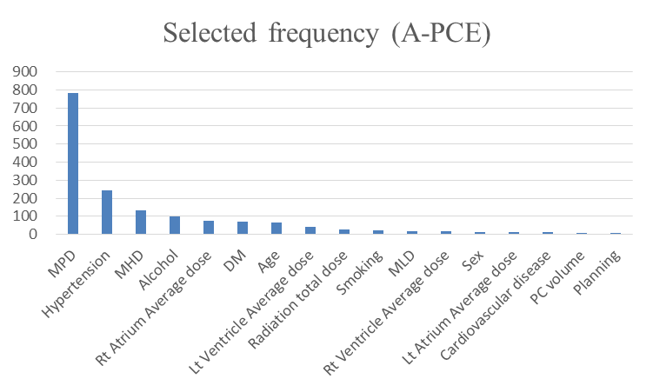

A-PCE: pericardial effusion in any grade; DM: diabetes mellitus; Lt: left; MHD: mean heart dose; MLD: mean lung dose; MPD: mean pericardial dose; PC: pericardium; PS: performance status; Rt: right.

Supplementary Figure 2. Calibration plots using the Hosmer–Lemeshow test of the observed vs. calculated risk for A-PCE
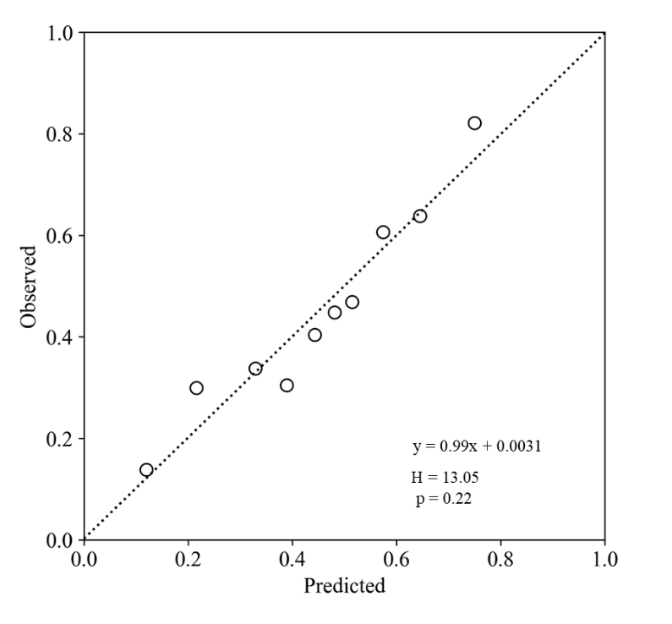
A-PCE: pericardial effusion in any grade
Supplementary Figure 3. Selected frequency for S-PCE by bootstrap analysis
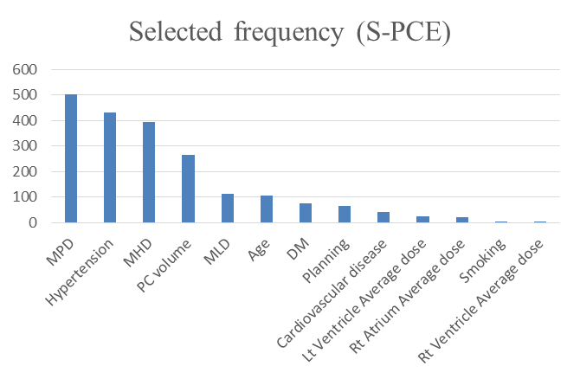
DM: diabetes mellitus; Lt: left; MHD: mean heart dose; MLD: mean lung dose; MPD: mean pericardial dose; PC: pericardium; Rt: right; S-PCE: symptomatic pericardial effusion.

Supplementary Figure 4. Calibration plots using the Hosmer–Lemeshow test of the observed vs. calculated risk for S-PCE
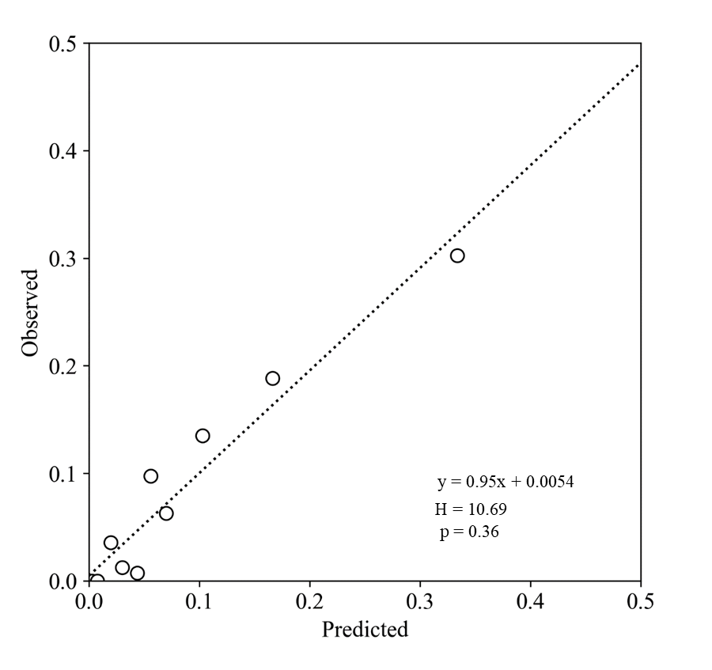
S-PCE: symptomatic pericardial effusion
Supplementary Figure 5. Calibration plots using the Hosmer–Lemeshow test of the observed vs. calculated risk by MHD (5a) and LKB (5b) model for A-PCE
(5a)
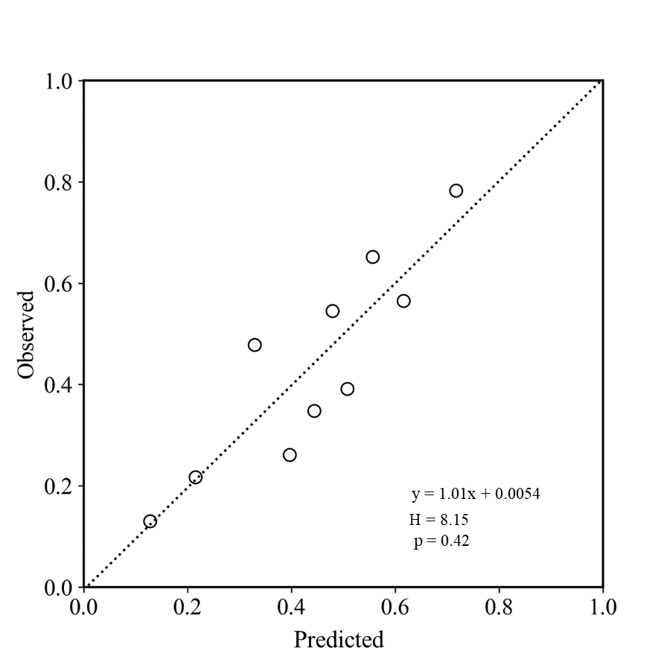
(5b)
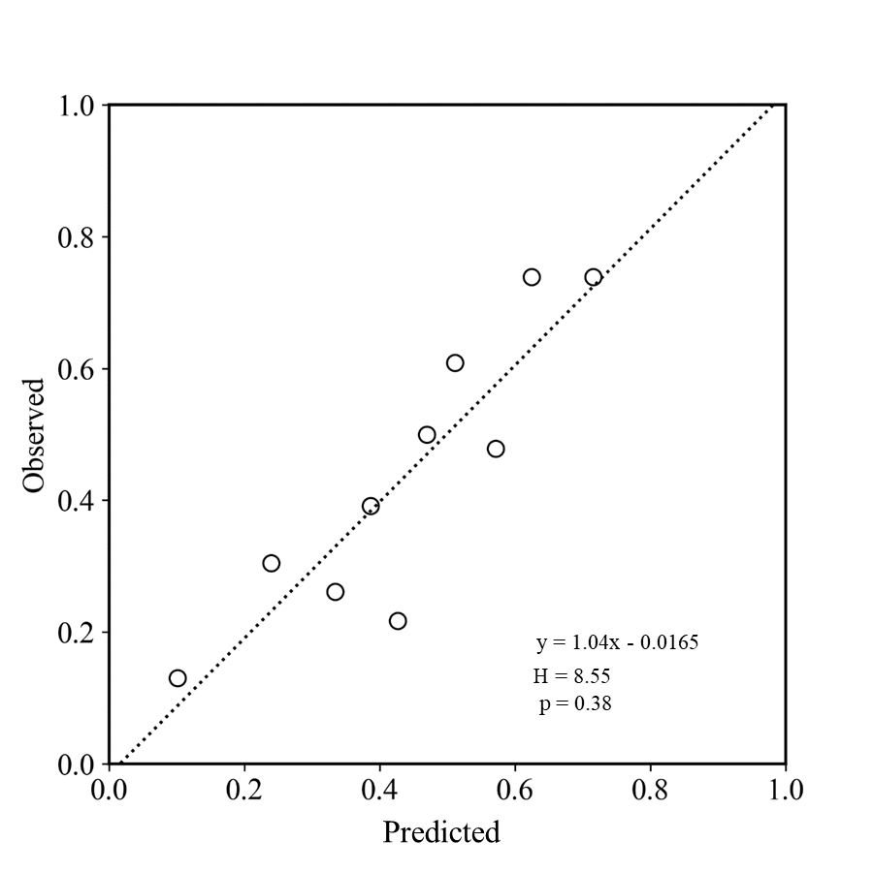
A-PCE: pericardial effusion in any grade; LKB: Lyman–Kutcher–Burman; MHD: mean heart dose
Supplementary Figure 6. Calibration plots using the Hosmer–Lemeshow test of the observed vs. calculated risk by MHD (6a) and LKB (6b) model for S-PCE
(6a)
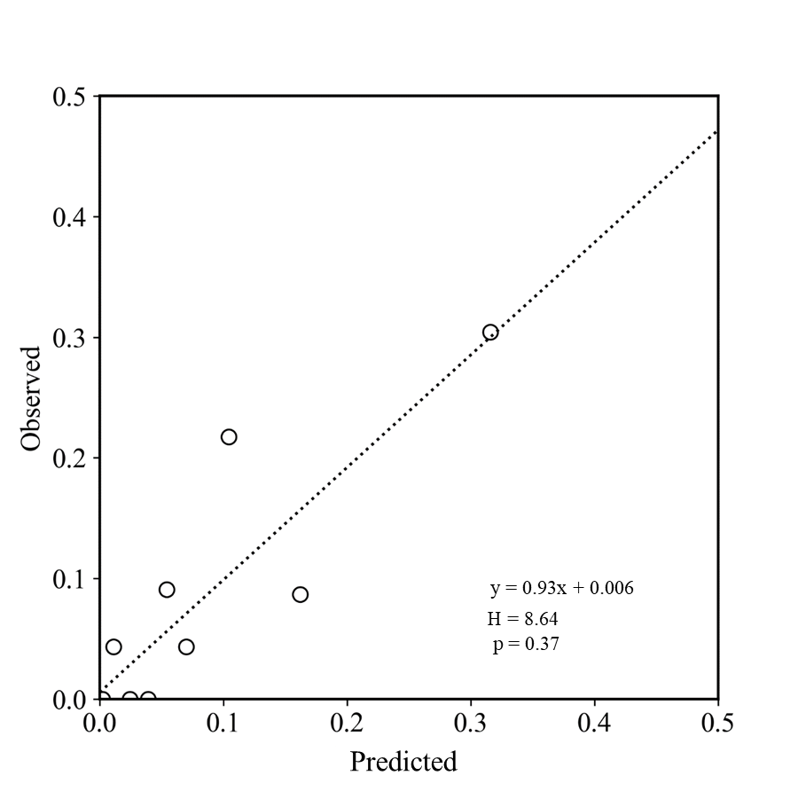
(6b)
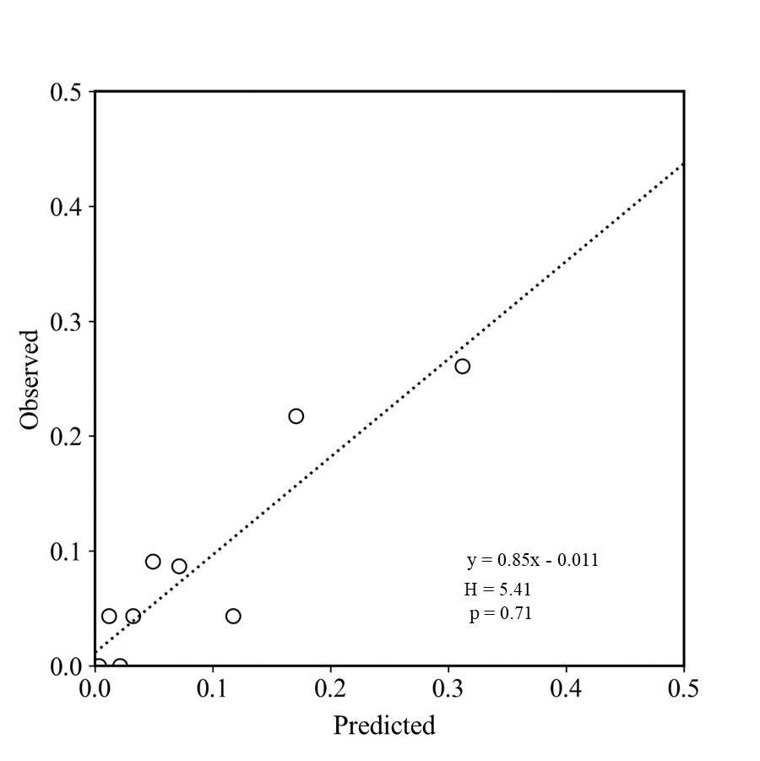

LKB: Lyman–Kutcher–Burman; MHD: mean heart dose; S-PCE: symptomatic pericardial effusion.
Supplementary Figure 7. Calibration plots using the Hosmer–Lemeshow test of the predicted risk by MHD-based model vs. LKB model for A-PCE
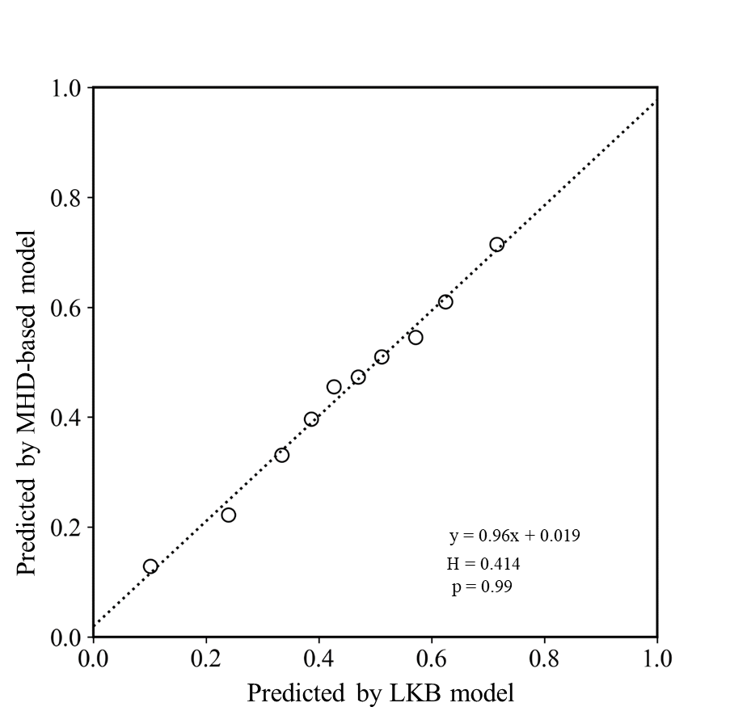
A-PCE: pericardial effusion in any grade; LKB: Lyman–Kutcher–Burman; MHD: mean heart dose

Supplementary Figure 8. Calibration plots using the Hosmer–Lemeshow test of the predicted risk by MHD-based model vs. LKB model for S-PCE
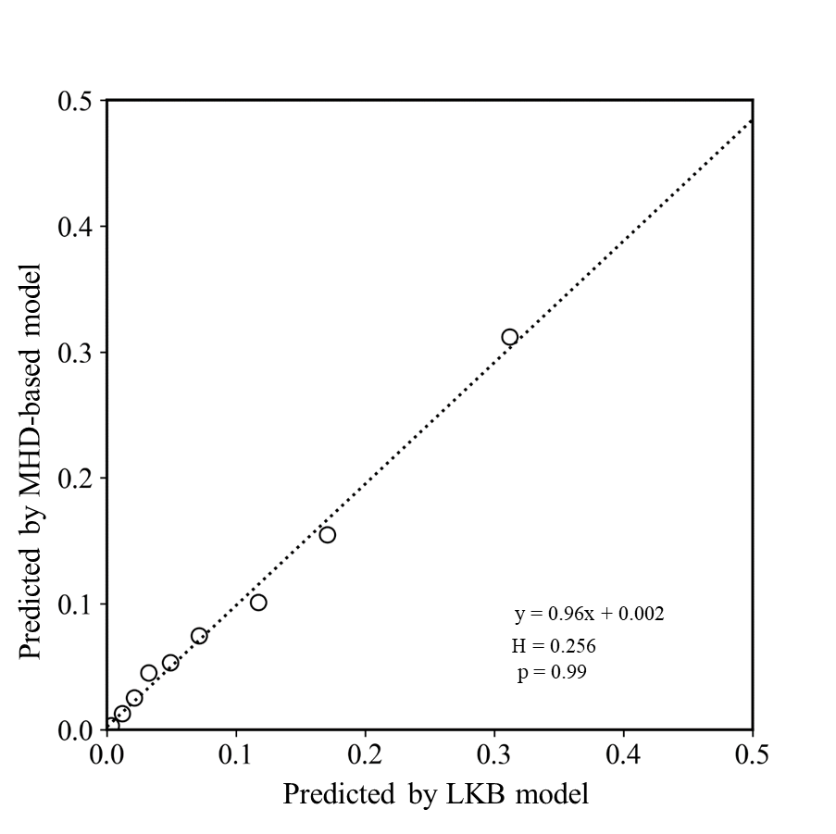

LKB: Lyman–Kutcher–Burman; MHD: mean heart dose; S-PCE: symptomatic pericardial effusion.

