Supplementary Material

Application of slow-release nitrogen fertilizer affected maize yield through regulating soil microbial diversity
Tiantian Meng¹, Jingjing Shi⁴, Xiangqian Zhang^{2,3*}, Xiaoqing Zhao^{2,3}, Dejian Zhang⁴, Liyu Chen^{2,3}, Zhanyuan Lu^{1,2,3*}, Yuchen Cheng^{2,3*}, Yonghe Hao⁵, Yu Wang^{5*}
* Correspondence:
Xiangqian Zhang
zhangxiangqian_2008@126.com
Yuchen Cheng
251677971@qq.com
Zhanyuan Lu
lzhy2811@163.com

Supplementary Data
Supplementary Material should be uploaded separately on submission. Please include any supplementary data, figures and/or tables.
Supplementary material is not typeset so please ensure that all information is clearly presented, the appropriate caption is included in the file and not in the manuscript, and that the style conforms to the rest of the article.

Supplementary Figures and Tables
For more information on Supplementary Material and for details on the different file types accepted, please see here.

Supplementary Figures

Supplementary Figure 1. The Spatial location (R), Nitrogen fertilizer application rate (N) and their interaction (R×N) on the Shannon index (a) and phylogenetic diversity (b) in two-way analysis of variance (ANOVA). The influence of dilution on the Shannon index in each fertilized soil was determined using one-way ANOVA. The asterisk (*) above the bar indicates a significant treatment effect, * P < 0.05, ** P < 0.01, *** P < 0.001.
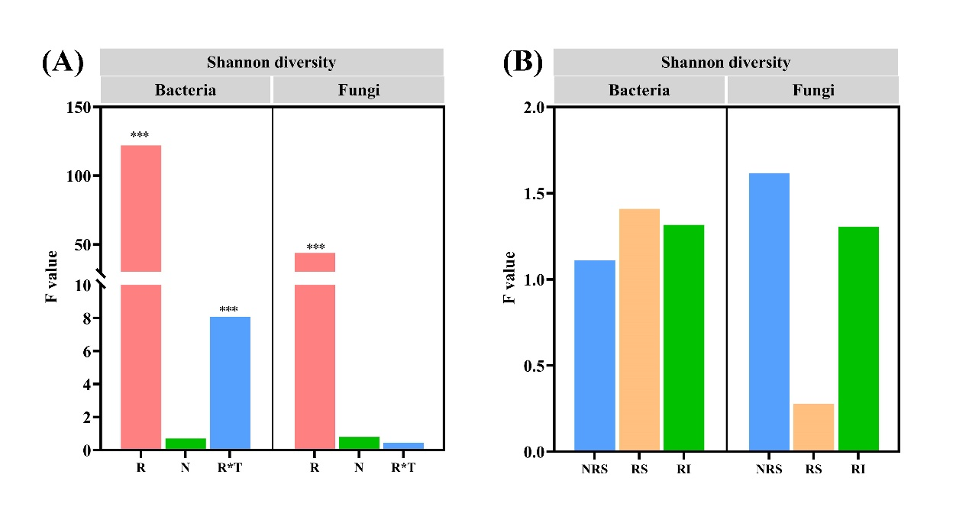
Supplementary Figure 2 Spesrman’s rank correlation heatmap (P , 0.05 *, P , 0.01**), used to study the correlation in the microbial communities of bacteria (a-c) and fungi (d-f) in soil chemical properties, microbiological and yield.
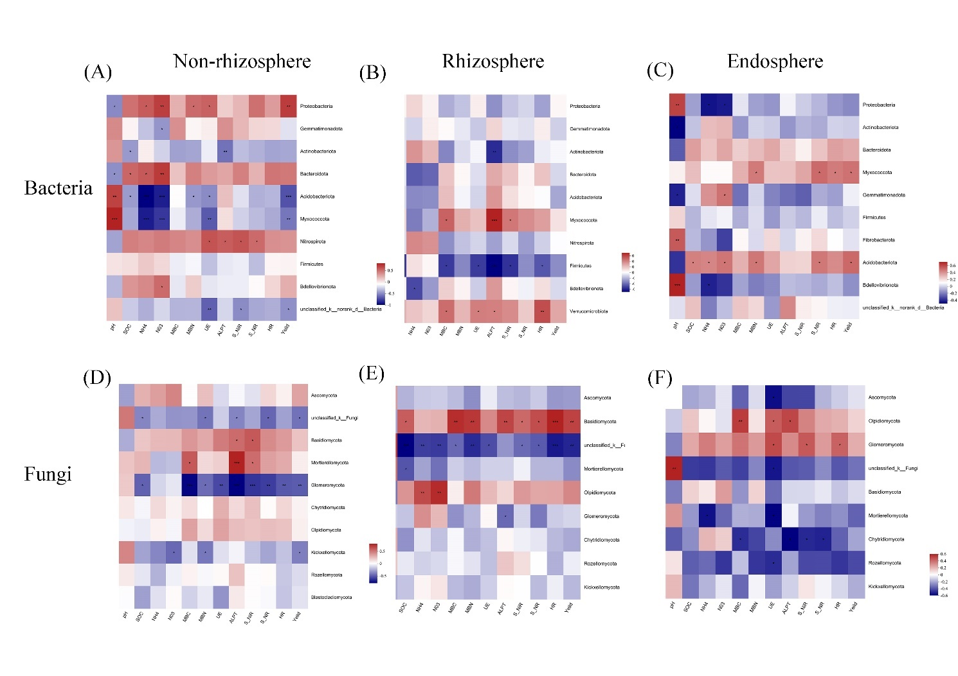
Supplementary Table 1 Average network distance, modularity index, clustering coefficient and graph density of network analysis graphs of bacteria and fungi at different locations
Microbial species | Spatial location | Average network distance | Modularity index | Clustering coefficient | Graph density
Bacteria | Non-rhizosphere | 3.577 | 0.492 | 0.19 | 0.029
Bacteria | Rhizosphere | 3.742 | 0.45 | 0.233 | 0.03
Bacteria | Endophyte | 3.327 | 0.495 | 0.215 | 0.036
Fungi | Non-rhizosphere | 3.047 | 0.412 | 0.342 | 0.054
Fungi | Rhizosphere | 2.738 | 0.43 | 0.341 | 0.064
Fungi | Endophyte | 3.46 | 0.585 | 0.331 | 0.037
Supplementary Table 2 Average network distance, modularity index, clustering coefficient and graph density of network analysis graphs of bacteria and fungi under different nitrogen application rate
Microbial species | Nitrogen fertilizer application rate | Average network distance | Modularity index | Clustering coefficient | Graph density
Bacteria | N0 | 1.56 | 0.161 | 0.763 | 0.507
Bacteria | N8 | 1.64 | 0.061 | 0.796 | 0.598
Bacteria | N12 | 1.617 | 0.064 | 0.794 | 0.52
Bacteria | N16 | 1.654 | 0.159 | 0.729 | 0.458
Bacteria | N20 | 1.535 | 0.12 | 0.744 | 0.526
Bacteria | N24 | 1.398 | 0.088 | 0.847 | 0.647
Fungi | N0 | 2.125 | 0.205 | 0.635 | 0.293
Fungi | N8 | 1.838 | 0.207 | 0.7 | 0.336
Fungi | N12 | 1.828 | 0.222 | 0.639 | 0.289
Fungi | N16 | 1.683 | 0.155 | 0.737 | 0.42
Fungi | N20 | 2.093 | 0.285 | 0.72 | 0.29
Fungi | N24 | 1.856 | 0.263 | 0.684 | 0.373
Supplementary Table 3. Average network distance, modularity index, clustering coefficient and graph density of network analysis graphs of bacteria and fungi under different nitrogen application rate
Node_Name | Phylum | Family | Node_Name | Phylum | Family | Node_Name | Phylum | Family | Node_Name | Phylum | Family | Node_Name | Phylum | Family | Node_Name | Phylum | Family
N0 |  |  | N8 |  |  | N12 |  |  | N16 |  |  | N20 |  |  | N24
ASV2885 | Proteobacteria | Pseudomonadaceae | ASV1152 | Bacteroidota | Hymenobacteraceae | ASV2895 | Bacteroidota | Hymenobacteraceae | ASV2771 | Gemmatimonadota | Gemmatimonadaceae | ASV2886 | Myxococcota | Myxococcaceae | ASV2914 | Acidobacteriota | Thermoanaerobaculaceae
ASV2771 | Gemmatimonadota | Gemmatimonadaceae | ASV1323 | Acidobacteriota | Subgroup_25 | ASV2771 | Gemmatimonadota | Gemmatimonadaceae | ASV1323 | Acidobacteriota | Subgroup_25 | ASV2914 | Acidobacteriota | Thermoanaerobaculaceae | ASV2895 | Bacteroidota | Hymenobacteraceae
ASV2888 | Actinobacteriota | Iamiaceae | ASV2885 | Proteobacteria | Pseudomonadaceae | ASV4984 | Proteobacteria | Rhodobacteraceae | ASV17 | Actinobacteriota | Streptomycetaceae | ASV2885 | Proteobacteria | Pseudomonadaceae | ASV2885 | Proteobacteria | Pseudomonadaceae
ASV49 | Gemmatimonadota | Gemmatimonadaceae | ASV1159 | Bacteroidota | Chitinophagaceae | ASV2886 | Myxococcota | Myxococcaceae | ASV1177 | Proteobacteria |  | ASV1323 | Acidobacteriota | Subgroup_25 | ASV2910 | Bacteroidota | Hymenobacteraceae
ASV2886 | Myxococcota | Myxococcaceae | ASV2886 | Myxococcota | Myxococcaceae | ASV2888 | Actinobacteriota | Iamiaceae | ASV2948 | Gemmatimonadota | Longimicrobiaceae | ASV49 | Gemmatimonadota | Gemmatimonadaceae | ASV1323 | Acidobacteriota | Subgroup_25
ASV23 | Proteobacteria | Sphingomonadaceae | ASV2895 | Bacteroidota | Hymenobacteraceae | ASV9 | Proteobacteria | Sphingomonadaceae | ASV1354 | Bacteroidota | Flavobacteriaceae | ASV1158 | Bacteroidota | Chitinophagaceae | ASV2886 | Myxococcota | Myxococcaceae
ASV1428 | Myxococcota | Eel-36e1D6 | ASV2355 | Proteobacteria | Cellvibrionaceae | ASV1323 | Acidobacteriota | Subgroup_25 | ASV70 | Proteobacteria | Xanthomonadaceae | ASV1177 | Proteobacteria |  | ASV2888 | Actinobacteriota | Iamiaceae
ASV1354 | Bacteroidota | Flavobacteriaceae | ASV4960 | Proteobacteria | Unknown_Family | ASV4 | Actinobacteriota | Streptomycetaceae | ASV1428 | Myxococcota | Eel-36e1D6 | ASV17 | Actinobacteriota | Streptomycetaceae | ASV10 | Proteobacteria | Sphingomonadaceae
ASV1323 | Acidobacteriota | Subgroup_25 | ASV43 | Proteobacteria | Sphingomonadaceae | ASV2897 | Bacteroidota | Flavobacteriaceae | ASV1146 | Bacteroidota | Saprospiraceae | ASV9 | Proteobacteria | Sphingomonadaceae | ASV1159 | Bacteroidota | Chitinophagaceae
ASV104 | Proteobacteria | Sphingomonadaceae | ASV8 | Proteobacteria | Rhizobiaceae | ASV5 | Proteobacteria | Rhizobiaceae | ASV311 | Actinobacteriota | Glycomycetaceae | ASV2261 | Gemmatimonadota | S0134_terrestrial_group | ASV36 | Proteobacteria | Nitrosomonadaceae
ASV5 | Proteobacteria | Rhizobiaceae | ASV10 | Proteobacteria | Sphingomonadaceae | ASV27 | Proteobacteria | Pseudomonadaceae | ASV20 | Proteobacteria | Dongiaceae | ASV1159 | Bacteroidota | Chitinophagaceae | ASV13 | Proteobacteria | Sphingomonadaceae
ASV1152 | Bacteroidota | Hymenobacteraceae | ASV5 | Proteobacteria | Rhizobiaceae | ASV8 | Proteobacteria | Rhizobiaceae | ASV58 | Gemmatimonadota | Gemmatimonadaceae | ASV7 | Proteobacteria | Sphingomonadaceae | ASV58 | Gemmatimonadota | Gemmatimonadaceae
ASV7 | Proteobacteria | Sphingomonadaceae | ASV16 | Proteobacteria | Oxalobacteraceae | ASV16 | Proteobacteria | Oxalobacteraceae | ASV55 | Proteobacteria | Sphingomonadaceae | ASV104 | Proteobacteria | Sphingomonadaceae | ASV61 | Proteobacteria | Oxalobacteraceae
ASV4337 | Bacteroidota | Muribaculaceae | ASV1273 | Bacteroidota | Flavobacteriaceae | ASV1126 | NB1-j | NB1-j | ASV1118 | Proteobacteria | Rhodanobacteraceae | ASV55 | Proteobacteria | Sphingomonadaceae | ASV9 | Proteobacteria | Sphingomonadaceae
ASV2898 | Bacteroidota | Hymenobacteraceae | ASV4953 | Firmicutes | Exiguobacteraceae | ASV1177 | Proteobacteria | Bacteroidia | ASV7 | Proteobacteria | Sphingomonadaceae | ASV70 | Proteobacteria | Xanthomonadaceae | ASV44 | Proteobacteria | Rhizobiaceae
ASV2355 | Proteobacteria | Cellvibrionaceae | ASV506 | Proteobacteria | Rhizobiaceae | ASV36 | Proteobacteria | Nitrosomonadaceae | ASV1159 | Bacteroidota | Chitinophagaceae | ASV6 | Actinobacteriota | Pseudonocardiaceae | ASV8 | Proteobacteria | Rhizobiaceae
ASV43 | Proteobacteria | Sphingomonadaceae | ASV49 | Gemmatimonadota | Gemmatimonadaceae | ASV13 | Proteobacteria | Sphingomonadaceae | ASV506 | Proteobacteria | Rhizobiaceae | ASV16 | Proteobacteria | Oxalobacteraceae | ASV5 | Proteobacteria | Rhizobiaceae
ASV36 | Proteobacteria | Nitrosomonadaceae | ASV25 | Proteobacteria | Xanthomonadaceae | ASV1354 | Bacteroidota | Flavobacteriaceae | ASV2893 | Actinobacteriota | uncultured | ASV5 | Proteobacteria | Rhizobiaceae | ASV2260 | Actinobacteriota | Streptomycetaceae
ASV1159 | Bacteroidota | Chitinophagaceae | ASV36 | Proteobacteria | Nitrosomonadaceae | ASV2355 | Proteobacteria | Cellvibrionaceae | ASV27 | Proteobacteria | Pseudomonadaceae | ASV36 | Proteobacteria | Nitrosomonadaceae | ASV2897 | Bacteroidota | Flavobacteriaceae
ASV32 | Proteobacteria | PLTA13 | ASV13 | Proteobacteria | Sphingomonadaceae | ASV2891 | Acidobacteriota | Thermoanaerobaculaceae | ASV2323 | Proteobacteria | Oxalobacteraceae | ASV110 | Actinobacteriota | uncultured | ASV110 | Actinobacteriota | uncultured
Supplementary Table 4 Average network distance, modularity index, clustering coefficient and graph density of network analysis graphs of bacteria and fungi under different nitrogen application rate
Node_Name | Phylum | Family | Node_Name | Phylum | Family | Node_Name | Phylum | Family | Node_Name | Phylum | Family | Node_Name | Phylum | Family | Node_Name | Phylum | Family
N0 |  |  | N8 |  |  | N12 |  |  | N16 |  |  | N20 |  |  | N24
ASV418 | unclassified_k__Fungi | unclassified_k__Fungi | ASV186 | Basidiomycota | Piskurozymaceae | ASV156 | unclassified_k__Fungi | unclassified_k__Fungi | ASV145 | Ascomycota | Helotiaceae | ASV97 | Ascomycota | Lasiosphaeriaceae | ASV207 | Ascomycota | Nectriaceae
ASV2 | Olpidiomycota | Olpidiaceae | ASV419 | unclassified_k__Fungi | unclassified_k__Fungi | ASV152 | Ascomycota | Helotiaceae | ASV111 | Ascomycota | Pyronemataceae | ASV153 | Ascomycota | Ascodesmidaceae | ASV153 | Ascomycota | Ascodesmidaceae
ASV167 | unclassified_k__Fungi | unclassified_k__Fungi | ASV158 | unclassified_k__Fungi | Rhizobiales_Incertae_Sedis | ASV78 | Ascomycota | Tubeufiaceae | ASV27 | Ascomycota | Nectriaceae | ASV144 | Ascomycota | Chaetomiaceae | ASV425 | Ascomycota | Lasiosphaeriaceae
ASV622 | unclassified_k__Fungi | unclassified_k__Fungi | ASV141 | Ascomycota | Chaetomiaceae | ASV831 | Glomeromycota | Glomeraceae | ASV152 | Ascomycota | Helotiaceae | ASV24 | Ascomycota | Nectriaceae | ASV18 | Basidiomycota | Bolbitiaceae
ASV1 | Olpidiomycota | Olpidiaceae | ASV27 | Ascomycota | Nectriaceae | ASV27 | Ascomycota | Nectriaceae | ASV139 | Ascomycota | Lasiosphaeriaceae | ASV103 | Ascomycota | Cladosporiaceae | ASV52 | Ascomycota | Pleosporaceae
ASV223 | unclassified_k__Fungi | unclassified_k__Fungi | ASV97 | Ascomycota | Lasiosphaeriaceae | ASV181 | Mortierellomycota | Mortierellaceae | ASV24 | Ascomycota | Nectriaceae | ASV178 | unclassified_k__Fungi | unclassified_k__Fungi | ASV2 | Olpidiomycota | Olpidiaceae
ASV111 | Ascomycota | Pyronemataceae | ASV139 | Ascomycota | Lasiosphaeriaceae | ASV137 | Ascomycota | Chaetomiaceae | ASV97 | Ascomycota | Lasiosphaeriaceae | ASV7 | Ascomycota | Microdochiaceae | ASV506 | Basidiomycota | Bolbitiaceae
ASV9 | Olpidiomycota | Olpidiaceae | ASV6 | Ascomycota | Myrmecridiaceae | ASV52 | Ascomycota | Pleosporaceae | ASV156 | unclassified_k__Fungi | unclassified_k__Fungi | ASV137 | Ascomycota | Chaetomiaceae | ASV97 | Ascomycota | Lasiosphaeriaceae
ASV222 | unclassified_k__Fungi | unclassified_k__Fungi | ASV199 | Basidiomycota | Pluteaceae | ASV103 | Ascomycota | Cladosporiaceae | ASV309 | unclassified_k__Fungi | unclassified_k__Fungi | ASV111 | Ascomycota | Pyronemataceae | ASV496 | Glomeromycota | Glomeraceae
ASV304 | unclassified_k__Fungi | unclassified_k__Fungi | ASV137 | Ascomycota | Chaetomiaceae | ASV18 | Basidiomycota | Bolbitiaceae | ASV8 | unclassified_k__Fungi | unclassified_k__Fungi | ASV56 | Basidiomycota | Psathyrellaceae | ASV20 | Ascomycota | Pleosporaceae
ASV4 | unclassified_k__Fungi | unclassified_k__Fungi | ASV152 | Ascomycota | Helotiaceae | ASV4 | unclassified_k__Fungi | unclassified_k__Fungi | ASV144 | Ascomycota | Chaetomiaceae | ASV139 | Ascomycota | Lasiosphaeriaceae | ASV488 | unclassified_k__Fungi | unclassified_k__Fungi
ASV206 | Glomeromycota | unclassified_Glomeromycota | ASV418 | unclassified_k__Fungi | unclassified_k__Fungi | ASV97 | Ascomycota | Lasiosphaeriaceae | ASV137 | Ascomycota | Chaetomiaceae | ASV27 | Ascomycota | Nectriaceae | ASV176 | unclassified_k__Fungi | unclassified_k__Fungi
ASV141 | Ascomycota | Chaetomiaceae | ASV146 | Basidiomycota | Mrakiaceae | ASV186 | Basidiomycota | Piskurozymaceae | ASV7 | Ascomycota | Microdochiaceae | ASV45 | Mortierellomycota | Mortierellaceae | ASV3 | Ascomycota | Phaeosphaeriaceae
ASV3 | Ascomycota | Phaeosphaeriaceae | ASV1 | Olpidiomycota | Olpidiaceae | ASV24 | Ascomycota | Nectriaceae | ASV110 | Ascomycota | Microascaceae | ASV78 | Ascomycota | Tubeufiaceae | ASV139 | Ascomycota | Lasiosphaeriaceae
ASV137 | Ascomycota | Chaetomiaceae | ASV111 | Ascomycota | Pyronemataceae | ASV45 | Mortierellomycota | Mortierellaceae | ASV147 | Mortierellomycota | Mortierellaceae | ASV156 | unclassified_k__Fungi | unclassified_k__Fungi | ASV33 | Ascomycota | Didymellaceae
ASV269 | unclassified_k__Fungi | unclassified_k__Fungi | ASV24 | Ascomycota | Nectriaceae | ASV68 | unclassified_k__Fungi | unclassified_k__Fungi | ASV1 | Olpidiomycota | Olpidiaceae | ASV110 | Ascomycota | Microascaceae | ASV412 | unclassified_k__Fungi | unclassified_k__Fungi
ASV97 | Ascomycota | Lasiosphaeriaceae | ASV167 | unclassified_k__Fungi | unclassified_k__Fungi | ASV111 | Ascomycota | Pyronemataceae | ASV45 | Mortierellomycota | Mortierellaceae | ASV141 | Ascomycota | Chaetomiaceae | ASV9 | Olpidiomycota | Olpidiaceae
ASV34 | Ascomycota | Hypocreales_fam_Incertae_sedis | ASV3 | Ascomycota | Phaeosphaeriaceae | ASV50 | Mortierellomycota | Mortierellaceae | ASV11 | Ascomycota | Phaeosphaeriaceae | ASV136 | Ascomycota | Microdochiaceae | ASV111 | Ascomycota | Pyronemataceae
ASV200 | Mortierellomycota | Mortierellaceae | ASV45 | Mortierellomycota | Mortierellaceae | ASV9 | Olpidiomycota | Olpidiaceae | ASV2 | Olpidiomycota | Olpidiaceae | ASV115 | Basidiomycota | Mrakiaceae | ASV6 | Ascomycota | Myrmecridiaceae
ASV110 | Ascomycota | Microascaceae | ASV144 | Ascomycota | Chaetomiaceae | ASV1686 | unclassified_k__Fungi | unclassified_k__Fungi | ASV78 | Ascomycota | Tubeufiaceae | ASV245 | Ascomycota | Lasiosphaeriaceae | ASV1 | Olpidiomycota | Olpidiaceae
Supplementary Figure 3 The ASV collinearity of bacterial communities was assessed under different nitrogen application rate
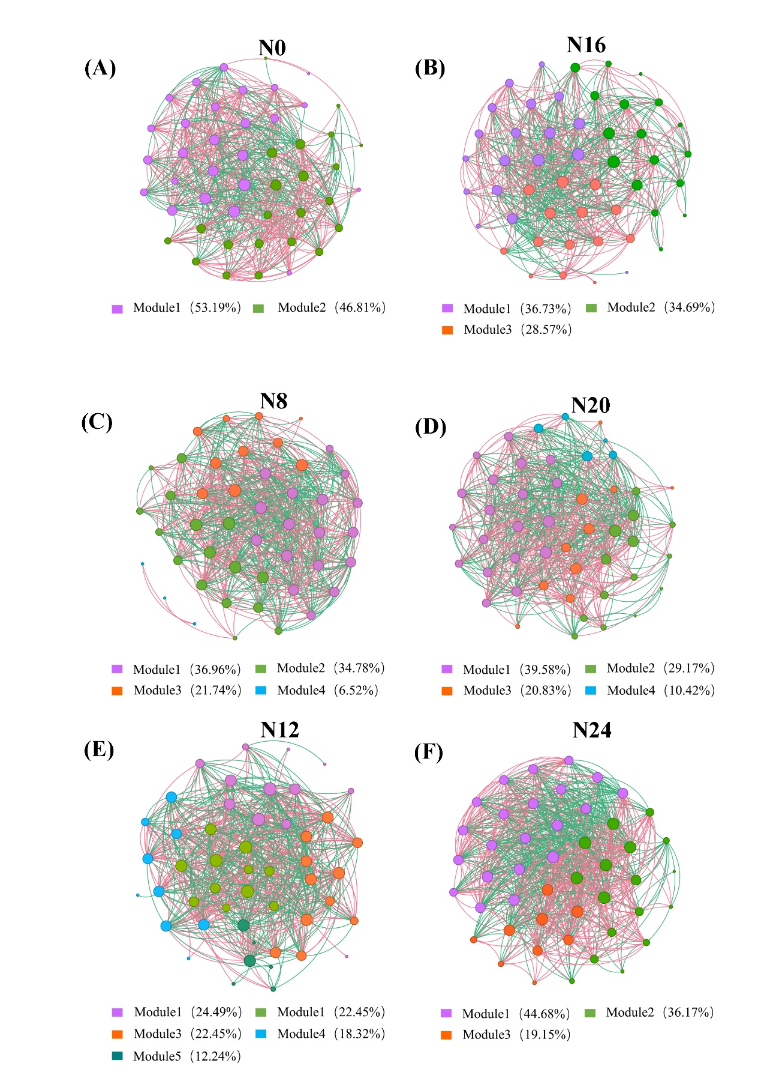

Supplementary Figure 4 The ASV collinearity of fungal communities was assessed under different nitrogen application rate
