Supplementary Information
Total interviewed respondents at T0
(n=4869)
Participants at two waves
(T0 and T1) (n=3925)
Participants at three waves
(T0, T1, and T2) (n=2622)
Participants at four waves
(T0, T1, T2 and T3) (n=2347)
Exclusions:
Lost to follow-up at T1 (n=944)
Exclusions:
Lost to follow-up at T2 (n=1303)
Exclusions:
Lost to follow-up at T3 (n=275)
Figure S1 Flow chart showing sample size included in the study.

Table S1 Characteristics of the study sample at four waves.
Variables  n=2347 | T0  N (%) or  mean (SD) | T1  N (%) or  mean (SD) |  | T2  N (%) or  mean (SD) | T3  N (%) or  mean (SD) |  | p
Gender |  |  |  |  |  |  | -
Men | 1194 (50.9) | 1194 (50.9) |  | 1194 (50.9) | 1194 (50.9)
Women | 1153 (49.1) | 1153 (49.1) |  | 1153 (49.1) | 1153 (49.1)
Grade | 3.01 (1.64) | 3.01 (1.64) |  | 4.01 (1.64) | 4.01 (1.64) |  | -
Average daily electronic device usage |  |  |  |  |  |  | -
 | 2.13 (2.70) | - |  | - | -
Physical Activity |  |  |  |  |  |  | <0.001
Yes | 1488 (63.4) | 1409 (60.0) |  | 1335 (56.9) | 1480 (63.1)
No | 859 (36.6) | 938 (40.0) |  | 1012 (43.1) | 867 (36.9)
Relationship with father |  |  |  |  |  |  | 0.684
Good | 1798 (76.6) | 1813 (77.2) |  | 1789 (76.2) | 1806 (76.9)
Average | 484 (20.6) | 459 (19.6) |  | 476 (20.3) | 458 (19.5)
Poor | 65 (2.8) | 75 (3.2) |  | 82 (3.5) | 83 (3.5)
Relationship with mother |  |  |  |  |  |  | 0.458
Good | 1975 (84.2) | 2000 (85.2) |  | 1957 (83.4) | 1975 (84.2)
Average | 327 (13.9) | 292 (12.4) |  | 335 (14.3) | 326 (13.9)
Poor | 45 (1.9) | 55 (2.3) |  | 55 (2.3) | 46 (2.0)
Mental health literacy | 34.8 (13.6) | - |  | - | -
Economic status |  |  |  |  |  |  | 0.005
Good | 459 (19.6) | 428 (18.2) |  | 398 (17.0) | 357 (15.2)
Average | 1750 (74.6) | 1793 (76.4) |  | 1823 (77.7) | 1844 (78.6)
Poor | 138 (5.9) | 126 (5.4) |  | 126 (5.4) | 146 (6.2)
Study problems |  |  |  |  |  |  | -
Yes | 1137 (48.4) | - |  | - | -
No | 1210 (51.6) | - |  | - | -
Stressful events |  |  |  |  |  |  | 0.139
Yes | 252 (10.7) | 241 (10.3) |  | 243 (10.4) | 285 (12.1)
No | 2095 (89.3) | 2106 (89.7) |  | 2104 (89.6) | 2062 (87.9)
Health status |  |  |  |  |  |  | 0.527
Well | 2185 (93.1) | 2165 (92.2) |  | 2174 (92.6) | 2160 (92.0)
Diseased | 162 (6.9) | 182 (7.8) |  | 173 (7.4) | 187 (8.0)
Perceived social support |  |  |  |  |  |  | <0.001
High support | 1344 (57.3) | 1355 (57.7) |  | 1269 (54.1) | 1221 (52.0)
Medium support | 928 (39.5) | 921 (39.2) |  | 989 (42.1) | 1056 (45.0)
Low support | 75 (3.2) | 71 (3.0) |  | 89 (3.8) | 70 (3.0)
Loneliness |  |  |  |  |  |  | <0.001
Yes | 538 (22.9) | 720 (30.7) |  | 742 (31.6) | 756 (32.2)
No | 1809 (77.1) | 1627 (69.3) |  | 1605 (68.4) | 1591 (67.8)
Emotional problems |  |  |  |  |  |  | 0.915
Yes | 347 (14.8) | 352 (15.0) |  | 350 (14.9) | 336 (14.3)
No | 2000 (85.2) | 1995 (85.0) |  | 1997 (85.1) | 2011 (85.7)
Peer problems |  |  |  |  |  |  | 0.089
Yes | 722 (30.8) | 743 (31.7) |  | 770 (32.8) | 799 (34.0)
No | 1625 (69.2) | 1604 (68.3) |  | 1577 (67.2) | 1548 (66.0)
Hyperactivity |  |  |  |  |  |  | 0.805
Yes | 220 (9.4) | 205 (8.7) |  | 203 (8.6) | 205 (8.7)
No | 2127 (90.6) | 2142 (91.3) |  | 2144 (91.4) | 2142 (91.3)
Conduct problems |  |  |  |  |  |  | <0.001
Yes | 156 (6.6) | 182 (7.8) |  | 244 (10.4) | 311 (13.3)
No | 2191 (93.4) | 2165 (92.2) |  | 2103 (89.6) | 2036 (86.7)
Note: Average daily electronic device usage, mental health literacy, and study problems were only measured at T0.
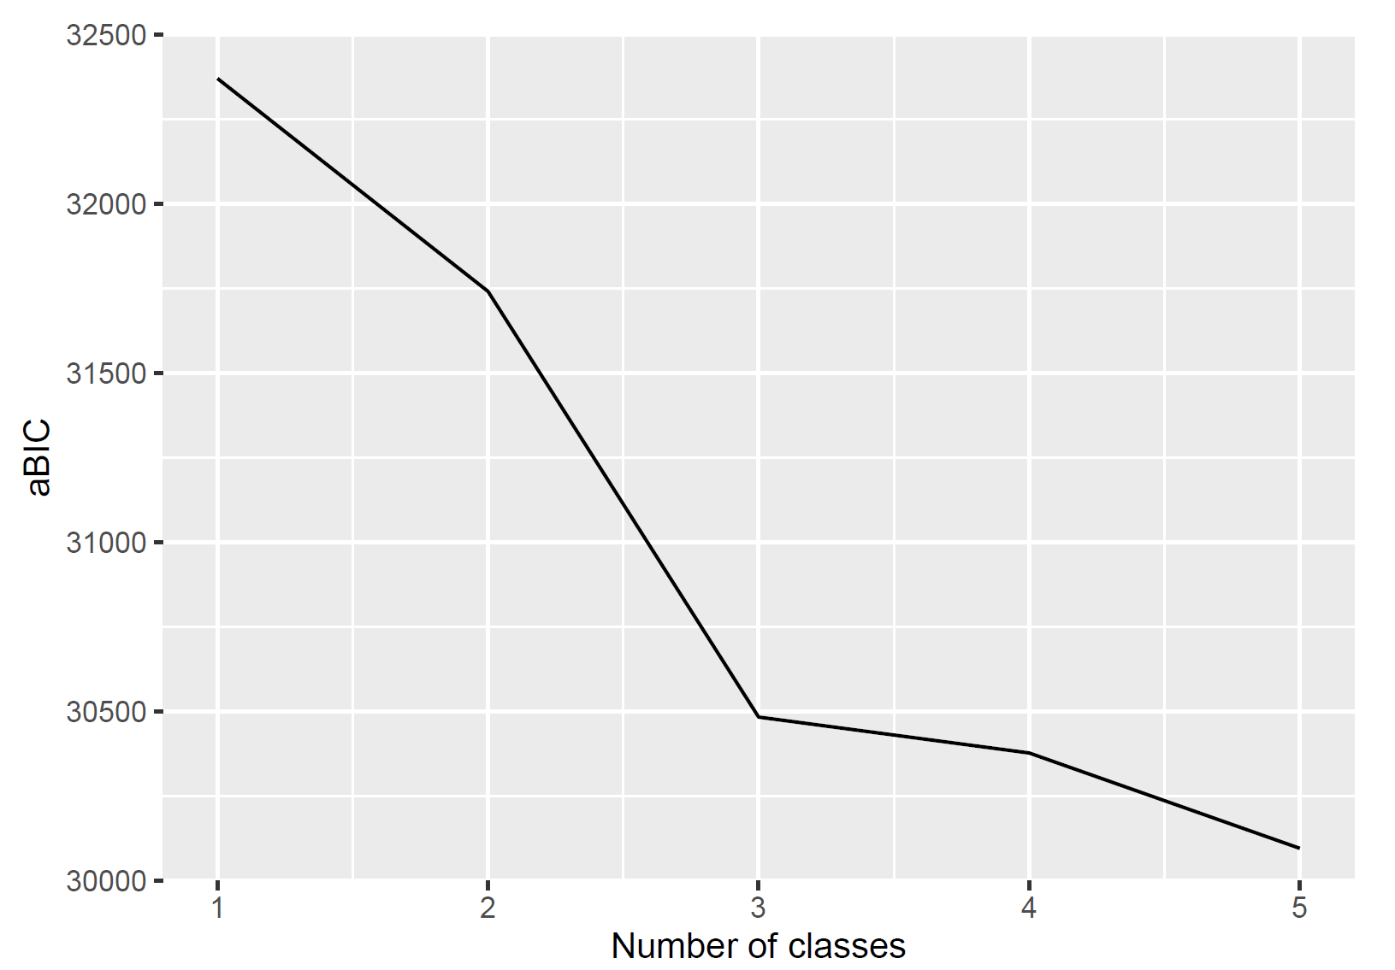
Figure S2 Elbow plot of aBIC.

Table S2 Unadjusted odds ratios of the predictors of loneliness trajectories
Variables |  | Increasing medium loneliness |  | Increasing high loneliness
Variables |  | （vs Decreasing low loneliness）
Variables |  | OR (95% CI) | p | OR (95% CI) | p
Gender | Women (Ref. men) | 1.26 (1.06-1.49) | 0.009 | 1.22 (0.83-1.79) | 0.312
Grade |  | 1.25 (1.18-1.32) | ＜0.001 | 1.15 (1.02-1.29) | 0.020
Average daily electronic device usage |  | 1.05 (1.02-1.08) | 0.003 | 1.04 (0.97-1.11) | 0.261
Physical Activity | No (Ref. yes) | 2.15 (1.81-2.58) | ＜0.001 | 3.57 (2.41-5.30) | ＜0.001
Relationship with father | Good | Ref. | Ref. | Ref. | Ref.
Relationship with father | Average | 2.04 (1.65-2.52) | ＜0.001 | 3.00 (1.95-4.60) | ＜0.001
Relationship with father | Poor | 2.29 (1.33-3.93) | 0.003 | 7.00 (3.23-15.19) | ＜0.001
Relationship with mother | Good | Ref. | Ref. | Ref. | Ref.
Relationship with mother | Average | 2.23 (1.74-2.85) | ＜0.001 | 2.65 (1.63-4.33) | ＜0.001
Relationship with mother | Poor | 3.15 (1.62-6.14) | ＜0.001 | 7.57 (2.97-19.29) | ＜0.001
Mental health literacy |  | 1.04 (1.04-1.05) | ＜0.001 | 1.07 (1.05-1.08) | ＜0.001
Economic status | Good | Ref. | Ref. | Ref. | Ref.
 | Average | 1.56 (1.24-1.96) | ＜0.001 | 1.04 (0.65-1.66) | 0.881
 | Poor | 3.40 (2.27-5.08) | ＜0.001 | 1.40 (0.55-3.58) | 0.483
Study problems | Yes (Ref. no) | 2.21 (1.86-2.63) | ＜0.001 | 3.61 (2.37-5.50) | ＜0.001
Stressful events | Yes (Ref. no) | 1.39 (1.06-1.83) | 0.018 | 2.01 (1.19-3.41) | 0.009
Health status | Diseased (Ref. well) | 2.39 (1.69-3.36) | ＜0.001 | 4.21 (2.39-7.41) | ＜0.001
Perceived social support | High support | Ref. | Ref. | Ref. | Ref.
Perceived social support | Medium support | 2.94 (2.45-3.52) | ＜0.001 | 4.58 (2.95-7.11) | ＜0.001
Perceived social support | Low support | 5.85 (3.31-10.34) | ＜0.001 | 28.06 (13.24-59.43) | ＜0.001

