Supplementary Document
Additive Manufacturing and Mechanics of Mathematically-generated Meta-structures

Advanced Composites and Hybrid Materials

Brandon Huffman¹, Anil Singh¹, Behrad Koohbor², and George Youssef^{1,*}

¹Experimental Mechanics Laboratory, Mechanical Engineering Department, San Diego State University, 5500 Campanile Drive, San Diego, Ca, 92182, USA

²Department of Mechanical Engineering, Rowan University, 201 Mullica Hill Road, Glassboro, NJ 08028, USA

*Corresponding author: gyoussef@sdsu.edu

Glass Microballoons
Fig. S1 consists of four scanning electron (SEM) micrographs of pristine and crushed glass microballoons. Only pristine microballoons were used as the reinforcing phase for the composite printing resin throughout this research, as discussed in the main document. The crushed counterparts are only displayed to elucidate the structure of the reinforcing glass microballoons. The microballoons were intentionally crushed to highlight their hollow characteristics with a wall thickness of ca. 0.5 μm. The pristine microballoons have an outer diameter of 9-13 μm.

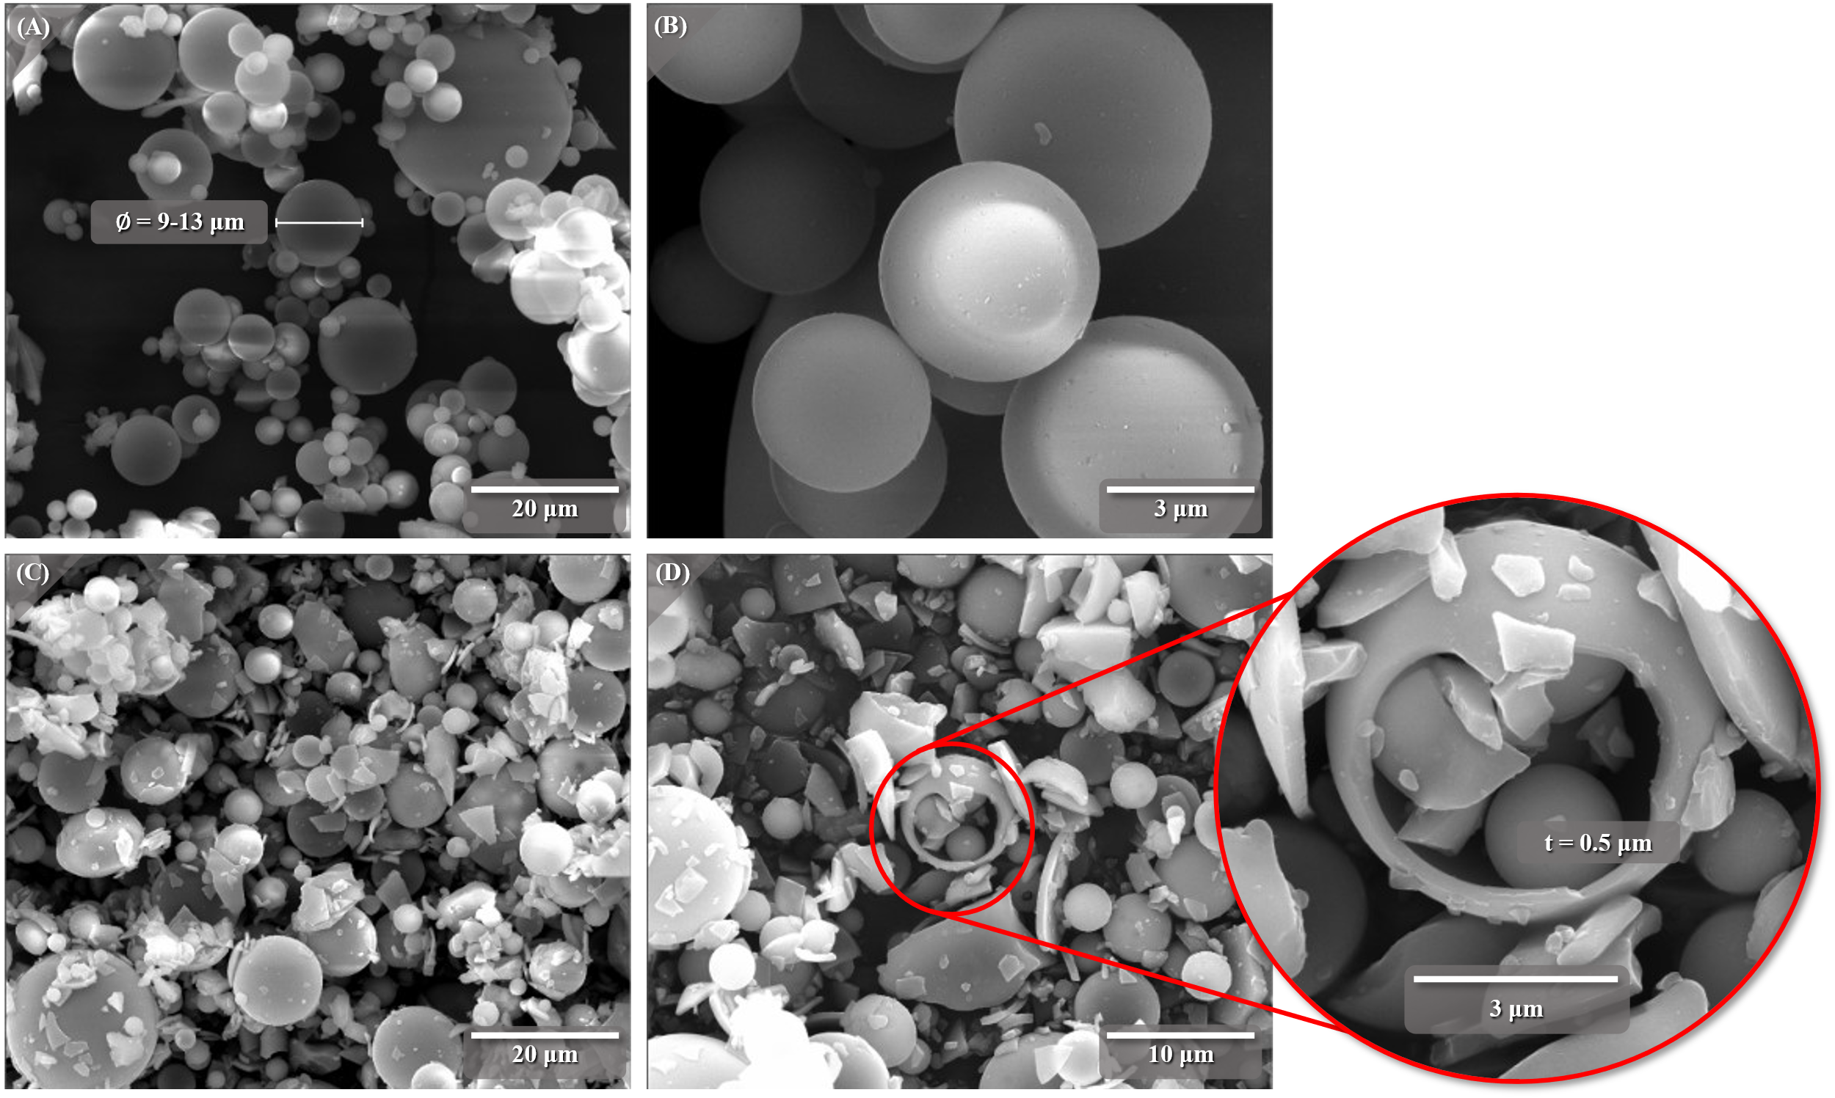
Fig. S1 Collage of SEM micrographs of pristine (A and B) and crushed (C and D) glass microballoons (only pristine glass microballoons were used in 3D printing of all samples and structures used in this research)

Tested Samples and Structures
Fig. S2 contains digital images of the tested compression, tension, and Schwarz diamond samples used to characterize the material properties of the hybridized resins and the mechanical response of the TPMS meta-structures. The compressive specimens were rectangular prisms sized in accordance with ASTM D695-15 (12.7 × 12.7 × 25.4 mm). The tensile counterparts were printed in a Type-IV geometry according to ASTM D638-14. The Schwarz diamond TPMS structures, irrespective of the reinforcing weight ratio, were 25.4 × 25.4 × 25.4 mm. All samples were 3D printed using a vat photopolymerization process with parameters specified in Table 1 in the main article. Fig. S2A and S2B show the tested compression samples with signs of secondary failure in the F69 sample (black blocks shown in Fig. S2A) and buckling failure in the F80 samples (pink blocks shown in Fig. S2B). All tensile samples (Fig. S2C) failed within the gauge length, with distinctive failure surfaces for F69 and F80 samples. The F80 compression samples immediately sprung back to their original geometry after testing while the F69 samples recovered over a prolonged period (>10 min.). Fig. S2D collages of the crushed TMPS structures show signs of disintegration.

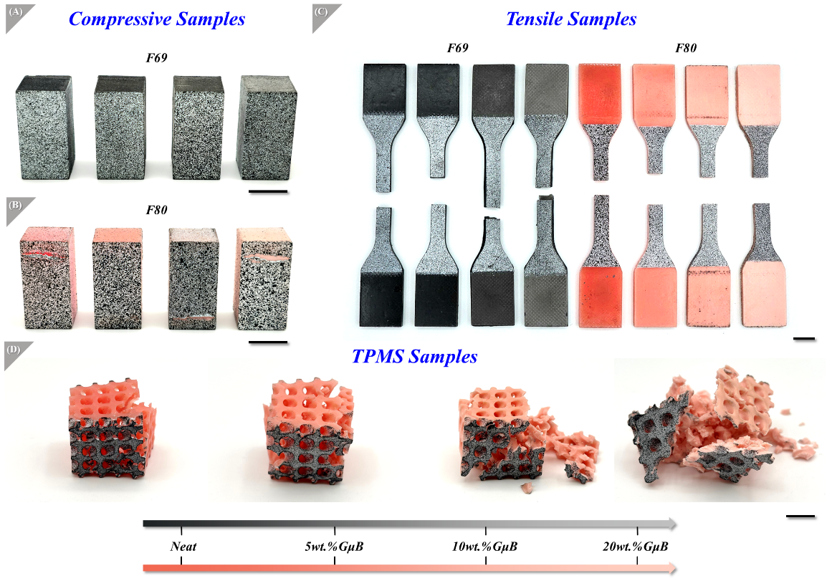
Fig. S2 Digital images of all tested (A) compressive, (B) tensile, and (C) crucshed Schwarz diamond meta-structures, with different weight ratios of rinforcing glass microballoons, ranging from neat to 20 wt.% (Scalebar = 10 mm)

Glass Microballoons Agglomeration
Fig. S3 contains several SEM images depicting the agglomeration of glass microballoons within the composite 3D printed samples, showing distinctive agglomeration patterns as a function of glass microballoons reinforcement. Fig. S3 also includes an SEM micrograph showing the potential agglomeration of the reinforcing microballoons on the surfaces of the 3D printed structures due to the pulsating motion associated with the vat photopolymerization approach. The figure (bottom panel) also includes a schematic portraying the evolution of agglomerate shape as the weight ratio of microballoons increases.

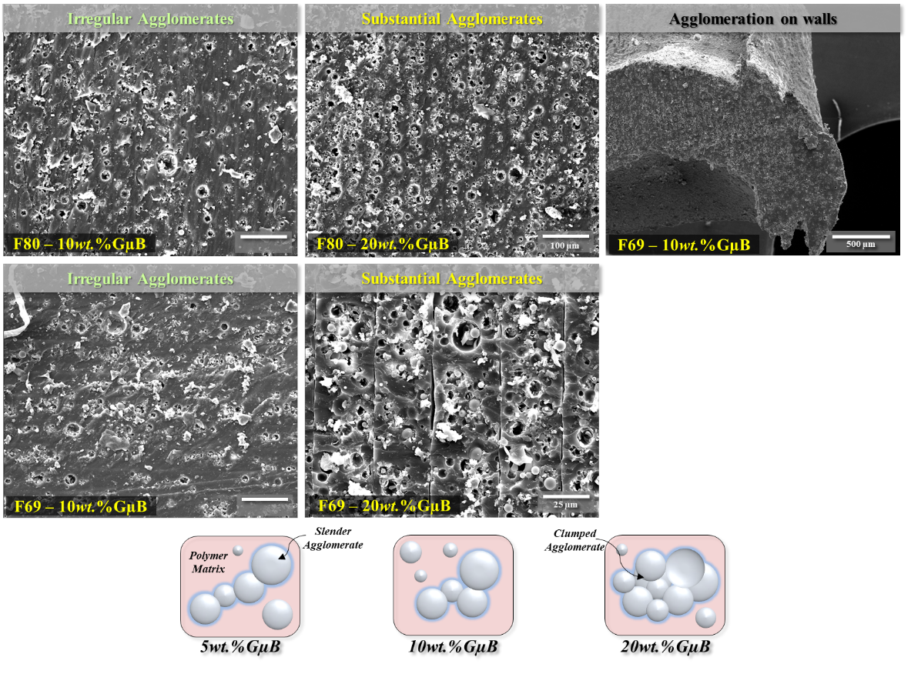
Fig. S3 (top panel) SEM micrographs showing microballoons agglomeration formation as a function of reinforcing weight ratio and resin type, elucidating distinctive patterns and (bottom panel) a schematic showing the evolution of agglomerate patterns as GµB content increases

Matrix/Microballoons Bonding
Fig. S4 includes SEM micrographs to elucidate the variety of bonding conditions between the glass microballoons and the resin matrix, ranging from complete bonding to unbonded, which is based on the reinforcement and matrix interactions during the mixing and printing processes. This figure supplements Fig. 4 of the main document.
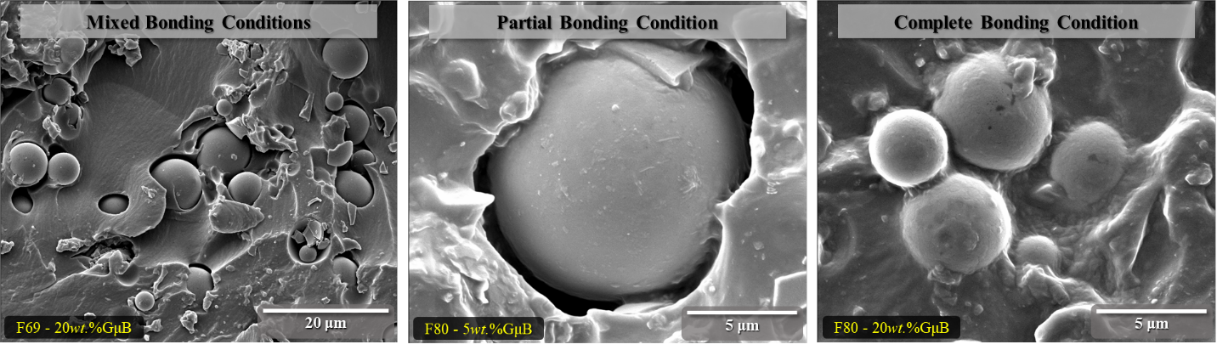
Fig. S4 SEM micrographs showing a range of bonding conditions between the glass microballoons and cured resin matrix, depicting unbonded, partially bonded, and completely bonded instances

Spectroscopic Analysis of Printing Resins
Fourier Transform Infrared Spectroscopy (FTIR) characterized the cured F69 and F80 photocurable printing resins. FTIR spectra were collected using an FTIR-ATR spectrometer (Thermo Scientific, Nicolet iS5) with 32 scans and a linewidth resolution of 4 cm⁻¹. The samples were scanned in the 400 cm⁻¹ to 4000 cm⁻¹ spectral region, capturing the fingerprint and functional group regions of photocurable resins. The transmittance spectra are shown in Fig. S5. An open-source software (OpenSpecy) was used to ascertain that the photocurable resins are predominately polyurethanes [1, 2], leading to the insights discussed in §3.1, of the main document.

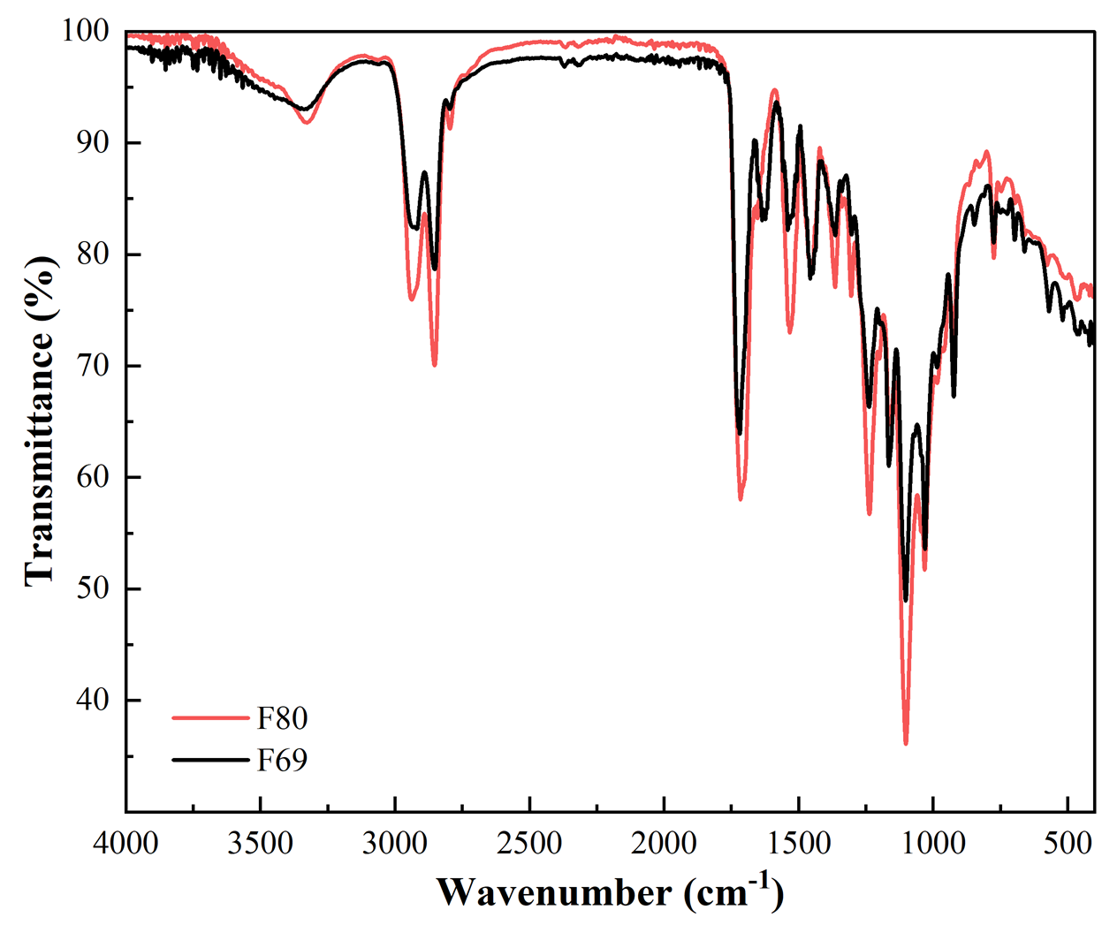
Fig. S5 FTIR transmittance spectra of cured F69 and F80 printing resins

Strain Contours in Reinforced Tensile Samples
Fig. S6 is the axial strain contour plots of 10wt.%GµB samples for both resin systems as a function of global strains, highlighting the strain localization due to the 3D printing edge effect, shear yielding, and crack nucleation, as discussed in the main document. The 5wt.%GµB samples exhibited similar trends.

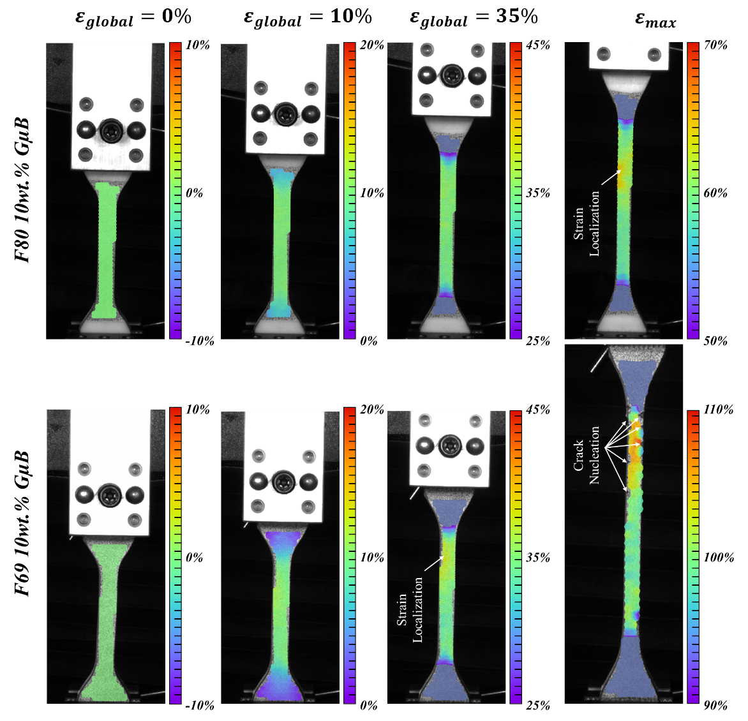
Fig. S6 Local axial strain contours for 10wt.%GµB tensile samples from F69 and F80 photocurable resins, showing evidence of strain localization and crack nucleation

Resolved Strain Contours for Compression Samples
Fig. S7 is a series of the axial strains in samples fabricated with hybridized photocurable F80 and F69 resins as a function of reinforcing weight ratio, ranging from neat to 20 wt.% of glass microballoons. The strain contours are also plotted as a function of global nominal strains, which are reported in Fig. 3 of the main document.

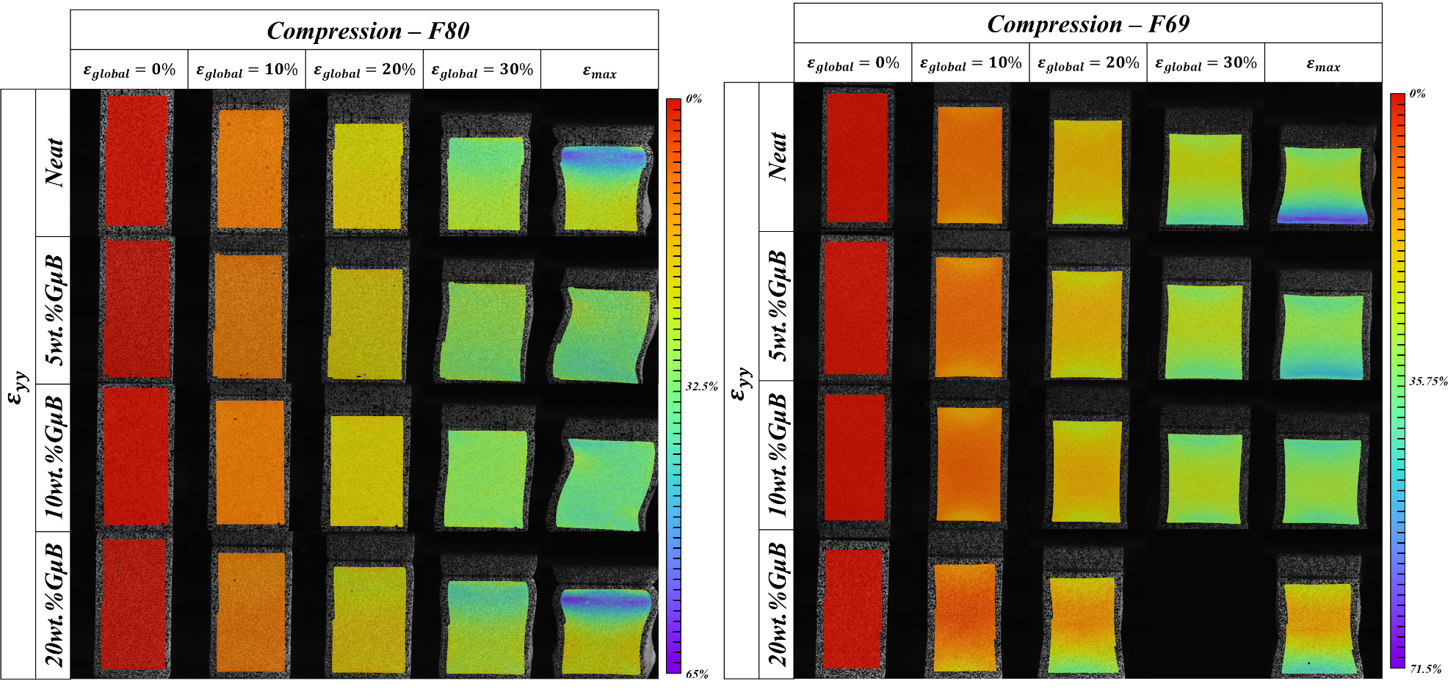
Fig. S7 Axial strain contours for F80 and F69 compression samples at different global strains (0, 10, 20, 30%, and maximum compression) and as a function of reinforcing weight ratio
The axial strain contours are extracted at global strains of 0, 10, 20, and 30%, as well as at maximum compression. All samples, irrespective of resin type and reinforcing weight ratio, generally exhibit a homogenous strain distribution throughout the field of view at smaller global strains (<20%). Thereafter, the F80-based samples begin to buckle, leading to dislodging of the samples from the testing fixtures. The F69-based samples continued to deform, exemplifying differences in lateral expansion at the top and bottom surfaces, potentially due to variations in frictional conditions, with apparent negative Poisson’s effect at the samples’ waist.

DIC Results of Schwarz Diamond TPMS Meta-structure
Fig. S8 is the resolved in-plane strain contours, including axial, lateral, and shear components, as a function of global compressive strain for the 5wt.%GµB and 10wt.%GµB TPMS meta-structures.

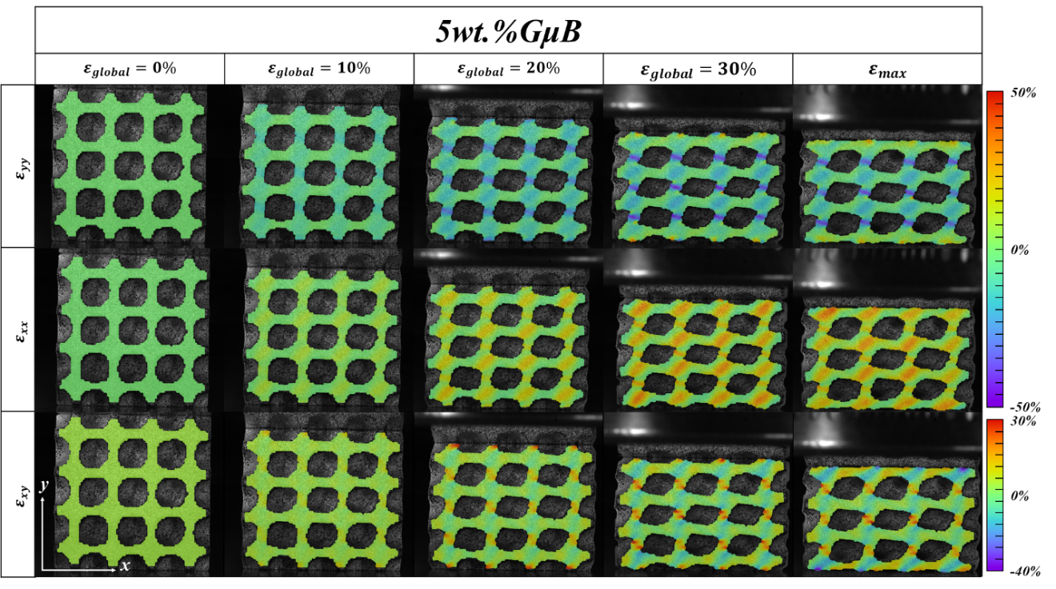
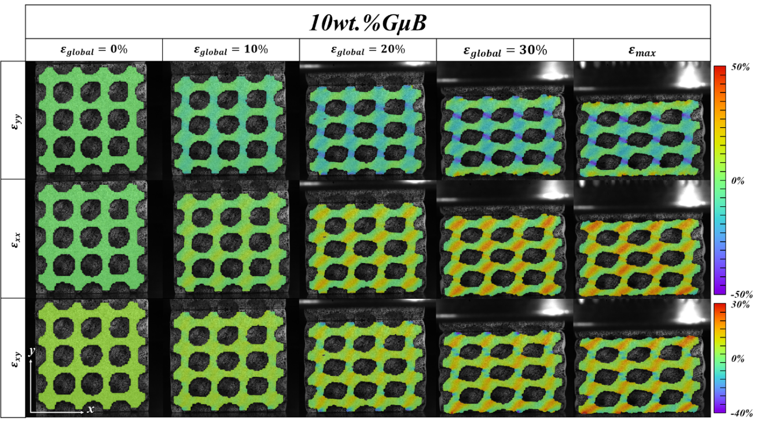
Fig. S8 Local strain contours for 5wt.%GµB and 10wt.%GµB TPMS structures, resolved in axial (ε_{yy}), lateral (ε_{xx}), and shear (ε_{xy}) strain components, as a function of global strains of 0, 10, 20, 30%, and maximum compression

Strain Comparisson
Fig. S9 is the resolved axial strains (ε_{yy}) for struts and the wall surfaces Schwarz diamond TPMS metastructures fabricated using neat, flexible resin. The figure shows the distinct strain patterns of the neat TPMS structures. The compression bands within the cell walls (bottom panels in Fig. S9) coincide with the comparable patterns on the external struts. In other words, the cell walls in Fig. S9 are part of the struts in neighboring unit cells.

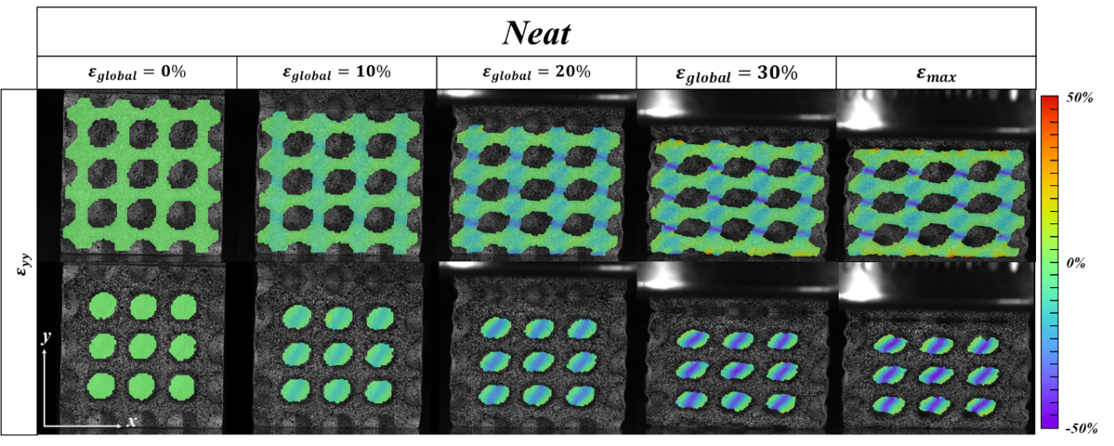
Fig. S9 Strain contours of both wall struts and wall surfaces of neat TPMS structures in the axial (ε_{yy}) direction as a function of 0, 10, 20, 30%, and maximum compression

References
1. Cowger, W., et al., Microplastic Spectral Classification Needs an Open Source Community: Open Specy to the Rescue! Analytical Chemistry, 2021. 93(21): p. 7543-7548.
2. Trovati, G., et al., Characterization of polyurethane resins by FTIR, TGA, and XRD. Journal of Applied Polymer Science, 2010. 115(1): p. 263-268.

