Dynamics and drivers of tidal flat morphology in China

Shuai Liu¹, Zhan Hu^{1,2,3}*, Tim J. Grandjean^{4,5}, Zheng B. Wang^{6,7}, Vincent T. M. van Zelst^{6,7}, Lin Qi⁸, Tianping Xu¹, Jun Y. Seo⁹, Tjeerd J. Bouma^{4,5}

¹ School of Marine Sciences, Sun Yat-Sen University, and Southern Marine Science and Engineering Guangdong Laboratory (Zhuhai), Zhuhai, China.
² Guangdong Provincial Key Laboratory of Marine Resources and Coastal Engineering, Guangzhou, China.
³ Pearl River Estuary Marine Ecosystem Research Station, Ministry of Education, Zhuhai
⁴ Department of Estuarine and Delta Systems, Royal Netherlands Institute for Sea Research (NIOZ), Yerseke, The Netherlands.
⁵ Faculty of Geosciences, Department of Physical Geography, Utrecht University, Utrecht, The Netherlands.
⁶ Faculty of Civil Engineering and Geosciences, Delft University of Technology, 2628 CN Delft, the Netherlands.
⁷ Deltares, 2600 MH Delft, the Netherlands.
⁸ NOAA Center for Satellite Applications and Research, College Park, MD 20740, USA.
⁹ Department of Oceanography, Chonnam National University, Gwangju, Republic of Korea.
* Corresponding author.
E-mail address: huzh9@mail.sysu.edu.cn

Contents of this file
Supplementary Text
Supplementary Figures 1 to 16
Supplementary Tables 1 to 3

Supplementary Text

Interpretation of the elastic response of tidal flats to SSC trend

To investigate the elastic response of tidal flat width to changes in SSC and the causes of two hot zones (Fig. 5) on a national scale, we conducted a series of ideal experiments at 34 stations with varying SSC supply. We established four different SSC trends (+2 mg/L/year, +1 mg/L/year, -1 mg/L/year, -2 mg/L/year).

In the DET-ESTMORF model, morphological changes are primarily driven by the deviation between the actual sediment concentration and the local equilibrium concentration (Supplementary Fig. 14). When the actual sediment concentration at a location is lower than the local equilibrium concentration, it indicates that there is insufficient sediment to maintain the stability of the bed, leading to erosion and a decrease in bed level. Conversely, if the actual sediment concentration exceeds the local equilibrium concentration, it implies an excess of sediment at that location, resulting in sedimentation and an increase in bed level. This discrepancy in sediment concentrations reflects the variations in tidal currents, wave actions, and other sediment supply factors over time and space. The model simulates these deviations to predict the dynamic morphological evolution of tidal flats, thereby revealing the mechanisms driving morphological changes.

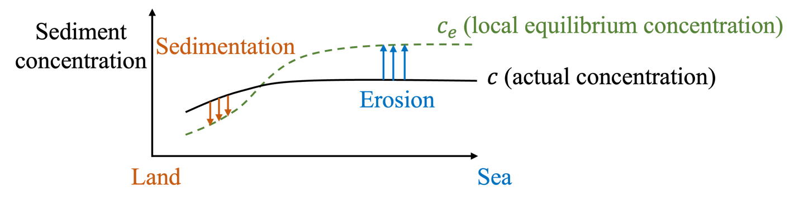

Supplementary Figure 14. The schematization of the DET-ESTMORF model.

According to the DET-ESTMORF model, equilibrium concentration can be expressed from equation (S1) and (S2) as
From these, equilibrium concentration can be described as follows:
Where A, B, and C are three constants related to erosion coefficient ($m_{e}$), sedimentation rate ($w_{s}$), and critical shear stress ($τ_{cr}$). Equation (S3) can be simplified as

It is posited that the equilibrium concentration is governed by the dynamic interplay between effective bed shear stress ($τ_{90}$) and actual concentration ($c_{E}$) (Supplementary Fig. 15). However, when the external SSC increases, the change in equilibrium concentration is mainly controlled by the change in $τ_{90}$ (R = 0.85), at which point the effect of ${f(c}_{E})$ is negligible. The variation in bed shear stress is directly linked to the initial sediment concentration, influencing the equilibrium concentration in the same direction. Thus, when an additional amount of sediment is introduced, sediment-rich systems exhibit a greater rise in equilibrium concentration (Supplementary Figs. 10a and b), reflecting an increased sediment requirement for balance, and the expansion of tidal flats is notably constrained.

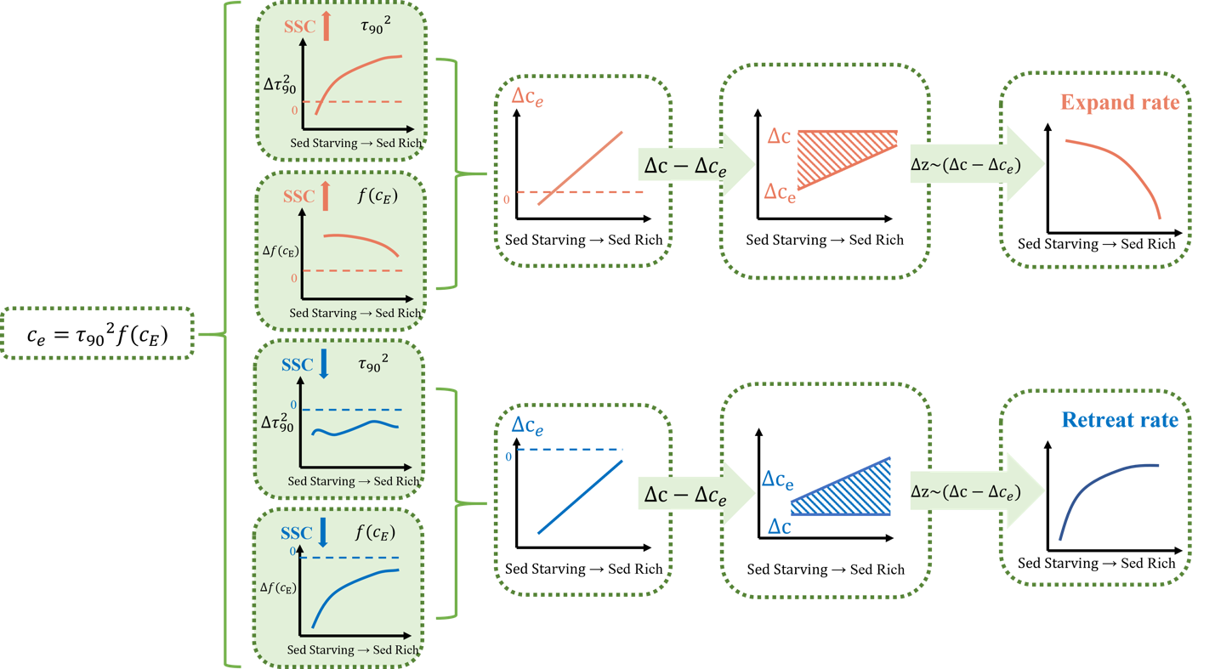

Supplementary Figure 15. Interpretation of the elastic response of tidal flats to SSC trend.

When the external SSC falls, changes in effective bed shear stress are negligible (< 0.01). Therefore, shifts in equilibrium concentration are mainly directed by the function ${f(c}_{E})$. As depicted in Supplementary Fig. 15, ${f(c}_{E})$ shows a slowing growth rate with increasing actual concentration. This suggests that the equilibrium concentration in sediment-starving tidal flats decreased more when SSC decreases (Supplementary Figs. 10c and d), indicating that these flats are less susceptible to erosion.

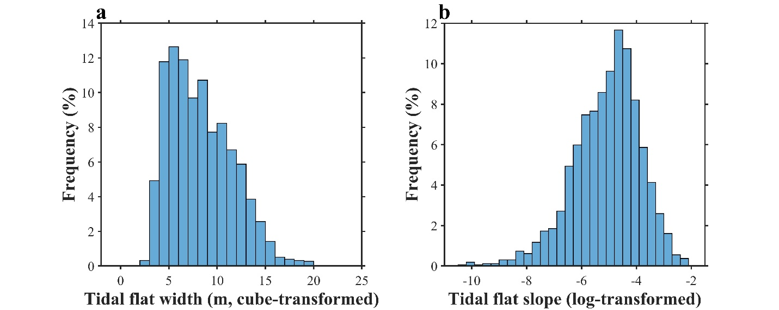

Supplementary Figure 1. Probability distribution of tidal flat width (a) and slope (b) in China. The width dataset resolution is 1km along the coast with 2538 in total. The slope dataset resolution is 1km along the coast with 1621 in total.

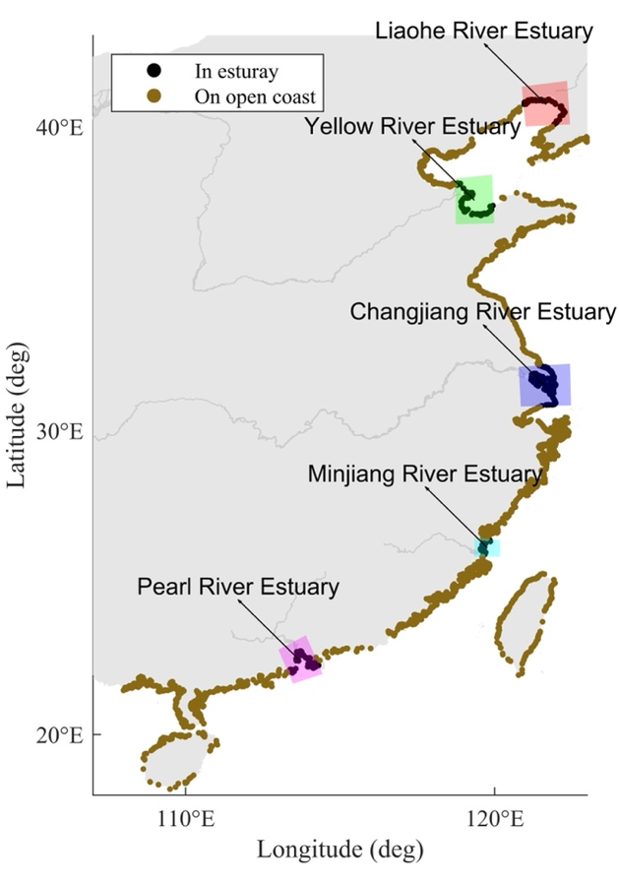

Supplementary Figure 2. Distribution of data points located in typical estuaries in China.

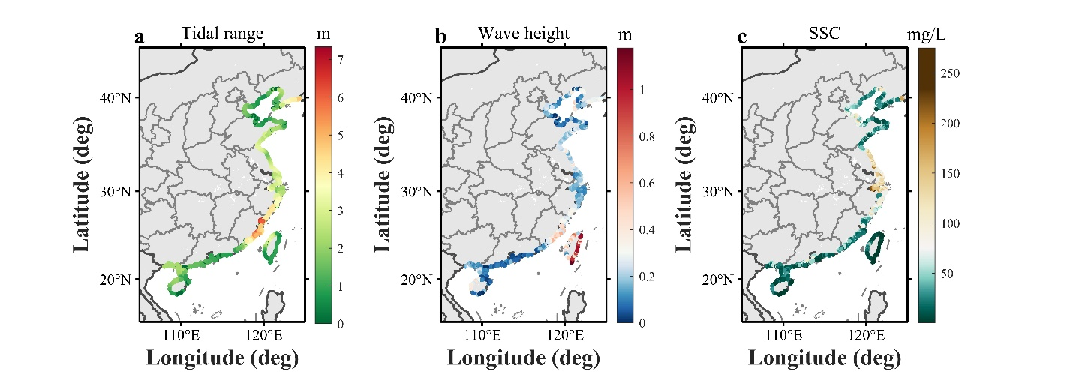

Supplementary Figure 3. Distribution of tidal range (a), wave height (b), and SSC (c) of tidal flats in China.

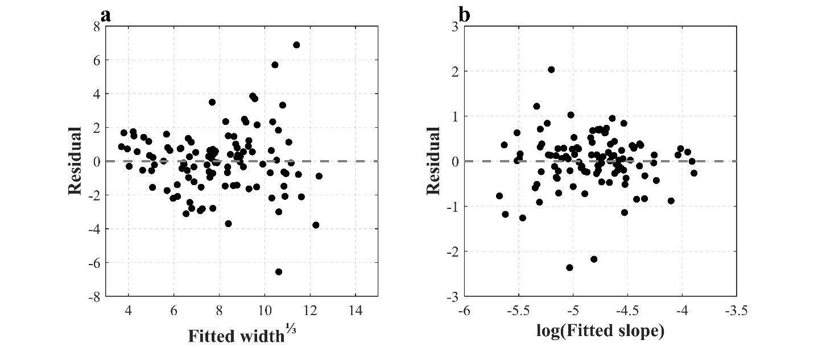

Supplementary Figure 4. The tidal flat width (a) and slope (b) final model residuals vs fitted values.

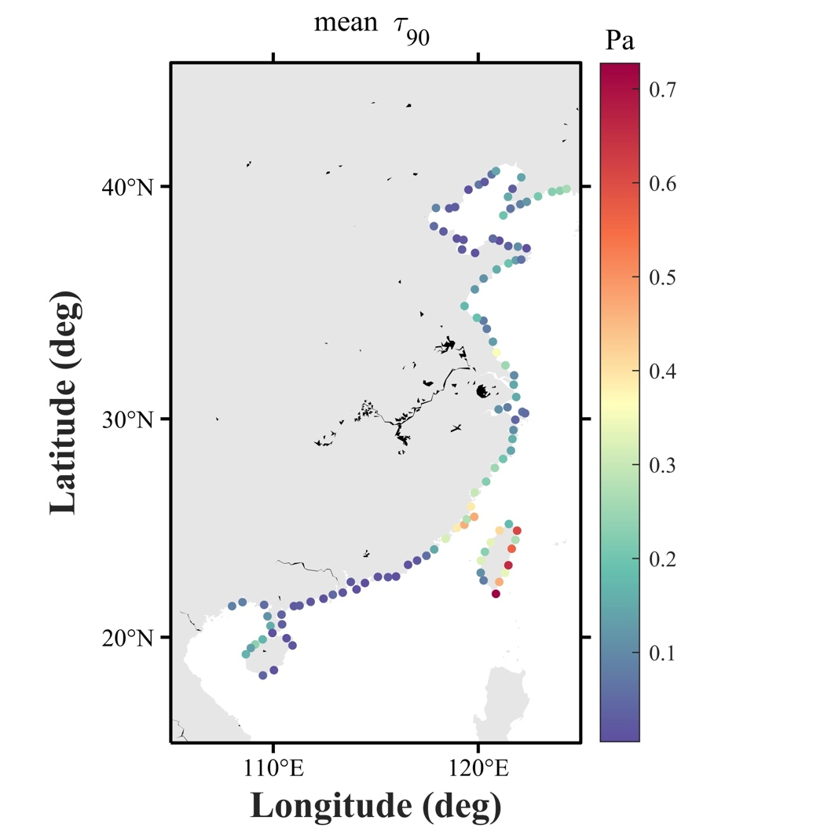

Supplementary Figure 5. Distribution of mean bed shear stress ($τ_{90})$ of tidal flats in China.

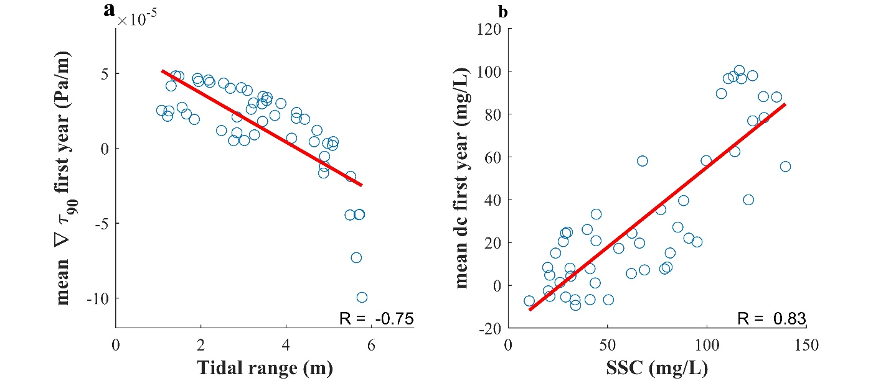

Supplementary Figure 6. Simulation-derived, the gradient of bed shear stress ($∇τ_{90})$ versus random tidal range in the first year (a) and difference between actual SSC and equilibrium concentration ($c_{e}$) versus random SSC (b).

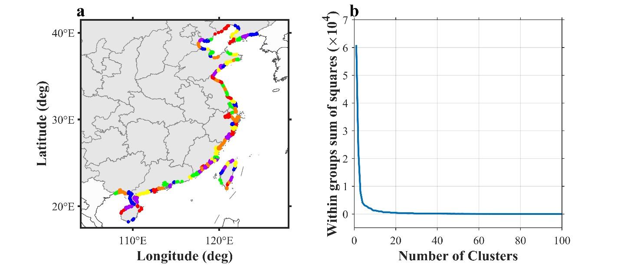

Supplementary Figure 7. Schematic of kmeans spatial clustering analysis (a), and within groups sum of squares with the number of Clusters (b). Here, a 100-category number kmeans clustering analysis is used.

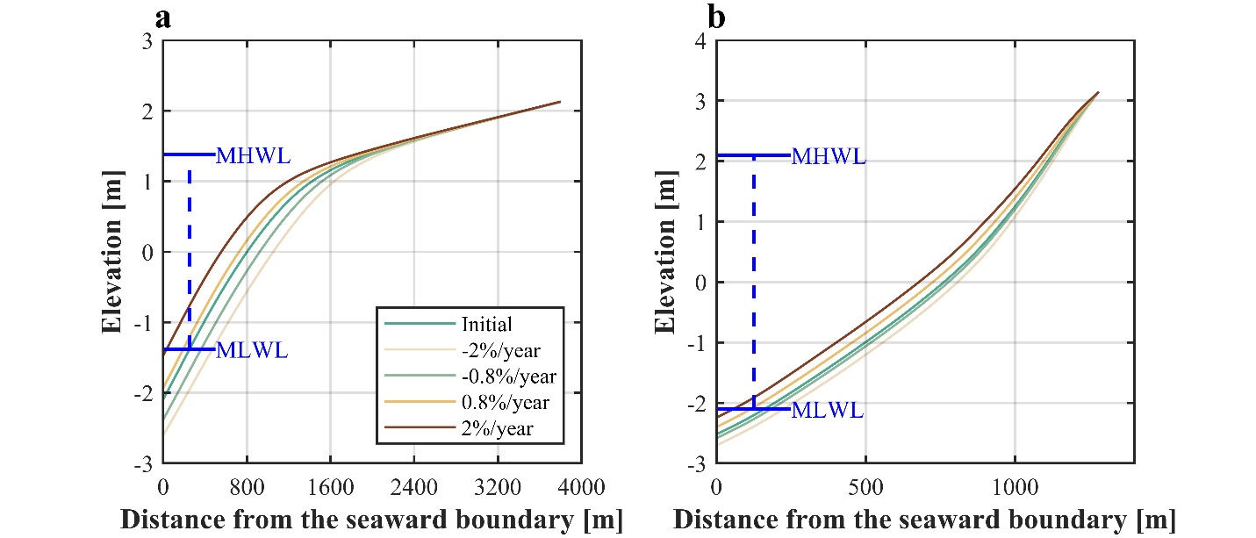

Supplementary Figure 8. Modeled tidal flat profiles of the Jiangsu coast (a) and the Western Scheldt estuary (b) under various trends of SSC variations Blue horizontal lines indicate mean high water level (MHWL) and mean low water level (MHLWL).

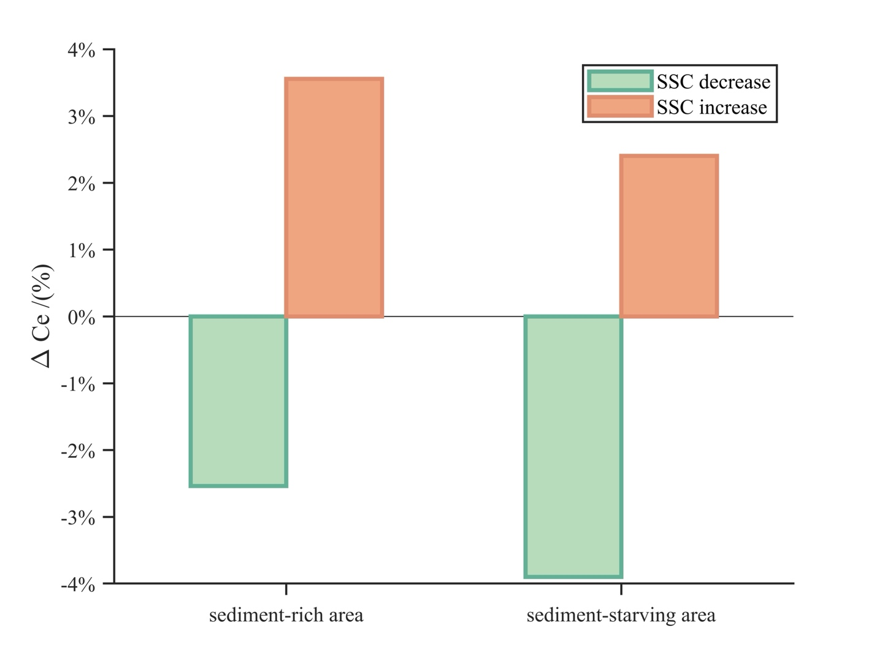

Supplementary Figure 9. Change in equilibrium concentration (${∆c}_{e}$) of simulated sediment-rich and sediment-starving tidal flats with increasing and decreasing SSC.

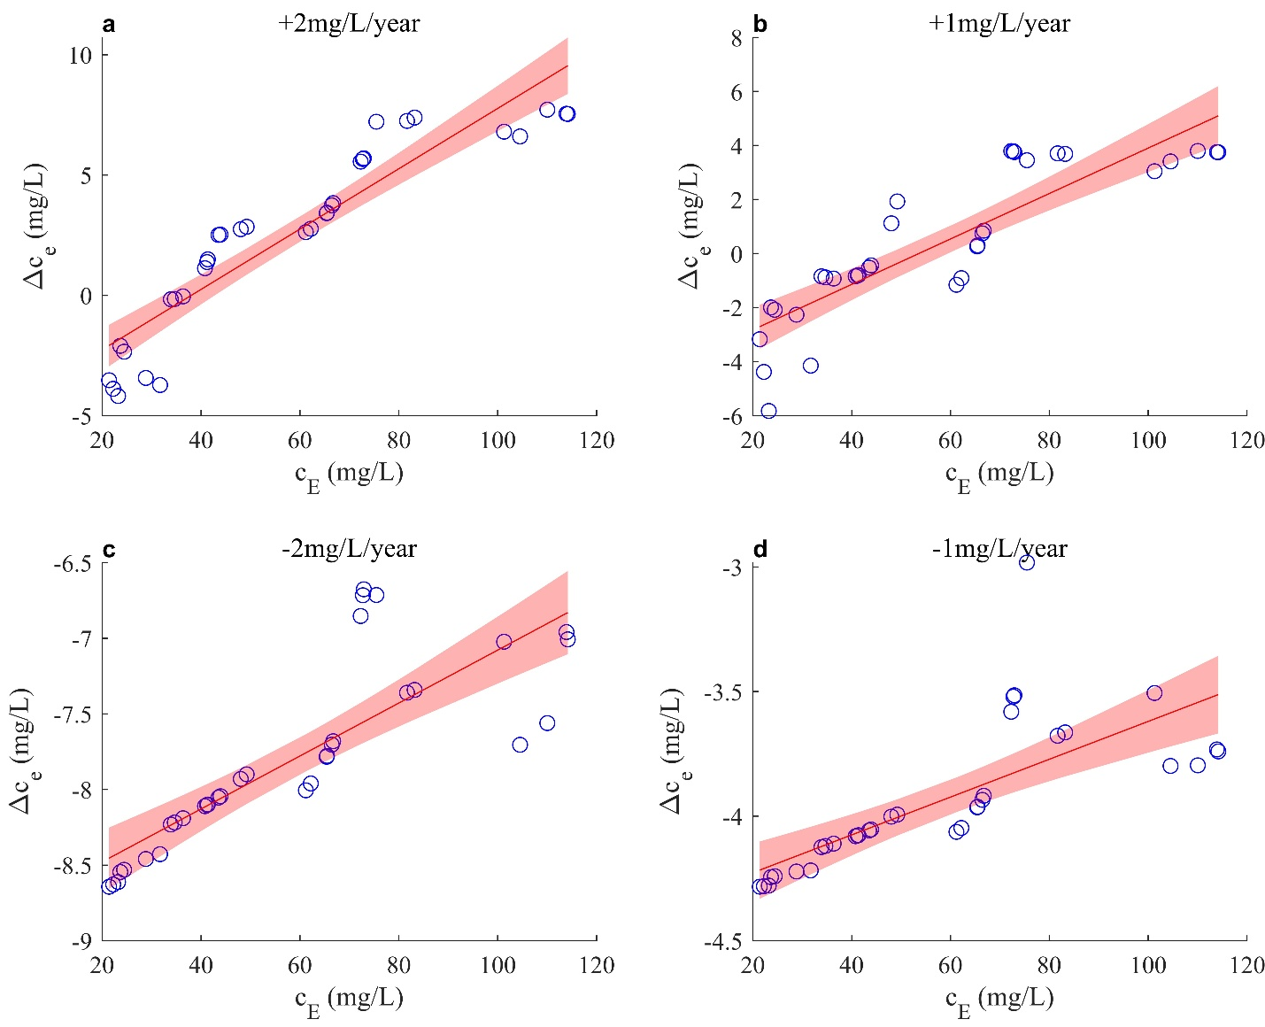

Supplementary Figure 10. Simulated equilibrium concentration trends at various sites in China under four SSC trends.

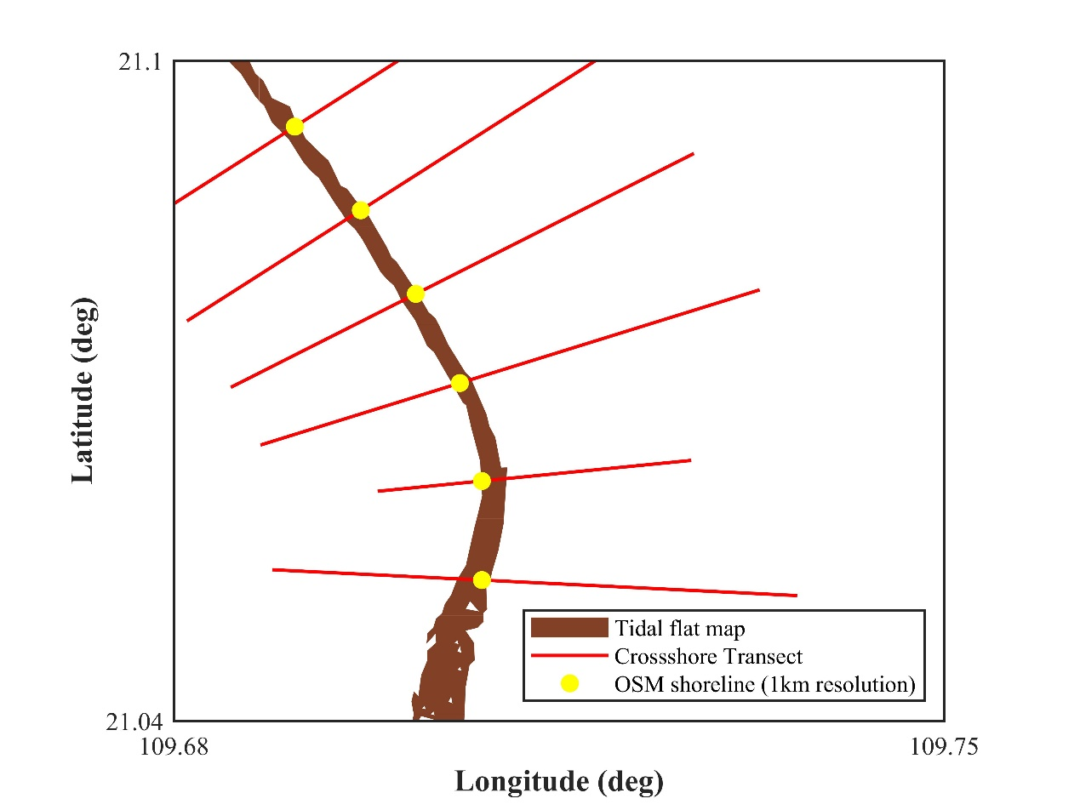

Supplementary Figure 11. Method of intercepting tidal flat width. Brown areas indicate tidal flats maps, red line segments indicate cross-shore transects perpendicular to the shoreline, and yellow dots indicate OSM shorelines (1km resolution).

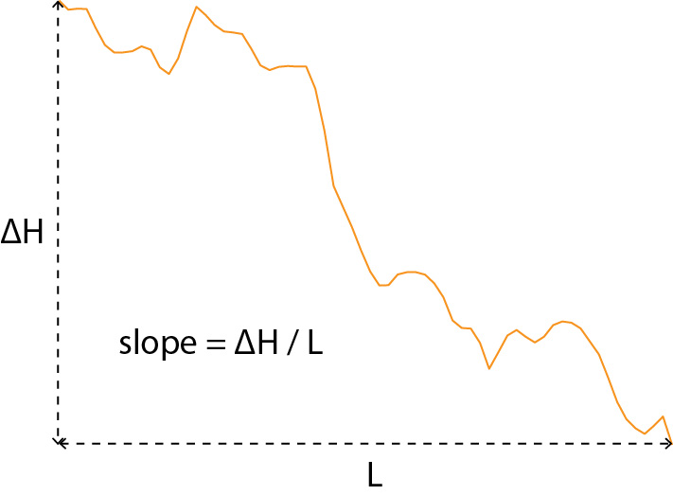

Supplementary Figure 12. Method of calculating slope. Orange lines indicate profile elevation distribution.

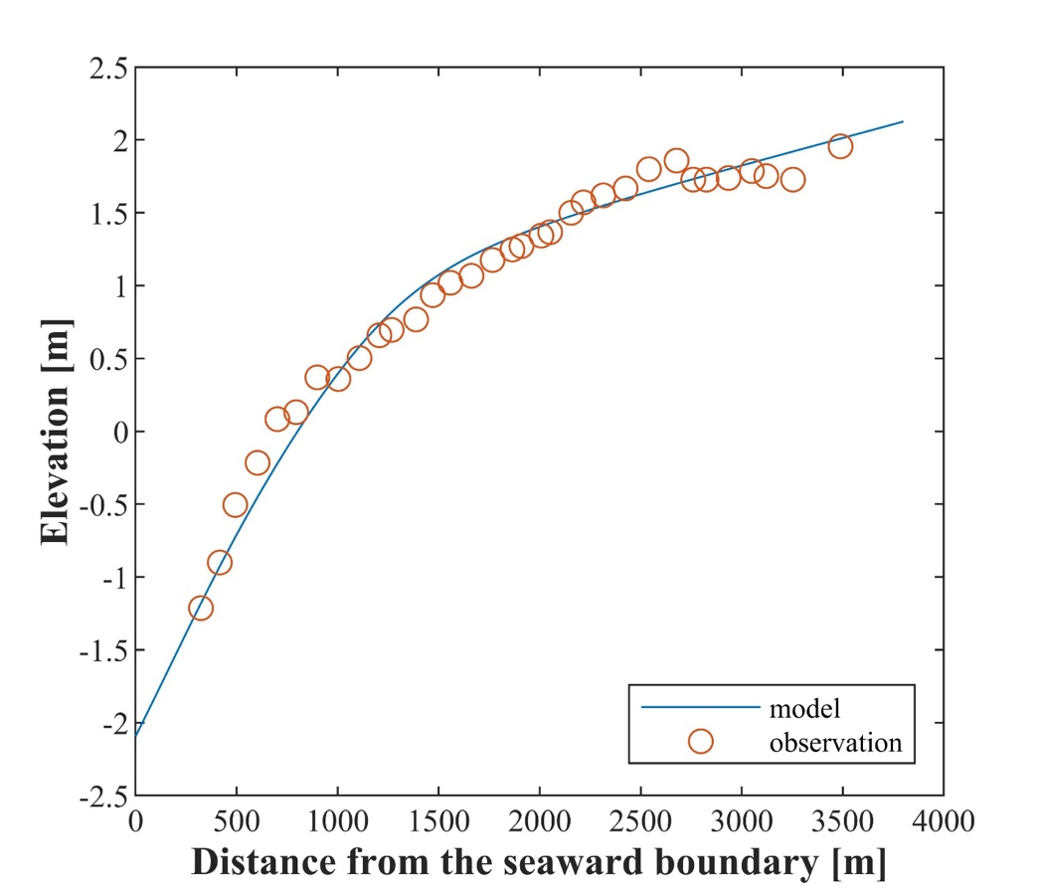

Supplementary Figure 13. Comparison of model calculated tidal flat profile and observed profile for Jiangsu site.

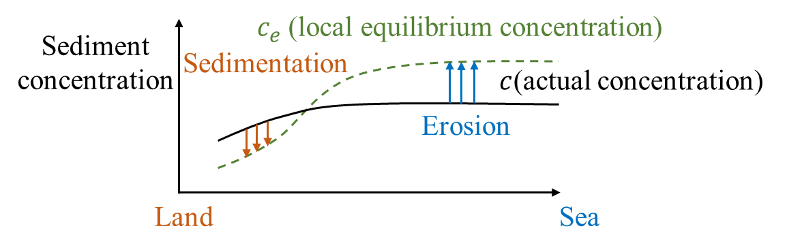

Supplementary Figure 14. The schematization of the DET-ESTMORF model.

Supplementary Figure 15. Interpretation of the elastic response of tidal flats to SSC trend.

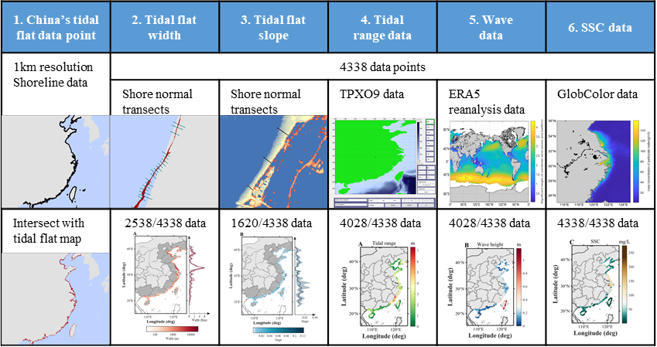

Supplementary Figure 16. Data acquisition process. Global database data extraction and remote sensing data acquisition methods.

Supplementary Table 1. Wave height data validation

Location | Recorded wave height | Simulated wave height
Leizhou Bay | 5-20cm | 9 cm
Yellow River Delta | 7cm | 6 cm
Chongming Island | 10-35 cm | 29 cm
Taiwan Longdong | 50-60cm | 65 cm

Supplementary Table 2. Wave period data validation

Location | Recorded mean wave period | ERA5 mean wave period
Leizhou Bay | 3s | 4.43s
Chongming Island | 3.4s | 3.82s
Jiangsu | 4-5s | 4.62s

Supplementary Table 3. Model settings for each simulation

Figure | Profile | Width of model grid (m) | Number of grids | SSC at the seaward boundary: (g/L) | Trend of SSC (%/year) | Wave height(m) | Diffusion coefficient: (m²/s) | Tidal range (m) | critical shear stress (pa)
4B (starving) | Initial | 3 | 321 | 0.058 | / | 0.30 | 200 | 4.23 | 0.205
4B (starving) | SSC change | 3 | 321 | 0.058 | -2/-0.8/0.8/2 | 0.30 | 200 | 4.23 | 0.205
4B (rich) | Initial | 10 | 381 | 0.134 | / | 0.36 | 100 | 2.78 | 0.18
4B (rich) | SSC change | 10 | 381 | 0.134 | -2/-0.8/0.8/2 | 0.36 | 100 | 2.78 | 0.18
5 | Initial | 0.5/10.1/18.5 /24.5/30/35 /39.1 | 101 | 0.02/0.489/0.063 /0.0778/0.0922 /0.1067/0.1211 | / | 0.30 | 200 | 2.8 | 0.15
5 | SSC change | 0.5/10.1/18.5 /24.5/30/35 /39.1 | 101 | 0.02/0.489/0.063 /0.0778/0.0922 /0.1067/0.1211 | -0.03~0.03 | 0.30 | 200 | 2.8 | 0.15
S6 | / | 10 | 101 | 0.02-0.15 | / | 0.2 | 200 | 2-7 | 0.15
S10 | Initial and SSC change | 400*cE (g/L) | 101 | Shown in Fig. 5 | / | 0.1 | 100 | 3 | 0.185

- The initial profiles in Figure 4B (rich) and 5 are derived from linear profile calculations over 100 years with elevations of 2m to -2m and 1.4m to -2m, respectively, and the measured data are used for the initial profiles in Figure 4B (starving).

