Additional File 1

Additional Table 1. Summary of the CSF biomarkers in SST person
1a. Summary of CSF biomarkers in person with sporadic human prion disease
Sex | 14-3-3 protein by western blotting | generation QuIC assay | generation QuIC assay | T-tau protein by ELISA (pg/) | T-tau protein by CLEIA (pg/)
male | positive | positive | positive | >2,200 | >2,000
male | positive | positive | positive | 1,910 | 1586
 | positive | positive | positive | >2,200 | >2,000
male | positive | positive | positive | >2,200 | >2,000
male | positive | positive | positive | >2,200 | >2,000
male | positive | positive | positive | >2,200 | >2,000
male | positive | positive | positive | >2,200 | >2,000
male | positive | positive | positive | >2,200 | >2,000
male | positive | positive | positive | >2,200 | >2,000
male | positive | positive | positive | >2,200 | >2,000
male | positive | positive | positive | >2,200 | >2,000
male | positive | positive | positive | 1,967 | 1,727
male | positive | positive | positive | >2,200 | >2,000
male | positive | positive | positive | 2180 | >2,000
male | positive | positive | positive | >2,200 | >2,000
male | negative | positive | positive | 1,870 | 1585
male | positive | positive | positive | >2,200 | >2,000
male | positive | positive | positive | >2,200 | >2,000
male | positive | positive | positive | >2,200 | >2,000
male | positive | positive | positive | 2,163 | 1,866
male | positive | positive | positive | >2,200 | >2,000
male | positive | positive | positive | >2,200 | >2,000
female | positive | positive | positive | >2,200 | >2,000
female | positive | positive | positive | >2,200 | >2,000
female | positive | positive | positive | >2,200 | >2,000
female | positive | positive | positive | >2,200 | >2,000
female | positive | positive | positive | >2,200 | >2,000
female | positive | positive | positive | >2,200 | >2,000
female | positive | positive | positive | >2,200 | >2,000
female | positive | positive | positive | >2,200 | >2,000
female | positive | positive | positive | >2,200 | >2,000
female | positive | positive | positive | 1,966 | 1,307
female | positive | positive | positive | >2,200 | >2,000
female | positive | positive | positive | >2,200 | >2,000
female | positive | positive | positive | 2,101 | >2,000
female | positive | positive | positive | >2,200 | >2,000
female | positive | positive | positive | >2,200 | >2,000
female | positive | positive | positive | >2,200 | >2,000
female | positive | positive | positive | >2,200 | >2,000
female | positive | positive | positive | >2,200 | >2,000
female | positive | positive | positive | 2,117 | >2,000
female | positive | positive | positive | >2,200 | >2,000
female | positive | positive | positive | >2,200 | >2,000
female | positive | positive | positive | >2,200 | >2,000
female | positive | positive | positive | >2,200 | >2,000

1b. Summary of CSF biomarkers in without sporadic human prion disease
Sex | 14-3-3 protein by western blotting | generation QuIC assay | generation QuIC assay | T-tau protein by ELISA (pg/ml) | T-tau protein by CLEIA (pg/ml) | Disease
male | negative | negative | negative | 1142.5 | 676 | primary malignant lymphoma
male | negative | negative | negative | 82.5 | 182 | drug toxic encephalopathy
male | negative | negative | negative | 174 | 169 | autoimmune encephalopathy
male | negative | negative | negative | 201.7 | 233 | alcohol-dependent LCCA
male | negative | negative | negative | 145 | 142 | hypoxic encephalopathy
male | negative | negative | negative | 693 | 480 | hypoxic encephalopathy
male | negative | negative | negative | 342 | 370 | epilepsy
male | negative | negative | negative | 157 | 208 | DLB
male | negative | negative | negative | 169 | 173 | epilepsy
male | negative | negative | negative | 356 | 450 | epilepsy
male | negative | negative | negative | 155 | 127 | hypoxic encephalopathy
male | negative | negative | negative | 155 | 215 | MSA-C
male | negative | negative | negative | 276.5 | 209 | alcohol-dependent LCCA
male | negative | negative | negative | 257 | 180 | metabolic encephalopathy
male | negative | negative | negative | 184 | 243 | DLB
male | negative | negative | negative | 187 | 228 | epilepsy
male | negative | negative | negative | 95 | 151 | autoimmune encephalopathy
male | negative | negative | negative | 578 | 605 | alcohol-dependent LCCA
male | negative | negative | negative | 394 | 602 | Alzheimer's disease
male | negative | negative | negative | 221 | 281 | COVID-19 syndrome
male | negative | negative | negative | 141 | 210 | SCA
male | negative | negative | negative | 423 | 381 | steroid-responsive encephalopathy
female | negative | negative | negative | 370 | 313 | epilepsy
female | negative | negative | negative | 402 | 430 | epilepsy
female | negative | negative | negative | 852 | 737 | epilepsy
female | negative | negative | negative | 186 | 213 | epilepsy
female | negative | negative | negative | 181 | 194 | epilepsy
female | negative | negative | negative | 109 | 104 | epilepsy
female | negative | negative | negative | 189 | 196 | epilepsy
female | negative | negative | negative | 820 | 585 | epilepsy
female | negative | negative | negative | 624.5 | 391 | epilepsy
female | negative | negative | negative | 132.1 | 207 | epilepsy
female | negative | negative | negative | 320.2 | 264 | epilepsy
female | negative | negative | negative | 1003.1 | 645 | epilepsy
female | negative | negative | negative | 801.4 | 535 | epilepsy
female | negative | negative | negative | 283 | 319 | epilepsy
female | negative | negative | negative | 202 | 307 | steroid-responsive encephalopathy
female | negative | negative | negative | 766 | 636 | epilepsy
female | negative | negative | negative | 1205 | 907 | steroid-responsive encephalopathy
female | negative | negative | negative | 198 | 325 | epilepsy
female | negative | negative | negative | 132 | 181 | epilepsy
female | negative | negative | negative | 469 | 490 | steroid-responsive encephalopathy
female | negative | negative | negative | 1237 | 1011 | steroid-responsive encephalopathy
female | negative | negative | negative | 507 | 479 | steroid-responsive encephalopathy
female | negative | negative | negative | 172 | 135 | steroid-responsive encephalopathy

Abbreviations: RT-QuIC, real-time quaking-induced conversion; ELISA, enzyme-linked immunosorbent assay; CLEIA, chemiluminescent enzyme immunoassays; LCCA left common carotid artery; DLB Lewy Body Dementia; MSA-C multiple system atrophy c type; SCA Spinocerebellar ataxia; COVID-19 Coronavirus disease 2019；
Additional Table 2. Relationship between t-tau protein levels measured ELISA and CLEIA
ANOVA
 |  | Sum of squares | DF | Meansquare | F | Sig
t0 | MSB | 96644.917 | 3 | 32214.972 | 0.257 | 0.855
t0 | MSE | 1003824.000 | 8 | 125478.000
t0 | SST | 1100468.917 | 11
t1 | MSB | 136660.667 | 3 | 45553.556 | 0.344 | 0.794
t1 | MSE | 1058743.333 | 8 | 132342.917
t1 | SST | 1195404.000 | 11
t2 | MSB | 94452.667 | 3 | 31484.222 | 0.251 | 0.859
t2 | MSE | 1003686.000 | 8 | 125460.750
t2 | SST | 1098138.667 | 11
t3 | MSB | 8214.000 | 1 | 8214.000 | 0.085 | 0.785
t3 | MSE | 386602.000 | 4 | 96650.500
t3 | SST | 394816.000 | 5

Abbreviations: ELISA, enzyme-linked immunosorbent assay; CLEIA, chemiluminescent enzyme immunoassays; t-tau, total tau protein; ANOVA Analysis of Variance; MSD Mean Square Displacement; MSEmean-square error; SST Sum of squares for total

Additional Table 3a. Mauchly's sphericity test conditional validation
Intrinsic effect | DF | Approximate square | DF | P | Epsilon^{b}
 |  |  |  |  | Greenhouse- Geissler | Xin-ferdt | Lower-bound
time | 0.000 |  | 14 |  | 0.399 | 0.992 | 0.200

3b. Levin equivalence test for error variance
 |  | F | DF 1 | DF 2 | sig P
t0 | mean value | 0.676 | 1 | 4 | 0.457
t0 | median | 0.144 | 1 | 4 | 0.723
t0 | median and adjustment for degrees of freedom | 0.144 | 1 | 3.201 | 0.728
t0 | mean after shear | 0.622 | 1 | 4 | 0.474
t1 | mean value | 0.566 | 1 | 4 | 0.494
t1 | median | 0.183 | 1 | 4 | 0.691
t1 | median and adjustment for degrees of freedom | 0.183 | 1 | 3.386 | 0.695
t1 | mean after shear | 0.532 | 1 | 4 | 0.506
t2 | mean value | 0.831 | 1 | 4 | 0.414
t2 | median | 0.244 | 1 | 4 | 0.648
t2 | median and adjustment for degrees of freedom | 0.244 | 1 | 3.158 | 0.654
t2 | mean after shear | 0.777 | 1 | 4 | 0.428
t3 | mean value | 1.103 | 1 | 4 | 0.353
t3 | median | 0.251 | 1 | 4 | 0.642
t3 | median and adjustment for degrees of freedom | 0.251 | 1 | 2.980 | 0.651
t3 | mean after shear | 1.016 | 1 | 4 | 0.371
t4 | mean value | 0.658 | 1 | 4 | 0.463
t4 | median | 0.189 | 1 | 4 | 0.686
t4 | median and adjustment for degrees of freedom | 0.189 | 1 | 3.352 | 0.690
t4 | mean after shear | 0.613 | 1 | 4 | 0.477
t5 | mean value | 0.652 | 1 | 4 | 0.465
t5 | median | 0.186 | 1 | 4 | 0.688
t5 | median and adjustment for degrees of freedom | 0.186 | 1 | 3.374 | 0.692
t5 | mean after shear | 0.607 | 1 | 4 | 0.480
t6 | mean value | 0.672 | 1 | 4 | 0.458
t6 | median | 0.235 | 1 | 4 | 0.653
t6 | median and adjustment for degrees of freedom | 0.235 | 1 | 3.282 | 0.658
t6 | mean after shear | 0.635 | 1 | 4 | 0.470
t7 | mean value | 0.457 | 1 | 4 | 0.536
t7 | median | 0.112 | 1 | 4 | 0.754
t7 | median and adjustment for degrees of freedom | 0.112 | 1 | 3.425 | 0.757
t7 | mean after shear | 0.423 | 1 | 4 | 0.551
t8 | mean value | 0.870 | 1 | 4 | 0.404
t8 | median | 0.251 | 1 | 4 | 0.643
t8 | median and adjustment for degrees of freedom | 0.251 | 1 | 3.103 | 0.650
t8 | mean after shear | 0.814 | 1 | 4 | 0.418
t9 | mean value | 0.758 | 1 | 4 | 0.433
t9 | median | 0.287 | 1 | 4 | 0.621
t9 | median and adjustment for degrees of freedom | 0.287 | 1 | 3.237 | 0.627
t9 | mean after shear | 0.719 | 1 | 4 | 0.444
We tested the null hypothesis that the error covariance matrix of the dependent variable after an orthogonal transformation would be proportional to the identity matrix.
ª Design: [: cutoff:
Abbreviations: DF, degree of freedom

Additional Table 4. Within-subject effect test
 |  | Sum of the squares III | DF | Mean square | F | P | Eta²
Time | spherical degree | 2562.556 | 5 | 512.511 | 2.123 | 0.105 | 0.347
 | Greenhouse | 2562.556 | 1.992 | 1286.191 | 2.123 | 0.182 | 0.347
 | Xin-ferdt | 2562.556 | 4.958 | 516.838 | 2.123 | 0.105 | 0.347
 | lower-bound | 2562.556 | 1 | 2562.556 | 2.123 | 0.219 | 0.347
Time * group | spherical degree | 1457.222 | 5 | 291.444 | 1.208 | 0.342 | 0.232
 | Greenhouse | 1457.222 | 1.992 | 731.405 | 1.208 | 0.348 | 0.232
 | Xin-ferdt | 1457.222 | 4.958 | 293.905 | 1.208 | 0.342 | 0.232
 | lower-bound | 1457.222 | 1 | 1457.222 | 1.208 | 0.334 | 0.232
Deviation (time) | spherical degree | 4827.222 | 20 | 241.361
 | Greenhouse | 4827.222 | 7.969 | 605.717
 | Xin-ferdt | 4827.222 | 19.833 | 243.399
 | lower-bound | 4827.222 | 4 | 1206.806

Abbreviations: DF, degree of freedom

Additional Table 5. Verification of the normal distribution of diurnal reproducibility (normality test)

0 |  | Kolmogorov–Smirnovª |  |  | Shapiro–Wilk
 |  | Value | DF | P | Value | DF | P
t0 | 1 | 0.212 | 3 | . | 0.990 | 3 | 0.810
t0 | 2 | 0.286 | 3 | . | 0.930 | 3 | 0.490
t1 | 1 | 0.228 | 3 | . | 0.982 | 3 | 0.742
t1 | 2 | 0.262 | 3 | . | 0.956 | 3 | 0.596
t2 | 1 | 0.215 | 3 | . | 0.989 | 3 | 0.797
t2 | 2 | 0.269 | 3 | . | 0.949 | 3 | 0.565
t3 | 1 | 0.213 | 3 | . | 0.990 | 3 | 0.807
t3 | 2 | 0.287 | 3 | . | 0.930 | 3 | 0.487
t4 | 1 | 0.241 | 3 | . | 0.973 | 3 | 0.687
t4 | 2 | 0.272 | 3 | . | 0.947 | 3 | 0.556
t5 | 1 | 0.246 | 3 | . | 0.970 | 3 | 0.668
t5 | 2 | 0.272 | 3 | . | 0.946 | 3 | 0.553
t6 | 1 | 0.216 | 3 | . | 0.988 | 3 | 0.794
t6 | 2 | 0.257 | 3 | . | 0.961 | 3 | 0.620
t7 | 1 | 0.226 | 3 | . | 0.983 | 3 | 0.752
t7 | 2 | 0.276 | 3 | . | 0.942 | 3 | 0.535
t8 | 1 | 0.201 | 3 | . | 0.995 | 3 | 0.858
t8 | 2 | 0.270 | 3 | . | 0.949 | 3 | 0.565
t9 | 1 | 0.219 | 3 | . | 0.987 | 3 | 0.782
t9 | 2 | 0.253 | 3 | . | 0.965 | 3 | 0.639
ª Rilley's significance correction
Abbreviations: DF, degree of freedom

Additional Table 6. Mauchly's sphericity test

Intrinsic effect | DF | Approximate square | DF | P | Epsilon^{b}
 |  |  |  |  | Greenhouse- Geissler | Xin-ferdt | lower-bound
Time | 0.000 |  | 44 | . | 0.294 | 1 | 0.111

We test the null hypothesis that the error covariance matrix of the dependent variable after an orthogonal transformation would be proportional to the identity matrix.
- Design: [: cutoff:
- Degree of freedom that can be used to adjust the mean significance test. The correction test is displayed in the within-subject effect test table.
Abbreviations: DF, degree of freedom

Additional Table 7. Within-subject effect test
 |  | Sum of the squares III | DF | Mean square | F | P | Eta²
Time | spherical degree | 11686.933 | 9 | 512.511 | 1298.548 | 5.627 | 0
Time | Greenhouse | 11686.933 | 2.648 | 1286.191 | 4414.264 | 5.627 | 0.017
Time | Xin-ferdt | 11686.933 | 9 | 516.838 | 1298.548 | 5.627 | 0
Time | lower-bound | 11686.933 | 1 | 2562.556 | 11686.93 | 5.627 | 0.077
Time * group | spherical degree | 3859.267 | 9 | 291.444 | 428.807 | 1.858 | 0.091
Time * group | Greenhouse | 3859.267 | 2.648 | 731.405 | 1457.681 | 1.858 | 0.2
Time * group | Xin-ferdt | 3859.267 | 9 | 293.905 | 428.807 | 1.858 | 0.091
Time * group | lower-bound | 3859.267 | 1 | 1457.222 | 3859.267 | 1.858 | 0.245
Deviation (time) | spherical degree | 8307.6 | 36 | 241.361 | 230.767
Deviation (time) | Greenhouse | 8307.6 | 10.59 | 605.717 | 784.465
Deviation (time) | Xin-ferdt | 8307.6 | 36 | 243.399 | 230.767
Deviation (time) | lower-bound | 8307.6 | 4 | 1206.806 | 2076.9
degree of freedom

Additional Table 8. Pair comparison

Time | (I) Group | (J) Group | (I-J) | SD | P | 95% CI
 |  |  |  |  |  | C1 | C2
1 | 1 | 2 | -218.667 | 261.978 | 0.451 | -946.033 | 508.7
1 | 2 | 1 | 218.667 | 261.978 | 0.451 | -508.7 | 946.033
2 | 1 | 2 | -267 | 275.068 | 0.387 | -1030.713 | 496.713
2 | 2 | 1 | 267 | 275.068 | 0.387 | -496.713 | 1030.713
3 | 1 | 2 | -230.333 | 270.391 | 0.442 | -981.06 | 520.393
3 | 2 | 1 | 230.333 | 270.391 | 0.442 | -520.393 | 981.06
4 | 1 | 2 | -236 | 261.894 | 0.418 | -963.133 | 491.133
4 | 2 | 1 | 236 | 261.894 | 0.418 | -491.133 | 963.133
5 | 1 | 2 | -221.667 | 257.495 | 0.438 | -936.588 | 493.255
5 | 2 | 1 | 221.667 | 257.495 | 0.438 | -493.255 | 936.588
6 | 1 | 2 | -244 | 262.79 | 0.406 | -973.622 | 485.622
6 | 2 | 1 | 244 | 262.79 | 0.406 | -485.622 | 973.622
7 | 1 | 2 | -221.667 | 263.575 | 0.448 | -953.468 | 510.135
7 | 2 | 1 | 221.667 | 263.575 | 0.448 | -510.135 | 953.468
8 | 1 | 2 | -209.333 | 266.905 | 0.477 | -950.381 | 531.715
8 | 2 | 1 | 209.333 | 266.905 | 0.477 | -531.715 | 950.381
9 | 1 | 2 | -248.667 | 280.726 | 0.426 | -1028.087 | 530.754
9 | 2 | 1 | 248.667 | 280.726 | 0.426 | -530.754 | 1028.087
10 | 1 | 2 | -236.667 | 276.041 | 0.44 | -1003.081 | 529.747
10 | 2 | 1 | 236.667 | 276.041 | 0.44 | -529.747 | 1003.081
a) Multiple comparison regulation: Bonferroni method.
Abbreviations: SD, standard deviation; CI, confidence interval

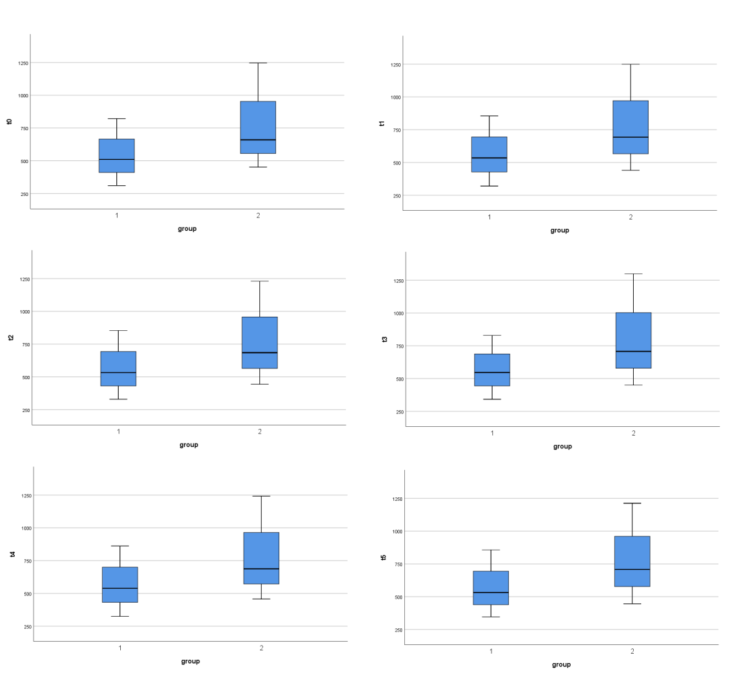
Additional Figure 1. Simultaneous reproducibility of t-tau protein CLEIA measurements same aliquots of the control and test samples (% CV)
Abbreviations: CSF, cerebrospinal fluid; t-tau, total tau; CLEIA, chemiluminescent enzyme immunoassay; CV, coefficient of variation

Additional Figure 2. Estimation of the marginal mean

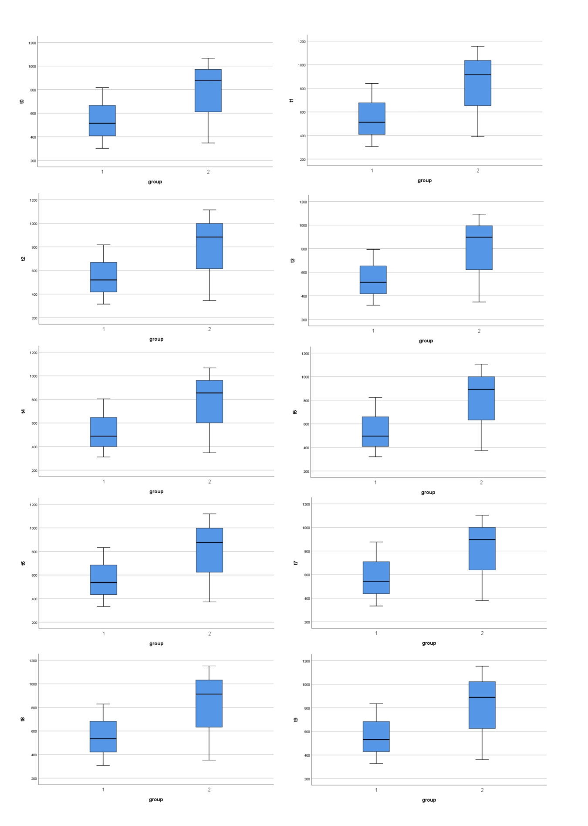
Additional Figure 3. Diurnal reproducibility of t-tau protein CLEIA measurements in the same aliquots of the control and test samples
Abbreviations: CSF, cerebrospinal fluid; t-tau, total tau; CLEIA, chemiluminescent enzyme immunoassay; CV, coefficient of variation

Additional Figure 4a. Repeatability of t-tau dilution results in cerebrospinal fluid samples under different dilution conditions (3 samples were randomly selected without dilution, 1/2 PBS dilution,1/2 pure water dilution, 1/2 total protein solution dilution)
Abbreviations: CSF, cerebrospinal fluid; t-tau, total tau

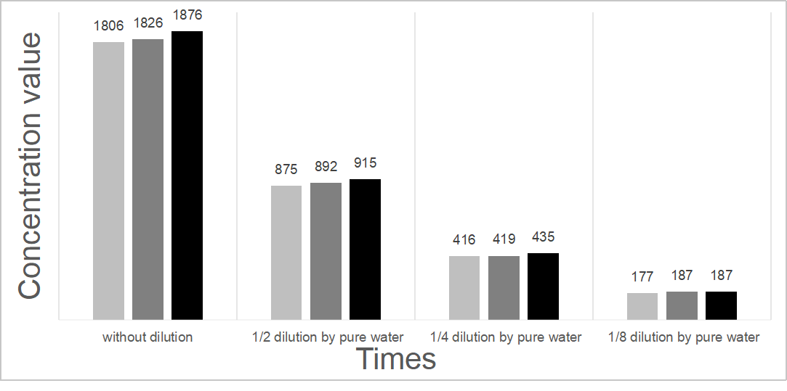Additional Figure 4b. Reproducibility of t-tau pure water dilution results in cerebrospinal fluid samples (No pure water dilution, 1/2 times pure water dilution, 1/4 times pure water dilution, 1/8 times pure water dilution from three random samples)
Abbreviations: CSF, cerebrospinal fluid; t-tau, total tau

