Site-specific molecular design of low-dielectric benzocyclobutene (BCB)-sub-nanometer inorganic nanocomposites
Meng Xie,^{[a]} Wenjie Fan,^{[a]} Menglu Li,^{[a]} Quan Sun,^{[a]} Yan He,^{[a]} Jennifer Q. Lu,*^{[b]} and Wenxin Fu*^{[a]}
[a] M. Xie, W. Fan, M. Li, Q. Sun, Y. He and Prof. W. Fu*
Key Laboratory of Science and Technology on High-tech Polymer Materials
Institute of Chemistry, Chinese Academy of Sciences
Beijing 100190, China
University of Chinese Academy of Sciences
Beijing 100049, China
E-mail: fuwenxin@iccas.ac.cn

[b] Prof. J. Q. Lu*
Materials Science and Engineering, School of Engineering,
University of California, Merced,
5200 North Lake Road, Merced, California 95343, United States
Email: jlu5@ucmerced.edu
Fig. S1 ¹H NMR of D₄Si_{3/2} in CDCl₃.
Fig. S2 APC spectra of D₄Si_{3/2}.
Table S1 Compositions and experimental data of D₄Si_{3/2}.
Content of D-n | D₄Si_{3/2}
TMSi | 2%
D-0 | 21%
D-1 | 30%
D-2 | 29%
D-3 | 18%
D₄^{Vi}: TMSi (Feeding molar ratio) | 2:3
Vinyl: TMSi (molar ratio by NMR) | 5:3

Although there was an overlap of different components in the APC results due to the slight differences in molecular weight among D₄Si_{3/2} products and potential condensation of the methoxyl groups during synthesis, the composition of the mixture was clearly understood through the split-peak fitting.

Fig. S3 FTIR of H-D₄Si_{3/2} before and after hydrolysis.

Fig. S4 (a) ¹³C NMR, (b) ¹H NMR, and (c) ²⁹Si NMR spectra of Me-BCB.
Fig. S5 ¹H NMR spectrum of P₀.
Fig. S6 GPC spectrum of P₀.
Fig. S7 FTIR spectrum of 1,6-Dimercaptohexane and XD-YP₀ (X+Y=100; X = 0, 10, 20, 30, 40, 50 indicating the molar percentage of D₄Si_{3/2}; Y, indicating the molar percentage of BCB group).
Fig. S8 FTIR spectrum of C-XD-YP₀ (X+Y=100; X = 0, 10, 20, 30, 40, 50 indicating the molar percentage of D₄Si_{3/2}; Y, indicating the molar percentage of BCB group).
Fig. S9 DSC curves of C-30D-70P₀ before and after curing.

Fig. S10 N₂ adsorption-desorption isotherms of C-XD-YP₀ (X+Y=100; X = 0, 10, 20, 30, 40, 50 indicating the molar percentage of D₄Si_{3/2}; Y, indicating the molar percentage of BCB group).
Fig. S11 The pore size distribution of C-XD-YP₀ (X+Y=100; X = 0, 10, 20, 30, 40, 50 indicating the molar percentage of D₄Si_{3/2}; Y, indicating the molar percentage of BCB group).

Fig. S12 FTIR spectrum of C-XD-YP₀ at 950cm⁻¹-1200cm⁻¹: X = (a) 0%; (b) 10%; (c) 20%; (d) 30%; (e) 40%; (f) 50% (X+Y=100; X = 0, 10, 20, 30, 40, 50 indicating the molar percentage of D₄Si_{3/2}; Y, indicating the molar percentage of BCB group).

Table S2. List of bands observed in the FTIR spectrum and the proposed assignation of vibrations and structures.
Peak | Wavenumber  (cm⁻¹) | Vibration  Assignation | Structural  Unit | Reference
1 | ~1005 | ν_{as} (Si-O-Si) ^{a)} | Linear siloxane; Cyclic trimers | ^{1, 2}
2 | ~1050 | ν_{ring-as} (Si-O-Si) ^{b)} | Ladder-like silsesquioxane | ^{1, 3, 4}
3 | ~1080 | ν_{ring-as} (Si-O-Si) | Ladder/Network/Cage-like silsesquioxane | ^{1, 5, 6}
4 | ~1135 | ν_{as} (Si-C) | Si-Ph-Si | ⁷
^{a)}ν_{as}, Asymmetric stretching vibration; ^{b)}ν_{ring-as}, Parallel displacements of O atoms on opposite sides of a (SiO)_{x} ring.

Fig. S13 SEM images of C-XD-YP₀: X = (a) 0%; (b) 10%; (c) 20%; (d) 30%; (e) 40%; (f) 50% (X+Y=100; X = 0, 10, 20, 30, 40, 50 indicating the molar percentage of D₄Si_{3/2}; Y, indicating the molar percentage of BCB group).

Fig. S14 Frozen-sectional TEM images of C-XD-YP₀: X = (a) 0%; (b) 10%; (c) 20%; (d) 30%; (e) 40%; (f) 50% (X+Y=100; X = 0, 10, 20, 30, 40, 50 indicating the molar percentage of D₄Si_{3/2}; Y, indicating the molar percentage of BCB group).
Fig. S15 Tan δ curves of C-XD-YP₀ (X+Y=100; X = 0, 10, 20, 30, 40, 50 indicating the molar percentage of D₄Si_{3/2}; Y, indicating the molar percentage of BCB group).
Fig. S16 DMA curves for the storage modulus at a heating rate of 3 °C min⁻¹ (X+Y=100; X = 0, 10, 20, 30, 40, 50 indicating the molar percentage of D₄Si_{3/2}; Y, indicating the molar percentage of BCB group).
Fig. S17 TGA results with a heating rate of 10 °C min⁻¹ under the N₂ atmosphere (X+Y=100; X = 0, 10, 20, 30, 40, 50 indicating the molar percentage of D₄Si_{3/2}; Y, indicating the molar percentage of BCB group).

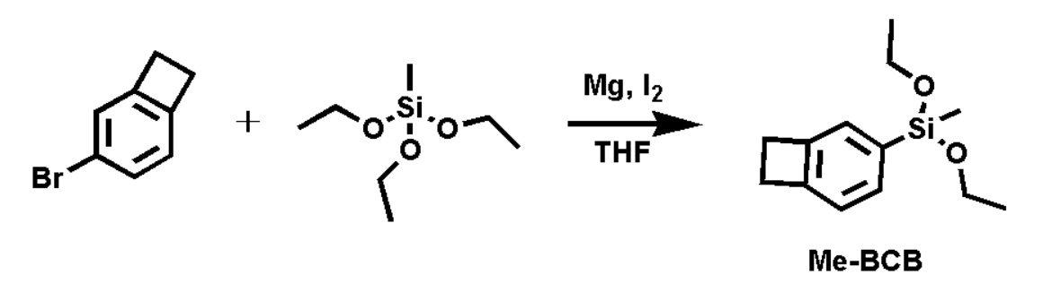
Fig. S18 Synthesis of diethoxy(1,2-dihydrocyclobutabenzen-5-yl) (methyl)silane (Me-BCB).

1. Sato Y, Hayami R, Gunji T. Characterization of NMR, IR, and Raman spectra for siloxanes and silsesquioxanes: a mini review. J. Sol-Gel Sci. Technol. 104, 36-52 (2022).
2. Cruz-Quesada G, Espinal-Viguri M, López-Ramón M, Garrido J. Novel Silica Hybrid Xerogels Prepared by Co-Condensation of TEOS and ClPhTEOS: A Chemical and Morphological Study. Gels 8, 677 (2022).
3. Yuan P, et al. Changes in Structure, Morphology, Porosity, and Surface Activity Of Mesoporous Halloysite Nanotubes Under Heating. Clays Clay Miner. 60, 561 (2012).
4. Lee L-H, Chen W-C, Liu W-C. Structural control of oligomeric methyl silsesquioxane precursors and their thin-film properties. J. Polym. Sci., Part A: Polym. Chem. 40, 1560-1571 (2002).
5. Wu X, et al. Facile synthesis of flexible and hydrophobic polymethylsilsesquioxane based silica aerogel via the co-precursor method and ambient pressure drying technique. J. Non-Cryst. Solids 530, 119826 (2020).
6. Lee AS, et al. Incompletely condensed POSS-based spin-on-glass networks for impeccable ultra low-k integration. J. Mater. Chem. C 3, 11605-11611 (2015).
7. Zhao Z, et al. Silole-containing poly(silylenevinylene)s: Synthesis, characterization, aggregation-enhanced emission, and explosive detection. J. Polym. Sci., Part A: Polym. Chem. 50, 2265-2274 (2012).

