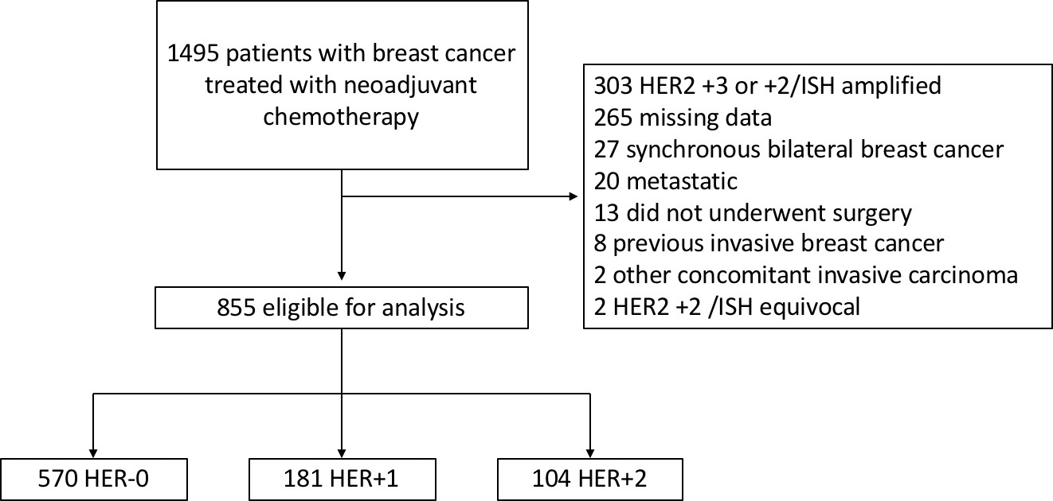

Supplementary figure 1 - CONSORT diagram for study entry.

Supplementary Table 1 - Baseline characteristics stratified by HER2-low status.

Characteristics | HER2-low  (N=285) | HER2-0  (N=570) | pa
Median age (range) | 46 (24-84) | 45 (24-90) | 0.15
Menopausal status (%)
Premenopausal | 179 (62.8) | 360 (63.2) | 0.22
Postmenopausal | 99 (34.7) | 184 (32.3)
Perimenopausal | 6 (2.1) | 25 (4.4)
Male | 1 (0.4) | 1 (0.1)
Histology (%)
Ductal | 246 (86.3) | 472 (82.8) | 1.0
Lobular | 18 (6.3) | 49 (8.6)
Other | 18 (6.3) | 48 (8.4)
missing | 3 (1.1) | 1 (0.2)
cT (%)
T1 | 12 (4.2) | 16 (2.8) | 0.06
T2 | 102 (35.8) | 216 (37.9)
T3 | 72 (25.3) | 181 (31.8)
T4 | 99 (34.7) | 157 (27.5)
cN positive (%) | 211 (74) | 373 (65.4) | 0.01
Clinical Stage (%)
I | 1 (0.4) | 12 (2.1) | 0.08
II | 108 (37.9) | 233 (40.9)
III | 176 (61.7) | 325 (57)
Histologic Grade (%)
I | 26 (9.1) | 24 (4.2) | <.001
II | 148 (51.9) | 255 (44.7)
III | 100 (35.1) | 268 (47)
missing | 11 (3.9) | 23 (4.1)
Median Ki67 | 40 | 60 | <.001
(IQR) | (25-70) | (30-80)
Missing(%) | 16 (5.6) | 39 (6.8)
Subtype (%)
Luminal | 236 (82.8) | 306 (53.7) | <.001
TNBC | 49 (17.2) | 264 (46.3)

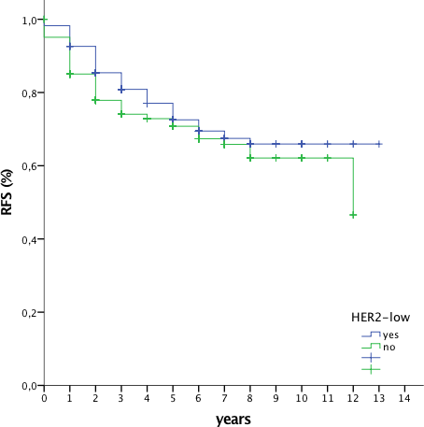
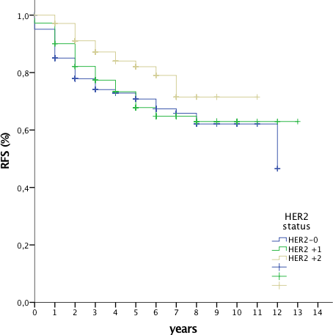
B
A
p=0.11
p=0.044

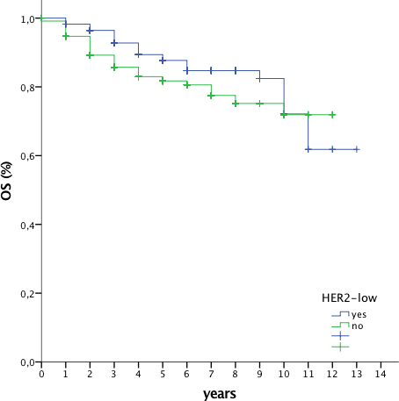
C D
p=0.02
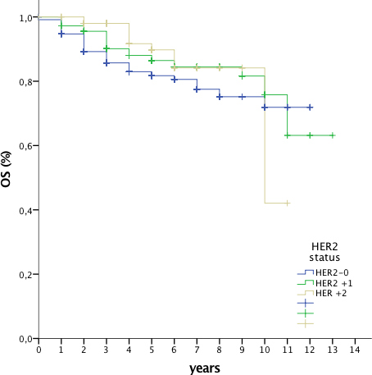
p=0.06
Supplementary figure 2. Relapse-free and overall survival curves according to HER2- low classification in the entire cohort. A and B show RFS according to HER2-low status and HER2-0/HER2+1/HER2+2 for the whole cohort. C and D show OS according to HER2-low status and HER2-0/HER2+1/HER2+2 for the whole cohort.

Luminal subtype
CNS
1,70%
p=0.09
4,60%
Visceral
9,30%
p=0.42
11,80%
Bone
13,70%
14,40%
p=0.90
0,00%
2,00%
4,00%
6,00%
8,00%
10,00% 12,00% 14,00% 16,00%
HER2-low HER2-0

TNBC
CNS
4,10%
p=0.39
8,70%
Visceral
10,20%
p=0.51
15,20%
Bone
6,10%
6,80%
p=1.0
0,00%
2,00%
4,00%
6,00%
8,00%
10,00% 12,00% 14,00% 16,00%
HER2-low HER2-0

Supplementary figure 3. Sites of recurrence in in Luminal/HER2-low (N=236), Luminal/HER2-0 (N=306) and TNBC/HER2-low (N=49), TNBC/HER2-0 (N=264).
Frequencies were compared with Fisher’s exact test.

