Additional file 1. Study consort diagram.
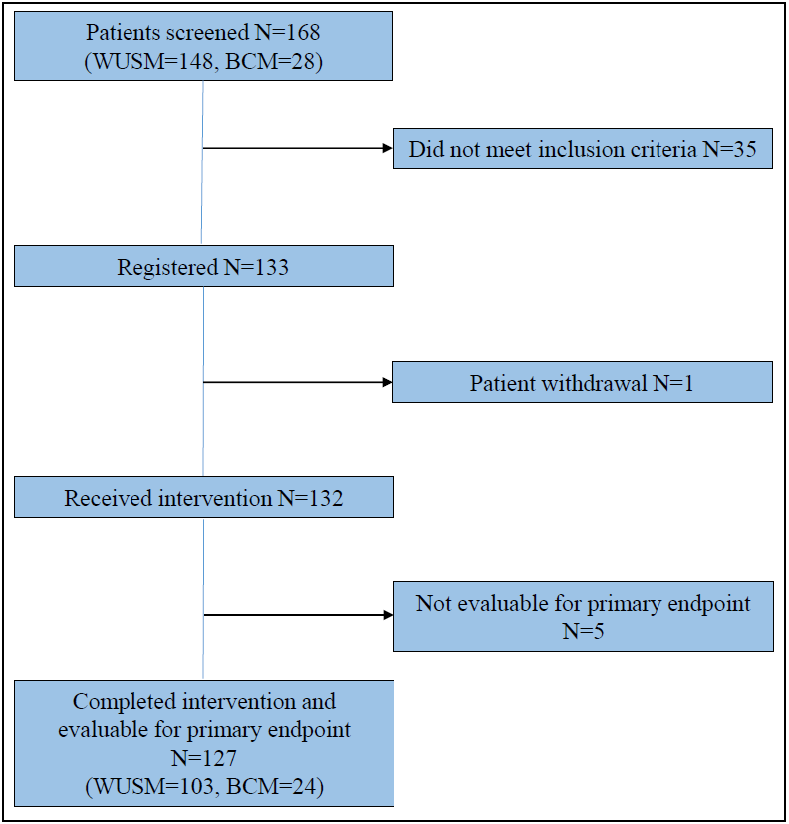
WUSM- Washington University School of Medicine
BCM- Baylor College of Medicine

