Appendix, Figure 1. Calibration plots for Intensive Care Unit (ICU) admission
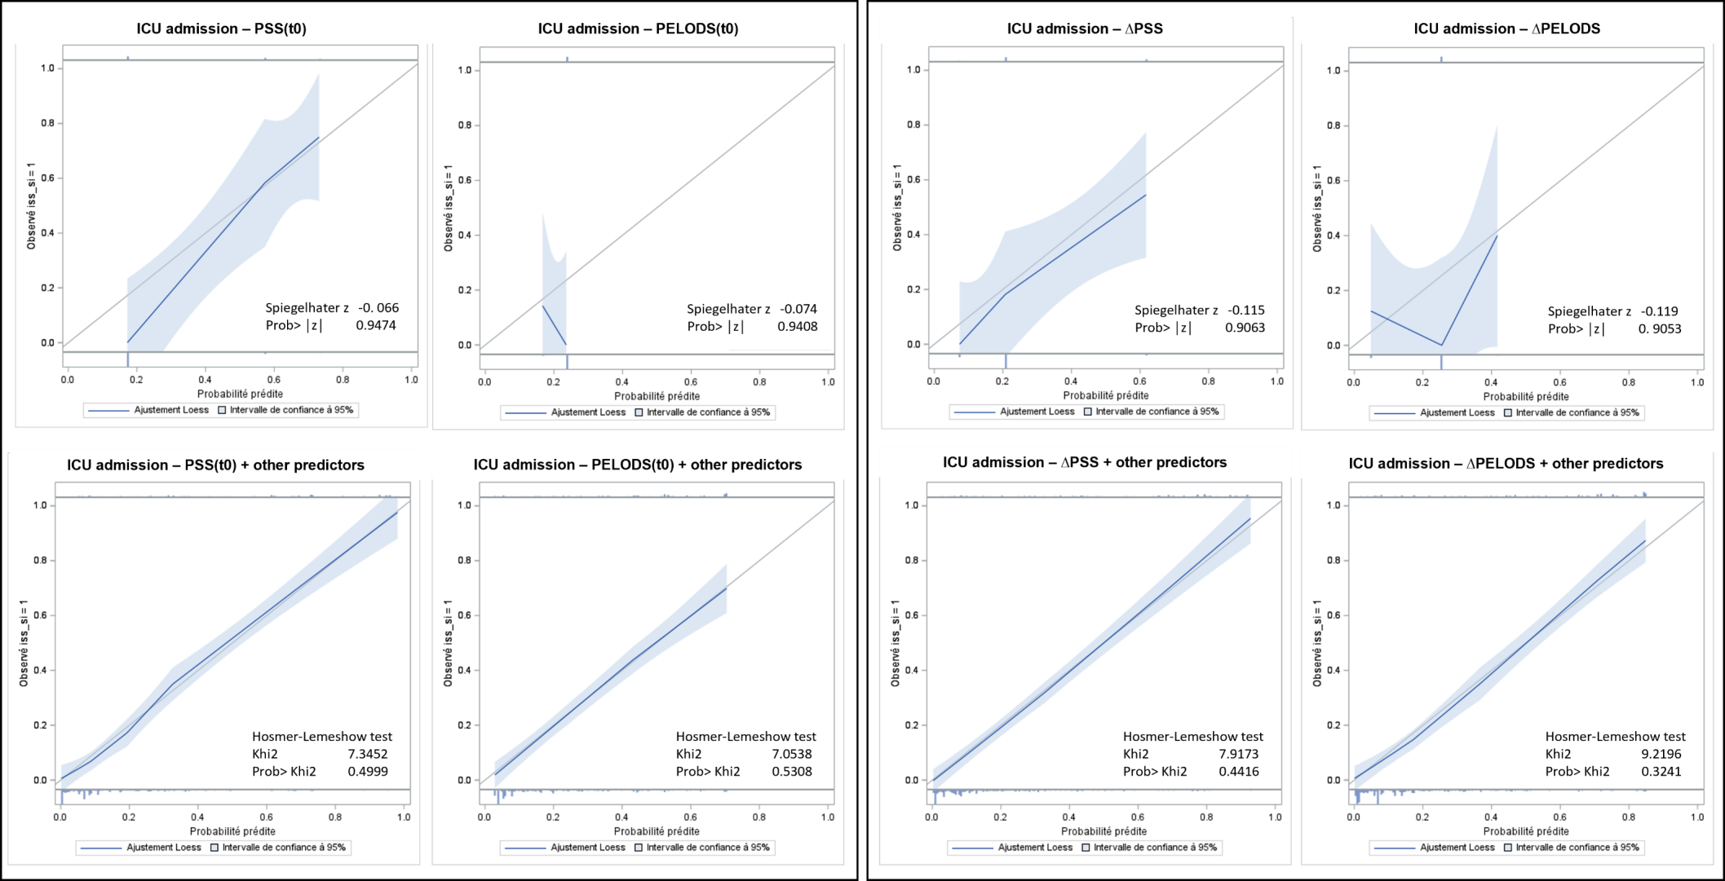

Appendix, Figure 2. Calibration plots for a length of stay ≥ 12 hours
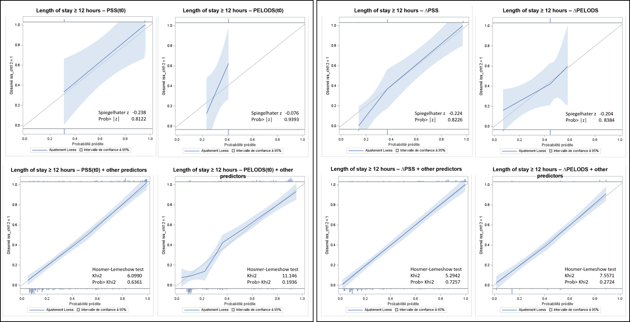

Appendix, Figure 3. Calibration plots for post-discharge follow-up or hospitalization in a psychiatric facility
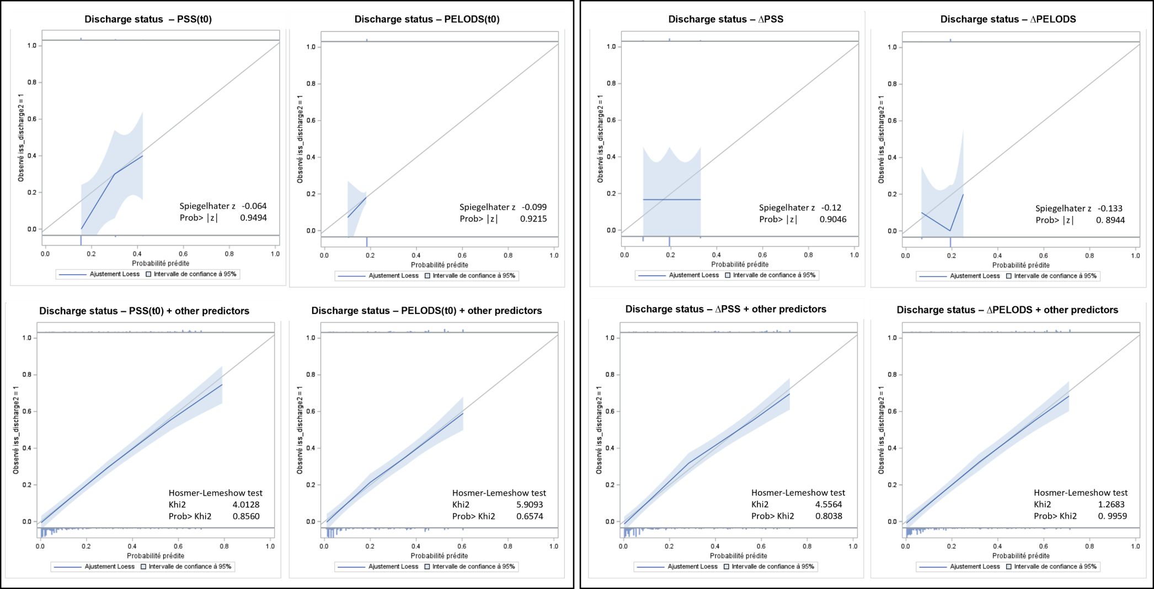
Appendix, Table 1. Discrimination characteristics of the PSS and comparison to the PELODS in the 261 children aged 0 to 5
 | Unadjusted models* |  |  | Adjusted models**
 | PSS(t0)  AUC | PELODS(t0)  AUC | DeLong test** |  |  | PSS(t0)  AUC | PELODS(t0)  AUC | DeLong test**
 | (95% CI) | (95% CI) | p-value |  |  | (95% CI) | (95% CI) | p-value
Admission  N = 27 / 261 (10.3%) | 0.617  (0.532-0.702) | 0.503  (0.464-0.541) | 0.03 |  |  | 0.831  (0.748-0.915) | 0.759  (0.642-0.877) | 0.09
ICU hospitalization  N = 25 / 261 (9.6%) | 0.583  (0.502-0.664) | 0.501  (0.460-0.542) | 0.1 |  |  | 0.813  (0.718-0.908) | 0.796  (0.689-0.902) | 0.2
Hospital length of stay ≥ 12 hours  N = 45 / 261 (17.2%) | 0.631  (0.566-0.697) | 0.512  (0.486-0.538) | 0.002 |  |  | 0.804  (0.718-0.891) | 0.790  (0.704-0.877) | 0.2
Follow-up after discharge or psychiatric hospitalization  N = 9 / 261 (3.4%) | 0.539  (0.430-0.648) | 0.522  (0.509-0.535) | 0.8 |  |  | 0.814  (0.686-0.941) | 0.806  (0.681-0.931) | 0.7
 | ∆PSS  AUC  (95% CI) | ∆PELODS  AUC  (95% CI) | DeLong test**  p-value |  |  | ∆PSS  AUC  (95% CI) | ∆PELODS  AUC  (95% CI) | DeLong test**  p-value
Admission  N = 27 / 261 (10.3%) | 0.568  (0.482-0.653) | 0.500  (0.500-0.500) | 0.1 |  |  | 0.797  (0.701-0.892) | 0.766  (0.662-0.871) | 0.2
ICU hospitalization  N = 25 / 261 (9.6%) | 0.552  (0.466-0.638) | 0.500  (0.500-0.500) | 0.2 |  |  | 0.809  (0.731-0.887) | 0.783  (0.687-0.879) | 0.3
Hospital length of stay ≥ 12 hours  N = 45 / 261 (17.2%) | 0.578  (0.508-0.647) | 0.500  (0.500-0.500) | 0.03 |  |  | 0.784  (0.696-0.873) | 0.780  (0.687-0.873) | 0.8
Follow-up after discharge or psychiatric hospitalization  N = 9 / 261 (3.4%) | 0.543  (0.435-0.652) | 0.500  (0.500-0.500) | 0.4 |  |  | 0.823  (0.696-0.951) | 0.821  (0.707-0.935) | 0.9
The PSS(t0) was included in the models as 3-levels hierarchical variables (0, 1, 2-3). The PELODS(t0) had only two categories and was treated as a binary variable (0 and 1). The ∆PSS and ∆PELODS were treated as 3-classes categorical variables: decrease, stabilization, and increase. Statistically significant comparison tests are in bold (p-value < 0.05).
*Modeling of each outcome according to the severity scores only.
**Adjusted for the severity scores and: physicians' main specialty, age group, sex, presence of comorbidities, ingestion of ≥2 toxic substances, poisoning mechanism, and the delay between intoxication and arrival at the Emergency Department.

Appendix, Table 2. Discrimination characteristics of the PSS and comparison to the PELODS after exclusion of the 20 children transferred from another hospital
 | Unadjusted models* |  |  | Adjusted models**
 | PSS(t0)  AUC | PELODS(t0)  AUC | DeLong test** |  |  | PSS(t0)  AUC | PELODS(t0)  AUC | DeLong test**
 | (95% CI) | (95% CI) | p-value |  |  | (95% CI) | (95% CI) | p-value
Admission  N = 127 / 449 (28.3%) | 0.695  (0.651-0.739) | 0.505  (0.489-0.522) | <.0001 |  |  | 0.913  (0.884-0.943) | 0.884  (0.849-0.918) | 0.001
ICU hospitalization  N = 96 / 449 (21.4%) | 0.652(0.601-0.703) | 0.507  (0.489-0.524) | <.0001 |  |  | 0.908  (0.875-0.941) | 0.883  (0.844-0.922) | 0.005
Hospital length of stay ≥ 12 hours  N = 175 / 449 (39.0%) | 0.668  (0.632-0.704) | 0.512  (0.496-0.527) | <.0001 |  |  | 0.908  (0.878-0.937) | 0.888  (0.856-0.920) | 0.001
Follow-up after discharge or psychiatric hospitalization  N = 79 / 449 (17.6%) | 0.563  (0.512-0.613) | 0.511  (0.496-0.527) | 0.7 |  |  | 0.886  (0.850-0.921) | 0.887  (0.851-0.922) | 0.6
 | ∆PSS  AUC  (95% CI) | ∆PELODS  AUC  (95% CI) | DeLong test**  p-value |  |  | ∆PSS  AUC  (95% CI) | ∆PELODS  AUC  (95% CI) | DeLong test**  p-value
Admission  N = 127 / 449 (28.3%) | 0.627  (0.580-0.674) | 0.498  (0.484-0.511) | <.0001 |  |  | 0.894  (0.861-0.928) | 0.881  (0.847-0.916) | 0.03
ICU hospitalization  N = 96 / 449 (21.4%) | 0.605  (0.552-0.657) | 0.496  (0.478-0.514) | 0.0001 |  |  | 0.881  (0.841-0.920) | 0.873  (0.832-0.914) | 0.4
Hospital length of stay ≥ 12 hours  N = 175 / 449 (39.0%) | 0.609  (0.571-0.647) | 0.489  (0.478-0.500) | <.0001 |  |  | 0.889  (0.855-0.922) | 0.884  (0.852-0.916) | 0.5
Follow-up after discharge or psychiatric hospitalization  N = 79 / 449 (17.6%) | 0.520  (0.467-0.573) | 0.498  (0.485-0.511) | 0.4 |  |  | 0.859  (0.815-0.903) | 0.861  (0.819-0.903) | 0.8
The PSS(t0) was included in the models as 3-levels hierarchical variables (0, 1, 2-3). The PELODS(t0) had only two categories and was treated as a binary variable (0 and 1). The ∆PSS and ∆PELODS were treated as 3-classes categorical variables: decrease, stabilization, and increase. Statistically significant comparison tests are in bold (p-value < 0.05).
*Modeling of each outcome according to the severity scores only.
**Adjusted for the severity scores and: physicians' main specialty, age group, sex, presence of comorbidities, ingestion of ≥2 toxic substances, poisoning mechanism, and the delay between intoxication and arrival at the Emergency Department.

Appendix, Table 3. Discrimination characteristics of the PSS and comparison to the PELODS after exclusion of the 3 children who left ED against medical advice
 | Unadjusted models* |  |  | Adjusted models**
 | PSS(t0)  AUC | PELODS(t0)  AUC | DeLong test** |  |  | PSS(t0)  AUC | PELODS(t0)  AUC | DeLong test**
 | (95% CI) | (95% CI) | p-value |  |  | (95% CI) | (95% CI) | p-value
Admission  N =140 / 466 (30.0%) | 0.690  (0.648-0.732) | 0.506  (0.491-0.522) | <.0001 |  |  | 0.902  (0.872-0.933) | 0.878  (0.844-0.912) | 0.001
ICU hospitalization  N = 109 / 466 (23.4%) | 0.649  (0.601-0.696) | 0.508  (0.492-0.523) | <.0001 |  |  | 0.901  (0.868-0.919) | 0.882  (0.844-0.919) | 0.001
Hospital length of stay ≥ 12 hours  N = 189 / 466 (40.6%) | 0.666  (0.632-0.700) | 0.512  (0.497-0.527) | <.0001 |  |  | 0.897  (0.867-0.928) | 0.881  (0.848-0.913) | 0.003
Follow-up after discharge or psychiatric hospitalization  N = 83 / 466 (17.8%) | 0.569  (0.519-0.619) | 0.511  (0.496-0.526) | 0.04 |  |  | 0.886  (0.851-0.921) | 0.886  (0.852-0.922) | 0.7
 | ∆PSS  AUC  (95% CI) | ∆PELODS  AUC  (95% CI) | DeLong test**  p-value |  |  | ∆PSS  AUC  (95% CI) | ∆PELODS  AUC  (95% CI) | DeLong test**  p-value
Admission  N =140 / 466 (30.0%) | 0.626  (0.581-0.670) | 0.498  (0.485-0.511) | <.0001 |  |  | 0.889  (0.857-0.921) | 0.876  (0.843-0.909) | 0.03
ICU hospitalization  N = 109 / 466 (23.4%) | 0.604  (0.555-0.652) | 0.488  (0.472-0.503) | <.0001 |  |  | 0.872  (0.833-0.911) | 0.867  (0.827-0.906) | 0.4
Hospital length of stay ≥ 12 hours  N = 189 / 466 (40.6%) | 0.609  (0.572-0.645) | 0.489  (0.479-0.500) | <.0001 |  |  | 0.882  (0.848-0.915) | 0.874  (0.841-0.907) | 0.25
Follow-up after discharge or psychiatric hospitalization  N = 83 / 466 (17.8%) | 0.529  (0.476-0.582) | 0.498  (0.485-0.511) | 0.3 |  |  | 0.863  (0.822-0.904) | 0.868  (0.82-0.907) | 0.4
The PSS(t0) was included in the models as 3-levels hierarchical variables (0, 1, 2-3). The PELODS(t0) had only two categories and was treated as a binary variable (0 and 1). The ∆PSS and ∆PELODS were treated as 3-classes categorical variables: decrease, stabilization, and increase. Statistically significant comparison tests are in bold (p-value < 0.05).
*Modeling of each outcome according to the severity scores only.
**Adjusted for the severity scores and: physicians' main specialty, age group, sex, presence of comorbidities, ingestion of ≥2 toxic substances, poisoning mechanism, and the delay between intoxication and arrival at the Emergency Department.

Appendix, Table 4. Discrimination characteristics of the PSS and comparison to the PELODS after exclusion of the 186 children decontaminated with activated charcoal or treated with antidote(s)
 | Unadjusted models* |  |  | Adjusted models**
 | PSS(t0)  AUC | PELODS(t0)  AUC | DeLong test** |  |  | PSS(t0)  AUC | PELODS(t0)  AUC | DeLong test**
 | (95% CI) | (95% CI) | p-value |  |  | (95% CI) | (95% CI) | p-value
Admission  N =46 / 283 (16.3%) | 0.575  (0.518-0.631) | 0.502  (0.478-0.525) | 0.02 |  |  | 0.885  (0.831-0.940) | 0.880  (0.825-0.934) | 0.4
ICU hospitalization  N = 37 / 283 (13.1%) | 0.518  (0.472-0.565) | 0.501  (0.473-0.530) | 0.6 |  |  | 0.880  (0.820-0.941) | 0.880  (0.819-0.942) | 0.9
Hospital length of stay ≥ 12 hours  N = 70 / 283 (24.7%) | 0.581  (0.536-0.626) | 0.507  (0.489-0.525) | 0.002 |  |  | 0.890  (0.844-0.936) | 0.881  (0.833-0.928) | 0.09
Follow-up after discharge or psychiatric hospitalization  N = 42 / 283 (14.8%) | 0.528  (0.480-0.575) | 0.515  (0.504-0.525) | 0.6 |  |  | 0.905  (0.857-0.953) | 0.894  (0.841-0.947) | 0.08
 | ∆PSS  AUC  (95% CI) | ∆PELODS  AUC  (95% CI) | DeLong test**  p-value |  |  | ∆PSS  AUC  (95% CI) | ∆PELODS  AUC  (95% CI) | DeLong test**  p-value
Admission  N =46 / 283 (16.3%) | 0.539  (0.479-0.599) | 0.489  (0.452-0.526) | 0.2 |  |  | 0.860  (0.800-0.921) | 0.850  (0.788-0.912) | 0.5
ICU hospitalization  N = 37 / 283 (13.1%) | 0.504  (0.444-0.564) | 0.487  (0.440-0.533) | 0.7 |  |  | 0.838  (0.766-0.910) | 0.848  (0.775-0.922) | 0.5
Hospital length of stay ≥ 12 hours  N = 70 / 283 (24.7%) | 0.543  (0.491-0.595) | 0.493  (0.469-0.517) | 0.06 |  |  | 0.861  (0.806-0.916) | 0.858  (0.804-0.912) | 0.8
Follow-up after discharge or psychiatric hospitalization  N = 42 / 283 (14.8%) | 0.502  (0.449-0.555) | 0.492  (0.468-0.516) | 0.7 |  |  | 0.892  (0.838-0.946) | 0.841  (0.776-0.906) | 0.09
The PSS(t0) was included in the models as 3-levels hierarchical variables (0, 1, 2-3). The PELODS(t0) had only two categories and was treated as a binary variable (0 and 1). The ∆PSS and ∆PELODS were treated as 3-classes categorical variables: decrease, stabilization, and increase. Statistically significant comparison tests are in bold (p-value < 0.05).
*Modeling of each outcome according to the severity scores only.
**Adjusted for the severity scores and: physicians' main specialty, age group, sex, presence of comorbidities, ingestion of ≥2 toxic substances, poisoning mechanism, and the delay between intoxication and arrival at the Emergency Department.

Appendix, Table 5a. Mean values of PSS and PELODS according to admission status in the 0-17 years-old cohort (n = 469)
 | Total  N = 469 | Admitted  N = 140
Initial mean PSS, n (%)
0 = no symptom | 330 (70.4) | 45 (32.1)
1 = minor intoxication | 122 (26.0) | 78 (55.7)
2 = moderate intoxication | 16 (3.4) | 16 (11.4)
3 = severe intoxication | 1 (0.2) | 1 (0.7)
4 = death | - | -
Initial mean PELODS, n (%)
1 = low severity | 454 (96.8) | 136 (97.1)
2 = moderate severity | 15 (3.2) | 4 (2.9)
3 = high severity | - | -
Mean ∆PSS, n (%)
Decreased toxicity | 154 (32.8) | 10 (7.1)
Stable toxicity | 211 (45.0) | 45 (32.1)
Increased toxicity | 104 (22.2) | 85 (60.8)
Mean ∆PELODS, n (%)
Decreased toxicity | 86 (18.3) | 4 (2.9)
Stable toxicity | 338 (72.1) | 110 (78.6)
Increased toxicity | 45 (9.6) | 26 (18.5)

Appendix, Table 5b. Discrimination characteristics of the mean-PSS and comparison to the mean-PELODS
 | Unadjusted models* |  |  | Adjusted models**
 | PSS(t0)  AUC | PELODS(t0)  AUC | DeLong test** |  |  | PSS(t0)  AUC | PELODS(t0)  AUC | DeLong test**
 | (95% CI) | (95% CI) | p-value |  |  | (95% CI) | (95% CI) | p-value
Admission  N = 140 / 469 (29.9%) | 0.781  (0.736-0.824) | 0.502  (0.486-0.519) | <.0001 |  |  | 0.9002  (0.872-0.933) | 0.879  (0.845-0.913) | 0.01
ICU hospitalization  N = 109 / 469 (23.3%) | 0.770  (0.721-0.818) | 0.503  (0.485-0.521) | <.0001 |  |  | 0.906  (0.874-0.938) | 0.882  (0.845-0.919) | 0.01
Hospital length of stay ≥ 12 hours  N = 189 / 469 (40.3%) | 0.752  (0.713-0.791) | 0.509  (0.494-0.524) | <.0001 |  |  | 0.901  (0.872-0.930) | 0.882  (0.850-0.913) | 0.02
Follow-up after discharge or psychiatric hospitalization  N = 83 / 469 (17.7%) | 0.690  (0.632-0.748) | 0.512  (0.497-0.527) | <.0001 |  |  | 0.889  (0.855-0.923) | 0.887  (0.852-0.922) | 0.6
 | ∆PSS  AUC  (95% CI) | ∆PELODS  AUC  (95% CI) | DeLong test**  p-value |  |  | ∆PSS  AUC  (95% CI) | ∆PELODS  AUC  (95% CI) | DeLong test**  p-value
Admission  N = 140 / 469 (29.9%) | 0.736  (0.684-0.789) | 0.571  (0.536-0.607) | <.0001 |  |  | 0.887  (0.856-0.918) | 0.873  (0.838-0.909) | 0.06
ICU hospitalization  N = 109 / 469 (23.3%) | 0.730  (0.673-0.788) | 0.597  (0.554-0.640) | 0.001 |  |  | 0.888  (0.853-0.924) | 0.864  (0.823-0.905) | 0.01
Hospital length of stay ≥ 12 hours  N = 189 / 469 (40.3%) | 0.751  (0.706-0.796) | 0.553  (0.526-0.580) | <.0001 |  |  | 0.883  (0.850-0.916) | 0.879  (0.884-0.911) | 0.5
Follow-up after discharge or psychiatric hospitalization  N = 83 / 469 (17.7%) | 0.673  (0.611-0.734) | 0.540  (0.495-0.585) | 0.001 |  |  | 0.862  (0.820-0.904) | 0.847  (0.803-0.890) | 0.02
The PSS(t0) was included in the models as 3-levels hierarchical variables (0, 1, 2-3). The PELODS(t0) had only two categories and was treated as a binary variable (0 and 1). The ∆PSS and ∆PELODS were treated as 3-classes categorical variables: decrease, stabilization, and increase. Statistically significant comparison tests are in bold (p-value < 0.05).
*Modeling of each outcome according to the severity scores only.
**Adjusted for the severity scores and: physicians' main specialty, age group, sex, presence of comorbidities, ingestion of ≥2 toxic substances, poisoning mechanism, and the delay between intoxication and arrival at the Emergency Department.

Appendix, Table 6a. Description of missing data for the 12-hour PSS and the 12-hours PELODS
 | All children  N = 469 | Admitted  N = 140 (29.9%)
Before imputation
12-hour PSS
0 = no symptom | 165 (35.2) | 119 (85.0)
1 = minor intoxication | 19 (4.0) | 16 (11.4)
2 = moderate intoxication | 4 (0.9) | 4 (2.9)
3 = severe intoxication | - | -
4 = death | - | -
Missing data | 281 (59.9) | 1 (0.7)
12-hour PELODS
1 = low severity | 183 (39.0) | 135 (96.4)
2 = moderate severity | 5 (1.1) | 4 (2.9)
3 = high severity | - | -
Missing data | 281 (59.9) | 1 (0.7)
After imputation
12-hour PSS
0 = no symptom | 388 (82.8) | 120 (85.6)
1 = minor intoxication | 44 (9.4) | 16 (11.5)
2 = moderate intoxication | 37 (7.8) | 4 (2.9)
3 = severe intoxication | - | -
4 = death | - | -
12-hour PELODS
1 = low severity | 426 (90.9) | 136 (97.1)
2 = moderate severity | 43 (9.1) | 4 (2.9)
3 = high severity | - | -

Imputation model equation for both 12-hour minimal (and maximal) PSS and PELODS included 16 independent variables:
- The outcomes studied: admission to the hospital, hemodynamic support by vasopressors, extrarenal epuration, mechanical ventilation time, ICU admission, hospital LOS ≥ 12 hours, discharge status;
- And the potential baseline predictors of the missing data: age group, sex, comorbidities, usual medications, ingestion of ≥2 toxic substances, intentional exposure, time from ingestion to arrival at the hospital, initial PSS (minimal and maximal), initial PELODS (minimal and maximal), administration of ≥1 antidote or decontaminating agent.

Appendix, Table 6b. Discrimination characteristics of the ∆PSS and comparison to the ∆PELODS using the 188 complete cases only

 | Unadjusted models* |  |  | Adjusted models**
 | ∆PSS  AUC  (95% CI) | ∆PELODS  AUC  (95% CI) | DeLong test**  p-value |  |  | ∆PSS  AUC  (95% CI) | ∆PELODS  AUC  (95% CI) | DeLong test**  p-value
Admission  N = 139 / 188 (73.9%) | 0.618  (0.557-0.679) | 0.520  (0.491-0.548) | 0.01 |  |  | 0.853  (0.797-0.909) | 0.842  (0.783-0.900) | 0.4
ICU hospitalization  N = 108 / 188 (57.5%) | 0.535  (0.468-0.601) | 0.508  (0.488-0.528) | 0.4 |  |  | 0.922  (0.881-0.963) | 0.921  (0.881-0.961) | 0.8
Hospital length of stay ≥ 12 hours  N = 188 / 188 (100%) | - | - | - |  |  | - | - | -
Follow-up after discharge or psychiatric hospitalization  N = 69 / 188 (36.7%) | 0.539  (0.470-0.609) | 0.505  (0.485-0.525) | 0.4 |  |  | 0.855  (0.799-0.912) | 0.830  (0.770-0.890) | 0.2
The ∆PSS and ∆PELODS were treated as 3-classes categorical variables: decrease, stabilization, and increase. Statistically significant comparison tests are in bold (p-value < 0.05).
*Modeling of each outcome according to the severity scores only.
**Adjusted for the severity scores and: physicians' main specialty, age group, sex, presence of comorbidities, ingestion of ≥2 toxic substances, poisoning mechanism, and the delay between intoxication and arrival at the Emergency Department.

