Supplementary Material for

Mapping Surface Phonon Polaritons with Visible Light

Kiernan E. Arledge, Michael A. Meeker, Chase T. Ellis, Nazli Rasouli Sarabi, Vincent R. Whiteside, Chul Soo Kim, Mijin Kim, Daniel Ratchford, Binbin Weng, and Joseph G. Tischler

*Corresponding author. E-mail: tischler@ou.edu and kiernan.e.arledge-1@ou.edu

This PDF file includes:

Materials and Methods
Supplementary Text
Figs. S1 to S11
References

Materials and Methods

Sample preparation
InP nanopillar samples were prepared in 300 x 300 µm arrays with varying diameter and pitch. The structures were fabricated on undoped n-type InP, using a SiN hard mask to outline the pillar cross-section. The mask was produced using electron-beam lithography with a fluorine-based inductively coupled plasma etching (ICP). The pillars themselves were then etched into the substrate using a chlorine-based ICP (1). As mentioned in the main text, the InP nanopillars used for this investigation had a diameter of 10 μm, height of 1500 nm, and a center-to-center pitch of 20 µm. The SiC grating samples were prepared in 200 x 200 µm arrays with varying pitch and linewidth. The structures were fabricated on an undoped 4H-SiC substrate which had its surface prepared and activated via a ozone treatment in the Plasma Preen system. The 1D grating pattern was then generated using maskless direct laser writing using a Nanoscribe 3D printer. The nanostructure pattern is applied to a drop of IP-DIP resin. The 3D printed map is then etched into the SiC substrate using a SF6/O2 reactive ion etching process with O2 being used to remove any remaining polymer resist (2,3). The SiC gratings used for this investigation have a center-to-center period of 6 µm, a linewidth of 3.32 µm, and a height of 1.41 µm (see supplementary).

Experiments
Surface topography measurements: INP NANOPILLARS SEM IMAGES. Atomic force microscopy (AFM) maps were acquired using an NX10 AFM (Park Systems, South Korea) operating in noncontact mode using a silicon tip (PPP-NCHR; 42 N/m) with a nominal radius of < 10nm. The statistical analysis of the AFM maps was performed using XEI (Park Systems) software. Period, linewidth, and height were measured using a Z-axis cross section for the grating structure.
Reflection Spectroscopy: Reflectance measurements for the InP nanopillars were carried out using a Bruker 80v spectrometer, coupled with a Bruker Hyperion 1000 IR microscope. For the SiC gratings, reflectance measurements were carried out using a Bruker Tensor 27 FT-IR spectrometer, coupled with a Bruker Hyperion IR microscope. A reverse-Cassegrain microscope objective was used for both experiments to focus unpolarized IR light onto the sample with an angle of incidence that varied from 12° to 23.6°. The same microscope objective was used to collect the reflected light from the nanostructure sample and subsequently focused onto and detected by a HgCdTe detector. Steady-state reflectance measurements were normalized to the reflectance of a gold mirror. Spectra were taken with an average of 80 scans with 3 cm⁻¹ resolution acquired from a 150 µm² collection area.
Raman measurements: Raman spectra were recorded using a WITec Confocal Raman Microscope system (alpha 300R) with high-speed ultrahigh throughput spectrometers (WITec Inc., Germany). For all experiments, Raman signal was collected using a 100x (0.90 NA) Zeiss EC Epiplan-Neofluar objective (Zeiss, Germany) with a 50 – µm optic fiber, dispersed by a diffraction grating of 600 grooves/mm, and collected on a EMCCD detector. For the investigations on InP, Raman spectra were collected using a frequency-doubled Nd-YAG laser (WITec) providing excitation at an above-bandgap wavelength of 1064 nm perpendicular to the sample surface. For the SiC gratings, a laser excitation at 532 nm was employed. The linear polarization of both excitation lasers was adjusted using a λ/2 calcite waveplate, along with an identical λ/2 waveplate serving as the analyzer. Rayleigh scattered light was blocked by an edge filter. For the InP experiments, laser power was set to the 15 mW range and satisfactory signal-to-noise ratio was achieved using an acquisition time of 12 s. For the SiC experiments, laser power was set to the 30 mW range and satisfactory signal-to-noise ratio was achieved using an acquisition time of 7.5 s. For the InP nanopillars, fifteen confocal 2D (x-y) Raman maps (20 µm by 20 µm, 30 points per line, and 30 lines per image) from different focal planes (1.5 µm) were acquired at high spectral and spatial resolution by automatically scanning the sample along the z-axis (starting with the focal plane above the nanostructure surface and then focusing the beam progressively deeper into the nanostructure in 1.5 µm intervals). Data acquisition, evaluation, and processing were performed using the WITec Project Management and Image Project Plus software.

Data Analysis
Raman Data Processing: All Raman spectra shown in the main article were fitted to single-peak Gaussian functions. The center wavelength of each Gaussian is used to obtain the phonon energies reported.

Simulation
Electromagnetic Field Simulations: We used the finite element method (FEM) software COMSOL Multiphysics to simulate the far-field reflection spectrum from both the InP nanopillars and SiC gratings (Fig. 1C and 2A, respectively). For these calculations, the reflection spectrum was calculated for an infinite array of the nanostructures with dimensions chosen to match the measured size of both nanostructures. Near-field simulations of the electromagnetic fields (including the polarization fields) are similarly performed using the RF module of COMSOL. Simulations are performed for incident angles of 0°, 32°, and 64°, and the optical fields shown (Fig. 1E,F; Fig. 3, and Fig 4C) consist of equally weighted maps for each angle.
Electron-Phonon Coupling Simulations: The process of determining the spatial profile of electron-phonon coupling, shown in Fig. 4C, requires simulating the distribution of induced charges in the SiC gratings. Volume charge distributions (at point r and frequency ω) in the nanostructure are obtained, following the approach of Marty (4,5), as the divergence of the polarization vector:
$$ρ\left(r,ω\right)= -∇∙P(r,ω)$$
Maps of the charge distribution measured are reconstructed in the same manner as the polarization fields, as described in the next section. In order to estimate the amount of induced charge in the nanostructures, the shift in the Raman spectra is used to approximately determine the induced charge density. As mentioned in the main text, in the Raman spectrum of polar dielectrics like SiC, the spectral position of the LO phonon peak will blueshift and broaden its full-width half maximum when the dielectric is doped with free carriers (the LOPC effect). This effect occurs because the large dipole moment of the LO phonon can couple to the electron plasma (an effect which becomes more prominent as the doping density increases). Using the Raman spectra, the carrier density of 4H-SiC in the low doping regime is estimated using the approach of Nakashima, where the blueshift of the LO mode, $Δω$, is related to the carrier density n via a simple expression (6):
$n=1.25×{10}^{17}Δω$.
For the bulk SiC substrate there is no measured blueshift, indicated the very low background doping. Nevertheless, in very concentrated positions in the grating structure, a blueshift of up to $Δω=5 {cm}^{-1}$ is observed in the Raman spectra (Fig. 4B). To test the hypothesis that the local blueshifting is due to the electron-phonon coupling effect, we simulated both the polarization and charge distribution in the 1D gratings. Using Eq. (#) above, we can estimate the induced charge in the nanostructures from the spectral shift in the LO phonon at that location. To obtain the maps shown in Fig. 4C, the polarization field of the SPhP modes based on the Raman tensor are computed (identical to Fig. 3 for the LO mode), which serve as the baseline for spectra with no blueshifting. For larger carrier densities, the induced charge is computed using Eq. S1, and the final maps are a combination of both polarization and charge maps.

Reconstruction
The process to reconstruct the maps of SPhP modes (Fig. 1D,E, Fig. 3, Fig. 4C) generally follows the logical approach of EELS reconstruction (7-9). The details of the Raman reconstruction method are discussed in the supplementary materials. Procedurally, the Raman maps are constructed using an eigenmode decomposition, as in EELS, where the overall Raman scattering probability for a given phonon mode can be written as:
$$P_{Raman}= \sum_{k}{C_{k}P_{Raman}(u_{k})}$$
where the sum is performed over the index k, associated with a geometric SPhP eigenmode $u_{k}$ (such as a monopole in the nanopillars), $C_{k}$ is a coefficient specific to each geometric eigenmode and $P_{Raman}(u_{k})$ is the Raman scattering probability generated from each SPhP eigenmode, calculated from the Raman selection rules (see supplementary). Unlike most EELS experiments, we do not seek to algorithmically obtain $u_{k}$ and $C_{k}$ that provide the best match to experimental data, although that will likely be a future direction when theoretical knowledge of Raman mapping of SPhP is further investigated. Rather, in our work we obtain the eigenmodes $u_{k}$ from the reflection spectrum, sharp dips are identified as eigenmodes and constitute the basis set. Additionally, for simplicity, we arbitrarily set all coefficients $C_{k}$ to be equivalent (1, in this case), so that each simulated Raman map is an admixture of the Raman scattering probability associated with each SPhP mode. We anticipate that if even more precise methods are used to obtain the eigenbasis and coefficients, then the matching between experiment and simulations might be improved substantially, particularly the effect of the substrate.

Supplementary text

Supplementary experimental data
InP Nanopillars
The geometry of the InP pillar nanostructures was estimated from SEM imaging. The SEM images in Fig. S1 a,b demonstrate two periodic arrays of nanopillars with different characteristic dimensions. Fig. S1a shows the SEM image of the nanopillar array used in this paper’s investigation of Raman maps, with a measurement of the top diameter overlaid. Fig. S1b shows an array of nanopillars with smaller diameter, which will be investigated in the following supplementary data.
Both nanopillar arrays support localized SPhP modes, as demonstrated in Fig. S1c,d, which give simulated reflection spectra using the full-wave, 3D electromagnetic simulation approach in COMSOL described in the Materials and Methods. For both nanopillar sizes comparing the off-array reflection spectrum (black curve) with the on-array reflection spectrum (red curve) reveals that the nanopillars induce reflection dips associated with localized SPhP modes.
The SPhP modes of both nanopillar sizes can be mapped using Raman imaging techniques, as shown in Fig. S2. Figure S2 shows x-y Raman image cuts for four different nanopillar arrays, showing both the TO and LO mode for each nanopillar size selected. The image size is fixed at 20 μm x 20 μm.
The uppermost array in Fig. S2 corresponds to an array with a period of 20 μm and a diameter of 10 μm, which corresponds to the Raman images in the paper. As discussed in the paper, the correspondence between the TO(LO) phonon modes and the dipole(monopole) SPhP modes is evident. The panel below (period of 16 μm and diameter of 8 μm) shows similar images of the localized modes. The next panel below (period of 10 μm and diameter of 5 μm) shows multiple nanopillars within the array. While the obtained maps have become blurrier, the dipole and monopole field distributions remain evident and appear to be similar in each pillar of the array. The bottom panel (period of 6 μm and diameter of 3 μm) shows a map containing almost 12 full pillars. The persistence of monopole and dipole fields appears to be discernible, but the small size has made imaging difficult given the diffraction limitation. Nevertheless, the presence of localized modes can be verified for nanopillar sizes far smaller than the SPhP wavelength (~30 μm) and is not isolated to larger nanostructures. The largest nanopillars are chosen for the paper since their images are the easiest to visualize.
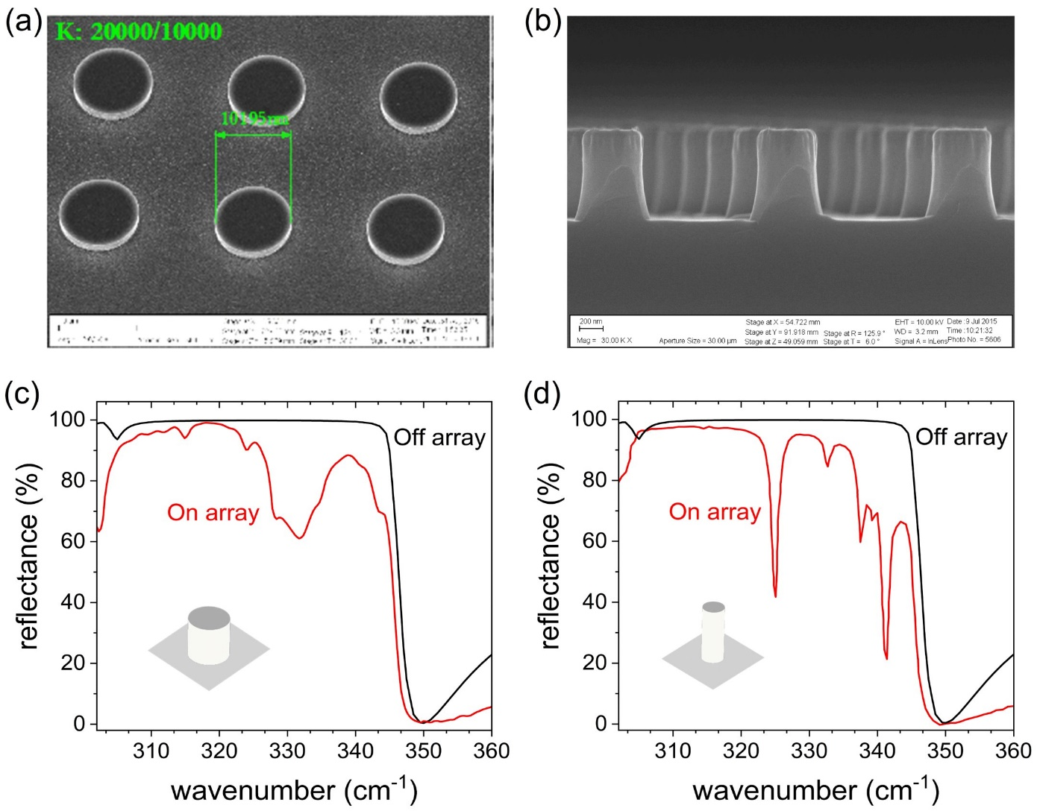
Fig. S1: SPhP resonances in InP nanopillars. A. SEM image of the InP nanopillars with 10 µm diameter, used in the paper. B. Cross-sectional SEM image of a nanopillar array with 300 nm diameters, far below the free-space polariton wavelength. C. Off array (black) and On-array (red) reflection spectra for the larger pillar array shown in panel (a) demonstrating the resonances associated with the localized SPhP modes. D. Off array (black) and on array (red) reflection spectra for the smaller pillar array shown in panel (b) demonstrating localized SPhP resonances.

Fig. S2: Raman mapping for different nanopillar arrays. A. Sketch of the nanopillar geometry, with diameter (D) and period (Λ) shown. B. Raman images of the TO and LO phonon modes for nanopillars of different sizes. The top panel shows a Λ = 20 µm, D = 10 µm nanopillar, as shown in the paper. Lower panels show nanopillars of decreasing feature sizes, demonstrating the continued confinement of the optical mode, with limited imaging resolution.
Figure 1 in the paper gives both x-y and x-z Raman maps for the largest nanopillar array, but x-y Raman scans were also collected for various focal depths in the order to visualize the mode intensity in the nanopillar and within the InP substrate, as depicted schematically in Figure S3 (a). As Figure S3(a) shows, we start at “Stack A” collected roughly 3.5 µm above the InP substrate and scan progressively down to “Stack J” roughly 1.5 µm into the substrate. Figure S3(b) demonstrates the result of these scans for the TO and LO phonons in the 10 µm diameter nanopillar. As the scans focus deeper into the InP substrate, we can visualize the monopole-like and dipole-like modes evolve through the vertical direction. In particular, the dipole-like TO phonon map has its profile fall apart and become noisier, while the monopole-like mode retains a strong profile through Stack J.
The results of the stack scan reinforce Figure 1(D) from the paper, where the cross-sectional map shows the TO mode losing its dipole-like field profile ~1.5 µm deep into the substrate, while the monopole remains strong over a larger distance. The results of these stack scans are also largely consistent with other investigations of SPhPs in nanopillars, which have noted the strong interaction of the monopole mode with the material substrate, necessary to maintain its charge neutrality.

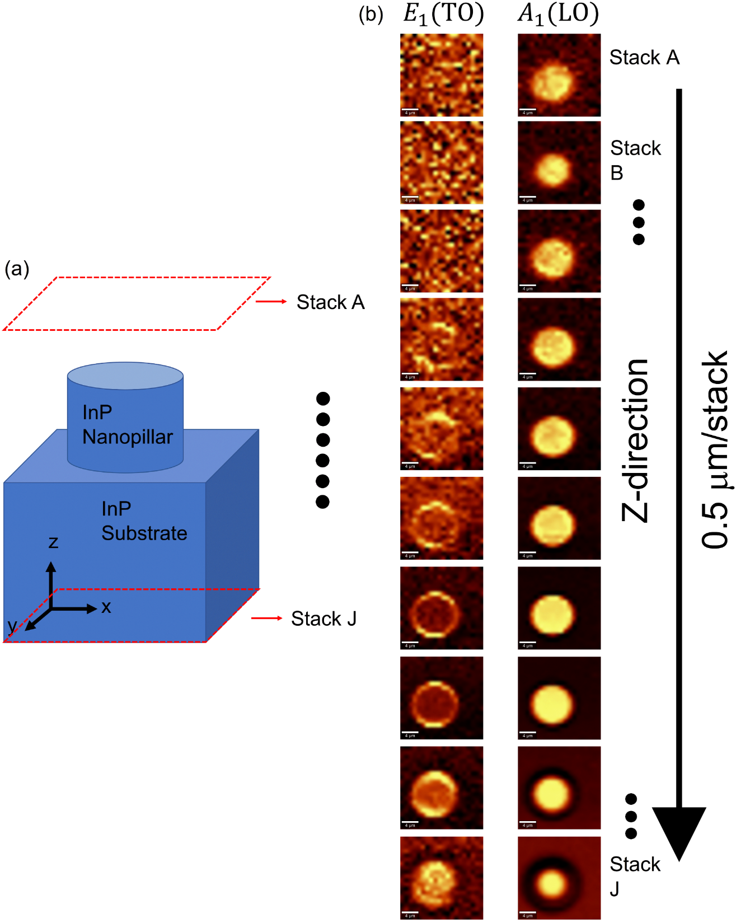
Fig. S3: Stack Scan of InP nanopillars. (A). Sketch of the experiment, where Raman maps in the x-y plane are collected at a constant z-focus, generating a stack of Raman maps from A to J, focusing progressively deeper. (B) Results of the stack scan measurements for the E₁(TO) and A₁(LO) phonon modes. The monopole-like LO mode has a similar field profile for almost the entire stack scan but the dipole-like TO mode profile becomes very noisy and more monopole-like as it progresses deeper into the substrate.
One dimensional (1D) SiC Gratings
Fig. S4: AFM measurements of SiC gratings. (A). x-y AFM scan for 1D grating used in the article, the red line shows the cut where z values are averaged to produce a cross-sectional profile. (B) cross-sectional profile of grating structure in the x-z plane, used to extract all geometric parameters used in modelling. The height H is shown. (C). 3D view of the gratings which gives a clear view of the parabolic geometry produced by the etching process. The period Λ and linewidth L are shown.

The geometry of the SiC gratings were measured using non-contact atomic force microscopy (AFM). Figure S4 shows the results of the AFM measurements on the grating array used in the article. Fig. S4(a) shows a x-y view of the AFM showing the location of the y-cut which is used to measure the grating structural parameters. The resulting x-z linescan, shown in Fig. S4(b), provides a cross-sectional view of the grating. The AFM scans show the parabolic shape of the gratings, which is a result of the etching process employed on SiC. The cross-sectional scan also allows for a measurement of the average grating height H above the substrate, along with the average period Λ and bottom linewidth L, as shown in the full 3D scan in Fig. S4(c). With Λ,L, and H having been measured, we can use those parameters to obtain a parabolic fit for the grating structure of the form z = ax²+bx+c, determining the value for parameters a,b, and c. These fits are then used to recreate the grating geometry used to simulate the SPhP modes in Fig. 2(a) and Fig. S5.

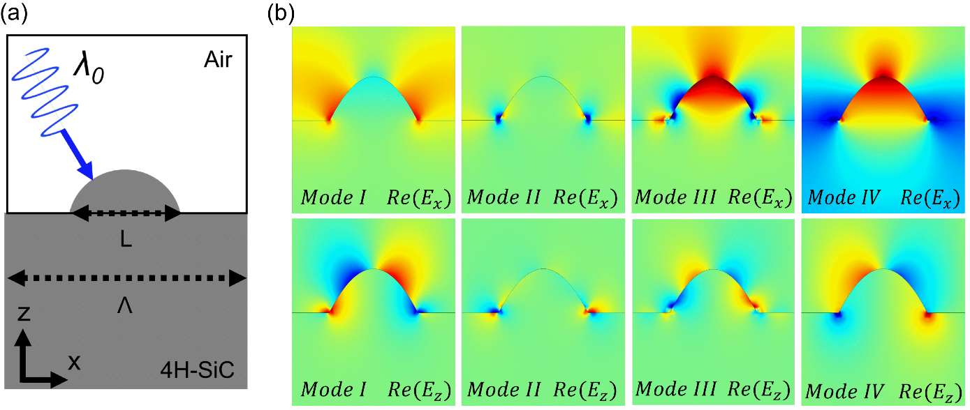
Fig. S5: FEM simulations of SPhP modes in SiC gratings. (A). Diagram of the computational geometry used for the modelling. The period Λ and linewidth L obtained in Fig. S4 are used to create the structure. (B). The Re(E_{x}) (top) and Re(E_{z}) (bottom) distributions of the four SPhP resonances in the SiC gratings. Energies of modes I-IV are shown in Fig. 2(a) in the article.

Having determined the grating geometry from AFM measurements, we can create accurate FEM models for the nanostructures in the RF package of COMSOL Multiphysics. Figure 2 in the article shows the results of FTIR measurements of the grating structure compared to the computational model which is designed based on the geometric measurements in Fig. S4. As mentioned in the article, the localized SPhP modes in Fig. 2 do not have the symmetry seen in the InP nanopillars, so we can’t simply classify them as monopole modes or dipole modes. Lacking a straightforward naming scheme, we labeled the modes I,II,III, and IV in Figure 2(a).
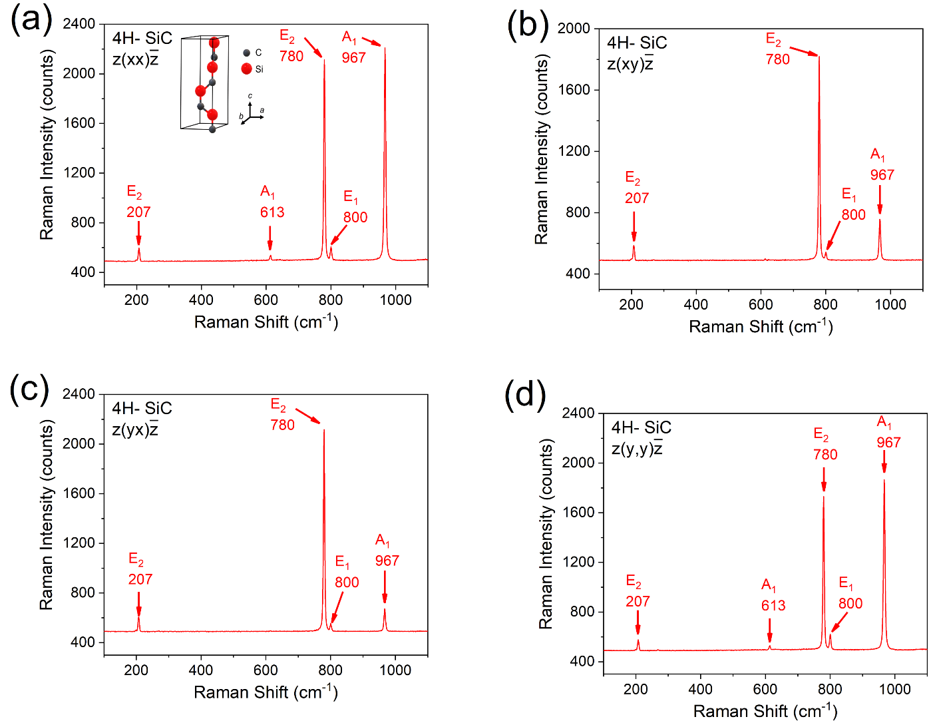
Fig. S6: Backscattering Raman spectra of 4H-SiC. We present the backscattering Raman spectra for bulk SiC material in all four polarizer-analyzer configurations: $z(xx)\overline{z}$ (a), $z(xy)\overline{z}$ (b), $z(yx)\overline{z}$ (c), and $z(yy)\overline{z}$ (d). Phonon modes are labeled by their symmetry classification.
In Figure S5 we show the electromagnetic fields of the SPhP modes shown in Figure 2(a).

Figure 5S(a) presents a schematic of the computational unit cell. The 4H-SiC grating structure is built using period Λ, linewidth L, and height H as determined in Fig. 4S. The structure is illuminated by light of wavelength λ₀, which is then swept to obtain the reflection spectrum. For each of the modes I, II, III, and IV labeled in Figure 2(a), we show the E_{x} and E_{z} fields in the nanostructure, demonstrating the subdiffractional confinement of electromagnetic energy by the SPhP modes. These 4 modes were selected to serve as the basis for the eigenmode reconstruction used to produce the simulated Raman maps in Fig. 3(b) and Fig. 4(b).

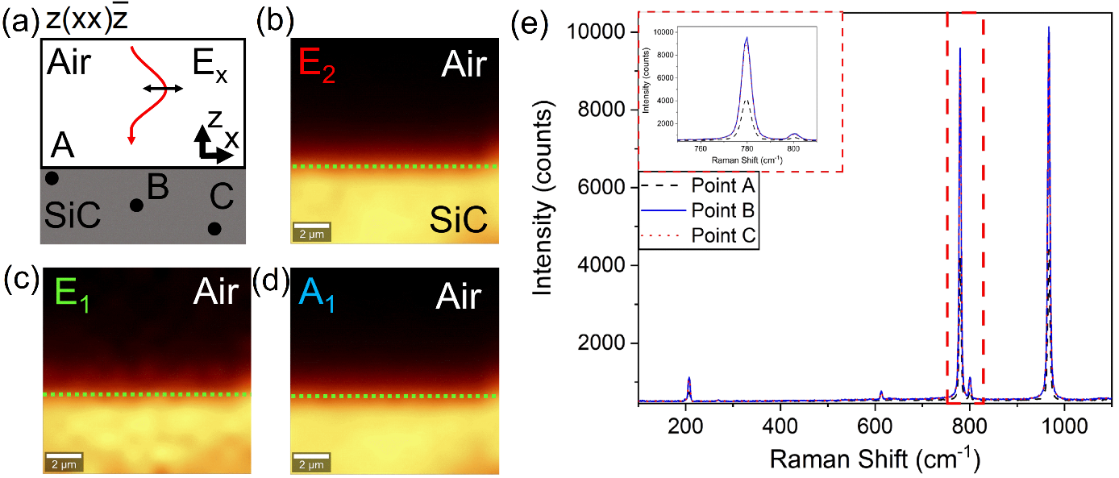
Fig. S7: Raman maps of bulk 4H-SiC. (A) Diagram of the experimental measurement. The incoming light is x-polarized incident on the SiC-air interface. Experimental maps of the Raman intensity are obtained for the E₂ (panel B), E₁ (panel C), and A₁ (panel D) phonon modes. (E). Collected Raman spectra at the three points shown in panel (A), the intensities get stronger with increasing focus depth, but relative intensities remain constant.

In Fig. 2(b) in the article we show the $z\left(x,x\right)\overline{z}$ Raman spectrum for the 4H-SiC substrate in order to present the 6 Raman-active phonon modes measured. Since all four polarizer and analyzer combinations were used to obtain Raman maps of the SPhP modes, we measured the bulk Raman spectrum of 4H-SiC under all four polarizer-analyzer combinations as a reference. Figure S5 shows the measured Raman spectra for the $z\left(x,x\right)\overline{z}$ (a), $z\left(x,y\right)\overline{z}$ (b), $z\left(y,x\right)\overline{z}$ (c), and $z\left(y,y\right)\overline{z}$ (d) scattering geometries. These Raman scans show that both the parallel (xx and yy) and cross (xy and yx) have similarities. In particular, the parallel polarizations show all 6 Raman-active phonons with similar relative intensities. The cross polarizations lead to considerable decreases in the E₁ and A₁ phonon intensities, as predicted by the Raman selection rules.
In addition to measuring the bulk Raman scattering in all polarizations, we also performed Raman mapping in the bulk SiC substrate. Figure S7(a) and Figure S8(a) show schematic representations of the SiC scattering geometries for both $z\left(x,x\right)\overline{z}$ (S7) and $z\left(x,x\right)\overline{z}$ (S8) polarization configurations. Using these setups, panels (b),(c), and (d) show the obtained Raman maps for all three optical phonon modes, E₂ (red), E₁ (green), and A₁ (blue). While there are variations in the signal-to-noise ratio among the phonon modes, all the Raman maps display the expected isotropy with uniform distribution, which distinguishes the bulk material from nanostructured 4H-SiC. Finally, Figure S7 (e) and Figure S8 (e) show the Raman spectra obtained at points A,B, and C in Figure 7,8 (a). There is expected depth dependence to the intensity of the Raman signals, but the relative intensities remain constant for all phonon modes, in contrast to the Raman signals in the SiC gratings where the relative phonon intensities show high local variation (Fig. 4A, for example).

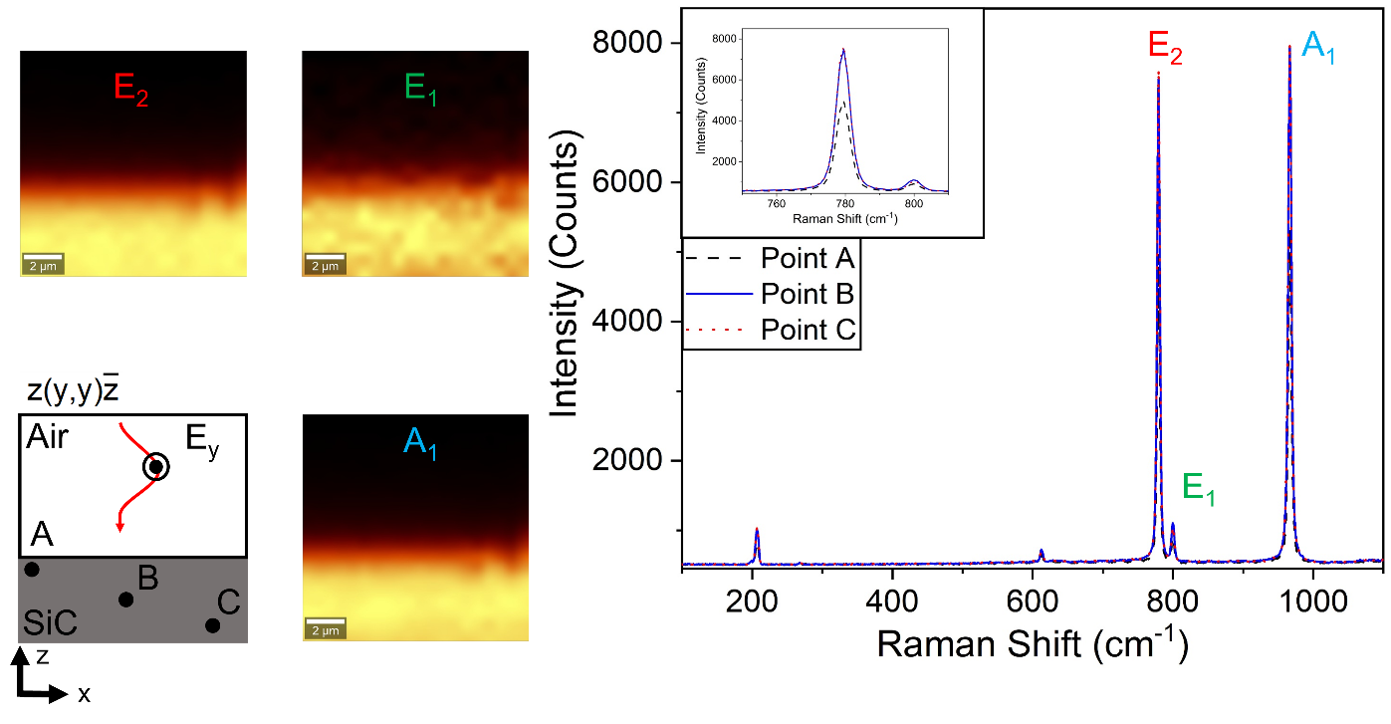
Fig. S8: Raman maps of bulk 4H-SiC. (A) Diagram of the experimental measurement. The incoming light is y-polarized incident on the SiC-air interface. Experimental maps of the Raman intensity are obtained for the E₂ (panel B), E₁ (panel C), and A₁ (panel D) phonon modes. (E). Collected Raman spectra at the three points shown in panel (A), the intensities get stronger with increasing focus depth, but relative intensities remain constant.
As a complement to Fig. S5, in Fig. S9 we show the results of the Raman maps obtained for the three optical phonon modes in all four polarizer configurations. The left most boxes denote the phonon symmetry which all modes in that row correspond to: E₁ (green), E₂ (red), and A₁ (blue). The top panels denote the polarizer-analyzer configuration corresponding to its column and additionally outlines the grating geometry with dashed green lines. As in Fig. 3, the Raman modes are largely similar across all the polarization configurations. Because the phonon modes mix polarizabilities in different directions, as the angle of incidence increases the relative strengths of the polarizabilities changes with the incident electric field. Thus, the large NA of our microscope objective acts to “smear” the Raman polarizabilities in both x and y polarizations, for a lower NA with a smaller solid angle the selection rules might be more visually evident.
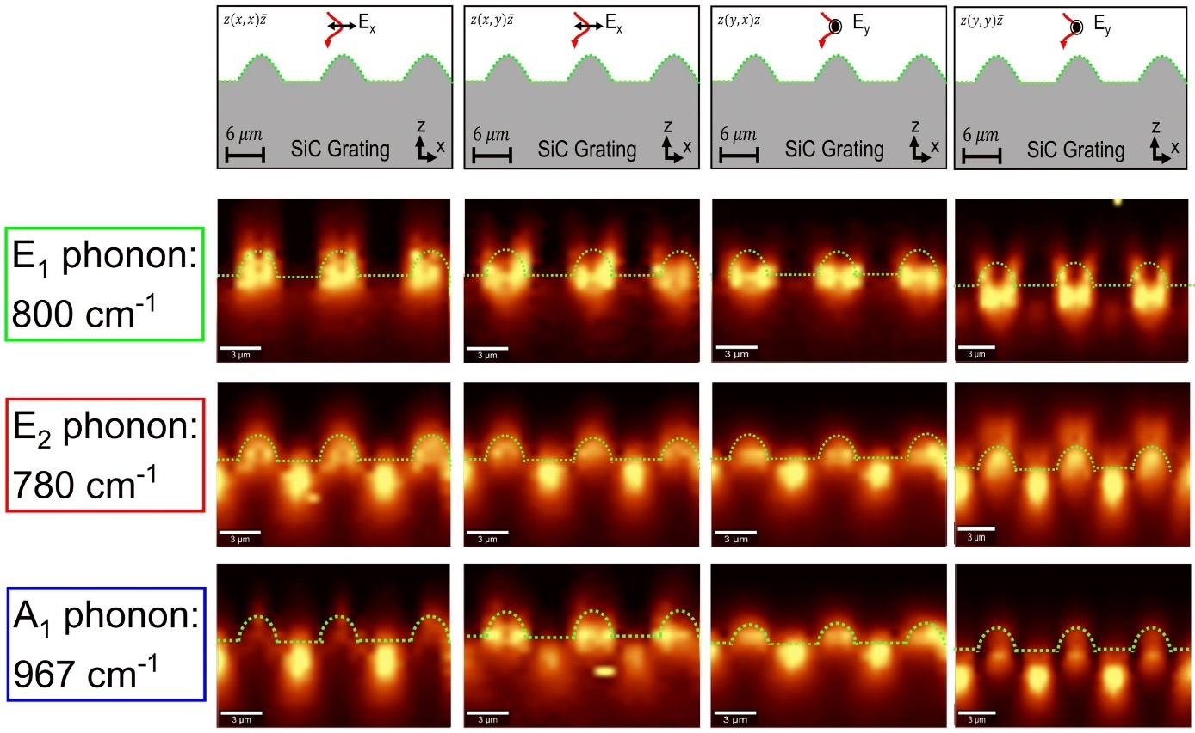
Fig. S9: Collected Raman maps in all polarization configurations for the optical phonon modes in the 4H-SiC grating nanostructures. The top row denotes the geometric setup for the Raman experiment, showing all four polarizer and analyzer configurations. The left column gives the three optical phonon modes. These 12 maps comprise all the polarized Raman maps obtained in the backscattering configuration.

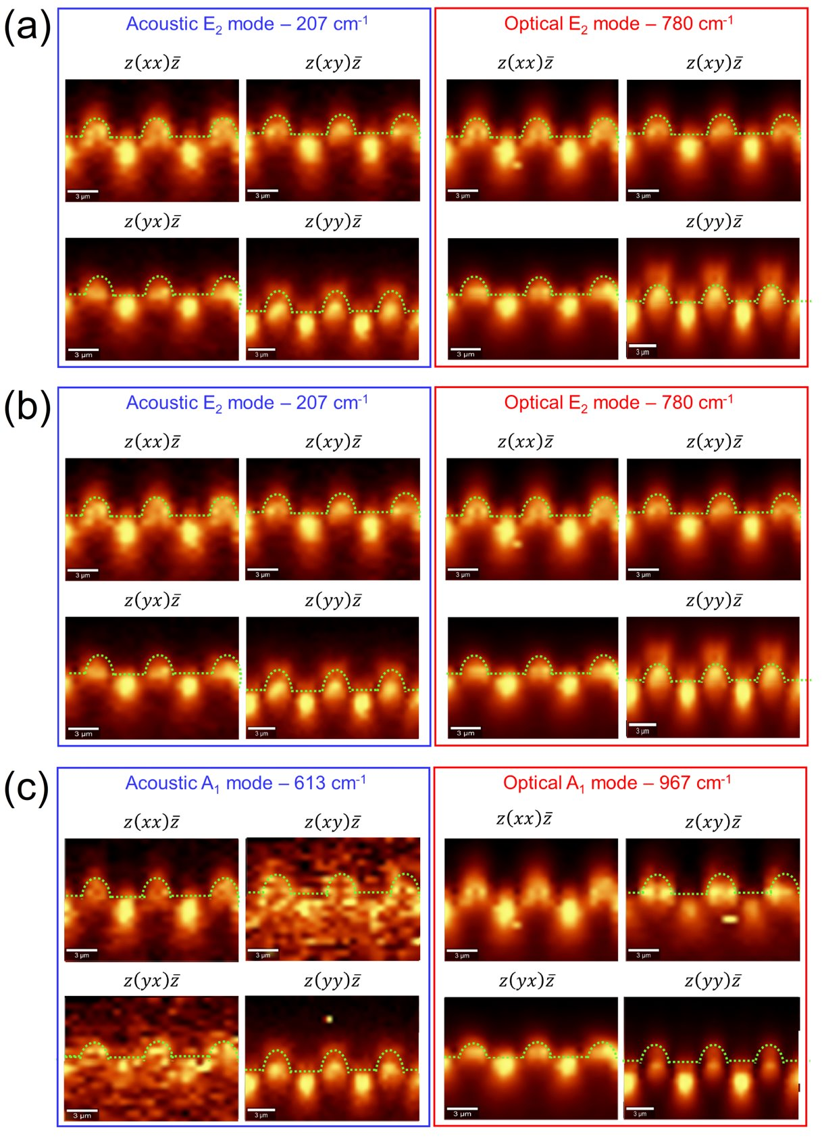
Fig. S10: Acoustic Phonon Raman Maps. (A). Collected Raman maps in all polarizer-analyzer configurations for both the acoustic and optical phonon mode with E₂ group symmetry, both sets of maps show remarkable agreement. (B). Same as (A) for the E₂ symmetry group phonons. (C). Same as (A) for the A₁ symmetry group phonons.

While the paper focuses entirely on the optical phonon modes in 4H-SiC and on their coupling to the SPhP modes, we were also able to obtain Raman maps for the three acoustic phonon modes, as shown in Fig. 2A and Fig. S6. Figure S10 displays the obtained Raman maps in all polarizer configurations, specifically to compare the optical and acoustic phonon modes for each symmetry classification. As shown in Fig. 2(b) and Fig. S5, there is one optical phonon and one acoustic phonon each for all three backscattering Raman-active phonon symmetries in 4H-SiC. Figure S10 shows the Raman maps for both the acoustic and optical phonon modes in the SiC grating structures for the E₂ group symmetry (panel a), E₁ group symmetry (panel b), and A₁ group symmetry (panel c). The Raman maps of both the acoustic and optical phonon clearly depict similar field distributions in the SiC gratings. Thus, the Raman maps shown in Fig. S10 demonstrate the remarkable fact that the coupling between SPhPs and bulk phonon modes applies to the acoustic phonon modes, as well. That is, even though acoustic phonons are thought to play no role in the physics of SPhPs and little role in optical systems in general, our Raman study provides evidence that their interaction with the SPhP modes mirrors that of the optical phonon modes owing to the small Raman polarizability associated with acoustic phonons. This surprising discovery indicates that there is a wider range of material interactions related to SPhp modes than previously thought, including material interactions far outside the Reststrahlen band.

References and Notes
- Dunkelberger, Adam D., et al. "Active tuning of surface phonon polariton resonances via carrier photoinjection." Nature Photonics 12.1 (2018): 50-56.
- Sharac, N., G. R. S. Iyer, and J. G. Tischler. "3D-printed infrared metamaterials." Quantum Sensing and Nano Electronics and Photonics XVI. Vol. 10926. SPIE, 2019.
- Thiel, Michael, et al. "Direct laser writing of three-dimensional submicron structures using a continuous-wave laser at 532 nm." Applied Physics Letters 97.22 (2010).
- Marty, Renaud, et al. "Charge distribution induced inside complex plasmonic nanoparticles." Optics Express 18.3 (2010): 3035-3044.
- Baffou, Guillaume, Christian Girard, and Romain Quidant. "Mapping heat origin in plasmonic structures." Physical review letters 104.13 (2010): 136805.
- Nakashima, S., et al. "Determination of free carrier density in the low doping regime of 4H-SiC by Raman scattering." Applied Physics Letters 93.12 (2008).
- Qi, Ruishi, et al. "Probing far-infrared surface phonon polaritons in semiconductor nanostructures at nanoscale." Nano letters 19.8 (2019): 5070-5076.
- Li, Xiaoyan, et al. "Three-dimensional vectorial imaging of surface phonon polaritons." Science 371.6536 (2021): 1364-1367.
- Hauer, Raphael, et al. "Tomographic reconstruction of quasistatic surface polariton fields." ACS photonics 10.1 (2022): 185-196.

