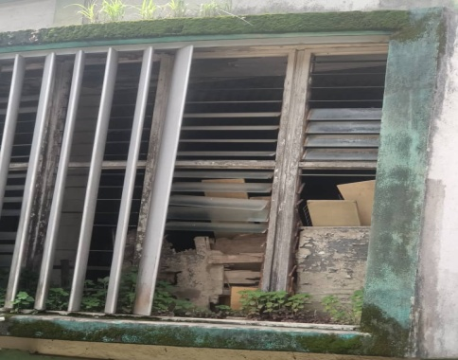
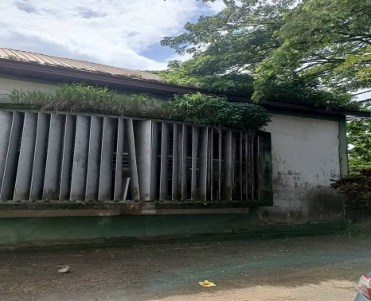
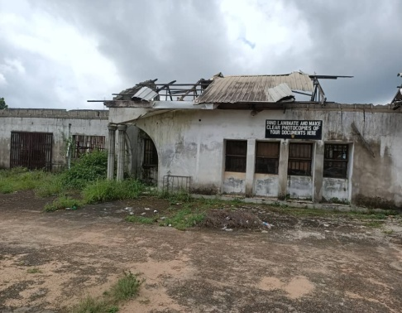
Building razed by fire and abandoned Broken shading devices & fungi growth Paint peeling & broken blades
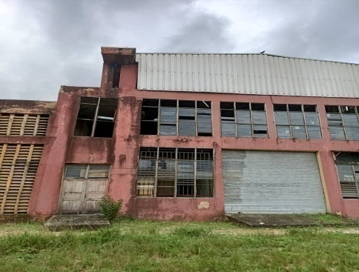
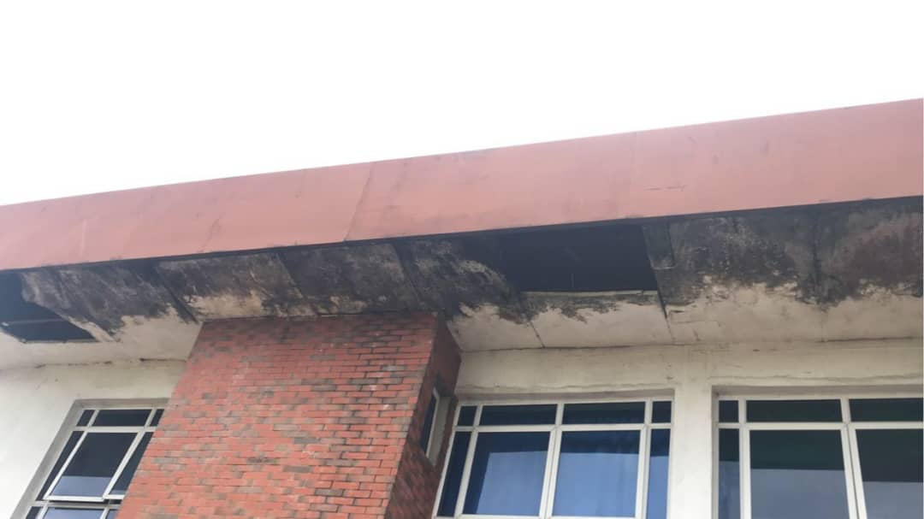
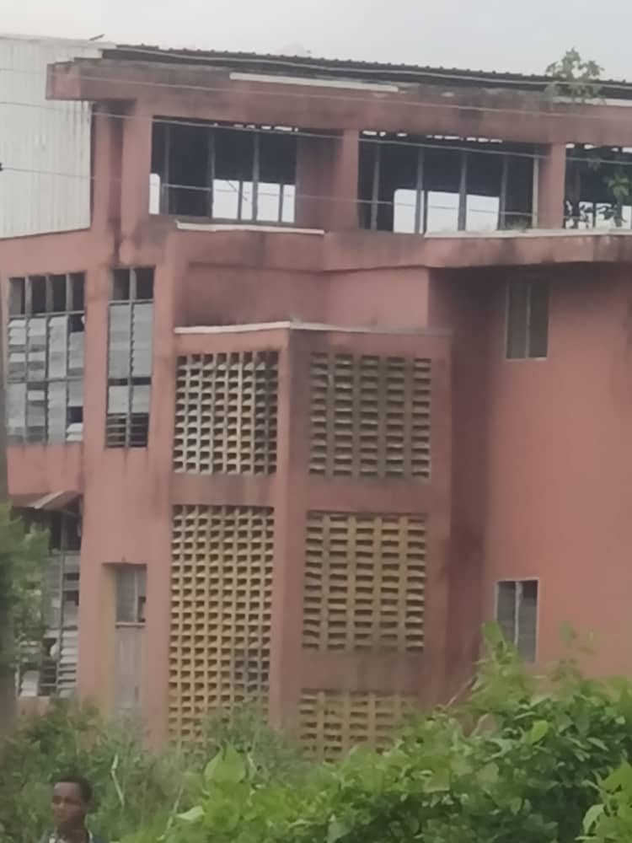
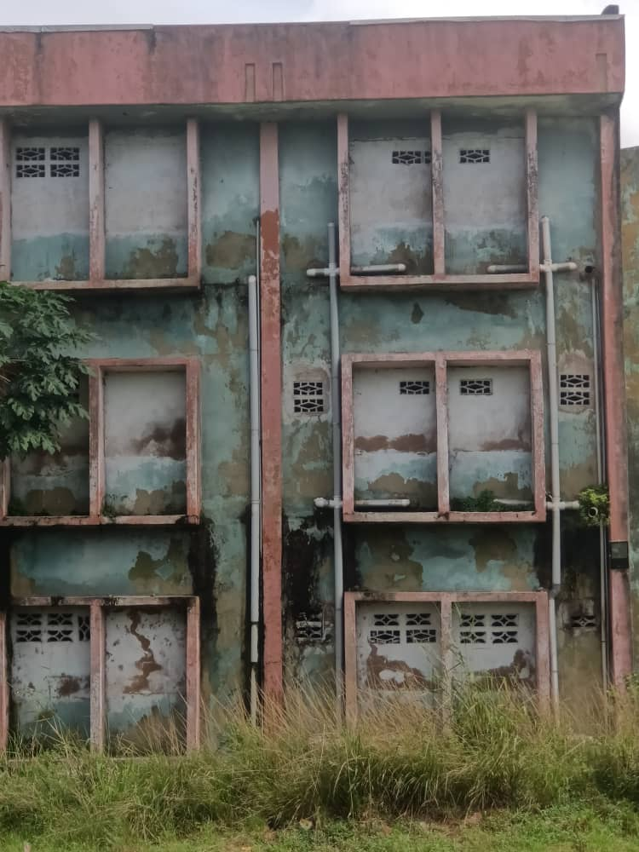
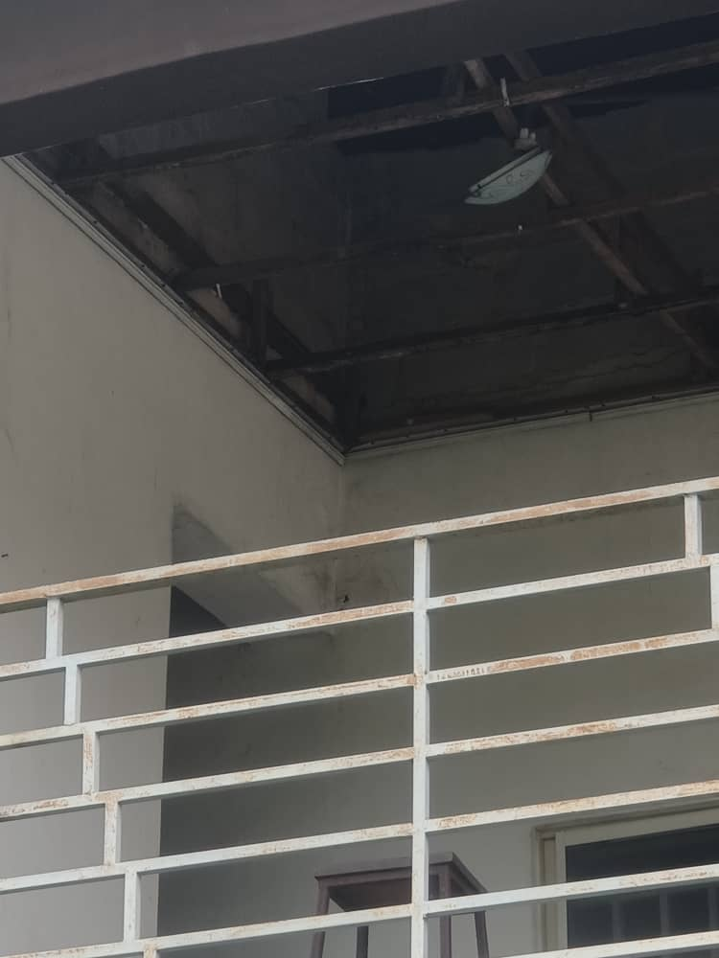
Collapsed ceiling & electrical fittings Broken window louver blades Leaking roof & broken ceiling boards
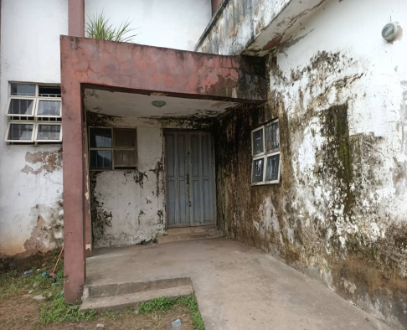
Dampness of wall & paint peeling Dampness from broken waste pipes Broken windows & unkempt environment

Plate1: Evidences of building defects in the tertiary institutions in Owerri metropolis.
Source: Authors field work July 2023 to December 2023

