Relationships between population size and fitness in four common and four rare alpine plant species
Alpine Botany
Hannah Inniger¹, Daniel Prati¹, Markus Fischer¹
¹ Institute of Plant Sciences, University of Bern, Bern, Switzerland
hannah.inniger@gmail.com
Table S1 ANOVA table of linear model investigating the effect of rarity on population size. The full model contained rarity, genus, the rarity - genus interaction, collection date and elevation as explanatory variables. Numeric variables were z-transformed and population size was transformed with the decadic logarithm. The final model contained only response variables for which there are statistical values in the table (SS: sum of squares, F: F-statistics, df: degrees of freedom; type II F-tests based on Satterthwaite's method). For the variables included in the final models, significance levels are given: p < 0.1; °, p < 0.05; *, p < 0.01; **, p < 0.001; ***.
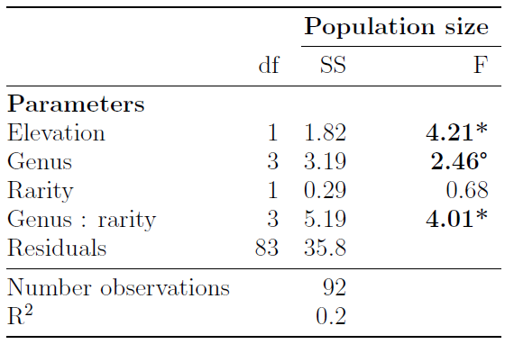

Table S2 ANOVA tables of mixed effect models investigating the effects of population size on fitness traits among populations of the rare Gentiana alpina and the common Potentilla crantzii. We tested each fitness trait separately within species. Numeric variables were z-transformed and population size, seed number and total seed mass per fruit were transformed with the decadic logarithm. Seed set and germination were fitted as binomial response variable (seed set: whether a fruit contained viable seeds or not, germination: number of germinated seeds, number of seeds that did not germinate, "cbind" function from base R). Final models contained only fixed effects for which there are statistical values in the table (χ²: Chi squared, SS: sum of squares, F: F-statistics, df: degrees of freedom; type II Wald χ²-square tests for generalised mixed effect models, type III F-tests based on Satterthwaite's method for linear mixed effect models). Number of groups indicate the number of levels for each of the random effects. For the variables included in the final models, significance levels are given: p < 0.1; °, p < 0.05; *, p < 0.01; **, p < 0.001; ***.
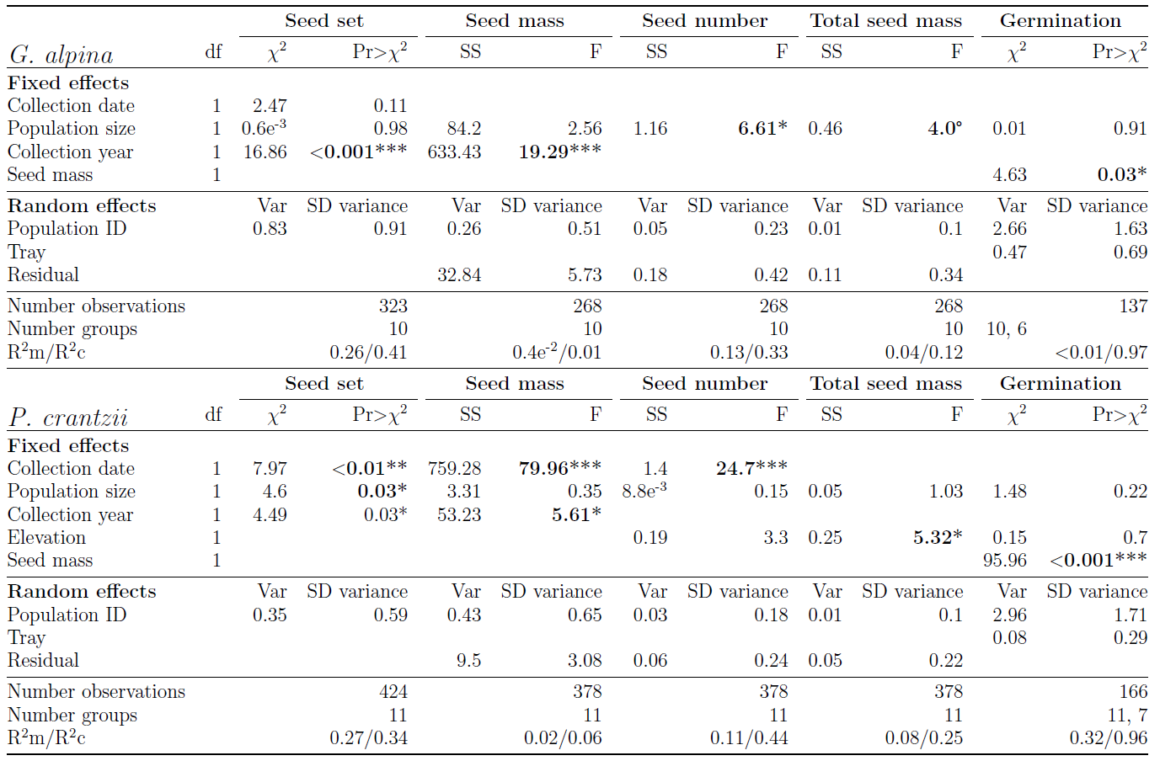

Table S3 Parameter estimates for mixed effect models investigating the effects of population size on fitness traits among populations of the common Gentiana acaulis and the rare Potentilla nivea. We tested each fitness trait separately within species. Numeric variables were z-transformed and population size was transformed with the decadic logarithm. We did not test seed set (whether fruits contained viable seeds or not) because only few plants had empty fruits (three among populations of G. acaulis and five among populations of P. nivea). Final models contained only fixed effects for which there are statistical values in the table (χ²: Chi squared, SS: sum of squares, F: F-statistics, df: degrees of freedom; type II Wald χ²-square tests for generalised mixed effect models, type III F-tests based on Satterthwaite's method for linear mixed effect models). Number of groups indicate the number of levels for each of the random effects. For the variables included in the final models, significance levels are given: p < 0.1; °, p < 0.05; *, p < 0.01; **, p < 0.001; ***.
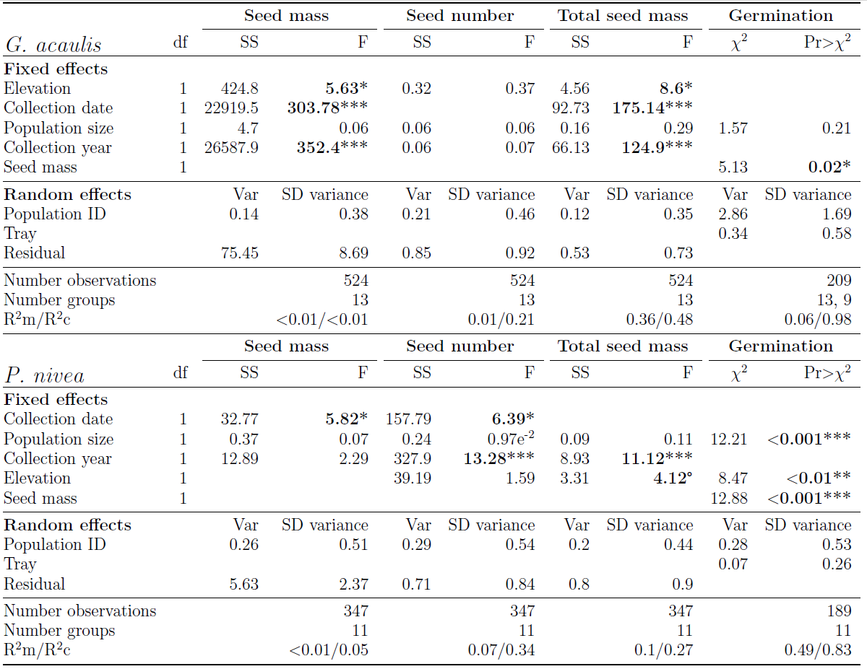

Table S4 Parameter estimates for mixed effect models investigating the effects of population size on fitness traits among populations of the common Androsace chamaejasme and the rare A. puberula. We tested each fitness trait separately within species. Numeric variables were z-transformed and population size, seed number and total seed mass per fruit were transformed with the decadic logarithm. For A. puberula, we transformed seed mass with the decadic logarithm. Seed set (whether a fruit contained viable seeds or not) was fitted as binomial response variable. Final models contained only fixed effects for which there are statistical values in the table (χ²: Chi squared, SS: sum of squares, F: F-statistics, df: degrees of freedom; type II Wald χ²-square tests for generalised mixed effect models, type III F-tests based on Satterthwaite's method for linear mixed effect models). Number of groups indicate the number of levels for each of the random effects. For the variables included in the final models, significance levels are given: p < 0.1; °, p < 0.05; *, p < 0.01; **, p < 0.001; ***.
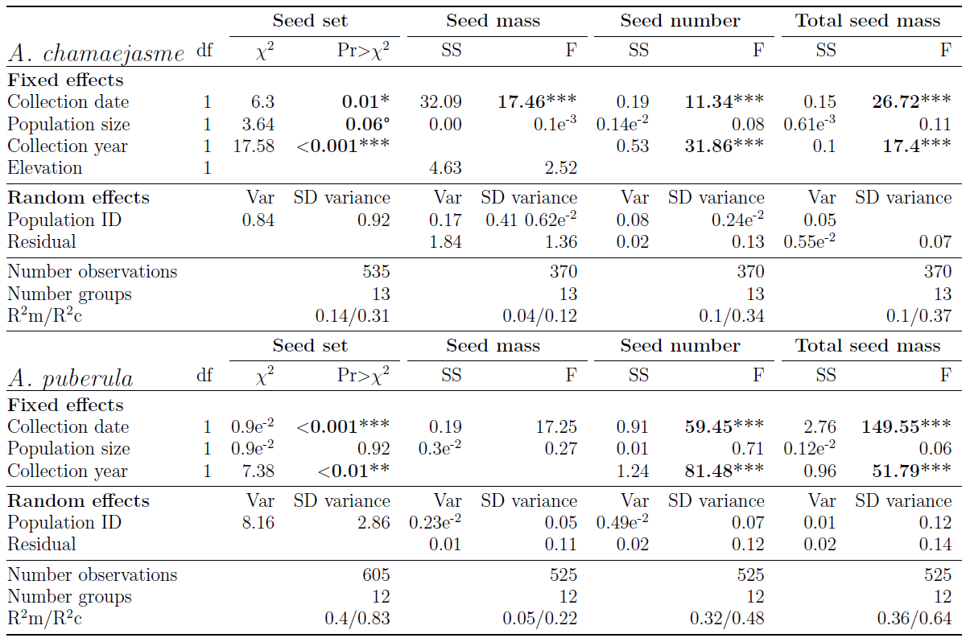

Table S5 Parameter estimates for mixed effect models investigating the effects of population size on fitness traits among populations of the common Viola calcarata the rare V. lutea. We tested each fitness trait separately within species. Numeric variables were z-transformed and population size, seed mass, seed number and total seed mass per fruit were transformed with the decadic logarithm. Seed set (whether a fruit contained viable seeds or not) was fitted as binomial response variable. Final models contained only fixed effects for which there are statistical values in the table (χ²: Chi squared, SS: sum of squares, F: F-statistics, df: degrees of freedom; type II Wald χ²-square tests for generalised mixed effect models, type III F-tests based on Satterthwaite's method for linear mixed effect models). Number of groups indicate the number of levels for each of the random effects. For the variables included in the final models, significance levels are given: p < 0.1; °, p < 0.05; *, p < 0.01; **, p < 0.001
