Relationships between population size and fitness in four common and four rare alpine plant species
Alpine Botany
Hannah Inniger¹, Daniel Prati¹, Markus Fischer¹
¹ Institute of Plant Sciences, University of Bern, Bern, Switzerland
hannah.inniger@gmail.com

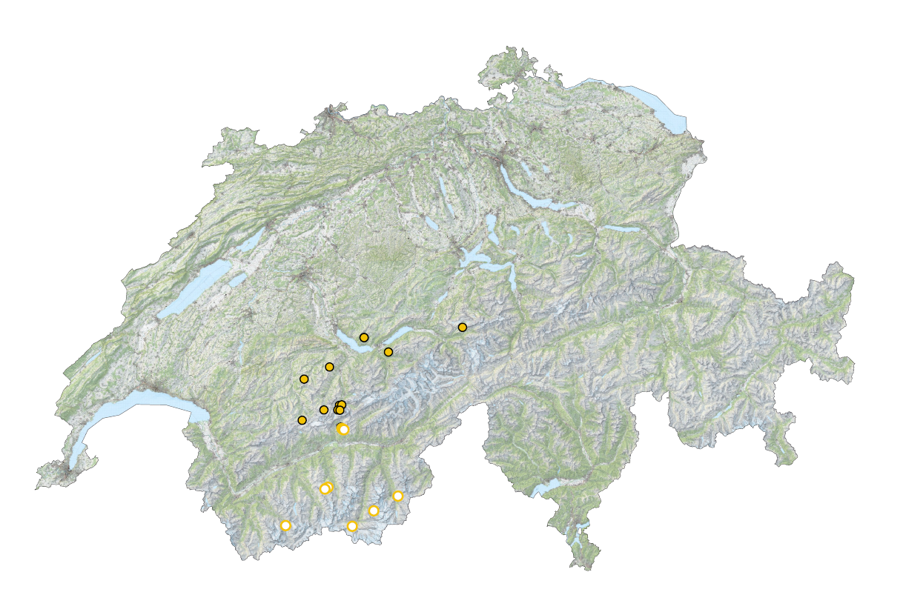
Fig. S2 Map of Switzerland (swisstopo.ch) with locations of sampled populations of the common Androsace chamaejasme (yellow dots with black outline, N = 12) and the rare Androsace puberula (white dots with yellow outline, N = 11). Dots are sometimes overlapping, however, the minimum distance between two populations was 250m. Maps were edited by Judith Hinderling in QGIS.
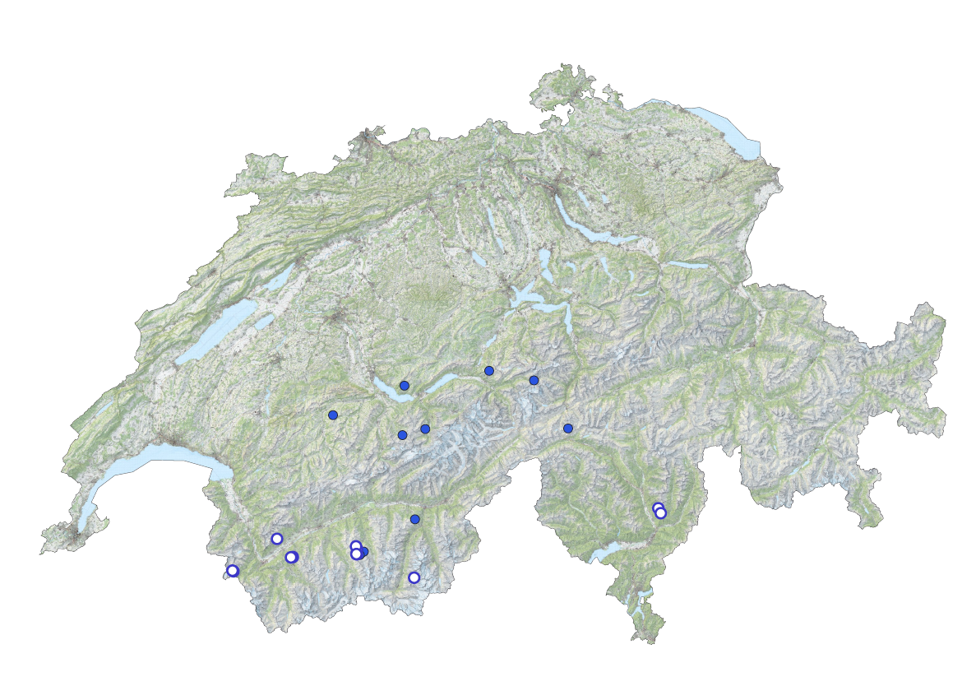
Fig. S3 Map of Switzerland (swisstopo.ch) with locations of sampled populations of the common Gentiana acaulis (blue dots with black outline, N = 12) and the rare Gentiana alpina (white dots with blue outline, N = 11). Dots are sometimes overlapping, however, the minimum distance between two populations was 250m. Maps were edited by Judith Hinderling in QGIS.
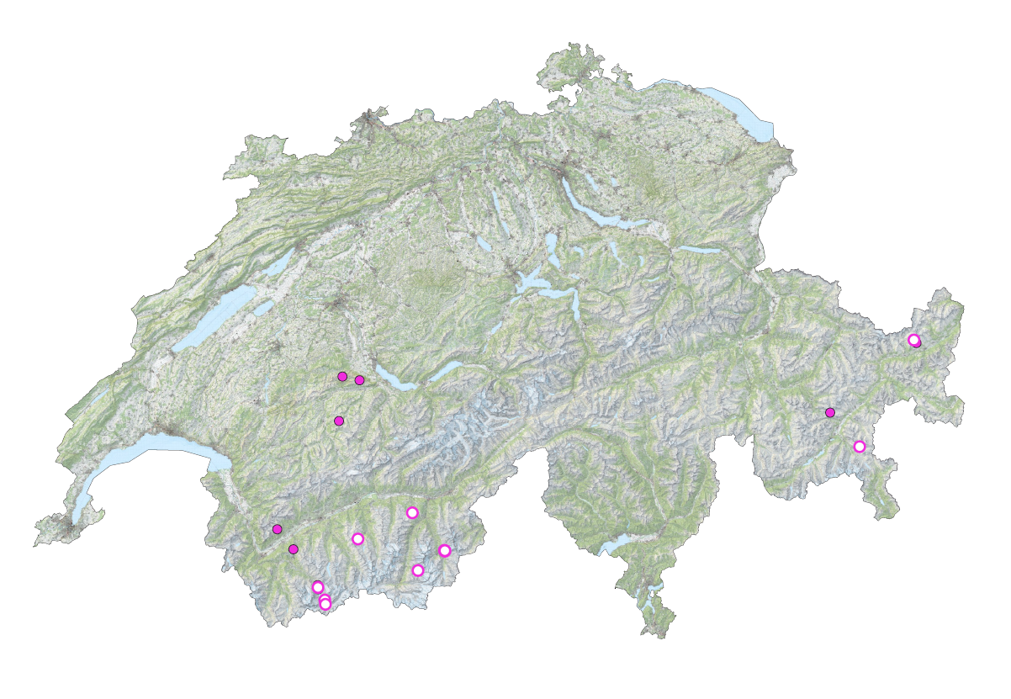
Fig. S4 Map of Switzerland (swisstopo.ch) with locations of sampled populations of the common Potentilla crantzii (pink dots with black outline, N = 11) and the rare Potentilla nivea (white dots with pink outline, N = 11). Dots are sometimes overlapping, however, the minimum distance between two populations was 250m. Maps were edited by Judith Hinderling in QGIS.
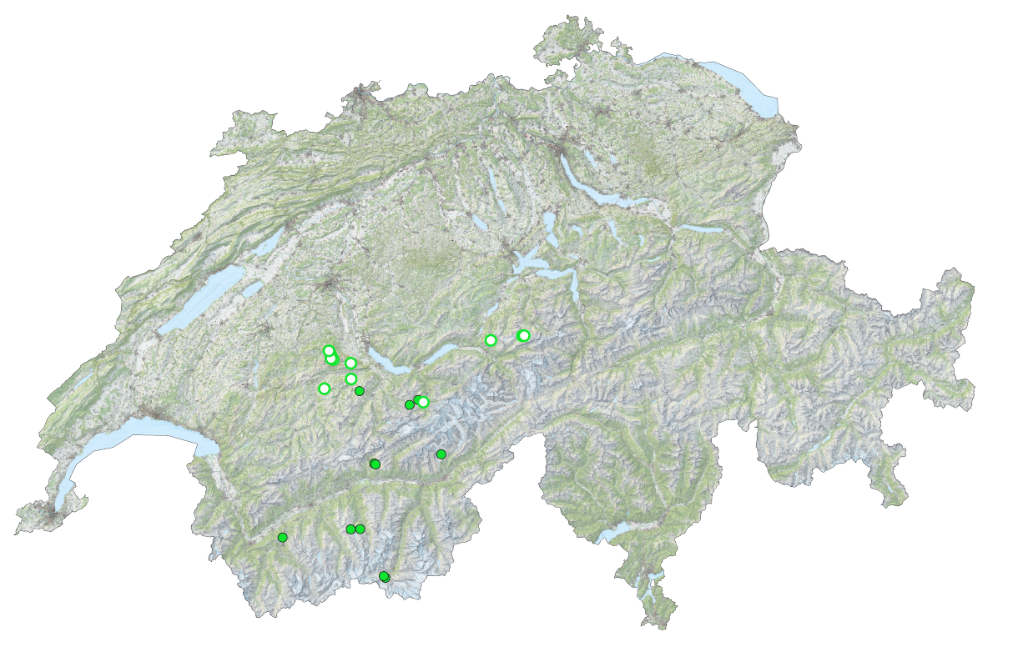
Fig. S5 Map of Switzerland (swisstopo.ch) with locations of sampled populations of the common Viola calcarata (green dots with black outline, N = 10) and the rare Viola lutea (white dots with green outline, N = 11). Dots are sometimes overlapping, however, the minimum distance between two populations was 250m. Maps were edited by Judith Hinderling in QGIS.

