Supplementary information
Bacterial growth in presence of bile acids with and without ¹³C-CA.
Growth was measured with OD₆₀₀ immediately before sample collection. All strains reached their maximum growth within 24 to 32 hours after the initial inoculation with an exponential phase culture after growth for approximately 12 hours (Supplementary Figure 10). The higher concentration of CDCA had an impact on bacterial growth although results were not as clear as previously reported¹⁹. Amendment of ¹³C-CA did not have an impact on bacterial growth, as the cultures generally followed the same growth curve as the CA group (without ¹³C-CA) (Supplementary Figure 10, D and F). The higher count of timepoints in the C. scindens ATCC 35704 was caused by a longer lag phase than expected which forced to follow closer the growth of this bacterium in order to capture the optimal RNA sample collection point (mid-log to late-log phase).

In vitro transformation of βMCA and impact of ¹³C-CA
As with αMCA, novel unknown compounds were detected in the presence of ¹³C-CA, albeit at lower concentrations and only in the highly active C. scindens VPI 12708. None of the strains tested had any detectable activity from βMCA when on its own. C. scindens ATCC 35704 had minute amounts of an unidentified oxo form labelled X-oxoβMCA with a maximum of 3.38 µM at 32 hours (Supplementary Figure 9A) (hypothetically, 3-oxo-6β,7β-Dihydroxy-5β-cholan-24-oic acid). C. scindens VPI 12708 amended with ¹³C-CA yielded a higher diversity of secondary BAs, although concentrations remained low. Small concentrations of 6-oxoMDCA were detected at the 32- and 48-hour time points, with its maximum at 0.42 µM after 32 hours (Supplementary Figure 9B). X- and Y- oxoβMCA forms were detected at maximum concentrations of 3.55 µM (32 hours) and 0.33 µM (48 hours), respectively (hypothetically, 3-oxo-6β,7β-Dihydroxy-5β-cholan-24-oic acid or 6-oxo-3α,7β-Dihydroxy-5β-cholan-24-oic acid). Moreover, very low concentrations of another BA with the same mass as 6-oxoMDCA (one oxidation and one dehydroxylation) were also detected at a maximum of 0.71 µM after 48 hours) (Supplementary Figure 9B) (currently unknown). E. muris SJ24 did not present any activity in the experiment that included ¹³C-CA (Supplementary Figure 9C), replicating the results observed from the αMCA group.

Supplementary Table 1. Experimental layout for in vitro 7-dehydroxylation assays. Single BA and BA + ¹³C-CA experiments were performed at different times for technical reasons. CA (100 µM) was included as a comparison to the single BA experiment. Growth conditions can be found in Materials and Methods. No BA control included an equivalent volume of solvent (ethanol). All three bacteria were tested using the same design. Each group had biological triplicates.
Single BA experiments
100 µM CA | 200 µM CDCA | 100 µM UDCA | 100 µM αMCA | 100 µM βMCA | No BA control

BA + ¹³C-CA experiments
100 µM CA | 200 µM CDCA + 100 µM ¹³C-CA | 100 µM UDCA + 100 µM ¹³C-CA | 100 µM αMCA + 100 µM ¹³C-CA | 100 µM βMCA + 100 µM ¹³C-CA | No BA control

Supplementary Table 2. Quantification Cycle (Cq) values of E. muris SJ24 bai genes in vivo. The values obtained from Oligo-MM12 control groups correspond to the non-specific, background amplification (corroborated by analysing their melting curve). Averages and standard deviations were calculated from three biological replicates with four technical replicates done in each case. Non template control (NTC) was done with only one replicate due to space constraints in the thermocycler. Each fold change (∆Cq = 1) corresponds to a power of 2 difference in expression. i. e., if the ∆Cq of baiCD equals 6.41, meaning that there is 2^6.41 times more signal from the Oligo-MM12 + E. muris SJ24 than the background. This difference and the specific melting curve (not shown) are enough to confirm expression of baiCD in vivo.
Gene | Cq average +/- std. dev.  Oligo-MM12 + E. muris SJ24 | Cq average and std. dev.  Oligo-MM12 control | Cq of NTC
baiCD | 29.03 +/- 0.93 | 35.44 +/- 44 | 37.41
baiE | 29.00 +/- 0.83 | 40.58 +/- 1.93 | 36.89
baiJ pseudogene | 26.15+/-0.75 | 31.83 +/- 1.23 | No signal
baiO | 27.07 +/- 0.89 | 35.05 +/- 0.91 | 36.13

Supplementary Table 3. RT-qPCR primer table. Primers labelled “Scindens” were used for both Clostridium scindens ATCC 35704 and VPI 12708 strain. All primers were tested for efficiency and redesigned if necessary.
Primer name | Primer sequence 5’ – 3’
Scindens_recA.Fw | GGAGAACGCCAAGTCATATCTG
Scindens_recA.Rv | TCTTCCGACTTCTCTTCTCCTG
Scindens_rho.Fw | AAGATATGACCCCGATCTTCCC
Scindens_rho.Rv | GGATACGATCATTCCCCTCTGT
Scindens_rpsJ.Fw | GTAGTGACAATCTTAAGGGCGG
Scindens_rpsJ.Rv | CAGCCGGCATCTCTAATCTAGA
Scindens_adk.Fw | GCCGCAAAGTATGGTATTCCTC
Scindens_adk.Rv | GTACCAGAAGTCCCTGATCCAT
Scindens_16S.Fw | TATTAGGAGGAACACCAGTGGC
Scindens_16S.Rv | CTAGTAGTCATCGTTTACGGCG
Scindens_gyrB.Fw | CCGGATGACACTATTTTCGAGG
Scindens_gyrB.Rv | CTCCGGTCTTTCATCCCTAAGT
Scindens_rpoB.Fw | TCCACAGGACCATATTCTCTGG
Scindens_rpoB.Rv | GACTTCACAGTCAGGATCTCCT
Scindens35704_baiCD.Fw | CTTAAGAACCGTATCGTCCTGC
Scindens35704_baiCD.Rv | CCGGACATAAGGCTACACATTC
Scindens35704_baiE.Fw | GATCTTTACGGACGGCAAGTAC
Scindens35704_baiE.Rv | GCCTGTTTCAAGGATGTACCAC
Scindens35704_baiJ.Fw | GCAGAGAGAGCAGGGAATCTAT
Scindens35704_baiJ.Rv | CCATCTTGATCAGCCATTCCAG
Scindens12708_baiCD.Fw | GAATACCGAAGTGACTGCAGAG
Scindens12708_baiCD.Rv | CATAGGTAGAGCCTACTGCGAT
Scindens12708_baiE.Fw | AAAGACGTAGGAATCAATGGCG
Scindens12708_baiE.Rv | GGATCTTTGGATCACGCATGAA
Scindens12708_baiJ.Fw | CCAGTATCATGTATCCGATGCG
Scindens12708_baiJ.Fw | CTGCTTGAACCCATACTGTACG
MurisSJ24_L3p.Fw | AAGATGCCTGGACATATGGGAA
MurisSJ24_L3p.Rv | CTAAAGATTTCTTCGGTCCCGG
MurisSJ24_16S.Fw | GGGGATAACAGCTAGAAATGGC
MurisSJ24_16.Rv | TACCGCACCAACTACCTAATCA
MurisSJ24_recA.Fw | GGGAGAAGGTAGGGATCATGTT
MurisSJ24_recA.Rv | ACGGATAGACGCGTAGAACTTA
MurisSJ24_rpoB.Fw | AGGTATGGAAGAAAAAGCTGCC
MurisSJ24_rpoB.Rv | CTCATTGGAAGTAGAGCGTTCC
MurisSJ24_gyrB.Fw | CGGTTGAAAAATCAGTCATGGC
MurisSJ24_gyrB.Rv | TTTTTGGGTCTTTGTCGGAACA
MurisSJ24_baiCD.Fw | TGTGACTCCGGAACTGATAGAG
MurisSJ24_baiCD.Rv | CCTTTGAGCACTTCATACTGGG
MurisSJ24_baiE.Fw | ATCGTGACCTCTTACTCCGATG
MurisSJ24_baiE.Rv | GCGGTAGTATCGCTGTCTATTG
MurisSJ24_pseudogenebaiJ.Fw | GGCAGAAGAAACAAGGCATCTT
MurisSJ24_pseudogenebaiJ.Rv | CGTCTTTGCACGTATAGAAGCT
MurisSJ24_baiO.Fw | ATTCTATCGAGACGATGGGAGG
MurisSJ24_baiO.Rv | CTCCTGTCTGCGTATCTTCAAC

Supplementary Table 4. List of bile acids quantified with the LC-MS and chromatogram with all standards. (*) Also known as 6-oxolithocholic acid (6-oxoLCA).
Bile acid common name | Abbreviations | Synonym
12-oxolithocholic acid | 12-oxoLCA | (3α,5β)-3-Hydroxy-12-oxocholan-24-oic acid
3-oxochenodeoxycholic acid | 3-oxoCDCA | 5β-Cholanic acid-7α-ol-3-one
3-oxolithocholic acid | 3-oxoLCA | 3-Oxo-5β-cholan-24-oic acid
6-oxo-allolithocholic acid | 6-oxo-alloLCA | 5α-Cholanic acid-3α-ol-6-one
7-oxodeoxycholic acid | 7-oxoDCA | 7-Ketodeoxycholic acid
Allolithocholic acid | alloLCA | (5α)-3β-Hydroxy-cholan-24-oic acid
α-muricholic acid | αMCA | 5β-Cholanic acid-3α,6β,7α-triol
Cholic acid | CA | 3α,7α,12α-Trihydroxy-5β-cholanic acid
Chenodeoxycholic acid-3-sulfate | CDCA3S | (3α,5β,7α)-7-Hydroxy-3-(sulphooxy)-cholan-24-oic Acid
Deoxycholic acid | DCA | 3α,12α-Dihydroxy-5β-cholanic acid sodium salt
Hyocholic acid | HCA | 3α,6α,7α-Trihydroxy-5β-cholanic acid
Hyodeoxycholic acid | HDCA | 3α,6α-Dihydroxy-5β-cholan-24-oic acid
Isolithocholic acid | isoLCA | (3β,5β)-3-Hydroxy-cholan-24-oic acid
Murideoxycholic acid | MDCA | 5β-Cholanic acid-3α, 6β-Diol
Tauro-β-muricholic acid | TβMCA | 5β-Cholanic acid-3α, 6β, 7β, -triol N-(2-sulphoethyl)-amide
Taurocholic acid-3-sulfate | TCA3S | Taurocholic acid 3-sulfate
Taurodeoxycholic acid | TDCA | Taurodeoxycholate
Taurolithocholic acid-3-sulfate | TLCA3S | Taurolithocholic acid 3-sulfate
Tauroursodeoxycholic acid | TUDCA | 3α,7β-Dihydroxy-5β-cholan-24-oic acid N-(2-sulphoethyl)-amide
Tauro-ω-muricholic acid | TωMCA | 5β-Cholanic acid-3α,6α,7β,-triol N-(2-sulphoethyl)-amide
12-oxoChenodeoxycholic acid | 12-oxoCDCA | 3α,7α-Dihydroxy-12-oxo-5β-cholanic acid
24-¹³C-cholic acid | 24-¹³C-CA | Cholic-24-¹³C acid
3-epi-deoxycholic acid | 3-epiDCA | 5β-Cholanic acid-3β,12α-diol
3-oxocholic acid | 3-oxoCA | 3-Oxo-7α,12α-hydroxy-5β-cholanoic acid
3-oxodeoxycholic acid | 3-oxoDCA | 5β-Cholanic acid-12α-ol-3-one
6-oxomurideoxycholic acid* | 6-oxoMDCA | 5-β-Cholanic acid-3α-ol-6-one
7,12-dioxolithocholic acid | 7,12-dioxoLCA | 5β-Cholanic acid-3α-ol-7, 12-dione
7-oxolithocholic acid | 7-oxoLCA | 3α-Hydroxy-7-oxo-5β-cholanic acid
β-muricholic acid | βMCA | 5β-Cholanic acid-3α,6β,7β-triol
Cholic acid-7-sulfate | CA7S | (3α,5β,7α,12α)-3,12-Dihydroxy-7-(sulfooxy)-cholan-24-oic acid
Chenodeoxycholic acid | CDCA | 5β-Cholanic acid-3α,7α-diol
Isodeoxycholic acid | isoDCA | 5β-Cholanic acid-7α,12α-diol
Lithocholic acid | LCA | 3α-Hydroxy-5β-cholan-24-oic acid
Tauro-α-muricholic acid | TαMCA | 5β-Cholanic acid-3α, 6β, 7α, -triol N-(2-sulphoethyl)-amide
Taurocholic acid | TCA | Taurocholate
Taurochenodeoxycholic acid | TCDCA | Taurochenodeoxycholate
Taurohyocholic acid | THCA | 5β-Cholanic acid-3α, 6α, 7α-triol N-(2-sulphoethyl)-amide
Taurohyodeoxycholic acid | THDCA | Taurohyodeoxycholate
Taurolithocholic acid | TLCA | Taurolithocholic acid
Tauromurideoxycholic acid | TMDCA | Tauromurideoxycholic acid
Ursodeoxycholic acid | UDCA | 5β-Cholan-24-oic acid-3α,7β-diol
ω-muricholic acid | ωMCA | 5β-Cholanic acid-3α, 6α, 7β-triol
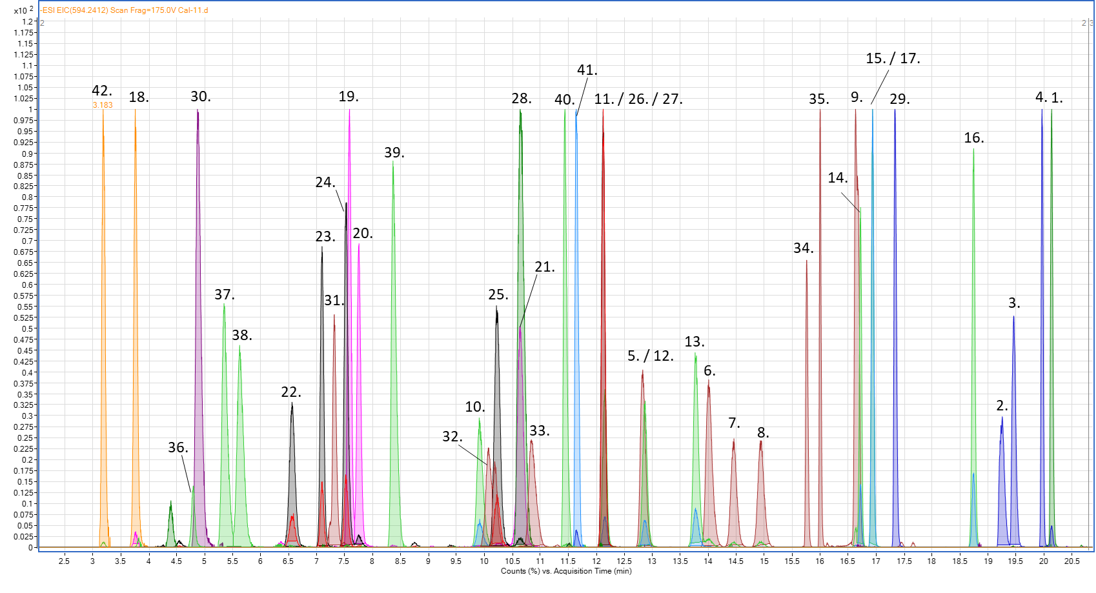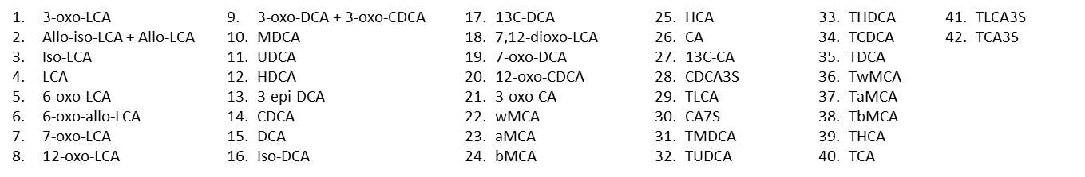
Supplementary Figure 1. In vitro 7-dehydroxylation of cholic acid by multiple strains. Bacteria were grown in BHIS-S in the presence of 100 µM of CA. This experiment is a repeat of that presented in Figure 2. However, it was performed at the same time as the experiment that included ¹³C-CA while the former was conducted at the same time as the experiment using single BAs. (A) Clostridium scindens ATCC 35704, (B) C. scindens VPI 12708 and (C) Extibacter muris DSM 28561 (SJ24). Bile acids were measured post-extraction from the suspended biomass. Error bars represent the standard deviation of the mean of biological triplicates.

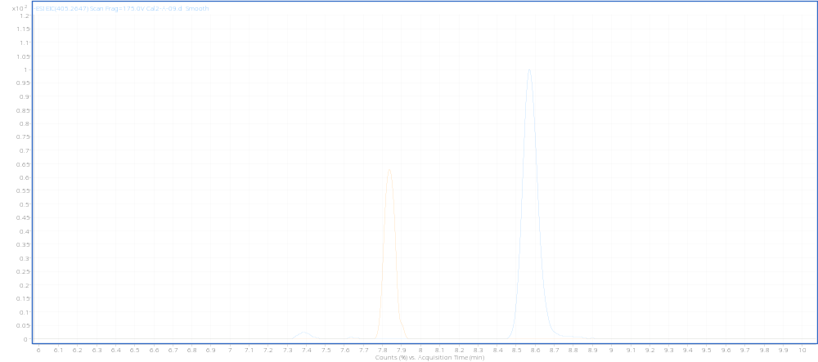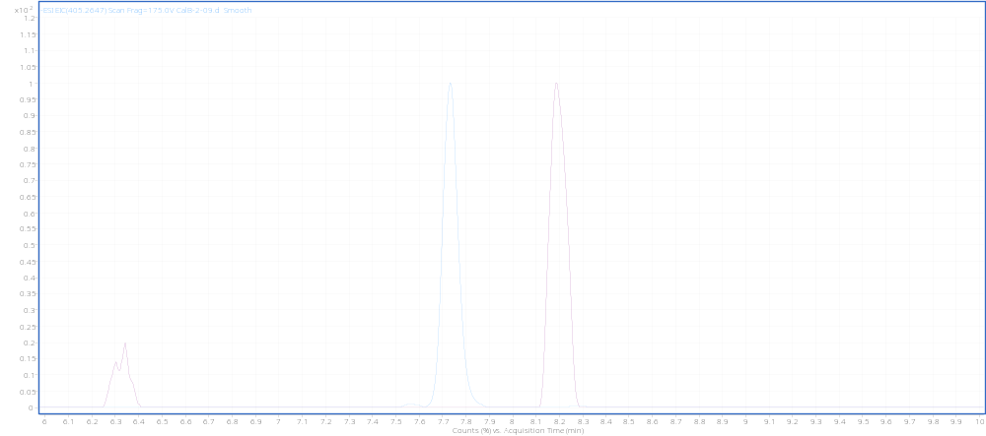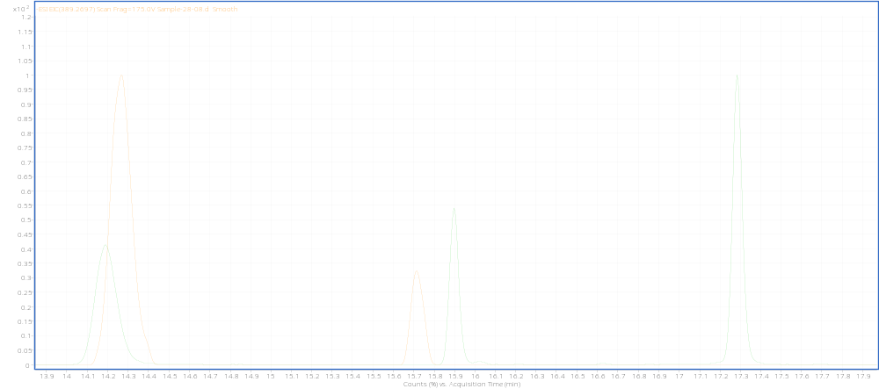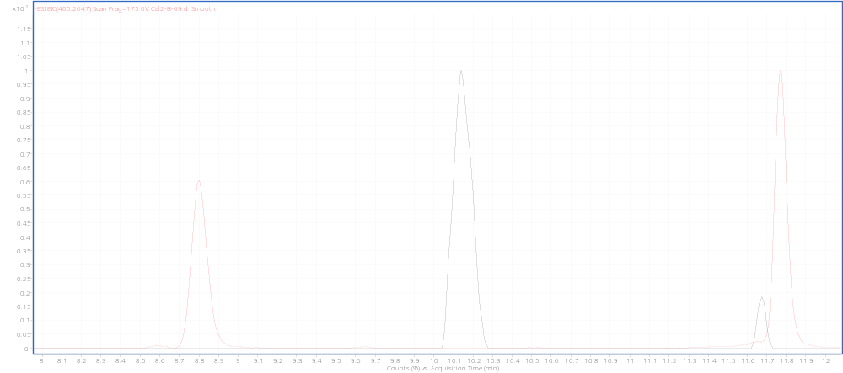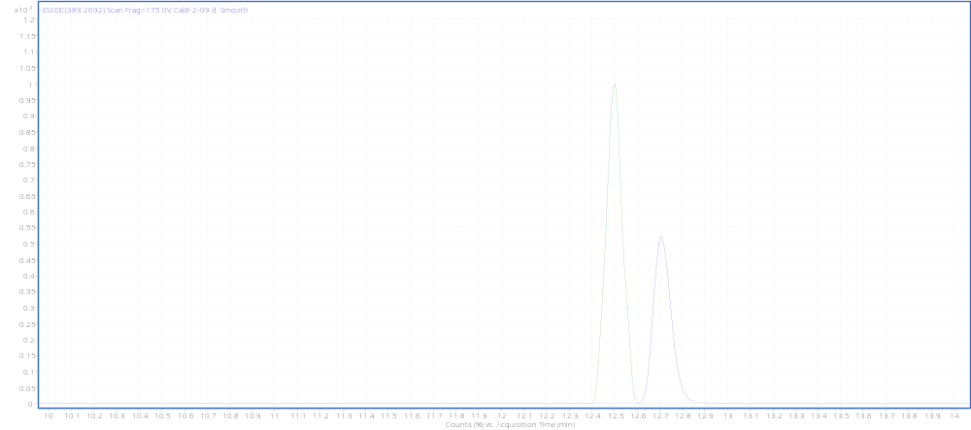
7-oxo-DCA STD
X-oxoαMCA (3-oxoαMCA or 6-oxoαMCA?)
A) m/z = 405.2647
12-oxoCDCA STD
Y-oxoαMCA (3-oxoαMCA or 6-oxoαMCA?)

B) m/z = 405.2647
3-oxoDCA STD
7-oxoLCA STD
Oxidised and dehydroxylated form of αMCA (3-oxoMDCA?)
6-oxoMDCA
6-oxoMDCA STD
C) m/z = 389.2697
X-oxoβMCA (3-oxoβMCA or 6-oxoβMCA?)
12-oxoCDCA STD
3-oxoCA STD
Y-oxoβMCA (3-oxoβMCA or 6-oxoβMCA?)
D) m/z = 405.2647
6-oxoMDCA STD
X-oxoUDCA (3-oxoUDCA?)
E) m/z = 389.2692
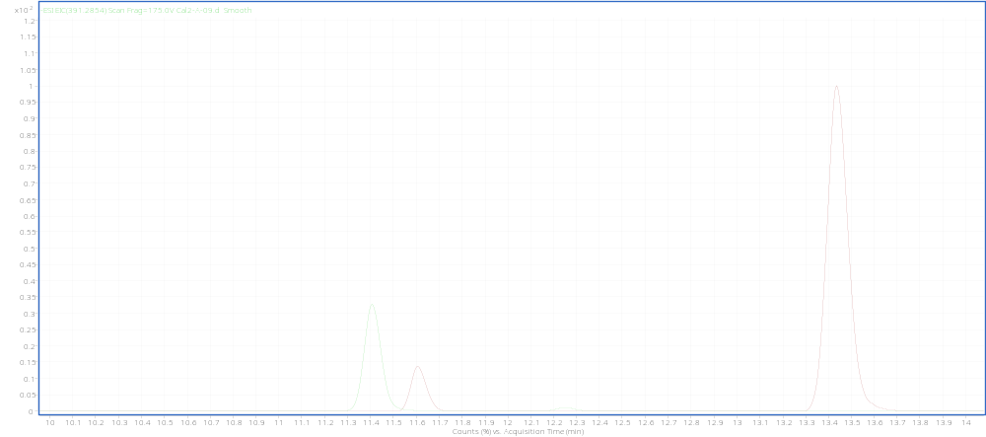
MDCA STD
Iso form of UDCA?
UDCA
F) m/z = 391.2854
Supplementary Figure 2. Extracted chromatograms for unknown bile acids identified in this study. Extracted chromatograms were chosen from a representative sample which contained one or more of the unknown BAs. Y axis represents signal intensity, X axis represents acquisition time in minutes (retention time). Chromatograms were set to “scale to largest in each chromatogram”. Shortened names are written in bold on top or near the peak. STD indicates standard. Extracted mass for each chromatogram is indicated on the top left corner. (A) X-oxoαMCA suggested to be 3- or 6- oxo-αMCA: 3-oxo-6β,7α-Dihydroxy-5β-cholan-24-oic acid or 6-oxo-3α,7α-Dihydroxy-5β-cholan-24-oic acid respectively. (B) Y-oxoαMCA suggested to be 3- or 6- oxo-αMCA: 3-oxo-6β,7α-Dihydroxy-5β-cholan-24-oic acid or 6-oxo-3α,7α-Dihydroxy-5β-cholan-24-oic acid respectively. We can’t assign a specific compound to either X-oxoαMCA or Y-oxoαMCA but can state that one is 3-oxo-αMCA and the other 6-oxo-αMCA. (C) The product of the oxidation and dehydroxylation of αMCA, suggested to be 3-oxoMDCA (3-oxo-6β-Hydroxy-5β-cholan-24-oic acid). (D) X-oxoβMCA and Y-oxoβMCA suggested to be 3- or 6- oxo-βMCA; 3-oxo-6β,7β-Dihydroxy-5β-cholan-24-oic acid or 6-oxo-3α,7β-Dihydroxy-5β-cholan-24-oic acid respectively. We can’t assign a specific compound to either X-oxoβMCA or Y-oxoβMCA but can state that one is 3-oxo-βMCA and the other 6-oxo-βMCA. (E) X-oxoUDCA suggested to be 3-oxoUDCA (3-oxo-7β-Hydroxy-5β-cholan-24-oic acid). (F) Proposed iso form of UDCA (3β,7β-Dihydroxy-5β-cholan-24-oic acid). None of these forms have available standards for purchase.

Supplementary Figure 3. 7-dehydroxylation of ¹³C-CA in the presence of the various primary bile acids tested (CDCA, αMCA, βMCA, UDCA). (A) Clostridium scindens ATCC 35704, (B) C. scindens VPI 12708 and (C) Extibacter muris DSM 28561 (SJ24). 100 µM of ¹³C-CA was used in addition to the other primary bile acids. Error bars represent the standard deviation of the mean from triplicates.

Supplementary Figure 4. C. scindens VPI 12708 baiCD, baiE and baiJ gene expression ratio in the presence of CDCA with and without ¹³C-CA. This figure is a detail of the same values shown in Figure 6B. Coloured dots represent individual replicates. Boxplot shown with minimum and maximum bars. Differences between single BA and BA + ¹³C-CA conditions were significant (p-values shown above the pairwise comparisons) when using a paired Wilcoxon test but not when doing a more complete linear model analysis as performed in Figure 6.

Supplementary Figure 5. rhaS gene expression in the presence of various primary BAs in Clostridium scindens ATCC 35704. The rhaS1 gene is also known as barA. At least three reference genes were used and a control group with an equivalent volume of solvent (ethanol) to that used in the groups with bile acids. CA, UDCA, αMCA, βMCA were used at 100 µM, CDCA was used at 200 µM. Dots represent the average and error bars represent the standard deviation from 12 replicates.

Supplementary Figure 6. E. muris DSM 28561 (SJ24) baiCD, baiE, pseudogene baiJ and baiO gene expression. (A) In presence of various BA cocktails and (B) in presence of 25 mg of cecal content from germ-free mice or from oligo-MM12 mice (cecal content mixed with 5% glycerol). For each experiment, the expression (normalized to at least three reference genes) is relative to a 100 µM CA condition that was included as a control. The composition of the BA cocktails is detailed in the materials and methods section of the paper. (A) Coloured dots represent the average and error bars represent the standard deviation of 12 replicates. (B) Box and whiskers highlight five-number summary for each group (maximum value, 75th percentile, median, 25th percentile and minimum value), the dot within each box shows the position of the mean. A two-way ANOVA did not find any significance in the differences between treatment groups for either assay.

Supplementary Figure 7. Control groups of cecal content with 100 µM of CA added. Control groups from Figure 8. 25 mg of (A) cecal content from germ-free mice and (B) cecal content from Oligo-MM12 colonized mice. The mass imbalance between the added CA (100 µM) and the measured (aprox. 80 µM) can be attributed to the presence of CoA- forms that cannot currently be quantified due to lack of pure standards. Error bars represent the standard deviation of biological triplicates.

Supplementary Figure 8. BA pool of Oligo-MM12 mice with and without E. muris SJ24. BAs were extracted from cecal content frozen immediately after sacrifice and until extraction and quantification. Results are presented as nM per gram of dry weight. Values within the cells represent the median value of 4 (Oligo-MM12 control) or 5 (Oligo-MM12 + E. muris SJ24) biological replicates. Arrows are used to highlight the secondary 7-DH-ed BAs DCA, TDCA, LCA and MDCA, exclusively present in the Oligo-MM12 + E. muris SJ24 group.

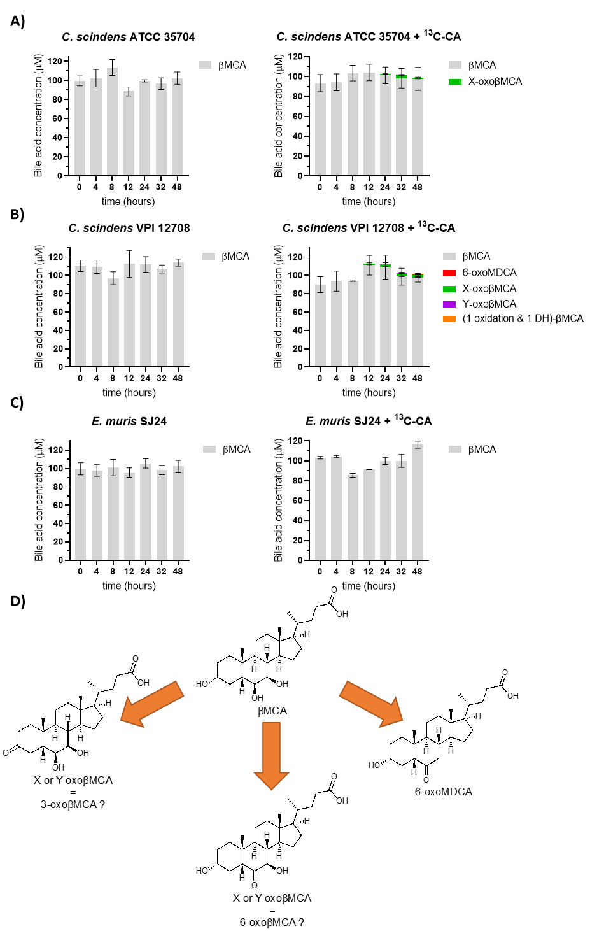
Supplementary Figure 9. In vitro 7-dehydroxylation of βMCA. The transformation of 100 µM of βMCA into secondary bile acids was tested with and without 100 µM of ¹³C-CA. (A) Clostridium scindens ATCC 35704, (B) C. scindens VPI 12708 and (C) Extibacter muris DSM 28561 (SJ24) were grown anaerobically in BHIS-S. Bile acids were extracted from suspended biomass. (D) Several compounds were detected that could not be identified due to missing standards but their oxidative state can be estimated based on their ionised mass. X- or Y- oxoβMCA had the same mass as other bile acids with one ketone group and two hydroxyl groups. The other unidentified compound had the same mass as secondary bile acids that have been dehydroxylated (-1 -OH), have one ketone group and one hydroxyl group. The retention times for these compounds was unique and therefore could not be identified further. Concentration values of the unknown BAs could only be estimated for the same reason. Error bars represent the standard deviation of the mean of biological triplicates.

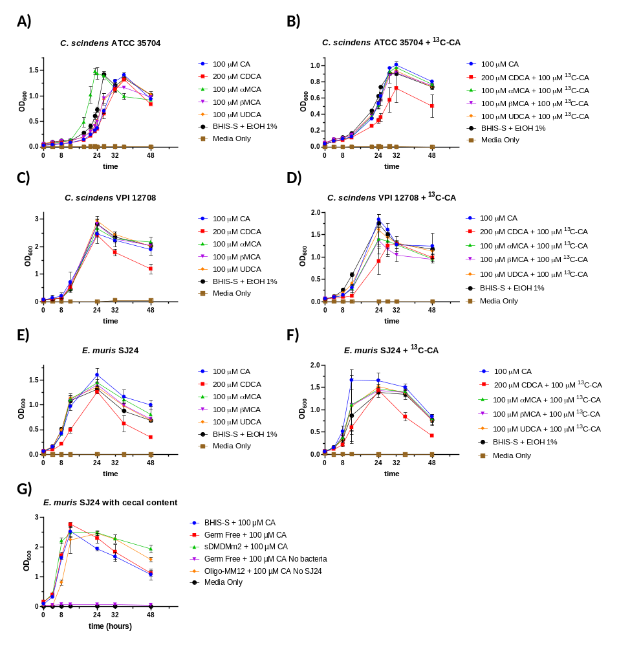
Supplementary Figure 10. Growth curves of 7-dehydroxylating bacteria strains in various primary bile acids. Bacteria were grown anaerobically in BHIS-S medium with CA, CDCA, αMCA, βMCA, or UDCA (A-F) or with 25 mg of cecal content (G) and a control with only the ethanol solvent (BHIS-S + EtOH 1%). Some experiments (B, D and F) received an additional 100 µM ¹³C-CA. A sterile control was included (Media Only). (A-B) Clostridium scindens ATCC 35704, (C-D) C. scindens VPI 12708, (E-G) Extibacter muris DSM 28561 (SJ24). Error bars represent the standard deviation calculated from biological triplicates.

