Supporting Information

Universal insights into the origin of ferroelectricity in doped hafnia
Gang Li^{1,2,#}, Shaoan Yan^{2,#}, Yulin Liu³, Wanli Zhang⁴, Yongguang Xiao³, Qiong Yang³, Minghua Tang^{3,5,*}, Jiangyu Li^{6,7,*}, Zhilin Long^{1,*}
¹College of Civil Engineering, Xiangtan University, Xiangtan 411105, China
²School of Mechanical Engineering and Mechanics, Xiangtan University, Xiangtan 411105, China
³School of Materials Science and Engineering, Xiangtan University, Xiangtan 411105, China
⁴ Key Laboratory of Micro Nano Optoelectronic Devices and Intelligent Perception Systems, Yangtze Normal University, Chongqing, 408100, China
⁵The National Center for Applied Mathematics in Hunan, Xiangtan University, Xiangtan, 411105, China
⁶Department of Materials Science and Engineering, Southern University of Science and Technology, Shenzhen, 518055, China
⁷Guangdong Provincial Key Laboratory of Functional Oxide Materials and Devices, Southern University of Science and Technology, Shenzhen, 518055, China
#These authors contributed equally to this work: Gang Li, Shaoan Yan
*E-mail address: tangminghua@xtu.edu.cn, lijy@sustech.edu.cn , longzl@xtu.edu.cn

Tab. S1 Lattice parameters (in Å) of the bulk phases of HfO₂ compared with previous theory computational studies and experiments. For the monoclinic (m) phase, β is the angle between a and c, which is the only non-perpendicular angle for this phase.
Phase | Lattice parameters | our work | Theory ^{[1]} | Experiment
Fm$\overline{\text{3}}$m (c) | a (Å) | 5.07 | 5.06 | 5.08 ^{[2]}
P4₂/nmc (t) | a, c (Å) | 5.07, 5.23 | 5.07, 5.19 | 5.06, 5.20 ^{[3]}
P2₁/c (m) | a, b, c (Å) | 5.14, 5.19, 5.25 | 5.11, 5.18, 5.30 | 5.12, 5.18, 5.29
P2₁/c (m) | β | 99.7° | 99.6° | 99.7° ^{[4]}
Pca2₁ (f) | a, b, c (Å) | 5.27, 5.05, 5.08 | 5.25, 5.04, 5.07 | 5.24, 5.06, 5.07 ^{[5]}
Pbca (o) | a, b, c (Å) | 10.06, 5.25, 5.08 | 10.05, 5.22, 5.04 | 10.02, 5.23, 5.06 ^{[6]}

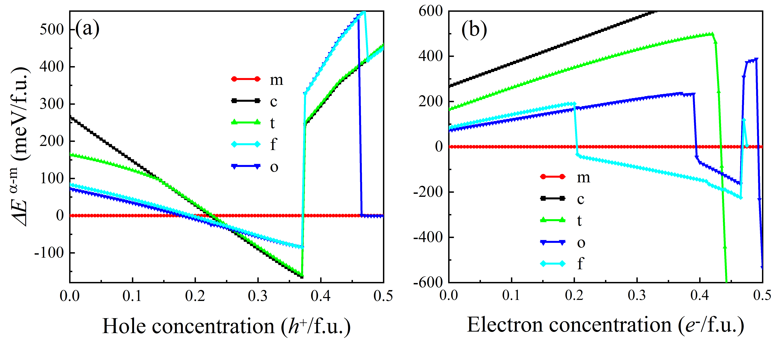
Figure S1 The phase energy differences for each HfO₂ relative to the m phase as a function of hole concentration (a) and electron concentration (b), ΔE^{α-m}=E^{α}-E^{m}, where E^{α} and E^{m} are the DFT computed energies of the doped α (α=m, c, t, f, o) and m phases, respectively. The lines are a guide to the eyes.

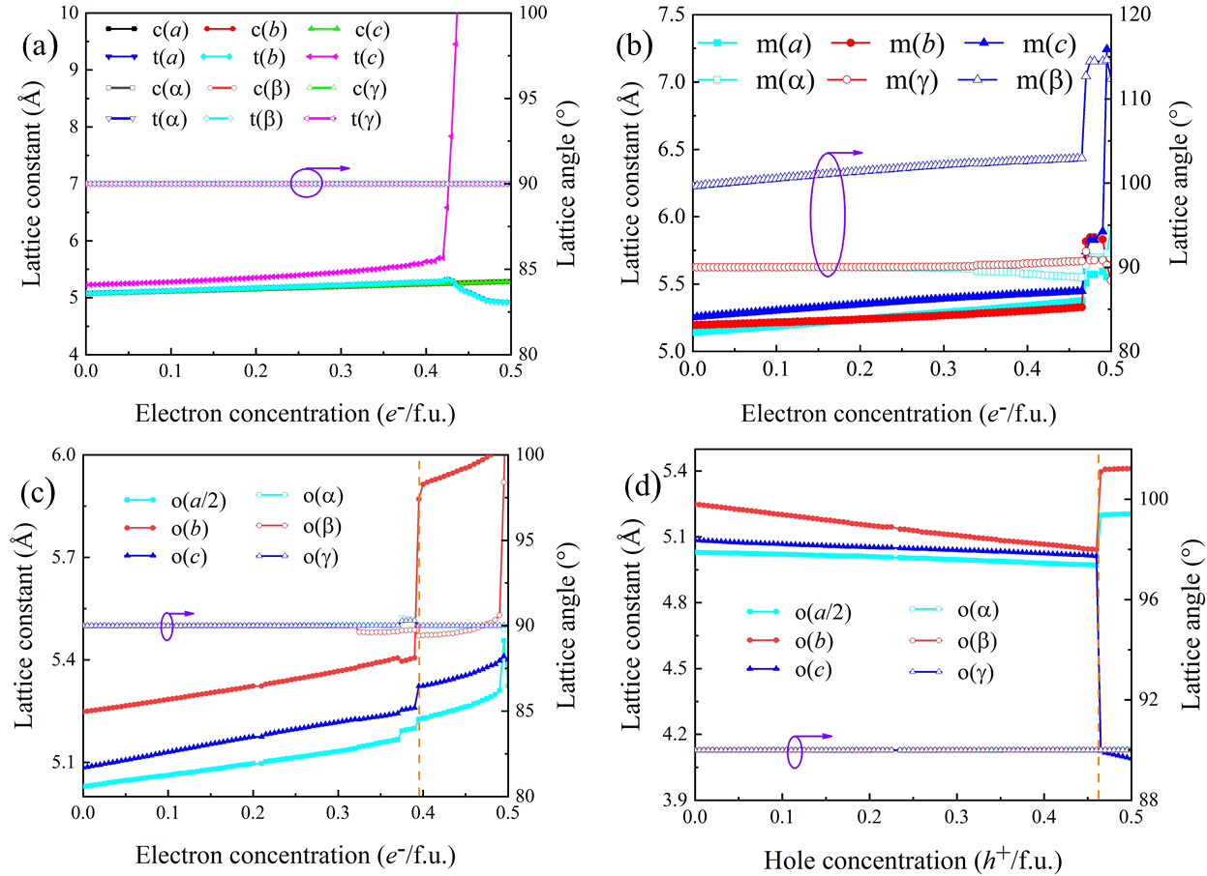
Figure S2 The lattice constant (a, b, c) and angle (α, β, γ) of the o-phase bulk HfO₂ versus hole concentration (a) and electron concentration (b), The vertical orange-yellow dashed line indicates that the phase structure transition occurs here.

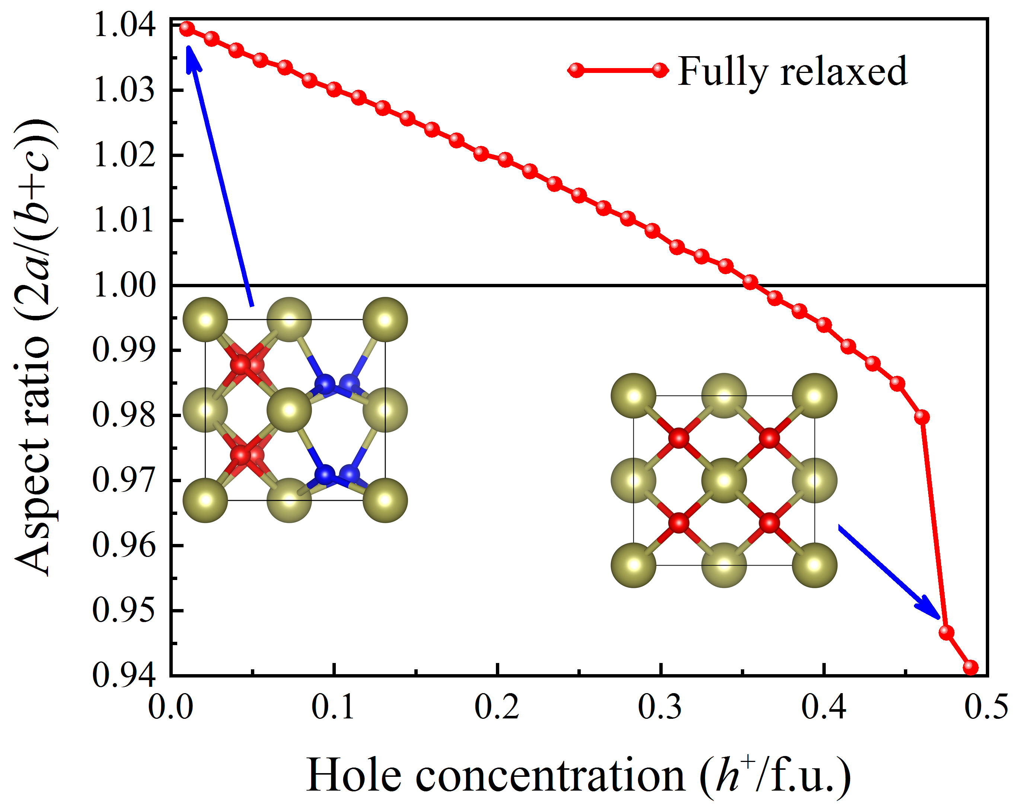
Figure S3 Aspect ratio 2a/(b+c) for the f-phase as a function of the hole concentration.

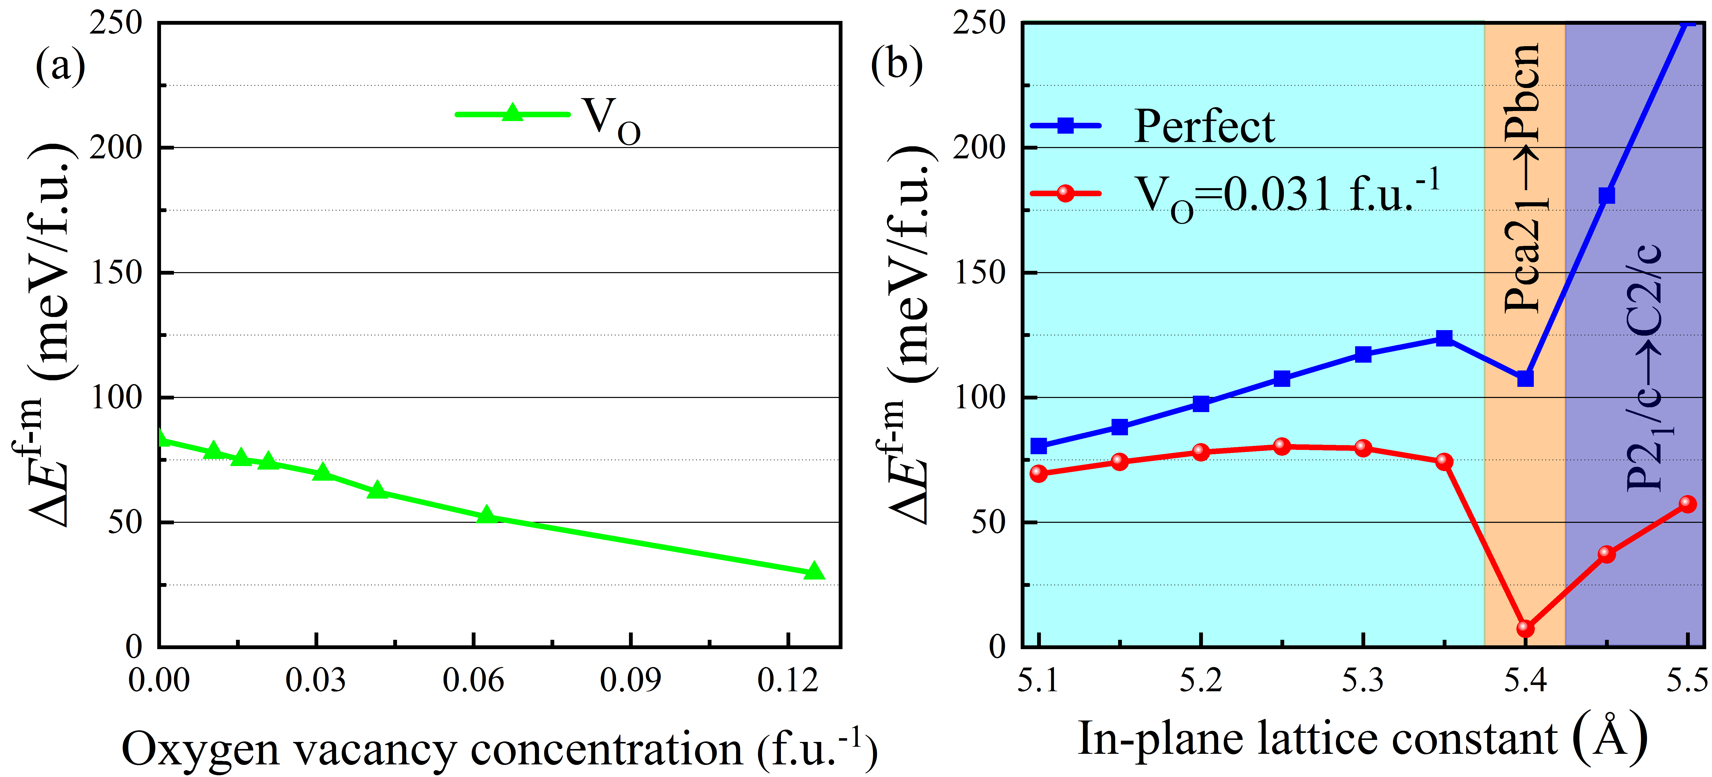
Figure S4 (a) Phase energy difference ΔE^{f-m} of bulk HfO₂ with in-phase strain as a function of oxygen vacancy (V_{O}) concentration. It can be seen that the ΔE^{f-m} is relatively large even at a large V_{O}=0.125 f.u.⁻¹. (b) Phase energy difference ΔE^{f-m} of HfO₂ with or without oxygen vacancy as a function of in-plane lattice constant, this is to simulate the tensile strain of hafnia grown on different substrates. With only tensile strain, ΔE^{f-m} is very large, even if the phase transitions to f″ phase, making hafnia ferroelectricity more unlikely. But once oxygen vacancies exist, the ΔE^{f-m} is significantly lowered after phase transitions, indicating that oxygen vacancies are beneficial to stabilize the ferroelectric phase of hafnia. Interestingly, the lattice constant of the Si substrate is 5.43 Å. Remove an oxygen atom in the supercell of 2×2×3, 2×2×2, 3×2×1, 2×2×1, 1×1×3, 1×1×2, and 1×1×1 to obtain the oxygen vacancy (V_{O}) concentration of 0.011, 0.016, 0.021, 0.031, 0.041, 0.063, and 0.125, respectively. The number of electrons introduced into the system is twice that of Ta doping. The phase transition of f phase HfO₂ occurs when the in-plane lattice constant reaches 5.4 Å, from Pca2₁ to Pbcn, while the phase transition of m phase HfO₂ takes place at 5.45 Å, from P2₁/c to C2/c.
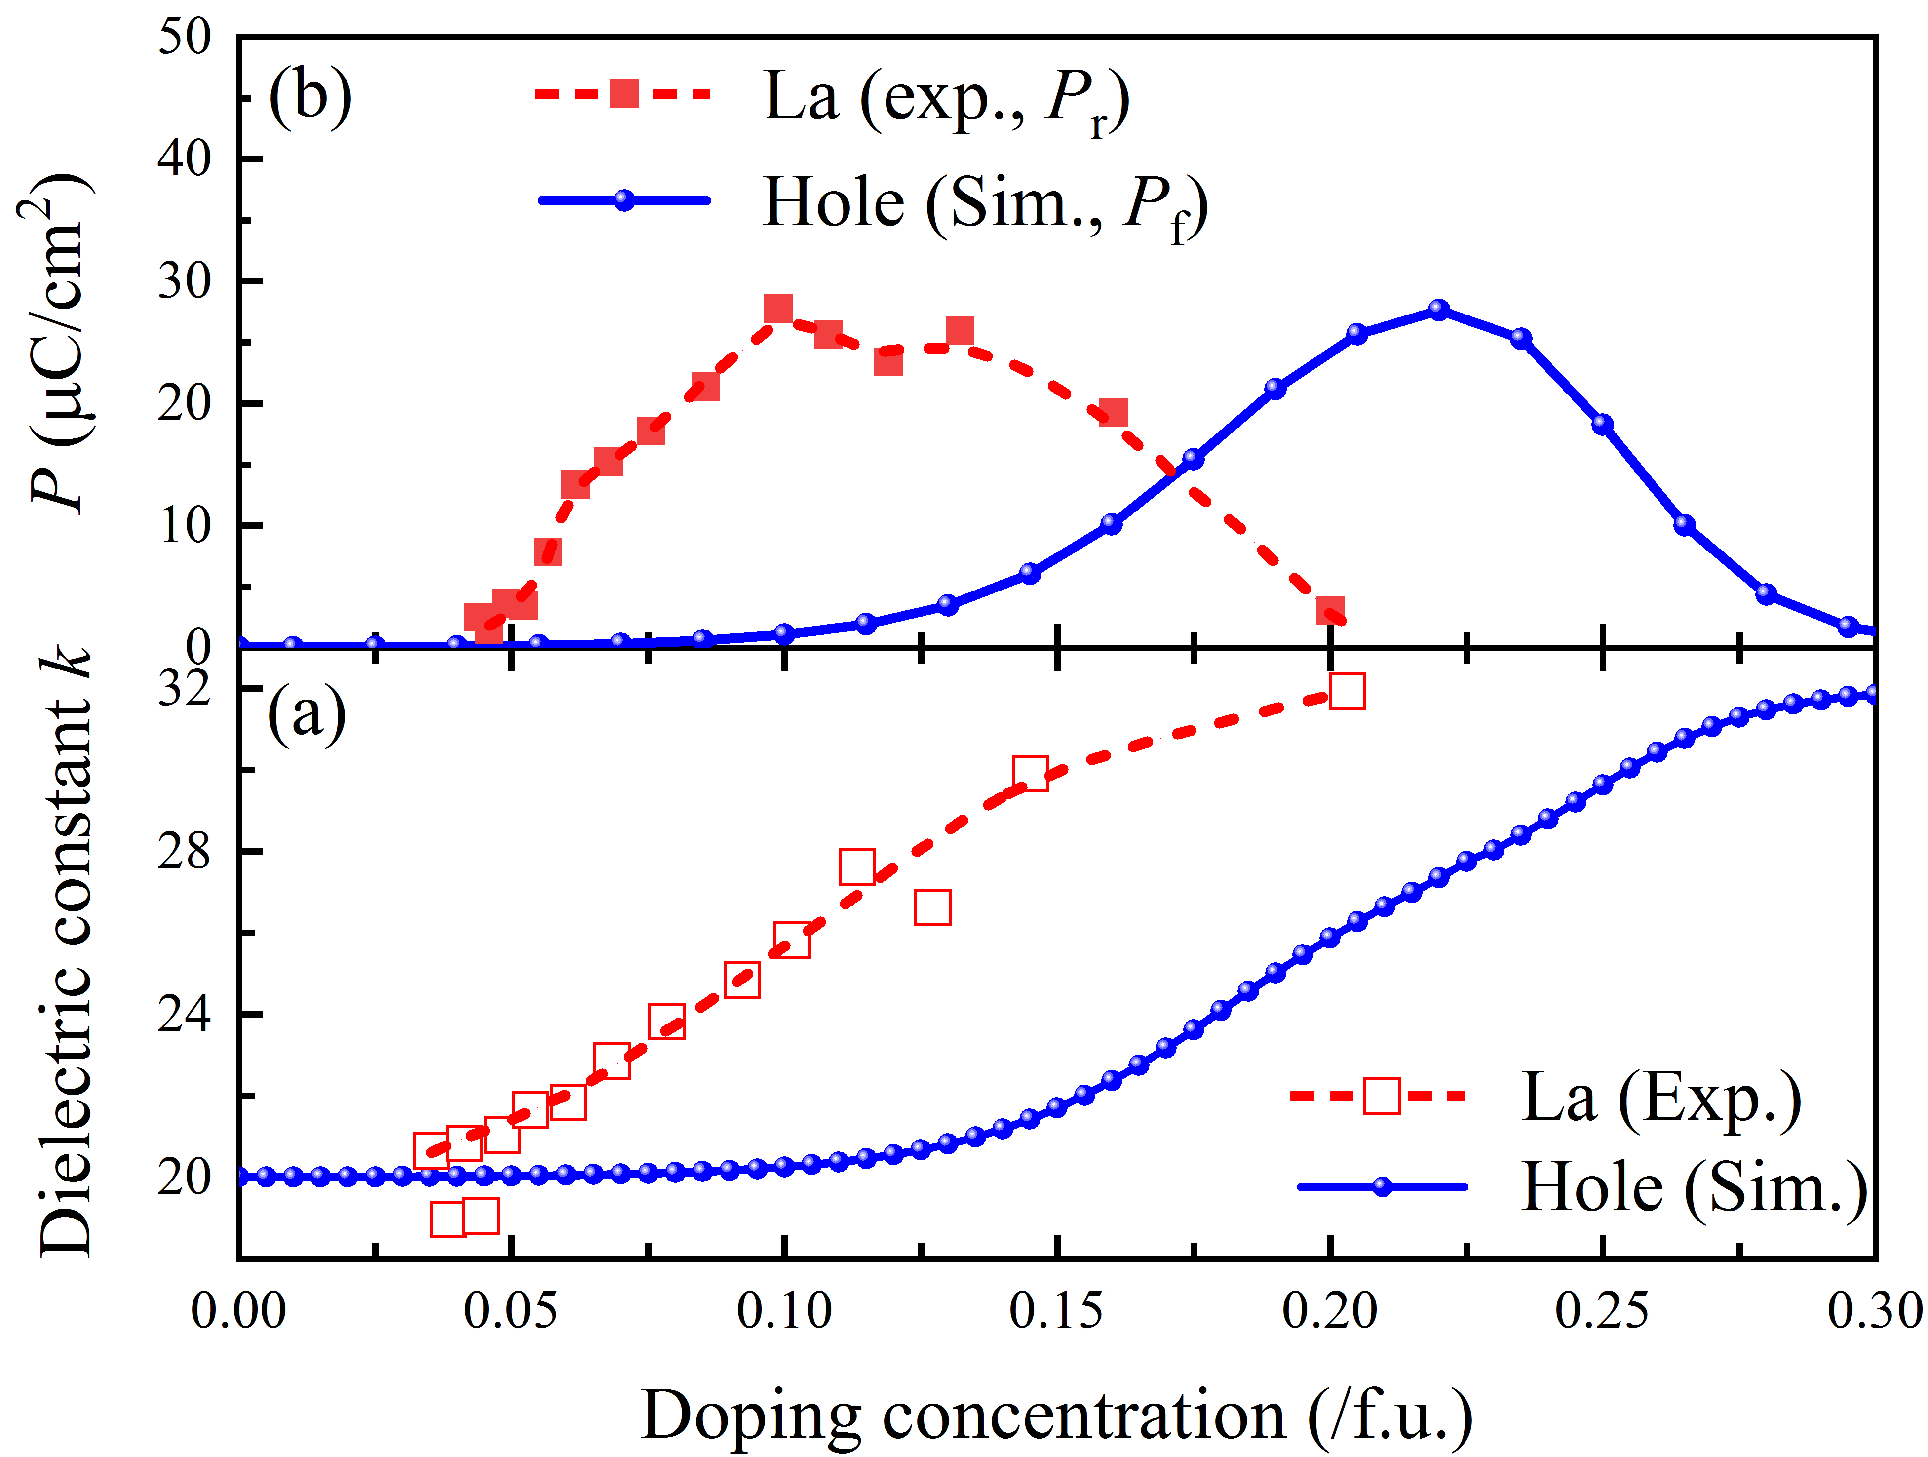
Figure S5 The dielectric constant k (a) and polarization magnitude P (b) of the multiphase HfO₂ as a function of doping concentration. La-doped hafnia thin films were used as a reference ^{[7]} P_{f}=P_{s}×f_{f}×w, k_{tot}= k_{m}×f_{m}+k_{f}×f_{f}+k_{c}×f_{c}, where the dielectric constants k of the m-, f-, and c- phases is 20, 28, and 32, respectively. Where phase factor f_{m}, f_{f}, and f_{c} is the m, f, and c phase fraction, respectively. The weighting factor w = 0.55, which is calculated from the slope between the remanent polarization P_{r} and the f phase fraction in the La-doped hafnia thin films. The trend of experimental results and our theoretical calculations on the polarization intensity and dielectric constant with doping concentration are roughly the same. However, the curve has some deviation because our theoretical calculations neglected the influence of other factors.

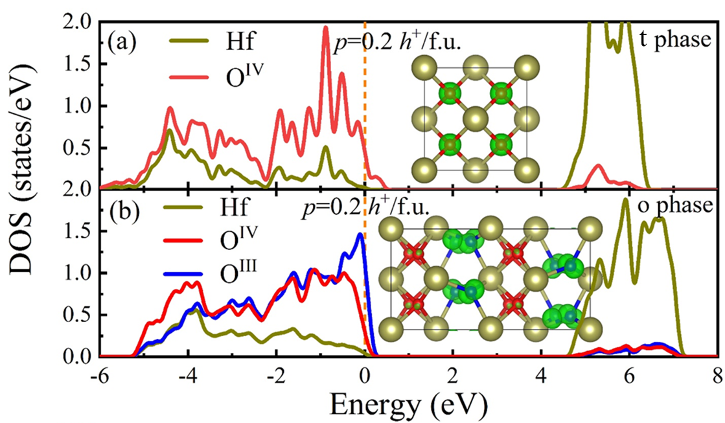
Figure S6 The atomic DOS of bulk HfO₂ with hole doping concentration p=0.2 h⁺/f.u., (a) t-phase, (b) o-phase. The orange-yellow vertical dashed line represents the Fermi level (E_{F}). The green isosurface demonstration of 3D charge density distributions of the doping holes is drawn in the inserts, in which the energy range of the doped HfO₂ system is [0, 1].
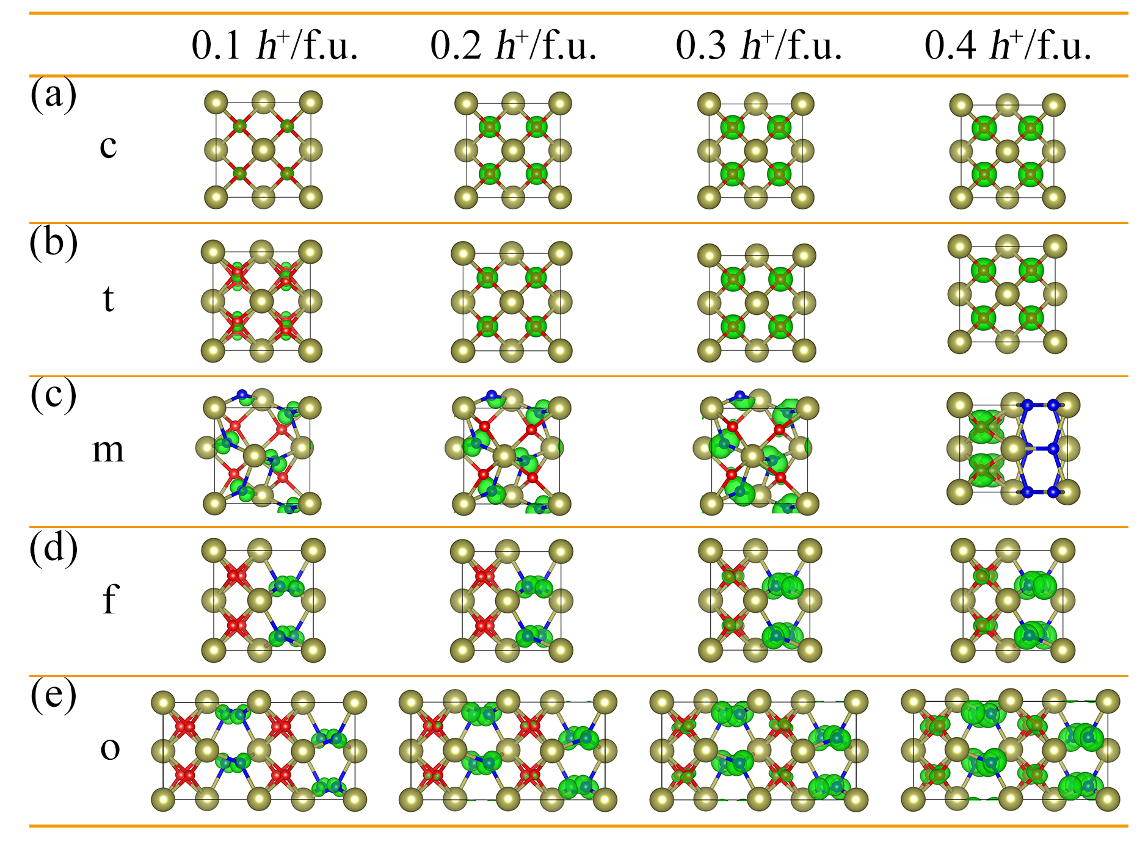
Figure S7 The green isosurface of 3D charge density distributions of bulk HfO₂ under different hole doping concentrations, in which the energy range of the p-type doped HfO₂ is [0, 1]. (a) c-phase, (b) t-phase, (c) m-phase, (d) f-phase, (e) o-phase.

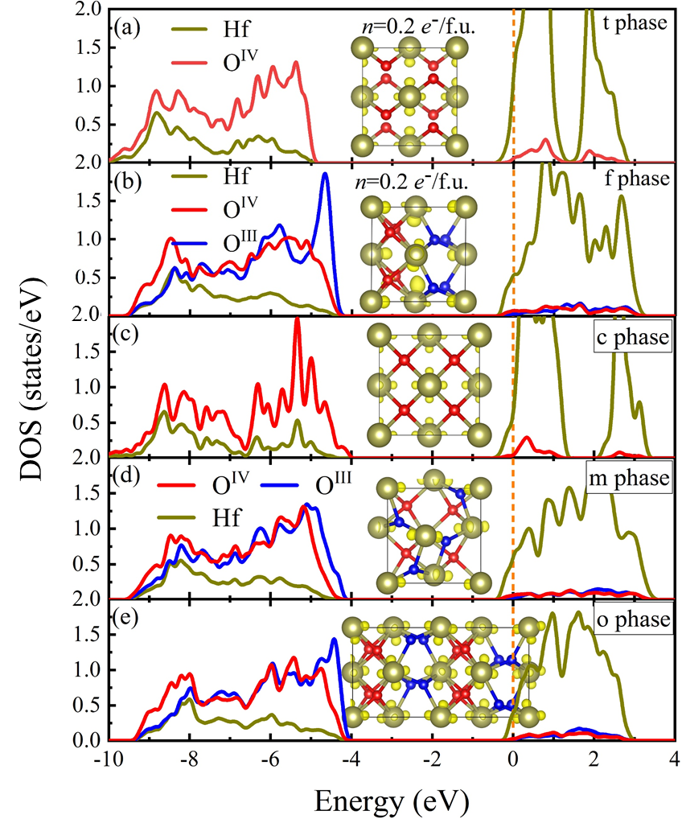
Figure S8 The atomic DOS of bulk HfO₂ with electron doping concentration n=0.2 e⁻/f.u., (a) c-phase, (b) m-phase, (c) o-phase. The orange-yellow vertical dashed line represents the Fermi level (E_{F}). The yellow isosurface demonstration of 3D charge density distributions of the doping electrons is drawn in the inserts, in which the energy range of the doped HfO₂ system is [-1, 0].
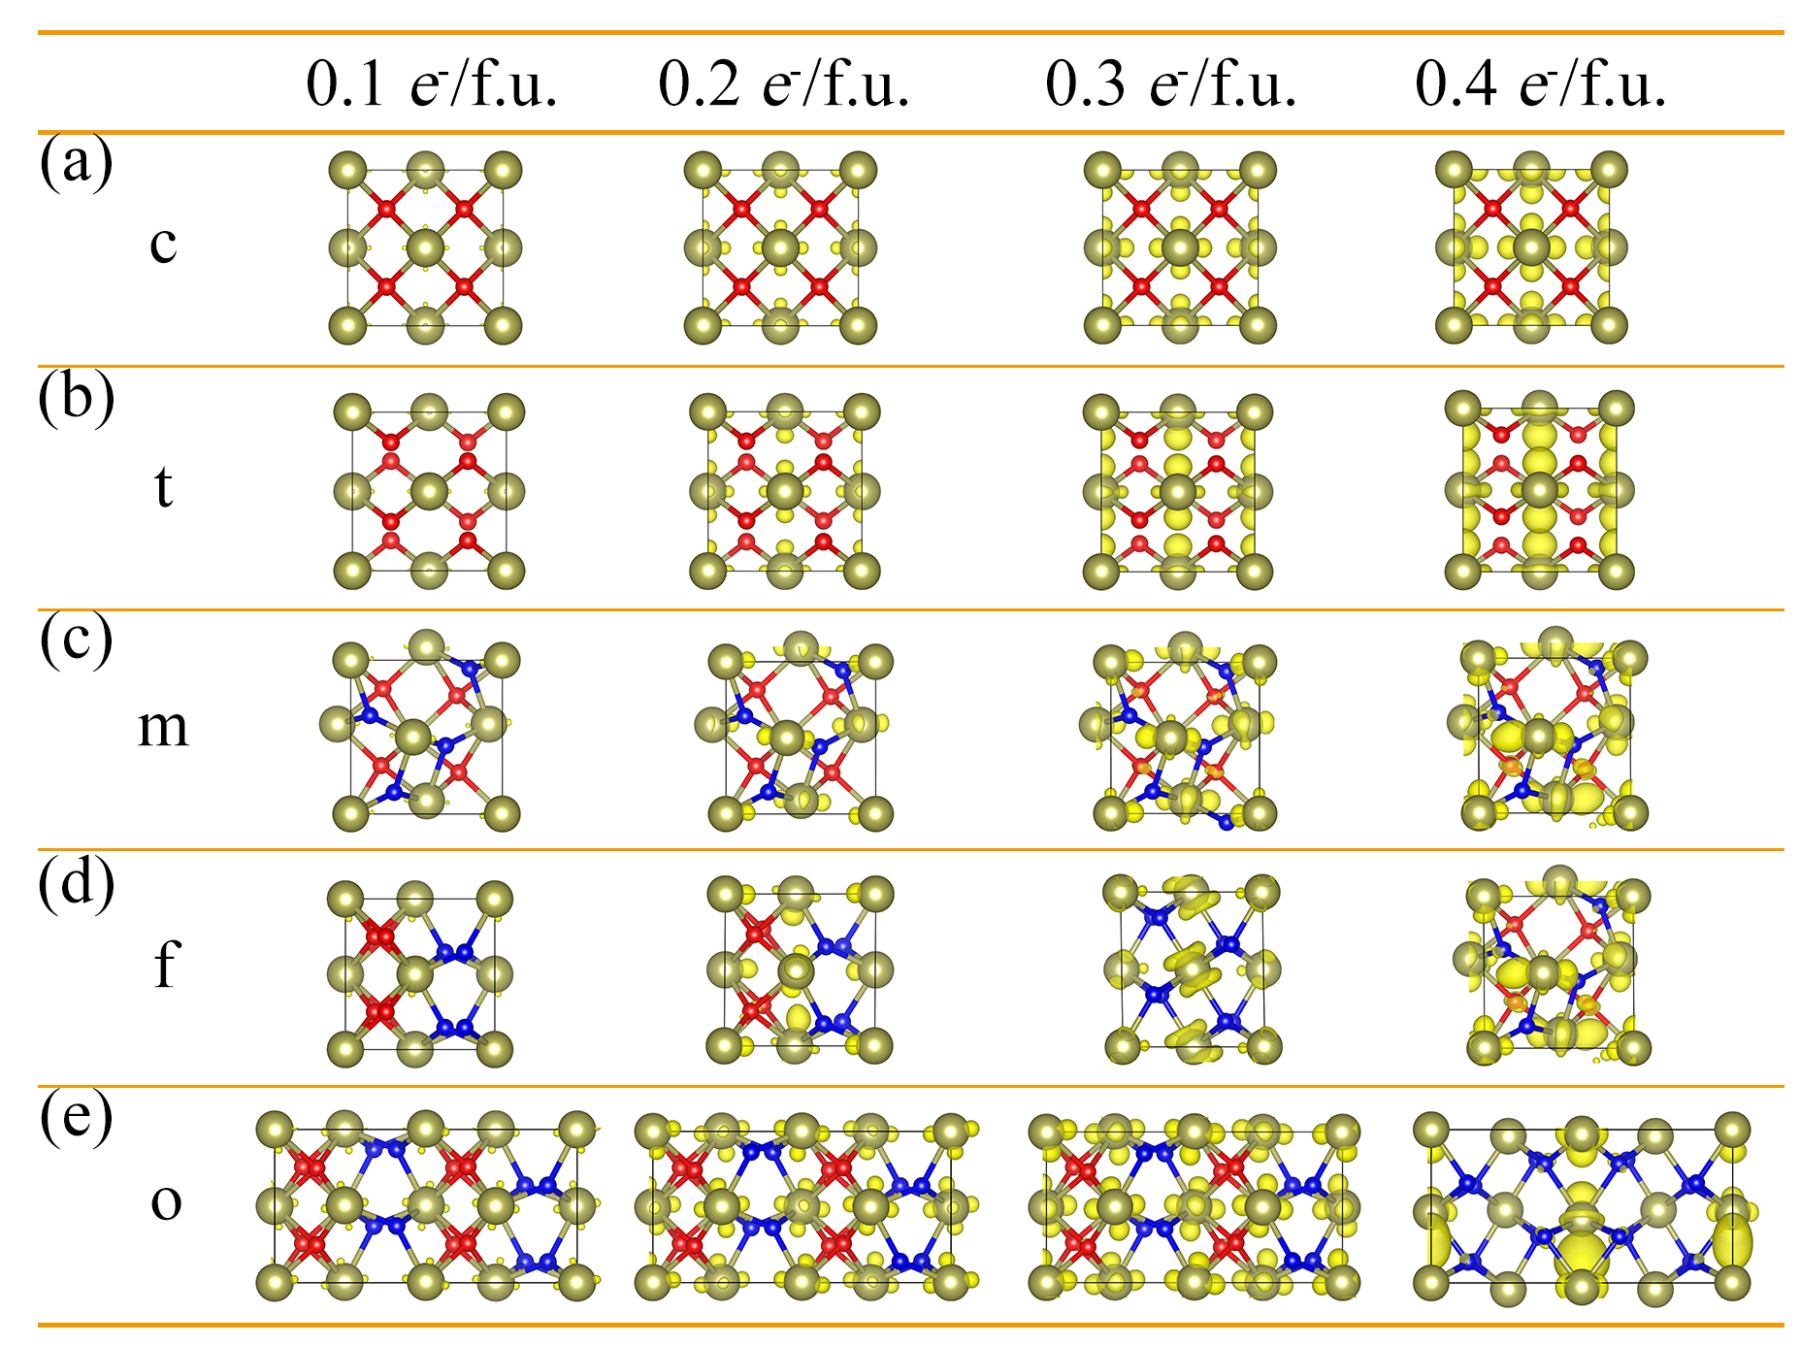
Figure S9 The yellow isosurface of 3D charge density distributions of bulk HfO₂ under different electron doping concentrations, in which the energy range of n-type doped HfO₂ is [-1, 0]. (a) c-phase, (b) t-phase, (c) m-phase, (d) f-phase, (e) o-phase.
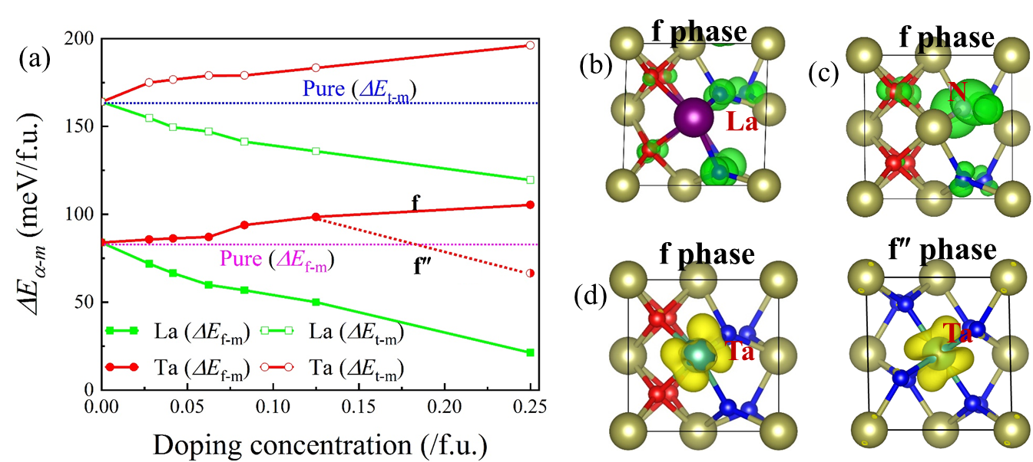
Figure S10 (a) Phase energy difference as a function of atomic doping concentration in doped HfO₂, with m phase as reference. Doping a La atom in the supercell of 3×3×1, 3×2×1, 2×2×1, 1×1×3, 1×1×2, and 1×1×1 to obtain the doping concentration of 0.028, 0.042, 0.063, 0.083, 0.125, and 0.25, respectively. The trend of the change in energy difference between different La and Ta doping concentrations is consistent with that of electrostatic doping. However, it was not found that the f (f″) phase became the ground state phase at high doping concentrations, which is also consistent with the current theoretical prediction. 3D charge density distribution of La-doped (b), N-doped (c), and Nb-doped (d) f (f″) phase HfO₂ with carrier doping concentration of 0.25 f.u.⁻¹, holes and electrons are depicted by green and yellow isosurfaces, respectively.

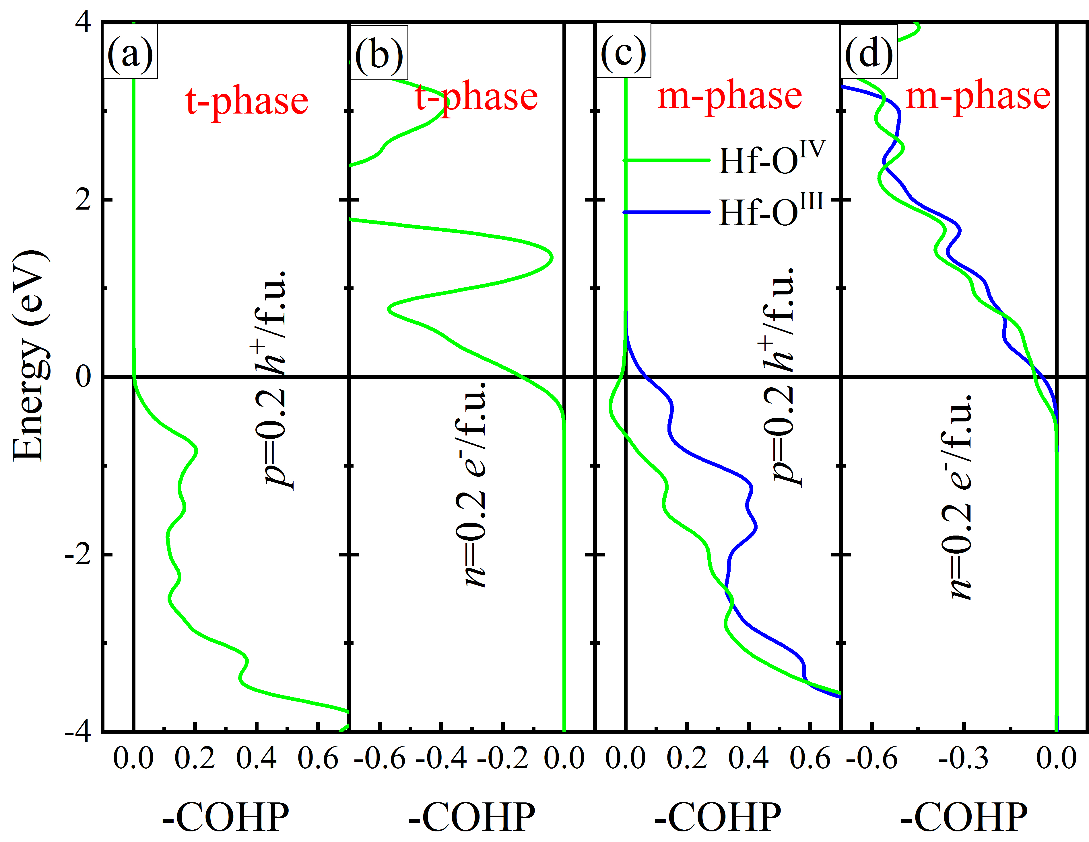
Figure S11 The -COHP of Hf-O bonds in the bulk HfO₂ under different carrier concentrations, (a) t-phase with p=0.2 h⁺/f.u., (b) t-phase with n=0.2 e⁻/f.u., (c) m-phase with p=0.2 h⁺/f.u., (d) m-phase with n=0.2 e⁻/f.u.

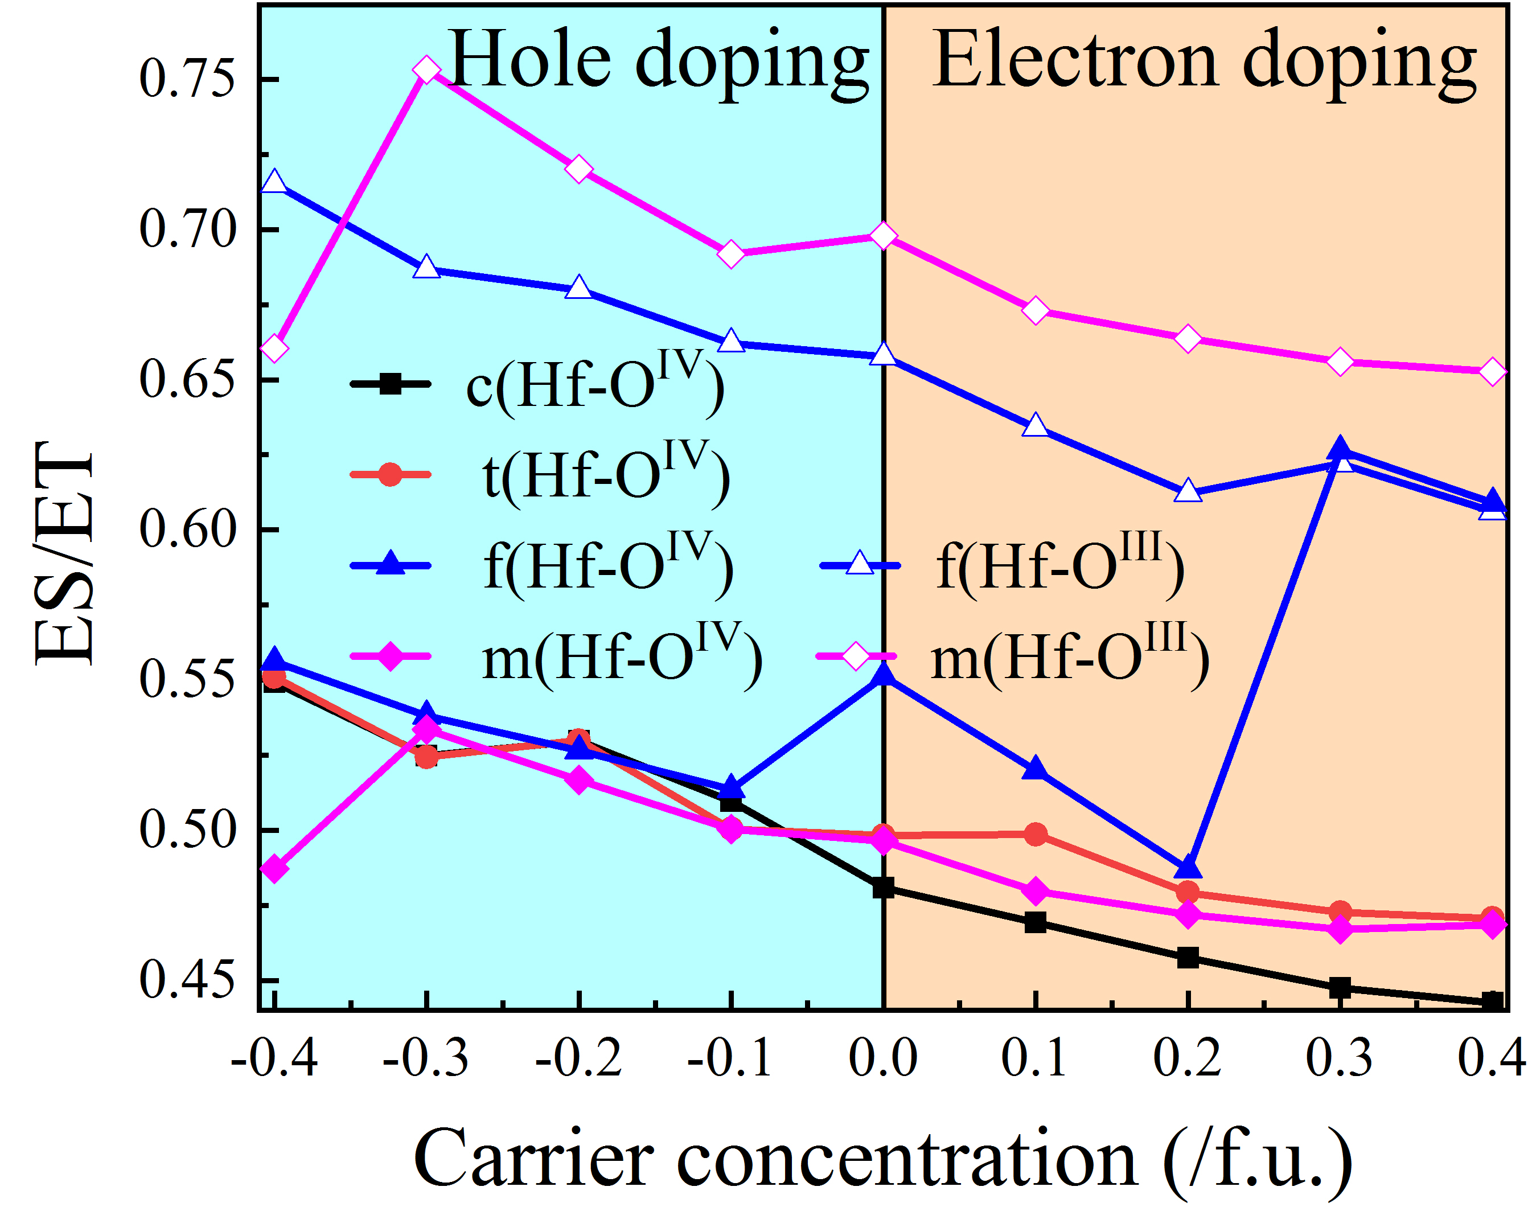
Figure S12 The ratio of electrons shared (ES) to electrons transferred (ET) of Hf-O bonds versus carrier concentration.

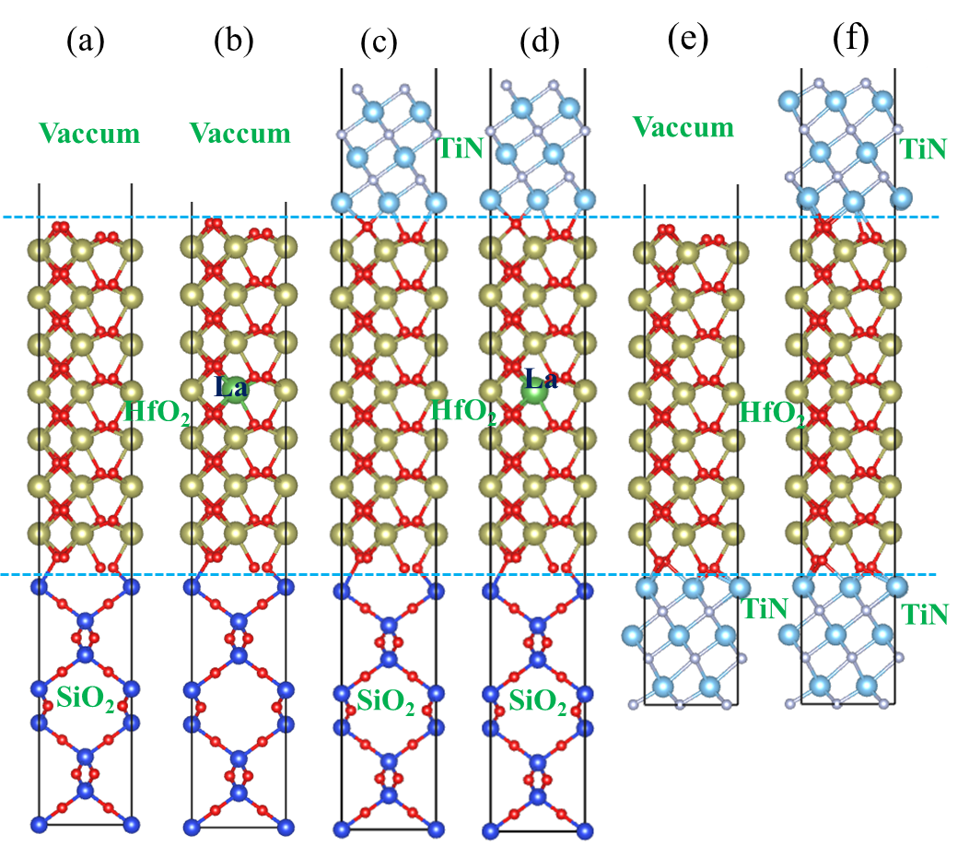
Figure S13 The constructed initial heterostructure models, (a) SiO₂/f-HfO₂, (b) SiO₂/f-HfO₂@La, (c) SiO₂/f-HfO₂/TiN, (d) SiO₂/HfO₂@La/TiN, (e) TiN/f-HfO₂, (f) TiN/f-HfO₂/TiN.

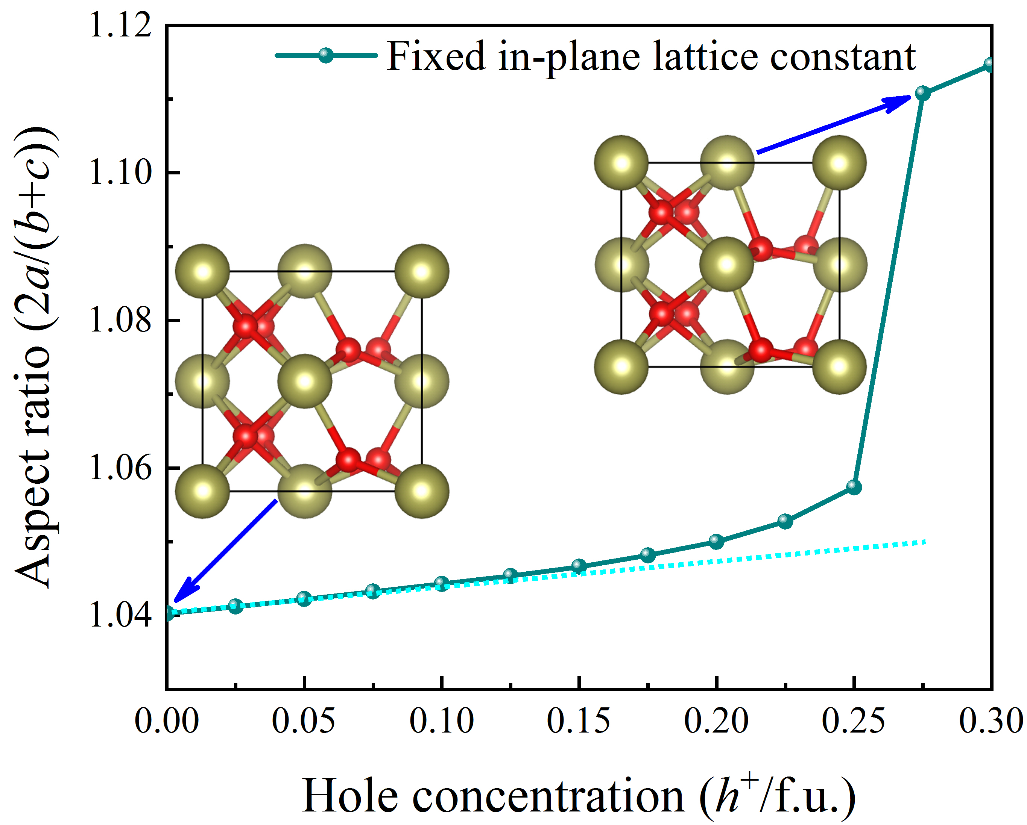
Figure S14 Aspect ratio 2a/(b+c) for the f-phase with fixed in-plane lattice constant as a function of the hole concentration. To simulate the aspect ratio at different thicknesses in HfO₂-based HS, here we fix the in-plane lattice constants. Since the number of holes generated by metal-oxygen dangling bonds at the interface and surface is fixed, the thinner the hafnia film, the greater the carrier concentration. The increasing trend of the aspect ratio of f-phase HfO₂ with the carrier concentration is consistent with the trend of the aspect ratio of the HZO thin films prepared by the experiment of Cheema et al ^{[8]}, which exponentially increases as the film thickness decreases.

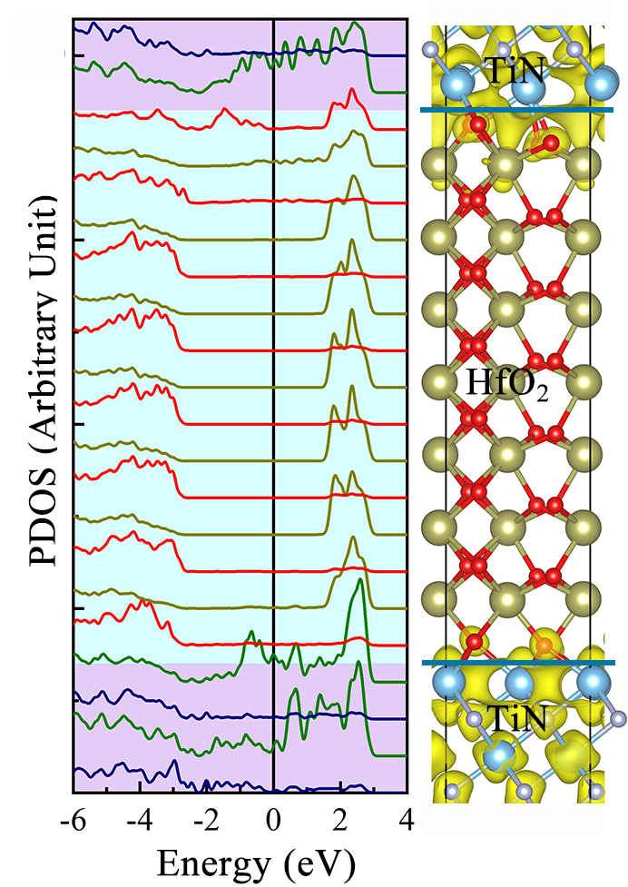
Figure S15 Calculated layer-resolved partial DOS along with its 3D charge density projected on the bands forming the metallic states near the Fermi level for TiN/f-HfO₂/TiN HS models. The electrons are depicted by yellow isosurfaces.

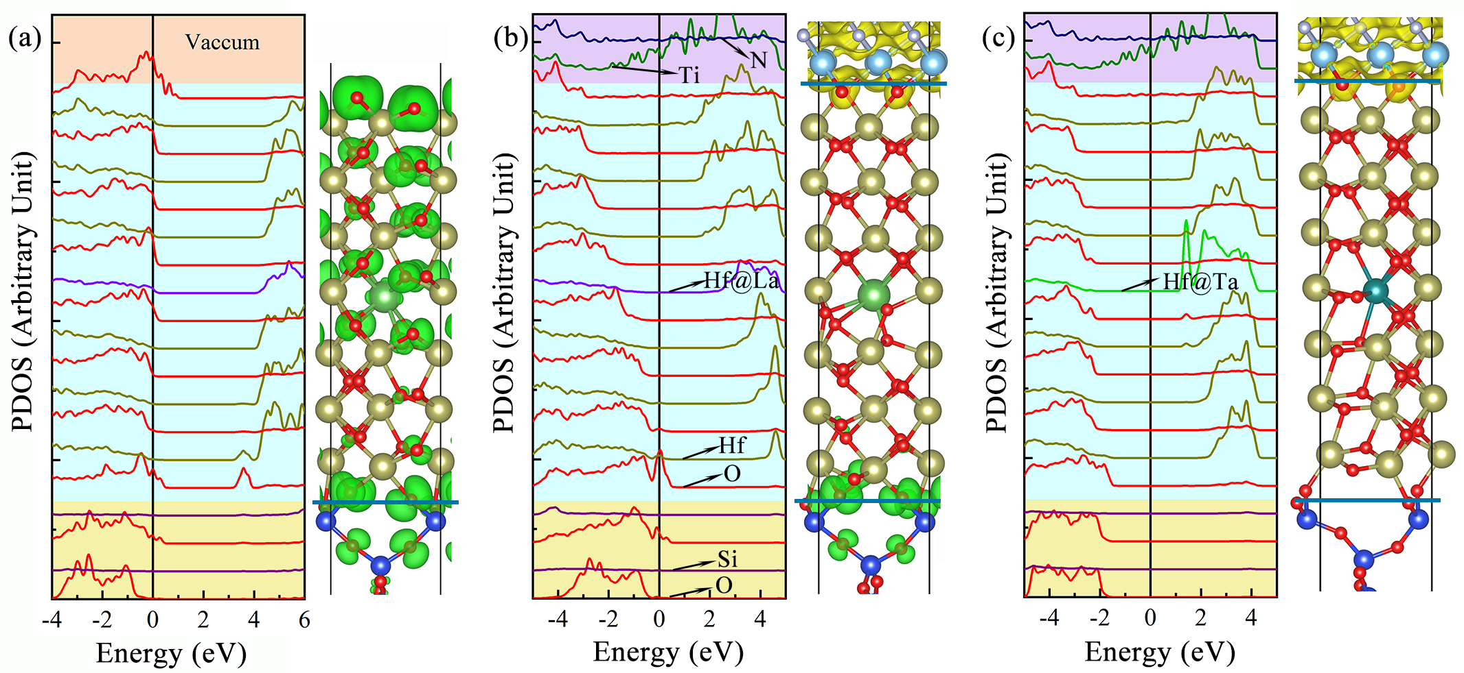
Figure S16 Calculated layer-resolved partial DOS along with its three-dimensional charge density projected on the bands forming the metallic states near the Fermi level for (a) SiO₂/f-HfO₂@La, (b) SiO₂/f-HfO₂@La/TiN, (c) SiO₂/f-HfO₂@Ta/TiN HS models. The holes and electrons are depicted by green and yellow isosurfaces, respectively. The strong electrostatic potential makes it so that polarization switching in SiO₂/f-HfO₂@La/TiN and SiO₂/f-HfO₂@Ta/TiN HS, like in SiO₂/f-HfO₂/TiN HS.

References
- M. Dogan, N. Gong, T. P. Ma, and S. Ismail-Beigi. Phys. Chem. Chem. Phys. 21, 12150-12162 (2019).
- I. A. El-Shanshoury, V. A. Rudenko and I. A. Ibrahim, J. Am. Ceram. Soc. 53, 264-268 (1970).
- I. MacLaren, T. Ras, M. MacKenzie, A. J. Craven, D. W. McComb and S. D. Gendt, J. Electrochem. Soc. 156, G103 (2009).
- R. Ruh and P. W. R. Corfield, J. Am. Ceram. Soc. 53, 126-129 (1970).
- E. D. Grimley, T. Schenk, T. Mikolajick, U. Schroeder and J. M. LeBeau, Adv. Mater. Interfaces 5, 1701258 (2018).
- R. Suyama, H. Takubo and S. Kume, J. Am. Ceram. Soc. 68, C-237 (1985).
- U. Schroeder, C. Richter, M. H. Park, T. Schenk, M. Pesic, et al, Inorg. Chem. 57, 2752-2765 (2018).
- S. S. Cheema, D. Kwon, N. Shanker, R. Reis, S. L. Hsu, et al, Nature 580 (7804), 478-482 (2020).

