Supplemental Appendix S1

Method 1
$Asy(\%)=\left(\frac{V_{larger}−V_{lower}}{V_{larger}}\right)×100$
The muscle tone and stiffness asymmetry index of the upper trapezius muscle was calculated using this equation.
Asy: asymmetery index; V_{larger}: larger value; V_{lower}: lower value.

Figure1
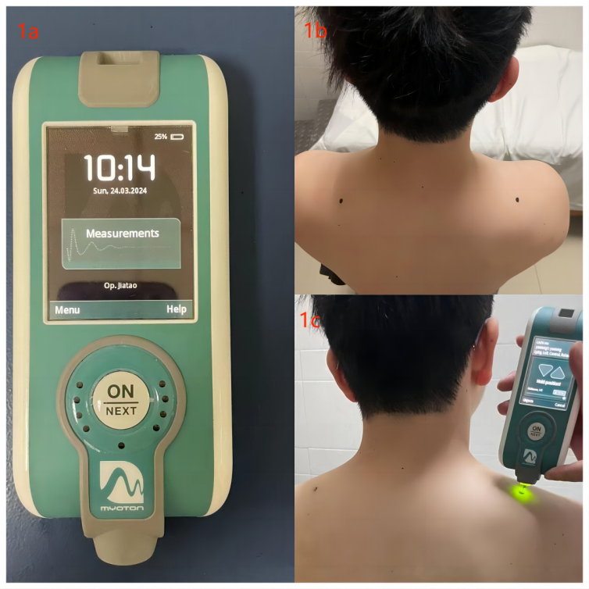
1a: New non-invasive muscle palpation device -MyotonPRO
1b: Measurement points of the participant's upper trapezius muscle
1c: The researcher employed MyotonPRO to conduct perform measurements.

Table 1. Asy_{tone} (UT), Asy_{stiffness} (UT) and VAS score among all groups
 | Asy_{tone} (UT) | Asy_{stiffness} (UT) | VAS score
Male
20-29 Y/O | 3.90 (1.30, 5.85) | 8.10 (6.78, 9.62) | 4.00 (3.00, 6.00)
30-39 Y/O | 4.48 (2.96, 5.73) | 8.59 (7.01, 9.62) | 5.00 (3.00, 6.00)
40-49 Y/O | 4.61 (3.70, 5.68) | 8.03 (7.27, 9.19) | 5.00 (4.00, 6.00)
50-59 Y/O | 5.52 (4.21, 6.82) | 8.81 (8.09, 9.56) | 5.00 (4.00, 6.00)
Female
20-29 Y/O | 6.09 (1.61, 10.20) | 4.64 (3.05, 8.61) | 6.00 (3.00, 8.00)
30-39 Y/O | 4.02 (2.98, 6.27) | 3.83 (1.01, 10.92) | 4.50 (3.25, 6.00)
40-49 Y/O | 3.83 (3.01, 5.06) | 4.41 (3.54, 5.13) | 4.00 (4.00, 6.00)
50-59 Y/O | 7.18 (5.43, 8.47) | 6.13 (5.43, 6.60) | 5.00 (3.25, 6.00)
Y/O, years old; Asytone (UT), Muscle tone asymmetry index; Asystiffness (UT), Stiffness asymmetry index.

