Setting number | Picture place 1 in setting | Picture place 2 in setting | VHM¹ in meter on walking route with 50 m buffer |  | NDVI² on walking route with 50 m buffer
 |  |  | M | SD | M | SD
1: UBHT³ | 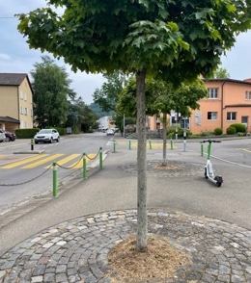 | 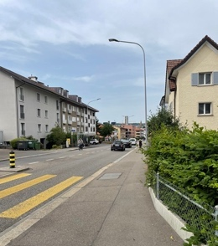 | 1.42 | 3.33 | 0.35 | 0.13
2: UBHT | 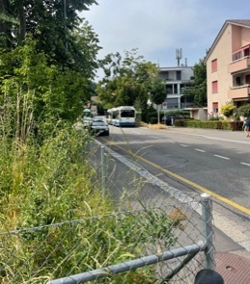 | 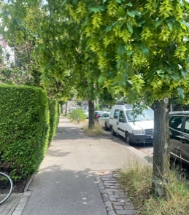 | 1.47 | 3.19 | 0.38 | 0.12
3: UBHT | 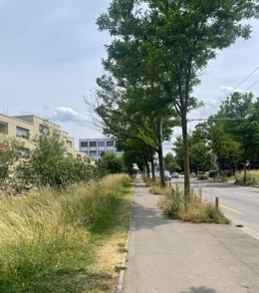 | 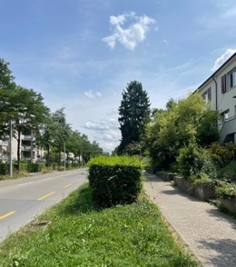 | 1.63 | 3.27 | 0.37 | 0.14
4: UBLT⁴ | 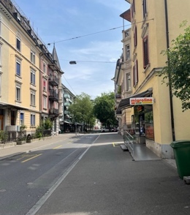 | 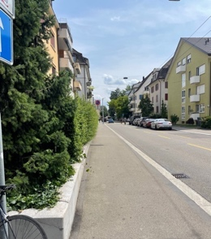 | 2.18 | 4.49 | 0.28 | 0.13
5: UBLT | 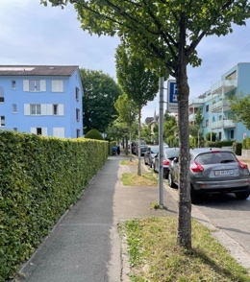 | 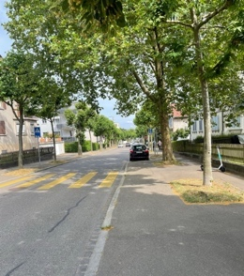 | 1.58 | 3.48 | 0.37 | 0.12
6: UBLT | 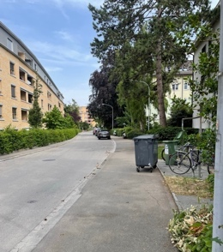 | 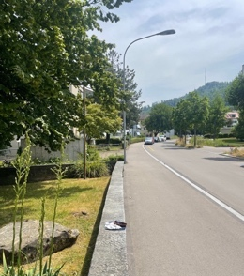 | 2.14 | 4.25 | 0.37 | 0.14
7: FHT⁵ | 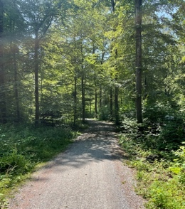 | 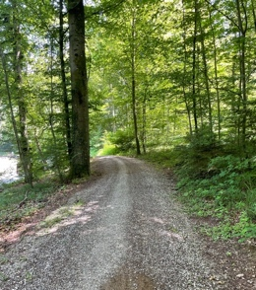 | 20.65 | 9.99 | 0.68 | 0.07
8: FHT | 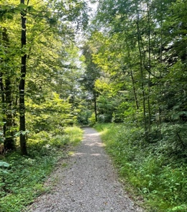 | 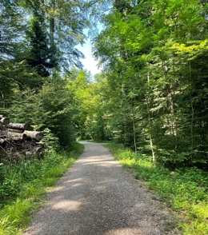 | 18.36 | 11.05 | 0.69 | 0.06
9: FHT | 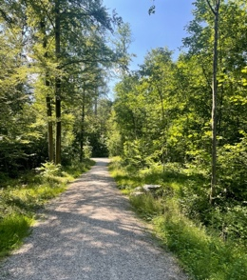 | 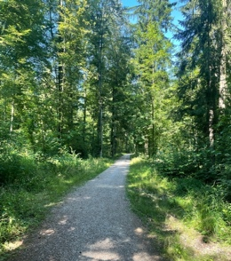 | 16.17 | 10.20 | 0.66 | 0.09
10: FLT⁶ | 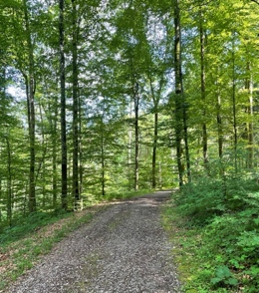 | 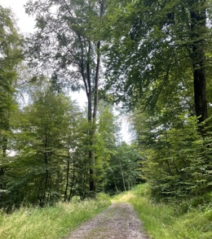 | 24.27 | 8.47 | 0.70 | 0.05
11: FLT | 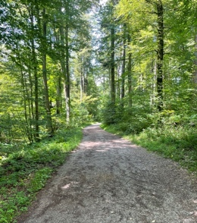 | 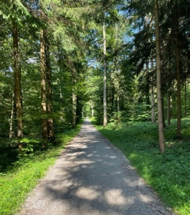 | 22.19 | 9.90 | 0.69 | 0.05
12: FLT | 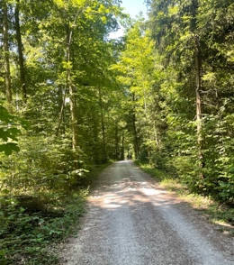 | 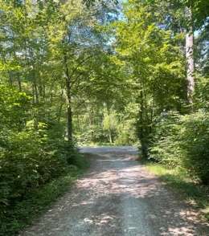 | 20.00 | 8.41 | 0.70 | 0.04
Notes. ¹VHM values in meters, calculated along each walking path, with 50-m wide buffer zones on both sides of the lines. Mean and standard deviation for the average maximum height of vegetation in the buffer zone. ²Median and SD NDVI values, calculated along each walking path, with 50-m wide buffer zones on both sides of the lines. ³UBHT= urban built with high traffic noise. ⁴UBLT= urban built with low traffic noise. ⁵FHT = forest with high traffic noise. ⁶FLT = forest with low traffic noise.

