T Lymphocyte-Macrophage Hybrid Membrane-Coated Biomimetic Nanoparticles Alleviate Myocarditis via Suppressing Pyroptosis by Targeting Gene Silencing
Yulong Xiong ^{a,b,‡}, Zhenhao Zhang ^{a,b,‡}, Shangyu Liu ^{a,b}, Lishui Shen ^{a,b}, Lihui Zheng ^{a,b}, Ligang Ding ^{a,b}, Limin Liu ª, Lingmin Wu ª, Zhicheng Hu ª, Le Li ª, Zhao Hu ª, Zhuxin Zhang ª, Likun Zhou ª, Mengtong Xu ª, Yan Yao ^{a,b,*}
Affiliations
ª Department of Cardiology, Fuwai Hospital, National Center for Cardiovascular Diseases, Chinese Academy of Medical Sciences and Peking Union Medical College, 167A Beilishi Road, Xi Cheng District, Beijing 100037, China.
^{b} State Key Laboratory of Cardiovascular Disease, Fuwai Hospital, National Center for Cardiovascular Diseases, Chinese Academy of Medical Sciences and Peking Union Medical College, 167A Beilishi Road, Xi Cheng District, Beijing 100037, China.
‡ Contributed equally.
* Corresponding author
Yan Yao, Department of Cardiology, Fuwai Hospital, National Center for Cardiovascular Diseases, Chinese Academy of Medical Sciences and Peking Union Medical College, 167A Beilishi Road, Xi Cheng District, Beijing 100037, China; State Key Laboratory of Cardiovascular Disease, Fuwai Hospital, National Center for Cardiovascular Diseases, Chinese Academy of Medical Sciences and Peking Union Medical College, 167A Beilishi Road, Xi Cheng District, Beijing 100037, China.
Tel.: +010 13901121319
Email address: ianyao@263.net.cn

Materials and methods

Instruments
Transmission electron microscopy (TEM) images were obtained on a Titan G2 transmission electron microscope (FEI, Hillsboro, OR, USA). The zeta potential and hydrodynamic size of the nanoparticles were determined after dilution with distilled deionized water by a Malvern Zetasizer Nano ZS (Malvern Panalytical, Malvern, UK). UV-Visible spectroscopic analysis was performed using a UV-2450 spectrophotometer (Shimadzu Corporation, Kyoto, Japan). The confocal images of the study were obtained by a Leica SP8 confocal microscope (Leica Microsystems, Germany) with a 40× water immersion objective lens. The in vivo imaging experiments were conducted by an in vivo imaging system (InVivo Smart-LF, VISQUE). Histological slides were digitized using a Pannoramic SCAN slide scanner (3DHISTECH Ltd., Budapest, Hungary).

Endo-lysosome escape of siIRF1@ZIF@HM NPs in M1 macrophages
RAW 264.7 macrophages were seeded in a 35 mm confocal dish and treated with 100 ng/mL LPS and 20 ng/mL IFN-γ for 48 h for M1 macrophage induction. After washing with PBS, the cells were incubated with 40 μg/mL siIRF1@ZIF@HM at 37 °C for 4 h. Subsequently, the endo-lysosomes were stained with 50 nM Lyso-Tracker Green (Beyotime) for 10 min, while nuclei were stained with 1× Hoechst 33342 staining solution for live cells (Beyotime) for 10 min. The cells were then washed with PBS three times and observed with confocal laser scanning microscopy.

Enzyme Linked Immunosorbent Assay (ELISA)
The level of Creatine Kinase MB Isoenzyme (CK-MB) in mouse serum was measured using ELISA kit from Elabscience, according to the manufacturer’s instructions. The blood samples were collected 21 days after EAM induction. Serum samples were isolated by centrifugation at 9,000 g for 20 min and stored at -80 ºC prior to further analysis.

Blood biochemistry analysis
The blood samples were collected after treatment and the concentrations of aspartate aminotransferase (AST), alanine aminotransferase (ALT), triglyceride (TG), total cholesterol (TC), creatine kinase (CK), and creatinine (CREA) in mouse serum from different groups were quantified by commercial colorimetric assay kits (Elabscience).

Purification of cell culture supernatant proteins
The proteins in the cell culture supernatants were extracted using a previously described methanol/chloroform precipitation method. Briefly, the supernatants were first collected and centrifuged to remove any cell debris. Subsequently, 500 μL of supernatant from each group was transferred into new tubes and mixed with 500 μL of methanol and 125 μL of chloroform by vortexing for 30 seconds, followed by centrifugation at 13,000 g for 5 min. The resulting upper aqueous phase was removed, being careful not to touch the protein layer. Another 500 μL of methanol was introduced, followed by vortexing and centrifugation at 13,000 g for 5 min. The resulting pellets were dried at 55 ºC for 5 min before adding 40 μL of 1×loading buffer and vortexing. Finally, the samples were boiled at 95 ºC for 10 min and subjected to Western blotting analysis.

Transfection of siRNA
The J774A.1 macrophages were transfected with IRF1 siRNA or negative control siRNA using LipofectamineTM RNAiMAX Transfection Reagent (Invitrogen, CA, USA) in Opti-MEM media. The IRF1 siRNA duplexes comprised a sense strand sequence of 5′-CAGAUCCCAAGACAUGGAATT-3′ and an antisense strand sequence of 5′-UUCCAUGUCUUGGGAUCUGTT-3′, which was synthesized by GenePharma (Shanghai, China). After the transfecting incubation for 12 h, the cell culture medium was changed for the following treatments.

Immunofluorescence
To perform myocardial immunofluorescence, cryosections were subjected to equilibration to room temperature for 15 min followed by fixation in 90% ethanol for 5 min. The frozen sections were washed three times with PBS for 3 min, and then incubated with blocking solution combined with 0.3% Triton X-100 for 1 h. For macrophage immunofluorescence after various treatments, cells on the coverslips or confocal dishes were washed with ice-cold PBS and fixed in 4% paraformaldehyde solution for 20 min. Subsequently, the cells were permeabilized with 0.1% Triton X-100 and blocked with normal blocking goat serum solution (ZLI-9056, ZSGB-BIO, Beijing, China). After blocking, both myocardial tissue sections and cells were incubated with primary antibodies overnight at 4 ºC, followed by PBS washing and incubation with secondary antibodies at room temperature for 1 h. The cell nuclei were stained with DAPI, and the immunofluorescence was observed using a fluorescence microscope. The mean fluorescence intensity was quantified using Image J software version 1.5.1.

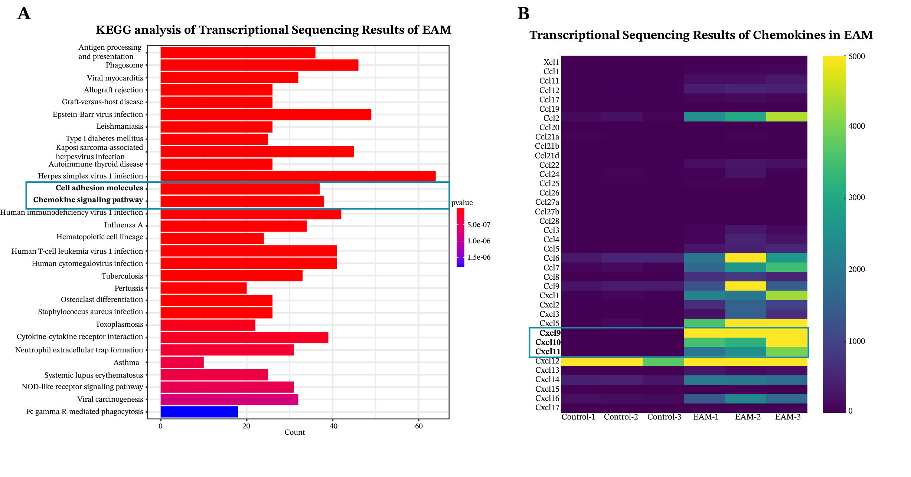
Figure S1. The transcriptomic analysis of myocarditis tissue. (A) KEGG analysis showing the top enriched pathways in myocarditis. (B) Heatmap of the chemokines identified in the transcriptional sequencing.

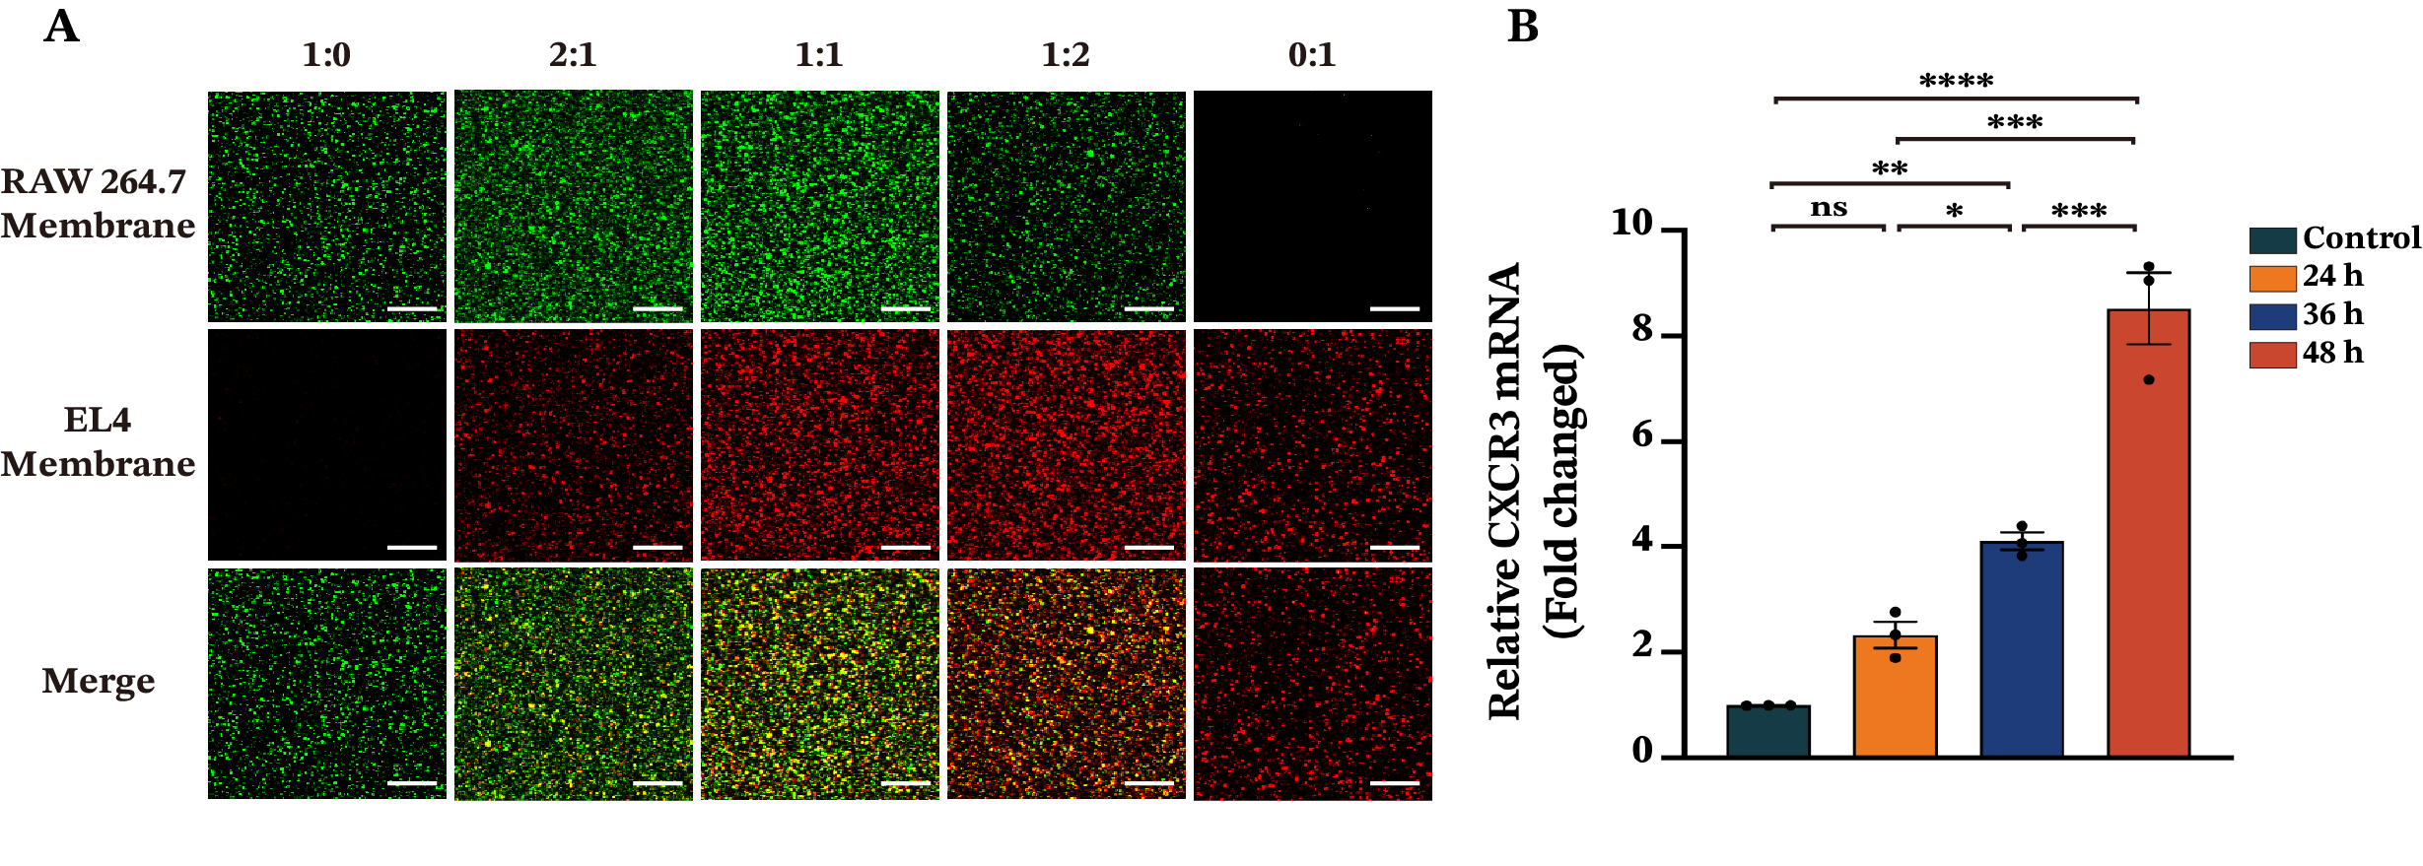
Figure S2. (A) Confocal images of the hybrid membrane at different fusion ratios. (B) The mRNA level of CXCR3 in EL4 cells stimulated with 50 ng/mL PMA for different time durations determined by qPCR. Data were presented as mean ± SEM (n=3). Scale bar: 50 μm. *P < 0.05, **P < 0.01, ***P < 0.001, ****P < 0.0001; ns, not significant.

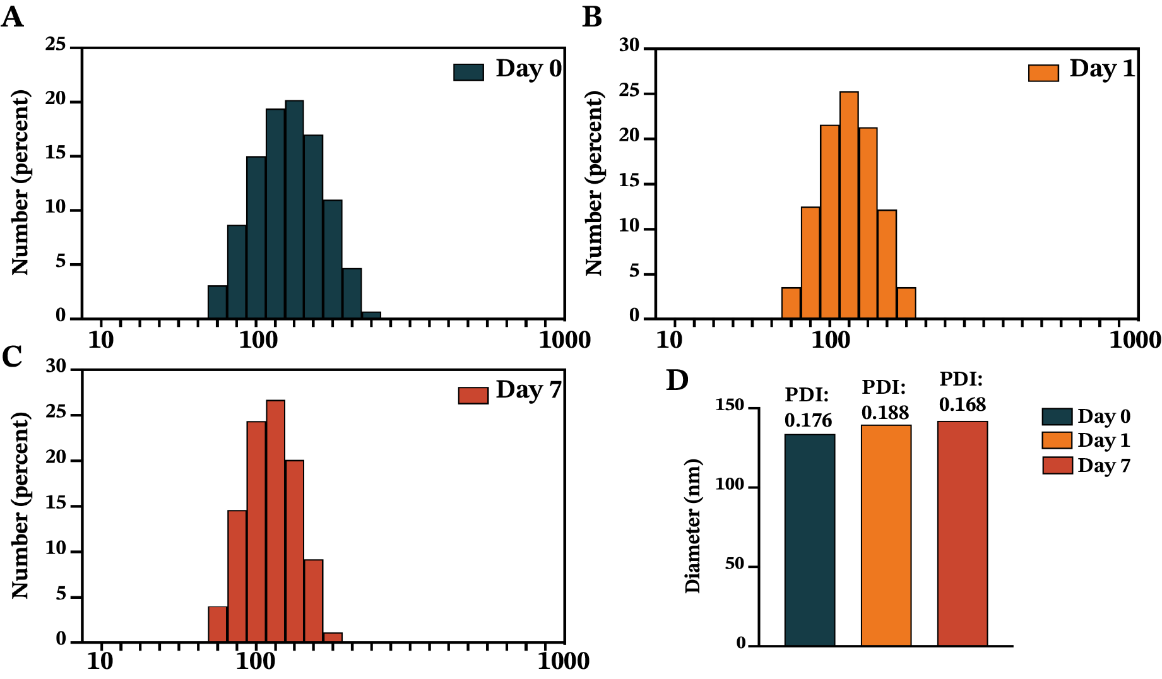
Figure S3. Hydrodynamic diameter of siIRF1@ZIF@HM NPs after storing in PBS (pH 7.4) for 0, 1, and 7 days determined by dynamic light scattering (DLS).

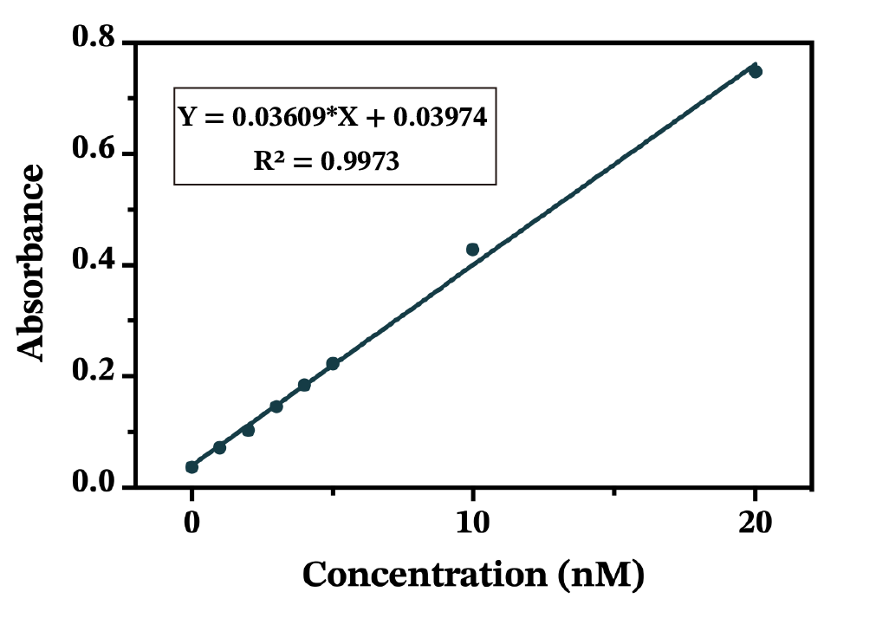
Figure S4. Calibration curve of the absorbance with various concentrations of Cy5-labeled siIRF1 for the drug loading capacity (DLC) calculation.

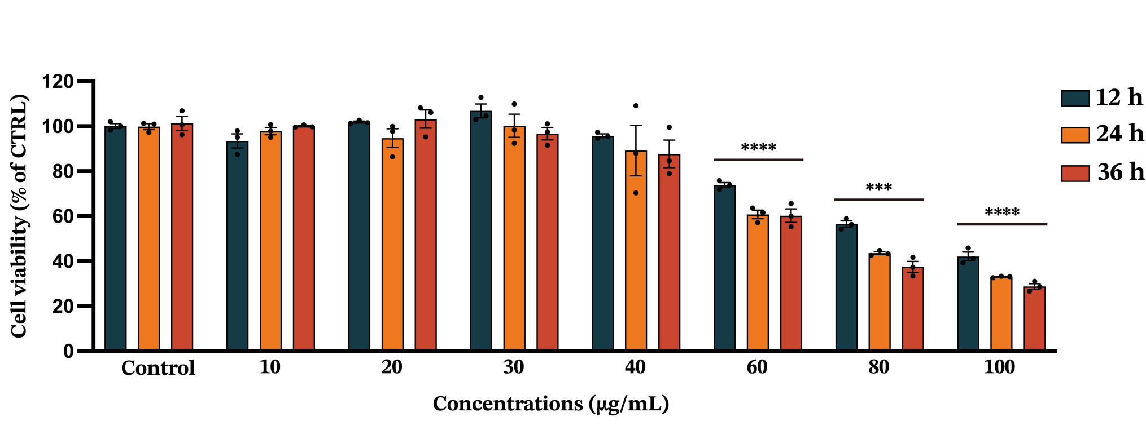
Figure S5. Cytotoxicity of siIRF1@ZIF NPs on mouse RAW 264.7 macrophages after incubation with different concentrations. Data were presented as mean ± SEM (n=3). ***P < 0.001, ****P < 0.0001.

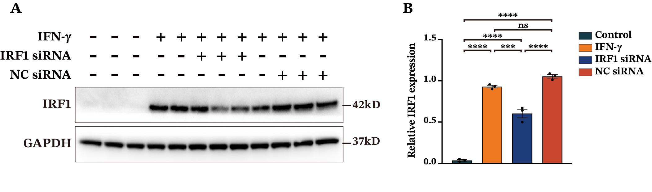
Figure S6. The knockdown efficacy of siIRF1 in J774A.1 macrophages treated with IFN-γ. (A and B) Western blot analysis and quantification of IRF1 expression. The J774A.1 macrophages were transfected with IRF1 siRNA or negative control siRNA, followed by 50 ng/mL IFN-γ incubation for 48 h. Data were presented as mean ± SEM (n=3). *P < 0.05, **P < 0.01, ***P < 0.001, ****P < 0.0001; ns, not significant.

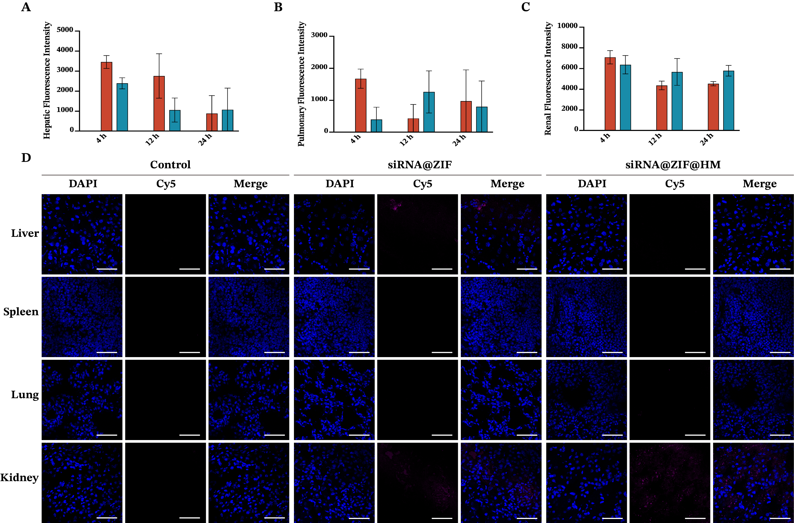
Figure S7. The biodistribution of siIRF1 in the major organs. (A-C) Quantifications fluorescence intensity of the liver, lung, and kidney after intravenous injection of PBS, siIRF1@ZIF NPs, and siIRF1@ZIF@HM NPs in EAM Balb/c mice. (D) Confocal images to observe the biodistribution of siIRF1. Cryosections of the liver, spleen, lung, and kidney were stained with DAPI and observed with confocal microscopy. Data were presented as mean ± SEM (n=3). Scale bar: 50 μm.

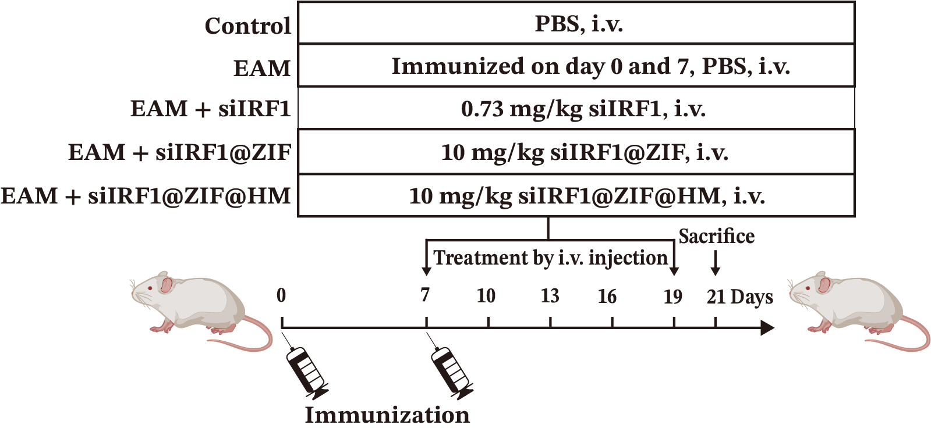
Figure S8. Schematic illustration of the treatment protocols to evaluate the therapeutic efficacy of siIRF1-loaded nanoparticles.

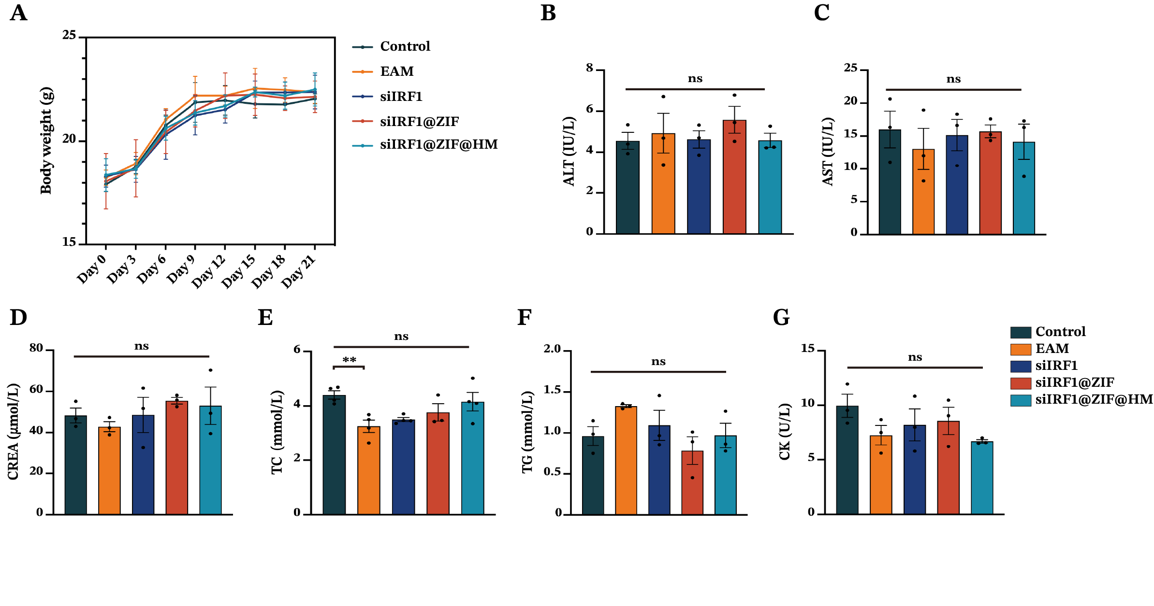
Figure S9. The biosafety evaluation of siIRF1 nano-therapies. (A) The body weights of Balb/c mice from different groups during treatment. (B-D) The biochemical assays of hepatic and renal functions. ALT, alanine aminotransferase, AST, aspartate aminotransferase, and CREA, creatinine. (E-G) The serum metabolic profile. TC, total cholesterol, TG, triglyceride, CK, creatine kinase. Data were presented as mean ± SEM (n=3). *P < 0.05, **P < 0.01, ***P < 0.001, ****P < 0.0001; ns, not significant.

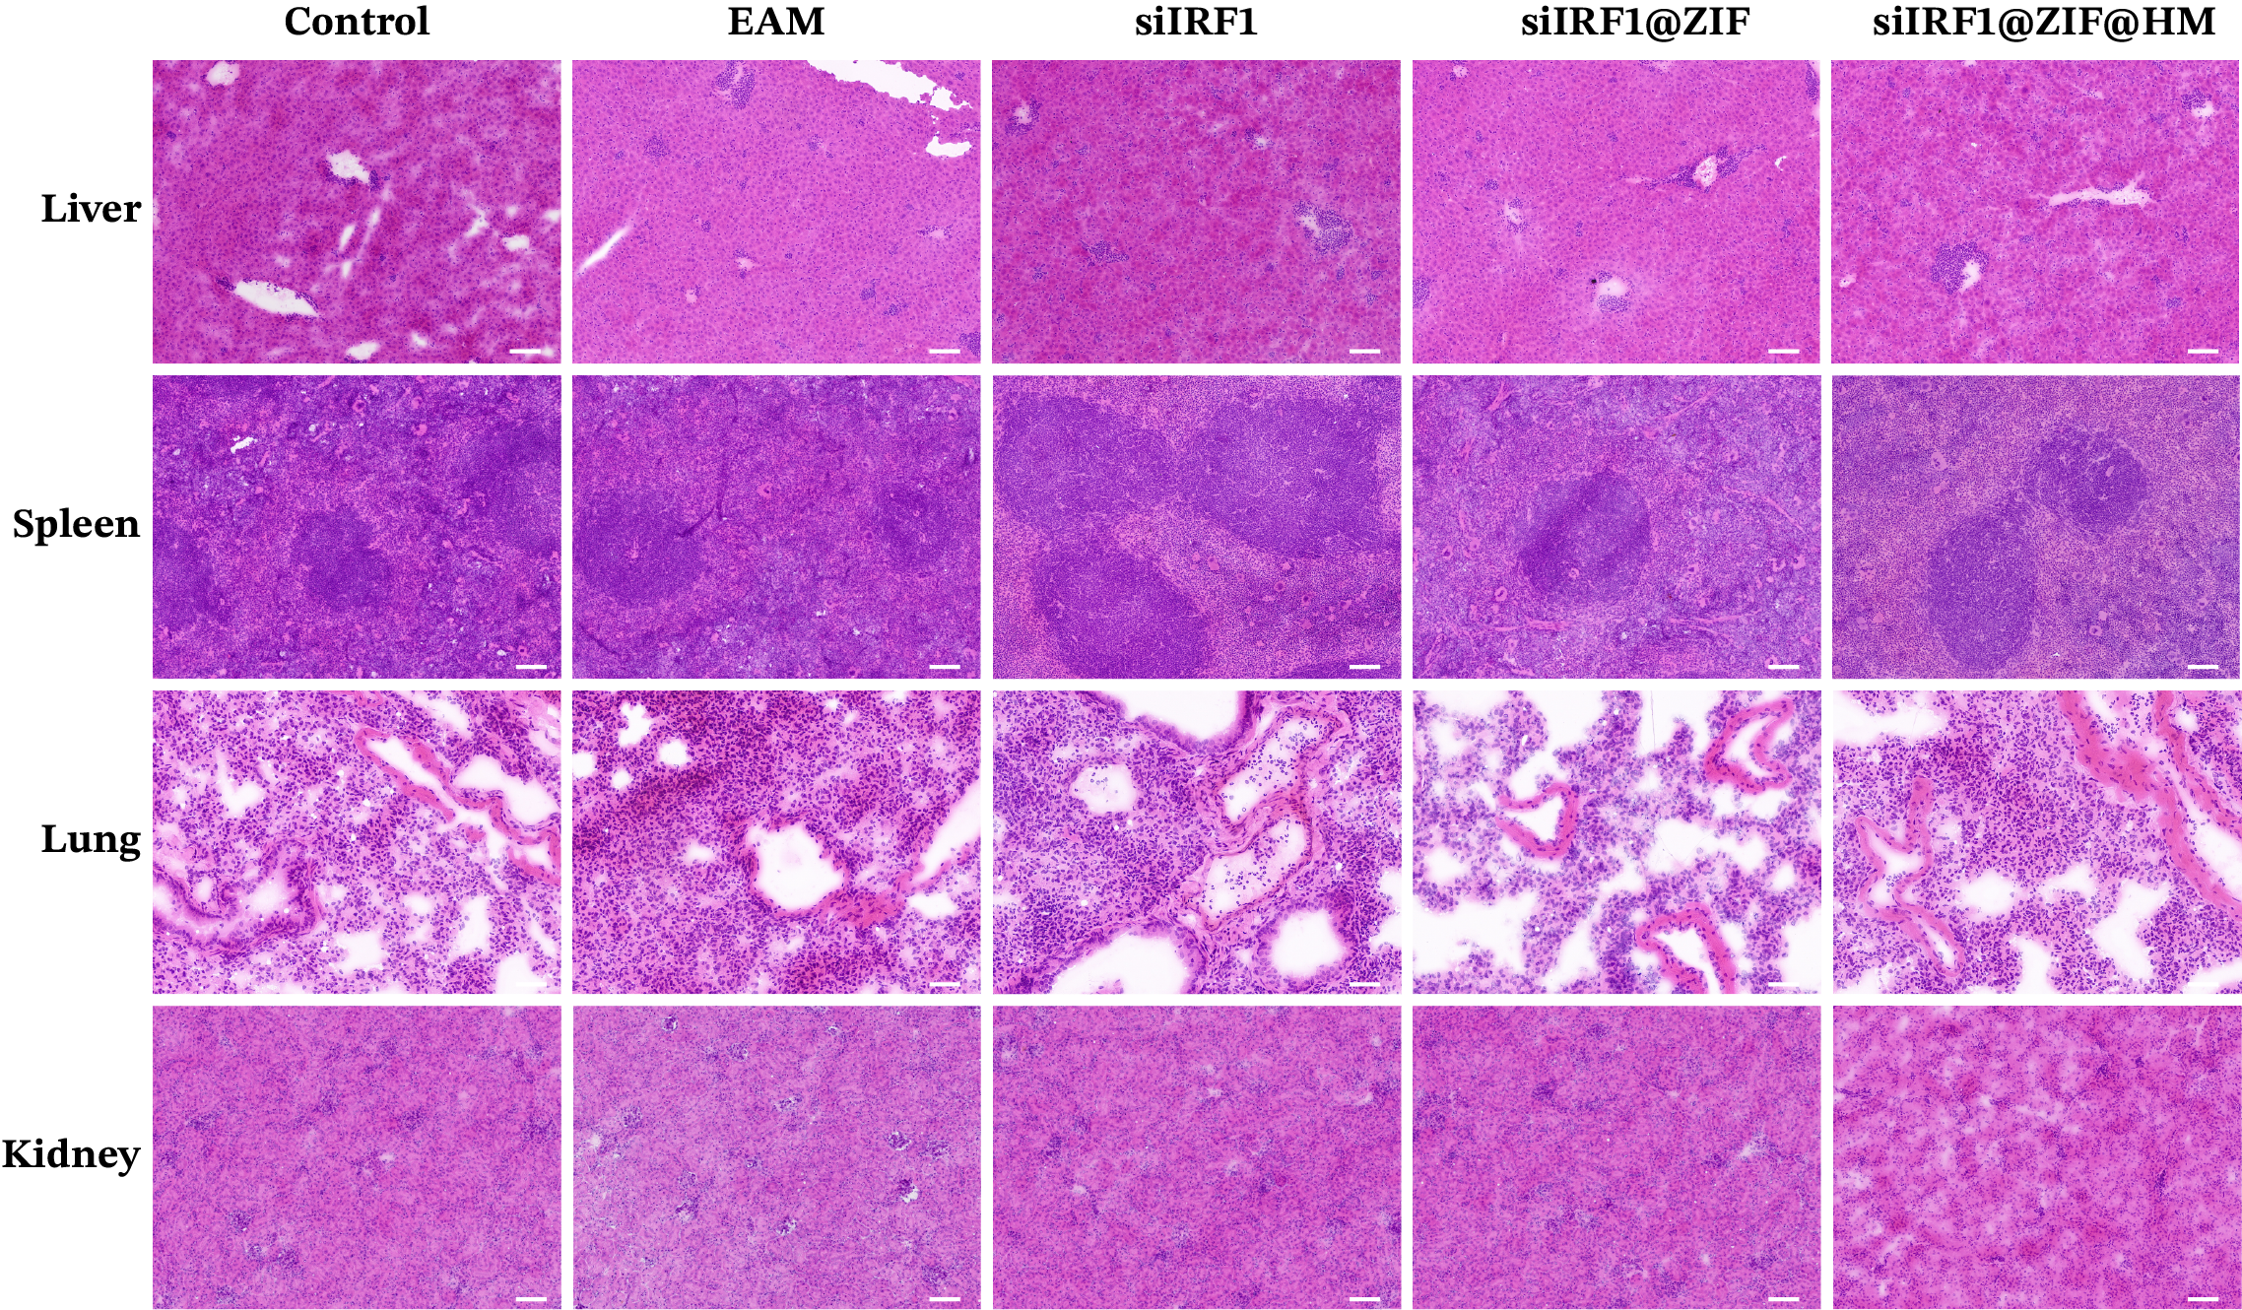
Figure S10. Representative images of HE staining of the main organs (liver, spleen, lung, and kidney) from mice after various treatments. Scale bar: 100 μm.

Table S1. List of mouse gene primers for qRT-PCR.
Gene | Forward primer | Reverse primer
IRF1 | ATGCCAATCACTCGAATGCG | TTGTATCGGCCTGTGTGAATG
CXCL9 | TCCTTTTGGGCATCATCTTCC | TTTGTAGTGGATCGTGCCTCG
CXCL10 | CCAAGTGCTGCCGTCATTTTC | GGCTCGCAGGGATGATTTCAA
CXCL11 | GGCTTCCTTATGTTCAAACAGGG | GCCGTTACTCGGGTAAATTACA
CXCR3 | TACCTTGAGGTTAGTGAACGTCA | CGCTCTCGTTTTCCCCATAATC
CASP1 | ACAAGGCACGGGACCTATG | TCCCAGTCAGTCCTGGAAATG
ZBP1 | AAGAGTCCCCTGCGATTATTTG | TCTGGATGGCGTTTGAATTGG
GBP1 | ACAACTCAGCTAACTTTGTGGG | TGATACACAGGCGAGGCATATTA
TNF-α | CCCTCACACTCAGATCATCTTCT | GCTACGACGTGGGCTACAG
IL-1β | GCAACTGTTCCTGAACTCAACT | ATCTTTTGGGGTCCGTCAACT
IL-6 | TAGTCCTTCCTACCCCAATTTCC | TTGGTCCTTAGCCACTCCTTC
GAPDH | AGGTCGGTGTGAACGGATTTG | TGTAGACCATGTAGTTGAGGTCA

Table S2. Histological scoring standard of myocardial inflammation.
Score | Pathological standard
0 | No inflammation
1 | Less than 10% of the myocardial cross-section involved
2 | 10 to 30% involved
3 | 30 to 50% involved
4 | 50 to 90% involved
5 | More than 90% involved

