Innovative technological and subsistence responses to marginal environments indicate complex cultural dynamics in southern Africa ~90 000 years ago
Supplementary Information
VR003 excavation history
VR003 has been excavated over five discontinuous seasons between 2009 and 2016. The initial two seasons had the primary objective of assessing the potential of the deposit, and only selected finds were plotted. The final three seasons 2014-2016 involved plotting of all cultural items using different size cut-offs for different classes of material (≥15 mm for lithics & pigments, ≥20 mm for bone). Some classes of material, notably OES, were only plotted if modified. All plotted artefacts were assigned unique provenience ID’s and individually bagged. Sedimentary aggregates were plotted with a single indicative point location, and volume was quantified as proportional bucket volume (FULL, ¾, ½, ¼). All aggregates were sieved on site through nested 3 mm and 1.5 mm mesh, and the residues from each bagged separately. All plotting was undertaken using a local grid, managed by control points emplaced around the site.
We currently recognise nine archaeological horizons and eight geological horizons in the Main Area sequence (1); for the sake of simplicity in this paper we refer to the lower two archaeological horizons in aggregate as the Lower Deposits. All geological horizons in the Main Area are associated with the MSA. Late Holocene LSA occurs as infill of the small extant shelter at a depth of 0.6-0.9 m. In the Main Area, I-03 and I-04 were assigned to the Howiesons Poort and Still Bay (1), though dated by OSL to 45.7 ±2.8 ka which is unusually young for Howiesons Poort and Still Bay units. That aside, the fossiles directeur for those units (backed artefacts and bifacial points respectively) occur as a discrete band across the entire site and include a single piece of engraved OES in the Link Trench (Figure S1). In the Main Area there is no recurrence of such artefacts in the underlying deposits, which we assign to the Early (ie., pre-Still Bay) MSA.

Figure S1. East section view of VR003 deposits showing distribution of Howiesons Poort (backed artefacts, blue triangles) and Still Bay (bifacial points, red triangles) type markers across the excavation area. Unifacial points (white triangles) may occur in either the post-Howiesons Poort or Still Bay; in this case they appear limited to the Still Bay and there is no clear post-Howiesons Poort signal in the sequence. a-c, truncated pointed backed pieces; d-f, segments; g-i, truncated oblique pieces; j-n, bifacial and partly-bifacial points and fragments; o, engraved ochre.

Geoarchaeology
Sedimentology. Grain size analysis, loss on ignition, magnetic susceptibility shows structure variation through the Main Area deposits (Figure S2). The upper 30cm (I-02 & I-03) is significantly finer grained that the rest of the Main Area deposit and shows large variations in magnetic susceptibility frequency dependence suggesting that these sediments contain a significant amount of superparamagnetic ferrimagnetic grains interpreted to be formed via anthropogenic burning. Though magnetic susceptibility increases in the lower deposits, the consistency of the frequency dependence indicates a natural signal likely driven by changes in the mineralogy of the deposit. The lower 1.6 m of Sector I show a deceasing grain size trend through units I-04-I-09, with a significant increase in carbonate percentage in the bottom 10cm of the section.
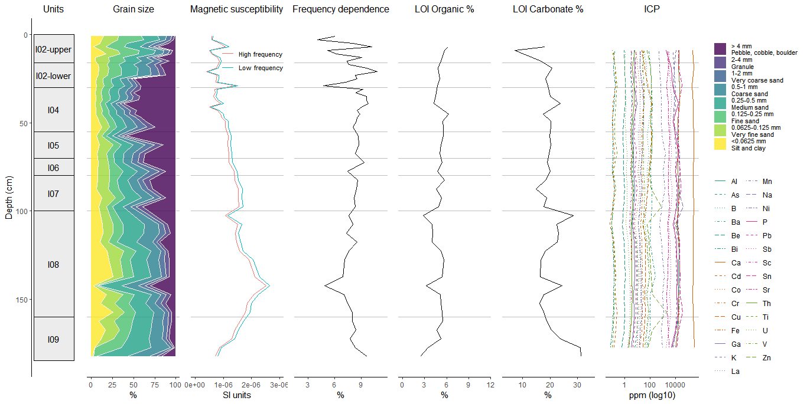

Figure S2. Grain size, LOI, and magnetic susceptibility data for the Main Area, Sector I.
Micromorphology. Micromorphological analysis were directed at investigating the sedimentary components and formation processes including post-depositional alterations. To this aim we collected 3 block samples from layers GH07, I-08 and their respective contact. One thin section of each was produced by P. Kritikakis (University of Tübingen, Germany), T. Beckmann (Schwülper-Lagesbüttel, Germany) and T. Culligan (University College Dublin, Ireland). The three thin sections show overall similar characteristic with each other but also with the upper deposits, GH01 to 05 as previously described (1). The related distribution of fine and coarse materials is dominantly porphyric, but sand sized grains generally exhibit a coating with fine material (Figure S3 C). Additionally, cemented areas were observed (Figures S3 A&B, Figure S3 A&C), which show a dense calcitic crystallitic micritic groundmass with floating coarse grains. Otherwise, void space is open and dominated by simple and complex packing voids. Star shaped vughs, channels and chambers are also present. The microstructure is thus massive to spongy, but can also appear as granular due to coated grains. One thin section from I-08 appears to be partially disturbed and shows several deviations from this general microstructure. This includes a clear and wavy contact with the intact part (Figure S4 A & F), silty crusts with vesicles (Figure S4 F), increased density/cementation, a darker shade (compare Figures S4 C, F, & G), and local areas with a massive, well sorted pellet structure (Figure S4 E). However, the disturbed part does not differ in its components from the intact part. In all three analyzed thin sections, the material composition can be divided into a fine silty, calcareous matrix with rare silty quartz grains, and coarse grained (> 0.02 mm) geogenic and anthropogenic components. Geogenic components include sand sized calcite crystals (e.g. Figure S3 A-C, & E), fine limestone gravel (e.g. Figure S3 A&E), sand to fine gravel sized quartz (angular or rounded, Figure S3 F&G), rare sand to fine gravel sized, rounded soil aggregates (Figure S3 A, D), fine gravel quartzite and gypsum (Figure S4 D). Gypsum is present as accumulations of lenticular crystals as well as in rounded rocks. The dominant anthropogenic component are bone fragments, which are sand to gravel sized, subrounded to subangular (Figure S3 A-C, Figure S4 A&E, Figure S5 A, 6). Several bone fragments show heating alterations, ranging from charring to superficial and complete calcination (Figure S3 F, Figure S4 B, E, & G, Figure S5 G). The presence of microscopic charcoal and dark amorphous staining, especially in the lowermost layer I-08, also indicates fire use activities at the site, possibly related to the observed heat treatment of silcrete at the site. Silcrete and quartz microdebitage, showing a particular ‘flaked’ shape compared to the geogenic rounded minerals/rocks, are also present (Figure S3 C&G). OES is another common anthropogenic components and fragments show a subangular to rounded shape (Figure S3 A&E, Figure S4 C, Figure S5 A, C, & D). A few OES fragments show a dark color, potentially as the result of charring of their organic content, and others show internal fractures (Figure S4 C, Figure S5 D). Finally, one iron-rich rock fragment was observed, potentially presenting a piece of ochre (Figure S5 B).
These micromorphological observations on the sediments allow us to reconstruct the anthropogenic and natural formation processes of I-08 and I-09 in the deep sounding. The calcareous matrix, calcite crystals and limestone originate from the weathering of the bedrock and colluvial deposition on the slope. The fine coating on sand sized components, the occurrence of rounding and of soil aggregates from the plateau above the site suggest transport processes (Bertran and Texier, 1999). However, the high frequency of microscopic bones and their broad size distrobution, the rarity of components from the plateau and that the fine coating is composed of typical slope material all indicate limited transport on the slope in front of the shelter and support the integrity of the archaeological record at the site. Post-depositional processes affecting the archaeological record are limited to impact fractures, possibly from trampling, local cementation and gypsum formation. The latter two result from circulating water and later evaporation. There is little difference between I-08 and I-09, which show the same general composition, structures as well as depositional and post-depositional processes. One difference, however, is a darker color of I-09 compared to I-08, resulting from an increase in microcharcoal in this layer. This increase in microcharcoal may indicate an intensification of fire use activities at the site at this time, but may also just reflect a local phenomenon in this layer. Generally, fire use activities appear to be of different fire intensity or duration as reflected in the variable heating signal recorded in the bones. As we have not yet discovered any in situ combustion features, fire use interpretation remain limited. Regarding the disturbed part in one thin section from I-08, this most likely presents an ancient biogenic structure, possibly an underground nest structure. The observed structure does not, however, resemble the published microstructure of termite mounds (2-5) or of underground bee nests (6), which are both known in the area.

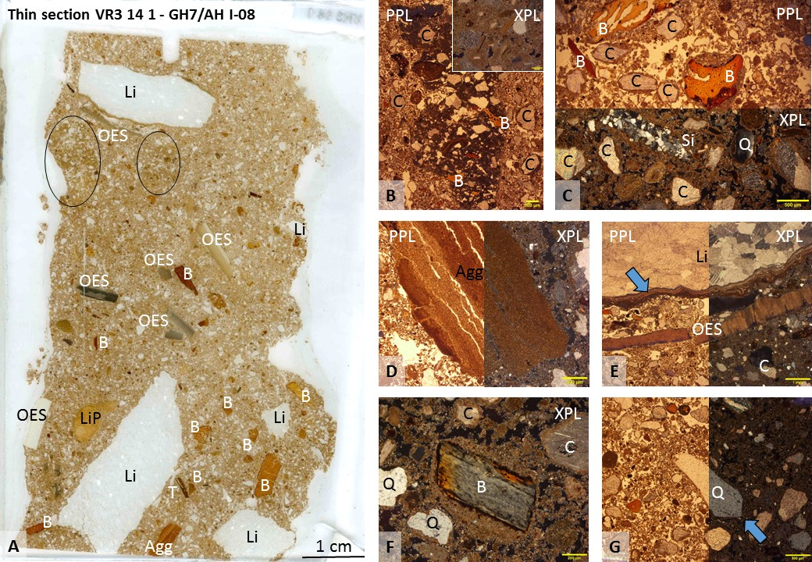
Figure S3. Micromorphology sample VR003 14 1 (I-08). A. Scan of thin section VR 14 1 showing a homogenous appearance and random orientation of coarse grains. Coarse grains are mainly limestone and calcite crystals originating from limestone weathering (white grains) as well as quartz (also white grains, more rare than calcite), bones (almost all brown grains, larger ones labelled), ostrich egg shell and rarely teeth, speleothem pendants and aggregates. Two cemented areas are present (black circles), but only become visible at higher magnification (see B). B. Cemented area showing a dark color and clear boundaries to the surrounding matrix. The inlet at the upper right shows the dense microstructure in the cemented area, which otherwise does not differ from the surrounding matrix indicating in situ formation. Scale 500 µm, scale inlet 200 µm. C. Sand to fine gravel sized grains, including bones, often exhibit a coating composed of fine material, a typical feature of slope deposits. The coating and the general matrix are composed of the same calcareous silt suggesting transport on the slope and not from the plateau above. Large grains such as limestone gravel, or elongated objects such as silcrete and ostrich egg shell, generally do not show coatings. Scale 500 µm. D. A subrounded surface slack aggregate, enriched in organics and clay. This aggregate originates from the plateau above the site. Scale 500 µm. E. In situ snapped ostrich eggshell below limestone. Note the coarse-crystalline nature of the limestone and a laminated pendant (arrow) formed on its surface. Scale 1 mm. F. Calcined bone (grey color). Scale 200µm. G. Quartz microdebitage with elongated shape and acute edges (arrow), indicating that this quartz presents a knapping byproduct. Scale 500µm. Abbreviations used here and in subsequent figures: Agg = Aggregate, B = Bone, C = Calcite, Ch = Charcoal, Gy = Gypsum, Ir = iron rich rock, Li = Limestone, OES = Ostrich eggshell, OIL = Oblique Incident Light, PPL and XPL= plane and Cross Polarized Light, Q = Quartz, Si= silcrete, T = Tooth, OIL plane and Cross Polarized Light, Q = Quartz, Si= silcrete, T = Tooth, OIL.
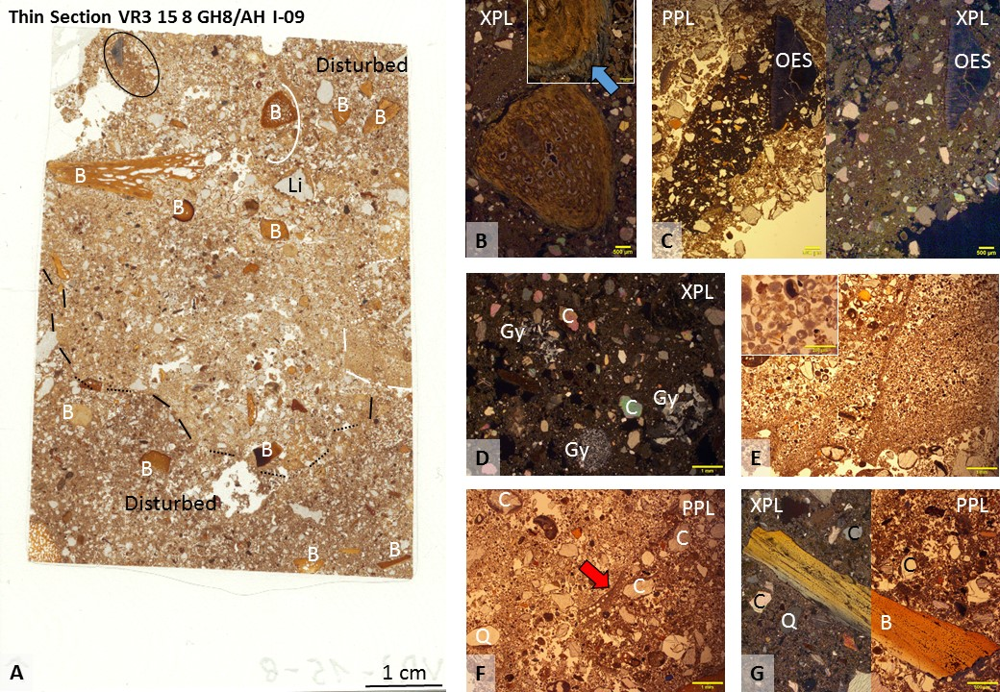
Figure S4. Micromorphology sample VR003 15 8 (I-09). A. Scan of thin section VR3 15 8 showing local disturbances (dark colored areas at bottom and upper right corner of slide). The contact is clear (marked by lines) and the intact part shows similar characteristics to thin section VR 14 1. Also here the deposit shows a calcareous matrix with limestone gravel, calcite crystals, fine gravel to sand sized bones (almost all brown grains) and a cemented areas (black circle) occurs. B. Superficially calcined bone (blue arrow in inlet indicating grey, calcined phase), suggesting short exposure to a high temperature fire. Scale 500 µm, inlet 200 µm. C. Cemented area with dark color and clear boundaries to surrounding matrix, but showing same composition with calcareous silt (see XPL) and calcite crystals, bones and ostrich eggshell. Note also the internal fractures in the ostrich eggshell. Scale 500 µm. D. Gypsum is present in variable forms with accumulations of lenticular crystals to rounded aggregates/rocks. Scale 1 mm. E. Disturbed area with pellet structures, sorted for very fine sand, and fine coating of the wall, indicating a biogenic origin. Scale 1 mm. F. Clear contact of the disturbed part with the intact part. Note a silty crust with vesicles here. Scale 1 mm. G. Superficially calcined bone (grey color) in the disturbed part of the thin section. Scale 500 µm.

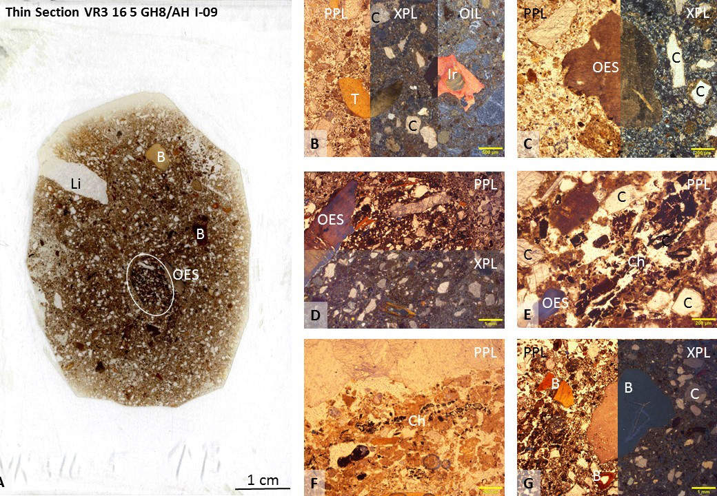
Figure S5. Micromorphology sample VR003 16 5 (I-09). A. Scan thin section VR16 5 showing darker color compared to the upper thin sections, resulting from microscopic charcoal and amorphous black staining in the matrix here (see E and F). Otherwise, the deposits shows similar characteristics, with limestone and calcite crystals, many microscopic bones, a cemented area (white circle) and a homogenous, porphyric appearance. B. Tooth (T) and an iron rich rock fragment, possibly ochre. Scale 500 µm. C. Rounded ostrich eggshell suggesting transport. Scale 200 µm. D. Cemented area next to an ostrich eggshell with internal fractures/dissolution traces. The fine material appears darker here due to increased density and black amorphous staining. Note also the bones in the cemented area. Scale 1 mm. E. Details of cemented area with microscopic charcoal. Scale 200 µm. F. Microscopic charcoal in the general matrix. Scale 200 µm. G. Bone fragments, some heated (central grey) and others without heating alterations (brown). Scale 1 mm.
Fabric analysis. During excavation, elongated lithics and bones axis were plotted with two spatial points to record their orientation and slope. The three-dimensional plunge and bearing of each artefact was plotted in a Benn diagram along with comparative data for geological processes modelled by (7). Confidence intervals (p = .95) in the Benn diagrams were calculated using a permutation test developed by (8), which involves resampling the assemblage 10000 times and plotting contour lines that accounts for 95% of the resampled indices. Rayleigh and Kolmogorov-Smirnov tests were used to determine if the orientation (bearing) and slope (plunge) of artefacts differed significantly from a uniform distribution, and were run using the CircStats package in R. Mean slope values for the two point objects (10.78°) do not deviate substantially from the low to moderate slope of the sediments the Lower Deposits, and the artefacts show no preferential pattern in orientation.

Figure S6. Benn diagrams for two-point lithics and bones from I-08 against expectations for various depositional processes.

Refits. Refit analysis of lithic artefacts was used principally as a means of assessing the integrity and slope of the archaeological deposits. Only silcrete and chert artefacts were included, as these materials are visually diverse and distinctive, particularly when compared to the other major materials in the assemblage (quartz, quartzite, and hornfels). A total of 12 refit sets was found in I-08 and I-09, comprising nine instances of sequential flake removals, two sets of conjoining flake fragments, and one instance where two pieces of heat shatter could be refit. Refits over short distances occur at various orientations (Figure S7). Refits over long distances typically follow the slope of the surface and lower strata.

Figure S7. Distribution and orientation of lithic refit sets in I-08, with indicative examples of refitting flakes.

Luminescence dating
Sample collection and preparation. Samples were collected during the excavation of VR003 by hammering metal tubes into cleaned section faces. These tubes were sealed with adhesive tape and wrapped in opaque plastic bags for transportation. In the laboratory, samples were processed under subdued red light. Sunlight exposed material was removed from each end of the sample tube and retained for dose rate measurement. K-feldspar were extracted from the portion of each sample which had not been exposed to sunlight since burial. Samples were initially wet-sieved to isolate the 212-180 µm size fraction. This removes large bedrock clasts from the sample before acid treatment, meaning that the possibility of incorporating grains liberated by dissolution of the bedrock was minimized. Carbonates and organic matter were subsequently removed from the 212-180 µm fraction using 1M HCl and H₂O₂ respectively. The resulting material was re-sieved at 180 µm. K-feldspar was extracted from the <2.62 g/cm³ fraction using density separations at 2.58 and 2.53 g/cm³ and stored in opaque containers prior to measurement.

Environmental dose rate calculation. For unetched sand-sized K-feldspar, the environmental dose rate consists of external alpha, beta, gamma and cosmic ray components, with an additional internal dose rate derived from potassium and rubidium within the grains themselves.

External alpha, beta and gamma dose rates were determined using alpha counting, beta counting and field gamma-spectrometry respectively. Alpha and beta counting was performed on dried, homogenised sub-samples of the light-exposed material removed from the sample tube prior to extraction of the dating sample. Uranium and thorium concentrations ware calculated for each sample using thick-source alpha counts obtained using Daybreak Model 583 alpha counters. External alpha dose rates were calculated from these data using standard conversion factors (9) and assuming secular equilibrium in the U and Th decay series. Beta dose rates were measured with a Risø GM-25-5 low-level beta counting system (10) using MgO and Volkagem (11) loess standards. Gamma dose rates were measured with an EG&G Ortec digiDart-LF gamma-spectrometer using the “threshold” method. External dose rates were corrected for moisture content (10±5%), attenuation of alpha (12) and beta (13) radiation due to grain size and alpha efficiency, using an a-value of 0.11±0.03 (14). The internal dose rate to K-feldspar grains was calculated assuming a K concentration of 12±1% and a K/Rb concentration ratio of 270:1 (15). The assumed K concentration encompasses (at 2σ) nearly the full range of K concentrations (9-14%) measured for single-grains of K-feldspar emitting detectable luminescence signals (16-19) and is consistent with the widely adopted value of 12.5±1.0% (20). Cosmic ray dose rates were calculated using site location (31.5°S, 18.5°E, 50 m elevation) and present day sediment burial depths, assuming a sediment overburden density of 1.8±0.1 g/cm³. Dose rates were calculated using the DRAC dose rate calculator (21). Dose rates are presented in Table S1. Here and throughout the luminescence Supplementary Information, uncertainties are given at 1σ except where otherwise stated.

Table S1. Sample depths and dose rates for VR003 samples. Depths are given below present-day sediment surface.
Layer | Sample  (VR003-…) | Sample  depth (m) | External dose rate (Gy/ka)ª |  |  |  | Total dose rate, D_{r}  (Gy/ka)^{b}
Layer | Sample  (VR003-…) | Sample  depth (m) | Alpha | Beta | Gamma | Cosmic | Total dose rate, D_{r}  (Gy/ka)^{b}
X | 2432 | 1.2±0.2 | 0.06±0.01 | 0.70±0.05 | 0.57±0.04 | 0.18±0.02 | 2.30±0.11
8 | 8710 | 1.4±0.2 | 0.06±0.01 | 1.09±0.08 | 0.64±0.05 | 0.17±0.02 | 2.74±0.13
9 | 8678 | 1.7±0.2 | 0.06±0.01 | 1.15±0.10 | 0.60±0.04 | 0.17±0.02 | 2.76±0.14
10 | 11918 | 1.9±0.2 | 0.05±0.01 | 0.67±0.05 | 0.50±0.04 | 0.16±0.02 | 2.17±0.11
ª External dose rates after correction for sample moisture content (10±5%) and, where appropriate, corrected for attenuation due to grain size and alpha efficiency. ^{b} Total dose rates are the sum of external dose rates plus an internal dose rate contribution of 0.79±0.08 Gy/ka.

Luminescence measurement equipment. Grains of K-feldspar were mounted in aluminium discs drilled with 100 holes, each 300 µm deep and 300 µm in diameter. All luminescence measurements presented in this study were carried out using a Risø TL/OSL-DA-15 automated dating system (22), fitted with a dual laser single-grain attachment (23, 24). Individual grains were stimulated using a 140 mW TTL modulated infra-red (IR, 830 nm) laser with a Schott RG 780 longpass filter mounted in the beamline. Simultaneous illumination of all grains on a disc was carried out using IR (870 nm) light emitting diodes (LEDs). Luminescence was detected using an Electron Tubes Ltd 9235QB15 photomultiplier tube shielded by Schott BG3 and BG39 filters. Irradiation was carried out using a 1.48 GBq ⁹⁰Sr/⁹⁰Y beta source. This source is calibrated relative to the National Physical Laboratory, Teddington ⁶⁰Co γ-source (Hotspot 800)(25). Due to the spatial inhomogeneity of beta emitters across the active face of our ⁹⁰Sr/⁹⁰Y beta source, it was necessary to calibrate the dose rate to each individual grain position on a single-grain disc (26). All single-grain discs were placed into the Risø instrument at the same angle relative to the ⁹⁰Sr/⁹⁰Y beta source. For the instrument used in this study, the sample discs rotated 0.04±0.03° per measurement cycle within the single-aliquot regenerative-dose method (see below). Consequently, it is possible to accurately correct for the effects of inhomogeneity in our ⁹⁰Sr/⁹⁰Y beta source by applying a grain position correction to each equivalent dose. Position-corrected equivalent doses were used in all age calculations.

Single-grain pIRIR measurements. Equivalent doses (D_{e}) were determined using the single-aliquot regenerative-dose (SAR) method (27). This method allows an independent estimate of D_{e} to be generated for each aliquot or mineral grain measured, though in practice single-grain measurements suffer a high rejection rate. The SAR technique involves making a series of paired measurements of luminescence intensity. The first measurement in each pair gives the natural (L_{n}) or regenerated (L_{x}) luminescence intensity, while the second measurement (T_{x}) gives the luminescence intensity in response to a fixed test dose. T_{x} is used to monitor changes in sensitivity (luminescence per unit dose) during the measurement sequence. By dividing the natural or regenerated luminescence intensities by their respective test dose intensity (i.e. L_{n}/T_{n} or L_{x}/T_{x}), a sensitivity-corrected luminescence response is determined. In this study, K-feldspars were measured using a post-infrared, infrared stimulated luminescence (pIRIR) measurement sequence (Table S2). In this sequence, the sample is illuminated using IR diodes for 200 s prior to measurement of the signal (L_{x} or T_{x}) from individual grains using an IR laser. This procedure removes luminescence signals which are prone to “fading”, which could otherwise lead to underestimation of D_{e} (28, 29). In addition, samples underwent an elevated temperature (225 °C for 500 s) IR diode stimulation after measurement of L_{x} or T_{x}, to prevent carry-over of charge from one measurement to the next (30).

Table S2. The SAR measurement sequence used to produce a) single-grain equivalent dose estimates and b) fading rates from K-feldspars from VR003.
Step | a) Single-grain K-feldspar pIRIR | b) K-feldspar pIRIR fading rates
1 | Give regenerative dose, D_{i}ª | Give regenerative dose (~50 Gy)^{c}
2 | Preheat 1 (255 °C for 60 s) | Preheat 1 (255 °C for 60 s)
3 | IR diode stimulation (60 °C for 200 s) | Pause^{d}
4 | IR laser stimulation (225 °C, 2 s), L_{x}^{b} | IR diode stimulation (60 °C for 200 s)
5 | IR diode stimulation (225 °C for 500 s) | IR diode stimulation (225 °C for 200 s), L_{x}^{e}
6 | Give test dose, D_{t} (~50 Gy) | Give test dose, (~50 Gy)
7 | Preheat 2 (255 °C for 60 s) | Preheat 2 (255 °C for 60 s)
8 | IR diode stimulation (60 °C for 200 s) | IR diode stimulation (60 °C for 200 s)
9 | IR laser stimulation (225 °C, 2 s), T_{x}^{b} | IR diode stimulation (225 °C for 200 s), T_{x}^{e}
10 | IR diode stimulation (225 °C for 500 s) | IR diode stimulation (290 °C for 150 s)
11 | Return to step 1 | Return to step 1
ª In the first cycle, where the natural luminescence intensity is observed, D_{i} = 0 Gy. ^{b} The luminescence signal (L_{x} or T_{x}) was that recorded during the first 0.3 s of stimulation, with a background signal from the last 0.3 s of stimulation subtracted. ^{c} Prior to the first measurement cycle, aliquots were illuminated for 150 s at 290 °C to remove any residual signal remaining after completion of the single-grain measurement sequence. ^{d} For each aliquot, ten measurements were made, of which three were prompt (no pause), three were made after a 1 hour pause, and two were made after 10 and 100 hour pauses. ^{e} The luminescence signal (L_{x} or T_{x}) was that recorded during the first 50 s of stimulation, with a background signal from the last 50 s of stimulation subtracted.

It has been observed widely that a large proportion of quartz and K-feldspar grains either do not yield a measureable luminescence signal, or display luminescence characteristics which indicate that they are unsuitable for age determination. Consequently, most dating studies adopt rejection criteria which exclude these grains. In the present study we adopted rejection criteria based on those used to analyse the very large single-grain pIRIR dataset from Denisova Cave, southern Siberia. In this analysis, grains were rejected where one or more of the following conditions were met:
- The initial T_{n} signal is less than 3σ above the corresponding background count, or the relative error on T_{n} is >20%.
- The recycling ratio (27) differs from unity by greater than 2σ.
- The IR-depletion ratio (31) is more than 2σ below unity.
- Recuperation is high. This criterion was met where L_{x}/T_{x} for the 0 Gy regeneration point is greater than 5 % of L_{x}/T_{x} for the maximum regenerative dose.
- The L_{x}/T_{x} ratios are too scattered to be reliably fitted with a curve. This criterion is met where the figure-of-merit (FOM) value (32, 33) exceeds 10%. The FOM is defined as:
$$FOM\left(\%\right)=\frac{\sum_{i=1}^{n}{\left|y_{i}^{o}-y_{i}^{f}\right|}}{\sum_{i=1}^{n}{y_{i}^{f}}}$$
where $y_{i}^{o}$ and $y_{i}^{f}$ denote the $i^{th}$ observed and fitted values respectively.
- The L_{n}/T_{n} ratio is statistically consistent with, or higher than, the saturation level of the corresponding dose response curve (DRC), so that a finite D_{e} value and error cannot be obtained.
- The D_{e} value is obtained by extrapolation of the fitted DRC, rather than interpolation among the regenerative dose signals.
Application of the rejection criteria was achieved using the function calSARED() provided in the R package numOSL (34, 35), with DRCs fitted using a general-order kinetic fit (36). For each accepted grain, the standard error associated with the D_{e} determination was estimated using a 1000 iteration Monte Carlo simulation. Rejection criteria were applied to grains in the order listed above, and only one cause for rejection was noted per grain (Table S3).

Table S3. The number of K-feldspar grains which were measured, rejected after application of rejection criteria, and accepted for inclusion in the calculation of the burial dose.
Sample (VR003-...) | 2432 | 8710 | 8678 | 11918
Layer | 8 | 8 | 9 | 9
Total number of grains measuredª
 | 1200 | 1200 | 1600 | 1200
Grains rejected for the following reasons
a) T_{n} signal <3*background or relative error >20% | 843 | 912 | 1285 | 868
b) Poor recycling ratio | 31 | 31 | 40 | 43
c) 0 Gy dose >5% of L_{x}/T_{x} for the maximum dose | 6 | 5 | 4 | 9
d) FOM >10% | 71 | 74 | 127 | 61
e) L_{n}/T_{n}>DRC | 0 | 1 | 2 | 0
f) D_{e} obtained by extrapolation | 2 | 10 | 4 | 2
Sum of rejected grains
 | 953 | 1033 | 1462 | 983
Acceptable individual D_{e} values
 | 247 | 167 | 138 | 217
ª Gives the number of grain positions measured i.e. 100 per single-grain disc. Discs were not inspected after use to assess the proportion of unoccupied grain positions, but a value ~3% has been reported by the same operator (SJA) when measuring similar material.

To determine the age of a sample which has been measured using single-grain luminescence techniques, it is first necessary to analyse the distribution of individual D_{e} values in order to generate a single burial dose (D_{b}). The Central Age Model (CAM) (37) was used to calculate D_{b}. The CAM generates D_{b} on the assumption that the dispersion of measured D_{e} values is explained by the overdispersion parameter (σ_{d}, the relative standard deviation of the true paleodoses) and measurement uncertainties. This model is appropriate for samples where the luminescence signal of all constituent grains was fully bleached prior to deposition, and where no post-depositional mixing has occurred. There is no evidence that these conditions are not met for the VR003 samples, and so the CAM was deemed appropriate for calculation of D_{b}. CAM burial doses were calculated using the function calc_CentralDose() in the R package Luminescence (Kreutzer et al., 2012). Equivalent dose distributions for the VR003 samples are shown in Figure S8.

Luminescence ages are calculated by dividing the burial dose, D_{b} by the total dose rate D_{r}. However, where feldspars exhibit measurable fading, it is necessary to correct this initial age for the effects of fading. Fading rates were assessed using the measurement sequence outlined in Supplementary Information Table Lum2b. These measurements were made on a subset (n=32) of the sample discs after completion of D_{e} measurements, but measurements and data analysis were conducted on bulk signals from each disc rather than those from individual grains. Fading rates (g-values normalised to t_{c} of 2 days) were calculated in Analyst v4.31.9 (38). Mean g-values for each sample were consistent with the mean for all measured aliquots (1.9±0.1 %/decade), and this value was used to correct each age. Fading corrections (39) were performed using the calc_FadingCorr() function in the R package Luminescence. CAM burial doses, dose rates and fading-corrected ages are presented in Supplementary Information Table Lum4.

Table S4. Single-grain K-feldspar CAM burial doses, overdispersion dose rate and ages.
Layer | Sample (VR003-…) | D_{b} (Gy) | σ_{d} (%) | D_{r} (Gy/ka) | Age (ka)ª
8 | 2432 | 162±4 | 38±2 | 2.30±0.11 | 84.7±4.7 (9.4)
8 | 8710 | 185±6 | 37±2 | 2.74±0.13 | 80.8±4.6 (9.2)
9 | 8678 | 196±6 | 35±2 | 2.76±0.14 | 84.9±5.0 (10.3)
9 | 11918 | 163±4 | 36±2 | 2.17±0.11 | 89.9±5.0 (10.1)
ª Fading corrected ages, with 1σ uncertainties and 2σ uncertainties in parentheses.

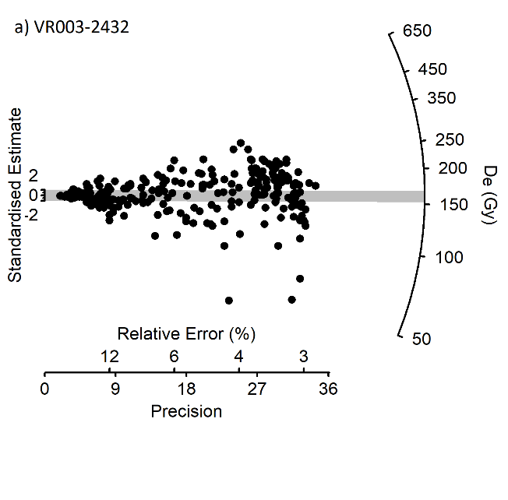 | 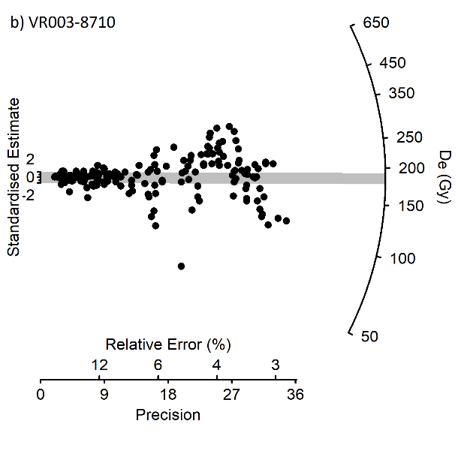
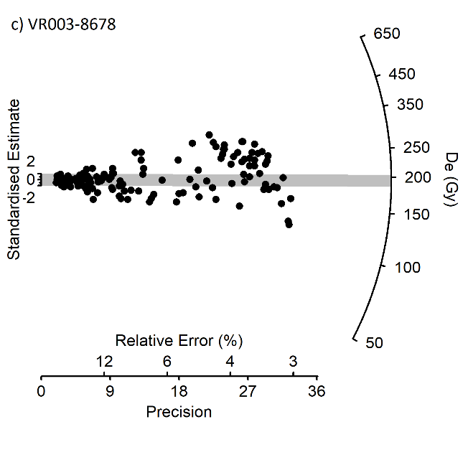 | 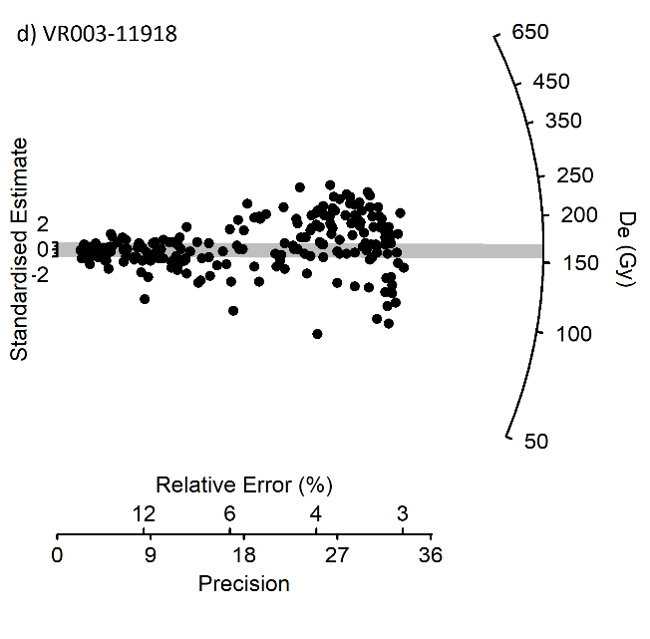
Figure S8. Single-grain K-feldspar D_{e} distributions for a) VR003-2432, b) VR003-8710, c) VR003-8678 and d) VR003-11918. Each point represents an individual grain. The grey bars are centered on the CAM D_{b} and all points that lie within the bars are consistent (at 2 σ) with this dose.
U-series Dating of Ostrich Eggshell
²³⁰Th/U burial dating. Ostrich eggshells (OES) consist of ~2 mm-thick, low-Mg calcite containing 1-3 wt.% organics and are suitable for ²³⁰Th/U dating, a technique capable of producing accurate, precise ages (~0.1%, 2σ) with a useful limit of >500 ka. Similar to other biominerals of higher animals, modern OES contain extremely low concentrations of primary U (c. 1 ppb or less); accordingly, most U in ancient OES is secondary. Until recently U-series dating of eggshells has been carried out without consideration of the effects of prolonged secondary uptake of U. In contrast, “²³⁰Th/U burial dating” of OES, which we employ herein, explicitly accounts for U uptake by OES from soil water after burial. In a previous study, we documented U uptake patterns in archaeological OES, showed that the effects of prolonged U uptake could be mitigated by applying a simple diffusion model to ages measured on OES subsamples, and demonstrated that resulting model ages termed ²³⁰Th/U burial ages were concordant with ¹⁴C ages measured on splits of latest Pleistocene to Holocene OES (40). Further work has shown that ²³⁰Th/U burial dating can be successfully used to date Pleistocene archaeological sites >100 ka, i.e., well beyond the ~50 ka ¹⁴C limit (41).
Laser ablation. U concentrations of archaeological OES, when profiled normal to their surface via laser ablation, exhibit characteristic asymmetric patterns controlled by the layered crystalline structure of OES (40). U profiles may therefore be used to identify OES suitable for ²³⁰Th/U burial dating and to select optimal locations of subsamples for U-series analysis. OES fragments from VR003 exhibit such U profiles (Figures S9-S11). Beginning at the outer surface, U typically falls rapidly in the first hundred microns or so, defines a flat or gently sloping plateau in the center of the eggshell, falls rapidly to a minimum value, and then rises rapidly with scattered values near the inner surface of the OES. Such a pattern indicates that U concentrations across most of the eggshell, from the outer surface to the U minimum, are controlled by U uptake at the outer surface. These patterns are associated with OES that yield ²³⁰Th/U burial ages concordant with ¹⁴C ages on splits of the same eggshell (40).
²³²Th/U profiles of VR003 OES were also carried out via laser ablation (see Figures S9-S11 as above. These data identify OES calcite with high common Th (²³²Th), an indicator of associated initial ²³⁰Th, which can degrade the accuracy and precision of ²³⁰Th/U ages. ²³²Th/U ratios generally decrease away from OES surfaces where eggshell calcite may be visibly contaminated by detritus from host sediment (40). The OES from VR003 follow this pattern, with ²³²Th/U ≥ 0.1 near their outer surfaces, while further inward rather pure OES calcite with much lower ²³²Th/U ratios occurs.
Combining information from U and ²³²Th/U profiles, the most suitable calcite for U-series dating can be identified. It occurs in the central part of the OES where the crystalline structure consists of radially-oriented, macroscopic columnar calcite crystal bundles of the palisade layer. There, relatively high U and low ²³²Th/U ratios coincide. For example, in sample VR003-9085, mean [U] in the palisade layer ranges from ~ 62 to 16 ppb (median = 42.7 ppb); in sample VR003-6612, mean [U] ranges from ~34 to 19 ppb in the palisade layer (median = 25.0 ppb); and in sample VR003-9300, [U] ranges between ~ 57 and 32 ppb in the palisade layer (median = 56.2 ppb) (Figure S12; Table S5). In the palisade layer of all three VR003 samples, favorable ²³²Th/U ratios of c. 0.01 or lower are observed, providing highly suitable material for U-series dating.

Table S5. All isotope ratios are activity ratios. Uncertainties are 2 standard deviations. Uncorrected ages are calculated from measured ratios. Ages were corrected for U and Th from detritus using (²³²Th/²³⁸U) = 1.21 ± 0.60, (²³⁰Th/²³⁸U) = 1.0 ± 0.1, and (²³⁴U/²³⁸U) = 1.0 ± 0.1. Decay constants are those of (42) for ²³⁸U and (43) for ²³⁰Th and ²³⁴U. Initial (²³⁴U/²³⁸U) is back-calculated from the measured ratio and the corrected age.
 |  |  |  |  |  |  |  |  |  |  |  |  |  |  |  | Uncorrected age | Corrected age | Burial age or minimum age
Sample Name | Sample wt (mg) | U (ppb) | ²³²Th (ppb) | (²³⁰Th/²³²Th) | (²³²Th/²³⁸U) | ± (2σ,%) | (²³⁰Th/²³⁸U) | ± (2σ,%) | (²³⁴U/²³⁸U) | ± (2σ,%) | Initial (²³⁴U/²³⁸U) | ± (2σ, ab.) | ka | ± (2σ), ka | ka | ± (2σ), ka | ka | ± (2σ), ka
VR003-6612 inner | 120.16 | 15.641 | 0.2925 | 136.9 | 0.0056 | 1.17 | 0.83050 | 1.76 | 1.6094 | 0.60 | 1.753 | 0.011 | 75.3 | 1.9 | 75.0 | 1.9 | 74.5 | 1.4
VR003-6612 outer | 102.47 | 19.800 | 0.3661 | 138.0 | 0.0056 | 0.83 | 0.82690 | 1.33 | 1.6157 | 1.26 | 1.759 | 0.022 | 74.4 | 1.9 | 74.1 | 1.9 | 74.5 | 1.4
VR003-9300 inner | 102.65 | 49.731 | 0.8685 | 157.6 | 0.0055 | 0.56 | 0.89620 | 0.86 | 1.6271 | 0.49 | 1.7904 | 0.0090 | 82.3 | 1.2 | 82.0 | 1.2 | 88.3 | 3.2
VR003-9300 outer | 95.83 | 49.836 | 0.4700 | 300.7 | 0.0029 | 0.87 | 0.92404 | 1.51 | 1.6245 | 0.50 | 1.7958 | 0.0099 | 86.0 | 2.0 | 85.9 | 2.0 | 88.3 | 3.2
VR003-9085-inner | 169.08 | 36.974 | 0.4197 | 264.6 | 0.0034 | 0.35 | 0.97754 | 0.50 | 1.6488 | 0.48 | 1.8389 | 0.0087 | 91.2 | 1.0 | 91.0 | 1.0 | 90.7 | 0.7
VR003-9085-outer | 176.02 | 52.418 | 0.7833 | 199.6 | 0.0047 | 0.40 | 0.97089 | 0.64 | 1.6465 | 0.44 | 1.8342 | 0.0081 | 90.6 | 1.0 | 90.3 | 1.1 | 90.7 | 0.7

²³⁰Th/U ages of OES. Three fragments of OES from layer MA08 were dated. U-series analytical data and ages are given in Table S5, above. Measured U concentrations of OES calcite range from ~15 to 50 ppb, ²³²Th/²³⁸U ratios are all <0.006, and corrections for initial ²³⁰Th from detritus are small (median = 0.25 ka), indicating that the samples are geochemically suitable for precise U-series dating. For OES fragment VR003-9300, we obtained an outer-shell age of 85.9 ±2.0 ka (errors are 2) and an inner-shell age of 82.0 ±1.2 ka, consistent with prolonged uptake of U originating from the outer surface of the eggshell. In such cases, we apply a simple 1-D diffusive uptake model to determine the time when the OES fragment was first exposed to U in soil pore water. To do so, we plot the measured ages versus their distances from the OES outer surface, normalized to the distance measured from the outer surface to the minimum [U] observed in the laser ablation profile, which defines the limit of U derived by uptake at the outer surface. Plotting ages of subsamples versus the square of their normalized distance from the outer surface causes the expected relationship between age and distance to become linear (Kohn, 2008; Sharp et al., 2019). Accordingly, a linear extrapolation of the measured age-distance relation to the outer OES surface, where U uptake was initiated, provides an estimate for the age of initial U uptake, which we term the ²³⁰Th/U burial age of the sample. Figure S12 shows these relationships for OES fragment VR003-9300, leading to a ²³⁰Th/U burial age of 88.3 ±3.2 ka, which we interpret as the best estimate for the depositional age of this OES.
Subsamples from two other OES fragments, VR003-9085 and VR003-6612, yield measured ages that are within analytical errors; i.e., 91.0 ±1.0 and 90.3 ±1.1 ka for VR003-9085 and 75.0 ±1.9 and 74.1 ±1.9 ka for VR003-6612, indicating relatively rapid U uptake (Figure S12). In such cases, we interpret the weighted mean of the subsample ages as the best estimate of the depositional age of the OES; i.e., 90.7 ±0.7 and 74.5 ±1.4 ka for VR003-9085 and VR003-6612, respectively. The different U uptake histories inferred for the OES fragments studied herein may result from distinct conditions in their host sediments including the availability and U concentrations of soil pore waters in contact with each of the OES fragments.
As discussed in the text, we interpret the age of OES VR003-6612 as a minimum age and infer an age for layer MA08 of 90.2 ±3.2 ka (2σ error), equal to the weighted mean ages of OES VR003-9300 and VR003-9085.
Figure S9. OES VR003-6612. Photo of analyzed OES fragment (upper right); photomicrograph of laser ablation mount showing laser ablation tracks (lower right); and plots of laser ablation results showing [U] and ²³²Th/U versus distance from outer surface of OES.

Figure S9. OES VR003-9085. Photo of analyzed OES fragment (upper right); photomicrograph of laser ablation mount showing laser ablation tracks (lower right); and plots of laser ablation results showing [U] and ²³²Th/U versus distance from outer surface of OES.
Figure S10. OES VR003-9300. Photo of analyzed OES fragment (upper right); photomicrograph of laser ablation mount showing laser ablation tracks (lower right); and plots of laser ablation results showing [U] and ²³²Th/U versus distance from outer surface of OES.
Figure S11. Photos of dated OES fragments (right) and plots of measured U-series ages (left). OES fragment VR003-6612 yields concordant U-series ages for two samples that define a weighted mean age; OES fragment VR003-9300 yields distinct U-series ages for two subsamples that define a ²³⁰Th/U burial age; and VR003-9085 yields concordant U-series ages for two samples that define a weighted mean age.
Figure S12. Plots comparing laser ablation results for the dated OES fragments. Points show the mean [U] or ²³²Th/U at each position, computed by averaging values measured along five parallel laser ablation tracks across each OES. Mean [U] and ²³²Th/U values are plotted versus distance from OES outer surfaces; vertical lines on points show 1σ errors.

Palaeoenvironmental data
Phytolith analysis. Phytolith counts were divided broadly into graminoid and non-graminoid groups, with classification based on the revised nomenclature (44) as well as previous studies (45, 46). Graminoid groups include morphotypes characteristic of Poaceae (grasses), Cyperaceae (sedges), and Restionaceae (restios). Poaceae includes short cells distinct to various grass subfamilies, with those of Pooideae (rondels, trapezoids, crenates, trapezoidal bilobates) and less so the Chloridoideae (short saddles) found in high concentrations at VR003. Restionaceae includes reniform, paddle-like, and various spheroidal morphotypes. Rarely, some Cyperaceae papillates were present, although these could also be attributed to Proteaceae shrubs (47). Various other non-specific graminoid morphotypes were present that cannot be attributed to a particular group, such as blocky and elongate, among others. Non-graminoid phytoliths representative of woody and shrubby vegetation were also present in relatively high concentrations (spheroidal, tracheary, among others). Spheroidal phytoliths from both Restionaceae and non-graminoids were counted together due to their considerable similarity; the combination of these two groups is considered an indicator of fynbos vegetation and therefore the distinction between these varieties is not crucial (46).
Two main ratios are presented in the results, the C₄ to C₃ grass ratio, and the ratio of Restionaceae and non-graminoid vegetation to Poaceae. The C₄ to C₃ grass ratio is used as an indicator of changing community composition driven by shifts in climate, particularly rainfall (45). High concentrations of C₃ grasses are driven by increased winter rainfall, while increasing C₄ grasses represent a decline in winter rainfall (45). The presence of Chloridoideae over the Panicoideae subfamily in turn suggests this was accompanied by a lack of summer rainfall (45). Separately, the Restionaceae and non-graminoid to Poaceae ratio is used as a characterization of Fynbos communities relative to grassland (46). These ratios, along with concentration data for key short cells, are presented in Table S6.
Table S6. Phytolith concentrations and key ratio data from VR003 samples.
 | Depth below surface (cm) | Concentration of Pooideae short cells (# per gram) | Concentration of Chloridoideae short cells (# per gram) | Concentration of total short cells (# per gram) | Total phytolith concentration (# per gram) | C4: C3 ratio | Restios and non-graminoids: Poaceae ratio | Damage to assemblage (%)
I-03 | 20-22 | 19.3 | 1.0 | 21.7 | 71.5 | 4.9 | 0.644 | 20.3
I-03/4 | 30-32 | 47.3 | 2.8 | 52.1 | 197.5 | 5.8 | 1.240 | 11.3
I-04(a) | 40-42 | 16.1 | 1.7 | 19.0 | 56.9 | 10.3 | 0.758 | 7.1
I-04(b) | 50-55 | 23.5 | 1.7 | 26.9 | 67.0 | 9.3 | 0.447 | 11.1
I-05/6 | 75-80 | 22.7 | 1.5 | 25.7 | 90.2 | 6.3 | 0.941 | 10.1
I-07 | 100-105 | 29.5 | 1.1 | 32.6 | 103.7 | 3.4 | 0.355 | 22.3
I-08(a) | 125-130 | 96.1 | 21.8 | 136.5 | 334.1 | 20.8 | 0.184 | 10.5
I-08(b) | 155-160 | 137.2 | 28.7 | 178.0 | 428.3 | 21.3 | 0.178 | 6.7
I-09 | 180-185 | 120.7 | 14.5 | 157.6 | 337.6 | 13.9 | 0.142 | 4.0

Cultural material.
Fauna. The Lower Deposit faunal assemblage (Table S6) has a substantial proportion of tortoise remains (n= 352, 67% of total NISP) and counts of distal humeri indicate at least 21 individuals present; when carapace and plastron pieces are identifiable to species they are predominately from angulate tortoises; one humerus was not an angulate but the alternative species could not be confidently assigned. Mammals comprise the other major component of the assemblage, primarily bovids of all size classes. Based on identifications of dental remains, among the small bovids, grysbok/steenbok were confirmed, and among the large bovids, eland were identified. While no identifiable dental remains of small-medium and medium-large bovids were preserved in I-08, in other Late Pleistocene contexts at VR003, small-medium bovids are represented by springbok (Antidorcas marsupialis) and large-medium bovids are represented by alcelaphines (wildebeest and hartebeest; Alcelaphus and Connochaetes) and the now extinct blue antelope (Hippotragus leucopheus). A single equid specimen of Cape zebra is also present in the Lower Deposits. Other mammals include rodents and small herbivores such as Cape porcupine, Cape dune mole-rat, and rock hyrax, and small carnivores. In addition to tortoises and mammals, a few snake (n=3) and bird (n=3) specimens are also present. Overall, terrestrial species representation suggests a relatively open, semi-arid environment, encompassing a variety of habitats such as savannas, grasslands and scrub forests, with both graze and browse available. More grass would have been available than was present in the region during the late Holocene, including historically.
Analysis of bone modifications was limited due to high fragmentation and poor preservation of the assemblage, and signs of hominin butchery and carcass processing may be obscured by some root etching, minor weathering damage, and the more common presence of concretions on many of the specimens. No cutmarks or percussion marks were observed but evidence of green breakage on a small portion (n=7) of bovid long bones could indicate cracking of fresh bone to access marrow. All major taxonomic categories (tortoises, bovids, small mammals/carnivores, birds) show some evidence of burning. No chewmarks, gastric etching, or other evidence of carnivore consumption were observed.

Table S7. The faunal remains from I-08 and I-09. The Number of Identified Specimens (NISP) are presented, along with the Minimum Number of Individuals (MNI). The bovid species counts are based on dental remains, and those counts are not included in the body-size categories. When possible to identify more specifically, the Testudinidae are Chersina angulate, with the exception of one humerus which was not. The birds and snakes were not identified to more specific taxa. Mammalian nomenclature based on (48).
Scientific name | Common name | NISP | MNI
Procavia capensis | rock hyrax (dassie) | 1 | 1
Bathyergus suillus | Cape dune mole-rat | 1 | 1
Hystrix africaeaustralis | Cape porcupine | 1 | 1
Felis silvestris libyca | African wild cat | 8 | 1
Mellivora capensis | honey badger (ratel) | 1 | 1
Equus capensis | Cape zebra | 1 | 1
Taurotragus oryx | eland | 5 | 2
Raphicerus sp(p.) | grysbok/steenbok | 4 | 1
 | small bovid(s) | 63 | 1
 | small-medium bovid(s) | 34 | 1
 | large-medium bovid(s) | 32 | 1
 | large bovid(s) | 15 | 1
Aves | birds | 3 | 1
Testudinidae | tortoises | 352 | 21
Serpentes | snakes | 3 | 1
 | Total | 524

Table S8. The marine shell remains from I-08 and I-09. The Number of Identified Specimens (NISP) are presented, along with the Minimum Number of Individuals (MNI); weight in grams and number of burnt specimens are also included. When MNI counts exceed one, they are based on the apices of the limpets.
Scientific name | Common name | NISP | MNI | Weight (g) | # Burnt
Choromytilus meridionalis | black mussel | 2 | 1 | 0.3 | 1
Cymbula granatina | granite limpet | 13 | 2 | 45.2 | 0
Scutellastra argenvillei | Argenville's limpet | 3 | 1 | 12.7 | 2
 | limpet | 4 | 1 | 1.5 | 4
 | mollusk | 4 | 1 | 1.2 | 1
Total |  | 26

Ostrich eggshell (OES). Fragments of OES recovered from the screens during excavation were sorted into categories based on color, representing the temperature of heat exposure consistent with that described by (49) (Table S8). Counts and weights were recorded, and all fragments were examined for evidence of anthropomorphic alteration, including beads in various stages of manufacture, intentional engraving, and any indication of deliberate or repeated percussive modification (i.e., flaking) (Table S9).
OES identified as possibly flaked were examined using a Nikon SMZ 1000 stereomicroscope with a magnification range of 8x to 80x. A Nikon D7100 was attached for microphotos that captured images at a magnification range of 16x to 160x. Flaking initiations can be seen, for example, on fragments VR003-6147, VR003-7833, and VR003-7114, indicating repeated application of downward percussive force in a series of precisely-aimed blows (Figure 3). A few samples preserved only simple notches from single blows (e.g., VR003-9220, VR003-7693) that could be carnivore perforations (50); in other cases such notches appear to reflect either errant blows or early stages of flaking (e.g., VR003-7974, VR003-9300, VR003-7340) prior to refinement of the flaking arc. Perforation notches may potentially reflect initial stages of flask opening.
Table S9. OES recovered from the screens divided into categories of heat exposure, including number of fragments and total weight in grams (gm). Below, the worked fragments of OES that were piece-plotted are sorted into heat exposure categories with the max diameter listed in millimeters (mm) and individual weights in grams.
I-08 & I-09 | OES < 200°C |  | OES 200°C - 350°C |  | OES > 350°C |  | Total OES
Aggregate samples | n= | Wt (g) | n= | Wt (g) | n= | Wt (g) | n= | Wt (g)
Aggregate samples | 2717 | 1603.4 | 3475 | 2690.4 | 9511 | 3262.4 | 15703 | 7556.2

Table S10. Details of flaked OES fragments recovered from I-08 and I-09. Concave refers to concavities formed by repeated flaking in an arc; notched refers to a concavity formed by a single flaking initiation. Arc radius and circle diameter estimated for concave flaked margins only.
Sample ID | Recovery | Max. dimension (mm) | N initiations | N margins flaked | Initiation from exterior? | Initiation from interior? | Concave (C) and/or notched (N)? | C Width (CW) | C Depth (CD) | CD / CW | N width | N depth | Est. radius | Est. diam.
5698 | screen | 41.3 | >3 | 1 | 1 | 0 | C | 9.3 | 0.6 | 15.50 |  |  | 18.32 | 36.64
6147 | plot | 24.6 | >3 | 1 | 1 | 0 | C | 14.8 | 1.8 | 8.22 |  |  | 16.11 | 32.22
7833 | plot | 30 | >3 | 1 | 1 | 0 | C | 18.8 | 3.1 | 6.06 |  |  | 15.80 | 31.60
7114 | screen | 18.8 | >3 | 1 | 1 | 0 | C | 11.3 | 1.1 | 10.27 |  |  | 15.06 | 30.12
7693 | screen | 17.6 | >3 | 1 | 1 | 0 | C | 10.6 | 1 | 10.60 |  |  | 14.55 | 29.09
5910 | screen | 23.7 | >3 | 1 | 1 | 0 | C | 12.6 | 1.7 | 7.41 |  |  | 12.52 | 25.05
8415 | plot | 30.5 | >3 | 1 | 1 | 0 | C | 13.4 | 2.1 | 6.38 |  |  | 11.74 | 23.48
6307 | plot | 38.4 | >3 | 1 | 1 | 0 | C | 13.3 | 2.1 | 6.33 |  |  | 11.58 | 23.16
9300 | screen | 17.9 | 3 | 1 | 1 | 0 | C,N | 11.8 | 1.7 | 6.94 | 5.8 | 1.2 | 11.09 | 22.18
7974 | screen | 29.7 | >3 | 1 | 1 | 0 | C,N | 14.1 | 2.6 | 5.42 | 6.3 | 2 | 10.86 | 21.72
8417 | screen | 13.1 | >3 | 1 | 1 | 0 | C | 6.4 | 0.5 | 12.80 |  |  | 10.49 | 20.98
8348 | plot | 27.6 | >3 | 1 | 1 | 1 | C | 11.3 | 1.8 | 6.28 |  |  | 9.77 | 19.53
8100 | screen | 23 | >3 | 1 | 1 | 0 | C | 8.9 | 1.1 | 8.09 |  |  | 9.55 | 19.10
6060 | screen | 22 | >3 | 1 | 1 | 0 | C | 8.5 | 1.1 | 7.73 |  |  | 8.76 | 17.52
6199 | screen | 28.2 | >3 | 1 | 1 | 0 | C | 8.8 | 1.2 | 7.33 |  |  | 8.67 | 17.33
6612 | screen | 17.7 | >3 | 1 | 1 | 0 | C | 6.7 | 0.7 | 9.57 |  |  | 8.37 | 16.73
9340 | screen | 17.9 | 2 | 1 | 1 | 0 | C,N | 8.4 | 1.3 | 6.46 | 4.5 | 1.2 | 7.43 | 14.87
8344 | screen | 32.7 | 1 | 1 | 0 | 0
5169 | screen | 22.3 | 2 | 2 | 1 | 0
9220 | screen | 19.2 | 1 | 1 | 1 | 0 | N |  |  |  | 5.1 | 2.9
7693 | screen | 18.9 | 1 | 1 | 1 | 0 | N |  |  |  | 4.9 | 1.6

Pigments. Data recorded on all pigments >5 mm from the Lower Deposits include nodule morphology, weathering, friability, hardness, magnetism, texture, luster, and type of inclusions. It was noted whether or not each pigment nodule was washed before analysis in case of ambiguous traces. Macroscopic observations were made using a Nikon SMZ 1000 stereomicroscope with a magnification range of 8x to 80x. A Nikon D7100 was attached for microphotos, capturing images at magnifications from 16x to 160x. For pigment nodules that were anthropogenically modified, modification form, proportion, number of facets, and profile type were recorded. Pigment nodules were tested for streakability on a ceramic plate. If nodules did not streak or exhibited poor staining power, they were excluded from the final count. Pigment streak color was assessed using a Munsell CAPTURE Color Matching Tool, directly applied to the ceramic plates following device protocols. Munsell color values were captured multiple times to ensure accuracy. If multiple values were obtained, the value that was captured more often was used. Munsell color values were then converted to the RGB color model using the xyY-to-sRGB formula at https://pteromys.melonisland.net/munsell/.
The Lower Deposit pigment assemblage comprises 78 pieces (Table S10) featuring considerable variation in morphology and mineralogy (including pieces rich in hematite, limonite, and manganese). Nodules masses range from 0.05g to 12.01g with the vast majority <1g. Pigment nodules have varying morphologies that include irregular chunks (n=48), rounded lumps (n=16), flakes (n=6), chips (n=6), a tabular piece, and a prismatic (crayon-like) one (Table S10). Nodules described as chunks exhibit an irregular thick morphology with sharp edges (Fig. 1), while chips and flakes are thin portions derived from larger nodules. Chips are rounded in outline, while flakes are angular. Nodules exhibit some weathering with almost all having some amount of sediment adhering to them (n=75) and many with indications of rounding (n=38). A small number of pigments nodules were either burned (n=2; Figure S13) or have ash adhering to the surface (n=1). Nodules are generally well or moderately cemented, though three nodules are friable to the touch. Many nodule colors are represented in this assemblage including pink, red, purple, black, grey, greenish brown, yellow, and orange; nodules streak in a wide variety of colors and hues from dark reds and reddish browns to light reds and pale browns with reddish yellows, strong browns, and medium reds in between (Figure S13). Three of the specimens appear to be massive hematite nodules, which generally are substantial, smooth, dark, and glossy in appearance. While many similar objects such as these did not produce a color when streaked on a ceramic tile, the three included in this dataset exhibited relatively good staining power in colors such as very pale brown and yellowish red. The majority of the pigment nodules are unmodified, but eight are ground, scraped, and/or polished (Figure S13; Table S10). Two of the modified nodules have multiple wear facets including the prismatic piece which has nine separate facets. The modified nodules streak a variety of colors including pink, red, yellowish red, greyish red, and very pale brown when tested on a ceramic tile (Figure S13).

Table S11. Number of pigment modified and unmodified nodules by morphology, I-08 & I-09.
Pigment nodule morphologies | Number of pigment nodules | Number of modified nodules
Chunk | 23 | 4
Flake | 6 | 0
Lump | 4 | 0
Prismatic | 1 | 1
Tabular | 1 | 1
Small chip | 6 | 0
Small chunk | 25 | 2
Small lump | 12 | 0
TOTAL | 78 | 8

Figure S13. (A) Pigment nodule VR003-8511 (I-08) with anthropogenic modifications including polish and grinding with minor burning on the surface. This nodule is characterized as a chunk, weighs 4.18g, measures 24.74 x 19.9 x 9.97mm, and streaks a very pale brown color (Munsell color system: 10YR 7/3). (B) Proportion of pigment colors from Lower Deposits when streak on a ceramic tile.
Lithics. The analysed assemblage from the Lower Deposit comprises 3062 flaked artefacts >15 mm; artefacts below this cut-off were not analysed individually. The breakdown of primary classes by raw material is given in Table S13. Silcrete is the single most common rock type in the sample (41.6%), followed by quartz (29.8%) and quartzite (20.9%); between them these three lithologies account for more than 90% of the artefacts. The fine-grained rocks hornfels and chert account for a further 6.2% of artefacts, followed by the ‘other’ category which includes sandstone, shale, ironstone, limestone and unidentified igneous lithologies. The raw material composition of I-08 is interesting relative to previously published strata from the site: in all other units which we have analysed, quartz was the dominant rock (>50% of total) and silcrete never exceeded 17% (1).
Table S12. Breakdown of Lower Deposit flaked lithic assemblage by raw material and artefact class.
 | silcrete | quartz | quartzite | hornfels | chert | other | total | %
flakes | 813 | 712 | 554 | 76 | 66 | 26 | 2247 | 73.4
retouched flakes | 29 | 44 | 18 | 10 | 4 | 1 | 106 | 3.5
cores | 72 | 25 | 13 | 3 | 4 | 0 | 117 | 3.8
flaked pieces | 67 | 119 | 26 | 4 | 7 | 8 | 231 | 7.5
heat shatter | 313 | 9 | 20 | 8 | 5 | 6 | 361 | 11.8
total | 1294 | 909 | 631 | 101 | 86 | 41 | 3062
% | 41.6 | 29.8 | 20.9 | 3.3 | 2.9 | 1.4 |  | 100.0

Flakes are the most common of the primary artefact classes (73.4%), with cores (3.8%) and retouched flakes (3.4%) having similarly low frequencies. Heat shattered pieces – pieces formed by heat-induced fracture – account for 11.8% of the total. This value is much higher than the proportion of heat shattered artefacts in the MSA samples from nearby sites such as Diepkloof (1.7%), Klein Kliphuis (1.3%) and Putslaagte 8 (4.0%) (51-53). This abundance is driven principally by silcrete among which it accounts for nearly a quarter (24.2%) of all artefacts, including many large pieces (Figure S14). Among all other raw materials combined heat shatter accounts for 3.0% of artefacts, with hornfels (8.8%) having the highest value after silcrete. This pattern might partly be explained by the relative identifiability of heat effects on different lithologies. The characteristics of heat shatter are generally visually-obvious on fine-gained sedimentary/metamorphic rocks such as silcrete, chert and hornfels, and to an extent on the coarse-grained rocks such as quartzite, but can be hard to identify on crystalline rocks like quartz which often exhibit non-conchoidal fracture. This does not, however, explain the differences observed here for heat shatter frequencies between silcrete, chert and hornfels. Chert should be more sensitive to shatter than silcrete (54).
Notable variation is also observed in the prevalence of other primary artefact classes by raw material. Silcrete, for example, contributes the majority of the cores (61.4%) but only 27.4% of the retouch flakes. Indeed, silcrete is only the lithology in which cores exceed retouched flakes. Among other rock types the retouched flake to core ratio varies from 1 (chert / other) to 3.3 (hornfels); for silcrete the value is 0.4. These base data suggest differences in the delivery and treatment of silcrete vs non-silcrete artefacts in the Lower Deposit assemblage.
Complete flakes were classified into three shape types: flakes, blades and points (Figure S15). We define blades here as any flake with elongation (percussion length / maximum percussion width) of 2 or greater. We do not distinguish blades and bladelets, and given our cut-off of 15 mm many of the latter would have been missed during analysis. ‘Points’ we define as flakes with a consistent taper through at least their distal two-thirds. The type ‘flakes’ refers to any shape that does not conform to these other types. Where points are elongate the type ‘point’ was selected over the type ‘blade’.
Table S13. Numbers of different flake types in the Lower Deposits divided by raw material, complete flakes only.
 | silcrete | quartz | quartzite | hornfels | chert | other | total | %
flakes | 434 | 323 | 269 | 37 | 35 | 14 | 1111 | 88.7
blades | 36 | 14 | 20 | 10 | 3 | 0 | 83 | 6.6
points | 24 | 8 | 20 | 3 | 4 | 0 | 59 | 4.7
total | 494 | 345 | 309 | 50 | 42 | 14 | 1253

Flakes dominate the sample (88.7%) with both blades and points relatively uncommon (6.6% and 4.7% respectively) (Table S14). Values for both are consistent across raw material classes with the exception of hornfels, where blades comprise an anomalous 20%, potentially implying different reduction patterns for that rock type. Only 18 (21.7%) of the blades related to laminar (unidirectional or bidirectional opposed) reduction systems, suggesting that the presence of the blades in the assemblage was largely incidental. Consistent with this, evidence for formal establishment and/or maintenance of blade removals is minimal; following Soriano, Villa and Wadley (55) most of the blades fail to conform to standard types (Table S15). The single class ‘C’ (maintenance) crested blade we identified is only partially crested, with the crest in lateral position. This artefact is made from silcrete and the proximal area of the left lateral reflects an episode of thermal fracture that occurred before the flake was struck (Figure S15 e). The scars that comprise the crest are smooth and lustrous, and consistent with working after heat treatment. Thus, the flake was struck from a core that had been heated to the point of fracture.
Table S14. Blade types from the Lower Deposits following (55). Empty columns (i.e., those with null values: classes B3, B5, B11, B13, B14, D1) are excluded. Class A blades reference initial phases of production (cortical blades); class B blades derive from the optimal phase; class C blades are those used for maintenance of core morphology; class D blades are those that do not conform with any of the standard definitions.
 | A1 | A2 | A3 | B1 | B2 | B4 | B6 | B7 | B8 | B9 | B10 | B12 | C2 | D2
silcrete | 1 | 2 | 2 | 5 |  |  |  | 2 | 1 | 1 |  |  | 1 | 20
quartz |  |  |  | 2 | 2 | 1 | 1 |  | 1 | 1 |  |  |  | 6
quartzite | 2 |  |  | 2 |  |  | 1 |  | 1 | 1 |  | 1 |  | 11
hornfels |  |  |  | 1 | 1 | 2 | 1 |  | 1 |  | 1 |  |  | 3
chert | 1 |  |  |  |  |  |  |  |  | 1 |  |  |  | 1
total | 4 | 2 | 2 | 10 | 3 | 3 | 3 | 2 | 4 | 4 | 1 | 1 | 1 | 41

Like blades, point production in our assemblage mostly seems opportunistic or incidental (Table S15). Only seven of 59 (11.8%) exhibit platform and dorsal scar configurations suggestive of Levallois reduction; across the entire sample this amounts to 0.6% of complete flakes. A further ten points (16.9%) appear to relate to discoidal flaking patterns. One of these was made from chert and refits to an earlier flake (Figure S6), suggesting that at least some of these points were made on site. As we note, though, there is nothing in the flake component to suggest that manufacture of points was an objective of reduction at the site.
Almost half of all flakes (46.5%) – including flakes, blades and points – have cortex (Table S16). Presence and prevalence of cortex between raw materials is quite consistent, varying from 41.2% (chert) to 56.8% (hornfels). Notably less well-represented lithologies present the outlying values, possibly reflecting sample-size effects. Within the main raw materials, variance is from 42.8% (silcrete) to 51.4% (quartzite). Similarly, proportions of flakes with cortical coverage across more than half of the dorsal and platform surfaces do not vary greatly between raw materials (7.5% (silcrete) to 10.3% (chert)). The main point of contrast in cortex between raw materials is in its form (Table S17). Quartzite and hornfels, which are both available in ancient cobble beds in the area, generally have fluvial cortex as their most common type (62.4% and 40.0% respectively); silcrete and quartz, the two flakable rocks that occur commonly as primary sources in the area, have very high proportions of outcrop cortex (83.8% and 74.1% respectively).
Table S15. Cortex classes for all complete flakes in the Lower Deposits.
 | silcrete | quartz | quartzite | hornfels | chert | total | %
51-100 | 35 | 29 | 25 | 4 | 4 | 97 | 8.6
26-50 | 33 | 21 | 33 | 6 | 0 | 93 | 8.0
1-25 | 127 | 112 | 74 | 15 | 12 | 340 | 29.9
0 | 299 | 183 | 177 | 25 | 26 | 710 | 53.5
total | 494 | 345 | 309 | 50 | 42 | 1240

Table S16. Cortex types for all complete flakes in the Lower Deposits.
 | silcrete | quartz | quartzite | hornfels | chert | total
outcrop | 160 | 120 | 6 | 4 | 5 | 295
fluvial | 9 | 11 | 82 | 10 | 2 | 114
crystal | 0 | 5 | 0 | 0 | 0 | 5
unsure | 26 | 28 | 44 | 11 | 9 | 118
total | 195 | 164 | 133 | 25 | 16 | 533

The 103 retouched flakes in the Lower Deposits include 63 complete pieces that we discuss briefly here. Notched pieces – comprising simple notches formed by a single blow and complex notches formed by multiple removals from the same concavity – are the most common retouched artefact type. These are followed by denticulates, defined as artefacts with three or more adjacent notches along a single margin. A very high proportion (41.9%) of retouched pieces could not be assigned to any type. Among the major lithologies, these ‘informal’ retouched pieces are most common on silcrete artefacts (60%); quartz has the next highest proportion at 41.7%. The retouched silcrete artefacts include one denticulate made on a piece of heat shatter. This is one of only three examples of retouch on heat shattered fragments (see Table S20 below) (e.g., Figure S15 m).
Table S17. Retouch flake types by raw material.
 | silcrete | quartz | quartzite | hornfels | chert | Other | total
Denticulate | 2 | 5 | 2 | 0 | 0 | 0 | 9
Notch, simple | 3 | 4 | 6 | 2 | 0 | 0 | 15
Notch, complex | 2 | 1 | 0 | 1 | 0 | 0 | 4
Scaled piece | 0 | 1 | 1 | 2 | 0 | 0 | 4
Scraper | 1 | 3 | 0 | 0 | 0 | 0 | 4
Other | 12 | 10 | 2 | 0 | 2 | 1 | 27
total | 20 | 24 | 11 | 5 | 2 | 1 | 63

Cores have been discussed in some detail in the main text, and we restrict our description here to limited additional information on the 91 complete pieces. As noted in the main text, the types of cores found in the Lower Deposit assemblage is quite diverse. ‘Other prepared’ pieces – comprising those with preparation of the striking platform but no clear organisation of the removal surface – are numerically most common, along with cores that conformed to no type. Most of these latter pieces were opportunistic, 23 of 24 (95.8%) having three or fewer removals >20% of the core maximum dimension. The ‘platform’ groups includes cores that are not technically single platform – they may have one or two blows from from a second surface – but which have a series of removals along a single dominant, and invariably linear platform.
Consistent with earlier observations on the flake component, evidence for blade production is rare: only 7 or the 91 (7.7%) complete cores retained one or more blade removal. Point removals were even less common (n=4, 4.4%). Of the blade removals recorded, most were extremely small, with a mean of 16.3 mm (std=6.2).
Table S18. Core types by raw material.
 | silcrete | quartz | quartzite | hornfels | chert | Other | total
Bipolar | 0 | 1 | 0 | 0 | 0 | 1 | 2
Discoidal | 3 | 1 | 1 | 0 | 0 | 0 | 5
Levallois, preferential | 3 | 1 | 2 | 0 | 0 | 0 | 6
Levallois, recurrent | 5 | 0 | 1 | 1 | 1 | 0 | 8
Other prepared | 15 | 5 | 3 | 1 | 0 | 0 | 24
Platform | 10 | 3 | 1 | 0 | 1 | 0 | 16
Rotated | 4 | 1 | 1 | 0 | 0 | 0 | 6
No type | 13 | 8 | 3 | 0 | 1 | 0 | 24
total | 53 | 20 | 12 | 2 | 3 | 1 | 91

Heat effects are prevalent in the Lower Deposit assemblage, but as noted in the main text, most commonly on silcrete. To that end, we restrict discussion of heat effects here to that raw material. Like prior sections of this SI, we exclude incomplete pieces to avoid duplicate counts of what may have been individual artefacts. Heat effects are classified following (56, 57). Without a detailed reference collection the identification of post-heat removals is subjective, relying on the evaluation that flake scars are smoother and more lustrous than might be expected for unheated silcrete. The classification ‘unsure’ was thus used quite frequently during analysis, and the firm identification of heat treatment largely restricted to those pieces with clear texture contrast between adjacent and/or sequential removal events, including double patina and surfaces with heat-induced non-conchoidal (HINC) fracture (Table S20).
Overall, 39.4% of silcrete artefacts appear likely to have been heated and 35.8% might confidently be classified as ‘heat treated’ in the sense that they were thermally altered before being worked (ie., all heated excluding ‘HINC – Flaked before’ and ‘HINC – Unsure’). Of those with clear signs of heat shatter (HINC fractures) at some point before or after discard, a very high proportion (79.8%) were flaked after shatter. Excluding those for which the sequence of shatter and flaking cannot be identified (HINC – Unsure) this value rises to 96.3%.
Evidence for heat effects occurs unevenly between different artefact classes. Approximately two thirds of all unretouched flakes (65.4%) and half of all retouched flakes (48.4%) show no clear signs of heat effect. This is true of only 5.6% of cores. Types of heat effects differ just as starkly. Heat treated pieces with no evidence of HINC are twice as common as pieces flaked after shatter among complete flakes and complete retouched flakes; among cores pieces flaked after shatter are twice as common as those with no evidence of HINC. Most simply, this difference may reflect flakes removed from areas of a heated core from which HINC fractures were absent. It is also possible that these flaking products derive from a heat treatment system in which heat-induced fracture was less prevalent. Based on the evidence from the silcrete cores in the Lower Deposits, however, such activities may have taken place off site.
Table S19. Classification of heat effects on silcrete artefacts of different classes. Double patina excludes pieces with HINC features. Flaked before, Flaked after, Both, and Unsure refers to the sequential relationship between the shatter event creating the HINC fracture and any flaking events evident on the piece.
Artefact class | No heat | Unsure | Heated
Artefact class | No heat | Unsure | Post-heat removals | Double patina | HINC |  |  |  | Total
 |  |  |  |  | Flaked before | Flaked after | Both | Unsure | Total
flakes | 66 | 257 | 48 | 47 | 3 | 55 | 2 | 16 | 494
retouched flakes | 1 | 8 | 1 | 5 | 0 | 3 | 0 | 1 | 19
cores | 1 | 2 | 3 | 14 | 0 | 32 | 0 | 1 | 53
Total | 68 | 267 | 52 | 66 | 3 | 77 | 2 | 17 | 553
Total | 68 | 267 | 218 |  |  |  |  |  | 553

Figure S14. Large, blocky silcrete heat shatter fragments from the Lower Deposits.

Figure S15. Flakes and unretouched flakes from the Lower Deposits. White arrows are used to indicate locations of HINC fractures that have been truncated by subsequent removals. (a-c) silcrete blades; (a) was heat shattered after manufacture, as indicated by HINC (potlids) on the ventral surface. (d) silcrete point with double patina on the left side (dorsal view) – note the texture contrast between the proximal (later) and distal (earlier) scars. (e-f) silcrete blades, including (e) partially crested blade; (f) was struck from a ridge formed by heat shatter. (h) hornfels blade with pecussion-shattered bulb. (i) silcrete flake with HINC on distal right lateral, truncated by the ventral. (j-k) denticulate and notched (respectively) quartz flakes. (j) hornfels scaled piece. (m) silcrete notched piece with HINC fracture truncated by both the ventral and one retouch scar. (n) silcrete complex notch. (o) silcrete scraper, retouch has removed the platform.

Figure S16. Annotated figure showing silcrete cores made on fragments of heat shatter.

References
1. Steele TE, et al. (2016) Varsche Rivier 003: A Middle and Later Stone Age site with Still Bay and Howiesons Poort assemblages in southern Namaqualand, South Africa. PaleoAnthropology 2016:100-163.
2. Villagran X, Strauss A, Alves M, & Oliveira RE (2019) Virtual micromorphology: The application of micro-CT scanning for the identification of termite mounds in archaeological sediments. Journal of Archaeological Science: Reports 24:785–795.
3. Cosarinsky MI (2011) The nest growth of the neotropical mound-building termite, Cornitermes cumulans: a micromorphological analysis. Journal of Insect Science 11:1-14.
4. Jungerius PD, van der Acker JAM, & Mücher HJ (1999) The contribution of termites to the microgranular structure of soils on the Uasin Gishu Plateau, Kenya. Catena 34:349-363.
5. Francis ML, Ellis F, Lambrechts JJN, & Poch RM (2012) A micromorphological view through a Namaqualand termitaria (Heuweltjie, a Mima-like mound). Catena 100:57-73.
6. Genise JF & Poire DG (2000) Fluidization in insect constructions in soils. Ichnos 7:127-134.
7. Lenoble A & Bertran P (2004) Fabric of Palaeolithic levels: methods and implications for site formation processes. Journal of Archaeological Science 31(4):457-469.
8. McPherron SP (2018) Additional statistical and graphical methods for analyzing site formation processes using artefact orientations. PLoS One 13(1):e0190195.
9. Guérin G, Mercier N, & Adamiec G (2011) Dose-rate conversion factors: Update. Ancient TL 29(1):5-8.
10. Bøtter-Jensen L & Mejdahl V (1988) Assessment of beta dose-rate using a GM multicounter system. International Journal of Radiation Applications and Instrumentation. Part 14(1-2):187-191.
11. De Corte F, et al. (2007) Preparation and characterization of loess sediment for use as a reference material in the annual radiation dose determination for luminescence dating. Journal of Radioanalytical and Nuclear Chemistry 272(2):311-319.
12. Brennan BJ, Lyons RG, & Phillips SW (1991) Attenuation of alpha particle track dose for spherical grains. International Journal of Radiation Applications and Instrumentation. Part 18(1-2):249-253.
13. Guérin G, Mercier N, Nathan R, Adamiec G, & Lefrais Y (2012) On the use of the infinite matrix assumption and associated concepts: A critical review. Radiation Measurements 47(9):778-785.
14. Balescu S & Lamothe M (1993) Thermoluminescence dating of the holsteinian marine formation of Herzeele, northern France. Journal of Quaternary Science 8(2):117-124.
15. Mejdahl V (1987) Internal radioactivity in quartz and feldspar grains. Ancient TL 5:10-17.
16. Neudorf CM, Roberts RG, & Jacobs Z (2012) Sources of overdispersion in a K-rich feldspar sample from north-central India: Insights from D e, K content and IRSL age distributions for individual grains. Radiation Measurements 47(9):696-702.
17. Gaar D, Lowick SE, & Preusser F (2014) Performance of different luminescence approaches for the dating of known-age glaciofluvial deposits from Northern Switzerland. Geochronometria 41(1):65-80.
18. Lamothe M, Balescu S, & Auclair M (1994) Natural IRSL intensities and apparent luminescence ages of single feldspar grains extracted from partially bleached sediments. Radiation Measurements 23(2-3):555-561.
19. Jacobs Z, et al. (2019) Timing of archaic hominin occupation of Denisova Cave in southern Siberia. Nature 565(7741):594-599.
20. Huntley DJ & Baril MR (1997) The K content of K-feldspars being measured in optical dating or in thermoluminescence dating. Ancient TL 15(11-13).
21. Durcan JA, King GE, & Duller GAT (2015) DRAC: Dose Rate and Age Calculator for trapped charge dating. Quaternary Geochronology 28:54-61.
22. Bøtter-Jensen L, Andersen CE, Duller GAT, & Murray AS (2003) Developments in radiation, stimulation and observation facilities in luminescence measurements. Radiation Measurements 37(4-5):535-541.
23. Duller GAT, Bøtter-Jensen L, Murray AS, & Truscott AJ (1999) Single grain laser luminescence (SGLL) measurements using a novel automated reader. Nuclear Instruments and Methods in Physics Research, Section B: Beam Interactions with Materials and Atoms 155(4):506-514.
24. Duller GAT, Bøtter-Jensen L, & Murray AS (2003) Combining infrared- and green-laser stimulation sources in single-grain luminescence measurements of feldspar and quartz. Radiation Measurements 37(4-5):543-550.
25. Armitage SJ & Bailey RM (2005) The measured dependence of laboratory beta dose rates on sample grain size. Radiation Measurements 39(2):123-127.
26. Ballarini M, Wintle AG, & Wallinga J (2006) Spatial variation of dose rate from beta sources as measured using single grains. Ancient TL 24(1):1-7.
27. Murray AS & Wintle AG (2000) Luminescence dating of quartz using an improved single-aliquot regenerative-dose protocol. Radiation Measurements 32(1):57-73.
28. Thomsen KJ, Murray AS, Jain M, & Bøtter-Jensen L (2008) Laboratory fading rates of various luminescence signals from feldspar-rich sediment extracts. Radiation Measurements 43(9-10):1474-1486.
29. Li B, Jacobs Z, Roberts RG, & Li SH (2014) Review and assessment of the potential of post-ir irsl dating methods to circumvent the problem of anomalous fading in feldspar luminescence. Geochronometria 41(3):178-201.
30. Colarossi D, Duller GAT, & Roberts HM (2018) Exploring the behaviour of luminescence signals from feldspars: Implications for the single aliquot regenerative dose protocol. Radiation Measurements 109:35-44.
31. Duller GAT (2003) Distinguishing quartz and feldspar in single grain luminescence measurements. Radiation Measurements 37(2):161-165.
32. Balian HG & Eddy NW (1977) Figure-of-merit (FOM), an improved criterion over the normalized Chi-squared test for assessing goodness-of-fit of gamma-ray spectral peaks. Nuclear Instruments and Methods 145:389-395.
33. Peng J, Pagonis V, & Li B (2016) On the intrinsic accuracy and precision of the standardised growth curve (SGC) and global-SGC (gSGC) methods for equivalent dose determination: A simulation study. Radiation Measurements 94:53-64.
34. Peng J & Li B (2017) Single-aliquot regenerative-dose (SAR) and standardised growth curve (SGC) equivalent dose determination in a batch model using the R package ‘numOSL’. Ancient TL 35:32-53.
35. Peng J, Dong Z, Han F-Q, Long H, & Liu X-J (2013) R package numOSL: numeric routines for optically stimulated luminescence dating. . Ancient TL 31:41-48.
36. Guralnik B, et al. (2015) Radiation-induced growth and isothermal decay of infrared-stimulated luminescence from feldspar. Radiation Measurements 81:224-231.
37. Galbraith RF, Roberts RG, Laslett GM, Yoshida H, & Olley JM (1999) Optical dating of single and multiple grains of quartz from Jinmium rock shelter, northern Australia: Part I, experimental design and statistical models. Archaeometry 41(2):339-364.
38. Duller G (2007) Assessing the error on equivalent dose estimates derived from single aliquot regenerative dose measurements. Ancient TL 25:15-24.
39. Huntley DJ & Lamothe M (2001) Ubiquity of anomalous fading in K-feldspars and the measurement and correction for it in optical dating. Canadian Journal of Earth Sciences 38(7):1093-1106.
40. Sharp WD, et al. (2019) 230Th/U burial dating of ostrich eggshell. Quaternary Science Reviews 219:263-276.
41. Niespolo EM, Sharp WD, Avery G, & Dawson TE (In review) Early, intensive marine resource exploitation by Middle Stone Age humans at Ysterfontein 1 rockshelter, South Africa. Proceedings of the National Academy of Sciences, USA.
42. Jaffey AH, Flynn KF, Glendenin LE, & Essling AM (1971) Precision measurement of half-lives and specific activities of ²³⁵U and ²³⁸U. Physical Review C 4:1889-1906.
43. Cheng H, et al. (2013) Improvements in ²³⁰Th dating, ²³⁰Th and ²³⁴U half-life values, and U–Th isotopic measurements by multi-collector inductively coupled plasma mass spectrometry. Earth and Planetary Science Letters 371-372:82-91.
44. Neumann K, et al. (2019) International Code for Phytolith Nomenclature (ICPN) 2.0. Annals of Botany 124:189-199.
45. Cordova CE (2013) C3 Poaceae and Restionaceae phytoliths as potential proxies for reconstructing winter rainfall in South Africa. Quaternary International 287:121-140.
46. Esteban I, et al. (2017) Modern soil phytolith assemblages used as proxies for paleoscape reconstruction on the south coast of South Africa. Quaternary International 434:160-179.
47. Novello A, Bamford MK, van Wijk Y, & Wurz S (2018) Phytoliths in modern plants and soils from Klasies River, Cape Region (South Africa). Quaternary International 464:440-459.
48. Skinner JD & Chimimba CT (2005) The Mammals of the Southern African Subregion (Cambridge University Press, Cambridge) 3rd edition Ed.
49. Collins B & Steele TE (2017) An often overlooked resource: Ostrich ( Struthio spp.) eggshell in the archaeological record. Journal of Archaeological Science: Reports 13:121-131.
50. Kandel AW (2004) Modification of ostrich eggs by carnivores and its bearing on the interpretation of archaeological and paleontological find. Journal of Archaeological Science 31:377-391.
51. Mackay A (2009) History and Selection in the Late Pleistocene Archaeology of the Western Cape, South Africa. PhD (Australian National University).
52. Mackay A (2010) The Late Pleistocene archaeology of Klein Kliphuis rockshelter, Western Cape, South Africa: 2006 excavations. South African Archaeological Bulletin 65(192):132-147.
53. Mackay A, et al. (2014) Putslaagte 1 (PL1), the Doring River, and the later Middle Stone Age in southern Africa’s Winter Rainfall Zone. Quaternary International 350:43-58.
54. Schmidt P, Buck G, Berthold C, Lauer C, & Nickel KG (2018) The mechanical properties of heat-treated rocks: a comparison between chert and silcrete. Archaeological and Anthropological Sciences.
55. Soriano S, Villa P, & Wadley L (2007) Blade technology and tool forms in the Middle Stone Age of South Africa: the Howiesons Poort and post-Howiesons Poort at Rose Cottage Cave. Journal of Archaeological Science 34(5):681-703.
56. Schmidt P, et al. (2013) Heat treatment in the South African Middle Stone Age: temperature induced transformations of silcrete and their technological implications. Journal of Archaeological Science 40(9):3519-3531.
57. Schmidt P, et al. (2015) A previously undescribed organic residue sheds light on heat treatment in the Middle Stone Age. J Hum Evol.

