ELECTRONIC SUPPLEMENTARY FILE (ESF)

Major depressive disorder, neuroticism, suicidal behaviors, and depression severity are all associated with neurotoxic immune networks and their intricate interactions with metabolic syndrome.

(1-9) Michael Maes*, (3,4,10) Ketsupar Jirakran*, (3,4) Asara Vasupanrajit, (1,2) Bo Zhou$, (3,4,5) Chavit Tunvirachaisakul; (3) Abbas F. Almulla$

* Joined first authorships; $ joined corresponding authors.

ESF, Table 1. Overview of the cytokines, chemokines, and growth factors measured in the current study

Protein abbreviations | Gene Symbol | > OOR (%) | Protein name / alias
IFN-α2 | IFNA2 | 60.8 | Interferon-α2
IFN-γ | IFNG | 81.9 | Interferon-γ
IL-1α | IL1A | 60.8 | Interleukin-1α
IL-1β | IL1B | 78.3 | Interleukin-1β
sIL-1RA | IL1RN | 100 | Soluble interleukin-1 receptor antagonist
IL-2 | IL2 | 24.6 | Interleukin-2
IL-2R | IL2RA | 100 | Soluble interleukin-2 receptor
IL-3 | IL3 | 0 | Interleukin-3
IL-4 | IL4 | 100 | Interleukin-4
IL-5 | IL5 | 5.8 | Interleukin-5
IL-6 | IL6 | 27.5 | Interleukin-6
IL-7 | IL7 | 2.9 | Interleukin-7
IL-9 | IL9 | 100 | Interleukin-9
IL-10 | IL10 | 56.4 | Interleukin-10
IL-12p70 | IL12A/B | 37.0 | Interleukin-12 p70
IL-12p40 | IL12B | 60.8 | Interleukin-12 p40
IL-13 | IL13 | 68.1 | Interleukin-13
IL-15 | IL15 | 10.9 | Interleukin-15
IL-16 | IL16 | 100 | Interleukin-16
IL-17 | IL17A | 60.8 | Interleukin-17
IL-18 | IL18 | 100 | Interleukin-18
TNF-α | TNF | 100 | Tumor necrosis factor-α
TNF-β | LTA | 100 | Tumor necrosis factor-β or lymphotoxin-alpha (LT-α)
TRAIL | TNFSF10 | 100 | TNF-related apoptosis-inducing ligand (TRAIL) or tumor necrosis factor ligand superfamily member 10 (TNFSF10)
LIF | LIF | 94.2 | Leukemia inhibitory factor
MIF | MIF | 100 | Macrophage migration inhibitory factor-like protein (MIF) or glycosylation-inhibiting factor
G-CSF | CSF3 | 100 | Granulocyte colony stimulating factor (G-CSF) or colony stimulating factor 3 (CSF3)
M-CSF | CSF1 | 100 | Macrophage colony-stimulating factor (M-CSF) or colony stimulating factor 1 (CSF1)
GM-CSF | CSF2 | 60.8 | Granulocyte-macrophage colony-stimulating factor (GM-CSF) or colony-stimulating factor 2 (CSF2)
CCL2 or MCP1 | CCL2 | 100 | C-C motif chemokine ligand 2 (CCL2) or monocyte chemoattractant protein 1 (MCP1)
CCL3 or MIP-1α | CCL3 | 100 | C-C motif Chemokine ligand 3 (CCL3) or macrophage inflammatory protein 1-alpha (MIP-1α)
CCL4 or MIP-1β | CCL4 | 100 | C-C motif chemokine ligand 4 (CCL4) or macrophage inflammatory protein 1β (MIP-1β) or lymphocyte activation gene 1 protein
CCL5 or RANTES | CCL5 | 100 | C-C motif chemokine ligand 5 (CCL5) or regulated upon activation, normally T-expressed, and presumably Secreted (RANTES)
CCL7 or MCP3 | CCL7 | 60.8 | C-C motif chemokine ligand 7 (CCL7) or monocyte-chemotactic protein 3 (MCP3).
CCL11 or Eotaxin | CCL11 | 100 | C-C motif chemokine ligand 11 (CCL11) or eosinophil chemotactic protein
CCL27 or CTACK | CCL27 | 100 | C-C motif chemokine ligand 27 (CCL27) or cutaneous T-cell attracting chemokine (CTACK)
CXCL1 or GRO-α | CXCL1 | 100 | C-X-C motif chemokine 1 (CXCL1) or growth-regulated alpha protein (GRO)
CXCL8 or IL-8 | CXCL8 | 100 | C-X-C motif chemokine ligand 8 (CXCL8) or interleukin-8 (IL-8)
CXCL9 or MIG | CXCL9 | 100 | C-X-C motif chemokine ligand 9 (CXCL9) or monokine induced by gamma interferon (MIG)
CXCL10 or IP10 | CXCL10 | 100 | C-X-C motif chemokine ligand 10 (CXCL10) or Interferon gamma-induced protein 10 (IP10)
CXCL12 or SDF-1α | CXCL12 | 100 | C-X-C motif chemokine 12 (CXCL12) or stromal cell-derived factor 1 (SDF-1α)
FGF | FGF2 | 91.3 | Fibroblast growth factor 2 (FGF) or basic fibroblast growth factor
HGF or SF | HGF | 100 | Hepatocyte growth factor (HGF) or scatter factor (SF)
BNGF | NGF | 63.8 | β-nerve growth factor (NGF)
PDGF | PDGFA | 100 | Platelet derived growth factor (PDGF)
SCF | KITLG | 100 | Stem cell factor (SCF) or Kit ligand (KITLG)
SCGF-β or CLEC11A | CLEC11A | 100 | Stem cell growth factor (SCGF) or C-type lectin domain family 11 member A (CLEC11A)
VEGF | VEGFA | 89.1 | Vascular endothelial growth factor (VEGF)

Adapted from: Maes M, Rachayon M, Jirakran K, Sodsai P, Klinchanhom S, Gałecki P, Sughondhabirom A, Basta-Kaim A. The Immune Profile of Major Dysmood Disorder: Proof of Concept and Mechanism Using the Precision Nomothetic Psychiatry Approach. Cells. 2022 Mar 31;11(7):1183. doi: 10.3390/cells11071183. PMID: 35406747; PMCID: PMC8997660.
Kalayasiri R, Dadwat K, Supaksorn T, ,Sirivichayakul S, Maes M. Methamphetamine (MA) use, MA dependence, and MA-induced psychosis are associated with increasing aberrations in the compensatory immunoregulatory system and interleukin-1α and CCL5 levels. medRxiv 2023.03.26.23287766; doi: https://doi.org/10.1101/2023.03.26.23287766

ESF, Table 2. Description of the immune profiles used in this study

Immune Profile | Members
M1 macrophage | IL-1β, IL-6, TNF-α, IL-12p70, IL-15, CCL2, CCL5, CXCL1, CXCL8, CXCL9, CXCL10
M2 macrophages | IL-10, IL-4, IL-13, VEGF, PDGF, sIL-1RA
z M1 – z M2 | zM1 – zM2
T helper (Th)-1 | IL-2, sIL-2R, IFN-a, IFN-γ, IL-12p70, IL-16, TNF-α, TNF-β
Th-2 | IL-4, IL-5, IL-9, IL-13, IL-10, IL-6
z Th- z Th-2 | zTh-1 – zTh-2
IRS | IL-1α, IL-1β, IL-6, IL-12p70, IL-15, IL-16, IL-17, IL-18, CCL2, CCL3, CCL4, CCL5, CCL7, CCL11, CXCL1, CXCL8, CXCL9, CXCL10, IL-2, IFN-α, IFN-γ, TNF-α, TNF-β, TRAIL, GM-CSF, M-CSF, G-CSF, SCGF
CIRS | IL-4, IL-10, sIL-1RA, sIL-2R
z IRS – z CIRS | zIRS – zCIRS
IL-1 signaling | aIL-1α + zIL-1β - zsIL1RA
TNF signaling | TNF-α, TNF-β, TRAIL

IRS: immune-inflammatory response system; CIRS: compensatory immunoregulatory system
Adapted from:
Maes M, Rachayon M, Jirakran K, Sodsai P, Klinchanhom S, Gałecki P, Sughondhabirom A, Basta-Kaim A. The Immune Profile of Major Dysmood Disorder: Proof of Concept and Mechanism Using the Precision Nomothetic Psychiatry Approach. Cells. 2022 Mar 31;11(7):1183. doi: 10.3390/cells11071183. PMID: 35406747; PMCID: PMC8997660.

Kalayasiri R, Dadwat K, Supaksorn T, ,Sirivichayakul S, Maes M. Methamphetamine (MA) use, MA dependence, and MA-induced psychosis are associated with increasing aberrations in the compensatory immunoregulatory system and interleukin-1α and CCL5 levels. medRxiv 2023.03.26.23287766; doi: https://doi.org/10.1101/2023.03.26.23287766
ESF, Table 3a. Differences in immune profiles between patients with major depression (MDD, 1) and healthy controls (noMDD, 0).

Estimates
Dependent Variable | MDD_NoMDD | Mean | Std. Error | 95% Confidence Interval
 |  |  |  | Lower Bound | Upper Bound
M1 | .00 | -.059ª | .124 | -.305 | .186
M1 | 1.00 | .063ª | .125 | -.185 | .311
M2 | .00 | -.098ª | .121 | -.337 | .142
M2 | 1.00 | .099ª | .122 | -.143 | .341
zM1-zM2 | .00 | .046ª | .122 | -.195 | .288
zM1-zM2 | 1.00 | -.044ª | .123 | -.287 | .200
Th-1 | .00 | -.084ª | .124 | -.329 | .161
Th-1 | 1.00 | .086ª | .125 | -.161 | .334
Th-2 | .00 | -.063ª | .123 | -.305 | .180
Th-2 | 1.00 | .058ª | .124 | -.187 | .303
zTh1-zTh2 | .00 | -.003ª | .123 | -.247 | .241
zTh1-zTh2 | 1.00 | .009ª | .124 | -.237 | .255
IRS | .00 | -.034ª | .125 | -.280 | .213
IRS | 1.00 | .033ª | .126 | -.216 | .282
CIRS | .00 | .042ª | .124 | -.203 | .286
CIRS | 1.00 | -.047ª | .125 | -.294 | .200
zIRS-zCIRS | .00 | -.088ª | .124 | -.333 | .157
zIRS-zCIRS | 1.00 | .093ª | .125 | -.154 | .341
IL-1 signaling | .00 | .280ª | .112 | .058 | .503
IL-1 signaling | 1.00 | -.294ª | .114 | -.519 | -.070
TNF signaling | .00 | -.265ª | .120 | -.502 | -.028
TNF signaling | 1.00 | .272ª | .121 | .033 | .512
a. Covariates appearing in the model are evaluated at the following values: Sex = .203, Age = 37.436.
All data are shown as z scores.

Univariate Tests
Dependent Variable |  | Sum of Squares | df | Mean Square | F | Sig.
M1 | Contrast | .479 | 1 | .479 | .472 | .493
M1 | Error | 129.867 | 128 | 1.015
M2 | Contrast | 1.242 | 1 | 1.242 | 1.284 | .259
M2 | Error | 123.799 | 128 | .967
zM1-zM2 | Contrast | .261 | 1 | .261 | .266 | .607
zM1-zM2 | Error | 125.379 | 128 | .980
Th-1 | Contrast | .930 | 1 | .930 | .917 | .340
Th-1 | Error | 129.770 | 128 | 1.014
Th-2 | Contrast | .471 | 1 | .471 | .475 | .492
Th-2 | Error | 126.982 | 128 | .992
zTh1-zTh2 | Contrast | .005 | 1 | .005 | .005 | .945
zTh1-zTh2 | Error | 128.143 | 128 | 1.001
IRS | Contrast | .142 | 1 | .142 | .139 | .710
IRS | Error | 130.929 | 128 | 1.023
CIRS | Contrast | .251 | 1 | .251 | .249 | .619
CIRS | Error | 129.029 | 128 | 1.008
zIRS-zCIRS | Contrast | 1.061 | 1 | 1.061 | 1.049 | .308
zIRS-zCIRS | Error | 129.435 | 128 | 1.011
IL-1 signaling | Contrast | 10.607 | 1 | 10.607 | 12.733 | .001
IL-1 signaling | Error | 106.625 | 128 | .833
TNF signaling | Contrast | 9.274 | 1 | 9.274 | 9.779 | .002
TNF signaling | Error | 121.398 | 128 | .948
All results of univariate GLM analyses with metabolic syndrome as second factor, and age and sex as covariates. The F tests the effect of MDD_NoMDD. This test is based on the linearly independent pairwise comparisons among the estimated marginal means.
See Table 2 for explanation of the immune profiles.

ESF, Table 3b. Differences in immune profiles between patients with and without metabolic syndrome (MetS).

Estimates
Dependent Variable | MetS_NoMetS | Mean | Std. Error | 95% Confidence Interval
 |  |  |  | Lower Bound | Upper Bound
M1 | .00 | -.030ª | .129 | -.286 | .226
M1 | 1.00 | .034ª | .135 | -.234 | .301
M2 | .00 | .007ª | .126 | -.243 | .257
M2 | 1.00 | -.006ª | .132 | -.267 | .255
zM1-zM2 | .00 | -.045ª | .127 | -.297 | .207
zM1-zM2 | 1.00 | .048ª | .133 | -.215 | .310
Th-1 | .00 | -.015ª | .129 | -.271 | .242
Th-1 | 1.00 | .017ª | .135 | -.250 | .284
Th-2 | .00 | .071ª | .128 | -.183 | .324
Th-2 | 1.00 | -.075ª | .134 | -.339 | .189
Th1-Th2 | .00 | -.075ª | .129 | -.329 | .179
Th1-Th2 | 1.00 | .081ª | .134 | -.185 | .347
zIRS | .00 | .018ª | .130 | -.239 | .275
zIRS | 1.00 | -.019ª | .136 | -.288 | .249
zCIRS | .00 | .054ª | .129 | -.201 | .310
zCIRS | 1.00 | -.059ª | .135 | -.326 | .207
zIRS-zCIRS | .00 | -.042ª | .129 | -.298 | .213
zIRS-zCIRS | 1.00 | .047ª | .135 | -.220 | .314
IL-1 signaling | .00 | .119ª | .117 | -.113 | .351
IL-1 signaling | 1.00 | -.133ª | .122 | -.375 | .110
TNF signaling | .00 | -.037ª | .125 | -.285 | .210
TNF signaling | 1.00 | .044ª | .131 | -.214 | .303
a. Covariates appearing in the model are evaluated at the following values: Sex = .203, Age = 37.436.

Pairwise Comparisons
Dependent Variable | (I) MetS_NoMetS | (J) MetS_NoMetS | Mean Difference (I-J) | Std. Error | Sig. | 95% Confidence Interval for Differenceª
 |  |  |  |  |  | Lower Bound | Upper Bound
M1 | .00 | 1.00 | -.064 | .199 | .748 | -.457 | .329
M1 | 1.00 | .00 | .064 | .199 | .748 | -.329 | .457
M2 | .00 | 1.00 | .013 | .194 | .947 | -.371 | .396
M2 | 1.00 | .00 | -.013 | .194 | .947 | -.396 | .371
zM1-zM2 | .00 | 1.00 | -.093 | .195 | .635 | -.479 | .293
zM1-zM2 | 1.00 | .00 | .093 | .195 | .635 | -.293 | .479
Th-1 | .00 | 1.00 | -.031 | .199 | .874 | -.424 | .361
Th-1 | 1.00 | .00 | .031 | .199 | .874 | -.361 | .424
Th-2 | .00 | 1.00 | .146 | .196 | .460 | -.243 | .534
Th-2 | 1.00 | .00 | -.146 | .196 | .460 | -.534 | .243
zTh1-zTh2 | .00 | 1.00 | -.156 | .197 | .430 | -.546 | .234
zTh1-zTh2 | 1.00 | .00 | .156 | .197 | .430 | -.234 | .546
zIRS | .00 | 1.00 | .037 | .199 | .852 | -.357 | .432
zIRS | 1.00 | .00 | -.037 | .199 | .852 | -.432 | .357
zCIRS | .00 | 1.00 | .114 | .198 | .567 | -.278 | .505
zCIRS | 1.00 | .00 | -.114 | .198 | .567 | -.505 | .278
zIRS-zCIRS | .00 | 1.00 | -.089 | .198 | .653 | -.482 | .303
zIRS-zCIRS | 1.00 | .00 | .089 | .198 | .653 | -.303 | .482
IL-1 signaling | .00 | 1.00 | .251 | .180 | .165 | -.105 | .607
IL-1 signaling | 1.00 | .00 | -.251 | .180 | .165 | -.607 | .105
TNF signaling | .00 | 1.00 | -.082 | .192 | .671 | -.462 | .298
TNF signaling | 1.00 | .00 | .082 | .192 | .671 | -.298 | .462
All results of univariate GLM analyses with metabolic syndrome as second factor, and age and sex as covariates. The F tests the effect of MDD_NoMDD. This test is based on the linearly independent pairwise comparisons among the estimated marginal means.
See Table 2 for explanation of the immune profiles.

ESF, Table 4. Construction four principal components
Construction of PC04

KMO and Bartlett's Test
Kaiser-Meyer-Olkin Measure of Sampling Adequacy. |  | .860
Bartlett's Test of Sphericity | Approx. Chi-Square | 2302.773
Bartlett's Test of Sphericity | df | 351
Bartlett's Test of Sphericity | Sig. | .000

Component Matrixª
 | Component
 | 1
CCL27 | .418
FGF | .422
G-CSF | .614
CXCL1 | .510
HGF | .606
IFN-g | .437
sIL-1RA | .658
sIL-2R | .619
IL-4 | .758
IL-8 | .561
IL-9 | .643
IL-16 | .619
IL-17 | .614
CCL2 | .568
M-CSF | .417
MIF | .579
CXCL9 | .416
CCL3 | .550
CCL4 | .744
PDGF | .677
CCL5 | .714
SCF | .424
SCGF | .598
CXCL12 | .575
TNF-a | .731
TNF-b | .618
TRAIL | .432
Extraction Method: Principal Component Analysis.
a. 1 components extracted.

Construction of PC05

KMO and Bartlett's Test
Kaiser-Meyer-Olkin Measure of Sampling Adequacy. |  | .867
Bartlett's Test of Sphericity | Approx. Chi-Square | 1829.627
Bartlett's Test of Sphericity | df | 190
Bartlett's Test of Sphericity | Sig. | .000

Component Matrixª
 | Component
 | 1
G-CSF | .588
CXCL1 | .524
HGF | .625
sIL-1RA | .652
sIL-2R | .568
IL-4 | .756
IL-8 | .556
IL-9 | .684
IL-16 | .602
IL-17 | .607
CCL2 | .560
MIF | .571
CCL3 | .524
CCL4 | .766
PDGF | .718
CCL5 | .740
SCGF | .614
CXCL12 | .586
TNF-a | .748
TNF-b | .668
Extraction Method: Principal Component Analysis.
a. 1 components extracted.

Construction of PC06

KMO and Bartlett's Test
Kaiser-Meyer-Olkin Measure of Sampling Adequacy. |  |  |  | .866
Bartlett's Test of Sphericity |  |  | Approx. Chi-Square | 794.053
 |  |  | df | 45
 |  |  | Sig. | .000
Component Matrixª
 | Component
 | 1
sIL-1RA | .611
IL-4 | .804
IL-9 | .767
IL-17 | .648
CCL4 | .787
PDGF | .749
CCL5 | .777
CXCL12 | .635
TNF-a | .777
TNF-b | .789
Extraction Method: Principal Component Analysis.
a. 1 components extracted.
Construction of PCinv

KMO and Bartlett's Test
Kaiser-Meyer-Olkin Measure of Sampling Adequacy. |  | .715
Bartlett's Test of Sphericity | Approx. Chi-Square | 220.576
Bartlett's Test of Sphericity | df | 28
Bartlett's Test of Sphericity | Sig. | .000

Component Matrixª
 | Component
 | 1
IFN-a2 | .528
IL-1a | .511
IL-1b | .637
IL-12p40 | .460
IL-13 | .445
NGF | .757
VEGF | .778
IL10dummy | .520
Extraction Method: Principal Component Analysis.
a. 1 components extracted.

ESF, Table 5a. Differences in the four principal components between major depression (MDD, 1) and controls (noMDD, 0)

Multivariate Testsª
Effect |  | Value | F | Hypothesis df | Error df | Sig.
Intercept | Pillai's Trace | .015 | .481^{b} | 4.000 | 124.000 | .750
Intercept | Wilks' Lambda | .985 | .481^{b} | 4.000 | 124.000 | .750
Intercept | Hotelling's Trace | .016 | .481^{b} | 4.000 | 124.000 | .750
Intercept | Roy's Largest Root | .016 | .481^{b} | 4.000 | 124.000 | .750
Sex | Pillai's Trace | .159 | 5.861^{b} | 4.000 | 124.000 | .000
Sex | Wilks' Lambda | .841 | 5.861^{b} | 4.000 | 124.000 | .000
Sex | Hotelling's Trace | .189 | 5.861^{b} | 4.000 | 124.000 | .000
Sex | Roy's Largest Root | .189 | 5.861^{b} | 4.000 | 124.000 | .000
Age | Pillai's Trace | .008 | .261^{b} | 4.000 | 124.000 | .902
Age | Wilks' Lambda | .992 | .261^{b} | 4.000 | 124.000 | .902
Age | Hotelling's Trace | .008 | .261^{b} | 4.000 | 124.000 | .902
Age | Roy's Largest Root | .008 | .261^{b} | 4.000 | 124.000 | .902
MDD_NoMDD | Pillai's Trace | .286 | 12.431^{b} | 4.000 | 124.000 | .000
MDD_NoMDD | Wilks' Lambda | .714 | 12.431^{b} | 4.000 | 124.000 | .000
MDD_NoMDD | Hotelling's Trace | .401 | 12.431^{b} | 4.000 | 124.000 | .000
MDD_NoMDD | Roy's Largest Root | .401 | 12.431^{b} | 4.000 | 124.000 | .000
MetS_NoMetS | Pillai's Trace | .015 | .478^{b} | 4.000 | 124.000 | .752
MetS_NoMetS | Wilks' Lambda | .985 | .478^{b} | 4.000 | 124.000 | .752
MetS_NoMetS | Hotelling's Trace | .015 | .478^{b} | 4.000 | 124.000 | .752
MetS_NoMetS | Roy's Largest Root | .015 | .478^{b} | 4.000 | 124.000 | .752
MDD_NoMDD * MetS_NoMetS | Pillai's Trace | .158 | 5.801^{b} | 4.000 | 124.000 | .000
MDD_NoMDD * MetS_NoMetS | Wilks' Lambda | .842 | 5.801^{b} | 4.000 | 124.000 | .000
MDD_NoMDD * MetS_NoMetS | Hotelling's Trace | .187 | 5.801^{b} | 4.000 | 124.000 | .000
MDD_NoMDD * MetS_NoMetS | Roy's Largest Root | .187 | 5.801^{b} | 4.000 | 124.000 | .000
a. Design: Intercept + Sex + Age + MDD_NoMDD + MetS_NoMetS + MDD_NoMDD * MetS_NoMetS
b. Exact statistic

ESF, Table 5b. Measurements of the principal component scores in patients with major depression (MDD, 1) and controls (NoMDD, 0)

Estimates
Dependent Variable | MDD_NoMDD | Mean | Std. Error | 95% Confidence Interval
 |  |  |  | Lower Bound | Upper Bound
PC04 | .00 | -.164ª | .120 | -.401 | .072
PC04 | 1.00 | .178ª | .121 | -.061 | .417
PC05 | .00 | -.306ª | .114 | -.531 | -.081
PC05 | 1.00 | .327ª | .115 | .099 | .554
PC06 | .00 | -.311ª | .114 | -.536 | -.086
PC06 | 1.00 | .330ª | .115 | .103 | .558
PCinv | .00 | .339ª | .113 | .115 | .563
PCinv | 1.00 | -.359ª | .114 | -.586 | -.133
a. Covariates appearing in the model are evaluated at the following values: Sex = .203, Age = 37.436.

Univariate Tests
Dependent Variable |  | Sum of Squares | df | Mean Square | F | Sig.
PC04 | Contrast | 3.760 | 1 | 3.760 | 3.982 | .048
PC04 | Error | 119.940 | 127 | .944
PC05 | Contrast | 12.819 | 1 | 12.819 | 15.001 | .000
PC05 | Error | 108.526 | 127 | .855
PC06 | Contrast | 13.173 | 1 | 13.173 | 15.427 | .000
PC06 | Error | 108.450 | 127 | .854
PCinv | Contrast | 15.641 | 1 | 15.641 | 18.549 | .000
PCinv | Error | 107.090 | 127 | .843
The F tests the effect of MDD_NoMDD. This test is based on the linearly independent pairwise comparisons among the estimated marginal means.

ESF, Table 5c. Differences in the four principal components between those with and without metabolic syndrome (MetS)

Estimates
Dependent Variable | MetS_NoMetS | Mean | Std. Error | 95% Confidence Interval
 |  |  |  | Lower Bound | Upper Bound
PC04 | .00 | .004ª | .125 | -.243 | .251
PC04 | 1.00 | .010ª | .130 | -.248 | .267
PC05 | .00 | -.025ª | .119 | -.260 | .210
PC05 | 1.00 | .046ª | .124 | -.199 | .291
PC06 | .00 | -.013ª | .119 | -.248 | .222
PC06 | 1.00 | .033ª | .124 | -.212 | .278
PCinv | .00 | .072ª | .118 | -.161 | .306
PCinv | 1.00 | -.093ª | .123 | -.337 | .151
a. Covariates appearing in the model are evaluated at the following values: Sex = .203, Age = 37.436.

Univariate Tests
Dependent Variable |  | Sum of Squares | df | Mean Square | F | Sig.
PC04 | Contrast | .001 | 1 | .001 | .001 | .978
PC04 | Error | 119.940 | 127 | .944
PC05 | Contrast | .131 | 1 | .131 | .154 | .696
PC05 | Error | 108.526 | 127 | .855
PC06 | Contrast | .056 | 1 | .056 | .065 | .799
PC06 | Error | 108.450 | 127 | .854
PCinv | Contrast | .702 | 1 | .702 | .833 | .363
PCinv | Error | 107.090 | 127 | .843

ESF, Table 6a. Differences in cytokines between major depression (MDD, 1) and controls (noMDD, 0)

Estimates
Dependent Variable | MDD_NoMDD | Mean | Std. Error | 95% Confidence Interval
 |  |  |  | Lower Bound | Upper Bound
CCL27 | .00 | -.046ª | .119 | -.282 | .190
CCL27 | 1.00 | .046ª | .122 | -.194 | .287
CCL11 | .00 | -.268ª | .113 | -.492 | -.043
CCL11 | 1.00 | .275ª | .116 | .046 | .504
FGF | .00 | .164ª | .121 | -.076 | .404
FGF | 1.00 | -.167ª | .124 | -.412 | .078
G-CSF | .00 | .133ª | .121 | -.106 | .372
G-CSF | 1.00 | -.138ª | .123 | -.382 | .106
GM-CSF | .00 | .108ª | .121 | -.131 | .347
GM-CSF | 1.00 | -.149ª | .123 | -.393 | .095
CXCL1 | .00 | -.098ª | .118 | -.332 | .137
CXCL1 | 1.00 | .051ª | .121 | -.188 | .290
HGF | .00 | .023ª | .116 | -.207 | .253
HGF | 1.00 | -.019ª | .119 | -.254 | .216
IFN-a2 | .00 | .143ª | .118 | -.091 | .376
IFN-a2 | 1.00 | -.150ª | .120 | -.388 | .089
IFN-g | .00 | -.134ª | .121 | -.374 | .106
IFN-g | 1.00 | .132ª | .124 | -.114 | .377
IL-1a | .00 | .169ª | .121 | -.071 | .409
IL-1a | 1.00 | -.189ª | .124 | -.435 | .056
IL-1b | .00 | .219ª | .118 | -.015 | .452
IL-1b | 1.00 | -.237ª | .120 | -.475 | .002
sIL-1RA | .00 | -.178ª | .102 | -.380 | .025
sIL-1RA | 1.00 | .177ª | .105 | -.030 | .384
IL-2R | .00 | .010ª | .120 | -.227 | .248
IL-2R | 1.00 | -.009ª | .123 | -.252 | .234
IL-4 | .00 | -.260ª | .113 | -.484 | -.035
IL-4 | 1.00 | .281ª | .116 | .052 | .510
IL-8 | .00 | .162ª | .124 | -.083 | .407
IL-8 | 1.00 | -.154ª | .126 | -.404 | .096
IL-9 | .00 | -.299ª | .118 | -.532 | -.066
IL-9 | 1.00 | .298ª | .120 | .060 | .536
IL-12p40 | .00 | .205ª | .122 | -.036 | .447
IL-12p40 | 1.00 | -.235ª | .125 | -.481 | .012
IL-13 | .00 | .033ª | .120 | -.204 | .270
IL-13 | 1.00 | -.057ª | .122 | -.299 | .185
IL-16 | .00 | .043ª | .120 | -.194 | .280
IL-16 | 1.00 | -.077ª | .122 | -.319 | .165
IL-17 | .00 | -.148ª | .121 | -.387 | .091
IL-17 | 1.00 | .151ª | .123 | -.093 | .395
IL-18 | .00 | -.005ª | .123 | -.248 | .239
IL-18 | 1.00 | .004ª | .126 | -.245 | .252
CCXCL10 | .00 | -.092ª | .115 | -.319 | .135
CCXCL10 | 1.00 | .059ª | .117 | -.173 | .291
LIF | .00 | -.073ª | .121 | -.312 | .167
LIF | 1.00 | .052ª | .123 | -.192 | .296
CCL2 | .00 | -.208ª | .119 | -.443 | .027
CCL2 | 1.00 | .217ª | .121 | -.023 | .457
CCL7 | .00 | .139ª | .123 | -.105 | .383
CCL7 | 1.00 | -.154ª | .126 | -.403 | .095
M-CSF | .00 | .177ª | .118 | -.057 | .411
M-CSF | 1.00 | -.182ª | .121 | -.420 | .057
MIF | .00 | .113ª | .121 | -.128 | .353
MIF | 1.00 | -.102ª | .124 | -.348 | .143
CXCL9 | .00 | -.124ª | .122 | -.366 | .118
CXCL9 | 1.00 | .126ª | .125 | -.122 | .373
CCL3 | .00 | .179ª | .120 | -.059 | .417
CCL3 | 1.00 | -.176ª | .123 | -.419 | .067
CCL4 | .00 | -.201ª | .120 | -.439 | .038
CCL4 | 1.00 | .191ª | .123 | -.052 | .434
NGF | .00 | .178ª | .120 | -.060 | .416
NGF | 1.00 | -.196ª | .123 | -.439 | .046
PDGF | .00 | -.285ª | .114 | -.511 | -.059
PDGF | 1.00 | .297ª | .117 | .067 | .528
CCL5 | .00 | -.259ª | .108 | -.473 | -.046
CCL5 | 1.00 | .242ª | .110 | .024 | .459
SCF | .00 | .037ª | .114 | -.189 | .262
SCF | 1.00 | -.021ª | .116 | -.251 | .209
SCGF | .00 | -.063ª | .122 | -.304 | .177
SCGF | 1.00 | .073ª | .124 | -.172 | .319
CXCL12 | .00 | -.353ª | .112 | -.575 | -.132
CXCL12 | 1.00 | .347ª | .114 | .121 | .573
TNF-a | .00 | -.139ª | .122 | -.381 | .103
TNF-a | 1.00 | .130ª | .125 | -.117 | .378
TNF-B | .00 | -.408ª | .112 | -.630 | -.187
TNF-B | 1.00 | .407ª | .114 | .181 | .633
TRAIL | .00 | -.084ª | .117 | -.316 | .148
TRAIL | 1.00 | .103ª | .119 | -.133 | .340
VEGF | .00 | .276ª | .114 | .051 | .502
VEGF | 1.00 | -.291ª | .116 | -.522 | -.061
a. Covariates appearing in the model are evaluated at the following values: Sex = .205, Age = 37.348, BMI = 27.1372.

Univariate Tests
Dependent Variable |  | Sum of Squares | df | Mean Square | F | Sig.
CCL27 | Contrast | .269 | 1 | .269 | .288 | .593
CCL27 | Error | 117.004 | 125 | .936
CCL11 | Contrast | 9.331 | 1 | 9.331 | 11.038 | .001
CCL11 | Error | 105.670 | 125 | .845
FGF | Contrast | 3.472 | 1 | 3.472 | 3.588 | .060
FGF | Error | 120.932 | 125 | .967
G-CSF | Contrast | 2.332 | 1 | 2.332 | 2.426 | .122
G-CSF | Error | 120.141 | 125 | .961
GM-CSF | Contrast | 2.093 | 1 | 2.093 | 2.178 | .143
GM-CSF | Error | 120.093 | 125 | .961
CXCL1 | Contrast | .699 | 1 | .699 | .757 | .386
CXCL1 | Error | 115.462 | 125 | .924
HGF | Contrast | .056 | 1 | .056 | .063 | .802
HGF | Error | 111.190 | 125 | .890
IFN-a2 | Contrast | 2.709 | 1 | 2.709 | 2.954 | .088
IFN-a2 | Error | 114.630 | 125 | .917
IFN-g | Contrast | 2.239 | 1 | 2.239 | 2.311 | .131
IFN-g | Error | 121.102 | 125 | .969
IL-1a | Contrast | 4.067 | 1 | 4.067 | 4.190 | .043
IL-1a | Error | 121.327 | 125 | .971
IL-1b | Contrast | 6.573 | 1 | 6.573 | 7.170 | .008
IL-1b | Error | 114.600 | 125 | .917
sIL-1RA | Contrast | 3.977 | 1 | 3.977 | 5.760 | .018
sIL-1RA | Error | 86.317 | 125 | .691
IL-2R | Contrast | .012 | 1 | .012 | .012 | .912
IL-2R | Error | 118.817 | 125 | .951
IL-4 | Contrast | 9.249 | 1 | 9.249 | 10.940 | .001
IL-4 | Error | 105.682 | 125 | .845
IL-8 | Contrast | 3.159 | 1 | 3.159 | 3.135 | .079
IL-8 | Error | 125.956 | 125 | 1.008
IL-9 | Contrast | 11.282 | 1 | 11.282 | 12.348 | .001
IL-9 | Error | 114.203 | 125 | .914
IL-12p40 | Contrast | 6.125 | 1 | 6.125 | 6.248 | .014
IL-12p40 | Error | 122.537 | 125 | .980
IL-13 | Contrast | .260 | 1 | .260 | .275 | .601
IL-13 | Error | 118.066 | 125 | .945
IL-16 | Contrast | .455 | 1 | .455 | .482 | .489
IL-16 | Error | 118.125 | 125 | .945
IL-17 | Contrast | 2.824 | 1 | 2.824 | 2.946 | .089
IL-17 | Error | 119.835 | 125 | .959
IL-18 | Contrast | .002 | 1 | .002 | .002 | .962
IL-18 | Error | 124.599 | 125 | .997
CCXCL10 | Contrast | .718 | 1 | .718 | .829 | .364
CCXCL10 | Error | 108.281 | 125 | .866
LIF | Contrast | .492 | 1 | .492 | .511 | .476
LIF | Error | 120.195 | 125 | .962
CCL2 | Contrast | 5.719 | 1 | 5.719 | 6.165 | .014
CCL2 | Error | 115.957 | 125 | .928
CCL7 | Contrast | 2.723 | 1 | 2.723 | 2.726 | .101
CCL7 | Error | 124.881 | 125 | .999
M-CSF | Contrast | 4.065 | 1 | 4.065 | 4.418 | .038
M-CSF | Error | 115.018 | 125 | .920
MIF | Contrast | 1.465 | 1 | 1.465 | 1.509 | .222
MIF | Error | 121.306 | 125 | .970
CXCL9 | Contrast | 1.978 | 1 | 1.978 | 2.006 | .159
CXCL9 | Error | 123.276 | 125 | .986
CCL3 | Contrast | 3.992 | 1 | 3.992 | 4.187 | .043
CCL3 | Error | 119.184 | 125 | .953
CCL4 | Contrast | 4.861 | 1 | 4.861 | 5.089 | .026
CCL4 | Error | 119.392 | 125 | .955
NGF | Contrast | 4.440 | 1 | 4.440 | 4.669 | .033
NGF | Error | 118.860 | 125 | .951
PDGF | Contrast | 10.728 | 1 | 10.728 | 12.488 | .001
PDGF | Error | 107.384 | 125 | .859
CCL5 | Contrast | 7.947 | 1 | 7.947 | 10.399 | .002
CCL5 | Error | 95.527 | 125 | .764
SCF | Contrast | .106 | 1 | .106 | .125 | .725
SCF | Error | 106.648 | 125 | .853
SCGF | Contrast | .590 | 1 | .590 | .607 | .438
SCGF | Error | 121.534 | 125 | .972
CXCL12 | Contrast | 15.555 | 1 | 15.555 | 18.892 | .000
CXCL12 | Error | 102.925 | 125 | .823
TNF-a | Contrast | 2.300 | 1 | 2.300 | 2.331 | .129
TNF-a | Error | 123.331 | 125 | .987
TNF-B | Contrast | 21.050 | 1 | 21.050 | 25.500 | .000
TNF-B | Error | 103.182 | 125 | .825
TRAIL | Contrast | 1.111 | 1 | 1.111 | 1.232 | .269
TRAIL | Error | 112.729 | 125 | .902
VEGF | Contrast | 10.198 | 1 | 10.198 | 11.928 | .001
VEGF | Error | 106.872 | 125 | .855
The F tests the effect of MDD_NoMDD. This test is based on the linearly independent pairwise comparisons among the estimated marginal means.
See ESF, table 1 for explanation of the

ESF, Table 6b. Differences in cytokines between those with (MetS, 1) and without (NoMetS, 0) metabolic syndrome

Estimates
Dependent Variable | MetS_NoMetS | Mean | Std. Error | 95% Confidence Interval
 |  |  |  | Lower Bound | Upper Bound
CCL27 | .00 | .123ª | .125 | -.124 | .369
CCL27 | 1.00 | -.136ª | .130 | -.394 | .121
CCL11 | .00 | .149ª | .118 | -.086 | .383
CCL11 | 1.00 | -.158ª | .124 | -.403 | .086
FGF | .00 | .043ª | .126 | -.206 | .292
FGF | 1.00 | -.058ª | .131 | -.318 | .202
G-CSF | .00 | .018ª | .129 | -.237 | .274
G-CSF | 1.00 | -.022ª | .135 | -.288 | .245
GM-CSF | .00 | .078ª | .126 | -.172 | .328
GM-CSF | 1.00 | -.093ª | .132 | -.353 | .168
CXCL1 | .00 | -.090ª | .128 | -.343 | .162
CXCL1 | 1.00 | .096ª | .133 | -.168 | .360
HGF | .00 | -.099ª | .126 | -.348 | .150
HGF | 1.00 | .112ª | .132 | -.149 | .372
IFN-a2 | .00 | .013ª | .124 | -.231 | .258
IFN-a2 | 1.00 | -.029ª | .129 | -.284 | .226
IFN-g | .00 | -.059ª | .127 | -.310 | .192
IFN-g | 1.00 | .071ª | .132 | -.191 | .333
IL-1a | .00 | .025ª | .127 | -.226 | .276
IL-1a | 1.00 | -.030ª | .132 | -.292 | .231
IL-1b | .00 | .051ª | .123 | -.192 | .293
IL-1b | 1.00 | -.062ª | .128 | -.315 | .192
sIL-1RA | .00 | -.147ª | .118 | -.382 | .087
sIL-1RA | 1.00 | .174ª | .123 | -.070 | .418
IL-2R | .00 | .008ª | .128 | -.246 | .262
IL-2R | 1.00 | -.001ª | .134 | -.266 | .264
IL-4 | .00 | .075ª | .118 | -.158 | .307
IL-4 | 1.00 | -.062ª | .123 | -.305 | .181
IL-8 | .00 | .003ª | .128 | -.251 | .257
IL-8 | 1.00 | -.003ª | .134 | -.268 | .263
IL-9 | .00 | -.080ª | .123 | -.323 | .163
IL-9 | 1.00 | .094ª | .128 | -.160 | .348
IL-12p40 | .00 | .028ª | .127 | -.223 | .279
IL-12p40 | 1.00 | -.039ª | .132 | -.301 | .223
IL-13 | .00 | .084ª | .124 | -.162 | .329
IL-13 | 1.00 | -.099ª | .130 | -.355 | .157
IL-16 | .00 | .025ª | .128 | -.229 | .278
IL-16 | 1.00 | -.021ª | .134 | -.285 | .244
IL-17 | .00 | .056ª | .125 | -.192 | .304
IL-17 | 1.00 | -.049ª | .131 | -.307 | .210
IL-18 | .00 | -.036ª | .130 | -.293 | .220
IL-18 | 1.00 | .041ª | .135 | -.226 | .309
CCXCL10 | .00 | -.116ª | .124 | -.361 | .129
CCXCL10 | 1.00 | .132ª | .129 | -.124 | .388
LIF | .00 | .062ª | .127 | -.190 | .313
LIF | 1.00 | -.069ª | .133 | -.332 | .193
CCL2 | .00 | -.004ª | .124 | -.249 | .241
CCL2 | 1.00 | .019ª | .129 | -.237 | .275
CCL7 | .00 | -.033ª | .128 | -.286 | .221
CCL7 | 1.00 | .038ª | .134 | -.227 | .302
M-CSF | .00 | .055ª | .124 | -.191 | .301
M-CSF | 1.00 | -.052ª | .130 | -.308 | .205
MIF | .00 | .037ª | .126 | -.212 | .286
MIF | 1.00 | -.036ª | .131 | -.296 | .224
CXCL9 | .00 | .019ª | .127 | -.232 | .270
CXCL9 | 1.00 | -.012ª | .132 | -.274 | .250
CCL3 | .00 | -.014ª | .128 | -.267 | .240
CCL3 | 1.00 | .010ª | .134 | -.254 | .275
CCL4 | .00 | .019ª | .127 | -.232 | .269
CCL4 | 1.00 | -.012ª | .132 | -.274 | .250
NGF | .00 | -.002ª | .128 | -.255 | .250
NGF | 1.00 | -.002ª | .133 | -.265 | .262
PDGF | .00 | -.019ª | .119 | -.255 | .218
PDGF | 1.00 | .034ª | .125 | -.213 | .280
CCL5 | .00 | -.017ª | .115 | -.244 | .210
CCL5 | 1.00 | .040ª | .120 | -.197 | .277
SCF | .00 | .129ª | .118 | -.106 | .363
SCF | 1.00 | -.127ª | .124 | -.371 | .118
SCGF | .00 | .020ª | .128 | -.234 | .273
SCGF | 1.00 | -.018ª | .134 | -.282 | .246
CXCL12 | .00 | .049ª | .116 | -.181 | .280
CXCL12 | 1.00 | -.041ª | .122 | -.282 | .199
TNF-a | .00 | .021ª | .127 | -.230 | .273
TNF-a | 1.00 | -.013ª | .133 | -.275 | .250
TNF-B | .00 | -.046ª | .117 | -.277 | .185
TNF-B | 1.00 | .064ª | .122 | -.177 | .305
TRAIL | .00 | -.054ª | .128 | -.306 | .199
TRAIL | 1.00 | .064ª | .133 | -.200 | .328
VEGF | .00 | .010ª | .120 | -.227 | .247
VEGF | 1.00 | -.027ª | .125 | -.275 | .220
a. Covariates appearing in the model are evaluated at the following values: Sex = .203, Age = 37.436.

Univariate Tests
Dependent Variable |  | Sum of Squares | df | Mean Square | F | Sig.
CCL27 | Contrast | 1.729 | 1 | 1.729 | 1.840 | .177
CCL27 | Error | 119.331 | 127 | .940
CCL11 | Contrast | 2.423 | 1 | 2.423 | 2.856 | .093
CCL11 | Error | 107.729 | 127 | .848
FGF | Contrast | .263 | 1 | .263 | .274 | .601
FGF | Error | 122.015 | 127 | .961
G-CSF | Contrast | .041 | 1 | .041 | .041 | .840
G-CSF | Error | 128.001 | 127 | 1.008
GM-CSF | Contrast | .747 | 1 | .747 | .775 | .380
GM-CSF | Error | 122.500 | 127 | .965
CXCL1 | Contrast | .891 | 1 | .891 | .903 | .344
CXCL1 | Error | 125.286 | 127 | .987
HGF | Contrast | 1.140 | 1 | 1.140 | 1.186 | .278
HGF | Error | 122.075 | 127 | .961
IFN-a2 | Contrast | .046 | 1 | .046 | .050 | .823
IFN-a2 | Error | 117.309 | 127 | .924
IFN-g | Contrast | .433 | 1 | .433 | .445 | .506
IFN-g | Error | 123.577 | 127 | .973
IL-1a | Contrast | .079 | 1 | .079 | .081 | .776
IL-1a | Error | 123.434 | 127 | .972
IL-1b | Contrast | .324 | 1 | .324 | .356 | .552
IL-1b | Error | 115.541 | 127 | .910
sIL-1RA | Contrast | 2.656 | 1 | 2.656 | 3.134 | .079
sIL-1RA | Error | 107.620 | 127 | .847
IL-2R | Contrast | .002 | 1 | .002 | .002 | .961
IL-2R | Error | 126.669 | 127 | .997
IL-4 | Contrast | .479 | 1 | .479 | .572 | .451
IL-4 | Error | 106.210 | 127 | .836
IL-8 | Contrast | .001 | 1 | .001 | .001 | .978
IL-8 | Error | 126.735 | 127 | .998
IL-9 | Contrast | .774 | 1 | .774 | .847 | .359
IL-9 | Error | 116.052 | 127 | .914
IL-12p40 | Contrast | .118 | 1 | .118 | .121 | .729
IL-12p40 | Error | 123.722 | 127 | .974
IL-13 | Contrast | .858 | 1 | .858 | .920 | .339
IL-13 | Error | 118.404 | 127 | .932
IL-16 | Contrast | .053 | 1 | .053 | .053 | .818
IL-16 | Error | 126.084 | 127 | .993
IL-17 | Contrast | .281 | 1 | .281 | .296 | .587
IL-17 | Error | 120.836 | 127 | .951
IL-18 | Contrast | .155 | 1 | .155 | .152 | .697
IL-18 | Error | 129.119 | 127 | 1.017
CCXCL10 | Contrast | 1.578 | 1 | 1.578 | 1.697 | .195
CCXCL10 | Error | 118.094 | 127 | .930
LIF | Contrast | .443 | 1 | .443 | .453 | .502
LIF | Error | 124.171 | 127 | .978
CCL2 | Contrast | .014 | 1 | .014 | .015 | .902
CCL2 | Error | 117.960 | 127 | .929
CCL7 | Contrast | .128 | 1 | .128 | .129 | .721
CCL7 | Error | 126.264 | 127 | .994
M-CSF | Contrast | .293 | 1 | .293 | .313 | .577
M-CSF | Error | 118.765 | 127 | .935
MIF | Contrast | .139 | 1 | .139 | .145 | .704
MIF | Error | 121.759 | 127 | .959
CXCL9 | Contrast | .026 | 1 | .026 | .026 | .871
CXCL9 | Error | 123.736 | 127 | .974
CCL3 | Contrast | .015 | 1 | .015 | .015 | .902
CCL3 | Error | 125.989 | 127 | .992
CCL4 | Contrast | .024 | 1 | .024 | .025 | .874
CCL4 | Error | 123.443 | 127 | .972
NGF | Contrast | 2.141E-5 | 1 | 2.141E-5 | .000 | .996
NGF | Error | 125.531 | 127 | .988
PDGF | Contrast | .071 | 1 | .071 | .082 | .775
PDGF | Error | 109.629 | 127 | .863
CCL5 | Contrast | .084 | 1 | .084 | .105 | .747
CCL5 | Error | 101.523 | 127 | .799
SCF | Contrast | 1.675 | 1 | 1.675 | 1.973 | .163
SCF | Error | 107.830 | 127 | .849
SCGF | Contrast | .036 | 1 | .036 | .036 | .849
SCGF | Error | 125.925 | 127 | .992
CXCL12 | Contrast | .212 | 1 | .212 | .258 | .612
CXCL12 | Error | 104.341 | 127 | .822
TNF-a | Contrast | .030 | 1 | .030 | .031 | .861
TNF-a | Error | 124.358 | 127 | .979
TNF-B | Contrast | .313 | 1 | .313 | .379 | .539
TNF-B | Error | 104.807 | 127 | .825
TRAIL | Contrast | .353 | 1 | .353 | .357 | .551
TRAIL | Error | 125.594 | 127 | .989
VEGF | Contrast | .037 | 1 | .037 | .042 | .838
VEGF | Error | 110.433 | 127 | .870
The F tests the effect of MetS_NoMetS. This test is based on the linearly independent pairwise comparisons among the estimated marginal means.

ESF, Table 6c. Associations between body mass index (BMI) and cytokines

 | Dependent Variable | Sum of Squares | df | Mean Square | F | Sig.
BMI | CCL27 | 2.173 | 1 | 2.173 | 2.322 | .130
BMI | CCL11 | 1.382 | 1 | 1.382 | 1.635 | .203
BMI | FGF | .196 | 1 | .196 | .202 | .654
BMI | G-CSF | 7.080 | 1 | 7.080 | 7.366 | .008
BMI | GM-CSF | .019 | 1 | .019 | .020 | .887
BMI | CXCL1 | .373 | 1 | .373 | .404 | .526
BMI | HGF | 10.495 | 1 | 10.495 | 11.798 | .001
BMI | IFN-a2 | 2.677 | 1 | 2.677 | 2.919 | .090
BMI | IFN-g | 2.197 | 1 | 2.197 | 2.268 | .135
BMI | IL-1a | 1.760 | 1 | 1.760 | 1.813 | .181
BMI | IL-1b | .302 | 1 | .302 | .330 | .567
BMI | sIL-1RA | 21.289 | 1 | 21.289 | 30.830 | .000
BMI | IL-2R | 7.481 | 1 | 7.481 | 7.870 | .006
BMI | IL-4 | .049 | 1 | .049 | .058 | .811
BMI | IL-8 | .386 | 1 | .386 | .383 | .537
BMI | IL-9 | 1.620 | 1 | 1.620 | 1.773 | .185
BMI | IL-12p40 | .081 | 1 | .081 | .083 | .774
BMI | IL-13 | .155 | 1 | .155 | .164 | .686
BMI | IL-16 | 5.569 | 1 | 5.569 | 5.893 | .017
BMI | IL-17 | .946 | 1 | .946 | .987 | .323
BMI | IL-18 | 4.441 | 1 | 4.441 | 4.455 | .037
BMI | CXCL10 | 5.253 | 1 | 5.253 | 6.064 | .015
BMI | LIF | 3.961 | 1 | 3.961 | 4.119 | .045
BMI | CCL2 | 1.980 | 1 | 1.980 | 2.134 | .147
BMI | CCL7 | .122 | 1 | .122 | .123 | .727
BMI | M-CSF | 3.704 | 1 | 3.704 | 4.025 | .047
BMI | MIF | .119 | 1 | .119 | .123 | .727
BMI | CXCL9 | .451 | 1 | .451 | .458 | .500
BMI | CCL3 | 5.368 | 1 | 5.368 | 5.630 | .019
BMI | CCL4 | 3.979 | 1 | 3.979 | 4.166 | .043
BMI | NGF | 3.723 | 1 | 3.723 | 3.915 | .050
BMI | PDGF | 2.192 | 1 | 2.192 | 2.552 | .113
BMI | CCL5 | .991 | 1 | .991 | 1.297 | .257
BMI | SCF | .978 | 1 | .978 | 1.147 | .286
BMI | SCGF | 3.245 | 1 | 3.245 | 3.337 | .070
BMI | CXCL12 | .228 | 1 | .228 | .277 | .599
BMI | TNF-a | .530 | 1 | .530 | .537 | .465
 | TNF-B | 1.007 | 1 | 1.007 | 1.220 | .272
 | TRAIL | 10.394 | 1 | 10.394 | 11.526 | .001
 | VEGF | 3.099 | 1 | 3.099 | 3.624 | .059

ESF, Table 7 Interaction patterns between major depression (MDD) and metabolic syndrome (MetS).

 |  | Type III sum of squares | df | Mean square | F | p
MDD* MetS_ | IL-1signaling | 3.719 | 1/127 | 3.719 | 4.590 | .034
MDD* MetS_ | TNF signaling | 5.034 | 1/127 | 5.034 | 5.494 | .021
MDD* MetS_ | PC04 | 7.723 | 1/127 | 7.723 | 8.178 | .005
MDD* MetS_ | PC05 | 11.480 | 1/127 | 11.480 | 13.435 | .000
MDD* MetS_ | PC06 | 10.976 | 1/127 | 10.976 | 12.854 | .000
MDD* MetS_ | PCinv | 5.198 | 1/127 | 5.198 | 6.164 | .014
See table 2 for explanation of interkeukin-1 (IL_ and tumor necrosis factor (TNF) signaling.
ESF, Figure 1. Effects of interaction between major depression (MDD) X metabolic syndrome (MetS) on interleukin-1 signaling. See ESF, Tables 2 and 4 for explanation. See ESF, Table 7 for statistics.

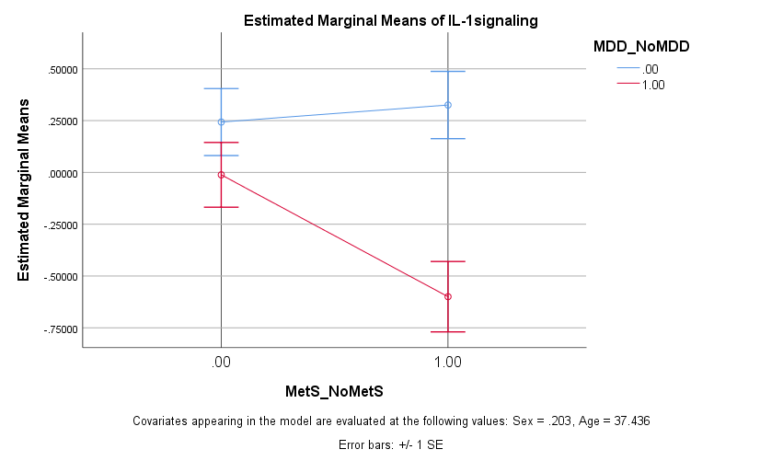

ESF, Figure 2. Effects of interaction major depression (MDD) X metabolic syndrome (MetS) on tumor necrosis factor (TNF) signaling. See ESF, Tables 2 and 4 for explanation. See ESF, Table 7 for statistics.

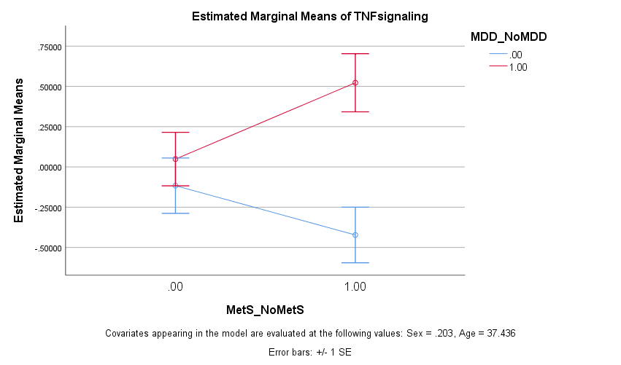

ESF, Figure 3. Effects of interaction major depression (MDD) X metabolic syndrome (MetS) on principal component 04 (PC04). See ESF, Tables 4 for explanation. See ESF, Table 7 for statistics.

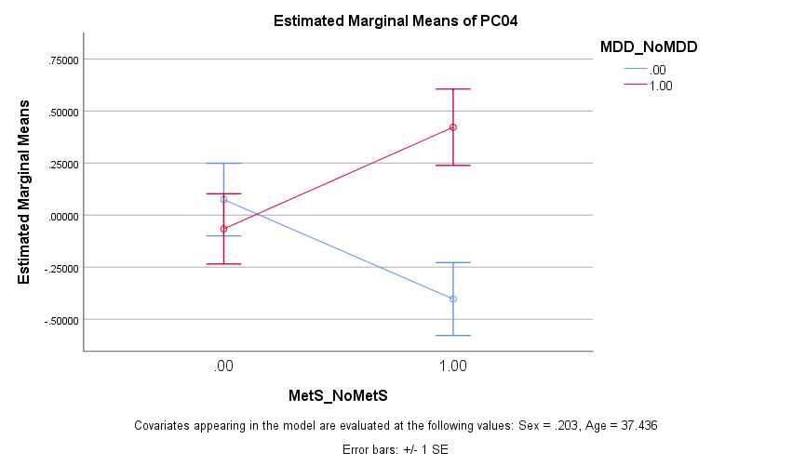

ESF, Figure 4. Effects of interaction major depression (MDD) X metabolic syndrome (MetS) on principal component 05 (PC05). See ESF, Tables 4 for explanation. See ESF, Table 7 for statistics.

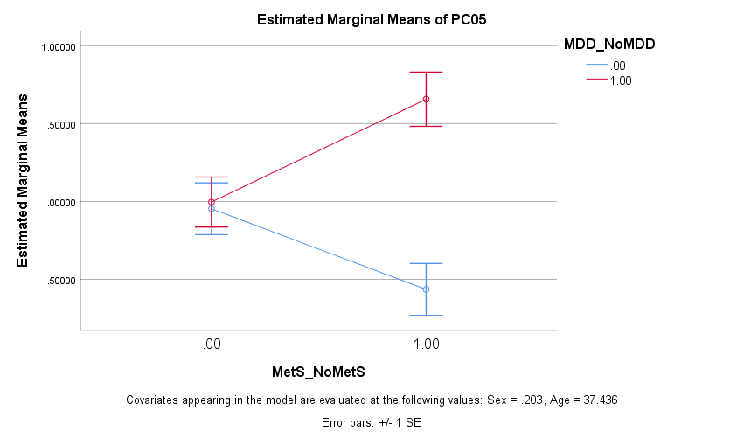

ESF, Figure 5. Effects of interaction major depression (MDD) X metabolic syndrome (MetS) on principal component 05 (PC05). See ESF, Tables 4 for explanation. See ESF, Table 7 for statistics.

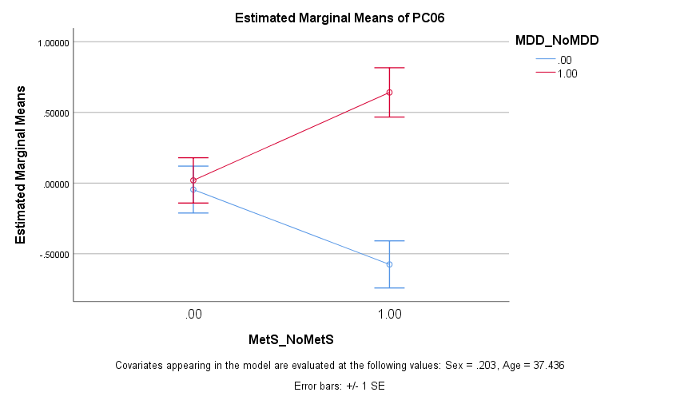

ESF, Figure 6. Effects of interaction major depression (MDD) X metabolic syndrome (MetS) on principal component inv (PCinv). See ESF, Tables 4 for explanation. See ESF, Table 7 for statistics.

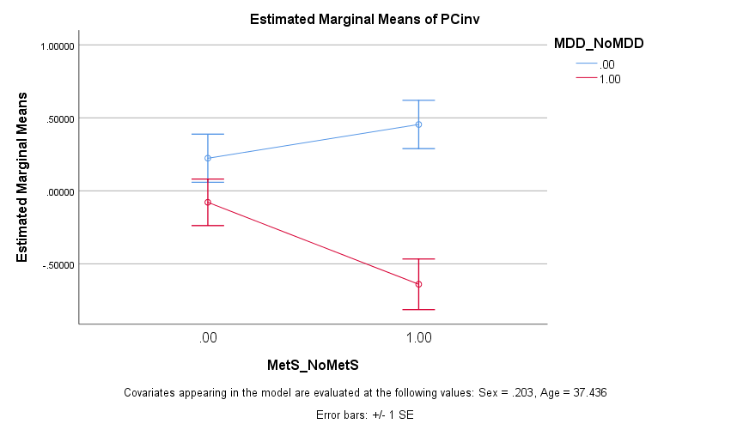

ESF, Table 8. Interaction patterns between major depression (MDD) and metabolic syndrome (MetS) on serum cytokine levels.

Source | Dependent Variable | Type III Sum of Squares | df | Mean Square | F | Sig.
MDD_* MetS | FGF | 4.725 | 1 | 4.725 | 4.918 | .028
MDD_* MetS | IFN-a2 | 9.226 | 1 | 9.226 | 9.989 | .002
MDD_* MetS | sIL-1RA | 8.896 | 1 | 8.896 | 10.498 | .002
MDD_* MetS | IL-2R | 3.960 | 1 | 3.960 | 3.970 | .048
MDD_* MetS | IL-4 | 12.745 | 1 | 12.745 | 15.240 | .000
MDD_* MetS | IL-13 | 4.186 | 1 | 4.186 | 4.490 | .036
MDD_* MetS | IL-17 | 5.608 | 1 | 5.608 | 5.894 | .017
MDD_* MetS | CCL2 | 7.409 | 1 | 7.409 | 7.977 | .006
MDD_* MetS | M-CSF | 6.567 | 1 | 6.567 | 7.022 | .009
MDD_* MetS | PDGF | 4.823 | 1 | 4.823 | 5.587 | .020
MDD_* MetS | CCL5 | 18.450 | 1 | 18.450 | 23.080 | .000
MDD_* MetS | SCF | 9.362 | 1 | 9.362 | 11.026 | .001
MDD_* MetS | TNF-a | 3.900 | 1 | 3.900 | 3.983 | .048
MDD_* MetS | TNF-B | 4.086 | 1 | 4.086 | 4.951 | .028
MDD_* MetS | VEGF | 8.855 | 1 | 8.855 | 10.184 | .002

See Table 1 for explanations

ESF, Figure 7. Effects of interaction major depression (MDD) X metabolic syndrome (MetS) on fibroblast growth factor (FGF). See ESF, Table 7 for statistics.

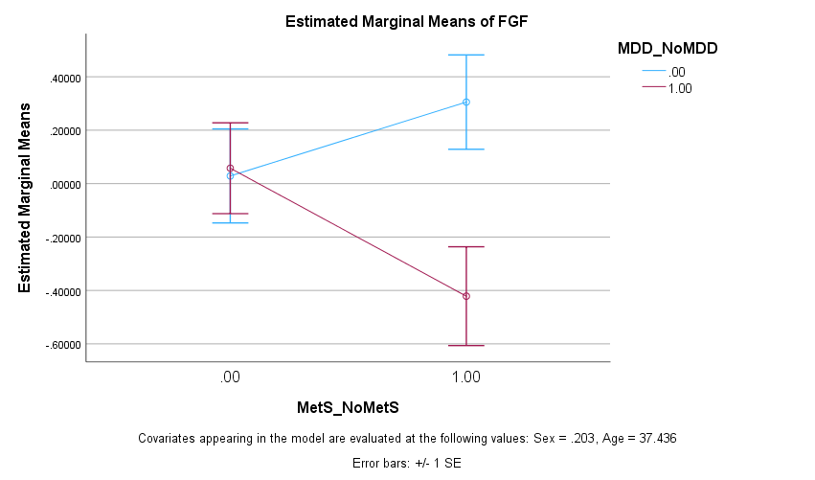

ESF, Figure 8. Effects of interaction major depression (MDD) X metabolic syndrome (MetS) on interferon alpha-2 (IFN-a2). See ESF, Table 7 for statistics.

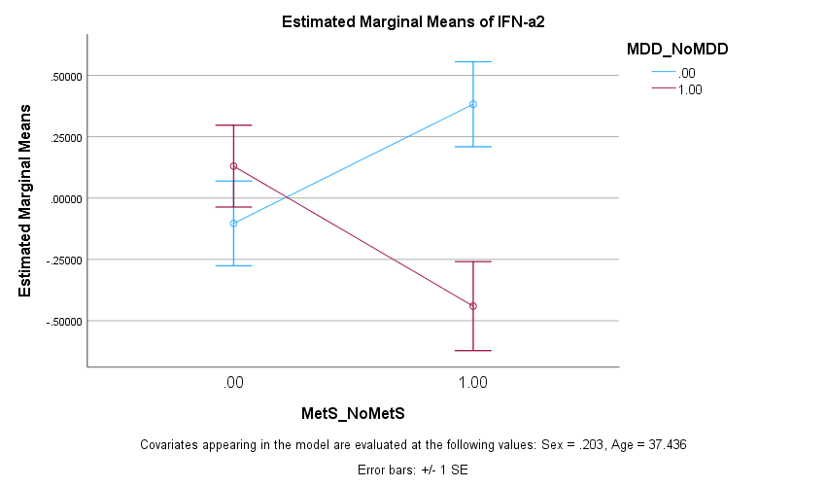

ESF, Figure 9. Effects of interaction major depression (MDD) X metabolic syndrome (MetS) on soluble interleukin-1 receptor antagonist (sIL-1RA). See ESF, Table 7 for statistics.

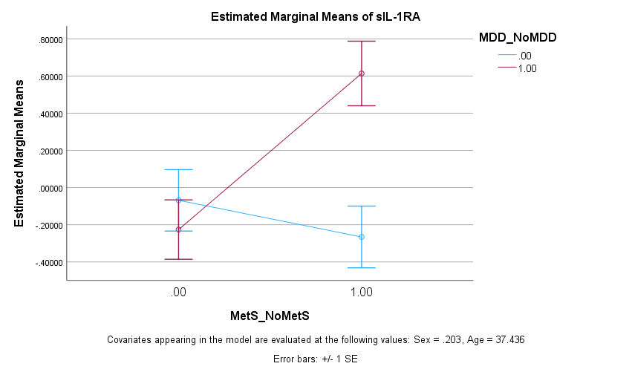

ESF, Figure 10. Effects of interaction major depression (MDD) X metabolic syndrome (MetS) on soluble interleukin-2 receptor (sIL-2R). See ESF, Table 7 for statistics.

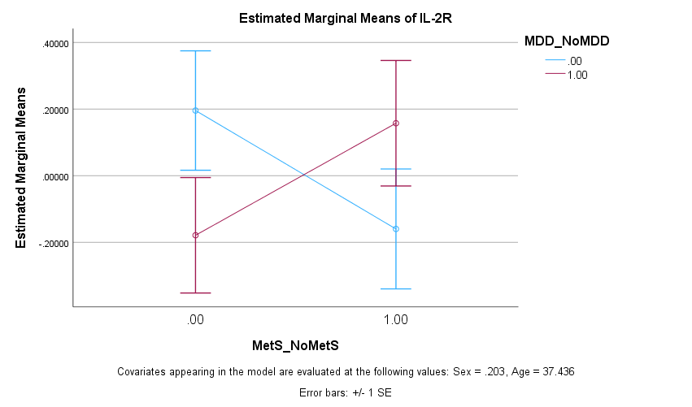

ESF, Figure 11. Effects of interaction major depression (MDD) X metabolic syndrome (MetS) on soluble interleukin-4 (IL-4). See ESF, Table 7 for statistics.

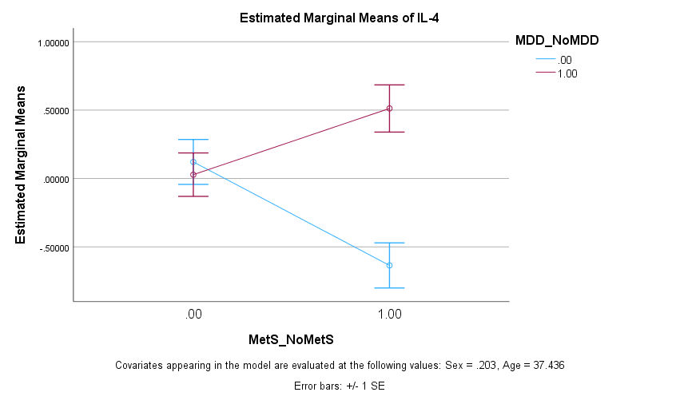

ESF, Figure 12. Effects of interaction major depression (MDD) X metabolic syndrome (MetS) on soluble interleukin-13 (IL-13). See ESF, Table 7 for statistics.

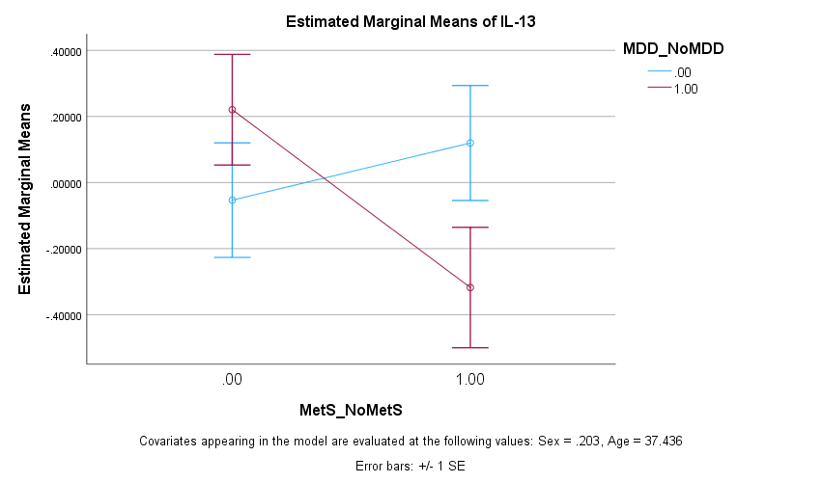

ESF, Figure 13. Effects of interaction major depression (MDD) X metabolic syndrome (MetS) on soluble interleukin-13 (IL-13). See ESF, Table 7 for statistics.

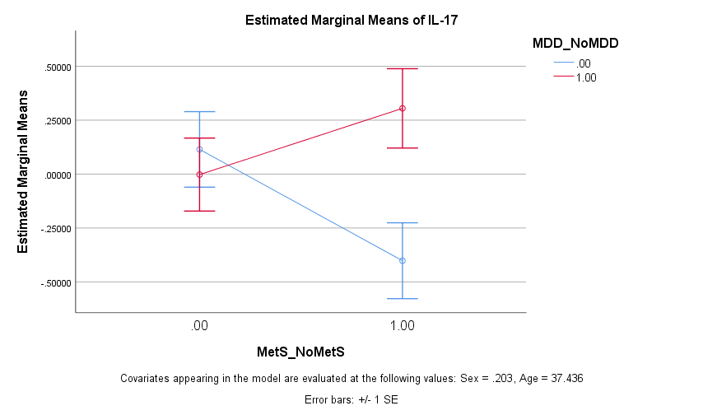

ESF, Figure 14. Effects of interaction major depression (MDD) X metabolic syndrome (MetS) on CCL2. See ESF, Table 7 for statistics.

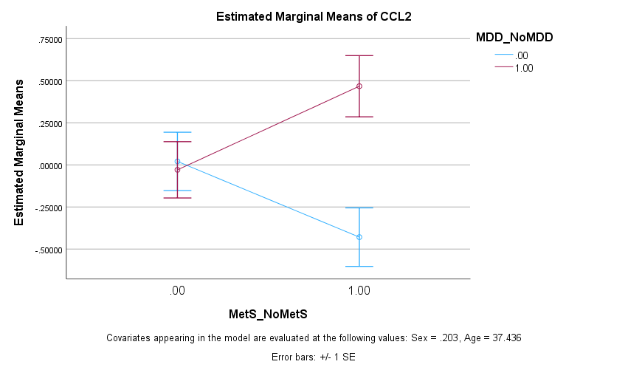

ESF, Figure 15. Effects of interaction major depression (MDD) X metabolic syndrome (MetS) on macrophage-colony stimulating factor (M-CSF). See ESF, Table 7 for statistics.

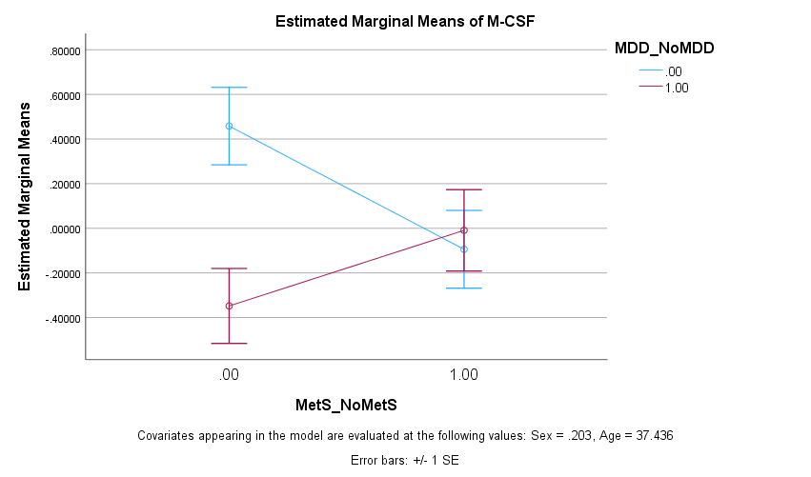

ESF, Figure 16. Effects of interaction major depression (MDD) X metabolic syndrome (MetS) on platelet-derived growth factor (PDGF). See ESF, Table 7 for statistics.

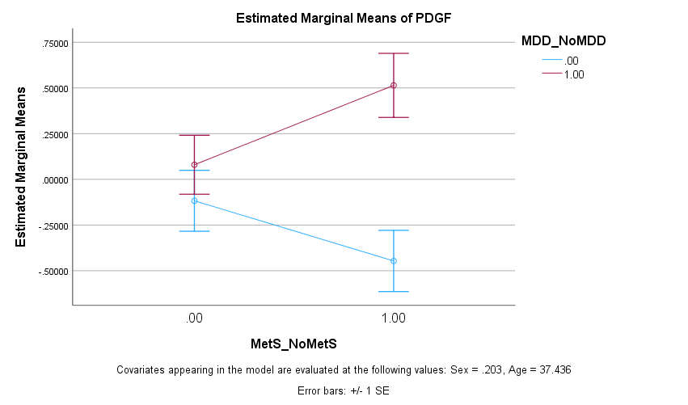

ESF, Figure 17. Effects of interaction major depression (MDD) X metabolic syndrome (MetS) on CCL5 (CCL5). See ESF, Table 7 for statistics.

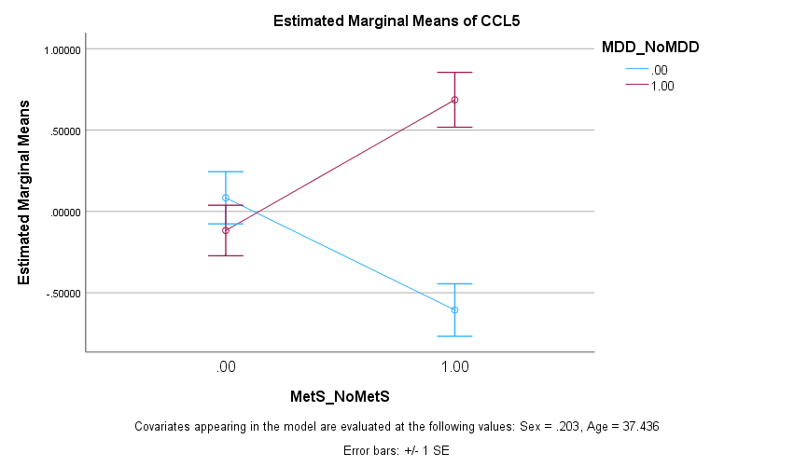

ESF, Figure 18. Effects of interaction major depression (MDD) X metabolic syndrome (MetS) on stem cell factor (SCF). See ESF, Table 7 for statistics.

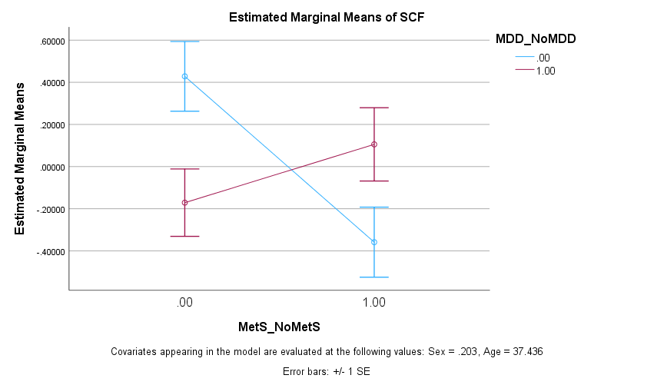

ESF, Figure 19. Effects of interaction major depression (MDD) X metabolic syndrome (MetS) on tumor necrosis factor alpha (TNF-a). See ESF, Table 7 for statistics.

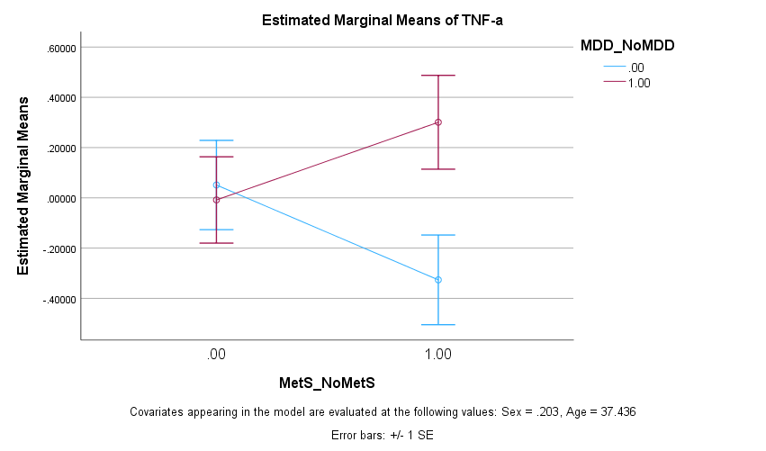

ESF, Figure 20. Effects of interaction major depression (MDD) X metabolic syndrome (MetS) on tumor necrosis factor beta (TNF-β). See ESF, Table 7 for statistics.

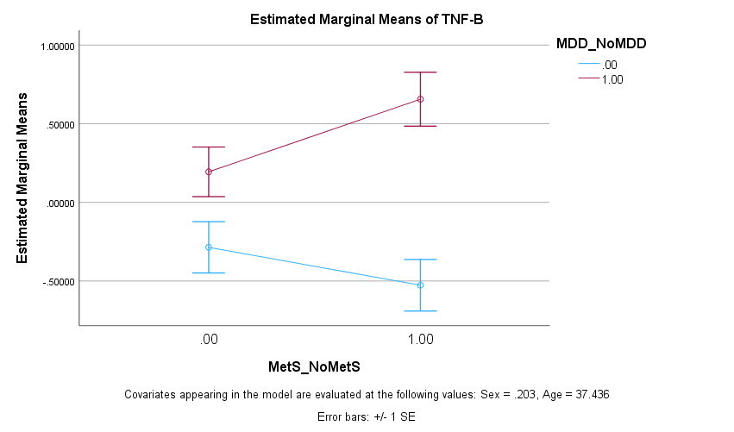

ESF, Figure 21. Effects of interaction major depression (MDD) X metabolic syndrome (MetS) on vascular endothelial growth factor (VEGF). See ESF, Table 7 for statistics.

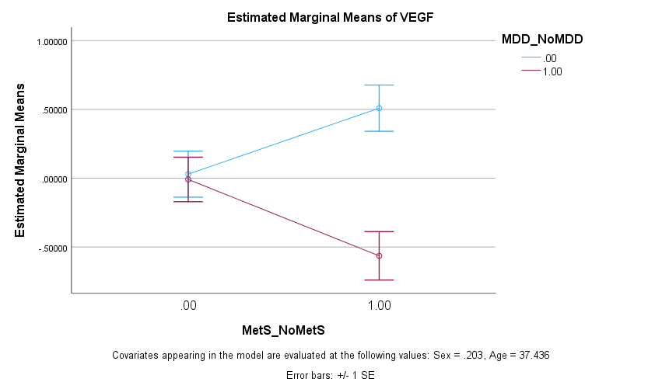

ESF, Table 9. Biological GO term classifications of upregulated differently expressed proteins in major depression.

ID term | Term description | Observed | Background | Strength | p FDR
GO:0006955 | Immune response | 17 | 1321 | 1.1 | 1.83e-13
GO:0006954 | Inflammatory response | 13 | 538 | 1.38 | 1.96e-12
GO:0019221 | Cytokine-mediated signaling pathway | 12 | 369 | 1.51 | 1.96e-12
GO:0032101 | Regulation of response to external stimulus | 15 | 964 | 1.19 | 1.96e-12
GO:0050900 | Leukocyte migration | 10 | 249 | 1.6 | 6.63e-11
GO:0006952 | Defense response | 15 | 1394 | 1.03 | 1.49e-10
GO:0002684 | Positive regulation of immune system process | 13 | 874 | 1.17 | 2.96e-10
GO:0032103 | Positive regulation of response to external stimulus | 11 | 453 | 1.38 | 2.96e-10
GO:0060326 | Cell chemotaxis | 9 | 210 | 1.63 | 5.17e-10
GO:0007165 | Signal transduction | 20 | 4714 | 0.62 | 5.59e-10
GO:0002688 | Regulation of leukocyte chemotaxis | 8 | 128 | 1.79 | 6.38e-10
GO:0002685 | Regulation of leukocyte migration | 9 | 231 | 1.58 | 6.67e-10

See ESF, Table 4 for the cytokines/chemokines/growth factors that are upregulated in principal component PC05.
Results of Gene Ontology (GO) biological process functional enrichment analysis (using STRING).
p FDR: False discovery rate p correction.

ESF, Table 10. Biological GO term classifications of upregulated differently expressed proteins in major depression.

ID term | Term description | Observed | Background | Strength | p FDR
GO:0048247 | Lymphocyte chemotaxis | 5 | 51 | 2.29 | 6.03e-07
GO:0006952 | Defense response | 9 | 1394 | 1.1 | 1.56e-06
GO:0006955 | Immune response | 9 | 1321 | 1.13 | 1.56e-06
GO:0048245 | Eosinophil chemotaxis | 4 | 17 | 2.67 | 1.56e-06
GO:0070098 | Chemokine-mediated signaling pathway | 5 | 82 | 2.08 | 1.56e-06
GO:0006954 | Inflammatory response | 7 | 538 | 1.41 | 2.08e-06
GO:0071675 | Regulation of mononuclear cell migration | 5 | 125 | 1.9 | 3.71e-06
GO:0002688 | Regulation of leukocyte chemotaxis | 5 | 128 | 1.89 | 3.84e-06
GO:0002548 | Monocyte chemotaxis | 4 | 43 | 2.26 | 6.61e-06
GO:2000501 | Regulation of natural killer cell chemotaxis | 3 | 8 | 2.87 | 1.52e-05
GO:0006950 | Response to stress | 10 | 3358 | 0.77 | 1.83e-05
GO:0002676 | Regulation of chronic inflammatory response | 3 | 10 | 2.77 | 2.21e-05

See Figure 1 for the cytokines/chemokines/growth factors that are upregulated in major depression (CXCL12, TNFB, PDGF, CCL11, IL9, IL4, CCL5, CCL2, CCL4, and IL1RA).
Results of Gene Ontology (GO) biological process functional enrichment analysis (using STRING).
p FDR: False discovery rate p correction.

ESF, Table 11. Important biological GO term classifications of downregulated differently expressed proteins in major depression.

ID term | Term description | p | p FDR | Number of DEPs | Genes
GO:0009967 | positive regulation of signal transduction | 2.72E-08 | 7.03E-05 | 7 | CCL3|CSF1|IL10|IL12B|IL1B|NGF|VEGFA
GO:0010941 | regulation of cell death | 3.07E-08 | 7.03E-05 | 7 | CCL3|CSF1|IL10|IL12B|IL1B|NGF|VEGFA
GO:0010647 | positive regulation of cell communication | 4.95E-08 | 7.03E-05 | 7 | CCL3|CSF1|IL10|IL12B|IL1B|NGF|VEGFA
GO:0045785 | positive regulation of cell adhesion | 6.54E-08 | 8.01E-05 | 5 | CSF1|IL10|IL12B|IL1B|VEGFA
GO:0045597 | positive regulation of cell differentiation | 8.18E-08 | 8.64E-05 | 6 | CCL3|CSF1|IL12B|IL1B|NGF|VEGFA
GO:0050769 | positive regulation of neurogenesis | 1.38E-07 | 9.63E-05 | 5 | CCL3|CSF1|IL1B|NGF|VEGFA
GO:0022603 | regulation of anatomical structure morphogenesis | 2.22E-08 | 2.09E-04 | 6 | CCL3|CSF1|IL10|IL1B|NGF|VEGFA
GO:0051962 | positive regulation of nervous system development | 7.890E-08 | 2.092E-04 | 5 | CCL3|CSF1|IL1B|NGF|VEGFA
GO:0010720 | positive regulation of cell development | 8.190E-08 | 2.092E-04 | 5 | CCL3|CSF1|IL1B|NGF|VEGFA
GO:0060326 | cell chemotaxis | 1.755E-07 | 3.223E-04 | 4 | CCL3|IL10|IL1B|VEGFA
GO:0019221 | cytokine-mediated signaling pathway | 2.435E-07 | 3.834E-04 | 5 | CCL3|CSF1|IL10|IL1B|VEGFA

See Figure 1 for the downregulated differentially expressed proteins (NGF, IL1B, CSF1, CCL3, IL12B, VEGFA, IL10).
Results of Gene Ontology (GO) biological process functional enrichment analysis (using GoNet).
p FDR: False discovery rate p correction.

ESF, Table 12. Biological GO term classifications of a subset of downregulated differently expressed proteins in major depression.

ID term | Term description | p | p FDR | Number of DEPs | Genes
GO:1901214 | regulation of neuron death | 2.78E-07 | 1.88E-03 | 4 | CCL3|CSF1|IL10|NGF
GO:0022603 | regulation of anatomical structure morphogenesis | 4.20E-07 | 1.88E-03 | 5 | CCL3|CSF1|IL10|NGF|VEGFA
GO:1904141 | positive regulation of microglial cell migration | 5.11E-07 | 1.88E-03 | 2 | CCL3|CSF1
GO:0002690 | positive regulation of leukocyte chemotaxis | 8.17E-07 | 2.25E-03 | 3 | CCL3|CSF1|VEGFA
GO:1904139 | regulation of microglial cell migration | 1.07E-06 | 2.25E-03 | 2 | CCL3|CSF1
GO:0051094 | positive regulation of developmental process | 1.41E-06 | 2.25E-03 | 5 | CCL3|CSF1|IL10|NGF|VEGFA
GO:0050769 | positive regulation of neurogenesis | 1.44E-06 | 2.25E-03 | 4 | CCL3|CSF1|NGF|VEGFA
GO:0002688 | regulation of leukocyte chemotaxis | 1.75E-06 | 2.25E-03 | 3 | CCL3|CSF1|VEGFA
GO:1903977 | positive regulation of glial cell migration | 1.84E-06 | 2.25E-03 | 2 | CCL3|CSF1
GO:0051962 | positive regulation of nervous system development | 2.48E-06 | 2.41E-03 | 4 | CCL3|CSF1|NGF|VEGFA
GO:0010720 | positive regulation of cell development | 2.55E-06 | 2.41E-03 | 4 | CCL3|CSF1|NGF|VEGFA
GO:0002687 | positive regulation of leukocyte migration | 2.62E-06 | 2.41E-03 | 3 | CCL3|CSF1|VEGFA

The differentially expressed proteins (DEPs) included are: CCL3, CSF1, VEGFA, NGF and IL10.
Results of Gene Ontology (GO) biological process functional enrichment analysis (using GoNet).
p FDR: False discovery rate p correction.

ESF, Table 13. Biological GO term classifications of downregulated differently expressed proteins in major depression.

ID term | Term description | p | p FDR | Number of DEPs | Genes
GO:1904894 | positive regulation of receptor signaling pathway via STAT | 1.00E-10 | 4.48E-07 | 5 | IFNA2|IL10|IL12B|IL13|VEGFA
GO:0019221 | cytokine-mediated signaling pathway | 4.00E-10 | 1.32E-06 | 7 | IFNA2|IL10|IL12B|IL13|IL1A|IL1B|VEGFA
GO:0042981 | regulation of apoptotic process | 1.24E-07 | 7.59E-05 | 7 | IL10|IL12B|IL13|IL1A|IL1B|NGF|VEGFA
GO:0043067 | regulation of programmed cell death | 1.36E-07 | 7.80E-05 | 7 | IL10|IL12B|IL13|IL1A|IL1B|NGF|VEGFA
GO:0043066 | negative regulation of apoptotic process | 4.970E-08 | 9.846E-05 | 6 | IL10|IL13|IL1A|IL1B|NGF|VEGFA
GO:0043069 | negative regulation of programmed cell death | 5.510E-08 | 9.846E-05 | 6 | IL10|IL13|IL1A|IL1B|NGF|VEGFA
GO:0002700 | regulation of production of molecular mediator of immune response | 8.280E-08 | 9.846E-05 | 4 | IFNA2|IL10|IL13|IL1B
GO:0060548 | negative regulation of cell death | 9.610E-08 | 9.846E-05 | 6 | IL10|IL13|IL1A|IL1B|NGF|VEGFA
GO:0010628 | positive regulation of gene expression | 9.640E-08 | 9.846E-05 | 7 | IFNA2|IL10|IL13|IL1A|IL1B|NGF|VEGFA
GO:0071345 | cellular response to cytokine stimulus | 1.027E-07 | 9.846E-05 | 6 | IFNA2|IL10|IL13|IL1A|IL1B|VEGFA
GO:2000026 | regulation of multicellular organismal development | 1.072E-07 | 9.846E-05 | 7 | IFNA2|IL10|IL13|IL1A|IL1B|NGF|VEGFA
GO:1901215 | negative regulation of neuron death | 4.30E-06 | 5.92E-03 | 3 | IL10|IL13|NGF

See ESF, Table 4 for the downregulated differentially expressed proteins (DEPs) of principal component PCinv (IFNA2, IL1A, IL1B, IL12B, NGF, IL10, IL13, and VEGFA.
Results of Gene Ontology (GO) biological process functional enrichment analysis (using GoNet).
p FDR: False discovery rate p correction.

