Supplementary material:

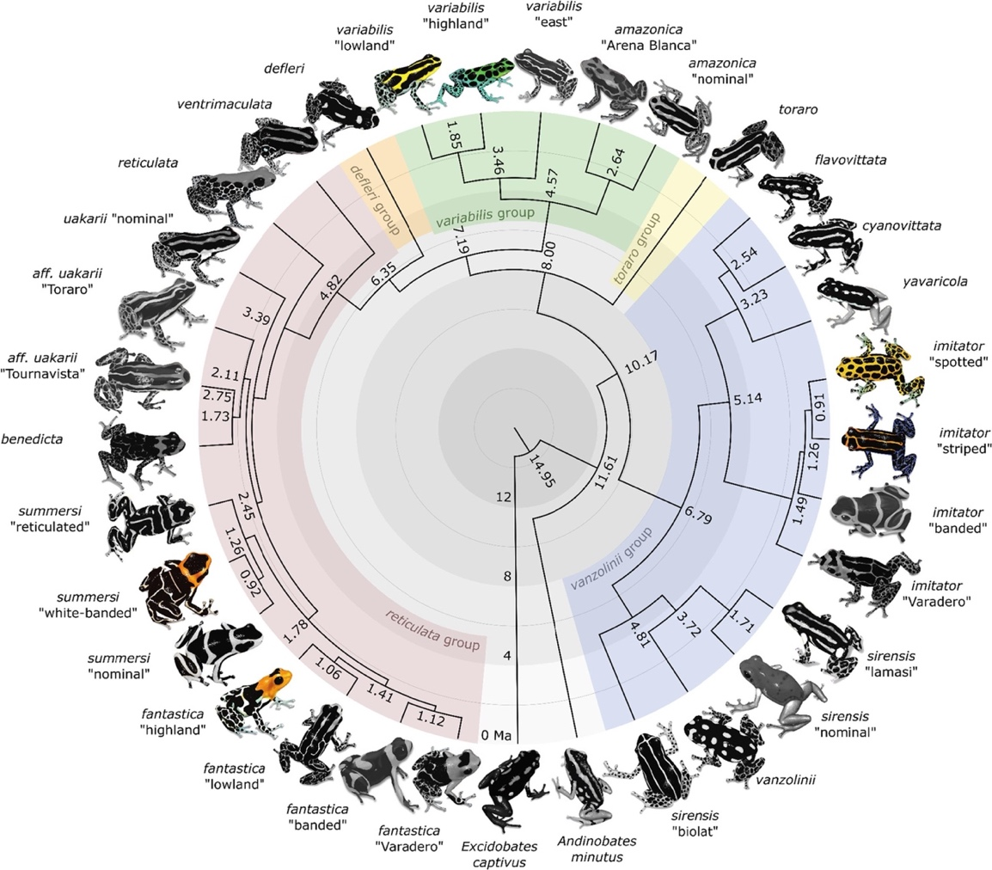
Supplementary Figure 1. Time-calibrated phylogeny modified from ¹⁷, highlighting our focal species and ecotypes (colored frogs) within the whole Ranitomeya clade (greyed frogs). Ranitomeya variabilis “spotted” and “striped” from our study refer to “highland” and “lowland” respectively, from the phylogeny. Ranitomeya fantastica “nominal” and “striped” from our study refer to “highland” and summersi “white-banded” respectively, from the phylogeny. We used the same denomination for Ranitomeya imitator.

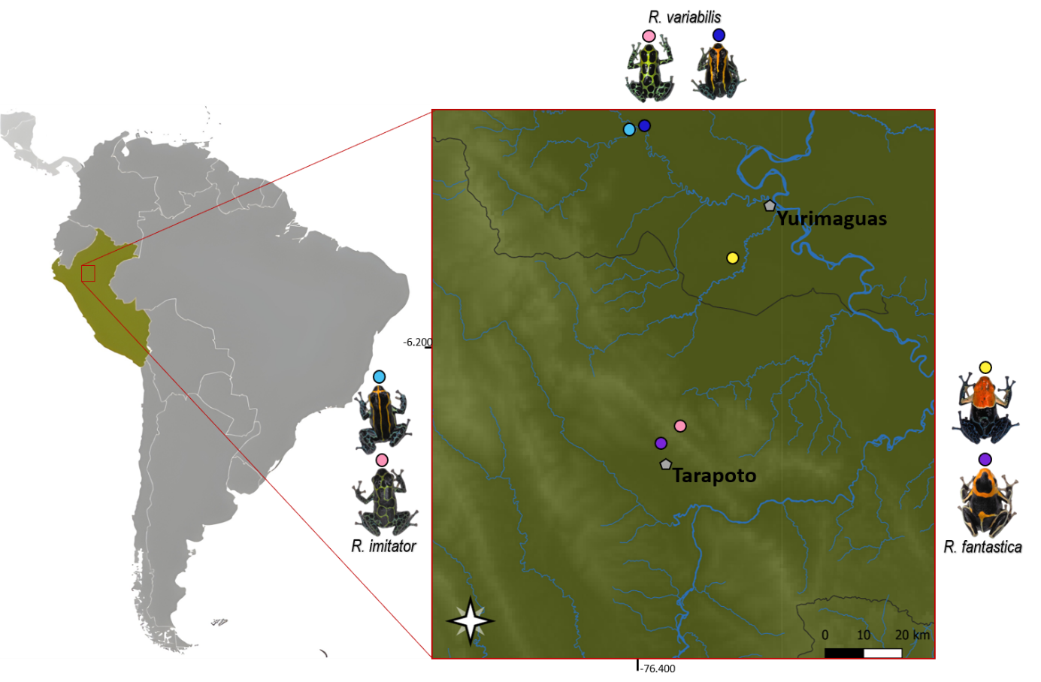
Supplementary Figure 2. Distribution map of studied species in the region of San Martin and Loreto, Northern Peru, with locality names/ecotypes (Locality name: Purple: Boca-Toma, Yellow: Michaela, Pink: San-Jose, Blue: Varadero, Light-Blue: Varadero-Banda).

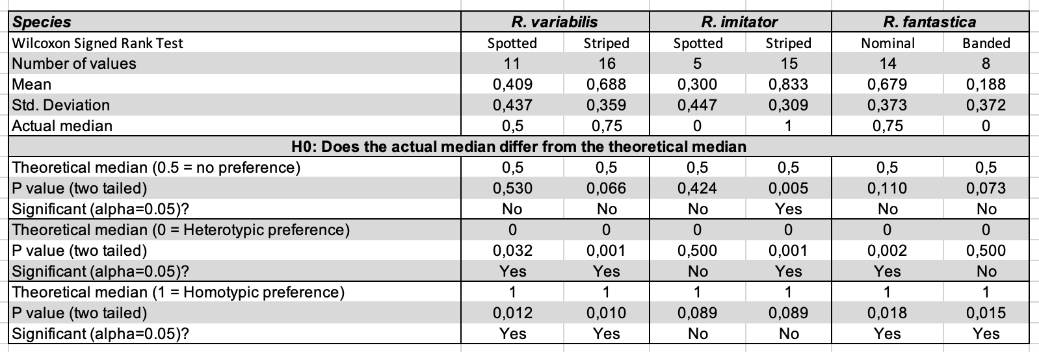
Supplementary Table 1. Prezygotic barriers: Individual phenotypic preference. Summary of data and results of the nonparametric Wilcoxon signed rank test.

Supplementary table 2. Summary statistics for development time showing the results of the Kruskal-Wallis test and the nonparametric Wilcoxon test.
Supplementary Table 3. Summary statistics for the survival rate from egg to tadpoles in crossbreed, presenting group means, and their associated p-value. “N.S” for non-significant difference in mean, and bold values when mean was significantly different from controls (in R. fantastica: Nominal, Spotted and Hybrid). Only the highest associated p-value is shown.

