Supplementary Table 1. Environmental exposure characteristics of the infant samples
Column “types” shows the composition of each exposure. Column “numbers” depicts the number of samples (N) for each factor. The group column shows how each variable is grouped.
Supplementary Table 2. Number of different lifestyle vOTUs
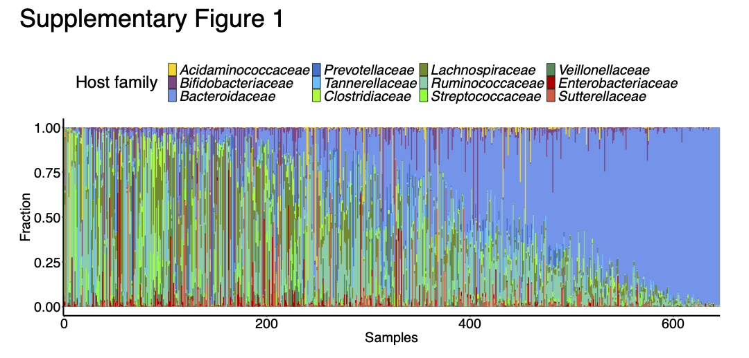
Supplementary Figure 1. Relative abundance of vOTUs across all samples grouped by their host bacterial family
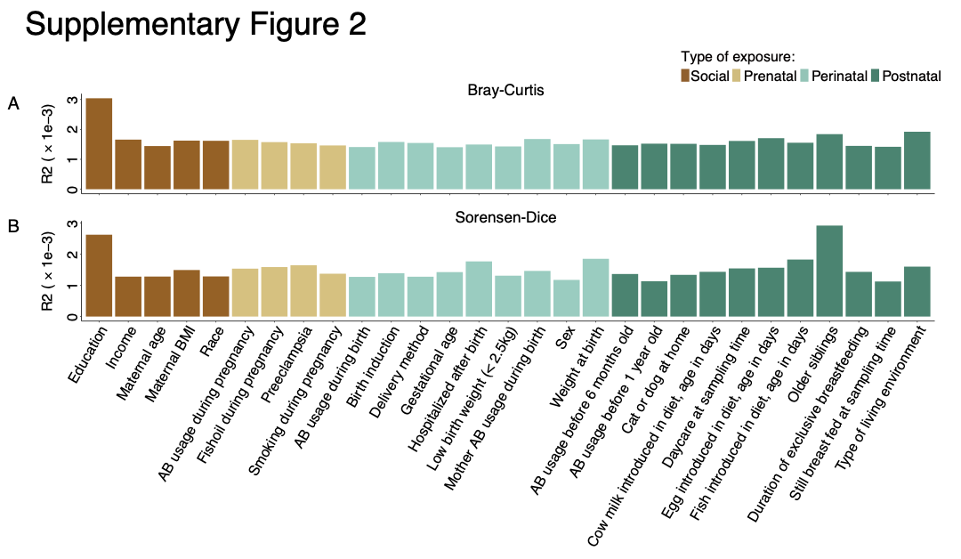
Supplementary Figure 2. Additional beta diversity analysis of environmental factors on gut virome
(A-B) The effect size of exposures on virome variation calculated by db-RDA on Bray-Curtis (A) and Sorensen-Dice (B) dissimilarity matrices.
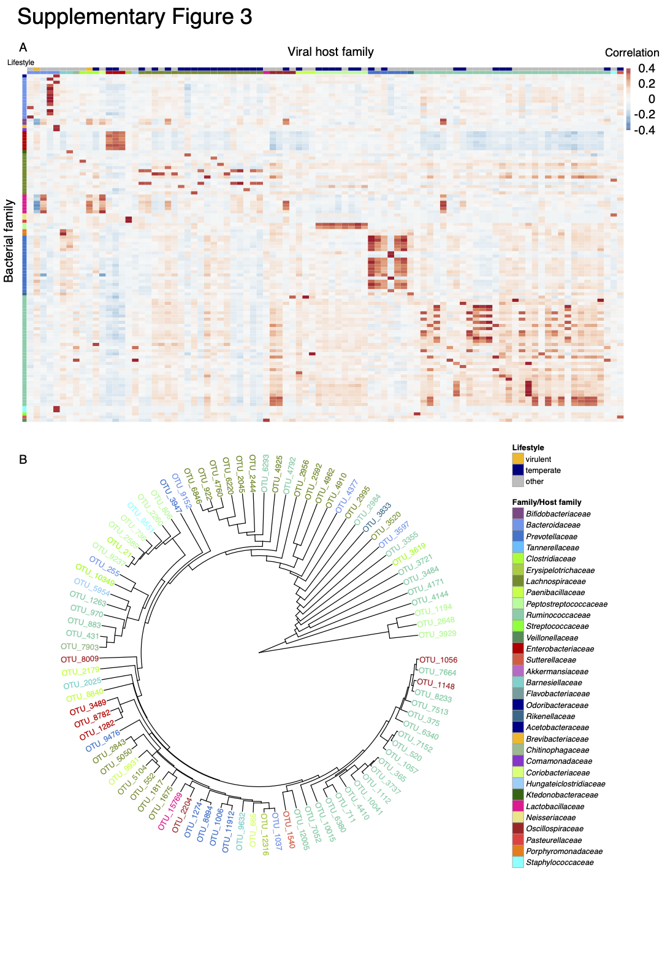
Supplementary Figure 3. Co-abundance of vOTUs and bacterial OTUs and the phylogeny of vOTUs
(A) Heatmap of Spearman’s rank correlation between the differentially abundant vOTUs and 16S rRNA (V4 region) data blocks. The rows represent the 91 vOTUs, and the columns represent the 110 bacterial OTUs. Virome contigs were labeled according to their host family. Bacterial OTUs were labeled according to their family.
(B) Phylogenetic tree showing genetic relationships of vOTUs.
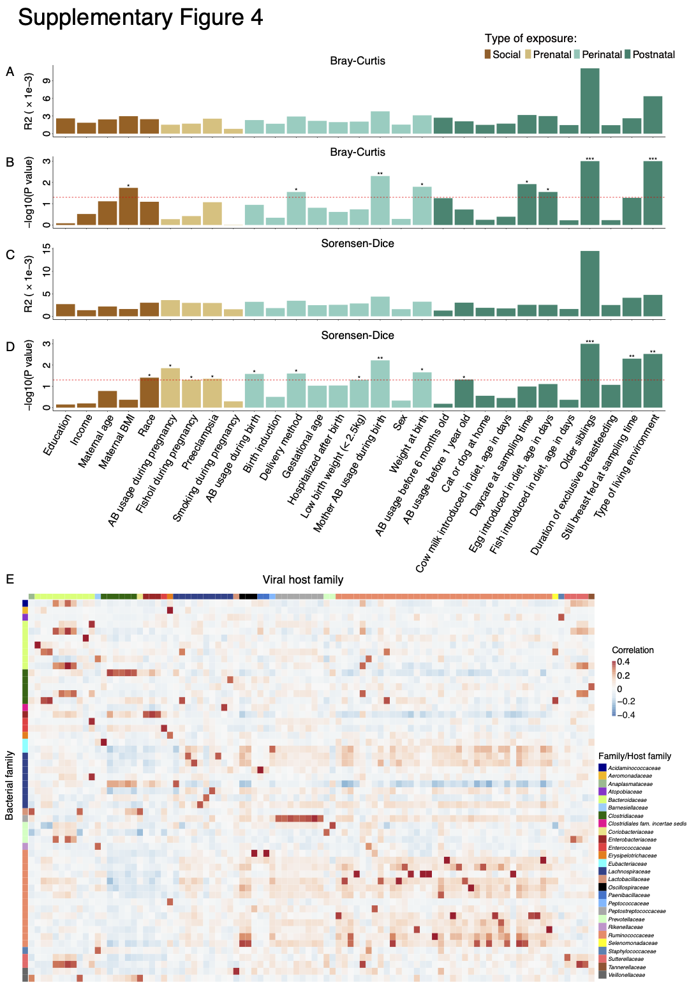
Supplementary Figure 4. Beta diversity analysis of environmental factors on gut bacterial community and additional co-abundance analysis
(A-D) Barplots showing p-values and effect sizes of db-RDA analysis for bacterial variation based on Bray-Curtis (A-B) and Sorensen-Dice (C-D) dissimilarity matrices. P-values were calculated by an ANOVA-like permutation test (n = 999).
(E) Heatmap of Spearman’s rank correlation between the differentially abundant vOTUs and whole-genome shotgun metagenome data blocks.
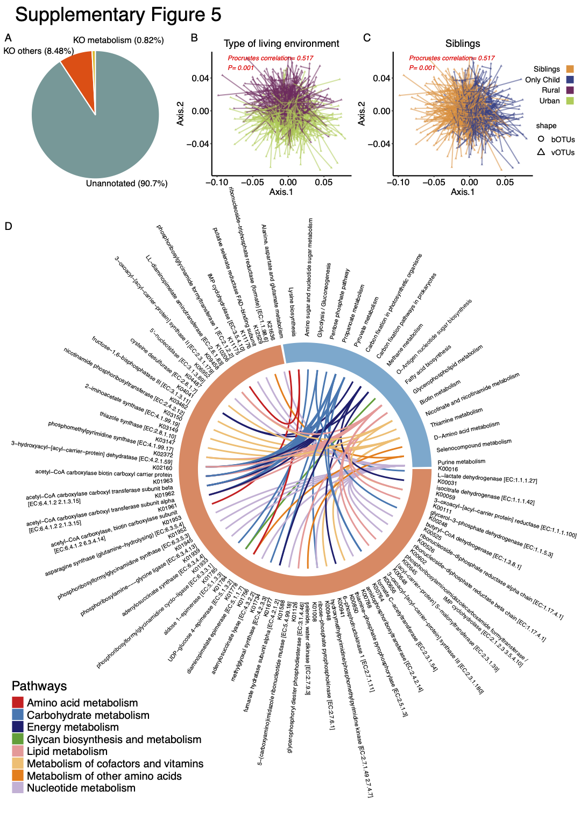
Supplementary Figure 5. The potential of phage-host association and enzymes encoded by phages
(A) Distribution of gene annotations to KEGG databases.
(B-C) Procrustes correlation between the virome data and bacterial 16S rRNA gene data. Sorensen-Dice was used to generate distance matrices, the results of db-RDA were taken into the procrustes analysis. The triangle represents the virome samples and the circle represents the bacteria samples.
(D) KOs (enzymes and E.C. numbers) that are associated with metabolism pathways.

