SUPPLEMENTARY MATERIAL

Title: Physical and Chemical Degradations of Bacterial Cellulose via Rearranging Fibers

Authors: Fulya Şahin¹, Ali Özhan Aytekin^{*2}

*Corresponding Author
e-mail: ali.aytekin@yeditepe.edu.tr; ozhanaytekin@gmail.com
ORCID: 0000-0002-8858-763X

¹Biotechnology Graduate Program, Graduate School of Natural and Applied Sciences, Yeditepe University, 34755 Istanbul, Turkey

²Genetics and Bioengineering Department, Engineering Faculty, Yeditepe University, 34755 Istanbul, Turkey

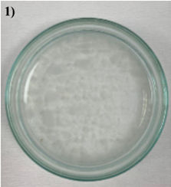 | 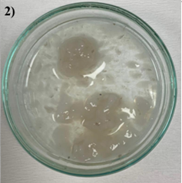
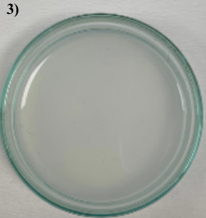 | 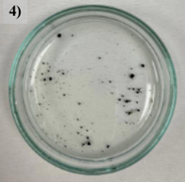

Figure S1. Pictures of (1) BCNF4, (2) BCNF3, (3) BCNF6, and (4) BCNF7.

