Supplementary information
Supplement 1. Distribution and Median Age of Malignant and Benign Diagnoses
 |  | AI model training | Real-time object detection under a microscope
 |  | Training, validation, and testing  (n = 96) | Cell cluster and slide level assessment  (n = 30) | Verification of diagnostic concordance with/without AI  (n = 20)
Malignant | Median age (range) | 57 (31–82) | 58 (38–83) | 54 (28–77)
Malignant | Number of cases | 47 | 10 | 20
Endometrioid carcinoma | Grade 1 | 24 | 10 | 5
Endometrioid carcinoma | Grade 2 | 17 | 3 | 4
Endometrioid carcinoma | Grade 3 | 5 | 0 | 0
Serous carcinoma |  | 1 | 2 | 1
Benign | Median age (range) | 47 (37–73) | 46 (30–57) | 45.5 (38–51)
Benign | Number of cases | 49 | 10 | 20
Leiomyoma |  | 49 | 10 | 20

Supplement 2
Supplement 2. Architecture of YOLOv5, detailing the process from image input to detection. The original images, with a resolution of 4,032 × 3,024 pixels, were first resized to 640 × 640 pixels during preprocessing. The YOLOv5 architecture comprises three main components: backbone, neck, and head. The backbone uses a cross-stage partial network with DarkNet53 to enhance feature map processing efficiency. This is achieved by splitting the input into two paths, preserving computational resources and information diversity. The neck uses a path aggregation network for improved feature propagation and spatial pyramid pooling fusion to handle inputs of varying sizes. This ensures robust detection across different object scales and contexts. The YOLOv3 architecture was used to complete the detection process.¹⁵

Supplement 3: Parameter settings for model optimization
Settings | Batch size | Epoch | Optimizer | Learning rate | Weight decay
YOLOv5x | 4 | 200 | SGD | 0.01 | 0.0005

Supplement 4: Metrics for evaluating the performance of YOLOv5x trained on static images of endometrial cytology

- Precision quantifies the proportion of accurate positive identifications relative to all positive identifications made by the model. It is expressed as follows:
$$Presicion = \frac{TP}{TP+FP}$$
where TP and FP denote true positives and false positives, respectively.
- Recall, also known as sensitivity, is the proportion of accurate positive identifications to all actual positive instances. It is expressed as:
$$Recall = \frac{TP}{TP+FN}$$
where FN denotes false negatives.
- F1 score is the harmonic mean of precision and recall, and is defined as follows:
$$F1 Score = \frac{2 × Precision×Recall}{Precision+Recall}$$

- Precision–recall (PR) curves plot precision against recall, where the area under the curve (AUC) measures the average precision (AP), a standard in object detection evaluation that provides a comprehensive metric by averaging the maximum precision values across various recall thresholds. AP is defined as:
$$AP=\sum_{k=1}^{m}{p\left(k\right)}△r\left(k\right)$$
where k denotes the number of abnormal cell clusters detected, p(k) denotes the precision at cutoff k in the list, and Δr(k) denotes the change in recall from items k − 1 to k.
- mAP is the average of AP, that is,
$$mAP=\frac{1}{n}\sum_{i=1}^{n}{AP\left(i\right)}$$
where n denotes the number of classes, and AP(i) denotes the AP value for class i. Because only one class of objects was trained, the AP and mAP in this study were equivalent.
Supplement 5
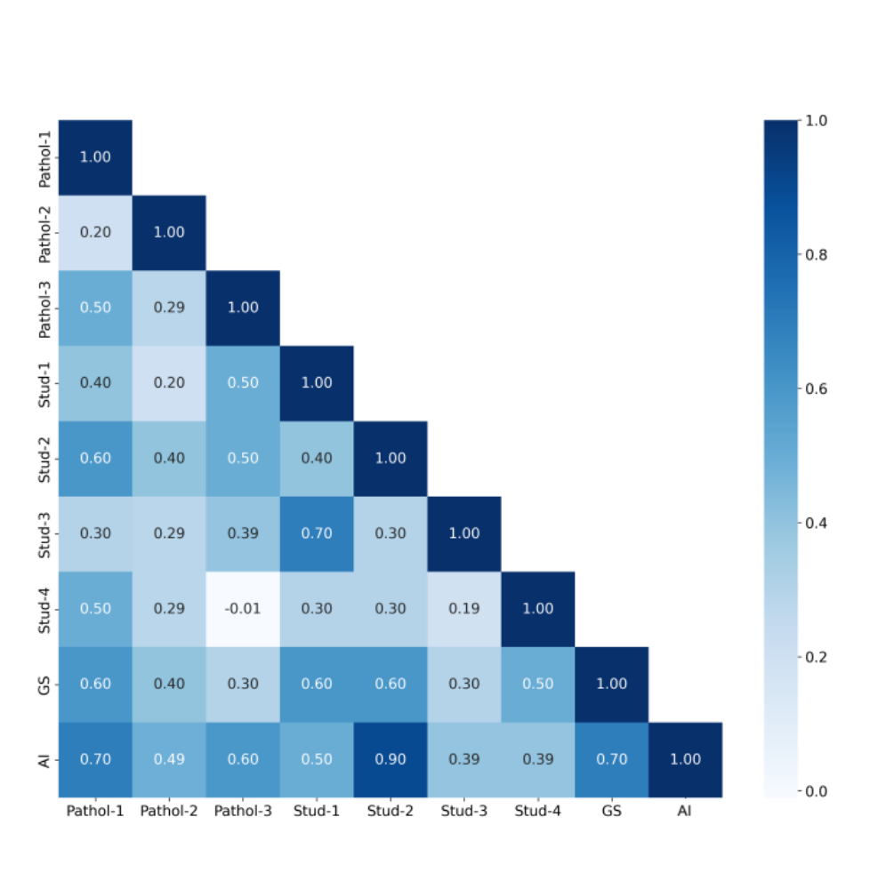
Supplement 5. Heatmap of Cohen’s kappa coefficients for comparing accuracy between evaluators based on diagnostic concordance of preoperative cytopathology. GS: Gold standard; Pathol-1: a gynecological pathologist; Pathol-2 and Pathol-3” two nongynecological pathologists; Stud-1 and Stud-2: two senior medical students; Stud-3 and Stud-4: two junior students; AI: YOLOv5x model. The color scale ranges from -0.01 (no agreement) to 1.00 (perfect agreement).

Supplement 6. Performance Metrics and Diagnostic Times with and without AI Assistance
Accuracy |  |  | Pathol-1 | Pathol-2 | Pathol-3 | Stud-1 | Stud-2 | Stud-3 | Stud-4
AI-assist | (- ) |  | 0.80 | 0.70 | 0.65 | 0.80 | 0.80 | 0.65 | 0.75
AI-assist | (+ ) |  | 0.75 | 0.75 | 0.80 | 0.85 | 0.85 | 0.65 | 0.60
Improved? |  |  | × | ✓ | ✓ | ✓ | ✓ | × | ×
Precision |  |  | Pathol-1 | Pathol-2 | Pathol-3 | Stud-1 | Stud-2 | Stud-3 | Stud-4
AI-assist | (- ) |  | 0.80 | 0.67 | 0.64 | 0.80 | 0.80 | 0.64 | 0.73
AI-assist | (+ ) |  | 0.69 | 0.67 | 0.75 | 0.82 | 0.82 | 0.64 | 0.60
Improved? |  |  | × | × | ✓ | ✓ | ✓ | × | ×
Recall |  |  | Pathol-1 | Pathol-2 | Pathol-3 | Stud-1 | Stud-2 | Stud-3 | Stud-4
AI-assist | (- ) |  | 0.80 | 0.80 | 0.70 | 0.80 | 0.80 | 0.70 | 0.80
AI-assist | (+ ) |  | 0.90 | 1.00 | 0.90 | 0.90 | 0.90 | 0.70 | 0.60
Improved? |  |  | ✓ | ✓ | ✓ | ✓ | ✓ | × | ×
F1 score |  |  | Pathol-1 | Pathol-2 | Pathol-3 | Stud-1 | Stud-2 | Stud-3 | Stud-4
AI-assist | (- ) |  | 0.80 | 0.73 | 0.67 | 0.80 | 0.80 | 0.67 | 0.76
AI-assist | (+ ) |  | 0.78 | 0.80 | 0.82 | 0.86 | 0.86 | 0.67 | 0.60
Improved? |  |  | × | ✓ | ✓ | ✓ | ✓ | × | ×
Diagnostic time (s) |  |  | Pathol-1 | Pathol-2 | Pathol-3 | Stud-1 | Stud-2 | Stud-3 | Stud-4
AI-assist |  | (- ) | 3,014 | 2,544 | 6,600 | 4,458 | 4,681 | 4,593 | 2,940
 |  | (+ ) | 1,800 | 2,040 | 2,700 | 1,860 | 3,354 | 2,764 | 2,460
Improved? |  |  | ✓ | ✓ | ✓ | ✓ | ✓ | ✓ | ✓
Note: “Pathol-1” represents a gynecological pathologist; “Pathol-2” and “Pathol-3” are nongynecological pathologists; “Stud-1” and “Stud-2” denote medical students involved in AI modeling; and “Stud-3” and “Stud-4” indicate medical students who received a 20 min lecture on endometrial cytology

