Supplementary information
Supplement 1. Distribution and Median Age of Malignant and Benign Patients
 |  | AI model training | Real-time object detection under a microscope
 |  | Training, validation, and testing cases  (n = 96) | Cases of cell cluster and slide-level assessment  (n = 30) | Cases of diagnostic concordance with/without AI  (n = 20)
Malignant | Median age (range) | 57 (31–82) | 58 (38–83) | 54 (28–77)
Malignant | Number of cases | 47 | 10 | 20
Endometrioid carcinoma | Grade 1 | 24 | 10 | 5
Endometrioid carcinoma | Grade 2 | 17 | 3 | 4
Endometrioid carcinoma | Grade 3 | 5 | 0 | 0
Serous carcinoma |  | 1 | 2 | 1
Benign | Median age (range) | 47 (37–73) | 46 (30–57) | 45.5 (38–51)
Benign | Number of cases | 49 | 10 | 20
Leiomyoma |  | 49 | 10 | 20

Supplement 2
Supplement 2. Architecture of YOLOv5, illustrating the process from image input to detection. The original images with a resolution of 4,032 × 3,024 pixels were first resized to 640 × 640 pixels during the processing sequence. The YOLOv5 architecture is structured around three main components: the backbone, neck, and head. The backbone uses a cross-stage partial network with DarkNet53 to enhance feature map processing efficiency. To achieve this, the backbone splits the input into two paths, which preserves computational resources and information diversity. The neck uses a path aggregation network for improved feature propagation and spatial pyramid pooling fusion to handle inputs of varying sizes, thereby facilitating robust detection across different object scales and contexts. The YOLOv3 architecture was used to complete the detection process.¹⁵

Supplement 3: Training conditions for model optimization
Settings | batch size | epoch | optimizer | learning rate | weight decay
YOLOv5x | 4 | 200 | SGD | 0.01 | 0.0005

Supplement 4: Cohen's Kappa Coefficients Heatmap for Accuracy Between Evaluators
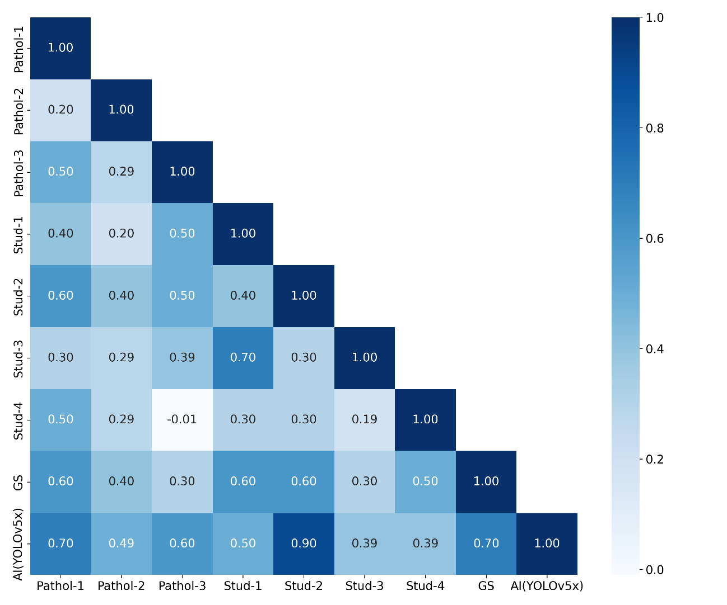

Heatmap of Cohen's kappa coefficients for accuracy between evaluators in diagnostic concordance of preoperative cytopathology. GS, Gold standard; Pathol-1, a gynecological pathologist; Pathol-2 and Pathol-3, two non-gynecological pathologists; Stud-1 and Stud-2, two senior medical students; Stud-3 and Stud-4, two junior students; AI, YOLOv5x model. The color scale ranges from -0.01 (no agreement) to 1.00 (perfect agreement).

Supplement 5. Performance Metrics and Diagnostic Times with and without AI Assistance
Accuracy |  |  | Pathol-1 | Pathol-2 | Pathol-3 | Stud-1 | Stud-2 | Stud-3 | Stud-4
AI-assist | (- ) |  | 0.80 | 0.70 | 0.65 | 0.80 | 0.80 | 0.65 | 0.75
AI-assist | (+ ) |  | 0.75 | 0.75 | 0.80 | 0.85 | 0.85 | 0.65 | 0.60
improvement |  |  | × | ✓ | ✓ | ✓ | ✓ | × | ×
Precision |  |  | Pathol-1 | Pathol-2 | Pathol-3 | Stud-1 | Stud-2 | Stud-3 | Stud-4
AI-assist | (- ) |  | 0.80 | 0.67 | 0.64 | 0.80 | 0.80 | 0.64 | 0.73
AI-assist | (+ ) |  | 0.69 | 0.67 | 0.75 | 0.82 | 0.82 | 0.64 | 0.60
improvement |  |  | × | × | ✓ | ✓ | ✓ | × | ×
Recall |  |  | Pathol-1 | Pathol-2 | Pathol-3 | Stud-1 | Stud-2 | Stud-3 | Stud-4
AI-assist | (- ) |  | 0.80 | 0.80 | 0.70 | 0.80 | 0.80 | 0.70 | 0.80
AI-assist | (+ ) |  | 0.90 | 1.00 | 0.90 | 0.90 | 0.90 | 0.70 | 0.60
improvement |  |  | ✓ | ✓ | ✓ | ✓ | ✓ | × | ×
F1 score |  |  | Pathol-1 | Pathol-2 | Pathol-3 | Stud-1 | Stud-2 | Stud-3 | Stud-4
AI-assist | (- ) |  | 0.80 | 0.73 | 0.67 | 0.80 | 0.80 | 0.67 | 0.76
AI-assist | (+ ) |  | 0.78 | 0.80 | 0.82 | 0.86 | 0.86 | 0.67 | 0.60
improvement |  |  | × | ✓ | ✓ | ✓ | ✓ | × | ×
Diagnostic time (second) |  |  | Pathol-1 | Pathol-2 | Pathol-3 | Stud-1 | Stud-2 | Stud-3 | Stud-4
AI-assist |  | (- ) | 3,014 | 2,544 | 6,600 | 4,458 | 4,681 | 4,593 | 2,940
 |  | (+ ) | 1,800 | 2,040 | 2,700 | 1,860 | 3,354 | 2,764 | 2,460
improvement |  |  | ✓ | ✓ | ✓ | ✓ | ✓ | ✓ | ✓
Note: “Pathol-1” represents a gynecological pathologist; “Pathol-2” and “Pathol-3” are nongynecological pathologists; “Stud-1” and “Stud-2” denote medical students involved in AI modeling; and “Stud-3” and “Stud-4” indicate medical students who received a 20 min lecture on endometrial cytology

