Supplementary information
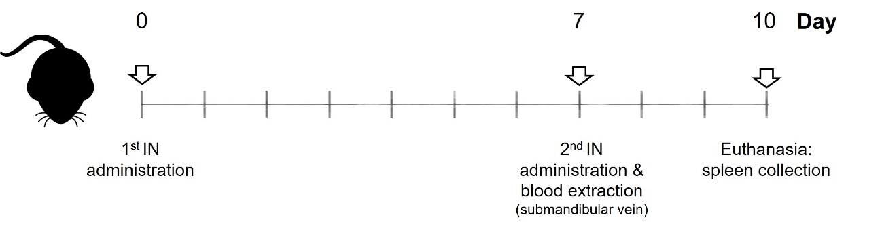
Supplementary Figure 1. Intranasal administration protocol for NE-13-mOVA and NC-4-DX-mOVA. Administration was performed at day 0 and 7 in C57BL/6J female mice (6-8 weeks old). Blood samples from submandibular vein were collected on day 7, and mice were euthanized on day 10, followed by spleen collection.
Abbreviations: DX: dextran sulphate. IN: intranasal. mOVA: mRNA encoding for ovalbumin. NE: nanoemulsion. NC: nanocapsule.

Supplementary Table 1. Physicochemical properties of selected NE-mRNAs and NC-mRNAs before and after lyophilization process in present of different cryoprotectants.
Code | Type of mRNA | Condition | Size (nm) | PDI | Z-Pot (mV)
NE-3 | mGFP (n = 1) | Before lyophilization | 93 | 0.12 | +36
NE-3 | mGFP (n = 1) | Sucrose 10% | 122 | 0.20 | +34
NE-3 | mLuc | Before lyophilization | 112 ± 16 | 0.17 ± 0.01 | +35 ± 6
NE-3 | mLuc | Sucrose 20% (n = 1) | 100 | 0.18 | +35
NE-4 | mGFP (n = 1) | Before lyophilization | 128 | 0.11 | +42
NE-4 | mGFP (n = 1) | Sucrose 10% | 168 | 0.17 | +42
NE-4 | mLuc (n = 1) | Before lyophilization | 123 | 0.22 | +45
NE-4 | mLuc (n = 1) | Sucrose 20% | 116 | 0.14 | +44
NE-9 | mLuc | Before lyophilization | 100 ± 3 | 0.17 ± 0.02 | +56 ± 7
NE-9 | mLuc | Sucrose 20% | 119 ± 14 | 0.15 ± 0.02 | +47 ± 4
NC-3-PR | mGFP (n = 1) | Before lyophilization | 154 | 0.11 | +28
NC-3-PR | mGFP (n = 1) | Trehalose 10% | 174 | 0.17 | +29
NC-3-PR | mLuc (n = 1) | Before lyophilization | 179 | 0.16 | +24
NC-3-PR | mLuc (n = 1) | Trehalose 10% | 180 | 0.16 | +24
NC-4-PR | mGFP (n = 1) | Before lyophilization | 168 | 0.10 | +27
NC-4-PR | mGFP (n = 1) | Trehalose 10% | 185 | 0.07 | +31
NC-4-DX | mLuc | Before lyophilization | 139 ± 21 | 0.14 ± 0.05 | -19 ± 4
NC-4-DX | mLuc | Sucrose 10% | 162 ± 20 | 0.12 ± 0.07 | -30 ± 11
Abbreviations: DX: dextran sulphate. mGFP: mRNA encoding for GFP. mLuc: mRNA encoding for luciferase. NC: nanocapsule. NE: nanoemulsion. PDI: polydispersity index. PR: protamine sulphate EP. Values represent the mean ± standard deviation (n ≥ 3, unless indicated otherwise).
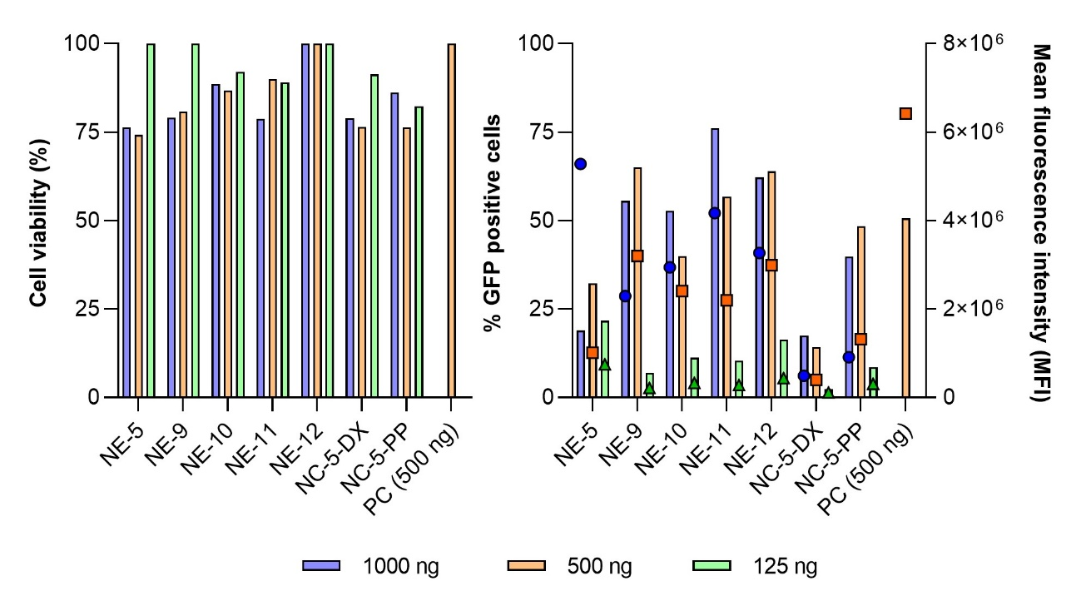
Supplementary Figure 2. Cytotoxicity (left) and GFP transfection (right) of NE-3-mGFP, NE-9-mGFP, NE-10-mGFP, NE-11-mGFP, NE-12-mGFP, NC-5-DX-mGFP and NC-5-PP-mGFP, at different mGFP concentrations. Transfection efficiency is expressed in percentage of GFP positive cells (left axis) and mean fluorescence intensity (right axis) in HeLa cells, 24 hours post transfection.
Abbreviations: DX: dextran sulphate. mGFP: mRNA encoding for GFP. NE: nanoemulsion. NC: nanocapsule. PC: positive control, lipofectamine. PP: PGA-PEG or PEG (5 kDa)-b-PGA (10) (Na). (n = 1).
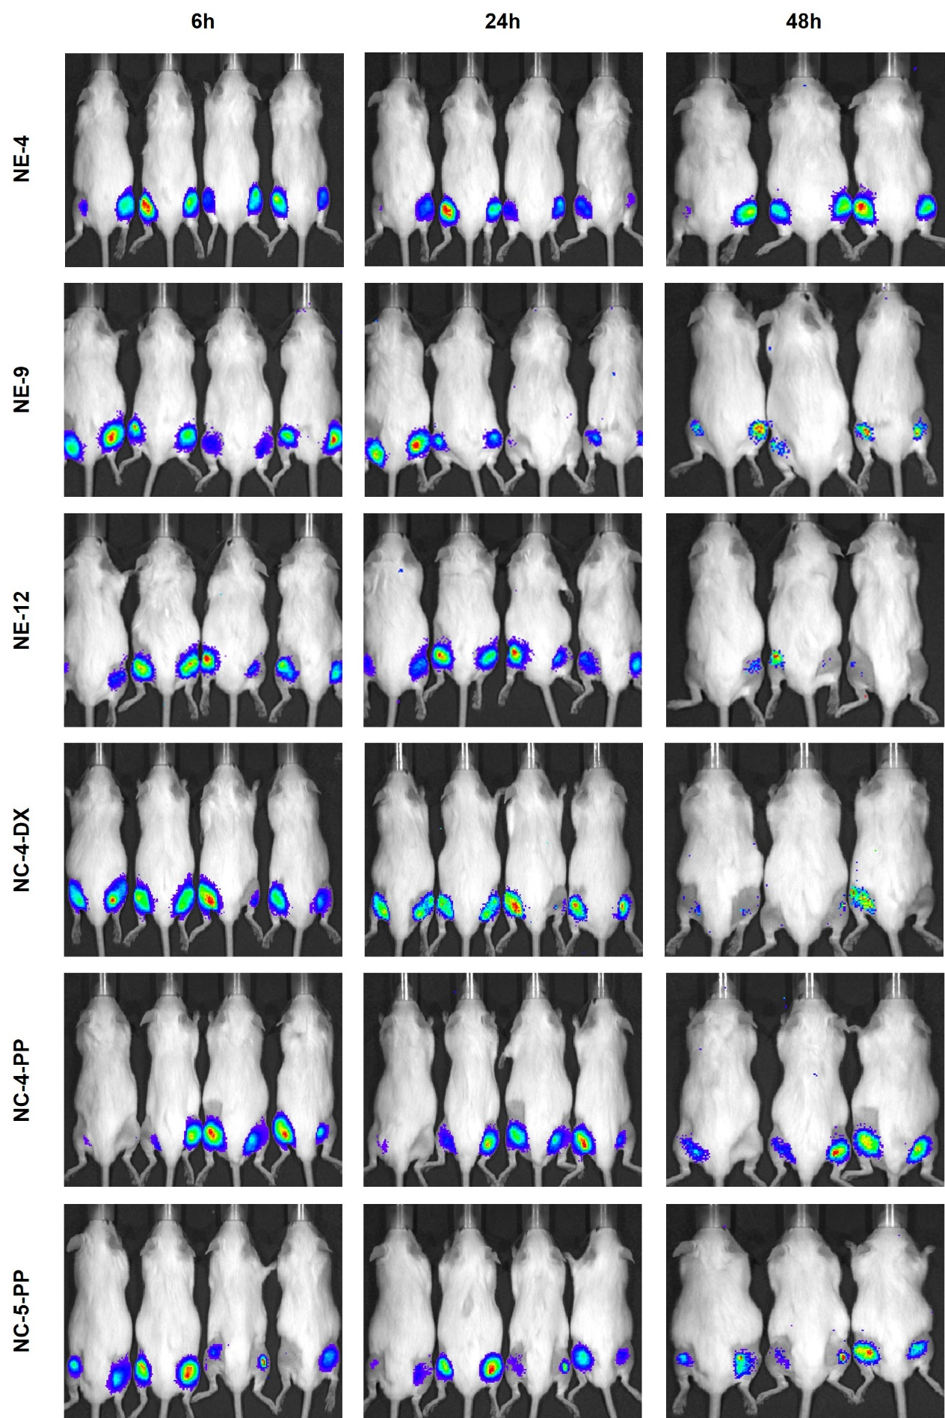
Supplementary Figure 3. Luciferase fluorescence signal detected by IVIS using NE-4-mLuc, NE-9-mLuc, NE-12-mLuc, NC-4-DX-mLuc, NC-4-PP-mLuc, and NC-5-PP-mLuc at different time points (6,24, and 48 hours) after intramuscular administration.
Abbreviations: DX: dextran sulphate. mLuc: mRNA encoding for luciferase. NE: nanoemulsion. NC: nanocapsule. PP: PGA-PEG or PEG (5 kDa)-b-PGA (10) (Na).

