Supplements
Lulu Zhang^{1#}, MD, Qi Wang ^{2#}, MBBS, Yidan Li¹, MD, Dongxue Ding¹, PhD, Juehua Zhu¹, PhD, Qi Fang¹, PhD, Ye Yao^{2,3,4}*, PhD, Xiang Tang¹*, PhD
¹Department of Neurology, First Affiliated Hospital of Soochow University, Suzhou, China,
²Department of Biostatistics, School of Public Health, Fudan University, Shanghai, China,
³National Clinical Research Centre for Aging and Medicine, Huashan Hospital, Fudan University, Shanghai, China,
⁴Key Laboratory of Public Health Safety of Ministry of Education, Fudan University, Shanghai, China

# Lulu Zhang and Qi Wang contributed equally to this work.
* Correspondence to: Ye Yao, Department of Biostatistics, School of Public Health, Fudan University, No. 130 Dongan Road, Shanghai 200032, China. Email: yyao@fudan.edu.cn, Office/Fax: +86-21 54237625.
Xiang Tang, Ph.D., Department of Neurology, First Affiliated Hospital of Soochow University, No. 899, Pinghai Road, Suzhou, Jiangsu 215006, China. E-mail: tangxiang163yx@163.com, Office/Fax: +86-512 67972205.

RESULTS
Table S1 Univariate analysis of CURB-65 score in SAP patients (continuous variables)
Variables | r | P value
Age | 0.31 | 0.01
Systolic Blood Pressure (mmHg) | -0.16 | 0.19
Diastolic Blood Pressure (mmHg) | -0.15 | 0.20
Triglyceride (mmol/L) | -0.08 | 0.53
Total Cholesterol (mmol/L) | 0.10 | 0.41
LDLC (mmol/L) | 0.05 | 0.68
Creatinine (μmol/L) | 0.23 | 0.05
Uric Acid (μmol/L) | 0.03 | 0.81
Fasting Blood Glucose (μmol/L) | 0.35 | 2.66×10⁻³*
Homocysteine (μmol/L) | 0.22 | 0.06
Hemoglobin A1c (%) | 0.16 | 0.19
Admission NIH Stroke Scale | 0.43 | 1.33×10⁻⁴*
Discharge NIH Stroke Scale | 0.47 | 2.74×10⁻⁵*
Length of hospital stay | 0.19 | 0.10
*: r > 0.3, P < 0.005.

Table S2 analysis of CURB-65 score in SAP patients (categorical variables)
Variables | Mean | SD | t/F | P value
Gender female/male | 1.80/1.44 | 0.76/0.90 | t = 1.72 | 0.09
Post stroke dysphagia  yes/no | 1.70/0.70 | 0.82/0.67 | t = -3.67 | 4.66×10⁻⁴*
Nasogastric tube placement yes/no | 1.79/0.95 | 0.84/0.60 | t = -4.09 | 1.12×10⁻⁴*
History of Hypertension  yes/no | 1.62/1.33 | 0.83/0.98 | t = -1.15 | 0.25
History of Diabetes yes/no | 1.67/1.53 | 0.84/0.88 | t = -0.59 | 0.56
Smoking yes/quit/no | 1.29/1.00/1.71 | 0.92/0.71/0.83 | F = 2.69 | 0.08
History of AF† yes/no | 2.00/1.36 | 0.95/0.75 | t = -3.10 | 2.77×10⁻³*
Other Heart Diseases  yes/no | 2.00/1.54 | 0.82/0.87 | t = -1.04 | 0.30
Previous Stroke yes/no | 1.42/1.61 | 0.69/0.92 | t = 0.82 | 0.41
ECG† (AF) yes/no | 1.96/1.31 | 0.92/0.73 | t = -3.35 | 1.30×10⁻³*
TOAST Classification† | 1.31/2.04/1.13/1.00/- | 0.71/0.92/0.64/- | F = 5.55 | 1.80×10⁻³*
Progressive Stroke yes/no | 1.90/1.43 | 0.97/0.80 | t = -2.10 | 0.04
Brain lesion location† | 1.84/1.51/1.56/1.00/  1.00/2.00/1.50 | 0.90/0.92/0.73/  0.63/-/-/0.71 | F = 0.88 | 0.52
Thrombolytic/  endovascular/no | 1.58/3.00/1.55 | 0.79/0/0.88 | F = 1.22 | 0.31
Epilepsy yes/no | 1.00/1.58 | 0/0.87 | t = 5.57 | 4.28×10⁻⁷*
*: P < 0.005.

Table S3 Multivariable Logistic Regression Model for Predicting Patients with Pneumonia Severity measured by CURB-65
Variables | β | SD | t | P value
Age | 0.02 | 0.01 | 3.25 | 1.90×10⁻³*
Gender female/male | 0.03 | 0.19 | 0.14 | 0.89
Post stroke dysphagia  yes/no | 0.68 | 0.28 | 2.44 | 0.02
Nasogastric tube placement yes/no | -0.08 | 0.25 | -0.33 | 0.74
History of AF† yes/no | -0.13 | 0.30 | -0.42 | 0.67
Fasting Blood Glucose (μmol/L) | 0.06 | 0.03 | 2.31 | 0.02
Admission NIH Stroke Scale | 0.04 | 0.02 | 2.41 | 0.02
Discharge NIH Stroke Scale | 1.65×10⁻³ | 0.02 | 0.09 | 0.93
ECG† (AF) yes/no | -0.57 | 0.50 | -1.14 | 0.26
Large-artery Atherosclerosis | 0.41 | 0.70 | 0.59 | 0.56
Cardioembolism | 1.43 | 0.89 | 1.60 | 0.11
Small-vessel Occlusion | 0.36 | 0.73 | 0.50 | 0.62
Progressive Stroke yes/no | 0.14 | 0.19 | 0.72 | 0.48
*: P < 0.005.

Table S4 Univariate Analysis for Predicting Patients with Pneumonia Severity measured by PSI (continuous variables)
Variables | r | P value
Age | 0.41 | 2.79×10⁻⁴*
Systolic Blood Pressure (mmHg) | 0.12 | 0.32
Diastolic Blood Pressure (mmHg) | -0.06 | 0.62
Triglyceride (mmol/L) | -0.12 | 0.33
Total Cholesterol (mmol/L) | -2.00×10⁻³ | 0.99
LDLC (mmol/L) | -0.08 | 0.52
Creatinine (μmol/L) | 0.25 | 0.03
Uric Acid (μmol/L) | 0.02 | 0.88
Fasting Blood Glucose (μmol/L) | 0.21 | 0.07
Homocysteine (μmol/L) | 0.10 | 0.40
Hemoglobin A1c (%) | 0.14 | 0.24
Admission NIH Stroke Scale | 0.26 | 0.03
Discharge NIH Stroke Scale | 0.36 | 1.92×10⁻³*
Length of hospital stay | 0.12 | 0.31
*: r > 0.3, P < 0.005.

Table S5 Univariate Analysis for Predicting Patients with Pneumonia Severity measured by PSI (categorical variables)
Variables | Mean | SD | t/F | P value
Gender female/male | 85.64/80.96 | 25.28/15.59 | t=0.98 | 0.33
Post stroke dysphagia  yes/no | 85.78/62.30 | 17.37/37.68 | t=-1.94 | 0.08
Nasogastric tube placement yes/no | 86.66/71.70 | 20.81/23.47 | t=-2.64 | 0.01
History of Hypertension  yes/no | 87.05/65.20 | 19.75/24.36 | t=-3.64 | 5.14×10⁻⁴*
History of Diabetes yes/no | 84.61/81.89 | 15.51/24.36 | t=-0.55 | 0.58
Smoking yes/quit/no | 78.88/70.40/84.98 | 23.76/40.98/19.61 | F=1.27 | 0.29
History of AF† yes/no | 89.30/79.46 | 25.14/20.61 | t=-1.77 | 0.08
Other Heart Diseases  yes/no | 89.00/82.19 | 21.49/22.58 | t=-0.59 | 0.56
Previous Stroke yes/no | 89.32/80.19 | 17.56/23.60 | t=-1.54 | 0.13
ECG† (AF) yes/no | 79.44/21.41 | 23.52/87.57 | t=-1.52 | 0.13
TOAST Classification† | 80.22/88.36/76.13/56.00/- | 22.38/23.27/16.52/- | F=1.47 | 0.23
Progressive Stroke yes/no | 91.10/79.34 | 22.37/21.80 | t=-2.04 | 4.51×10⁻²
Brain lesion location† | 87.89/82.06/80.22/77.00/70.00/101.00/65.00 | 27.51/21.86/15.86/  19.09/-/-/25.46 | F=0.61 | 0.72
Thrombolytic/  endovascular/no | 84.17/75.50/82.17 | 19.39/3.54/23.56 | F=0.28 | 0.84
Epilepsy yes/no | 77.50/82.70 | 10.61/22.70 | t=0.32 | 0.75
*: P < 0.005.

Table S6 Multivariable Linear Regression Model for Predicting Patients with Pneumonia Severity measured by PSI
Variables | β | SD | t | P value
Age | 0.63 | 0.20 | 3.15 | 2.40×10⁻³*
Gender female/male | 2.01 | 4.96 | 0.40 | 0.69
Nasogastric tube placement yes/no | 4.47 | 5.81 | 0.77 | 0.44
History of Hypertension  yes/no | 14.95 | 5.72 | 2.62 | 0.01
Discharge NIH Stroke Scale | 0.84 | 0.39 | 2.14 | 0.04
Progressive Stroke yes/no | 7.47 | 5.10 | 1.47 | 0.15
*: P < 0.005.

Table S7 Demographic and clinical data of SAP patients
Demographic and  clinical data | Controls  (n = 69) | Death or ICU  (n = 3) | t / χ2 / z | P-value
Age (years) | 70.93 ± 12.03 | 71.33 ± 7.64 | t = -0.06 | 0.95
Gender (female/male) | 25/44 | 0/3 | χ2 = 0.45 | 0.50
Dysphagia (no/yes) | 9/60 | 1/2 | z = 0.90 | 0.37
Feeding methods  (oral/nasal feeding) | 18/51 | 1/2 | z < 0.01 | 1.00
Systolic Blood Pressure (mmHg) | 143.40 ± 17.72 | 132.70 ± 28.02 | t = 1.01 | 0.32
Diastolic Blood Pressure (mmHg) | 80.41 ± 12.39 | 72.67 ± 5.51 | t = 1.07 | 0.29
History of hypertension (no/yes) | 12/57 | 2/1 | z = 1.67 | 0.09
History of diabetes (no/yes) | 51/18 | 3/0 | z = 0.57 | 0.57
Smoking (no/yes/quit) | 58/16/5 | 3/0/0 | z < 0.01 | 1.00
History of atrial fibrillation (no/yes) | 47/22 | 2/1 | z < 0.01 | 1.00
Other heart diseases (no/yes) | 65/4 | 3/0 | z < 0.01 | 1.00
History of stroke (no/yes) | 51/18 | 2/1 | z < 0.01 | 1.00
Triglyceride (mmol/L) | 1.23 ± 0.51 | 1.07 ± 0.36 | t = 0.54 | 0.59
Total cholesterol (mmol/L) | 4.12 ± 1.04 | 3.51 ± 0.52 | t = 0.99 | 0.33
LDL-C (mmol/L) | 2.33 ± 0.79 | 2.05 ± 0.40 | t = 0.61 | 0.55
Creatinine | 71.35 ± 18.85 | 64.23 ± 12.10 | t = 0.65 | 0.52
Uric acid (μmol/L) | 290.50 ± 111.80 | 241.20 ± 83.38 | t = 0.75 | 0.46
Fasting blood glucose (mmol/L) | 7.10 ± 3.13 | 4.89 ± 0.42 | t = 4.96 | 4.64$×$10-6*
Homocysteine | 11.35 ± 3.16 | 9.67 ± 2.65 | t = 0.91 | 0.37
HbA1c (%) | 6.94 ± 1.48 | 5.83 ± 0.35 | t = 1.29 | 0.20
ECG† (normal/abnormal) | 42/27 | 2/1 | χ2 < 0.01 | 1.00
Admission NIHSS | 11.71 ± 5.99 | 15.67 ± 17.95 | t = -0.38 | 0.74
Discharge NIHSS | 9.64 ± 6.44 | 8.67 ± 8.50 | t = 0.25 | 0.80
TOAST Classification† | 34/27/8/0/0 | 2/1/0/0/0 | z < 0.01 | 1.00
Progressive stroke (no/yes) | 49/20 | 3/0 | z = 0.59 | 0.56
Brain lesion location† | 17/35/8/5/1/1/2 | 1/0/1/1/0/0/0 | z = 1.29 | 0.20
Infarct volume | 33.74 ± 74.83 | 105.80 ± 130.00 | t = -1.59 | 0.12
Special Treatment Thrombolytic/endovascular/no | 10/2/57 | 1/1/1 | z = 2.04 | 0.04*
Epilepsy (no/yes) | 67/2 | 3/0 | z < 0.01 | 1.00
Progressive stroke (no/yes) | 64/5 | 2/1 | z = 1.19 | 0.23
Length of hospital stay | 10.90 ± 5.11 | 10.67 ± 3.79 | t = 0.08 | 0.94
*: P < 0.05
† AF refers to atrial fibrillation, LDLC refers to low density lipoprotein cholesterol, ECG refers to Electrocardiogram. TOAST refers to five classifications: (1) large-artery atherosclerosis, (2) cardioembolism, (3) small-vessel occlusion, (4) stroke of other determined etiology and (5) stroke of undetermined etiology. Brain lesion locations refer to seven classifications: (1) left cerebral hemisphere lesion, (2) right cerebral hemisphere lesion, (3) bilateral cerebral hemisphere lesions, (4) brainstem lesion, (5) left cerebral hemisphere and brainstem lesions, (6) right cerebral hemisphere and brainstem lesions, (7) bilateral cerebral hemisphere and brainstem lesions.

Table S8 Multivariate logistic regression model for predicting adverse outcomes in SAP patients
Variables | Odds ratio | 95% CI | χ2 | P-value
Age (years) | 1.04 | 0.92~1.17 | 0.34 | 0.56
Gender (female/male) | > 999.99 | < 0.01~ > 999.99 | 0.01 | 0.92
Fasting blood glucose (mmol/L) | 0.08 | 0.01~5.30 | 1.38 | 0.24
Special Treatment (no) | 1.00
thrombolysis | 40.30 | 0.33~ > 999.99 | 2.26 | 0.13
thrombectomy | 133.75 | 0.20~ > 999.99 | 2.16 | 0.14
thrombectomy + stent | > 999.99 | < 0.01~ > 999.99 | < 0.01 | 0.99

Figure S1. Details of study recruitment.
Study population (n=275)
Hemorrhagic stroke (n=45),
TIA (n=20)
Swallowing assessment
＞ 24 hours (n=21)
Possible preexisting dysphagia (n=15)
Severe hepatic and renal dysfuntion, End-stage severe disease (n=90)
Severe hepatic and renal dysfuntion (n=67)
MRI not available (n=86)
All acute stroke patients between October2017 and May 2018 from stroke unit at First Affiliated Hospital of Soochow University (n=552)
Swallowing assessment
within 24 hours (n=466)
AIS patients (n=487)
AIS: acute ischemic stroke; TIA: transient ischemic attack.
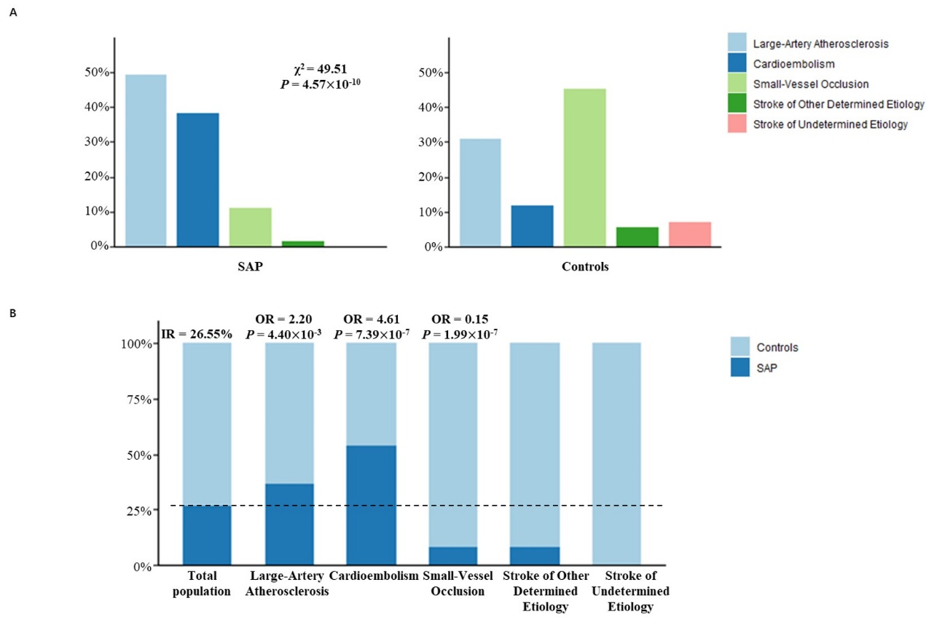
Figure S2. Pneumonia and Stroke Associations by TOAST Classification
Panel A: Composition ratios of TOAST classification (blue: large-artery atherosclerosis, indigo: cardioembolism, light green: small-vessel occlusion, green: stroke of other determined etiology and pink: stroke of undetermined etiology) in patients with post stroke pneumonia and controls, which indicates a significantly strong association between pneumonia and stroke by TOAST classifications (Chi-square test, χ² = 49.51, P = 4.57×10⁻¹⁰).
Panel B: Incidence rate of pneumonia in different TOAST classifications (patients with pneumonia in indigo and controls in blue). The incidence rate of the total population is 26.55%. Large-artery atherosclerosis and cardioembolism had odd ratios significantly larger than 1 with pneumonia (OR = 2.20, P = 4.40×10⁻³ and OR = 4.61, P = 7.39×10⁻⁷), while small-vessel occlusion had an odds ratio significantly lower than 1 (OR = 0.15, P = 1.99×10⁻⁷).

Figure S3. Pneumonia and Stroke Associations by Brain Lesion Locations
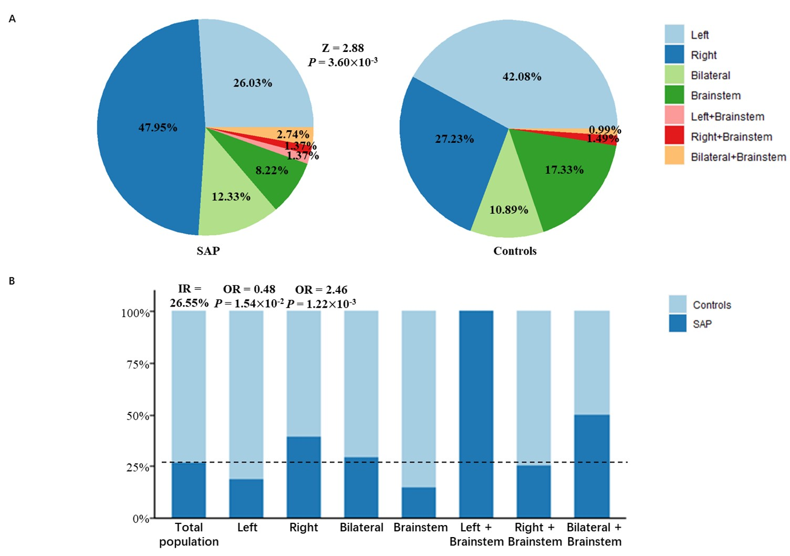
Panel A: Composition ratios of brain lesion locations (blue: left cerebral hemisphere, indigo: right cerebral hemisphere, light green: bilateral cerebral hemisphere, green: brainstem, pink: left cerebral hemisphere and brainstem, red: right cerebral hemisphere and brainstem, orange: bilateral cerebral hemispheres and brainstem) in patients with post stroke pneumonia and controls, which indicates a significantly strong association between pneumonia and stroke by brain lesion locations (Fisher’s exact test, z = -2.88, P = 3.60×10⁻³).
Panel B: Incidence rate of pneumonia in different brain lesion locations (patients with pneumonia in indigo and controls in blue). The incidence rate of the total population is 26.55%. The right cerebral hemisphere had odds ratios significantly larger than 1 with pneumonia (OR = 2.46, P = 1.22×10⁻³), while the left cerebral hemisphere had an odds ratio significantly lower than 1 (OR = 0.48, P = 1.54×10⁻²).

