D-dimer is valuable for predicting the extension of isolated distal deep vein thrombosis of the lower limb in neurocritical patients: a retrospective observational study

Supplemental Digital Content Tables and figures

Rui Tang, Zhi Gao, Min Du, Haiyan Liu, Yanyan Yang, Zongsu Ji, Min Zhou

Corresponding author: Min Zhou
Affiliation: Neurocritical Care Unit, The First Affiliated Hospital of USTC, Division of Life Sciences and Medicine, University of Science and Technology of China, Hefei, China
Address: No.1 Tianerhu Road, Hefei, Anhui province, China, 230031
E-mail: dminzhou@ustc.edu.cn
eTable 1. Comorbidities, treatment approaches of patients with IDDVT occurrence or extension compared with control subjects
 | IDDVT occurrence |  | Statistical data |  | IDDVT extension |  | Statistical data
 | Yes (n=129) | No (n=88) | t/x | p | Yes (n=22) | No (n=84) | t/x | p
Surgery time(min) | 192±106 | 182±75 | -3.55 | 0.01 | 195±111 | 186±97 | -0.035 | 0.973
Chronic comorbidities (n)
Cardiovascular disease | 101 | 57 | 4.832 | 0.028 | 17 | 66 |  | 1.000
Chronic pulmonary disease | 2 | 2 |  | 1.000 | 0 | 1 |  | 1.000
Diabetes mellitus | 20 | 10 | 0.753 | 0.386 | 2 | 12 |  | 0.729
Chronic renal disease | 4 | 2 |  | 1.000 | 0 | 3 |  | 1.000
Chronic liver disease | 3 | 1 |  | 0.648 | 2 | 3 |  | 0.276
Acute concurrent medical conditions (n)
Acute kidney injury | 7 | 2 |  | 0.319 | 0 | 6 |  | 0.333
Acute liver dysfunction | 26 | 14 | 0.627 | 0.479 | 3 | 20 |  | 0.393
Gastrointestinal bleeding | 5 | 6 |  | 0.359 | 0 | 3 |  | 1.000
Sepsis | 71 | 45 | 0.320 | 0.571 | 14 | 47 | 0.421 | 0.516
Treatment approaches (n)
Transfusion
Red blood cell | 21 | 16 | 0.134 | 0.854 | 6 | 14 |  | 0.357
Plasma | 2 | 2 |  | 1.000 | 1 | 8 |  | 0.681
Platelets |  |  |  |  | 0 | 1 |  | 1.000
Mechanical ventilation>48h | 128 | 85 |  | 0.306 | 22 | 84 |  | 1.000
Renal‑replacement therapy | 3 | 2 |  | 1.000 | 0 | 3 |  | 1.000
Endovascular therapy | 30 | 14 | 1.747 | 0.186 | 1 | 20 |  | 0.068
Second surgery | 15 | 9 | 0.104 | 0.747 | 1 | 11 |  | 0.453

efigure 1. Dynamic changes of prothrombin time among patients with IDDVT occurrence or extension compared with control subjects

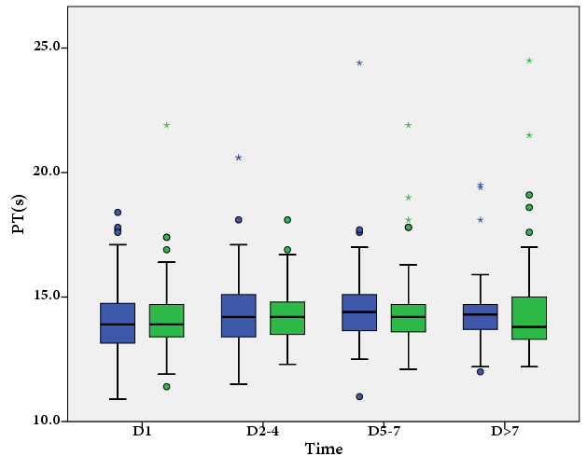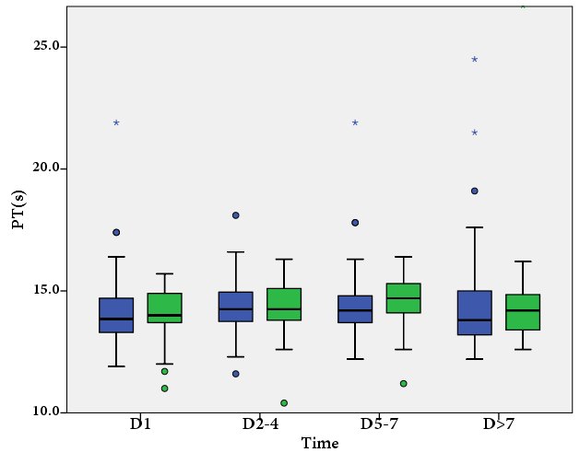
A
B
A, patients with IDDVT occurrence vs. without
Green box, patients with IDDVT occurrence (n =84); blue box, patients without IDDVT occurrence (n = 45). p = 0.460 for the effect of IDDVT occurrence or not; p = 0.525 for the effect of dynamic changes; p =0.224 for interaction.
B, patients with IDDVT extension vs. without
Green box, patients with IDDVT extension (n = 20); blue box, patients without IDDVT extension (n = 70). p = 0.926 for the effect of IDDVT extension or not; p = 0.766 for the effect of dynamic changes; p =0.383 for interaction.

efigure 2. Dynamic changes of activated partial thromboplastin time among patients with IDDVT occurrence or extension compared with control subjects

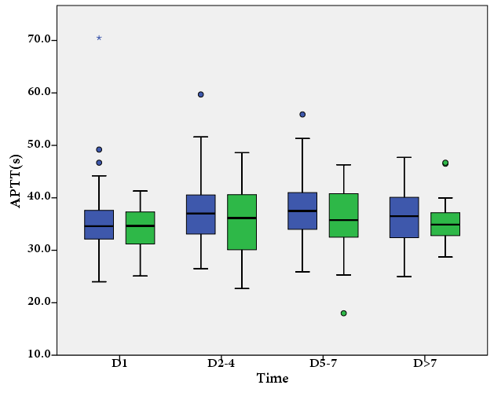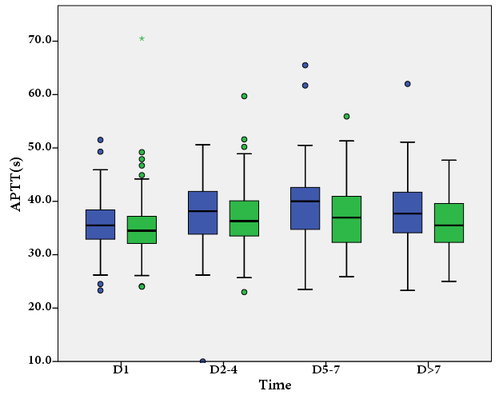
A
B
A, patients with IDDVT occurrence vs. without
Green box, patients with IDDVT occurrence (n = 45); blue box, patients without IDDVT occurrence (n = 84). p = 0.061 for the effect of IDDVT occurrence or not; p < 0.0001 for the effect of dynamic changes; p = 0.155 for interaction.
B, patients with IDDVT extension vs. without
Green box, patients with IDDVT extension (n = 20); blue box, patients without IDDVT extension (n = 70). p = 0.313 for the effect of IDDVT extension or not; p = 0.118 for the effect of dynamic changes; p = 0.834 for interaction.

efigure 3. Dynamic changes of fibrinogen among patients with IDDVT occurrence or extension compared with control subjects

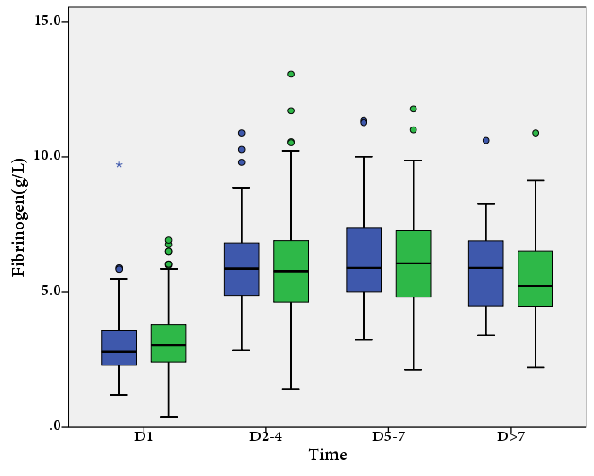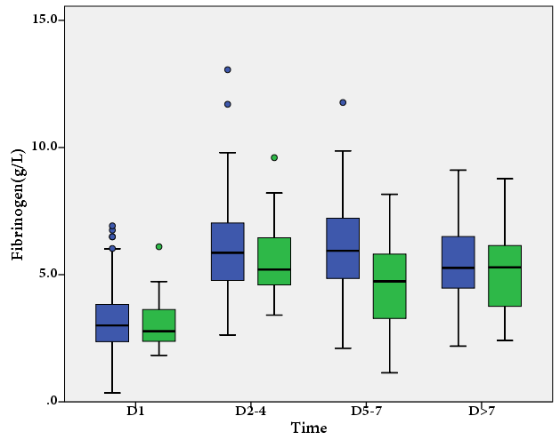
A
B
A, patients with IDDVT occurrence vs. without
Green box, patients with IDDVT occurrence (n = 45); blue box, patients without IDDVT occurrence (n = 84). p = 0.658 for the effect of IDDVT occurrence or not; p < 0.0001 for the effect of dynamic changes; p = 0.504 for interaction.
B, patients with IDDVT extension vs. without
Green box, patients with IDDVT extension (n = 20); blue box, patients without IDDVT extension (n = 70). p = 0.007 for the effect of IDDVT extension or not; p < 0.0001 for the effect of dynamic changes; p = 0.112 for interaction.

efigure 4. Dynamic changes of thrombin time among patients with IDDVT occurrence or extension compared with control subjects

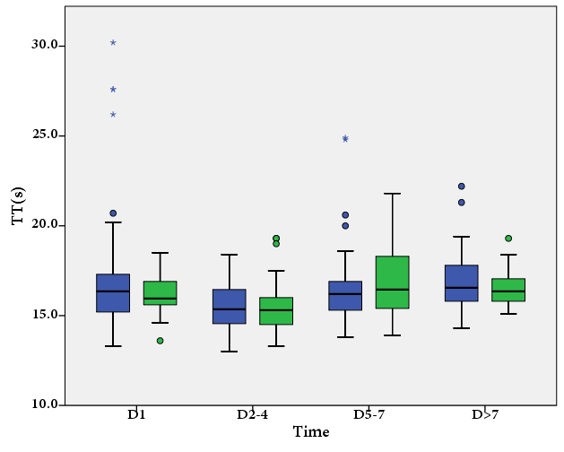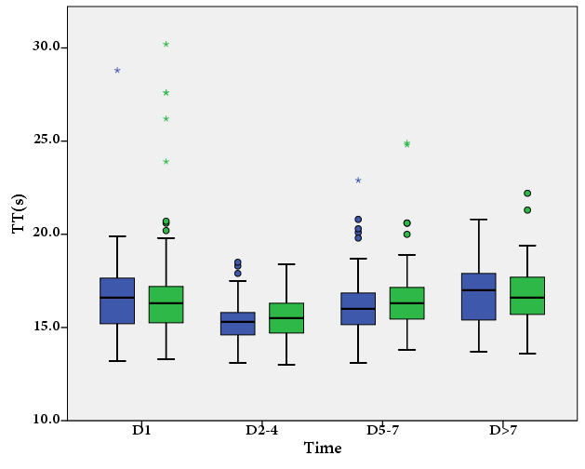
A
B
A, patients with IDDVT occurrence vs. without
Green box, patients with IDDVT occurrence (n = 45); blue box, patients without IDDVT occurrence (n = 84). p = 0.448 for the effect of IDDVT occurrence or not; p < 0.0001 for the effect of dynamic changes; p = 0.322 for interaction.
B, patients with IDDVT extension vs. without
Green box, patients with IDDVT extension (n = 20); blue box, patients without IDDVT extension (n = 70). p = 0.863 for the effect of IDDVT extension or not; p = 0.003 for the effect of dynamic changes; p = 0.367 for interaction.

efigure 5. Dynamic changes of platelets among patients with IDDVT occurrence or extension compared with control subjects

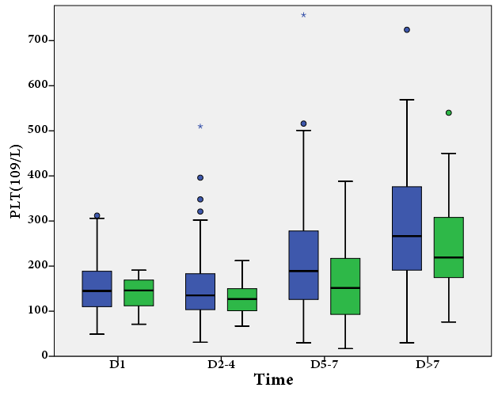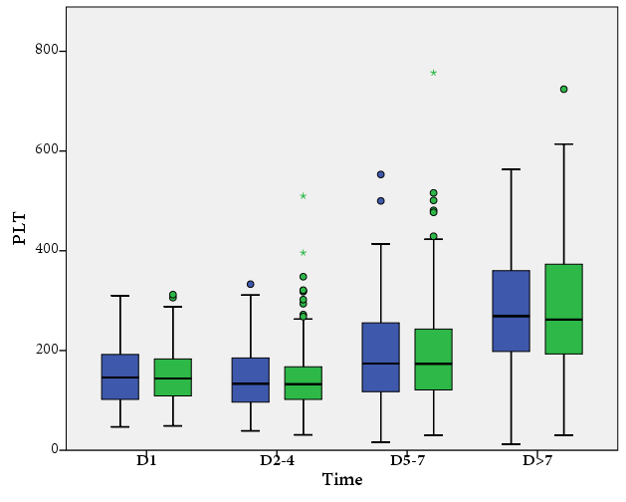
A
B
A, patients with IDDVT occurrence vs. without
Green box, patients with IDDVT occurrence (n = 45); blue box, patients without IDDVT occurrence (n = 84). p = 0.942 for the effect of IDDVT occurrence or not; p < 0.0001 for the effect of dynamic changes; p = 0.591 for interaction.
B, patients with IDDVT extension vs. without
Green box, patients with IDDVT extension (n = 20); blue box, patients without IDDVT extension (n = 70). p = 0.135 for the effect of IDDVT extension or not; p < 0.0001 for the effect of dynamic changes; p = 0.664 for interaction.

