Supplemental: Structure-Dynamics Relation in Metallic Glass Revealed by 5-Dimensional Scanning Transmission Electron Microscopy

Measurement of relaxation time
Gaussian blur with a variance of 0.21 nm⁻¹ was applied to diffraction patterns. Then $G\left(Q, t_{1}, t_{2}\right)$ was calculated from pixels whose $\left|Q\right|$ ranged from 4.2 to 4.6 nm⁻¹. $g\left(Q, t\right)$ was calculated from $G\left(Q, t_{1}, t_{2}\right)$ and the relaxation time was measured by fitting the KWW function. To reduce noise, $g\left(Q, 0\right)$ and $g\left(Q, t>t_{half}\right)$ were excluded from fitting. $t_{half}$ indicates half of the observation time. We set the range of relaxation time from 0 to 5,000 s and the range of γ from 0 to 3, and performed fitting.

Thickness measurement
Thickness was measured by EELS using the log-ratio method and a convergence semiangle of 20 mrad. We calculated the absolute thickness taking 110 nm as the mean free path of Zr₅₀Cu₄₀Al₁₀. This value is the average of mean free path values for each element weighted by its composition¹. The thickness variation across the sample and thickness dependences of $τ$, $γ$ and $V\left(Q\right)$ are shown in fig. S1; $τ$, $γ$ and $V\left(Q\right)$ are values averaged in the y-axis over a region of the same thickness. The values of $τ$ are high and $V\left(Q\right)$ is low at the left edge because of the spurious signals originating from a thin sample area. Thickness dependences of $V\left(Q\right)$, relaxation time, and $γ$ saturate at positions larger than 10 nm from the left edge, indicating a small thickness dependence in the range 35 to 50 nm. To reduce the effect of thickness, only data from this thickness range were used for measuring the average relaxation time, $γ$, $V\left(Q\right)$, characteristic length and correlation between heterogeneities.

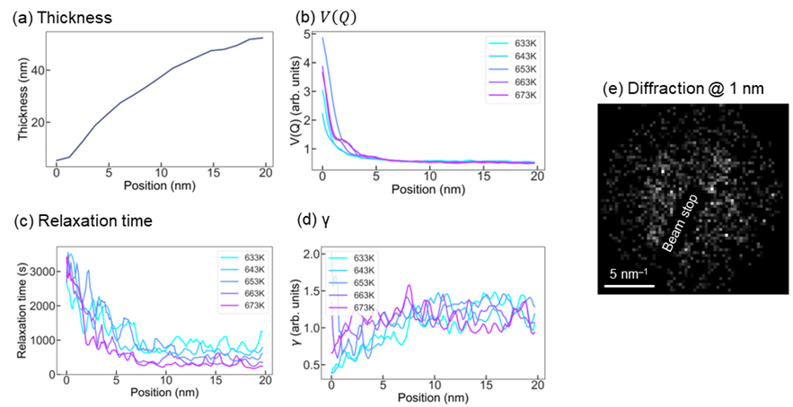
Fig. S1 (a) Thickness, (b) $V\left(Q\right)$, (c) relaxation time, and (d) $γ$, measured along the spatial x-axis and averaged along the y-axis. As shown in fig. S1(e), diffraction patterns acquired within 1 nm from the left edge of the sample exhibit no speckles and are dominated by low-frequency noise. The values of $V\left(Q\right)$, relaxation time, and $γ$ measured in this area are not reliable. Strong thickness dependences of $V\left(Q\right)$, relaxation time, and $γ$ are observed at positions from 1 nm to 10 nm. As the thickness increases, relaxation time and $γ$ increase and $V\left(Q\right)$ decreases in this sample area. Thickness dependences saturate at positions > 10 nm, which were used for measuring the average relaxation time, $γ$, $V\left(Q\right)$ and correlation between heterogeneities.

Mapping of $γ$
Spatial distributions of $γ$ are shown in Fig. S2. They are heterogeneous at all temperatures. The temperature dependence of average value of $γ$ is shown in Fig. S2(f). Note that $γ$ represents the nonlinearity and is expected to be smaller than 1 according to the heterogeneous dynamic scenario. However, at low temperatures, the average of $γ$ is around 1.2. As temperature approaches T_{g}, average $γ$ approaches 1.0 indicating the decrease of nonlinearity. Thus, in this experiment, the decay of correlation function takes compressed shape. Compressed relaxation functions below T_{g} was also observed by X-ray photon correlation spectroscopy in the Mg₆₅Cu₂₅Y₁₀ glass².
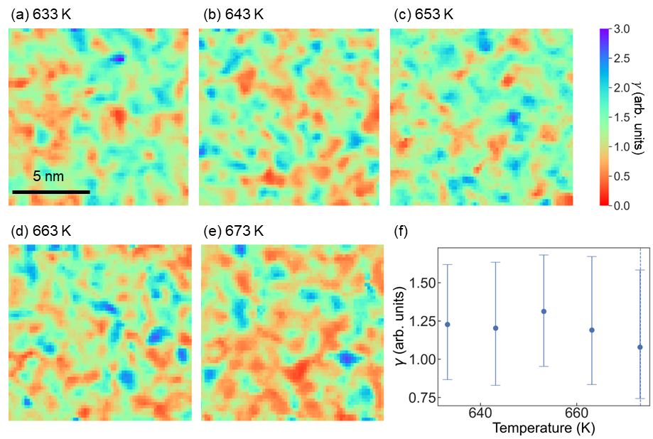
Fig. S2 Maps of $γ$ at (a) 633 K, (b) 643 K, (c) 653 K, (d) 663 K, and (e) 673 K. (f) Temperature dependence of the average value of $γ$.

Histograms of $τ$, $γ$ and $V\left(Q\right)$
Figure S3 show the histograms of $τ$, $γ$ and $V\left(Q\right)$. The frequency means the number of counts for each value. The bottom row shows the histograms normalized by their average values. As temperature increases, the frequency of small values of $τ$, $γ$ and $V\left(Q\right)$increases and the histograms become narrower. Normalization eliminated the temperature dependence for relaxation time, $V\left(Q\right)$, and possibly for $γ$ (considering the large uncertainty in its value). Thus, these values can be scaled by temperature.
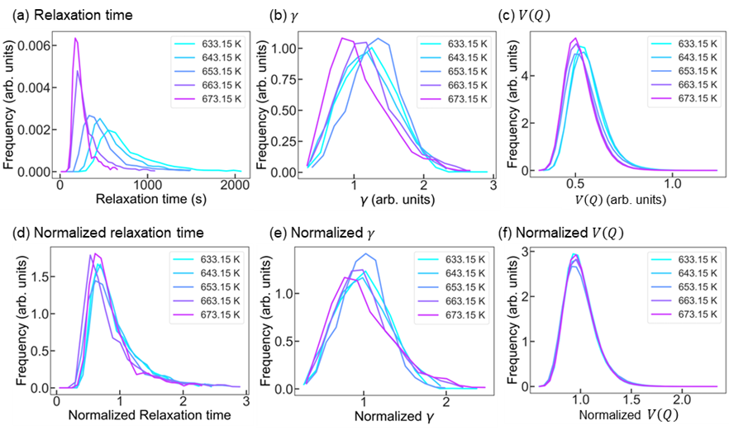
Fig. S3 Distributions of (a) relaxation time, (b)$γ$ and (c)$V\left(Q\right)$. Panels (d), (e), and (f) show the distributions of normalized relaxation time, $γ$, and $V\left(Q\right)$. Normalization was conducted by dividing distributions by their average values.

Correlation among $τ$, $γ$ and $V\left(Q\right)$
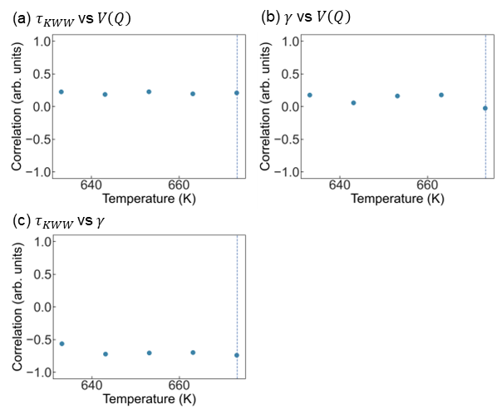
We also measured the positional correlation among $τ$, γ and $V\left(Q\right)$. The results are shown in Fig. S4. The correlation between $τ$ and $V\left(Q\right)$ at arbitrary γ ranges from 0.15 to 0.27 indicating a weaker positive correlation than correlation between $τ$ and $V\left(Q\right)$ measured at γ = 1. The correlation between γ and $V\left(Q\right)$ ranges from 0 to 0.17. The correlation between $τ$ and $V\left(Q\right)$ ranges from -0.74 to -0.56 indicating a strong negative correlation. Thus, a long relaxation time relates to a small γ. The small γ ($γ<1$) stretches the decay function and effectively lengthen relaxation time and vice versa. The correlation between $τ$ and $V\left(Q\right)$ is weaker at arbitrary γ than at γ = 1 because small γ and high $τ$ correspond to large $V\left(Q\right)$.
Fig. S4. Temperature dependences of pairwise correlations of (a)$τ_{KWW}$ vs $V\left(Q\right)$, (b)$γ$ vs $V\left(Q\right)$, and (c)$τ_{KWW}$ vs $γ$.

Characteristic length
To estimate the size of the dynamic heterogeneous region, we also measured the characteristic length of structural heterogeneity $ξ$ by calculating a four-point correlation. We used the following equation:
$$G_{4}\left(Q, Δr, Δt\right)=\frac{{\left\langle I\left(Q, r, t\right)I\left(Q, r+Δr, t\right)I\left(Q, r, t+Δt\right)I\left(Q, r+Δr, t+Δt\right)\right\rangle }_{k, r, t}}{{\left\langle I\left(Q, r, t\right)\right\rangle }_{k}{\left\langle I\left(Q, r+Δr, t\right)\right\rangle }_{k}{\left\langle I\left(Q,r, t+Δt\right)\right\rangle }_{k}{\left\langle I\left(Q,r+Δr, t+Δt\right)\right\rangle }_{k}}$$
The correlation was measured from the part of diffraction patterns whose spatial frequency ranged from 4.2. to 4.6 nm⁻¹. We measured $ξ$ by fitting the following equation.
$$G_{4}\left(Q, r, t\right)-1=β\exp\left(-2{\left(\frac{t}{τ}\right)}^{γ_{t}} \right)\exp\left(-2{\left(\frac{r}{ξ}\right)}^{γ_{r}} \right),$$
where $r$ is the position in real space and $γ_{t}$ and $γ_{r}$ are stretch factors. This fitting yields the length and time to lose the correlation between diffraction patterns. The characteristic length at 633 K was 0.69 nm, which is close to the diameter of the electron probe (0.78 nm). The temperature dependence of characteristic length is shown in Fig. S5. At all temperatures, the characteristic length was smaller than the diameter of the electron probe. Thus, no drastic change in the size of the dynamic heterogeneous region near T_{g} could be detected.
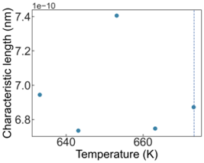
Fig. S5. Temperature dependence of the characteristic length of dynamical heterogeneity.

Possible oxidation
Zr-based glass is known to oxidize near T_{g}, even in high vacuum^{3–5}. We checked oxidation from the radial distribution function of diffraction patterns. We used rotationally and positionally averaged electron diffraction patterns recorded at different temperatures. If oxidation happened, then additional peak from Zr oxides would appear around 3.3-3.5 nm⁻¹ and 5.5 nm⁻⁶. No additional peaks are observed in Fig. S6 indicating that oxidation was negligible in our experiments.
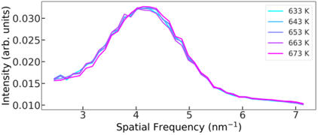
Fig. S6. RDF of diffraction patterns recorded at temperatures between 633 and 673 K.

Accuracy of measurement of relaxation time and $γ$
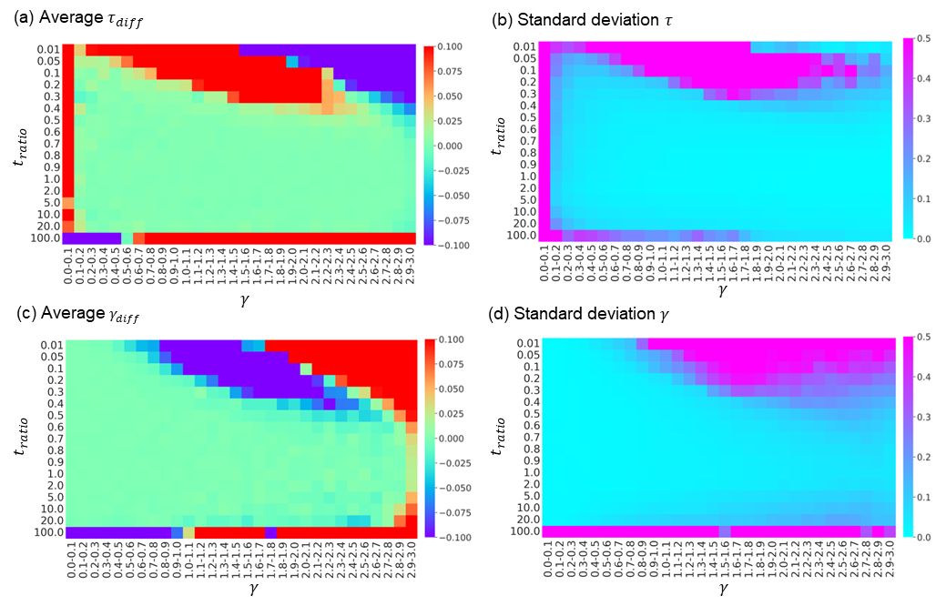
To verify the accuracy of measured relaxation time and $γ$, we have performed the following simulation. First, we generated a series of $g\left(t\right)$ datasets using the Kohlrausch-Williams-Watts (KKW) equation. Each $g\left(t\right)$dataset contained 50 time points to comply with our experiment. To each set, we added noise with a normal distribution and an amplitude of 0.02. This amplitude was again taken experiment as the standard deviation of difference between the experimental g curve and its KWW fit. We then performed two-time correlation fitting using the same KWW equation. Next, we calculated the average and variance of the differences between the fit $γ$ and $τ$ values and the $γ$ and $τ$ that were used to generate the g(t) sets, and plotted the results in Fig. S7. There t_{ratio} is observation window time T divided by $τ$.
Fig. S7. The average (a,c) and standard deviation (b,d) of the differences between the determined and preset values of $τ$ (a,b) and $γ$ (c,d). The KKW function was used both for the fit and for generating the preset data; $t_{ratio}$ is the ratio between relaxation time and observation time (observation time/relaxation time), similarly, the $τ$ is also normalized by the observation time. Red and blue colors in (a,c) indicate overestimation and underestimation, respectively.

Figure S7 reveals that for the practical range of 0.1<$γ$<2.9, a reasonable accuracy within 5% can be achieved with 0.4<t_{ratio}<20. The deterioration of accuracy at large t_{ratio} seems counterintuitive, but it results from the discretization errors – at large t_{ratio} values, the entire relaxation occurs within a few discretization steps. For our 633 K experiment, 0.4<t_{ratio}<20 corresponds to a range of 25<$τ$<1250 s, which covers nearly all datapoints (see Fig. S3). Hence, we believe that the chosen measurement window is adequate for our two-time correlation experiment.

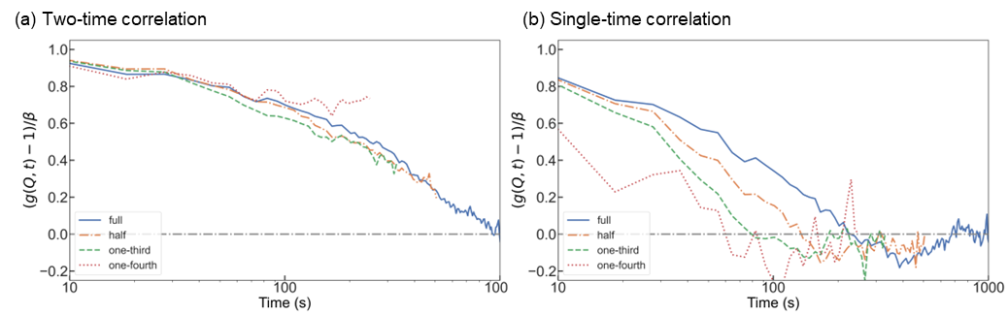
Please note that Zhang et al. [7] and other groups revealed that shortening of the observation window T results in a systematic reduction in the measured value of $τ$, and that t_{ratio} = T/$τ$ should be at least 40 for reliable measurements. However, this conclusion was reached for the single-time correlation procedure, while we have used two-time correlation, which allows to considerably shorten the observation time⁷.
Figure. S8. Comparison of relaxation curves derived using part of relaxation data, and two-time (a) or single-time correlation (b). For the full curve in (a), τ = 770 s and T = 1048 s.
In Figure S7, we have demonstrated the advantages of two-time correlation using synthetic data. In Figure S8, instead of synthetic data we employ measured data, and manually trim the observation window to half, one-third and one-fourth of the original value (1048 s). For comparison, we use both the single-time and two-time correlation methods. Figure S8 (b) reveals that shortening the experiment does result in a systematic underestimation of τ when using the single-time method, in agreement with previous articles [7]. Meanwhile, shortening of the experiment has a minor effect on the relaxation curve derived by two-time correlation (Figure S8 a).
The vast dissimilarity between Figures S8 (a) and (b) originates from the different calculation methods of $g_{2}\left(p\right)$. Zhang calculated $g_{2}\left(p\right)$ as [7]
$$\begin{aligned}g_{2}\left(p\right)=\frac{\left(N-p\right)\sum_{i=0}^{N-p-1}{I\left(i\right)I\left(i+p\right)}}{\left[\sum_{i=0}^{N-p-1}{I\left(i\right)}\right]\left[\sum_{i=0}^{N-p-1}{I\left(i+p\right)}\right]}. \#\left(R1\right)\end{aligned}$$

This function is calculated for pixels at $k=\sqrt{k_{x}^{2}+k_{y}^{2}}$ and averaged over $k$. Assuming that the difference between $\sum_{i=0}^{N-p-1}{I\left(i\right)}$ and $\sum_{i=0}^{N-p-1}{I\left(i+p\right)}$ is small, equation R1 can be modified to
$$\begin{aligned}g_{2}\left(p\right)=\frac{〈I\left(i\right)I\left(i+p\right)〉}{{〈I\left(i\right)〉}^{2}}.\#\left(R2\right)\end{aligned}$$

Here indicates average over time. If we define the $〈I\left(i\right)〉$ as $I_{ave}$ and deviation from average as $δI\left(i\right)$, R2 can be modified to
$$\begin{aligned}g_{2}\left(p\right)=\frac{〈\left(I_{ave}+δI\left(i\right)\right)\left(I_{ave}+δI\left(i+p\right)\right)〉}{I_{ave}^{2}}=1+\frac{〈δI\left(i\right)δI\left(i+p\right)〉}{I_{ave}^{2}} \#\left(R3\right)\end{aligned}$$
Considering that $δI\left(i\right)$ is the deviation from the average, $δI\left(i\right)$ and $〈δI\left(i\right)δI\left(i+p\right)〉$ do have negative value at certain $i$ or $p$ except when all $δI\left(i\right)$ = 0. Thus, $g_{2}\left(p\right)$ is strongly affected by the observation time, and decreases faster when the observation time is shorter. Hence, the required observation time should be approximately 40 to 400 times the relaxation time^{8,9}.
On the other hand, as shown in Fig. S9 below, our method measures the correlation between two images directly via equation (1). Thus, our method is weakly affected by the length of observation time. When calculating $g\left(Q, t\right)$ by equation (2), the length of observation time only affects the number of $G\left(Q, t_{1}, t_{2}\right)$ values that are used to calculate the average, and it does not significantly affect the shape of $g\left(Q, t\right)$.

Contribution of irreversible phenomena
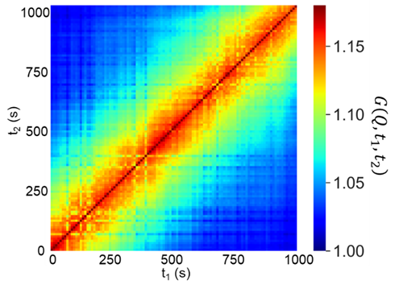
Irreversible phenomena, such as aging, could have distorted our measurements that aimed to characterize steady-state condition. We can confirm whether irreversible phenomena have occurred from the shape of $G\left(Q, t_{1}, t_{2}\right)$ distribution¹⁰.
Fig. S9. TTCF averaged over the sample area that was used for main results of the article.

In Figure S9 we averaged $G\left(Q, t_{1}, t_{2}\right)$ over the same sample area that was used for the main results of the article. Aging would reveal itself as a change in the width of the y = x diagonal, which is not observed. We also measured the $γ$ values from first and last halves of TTCF at 633 K (same data in main manuscript) as 1.1±0.4 and 1.1±0.4, respectively. The lack of difference between these values strikingly contrasts the $γ$ changes of 0.3-0.5 observed in case of aging¹⁰.

Comparison with previous research
Finally, as recommended by referee, we compare our τ(T) data with the literature. We are not aware of XPCS, TEM or ECM results for Zr-based metallic glasses in the studied temperature range (T/T_{g} = 0.94–1). Mechanical data are available. They can vary within a factor of 100 for a given temperature depending thermal history. We took data of Liu et al.¹¹ and Haruyama et al.¹², who studied as-cast Zr-Cu-Al alloys by three methods: static stress relaxation, dynamic mechanical analysis (DMA) and measurement of density (ρ). Their comparison in Fig. S10 reveals close agreement with our data.
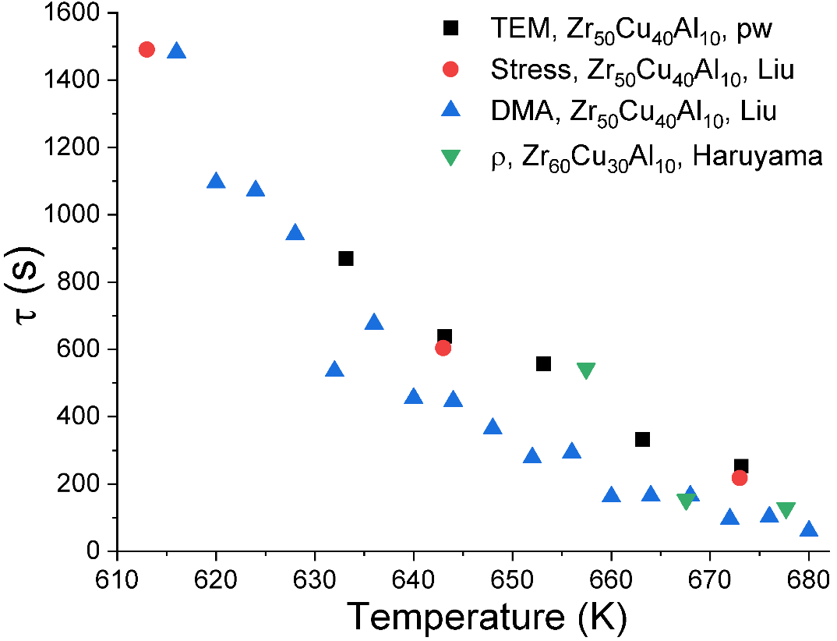
Figure. S10. Comparison of spatially averaged relaxation time measured in present work (pw) with the data of Liu et al. and Haruyama et al.

Movie S1. Temporal change of diffraction patterns with short relaxation time at 633 K. (1,000 s compressed to 10 s)
Movie S2. Temporal change of diffraction patterns with long relaxation time at 633 K. (1,000 s compressed to 10 s)

Supplemental references
1. Iakoubovskii, K., Mitsuishi, K., Nakayama, Y. & Furuya, K. Mean free path of inelastic electron scattering in elemental solids and oxides using transmission electron microscopy: Atomic number dependent oscillatory behavior. Phys Rev B 77, 104102 (2008).
2. Ruta, B., Chushkin, Y., Monaco, G., Cipelletti, L., Pineda, E., Bruna, P., Giordano, V. M. & Gonzalez-Silveira, M. Atomic-Scale Relaxation Dynamics and Aging in a Metallic Glass Probed by X-Ray Photon Correlation Spectroscopy. Phys Rev Lett 109, 165701 (2012).
3. Zhang, M., Yao, D., Wang, X. & Deng, L. Air oxidation of a Zr₅₅Cu₃₀Al₁₀Ni₅ bulk metallic glass at its super cooled liquid state. Corros Sci 82, 410–419 (2014).
4. Köster, U. & Jastrow, L. Oxidation of Zr-based metallic glasses and nanocrystalline alloys. Materials Science and Engineering: A 448–451, 57–62 (2007).
5. Haratian, S., Grumsen, F. B., Villa, M., Christiansen, T. L. & Somers, M. A. J. Self-repair by stress-induced diffusion of noble elements during oxidation of Zr₄₈Cu₃₆Al₈Ag₈ bulk metallic glass. Scr Mater 164, 126–129 (2019).
6. Voyles, P. & Hwang, J. in Characterization of Materials (ed. Kaufmann, E. N.) (John Wiley & Sons, Inc., 2012). doi:10.1002/0471266965.com138
7. Möller, J., Chushkin, Y., Prevost, S. & Narayanan, T. Multi-speckle X-ray photon correlation spectroscopy in the ultra-small-angle X-ray scattering range. J Synchrotron Radiat 23, 929–936 (2016).
8. Paeng, K., Park, H., Hoang, D. T. & Kaufman, L. J. Ideal probe single-molecule experiments reveal the intrinsic dynamic heterogeneity of a supercooled liquid. Proc Natl Acad Sci U S A 112, 4952–4957 (2015).
9. Zhu, F., Song, S., Reddy, K. M., Hirata, A. & Chen, M. Spatial heterogeneity as the structure feature for structure–property relationship of metallic glasses. Nat Commun 9, (2018).
10. Evenson, Z., Ruta, B., Hechler, S., Stolpe, M., Pineda, E., Gallino, I. & Busch, R. X-Ray Photon Correlation Spectroscopy Reveals Intermittent Aging Dynamics in a Metallic Glass. Phys Rev Lett 115, 175701 (2015).
11. Liu, C., Pineda, E. & Crespo, D. Characterization of mechanical relaxation in a Cu-Zr-Al metallic glass. J Alloys Compd 643, S17–S21 (2015).
12. Haruyama, O., Kisara, K., Yamashita, A., Kogure, K., Yokoyama, Y. & Sugiyama, K. Characterization of free volume in cold-rolled Zr₅₅Cu₃₀Ni₅Al₁₀ bulk metallic glasses. Acta Mater 61, 3224–3232 (2013).

