Supplementary Table 1. List of RNA strands used for the preparation of capped circular mRNA (a) Chemically synthesized 54-nt oligoribonucleotides. The molecular weight (MW) was determined by LC-ESI-MS after synthesis/purification. (b) Circular/linear Nluc mRNAs were prepared using chemically synthesized RNA fragments.
(a)
Name | Sequence*
F1_1 | 5′ p-GGCGCAUAUUAAGGUGACGCGUGUGGCCUCGAACACCGAGGGUAAAGCCACCAU 3′: Calcd MW, 17,523.5; found 17,527.6 (+4.1)
F1_2 | 5′ m⁷G-ppp-GGCGCAUAUUAAGGUGACGCGUGUGGCCUCGAACACCGAGGGUAAAGCCACCAU 3′
F2_1 | 5′ GGCGCAUAUUAAGGUGACGCGUGUGGCCUCGAACACCGAGGGUA-X-AAGCCACCAU 3′; Branched chain at X, 5′ p-G-: Calcd MW, 18,221.1; found 18,220.9 (-0.2)
F2_2 | 5′ GGCGCAUAUUAAGGUGACGCGUGUGGCCUCGAACACCGAGGGUA-X-AAGCCACCAU 3′; Branched chain at X, 5′ m⁷G-ppp-G-
F2_3 | 5′ phosphorylated F2_1
F2_4 | 5′ phosphorylated F2_2
F3_1 | 5′ GGCGCAUAUUAAGGUGACGCGUGUGGCCUCGAACACCGAGGGUA-X-AAGCCACCAU 3′; Branched chain at X, 5′ p-G_{m}-G_{m}-AGCG: Calcd MW, 19,919.2; found 19,918.7 (-0.5)
F3_2 | 5′ GGCGCAUAUUAAGGUGACGCGUGUGGCCUCGAACACCGAGGGUA-X-AAGCCACCAU 3′; Branched chain at X, 5′ m⁷G-ppp-G_{m}-G_{m}-AGCG
F3_3 | 5′ phosphorylated F3_1
F3_4 | 5′ phosphorylated F3_2
F4_1 | 5′ GGCGCAUAUUAAGGUGACGCGUGUGGCCUCGAACACCGAGGGUA-X-AAGCCACCAU 3′; Branched chain at X, 5′ p-G_{m}-G_{m}-AGCGUAUAAA-: Calcd MW, 21,848.3; found 21,847.5 (-0.8)
F4_2 | 5′ GGCGCAUAUUAAGGUGACGCGUGUGGCCUCGAACACCGAGGGUA-X-AAGCCACCAU 3′; Branched chain at X, 5′ m⁷G-ppp-G_{m}-G_{m}-AGCGUAUAAA-
F4_3 | 5′ phosphorylated F4_1
F4_4 | 5′ phosphorylated F4_2
F5_1 | 5′ GGCGCAUAUUAAGG-X-UGACGCGUGUGGCCUCGAACACCGAGGGUAAAGCCACCAU 3′; Branched chain at X, 5′ p-G-: Calcd MW, 18,221.1, found 18,225.2 (+4.1)
F5_2 | 5′ GGCGCAUAUUAAGG-X-UGACGCGUGUGGCCUCGAACACCGAGGGUAAAGCCACCAU 3′; Branched chain at X, 5′ m⁷G-ppp-G-
F5_3 | 5′ phosphorylated F5_1
F5_4 | 5′ phosphorylated F5_2

(b)
Name | Form/ length | Ligation substrate of chemically synthesized 54-nt RNA | m⁷G cap
CircR1 | Circular 604-nt | F1_1 | (-)
CircR2 | Circular 604-nt | F2_3 | (-)
CircR3 | Circular 604-nt | F2_4 | (+)
CircR4 | Circular 604-nt | F3_3 | (-)
CircR5 | Circular 604-nt | F3_4 | (+)
CircR6 | Circular 604-nt | F4_3 | (-)
CircR7 | Circular 604-nt | F4_4 | (+)
CircR8 | Circular 604-nt | F5_3 | (-)
CircR9 | Circular 604-nt | F5_4 | (+)
LinR1 | Linear 604-nt | F1_2 | (+)
* X represents the branch structure originating from Asymmetric Doubler (Lev) Phosphoramidite purchased from Glen Research. Phosphorylation of the 5’ end of the main strand of chemically synthesized branched oligoribonucleotides was performed using T4 polynucleotide kinase.
Supplementary Table 2. The molecular masses of the cORN molecules synthesized in this study were measured using LC-ESI-MS analysis.
Sample ID | cORN precursor (p-) |  |  | cORN (m⁷G-ppp-)
Sample ID | Calcd MS | Observed MS | Difference | Calcd MS | Observed MS | Difference
1 | 6,382.8 | 6,382.8 | 0.0 | 6,822.0 | 6,821.8 | -0.2
2 | 6,455.8 | 6,456.3 | +0.5 | 6,895.0 | 6,894.8 | -0.2
3 | 6,429.9 | 6,429.8 | -0.1 | 6,869.1 | 6,868.8 | -0.3
4 | 6,382.8 | 6,383.7 | +0.9 | 6,822.0 | 6,822.9 | +0.9
5 | 9,444.5 | 9,445.0 | +0.5 | 9,883.7 | 9,883.0 | -0.7
6 | 12,506.2 | 12,506.0 | -0.2 | 12,945.4 | 12,946.0 | +0.6
7 | 9,693.7 | 9,693.0 | -0.7 | 10,132.9 | 10,133.0 | +0.1
8 | 12,972.7 | 12,973.0 | +0.3 | 13,411.9 | 13,411.0 | -0.9
9 | 6,880.1 | 6,881.0 | +0.9 | 7,319.3 | 7,320.2 | +0.9
10 | 6,534.9 | 6,535.8 | +0.9 | 6,974.1 | 6,974.9 | +0.8
11 | 6,534.9 | 6,535.2 | +0.3 | 6,974.1 | 6,975.0 | +0.9
12 | 16,259.1 | 16,261.4 | +2.3 | 16,698.3 | 16,701.0 | +2.7
13 | 16,756.4 | 16,759.7 | +3.3 | 17,195.6 | 17,198.7 | +3.1
14 | 16,411.2 | 16,414.3 | +3.1 | 16,850.4 | 16,853.1 | +2.7
15 | 16,287.1 | 16,289.5 | +2.4 | 16,726.3 | 16,728.7 | +2.4
16 | 16,439.2 | 16,441.5 | +2.3 | 16,878.4 | 16,881.3 | +2.9
17 | 16,373.2 | 16,375.2 | +2.0 | 16,812.4 | 16,814.9 | +2.5
18 | 16,525.3 | 16,528.3 | +3.0 | 16,964.5 | 16,966.8 | +2.3
19 | 15,986.5 | 15,989.0 | +2.5 | 16,425.7 | 16,428.8 | +3.1
20 | 16,071.6 | 16,074.0 | +2.4 | 16,510.8 | 16,512.0 | +1.2
S1 | 17,929.1 | 17,926.5 | -2.6 | 18,368.3 | 18,365.0 | -3.3
S2 | 18,337.7 | 18,337.0 | -0.7 | 18,776.9 | 18,776.1 | -0.8
S3 | 18,237.5 | 18,237.0 | -0.5 | 18,676.7 | 18,675.9 | -0.8
S4 | 16,636.4 | 16,637.2 | +0.8 | 17,075.6 | 17,076.4 | +0.8
S5 | 16,646.4 | 16,647.2 | +0.8 | 17,085.6 | 17,086.4 | +0.8
S6 | 18,388.3 | 18,389.2 | +0.9 | 18,827.5 | 18,828.4 | +0.9
S7 | 16,603.4 | 16,604.3 | +0.9 | 17,042.6 | 17,043.4 | +0.8
S8 | 16,851.5 | 16,852.3 | +0.8 | 17,290.7 | 17,291.5 | +0.8
S9 | 16,565.3 | 16,566.2 | +0.9 | 17,004.5 | 17,005.3 | +0.8
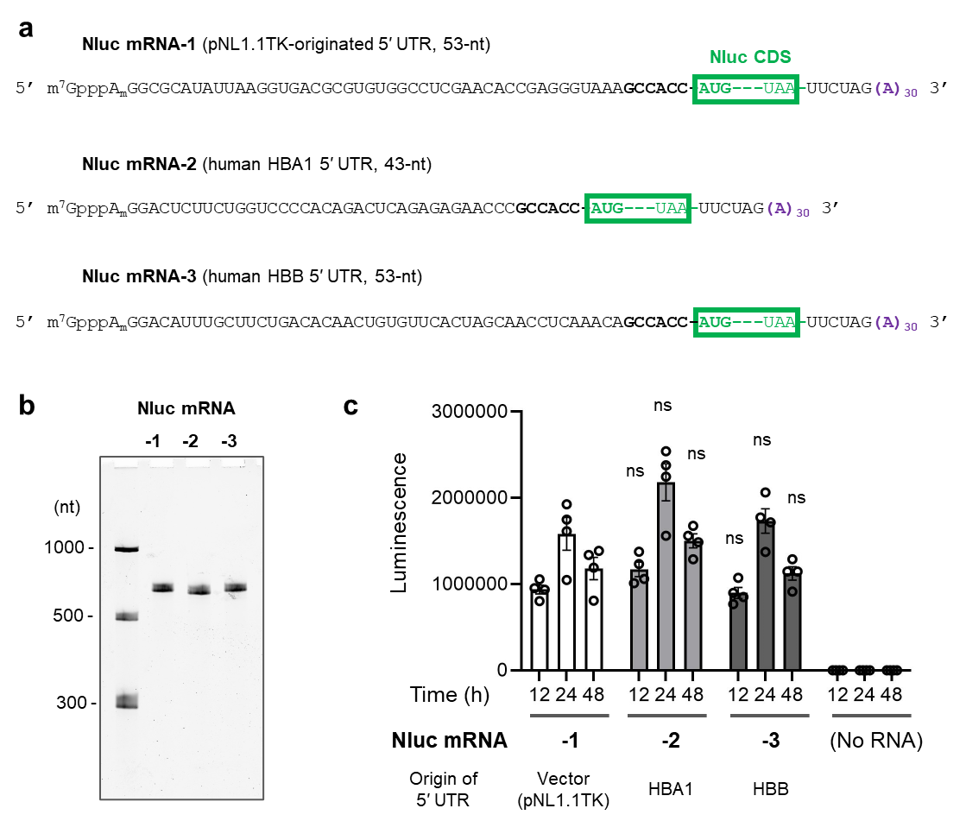
Supplementary Fig. 1. Comparison of the 5′ UTR used in this study with the canonical 5' UTRs in mRNA translation. (a) Sequences of the three Nluc mRNAs differ only in the 5’-UTR. Nluc mRNA-1 contained the 5’-UTR sequence used in the cap-circ mRNAs throughout this study, originating from the pNL1.1TK vector (Promega N1501). Nluc mRNA-2 and -3 contained a 5’-UTR originating from human hemoglobin subunit alpha 1 (HBA1) mRNA (NM_000558.5) and human hemoglobin subunit beta (HBB) mRNA (NM_000518.5), respectively. These mRNAs were prepared using the CleanCap AG capping reagent, modified with m¹Ψ, and column purified. (b) Denaturing PAGE analysis of the mRNAs. (c) Measurement of the translation activity of these Nluc mRNAs in cultured HeLa cells. The day before transfection, HeLa cells were seeded at 5.0 × 10³ cells/well in 96-well cell culture plates. mRNAs (10 ng per well) were transfected into the cells using Lipofectamine MessengerMAX reagent (0.15 µL per well) according to the manufacturer's protocol. Cells were lysed at the indicated time points and Nluc expression was measured using the Nano-Glo Luciferase Assay System (n = 4, mean ± S. E, M.). Statistical differences were analyzed using one-way ANOVA followed by Dunnett's test for Nluc mRNA-1 at the time point.

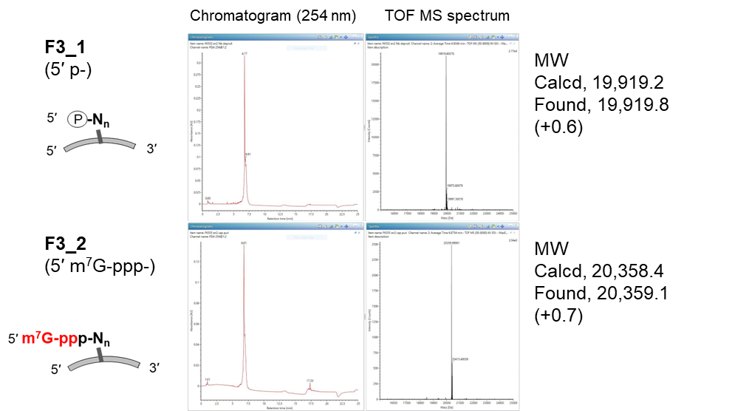
Supplementary Fig. 2. LC-ESI-MS analysis of 54-nt oligonucleotides before and after capping.

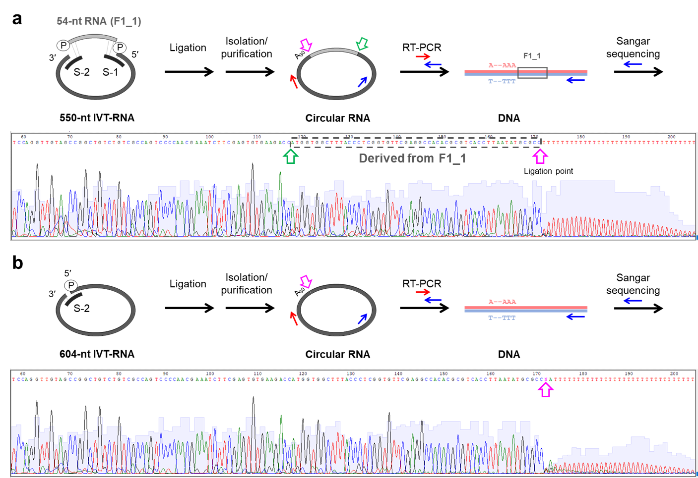
Supplementary Fig. 3. Sanger sequence analysis of 604-nt circular RNAs produced by ligation with T4 RNA ligase 2. Circular RNAs were purified by preparative denaturing PAGE and the target region around the ligation sites was amplified by RT-PCR. The PCR products were analyzed by Sanger sequencing using primer oligo DNA in the reverse direction. (a) Circular mRNA produced by joining two RNA fragments, 54-nt F1_1 and 550-nt IVT-RNA, was analyzed. (b) Circular mRNA produced by self-ligation of the 604-nt IVT-RNA was analyzed.

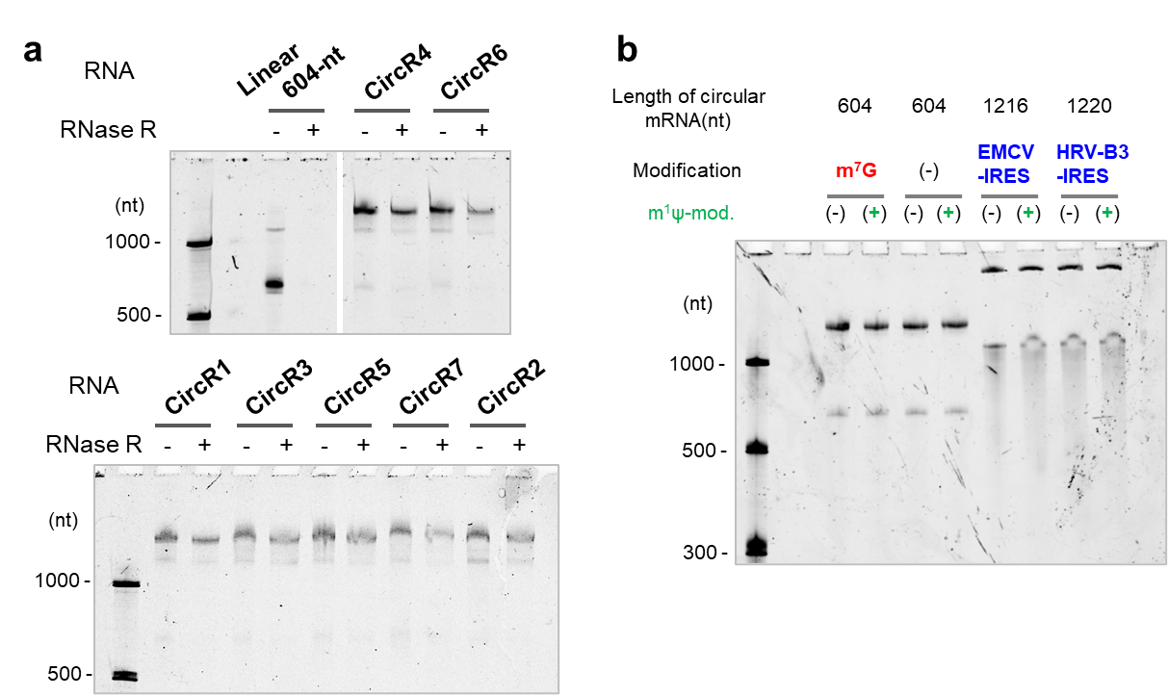
Supplementary Fig. 4. Denaturing PAGE (5%) analysis of purified circular mRNAs (10 ng RNA per lane in a, 30 ng RNA in b). The gel was visualized using SYBR Green II staining. The circularity of the RNA was confirmed by RNase R digestion in (a).

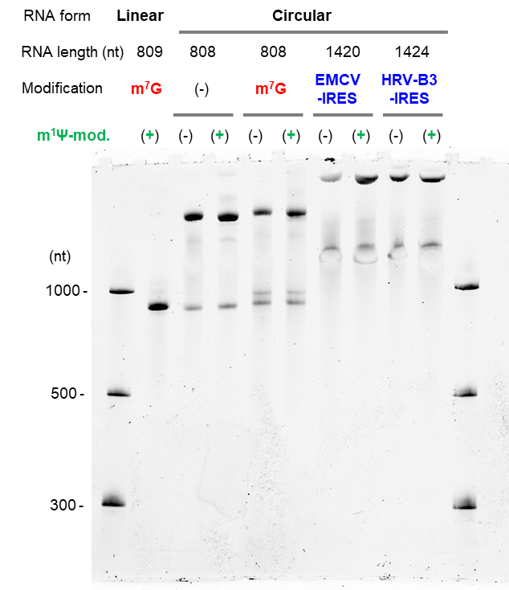
Supplementary Fig. 5. Circular eGFP mRNAs (40 ng each) were analyzed using 5% denaturing PAGE. The gel was visualized using SYBR Green II staining.

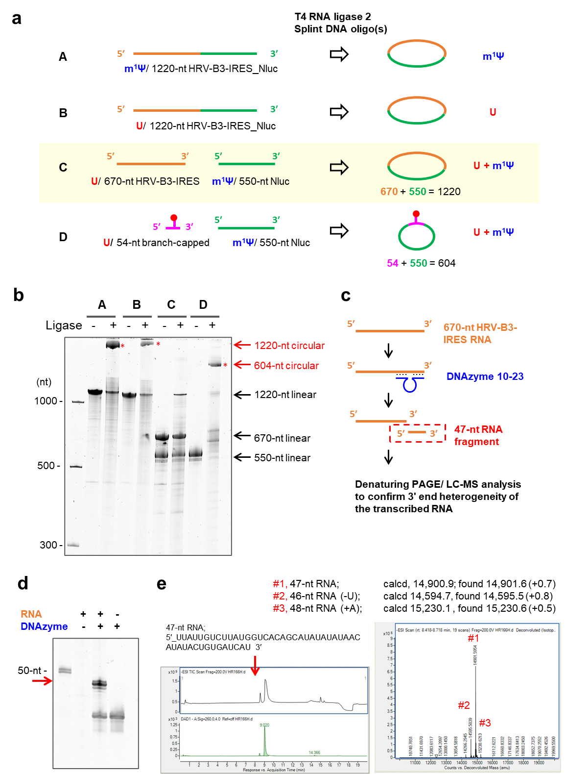

Supplementary Fig. 6. Preparation of U/m¹Ψ-chimeric circular mRNA. (a) Experimental strategies for preparing circular RNAs. As shown in A and B, IRES-containing circ mRNA was prepared by self-ligation at its 5′ and 3′ ends to form a circle. The preparation of chimeric HRV-B3-IRES_Nluc (1220-nt, C) was also tested. In C, IRES fragment prepared using UTP and Nluc fragment prepared using m¹ΨTP were joined to form a circle. D shows the preparation of cap-circ mRNAs, which utilized chemically synthesized short RNA fragments and IVT-RNA. (b) Denaturing PAGE (5%) analysis of ligation reaction using T4 RNA ligase 2 and splint DNA oligos. No circular RNA was produced in strategy C, while circular mRNAs were found in A, B, and D with a good conversion yield. (c‒e) Confirmation of the 3′-end uniformity of 670-nt HRV-B3-IRES IVT-RNA to identify the cause of unsuccessful ligation. (c) Experimental scheme to produce a 47-nt 3′-end fragment of RNA using DNAzyme 10-23, 5′ CCA TAA GAC AAT AAG GCT AGC TAC AAC GAA AGA AAA ATA AGA A 3′ (Proc. Natl. Acad. Sci. U. S. A. 1997, 94, 4262‒4266 (Ref. 26)). (d) 15% denaturing PAGE analysis of the cleavage reaction. The gels were visualized using SYBR Gold staining. (e) LC-ESI-MS analysis of cleaved RNA fragments.

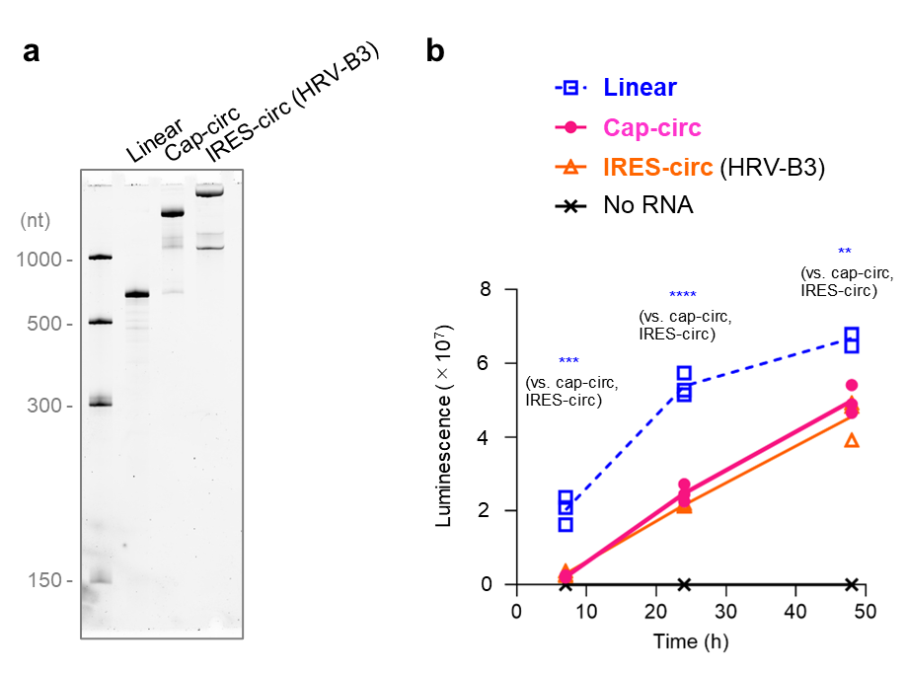
Supplementary Fig. 7. Translational activity of Nluc-encoding mRNAs in cultured HeLa cells. Cap-circ mRNA (m¹Ψ-modified, 604-nt), HRV-B3-IRES containing circ mRNA (U, 1220-nt), or control linear mRNA (m¹Ψ-modified, CleanCap AG-capped, 605-nt) were compared. (a) Denaturing PAGE (5% acrylamide, 7.5 M urea, 1 × TBE) analysis of purified RNAs used for translation activity measurement. The gel was visualized using SYBR Green II staining. (b) Translation activity of mRNAs in HeLa cells. One day before transfection, the HeLa cells were seeded at 1.0 × 10⁴ cells/well in a 96-well plate. RNA (20 ng per well) was transfected into cells using Lipofectamine MessengerMAX reagent (0.15 μL per well). The cells were lysed, and Nluc expression was evaluated at 7, 24, and 48 h after transfection (n = 4, mean ± S. E. M.). The statistically significant differences between the samples in one-way ANOVA followed by Tukey's test are marked as follows: ns, p > 0.05 (not marked); *, p < 0.05; **, p < 0.01; ***, p < 0.001, ****, p < 0.0001.
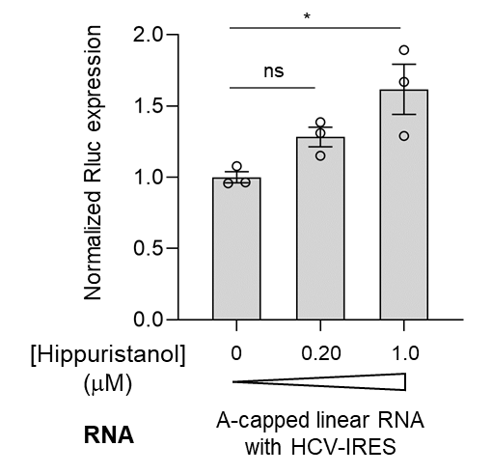
Supplementary Fig. 8. Effect of hippuristanol on HCV-IRES-dependent translation in cultured Flp-In™ T-Rex™ 293 cells (n = 3, mean ± S. E. M.). The statistically significant differences from the control samples (no hippuristanol added) in one-way ANOVA followed by Dunnett's test are marked as follows: ns, p > 0.05; *, p < 0.05; **, p < 0.01; ***, p < 0.001, ****, p < 0.0001.

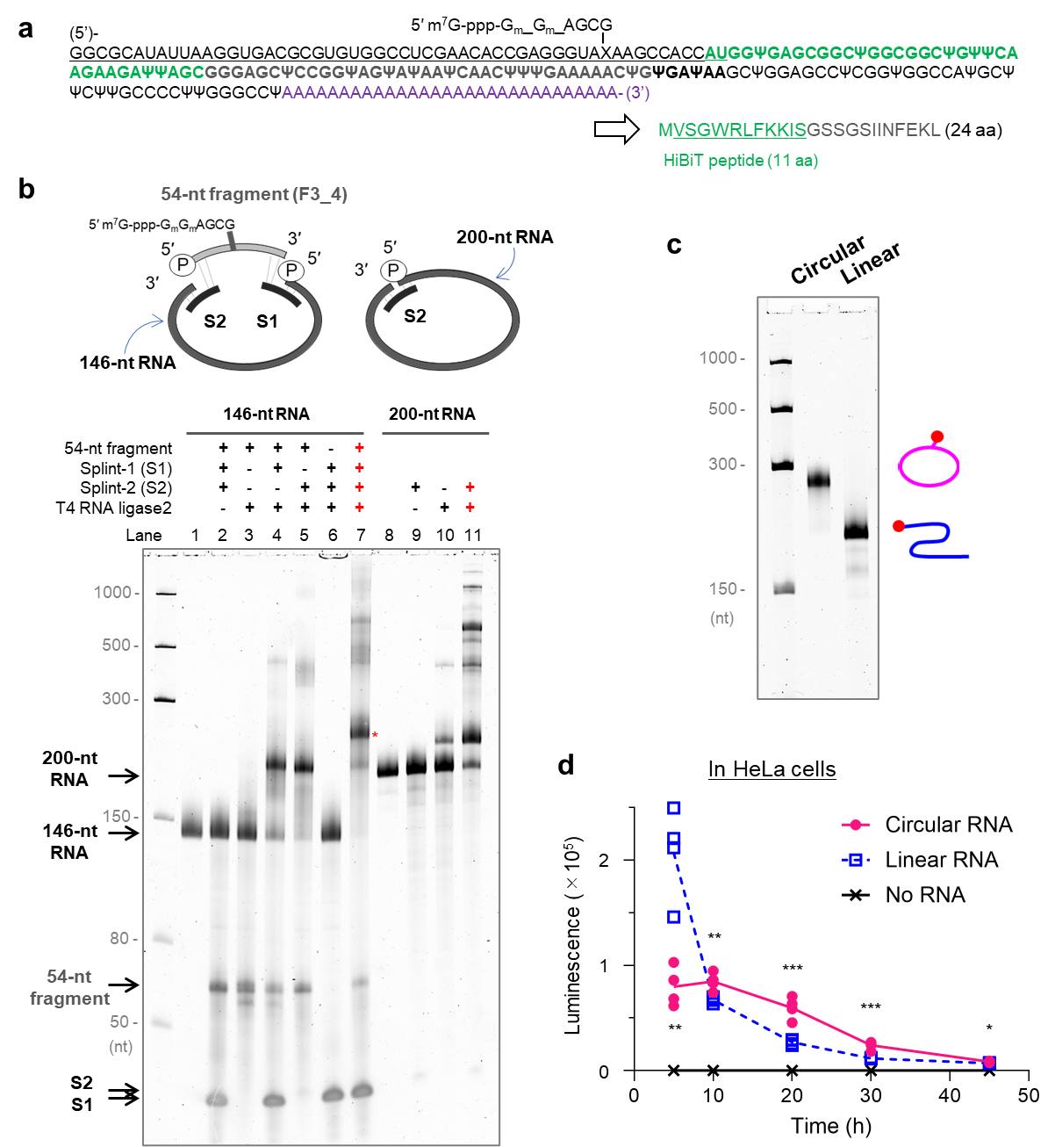
Supplementary Fig. 9. Preparation of 200-nt circular mRNA encoding the HiBiT peptide. (a) Nucleotide sequences of circular mRNA. The expected peptide sequence, as a translation product, is also shown. Bold letters indicate coding sequences. The region corresponding to the chemically synthesized fragment is underlined. X, the branching unit. Ψ, N¹-methylpeudouridine. (b) Denaturing PAGE (5% acrylamide, 7.5 M urea, 1 × TBE) analysis of the ligation reactions. Diagram showing RNAs as ligation substrates, splint DNA oligos, and their arrangement. Cap-containing circular RNA or its uncapped counterpart with one ligation point as the control is shown. The identified band of cap-containing circular RNA is marked with an asterisk (*) in Lane 7. The ligation reaction proceeded in a splint DNA-dependent manner. The gel was visualized using SYBR Green II staining. (c) Denaturing PAGE (5% acrylamide) analysis of the purified RNAs used for translation activity measurement. (e) Translation of HiBiT-coding RNAs in cultured HeLa cells. One day before transfection, HeLa cells were seeded at 1.0 × 10⁴ cells/well in a 96-well plate. RNA (50 ng per well) was transfected into cells using Lipofectamine MessengerMAX reagent (0.15 μL per well) (n = 4). At the indicated time points, the cells were lysed, and HiBiT expression was evaluated. Statistical significance between the samples at each time point was analyzed using an unpaired two-sided t-test. ns, p > 0.05; *, p < 0.05; **, p < 0.01; ***, p < 0.001.

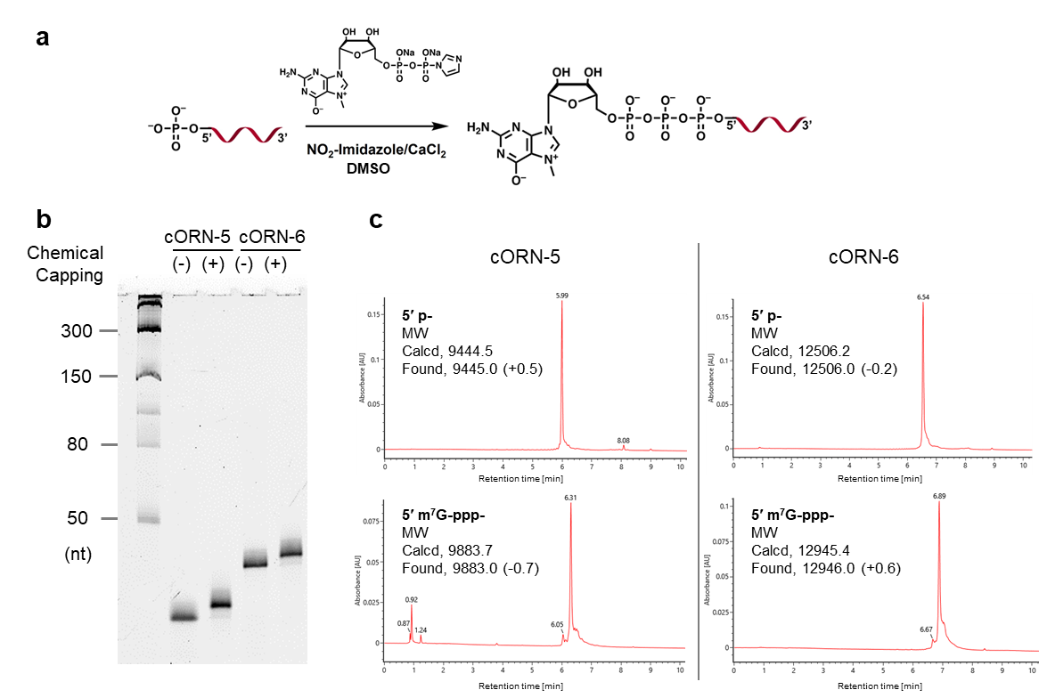
Supplementary Fig. 10. Synthesis of cORNs (30-nt cORN-5 and 40-nt cORN-6). The typical results obtained during the capping reaction are shown. (a) Scheme of the chemical capping reaction of 5′-phosphorylated oligoribonucleotides. (b) 15% denaturing PAGE analysis of the reaction mixture. (c) LC-ESI-MS analysis of cORN precursors and cORNs.

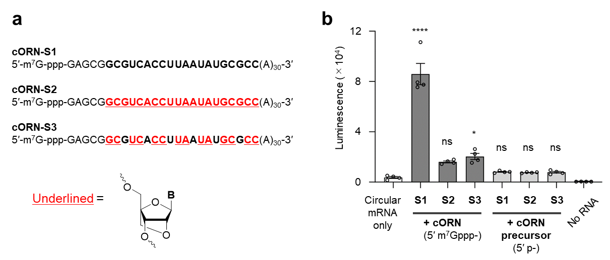
Supplementary Fig. 11. Effect of LNA/BNA modification on cORN. Three 55-nt cORNs were compared in terms of translation enhancement activity by binding to a 650-nt circular Nluc mRNA. (a) Nucleotide sequences of cORNs used in this study. cORN-S1 contained no LNA modifications, whereas cORN-S2 and S3 contained LNA/BNA modifications in the hybridization region to circular RNA Targeting site-1 shown in Fig. 6a. (b) The translation enhancement activity was reduced by LNA/BNA modification in cultured HeLa cells. The circular mRNA and ORN were annealed in a buffer and then transfected into cultured HeLa cells using Lipofectamine MessengerMAX reagent. Data are presented as mean ± S. E. M. for biological replicates (n = 4). Statistically significant differences between circular mRNA and cORN-transfected samples from the circular mRNA-only sample in one-way ANOVA test followed by Dunnett’s test are marked as follows: ns, p > 0.05; *, p < 0.05; **, p < 0.01; ***, p < 0.001; ****, p < 0.0001.
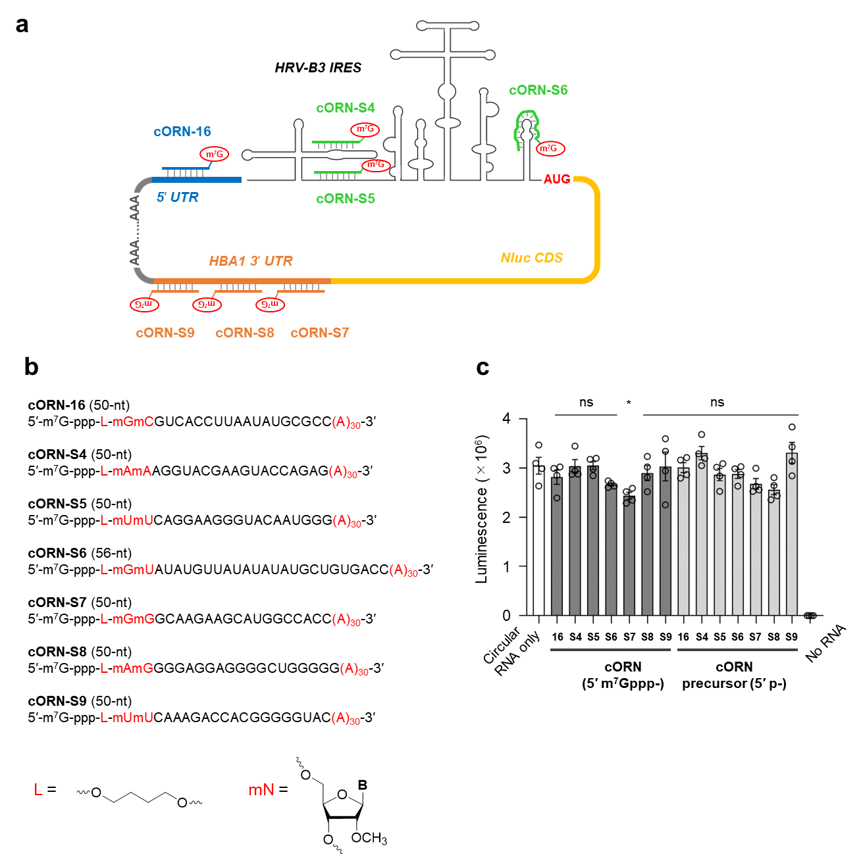
Supplementary Fig. 12. Effect of cORN binding on translation of HRV-B3-IRES containing circular mRNA. (a) Study design: Seven cORN molecules with complementary regions of 20- or 26-nt to circular mRNA were designed. The representation of the secondary structure formed in the IRES sequence was obtained from the literature (Nat. Biotechnol. 2023, 41, 262‒272 (Ref. 11); J. Allergy Clin. Immunol. 2010, 125, 1190‒1199 (Ref. 28). (b) Structure and sequence of cORNs. (c) Translation enhancement activity measured in cultured HeLa cells. The circular mRNA and ORN were annealed in a buffer and then transfected into cultured HeLa cells using Lipofectamine MessengerMAX reagent. Data are mean ± S. E. M. for biological replicates (n = 4). Statistically significant differences from the circular mRNA-only transfected sample in one-way ANOVA test followed by Dunnett’s test are marked as follows: ns, p > 0.05; *.
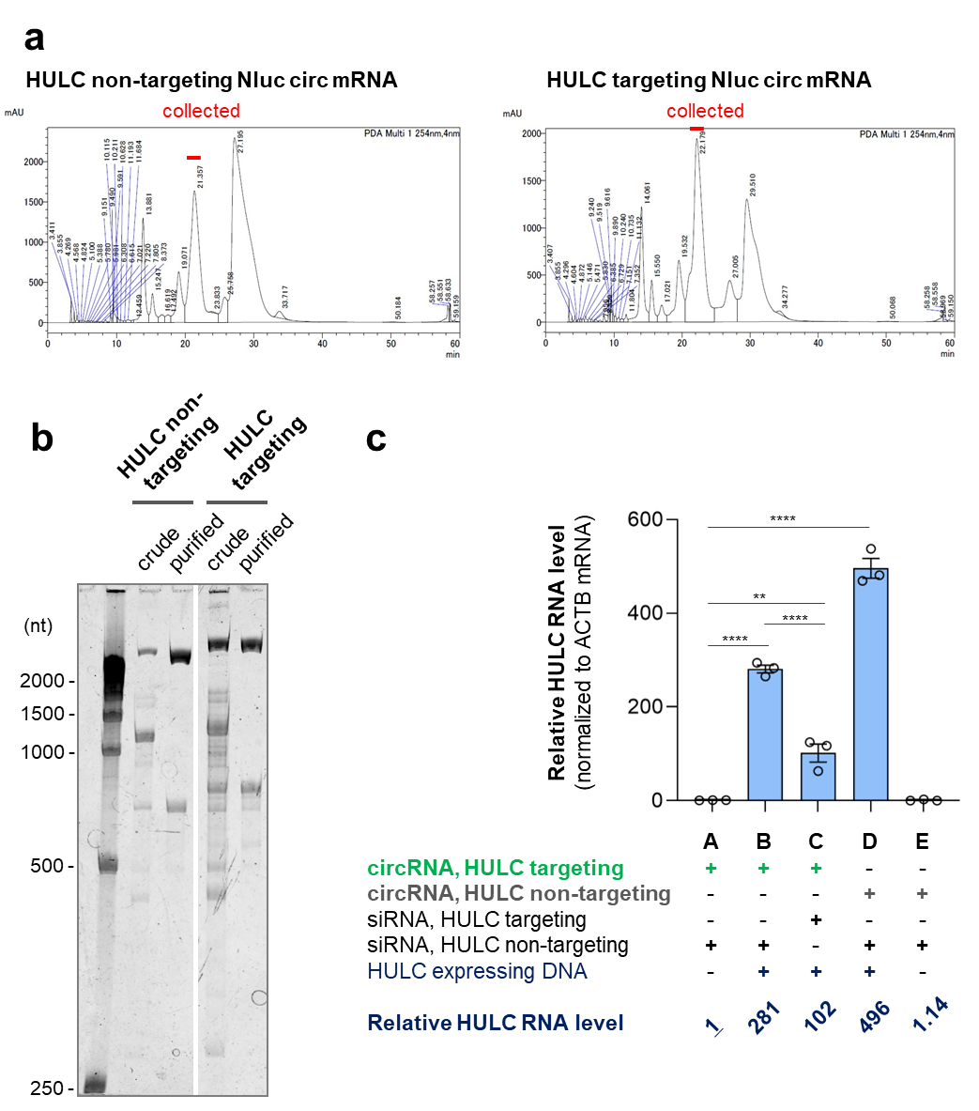
Supplementary Fig. 13. Synthesis of circular Nluc mRNA hybridizable to endogenously expressed HULC RNA. Two circular RNAs were prepared using a splicing system (Nat. Biotechnol. 41, 262‒272, 2023 (Ref. 11)) after IVT. (a) Isolation of the circular RNA from the mixture after the IVT/ splicing reaction using ion-pair RP-HPLC [System, Shimadzu Prominence; column, YMC Triart Bio C18 (4.6 mm I. D. × 250 mm); Solution A, 100 mM TEAA, 5% MeCN; Solution B, 100 mM TEAA, 50% MeCN; Solution gradient, 15 to 20 % B over 0 to 50 min (the column was equilibrated with 0% B); column temperature, 50 °C; Flow rate, 1 mL/min]. The area indicated by the red line represents the target circular mRNA. (b) 5% denaturing PAGE analysis of the crude RNA mixture after the IVT (as shown as “crude”) and the purified circ mRNA after the HPLC (as shown as “purified”). The gel was visualized using SYBR Green II staining. (c) Relative HULC RNA levels were quantified using RT-qPCR. The amount of HULC RNA was normalized to that of hACTB mRNA in the cell lysate.

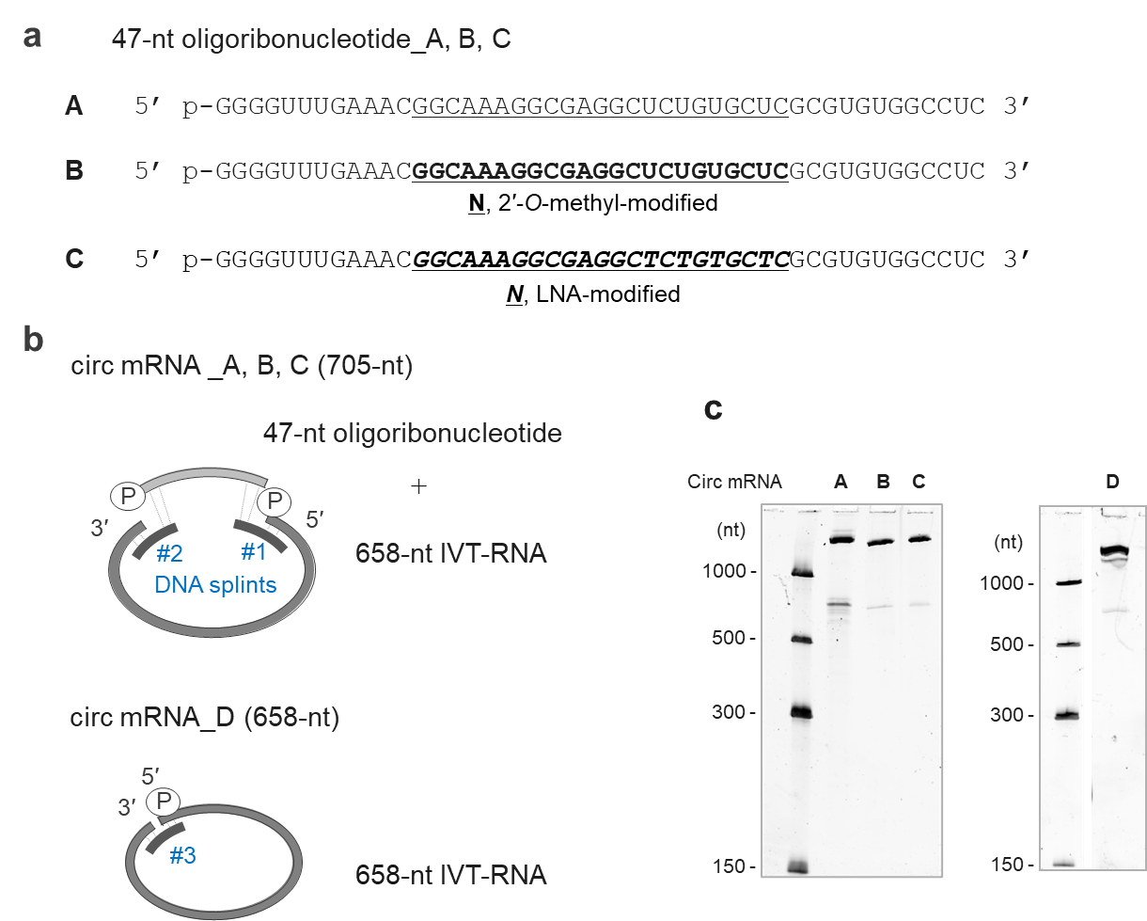
Supplementary Fig. 14. Synthesis of circular Nluc mRNAs hybridizable to hACTB mRNA. (a) Nucleotide sequence of the synthesized oligoribonucleotides. A 23-nt sequence complementary to the 26th to 48th from the 5' end of human ACTB mRNA (NM_001101.5) was included in the 47-nt chemically synthesized oligoribonucleotides (ORN) A, B, and C, which are shown as underlined letters. They were synthesized according to a standard protocol and identified using LC-ESI-MS analysis. ORN_A; calcd,15,299.1, found 15,300.2 (+1.1). ORN_B, calcd 15,621.1, found 15,622.4 (+1.3). ORN_C calcd, 15,716.1, found 15,716.0 (-0.1). (b) Synthetic scheme for the circular Nluc mRNAs. Circ mRNA A, B, and C were prepared by ligating two RNA fragments using T4 RNA ligase 2 in the presence of two splint DNAs. Circular mRNA D was prepared by intramolecularly joining the 5′- and 3′-ends. Splint DNA#1 (30-nt), 5′ ACA GTT TCA AAC CCC GAC CAG TTG GTA GGG 3′. Splint DNA#2 (30-nt), 5′ GGT CGC TCG GTG TTC GAG GCC ACA CGC ATG 3′. Splint DNA#3 (24-nt), 5′-GAG GCC ACA CGC GTT TCA AAC CCC 3′. (c) 5% denaturing PAGE analysis of circular mRNAs (100 ng each) after purification using preparative denaturing PAGE. The gel was visualized by SYBR Green II staining.

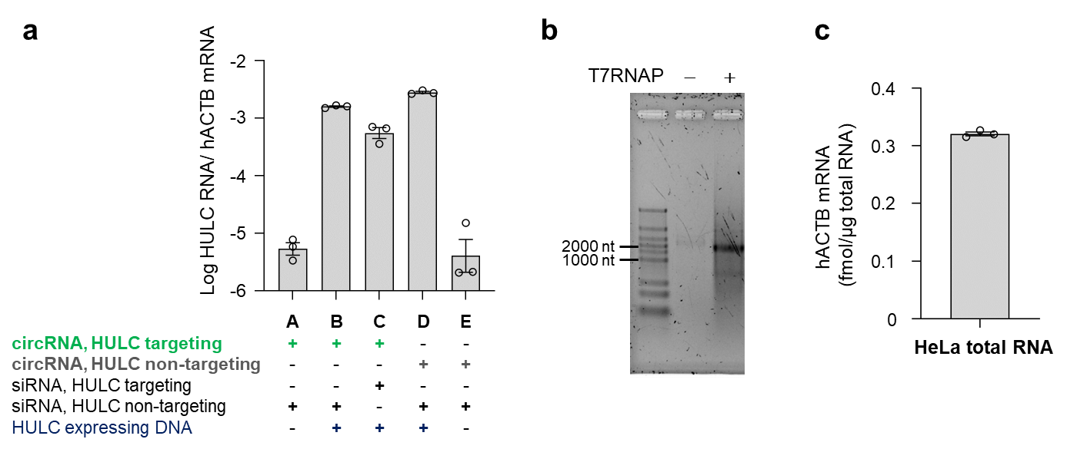
Supplementary Fig. 15. Quantification of HULC and hACTB mRNA in HeLa cells. (a) Quantification of HULC RNA levels normalized to hACTB mRNA expression. The expression level of HULC mRNA in HeLa cells was significantly lower than that of hACTB mRNA, with an estimated difference in abundance ranging from 10³ to 10⁵ fold. (b) Synthesis of hACTB mRNA for qPCR. (c) Quantification of hACTB mRNA levels in HeLa cells. The absolute amount of hACTB mRNA was calculated as 0.32 fmol/μg total RNA in HeLa cells.

