A tale of two nutrients: How nitrogen and phosphorus differentially control marine biomass production and stoichiometry

Seelen, Emily A.¹; Gleich, Samantha J.²; Kumler, William³; Anderson, Hanna^{4,5}; Bian, Xiaopeng¹; Bjӧrkman, Karin M.⁶; Caron, David A.²; Dyhrman, Sonya T.^{4,5}; Ferrón, Sara⁶; Finkel, Zoe V.⁷; Haley, Sheean T.⁴; Hu, Ying-Yu⁷; Ingalls, Anitra E.³; Irwin, Andrew J.⁸; Karl, David M.⁶; Kong, Kyeong Pil¹; Lowenstein, Daniel⁹; Salazar-Estrada, Andres⁶; Townsend, Emily¹; Tracey, John⁴; Turk-Kubo, Kendra¹⁰; Van Mooy, Benjamin A.S.⁹; John, Seth G.¹

¹ University of Southern California, Department of Earth Science, Los Angeles, California, USA
² University of Southern California, Department of Biological Sciences, Los Angeles, California, USA
³ University of Washington, School of Oceanography, Seattle, Washington, USA
⁴ Lamont-Doherty Earth Observatory, Department of Biology and Paleo Environment, Columbia University, Palisades, New York, USA
⁵ Columbia University, Department of Earth and Environmental Science, New York, NY, USA
⁶ University of Hawai’i at Mānoa, Department of Oceanography, Honolulu, HI, USA
⁷ Dalhousie University, Department of Oceanography, Halifax, NS, Canada
⁸ Dalhousie University, Department of Mathematics & Statistics, Halifax, Nova Scotia, Canada
⁹ Woods Hole Oceanographic Institution, Department of Marine Chemistry and Geochemistry, Woods Hole, Massachusetts, USA
¹⁰ University of California Santa Cruz, Ocean Sciences Department, Santa Cruz, California, USA

Supporting Information
12 figures are presented.

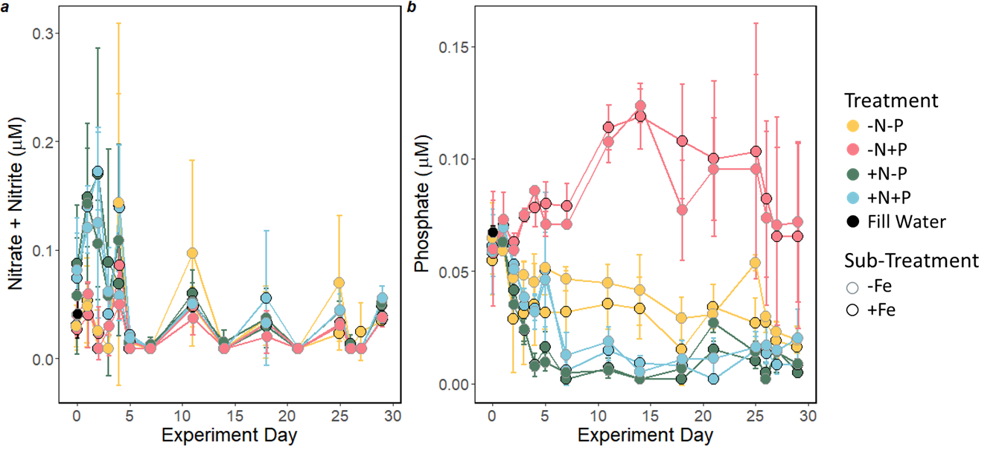
Figure S1. Trends in the major macronutrients nitrate + nitrite (a) and phosphate (b) in the incubation experiment over time. The fill and line colors represent the four macronutrient treatments, and the sub-treatment (+/- Fe addition) are differentiated by the point outline color. Points represent treatment averages, and error bars represent the 1 σ SD of the treatment replicates (n = 3).

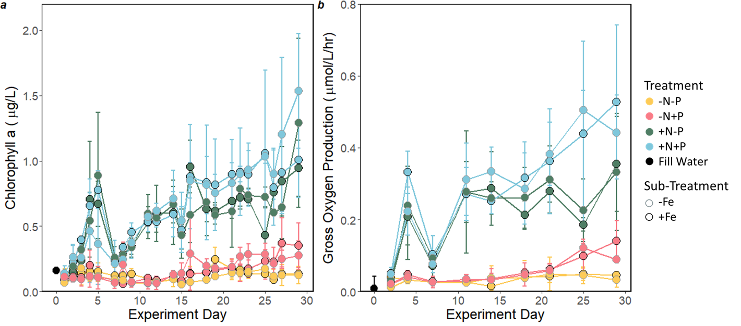
Figure S2. Concentrations of chlorophyll a (a) and rates of gross oxygen production (GOP; b). Error bars represent the 1 σ SD for treatment replicates (n = 3). Color formatting is as described in Fig. S1.

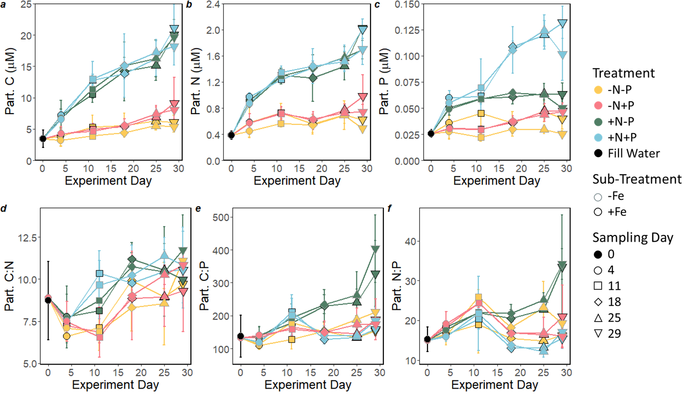

Figure S3. Concentrations of particulate carbon (C, a), nitrogen (N, b), and phosphorus (P, c) and particulate C:N (d), C:P (e), and N:P (f) ratios from all eight nutrient treatments applied to the incubations. Error bars represent the 1 σ SD for treatment replicates (n = 3). Point shapes indicate sampling day. Coloration is detailed in Fig. S1 figure caption.

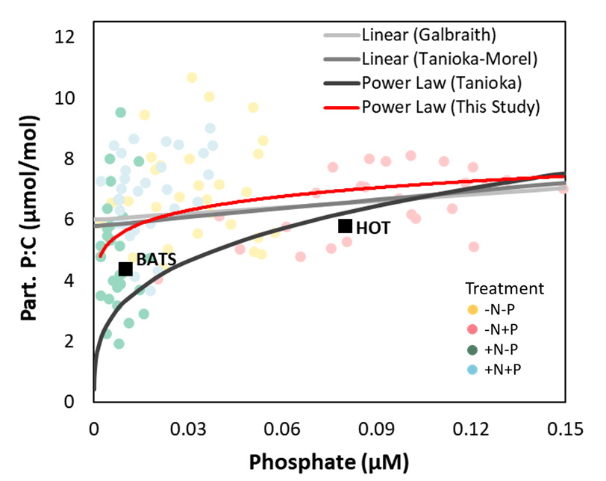
Figure S4. The particulate P:C ratio measured here (faded points and red fit line) is compared to previously determined fit lines for the relationship presented by Tanioka and Matsumoto¹, shown in shades of grey and labelled according to ¹. Surface averages from the Bermuda Atlantic Time-series Study (BATS) and the Pacific Ocean, Hawaii Ocean Time-series (HOT) study were also extracted from ¹.

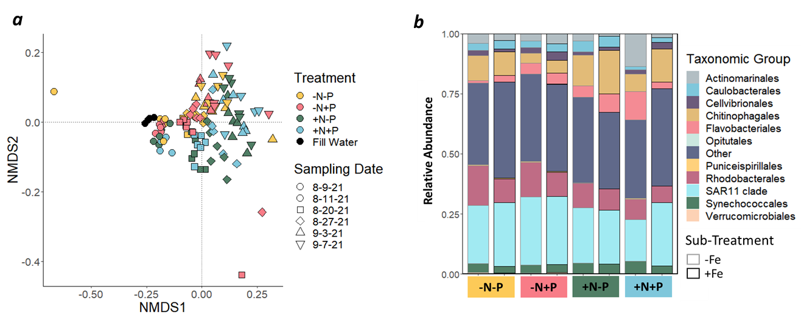

Figure S5. Prokaryote community structure clustered by nutrient supply over time, visualized using a non-metric multi-dimensional scaling (NMDS) plot (a) with time indicated by point shape. Community taxonomy at the end of the experiment (b; average of day 24 and day 29) shows the relative abundance of the major taxonomic groups.

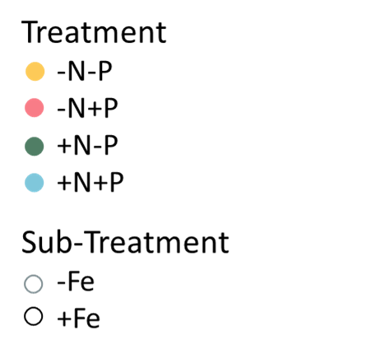
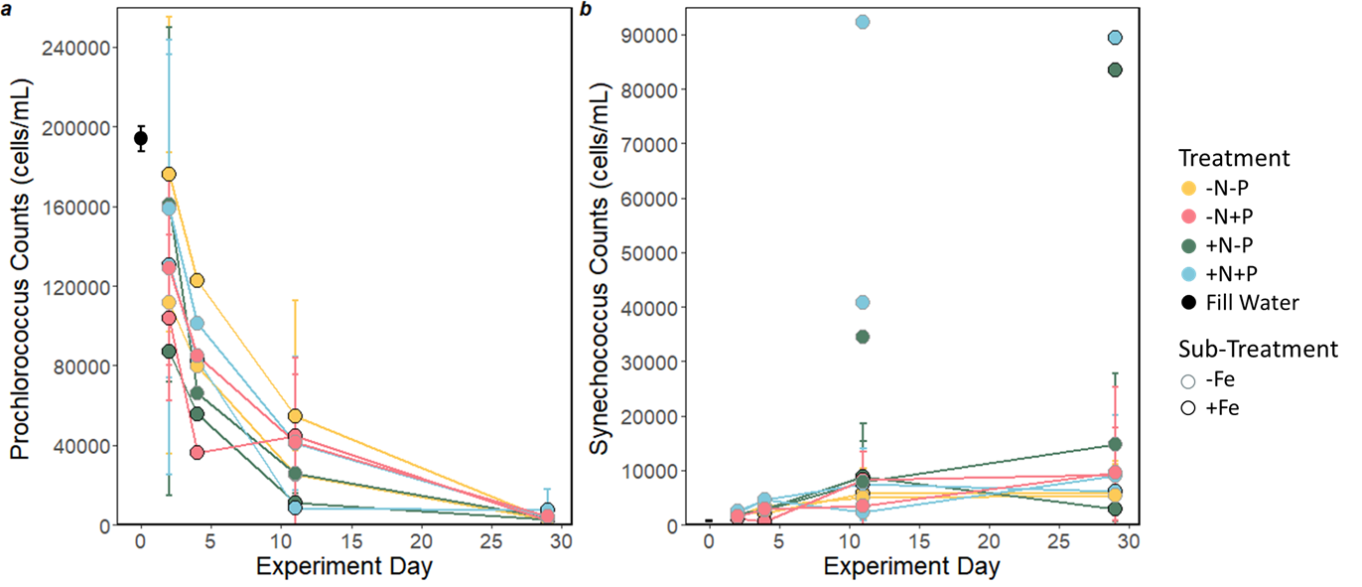

Figure S6. Prochlorococcus (a) counts declined in all treatments, as observed in similar incubation experiments², while Synechococcus (b) counts generally increase in all treatments relative to initial seawater used to fill the incubation chambers. Counts were determined by flow cytometry. Error bars represent the 1 σ SD for treatment replicates (n = 3).

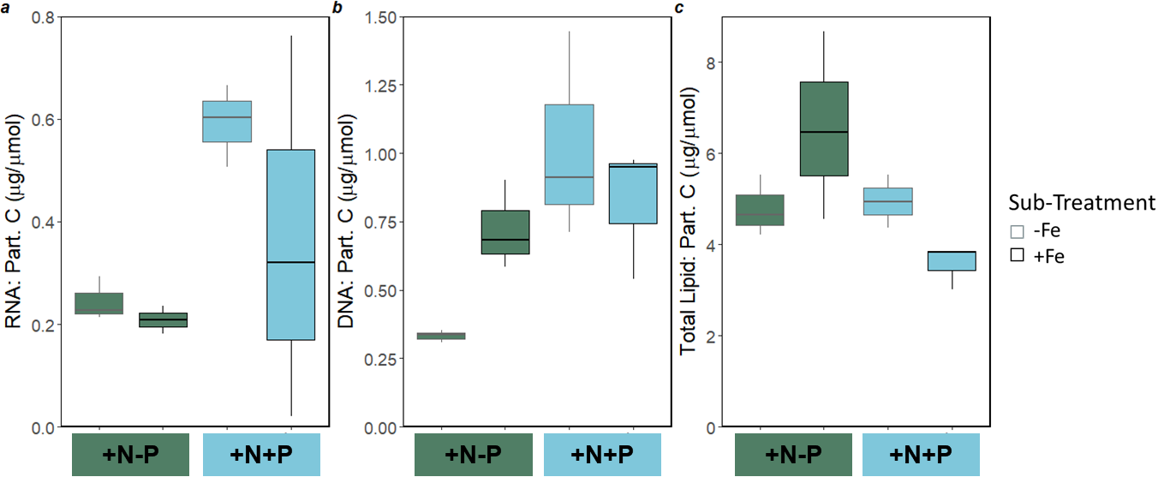

Figure S7. Total macromolecular analysis of ribonucleic acids (RNA) (a), deoxyribonucleic acids (DNA) (b), and Lipids (c) normalized to particulate C.

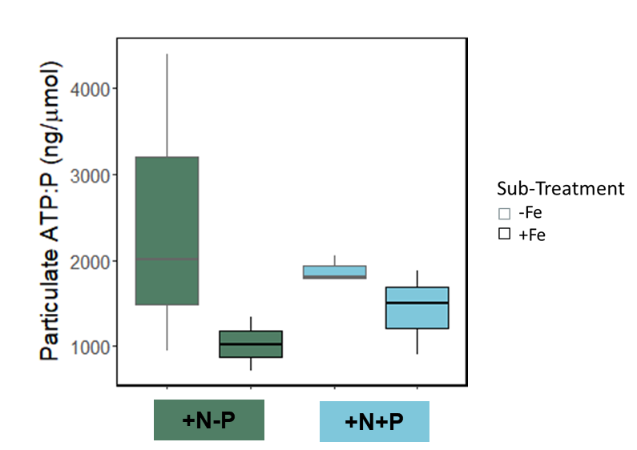

Figure S8. Particulate adenosine triphosphate (ATP) normalized to particulate phosphorus.

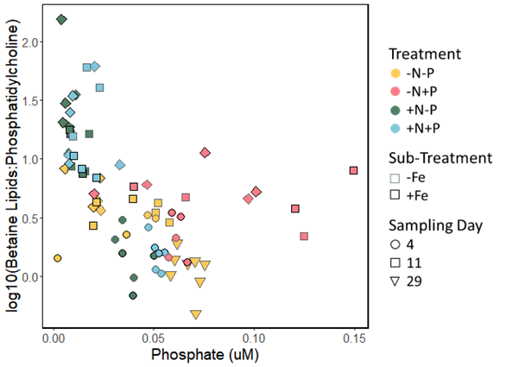

Figure S9. Betaine lipid:phosphatidylcholine (BL:PC) ratios significantly correlated to the measured phosphate concentrations instead of nutrient supply treatment.

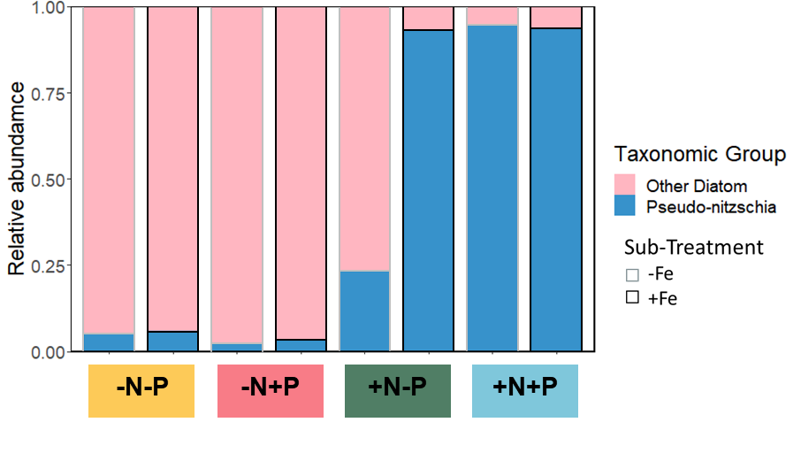
Figure S10. Relative abundance of Pseudo-nitzschia compared to all other measured diatoms at the end of the experiment, determined by 18S gene sequencing. Each bar represents the average value for available mesocosm replicates for each treatment.

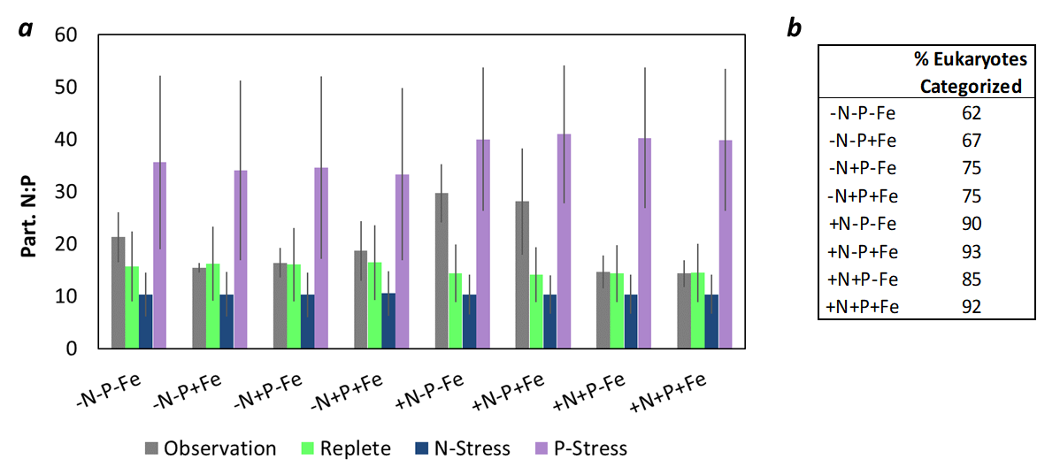Figure S11. Observed N:P ratios in this study (grey) for all treatments compared to calculated N:P ratios for our measured eukaryotic communities using results from the meta-analysis results of Sharoni and Halevy³ for phytoplankton grown under nutrient replete (green), nitrogen limited (blue), and phosphorus limited (purple) conditions (a). The eukaryotic groupings included diatoms, coccolithophores, green algae, and dinoflagellates. The percent of the community represented by those groupings is presented in the accompanying table (b).

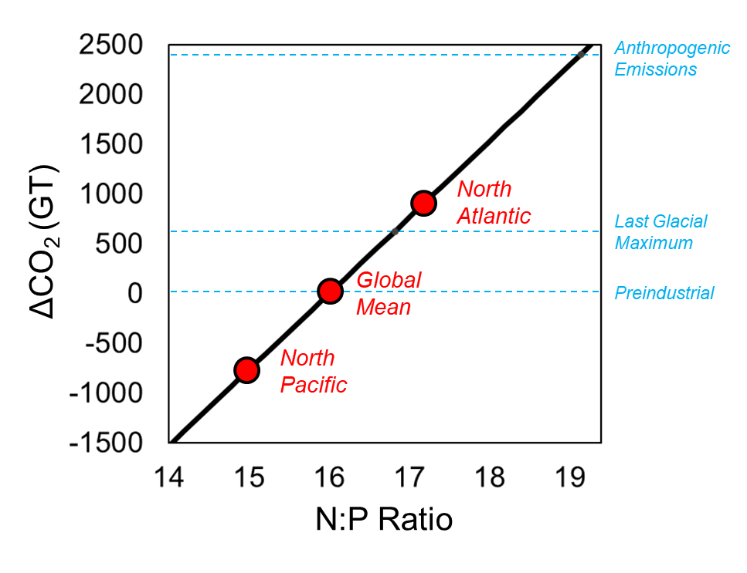
Figure S12. Primary producers fix C from dissolved CO₂ with macronutrients at ratios near 106C: 16N: 1P in the modern ocean. Regeneration of marine particles at depth isolates CO₂ from the atmosphere and replenishes deepwater nutrients reflecting that 16:1 N:P ratio. Observations suggest that biological C:N requirements are relatively fixed near 106:16, but N:P requirements are variable by taxa and heightened by cellular physiological acclimation. Assuming particulate C:N ratios are fixed near Redfield (106:16), we calculated potential changes in CO₂ with globally shifted N:P ratios that fall within ranges of what is observed in our modern ocean, for example, in the North Atlantic (17.2:1) and the North Pacific (15:1)⁴. The potential impacts on carbon cycling caused by changes in N:P are significant, being comparable in magnitude to increased change in ocean carbon storage during the LGM (625 GT), and the total magnitude of anthropogenic CO2 input to the atmosphere (2400 GT).

References
1. Tanioka, T. & Matsumoto, K. Buffering of ocean export production by flexible elemental stoichiometry of particulate organic matter. Glob. Biogeochem. Cycles 31, 1528–1542 (2017).
2. Böttjer-Wilson, D. et al. Effects of nutrient enrichments on oligotrophic phytoplankton communities: a mesocosm experiment near Hawai‘i, USA. Aquat. Microb. Ecol. 87, 167–183 (2021).
3. Sharoni, S. & Halevy, I. Nutrient ratios in marine particulate organic matter are predicted by the population structure of well-adapted phytoplankton. Sci. Adv. 6, eaaw9371 (2020).
4. Wu, J., Sunda, W., Boyle, E. A. & Karl, D. M. Phosphate depletion in the Western North Atlantic Ocean. Science 289, 759–762 (2000).

