Supplement

Please note that the nanoparticle shape is set as cuboid in the supplementary materials while the other parameter such as damping factor is the same as that in the main article.

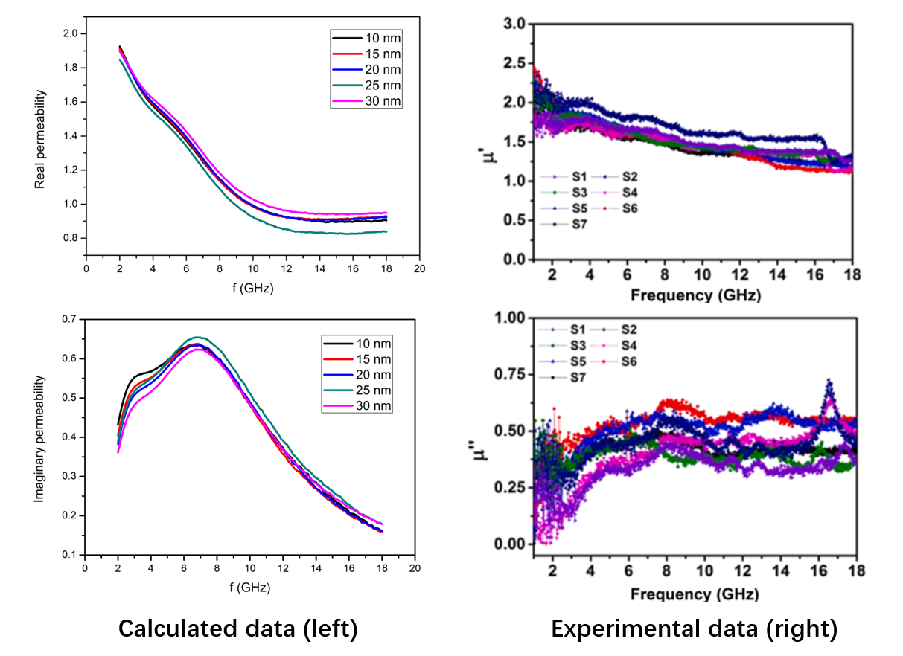
Supplementary Figure S1. (Left) The calculated permeability of iron-cobalt alloy in the main article. (Right) The experimental permeability data of iron-cobalt alloy from ref. [9].

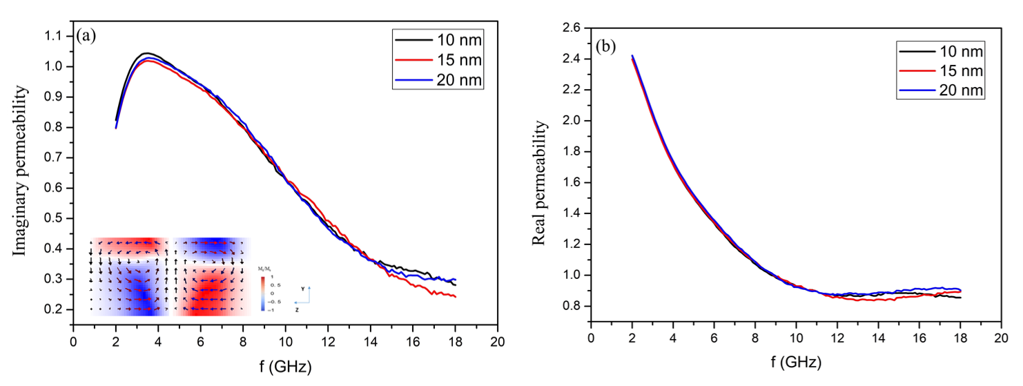
Supplementary Figure S2. (a) Imaginary part and (b) real part of the permeability vs frequency of cuboid shape nanoparticles with distances between 10 nm and 20 nm. Results of the permeability indicated that the cuboid shape nanoparticles have the similar behavior with the spherical nanoparticles in the main article.

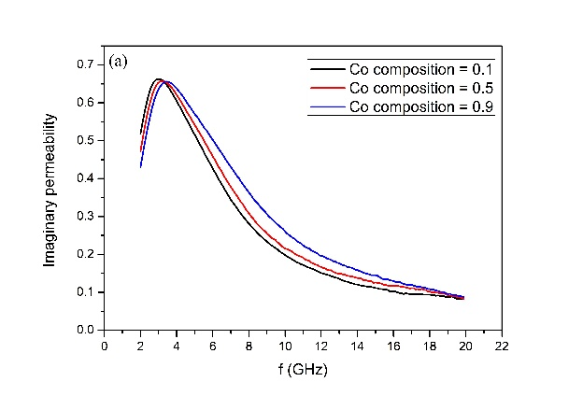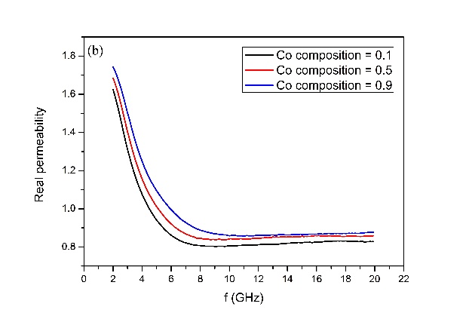
Supplementary Figure S3. (a) Imaginary part and (b) real part of the permeability vs frequency of iron-cobalt alloy with various Co compositions. Results of the permeablity indicated that the real permeability and natural resonance frequency increase as the Co composition increases, which is mainly attributed to the increase in anisotropy constant.

Supplementary Table S1. The iron and cobalt material parameters used in micromagnetic simulations.
Material type | M_{s} (A/m) | A_{ex} (J/m) | K (J/m³) | Ref.
Cobalt | 1.4◊10⁶ | 14◊10⁻¹² | 53◊10⁴ | [14]
Iron | 1.7◊10⁶ | 21◊10⁻¹² | 4.8◊10⁴ | [15]

