Supplementary information
Other detailed methods are shown in Supplementary methods.
Supplementary Figs.1-17. Uncropped images for IF and IHC of clinical samples, gating strategy for flow cytometry and uncropped images for western blot analyses.
Supplementary Table.1 Metabolomic profiling: A comparative analysis between EGFR wild-type (EGFR_{WT}) and EGFR-mutated (EGFR_{Mut}) tumors (T) and their matched non-tumor adjacent tissues (NAT). Related to Fig.1.
Supplementary Table.2 Metabolomics of BaF3 cells transfected EGFR-WT and -Mutated plasmids (Del19, L858R, T790M, T790M/Del19, T790M/L858R). Related to Fig.1 and Extended Data Fig.1.
Supplementary Table.3 Differential expression of HBP metabolic enzymes in proteomic data from 9 EGFR wild-type and 47 EGFR-mutated NSCLC samples. Related to Fig.1.
Supplementary Table.4 Clinical expression of HBP metabolic enzymes in main organs. Related to Fig.1 and Extended Data Fig.1.
Supplementary Table.5 RNA-seq performed on H1975 cells treated with EGF (20 ng/mL), Almonertinib (2 μM) for 24 h and EGFR knockdown. Related to Fig.1 and Extended Data Fig.2.
Supplementary Table.6 Tumor immune microenvironment in patients harboring different mutations. Related to Extended Data Fig.4
Supplementary Table.7 The proliferation and activity scoring of tumor infiltrating T cells post GFPT2 knockdown in EGFRmut LLC mouse model. Related to Fig.2 and Extended Data Fig.8.
Supplementary Table.8 Communication probability and infer cellular communication network of immune cells. Related to Fig.2.
Supplementary Table.9 N-glycoproteomic characteristics post GFPT2 knockdown in H1975 cells. Related to Extended Data Fig.5.
Supplementary Table.10 Metabolomics of TIF and plasma from shNC and shGFPT2 xenograft. Related to Fig.3 and Extended Data Fig.7.
Supplementary Table.11 Detailed information of pEGFR IHC staining, PHA IF staining and CD8⁺T IHC staining in GFPT2⁻ and GFPT2⁺ NSCLC patients. Related to Fig.5.
Supplementary Table.12 10 compounds identified from 190,295 candidates in Zinc15 with Schrödinger molecular docking. Related to Fig.5 and Extended Data Fig.9.
Supplementary Table.13 Patients' information and corresponding data of PDOTs. Related to Fig.5.

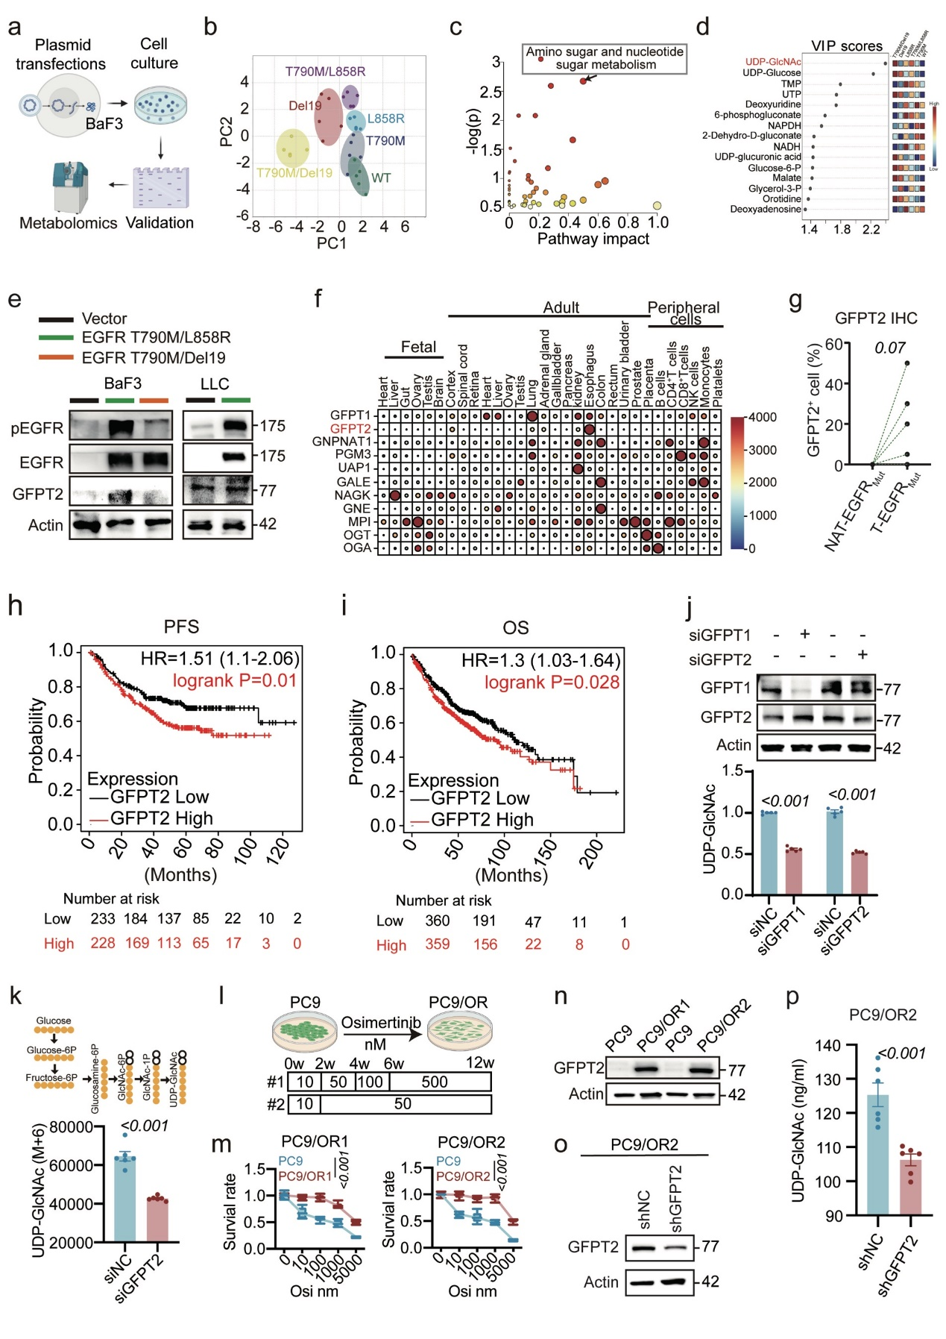
Extended Data Fig.1 Elevated GFPT2 expression in EGFR_{Mut} NSCLC (Related to Fig.1). a-d, Metabolomics in BaF3 cells with various EGFR mutations. (a) Experimental setup schematic, (b) PCA of metabolite profiles, (c) Metabolic pathway impact plot detailing significance and impact, and (d) VIP scores for leading metabolites. e, Immunoblots of pEGFR, EGFR, and GFPT2 in BaF3, LLC cells transfected with EGFR_{Mut} plasmids, with Actin as a loading control. f, Heatmap of HBP metabolic enzymes across primary organs and immune cells in both adult and fetal stages, sourced from the human proteome map (http://www.humanproteomemap.org/query.php). g, Quantifications of GFPT2 IHC staining. h-i, Progression free survival (PFS) and overall survival (OS) of highly or lowly expressed GFPT2-patients suffering LUAD according to Kaplan-Meier Plotter (http://kmplot.com/analysis/). j, UDP-GlcNAc concentrations in H1975 cells following GFPT1 or GFPT2 knockdown, measured by HPLC-QTRAP/MS (n=5). k, UDP-GlcNAc (M+6) levels in siNC and siGFPT2 H1975 cells cultured with U-¹³C₆ D-glucose (n=6). l, Generation of PC9/Osimertinib-resistant (PC9/OR) cells via gradual Osimertinib exposure. m, Viability of PC9/OR cells upon various Osimertinib concentrations (n=6). n-o, Immunoblots of GFPT2 expression in PC9 versus PC9/OR cells, with Actin as the loading control. p, HPLC-QTRAP/MS analysis of UDP-GlcNAc levels in PC9/OR2 cells (n=6). Data are mean ± s.e.m. except in g, Two-tailed paired Student’s t-test. j, k, p, Two-tailed unpaired Student’s t-test. m, Two-way ANOVA.

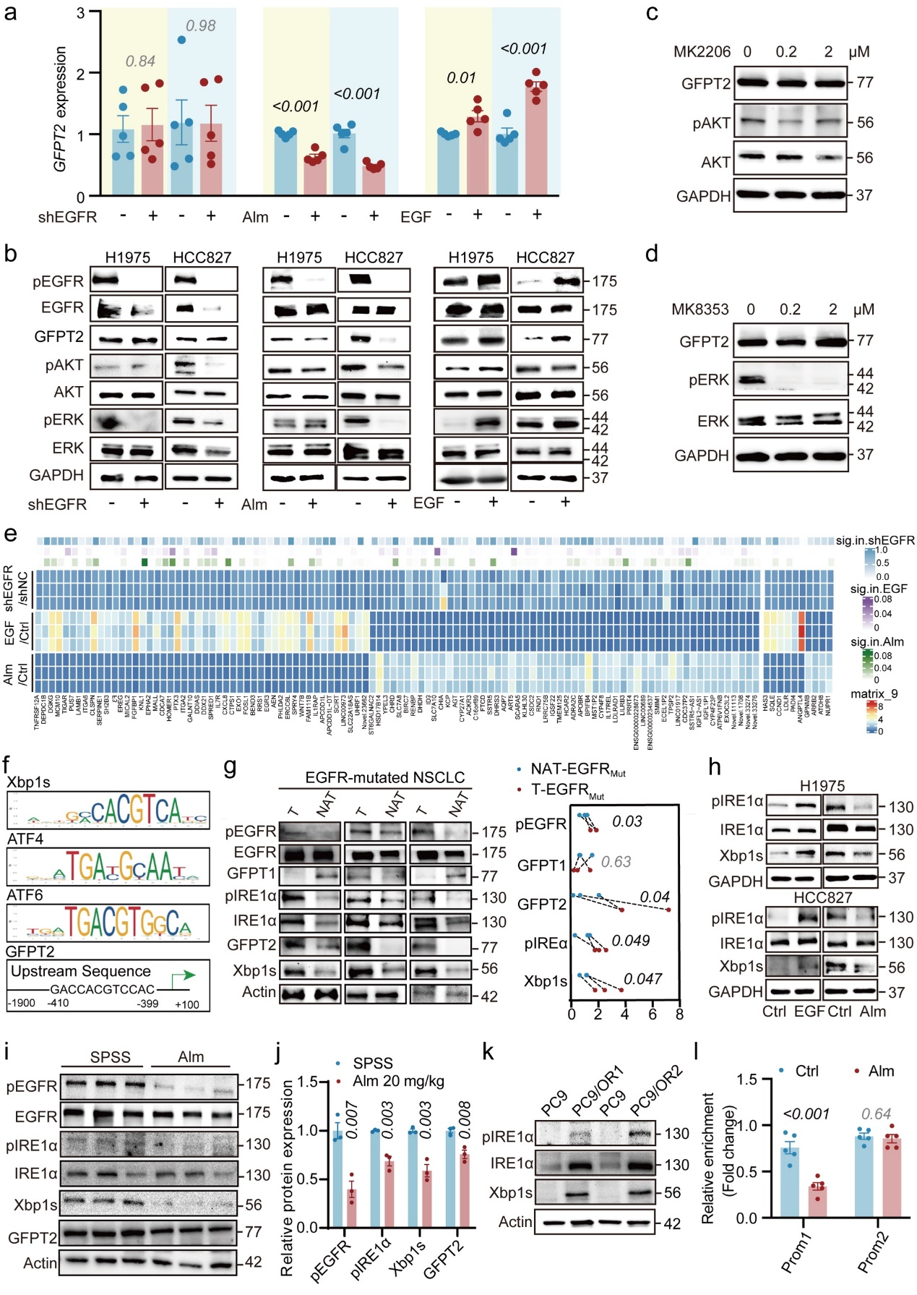
Extended Data Fig.2 Regulation of GFPT2 via the EGFR/IRE1α/Xbp1s pathway in EGFR_{Mut} NSCLC (Related to Fig.1). a, GFPT2 mRNA levels in H1975 and HCC827 cells post-treatment with Alm, EGF, and shEGFR interventions (n=5). b, Immunoblots of pEGFR, EGFR, phosphorylated AKT (pAKT), AKT, phosphorylated ERK (pERK), ERK, and GFPT2 in H1975 and HCC827 cells under the same treatments as in a, with GAPDH as a loading control. c, d, Immunoblots of GFPT2, pAKT, and AKT in H1975 cells treated with AKT inhibitor MK2206 or ERK inhibitor MK8353. e, RNA-seq based identification of differentially expressed genes in H1975 cells treated with EGF or Alm, compared to EGFR knockdown cells (n=3). f, Prediction of transcription factor binding sites involved in ERS signaling pathways on GFPT2 promoter region (2000 bp upstream) by Jasper website, highlighting sequences similar to canonical Xbp1s binding sites. g, Immunoblots comparing ER stress-related proteins in T versus NAT from EGFR-mutated NSCLC patients, with Actin as a loading control (n=3). h, Western blots of IRE1α, pIRE1α, Xbp1s in H1975 and HCC827 cells treated with EGF and Alm, with GAPDH as loading control. i-j, Analysis of pEGFR, EGFR, IRE1α, pIRE1α, Xbp1s, and GFPT2 in H1975 xenograft tumors in Balb/c nude mice post-Alm treatment, n=3, with Actin as loading control. k, Protein level comparison of IRE1α, pIRE1α, Xbp1s, and GFPT2 in PC9 and PC9/OR cells by Western blot, with Actin as loading control. l, ChIP-PCR quantification of Xbp1s binding to GFPT2 promoters in Alm-treated H1975 cells (n=5). Data are mean ± s.e.m. a, j, l, Two-tailed unpaired Student’s t-test.
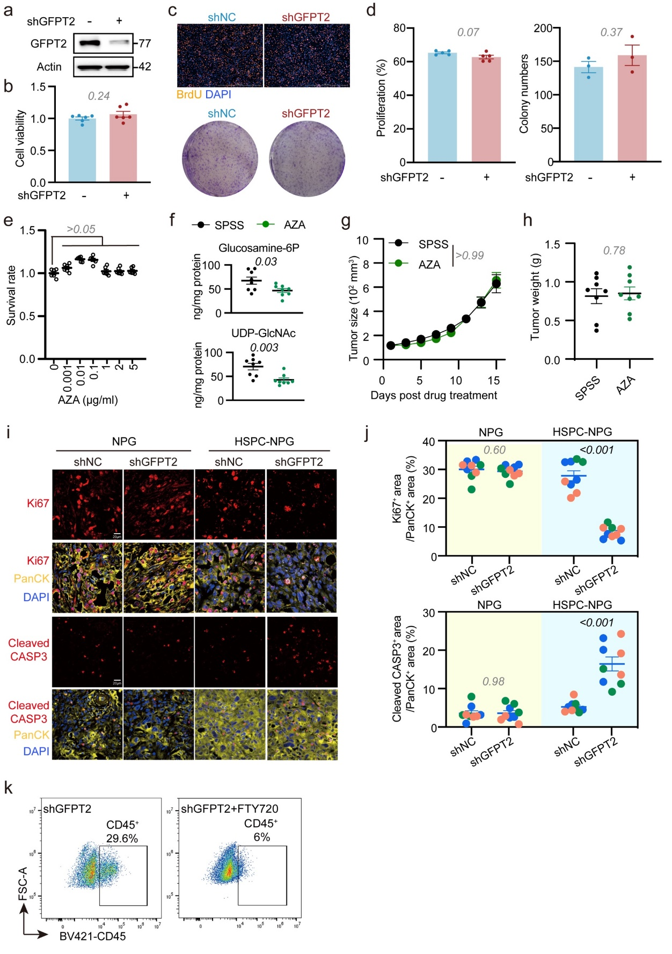
Extended Data Fig.3 Effects of GFPT2 inhibition on tumor growth (Related to Fig.2). a, Verification of GFPT2 knockdown stability via blotting, with Actin as loading control. b, Cell viability post GFPT2 knockdown (n=6). c-d, EdU staining (n=5) and colony formation assay (n=3) depicting proliferation in shNC and shGFPT2 H1975 cells. e, Survival rates of H1975 cells exposed to gradient concentrations of Azaserine (AZA) (n=6). f, HBP metabolite levels in tumor homogenates, assessed by HPLC-QTRAP/MS after two-week AZA administration (n=8). g, h, Tumor size and weight of H1975 xenograft in Balb/c nude mice following AZA treatment (n=8). i-j, Immunofluorescent detection of Ki67 and cleaved CASP3 in H1975 xenograft sections (n=3, three field each). k, CD45⁺cell amount in EGFR-mutated LLC xenograft post FTY720 treatment. Data are mean ± s.e.m. b, d, f, h, j Two-tailed unpaired Student’s t-test. e, One-way ANOVA. g, Two-way ANOVA for tumor size.
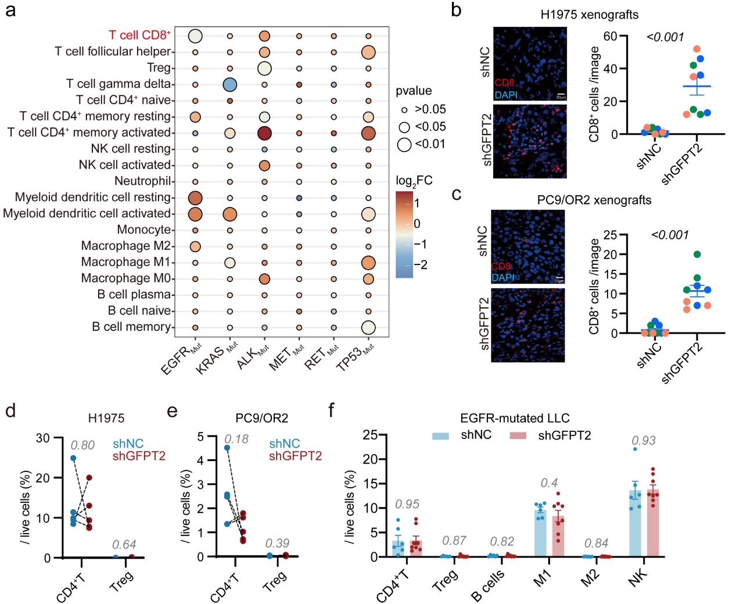
Extended Data Fig.4 Effects of GFPT2 inhibition on tumor immune microenvironment (Related to Fig.2). a, Tumor immune microenvironment in common oncogene mutation in LUAD according to TIMER2.0 (http://timer.cistrome.org/) with CIBERSORT Abs. mode. b, c, Immunofluorescent detection of CD8α in H1975 and PC9/OR2 xenograft sections (n=3, three field each). d-e, CD4⁺T cells and Tregs in HSPC-NPG mice xenografts from H1975 or PC9/OR2 cells post GFPT2 silenced were examined via FCM (n=5). f, Immune cells in C57BL/6N mice xenograft from EGFR-mutated LLC cells after GFPT2 knockdown (n=6 for shNC and n=8 for shGFPT2). Data are mean ± s.e.m. except in d, e, Two-tailed paired Student’s t-test. b, c, f, Two-tailed unpaired Student’s t-test.

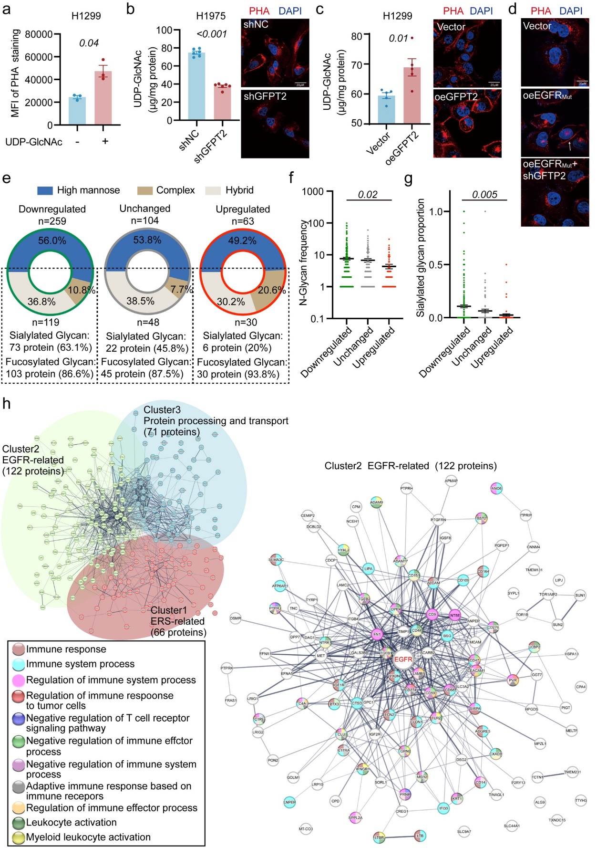
Extended Data Fig.5 N-glycoproteomes post genetic disruption of tumoral GFPT2. a, FCM analysis depicting mean fluorescent intensity (MFI) of PHA staining in H1299 cells treated with UDP-GlcNAc (10 mM) (n=3). b, c, LC-QTRAP/MS analysis illustrating UDP-GlcNAc levels and PHA staining of protein glycan coat in H1975 (n=6) and H1299 (n=5) cells. d, Representative images of shNC and shGFPT2 H1299 cells following the induction of oncogenic EGFR mutation (T790M/L858R) subjected to immunofluorescent staining for PHA. e, GFPT2-mediated alterations in 426 protein glycoforms, as revealed by N-glycoproteomic analysis. f, g, Changes in glycan occurrence and proportion of sialylated glycan on identified proteins. h, Protein exhibiting reduced glycosylation segregated by a K-means clustering algorithm into three discrete cohorts. Data are mean ± s.e.m. a, b, c, Two-tailed unpaired Student’s t-test. f, g, One-way ANOVA.
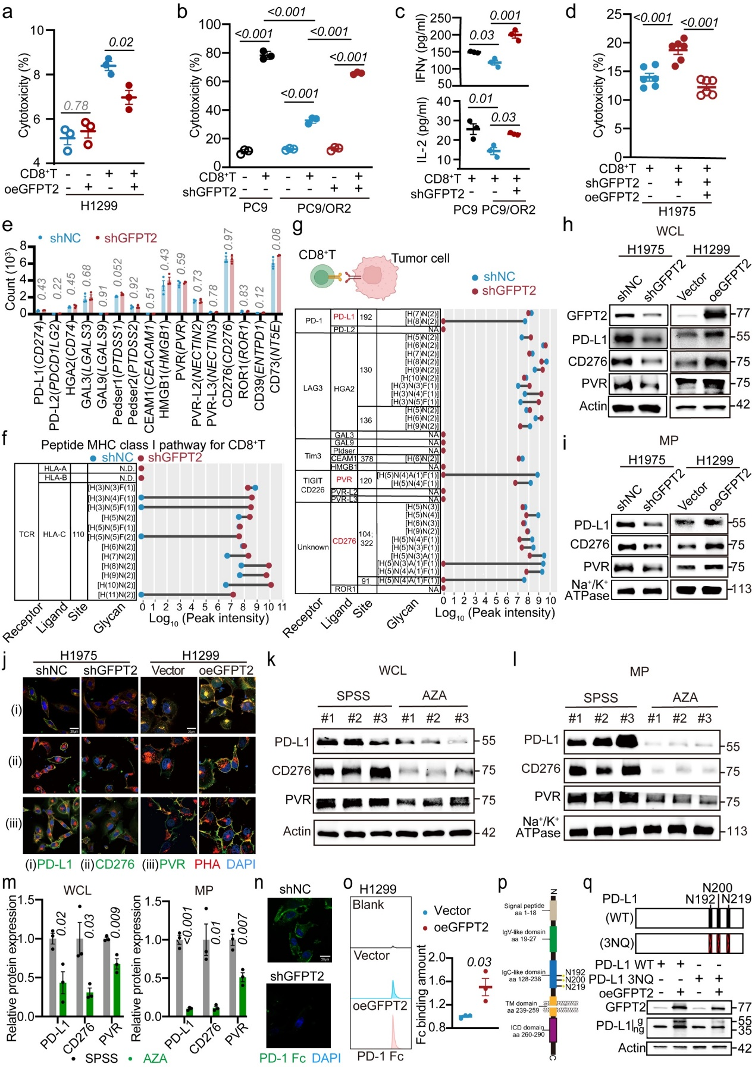
Extended Data Fig.6 GFPT2 increases the N-glycosylation of immunosuppressive ligands including PD-L1, CD276 and PVR (Related to Fig.3). a, b, FCM analyses of H1299 and PC9/OR2 cell survival in co-culture with activated human CD8⁺T cell sorted from PBMC (n=3).c, IFNγ and IL-2 secretion in cell supernatant in indicated co-culture settings (n=3). d, FCM analyses of H1975 cell survival in co-culture with activated human CD8⁺T cell sorted from PBMC (n=3). e, Bulk-seq analysis of gene expression levels of various immunogenicity ligands in H1975 cells following GFPT2 knockdown (n=3). f, g, Analysis of N-linked glycans and peak intensities indicating glycosylation modifications on indicated immune checkpoint ligands and MHC I protein in shNC and shGFPT2 H1975 cells. h-i, Immunoblotting analysis of PD-L1, CD276, and PVR in whole cell lysate (WCL) and membrane protein (MP). Actin is used as a loading control for WCL, and Na⁺/K⁺ ATPase as a loading control for MP. j, Immunofluorescent images of H1975 cells with GFPT2 knockdown and H1299 cells with overexpressed GFPT2, with specific labeling for indicated immunosuppressive ligands and its associated glycosylation patterns. k-m, Immunoblotting examined the expression of total and membrane-associated proteins of indicated immunosuppressive ligands in H1975 xenograft tumors treated with AZA (n=3). Actin is used as a loading control for total protein, and Na⁺/K⁺ ATPase as a loading control for membrane protein. n, Immunofluorescence (IF) analysis assessing PD-1 Fc binding in GFPT2-silenced H1975 cells (representative images for triple independent experiments). o, FCM quantification of PD-1 Fc binding to PD-L1 on H1299 cell membranes upon GFPT2 overexpression, calculated by multiplying the percentage of positive cells by mean fluorescence intensity (n=3). p, Schematic representation of PD-L1 structure and glycosylation sites. q, Immunoblotting analysis of the effects of GFPT2 on the glycosylation modifications of wild-type PD-L1 and mutant PD-L1. g, glycosylated form; ng, non-glycosylated form. Data are mean ± s.e.m. a, b, c, d, One-way ANOVA. e, m, o, Two-tailed unpaired Student’s t-test.

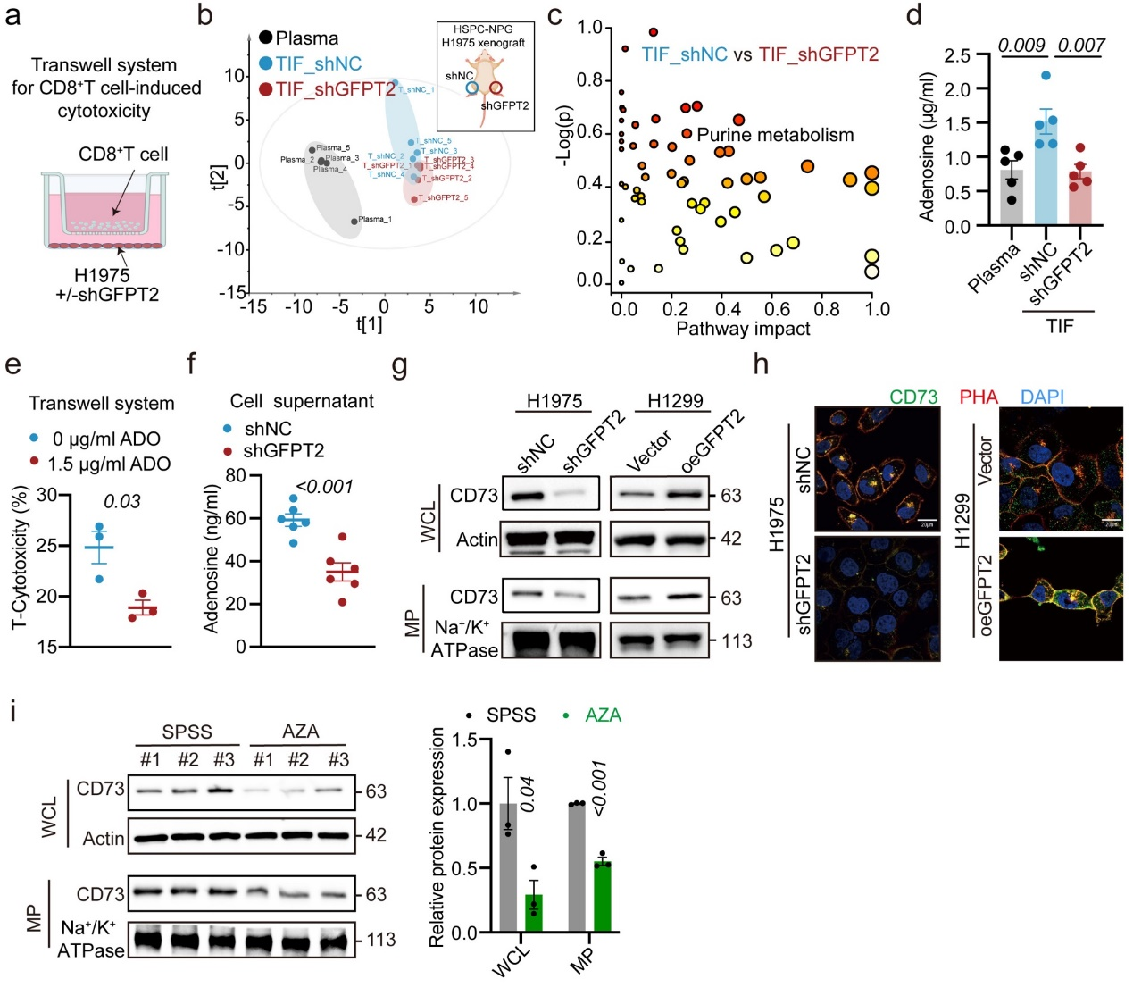
Extended Data Fig.7 GFPT2 increases the N-glycosylation of CD73 (Related to Fig.3). a, Schematic of the Transwell co-culture system. b-c, Metabolomic analysis comparing TIF in shNC and shGFPT2 xenografts, assayed by HPLC-QTOF/MS (n=5). (b) PCA comparing the metabolites. (c) Metabolic pathway impact plot measuring the significance (-log(p)) and impact (proportion of pathway altered). d, HPLC-QTRAP/MS quantitative analysis of adenosine concentrations in plasma and TIF (n=5). e, FCM analysis of H1975 cell survival during co-culture with activated human CD8⁺T sorted from PBMC with or without adenosine (ADO) treatment (n=3). f, HPLC-QTRAP/MS quantification of changes in adenosine levels in the supernatant of GFPT2-knockdown H1975 cells (n=5). g, Immunoblotting analysis of total and membrane protein levels of CD73. Actin is used as a loading control for total protein, and Na⁺/K⁺ ATPase as a loading control for membrane protein. h, Immunofluorescent images of H1975 cells with GFPT2 knockdown and H1299 cells with overexpressed GFPT2, with specific labeling for CD73 and associated glycosylation patterns. i, Immunoblotting analysis examining the expression of total and membrane-associated proteins of indicated immunosuppressive ligands in H1975 xenograft tumors treated with AZA (n=3). Actin is used as a loading control for total protein, and Na⁺/K⁺ ATPase as a loading control for membrane protein. Data are mean ± s.e.m. e, f, i, Two-tailed unpaired Student’s t-test. d, One-way ANOVA.
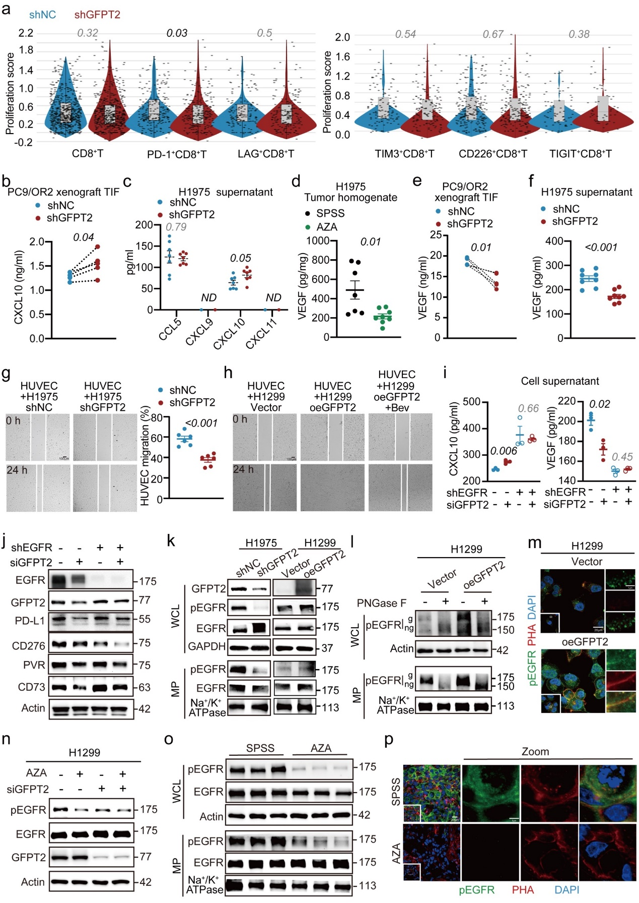
Extended Data Fig.8 Impact of tumor cell GFPT2 on the secretion of CXCL10 and VEGF, and its effect on EGFR glycosylation (Related to Fig.4). a, scRNA-seq analysis of sorted CD8⁺ T cells from EGFR-mutated LLC xenograft. Violin plots display proliferation signaling in intratumoral CD8⁺T cells. Box plots indicate median and interquartile range. b, ELISA measurement of CXCL10 in the TIF of shNC and shGFPT2 PC9/OR2 xenografts in mice (n=5). c, ELISA quantification of various chemokines in the culture supernatant of H1975 cells with GFPT2 knockdown (n=6). d-e, ELISA assessments of VEGF levels in tumor homogenates and TIF following treatment with GFPT inhibitor AZA (n=7) or genetic intervention of tumor cell GFPT2 (n=5). f, ELISA measurement of VEGF in the culture supernatant of H1975 cells with GFPT2 knockdown (n=8). g-h, Transwell co-culture system used to examine the effects of knocking down (n=6) or overexpressing GFPT2 (n=6) on endothelial cell migration. i, ELISA determination of CXCL10 and VEGF levels secreted in the supernatant of H1975 cells after specific genetic interventions (n=3). j, Immunoblotting examination of the expression of three immunosuppressive ligands and CD73 in H1975 cells. k-l, Immunoblotting analysis of the expression, activation, and glycosylation of EGFR in whole cell lysates and cell membrane fractions of H1975 cells with GFPT2 knockdown and H1299 cells with GFPT2 overexpression. m, IF investigation of membrane translocation and glycosylation levels of pEGFR in H1299 cells after GFPT2 overexpression. n, Immunoblotting examination of whether GFPT2 knockdown affects the AZA intervention on pEGFR. o, Immunoblotting analysis examining the expression of total and membrane-associated proteins of indicated immunosuppressive ligands in H1975 xenograft tumors treated with AZA (n=3). Actin is used as a loading control for total protein, and Na⁺/K⁺ ATPase as a loading control for membrane protein. p, Immunofluorescent images of AZA-treated H1975 xenografts, with specific labeling for pEGFR and its associated glycosylation patterns. Data are mean ± s.e.m. except in b, e, Two-tailed paired Student’s t-test. a, c, d, f, g, i,Two-tailed unpaired Student’s t-test.
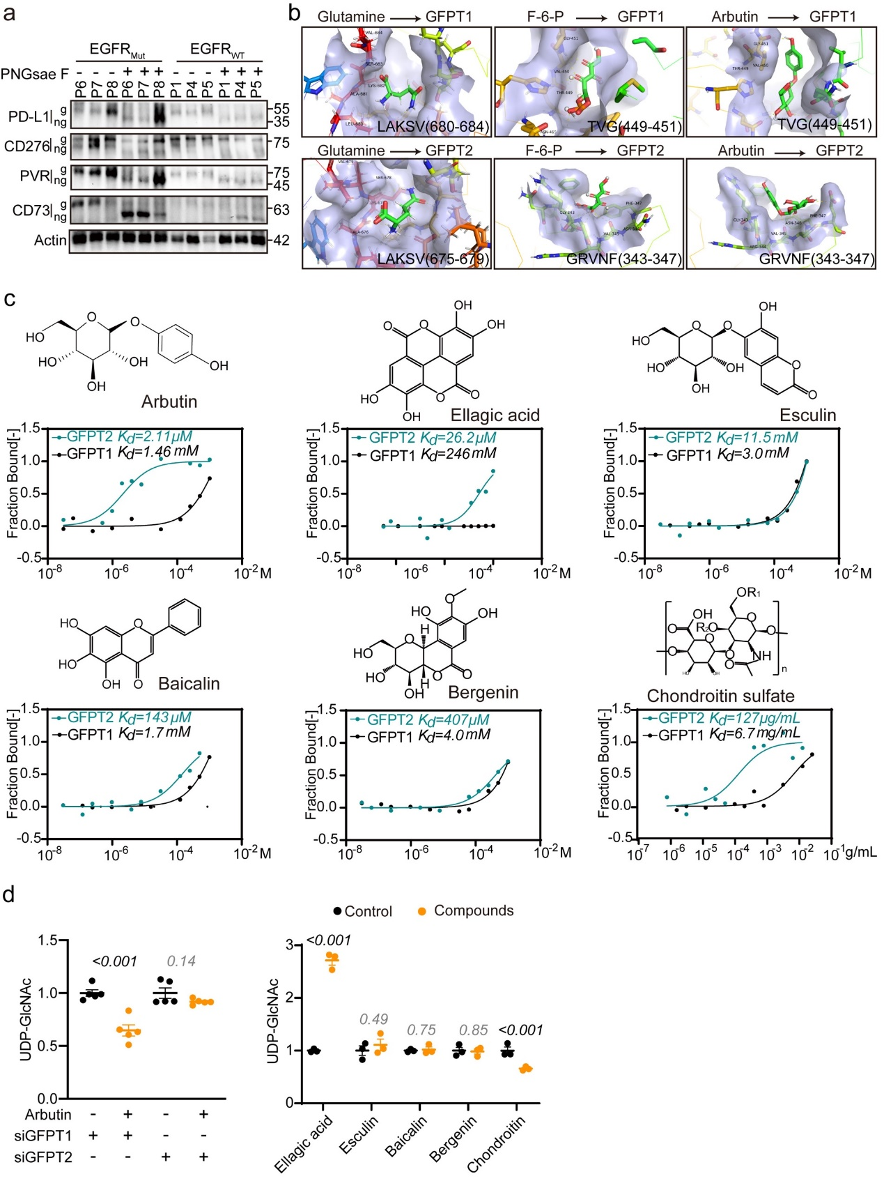
Extended Data Fig.9 Screening for GFPT2 isoform-specific inhibitor (Related to Fig.5). a, Immunoblotting for protein glycosylation of PD-L1, CD276, PVR, and CD73 in tumor tissues from NSCLC patients with EGFR wild-type and EGFR mutation (n=3). g, glycosylated form; ng, non-glycosylated form, with Actin as loading control. b, Binding patterns of glutamine, fructose-6-phosphate, and Arbutin with GFPT1 and GFPT2. c, Structural formulas of six candidate hits with their affinities to GFPT1 and GFPT2 assessed by Microscale Thermophoresis (MST) and calculation of dissociation constants (Kd values). d, Left: effects of silencing GFPT1 or GFPT2 on the inhibitory activity of Arbutin on intracellular UDP-GlcNAc production (n=5). Right: effects of other five candidate hits on intracellular UDP-GlcNAc production (n=3). Data are mean ± s.e.m. d, Two-tailed unpaired Student’s t-test.
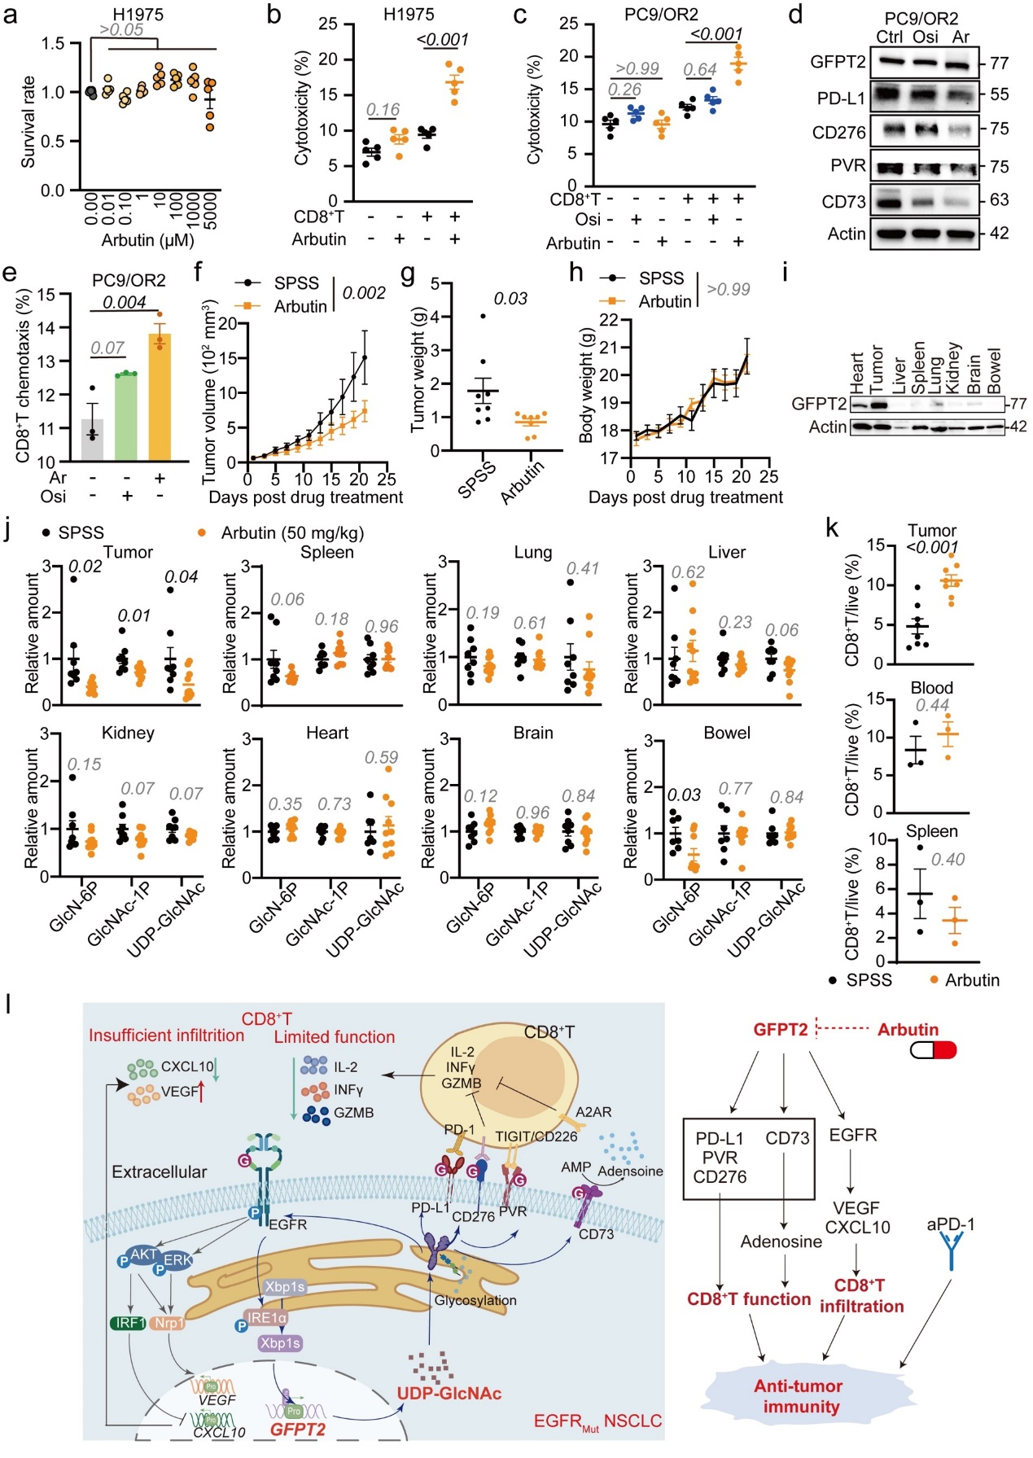
Extended Data Fig.10 Arbutin enhances the efficacy of immunotherapy (Related to Fig.5). a, CCK-8 assay evaluating the effect of different concentrations of Arbutin on the viability of H1975 cells (n=5). b-c, FCM analyses of H1975 and PC9/OR2 cell survival in co-culture with activated human CD8⁺T cells sorted from PBMC (n=5). d, Western blot analysis of specified protein levels in PC9/OR2 cells following treatment with Osimertinib (Osi) and Arbutin (Ar). e, PC9/OR2 cells and CD8⁺T cells were co-cultured using a Transwell system to assess the effects of Osi and Ar on CD8⁺T cell chemotaxis (n=3). f-h, Changes in tumor size, tumor weight, and body weight of EGFR-mutated LLC xenograft in C57BL/6N following Arbutin treatment (n=8). i, Immunoblotting for GFPT2 in tumor tissues and major organs with Actin serving as the loading control. j, HPLC-QTRAP/MS analysis of HBP metabolites in tumor tissues and major organs after Arbutin treatment (n=8). k, FCM analysis of changes in CD8⁺T cell infiltration within the tumor (n=8), as well as peripheral blood and spleen, following Arbutin administration (n=3). l, Schematic representation of how GFPT2 control the immune evasion in the EGFR-mutated NSCLC via metabolite-mediated modulation of protein glycosylation. Data are mean ± s.e.m. g, j, k, Two-tailed unpaired Student’s t-test. a, b, c, e, One-way ANOVA. f, h, Two-way ANOVA.

