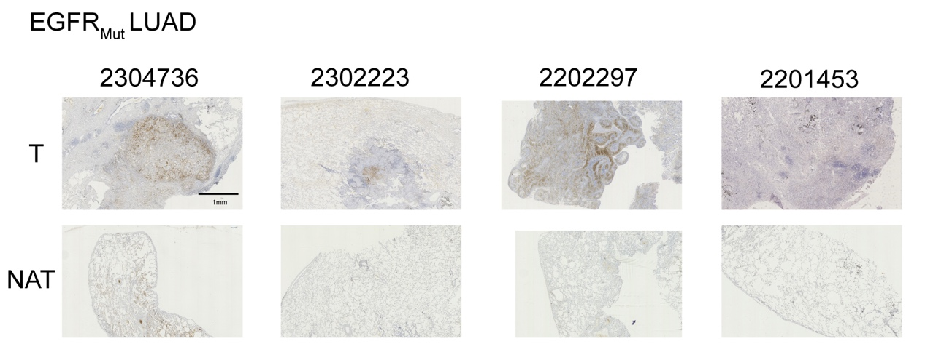
Supplementary Fig 1. IHC images for GFPT2 staining of T and NAT from 4 EGFR_{Mut} LUAD patients.

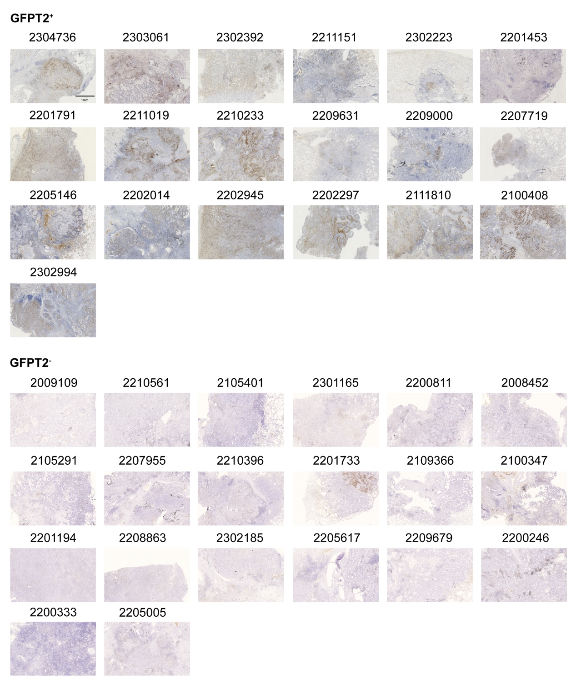
Supplementary Fig 2. IHC images for GFPT2 staining of 19 paired LUAD T and NAT.

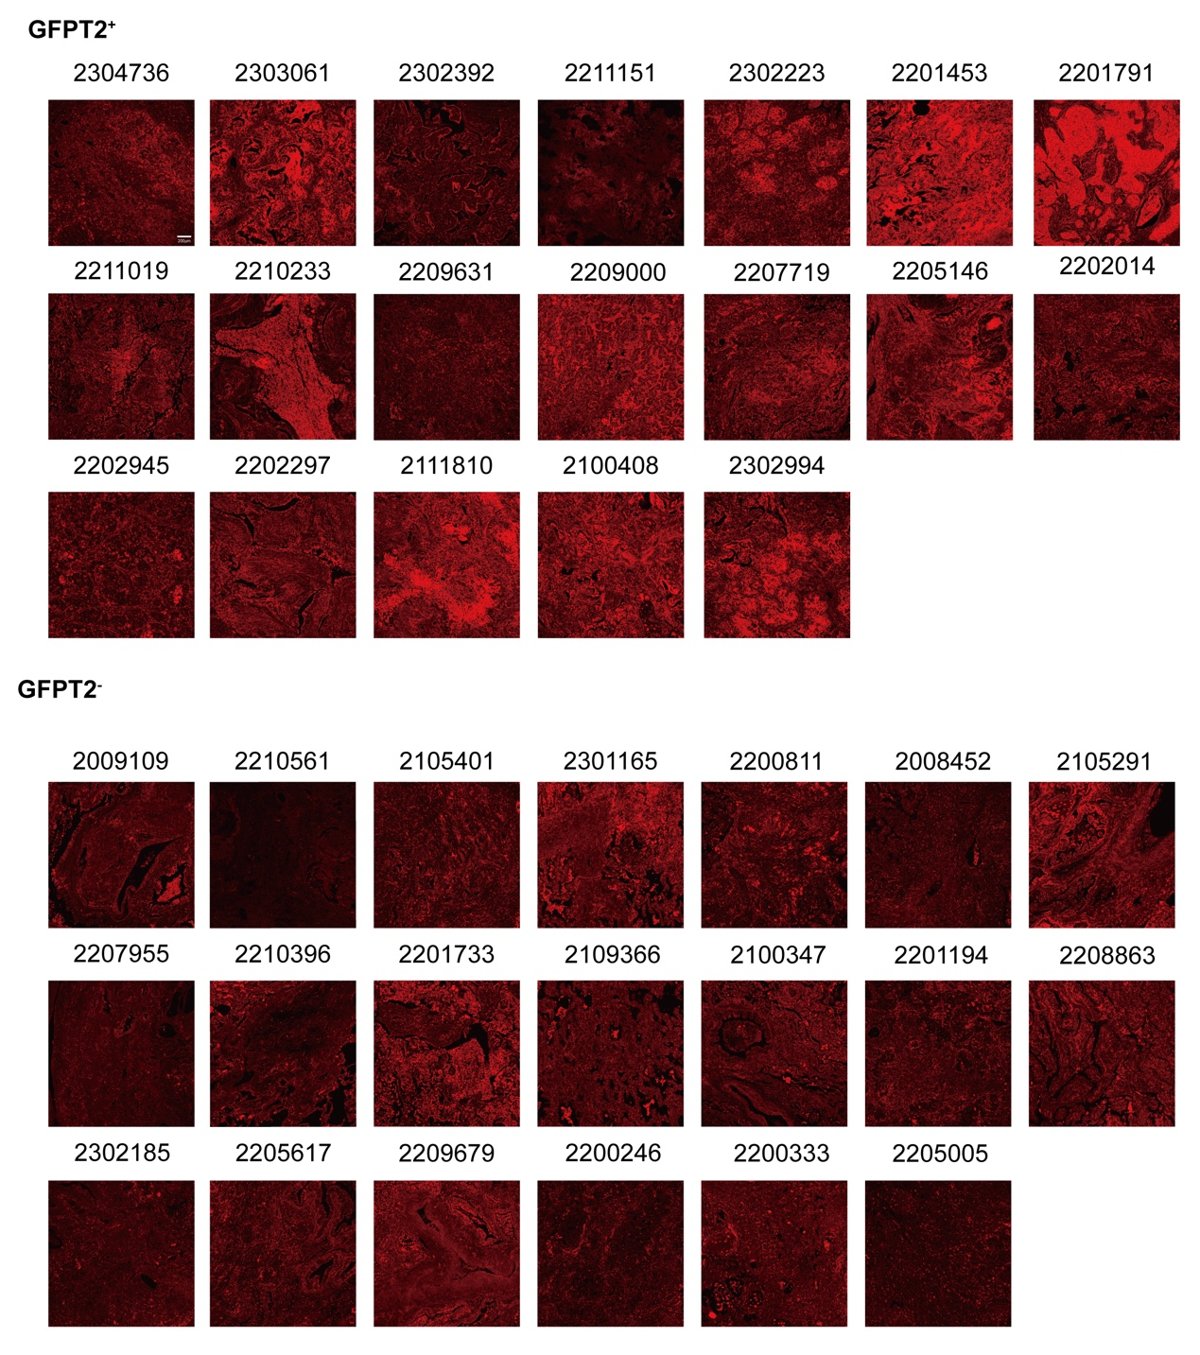
Supplementary Fig 3. IF images for PHA staining of 19 GFPT2 positive expressed LUAD T and 20 GFPT2 negative expressed LUAD T.

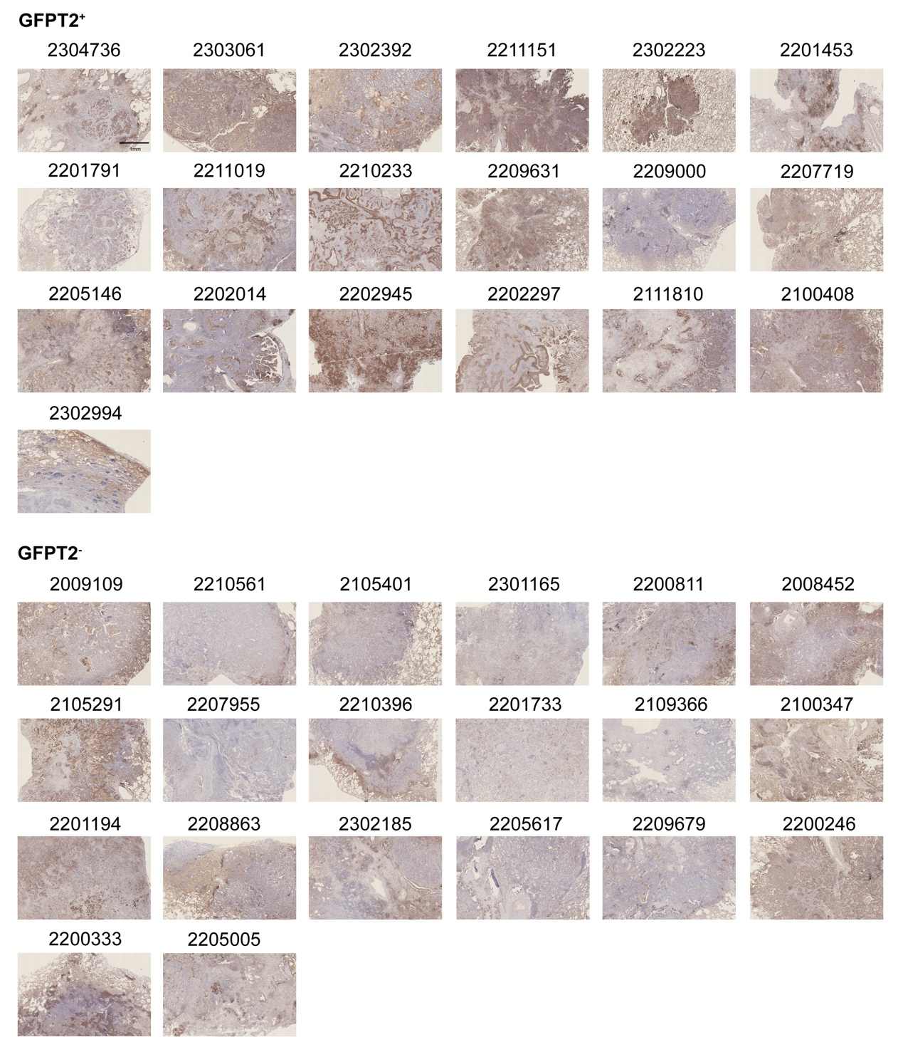
Supplementary Fig 4. IHC images for pEGFR staining of 19 GFPT2 positive expressed LUAD T and 20 GFPT2 negative expressed LUAD T.

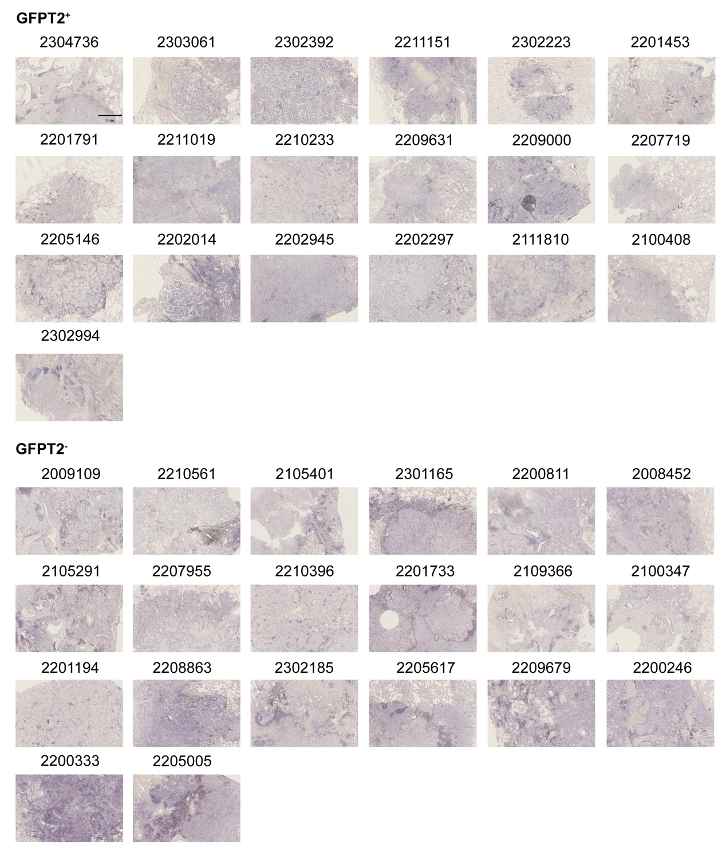
Supplementary Fig 5. IHC images for CD8⁺T staining of 19 GFPT2 positive expressed LUAD T and 20 GFPT2 negative expressed LUAD T.

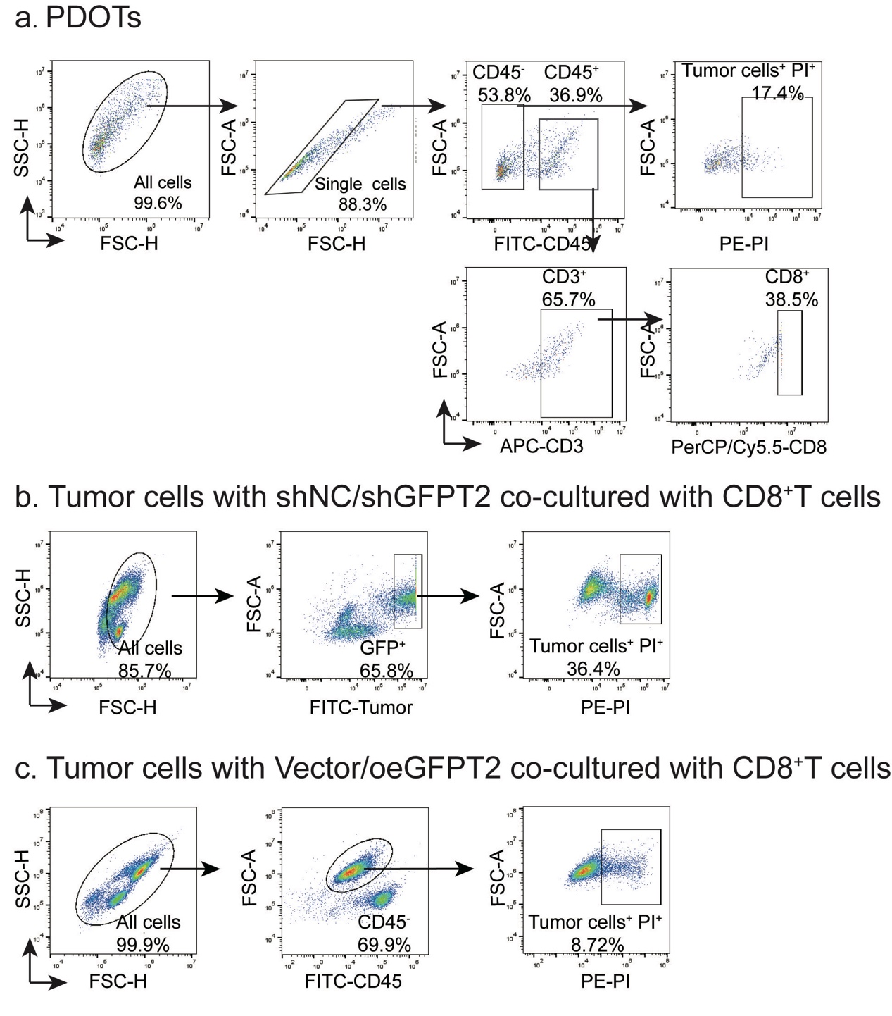

Supplementary Fig 6. Flow cytometry gating strategy for PDOTs and ex vivo co-culture.

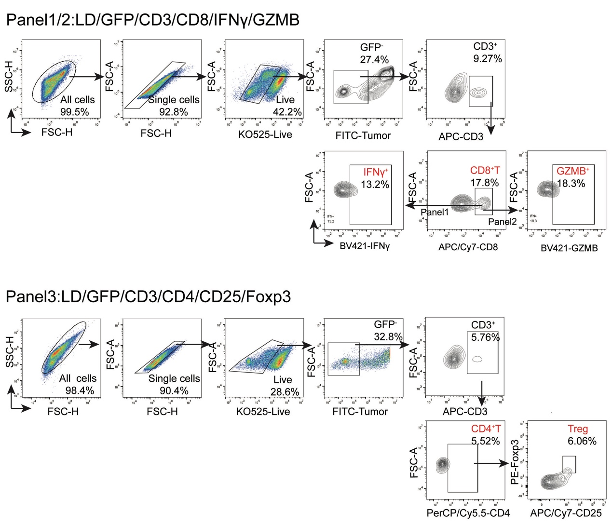
Supplementary Fig 7. Flow cytometry gating strategy for tumor immune microenvironment in humanized mouse models.

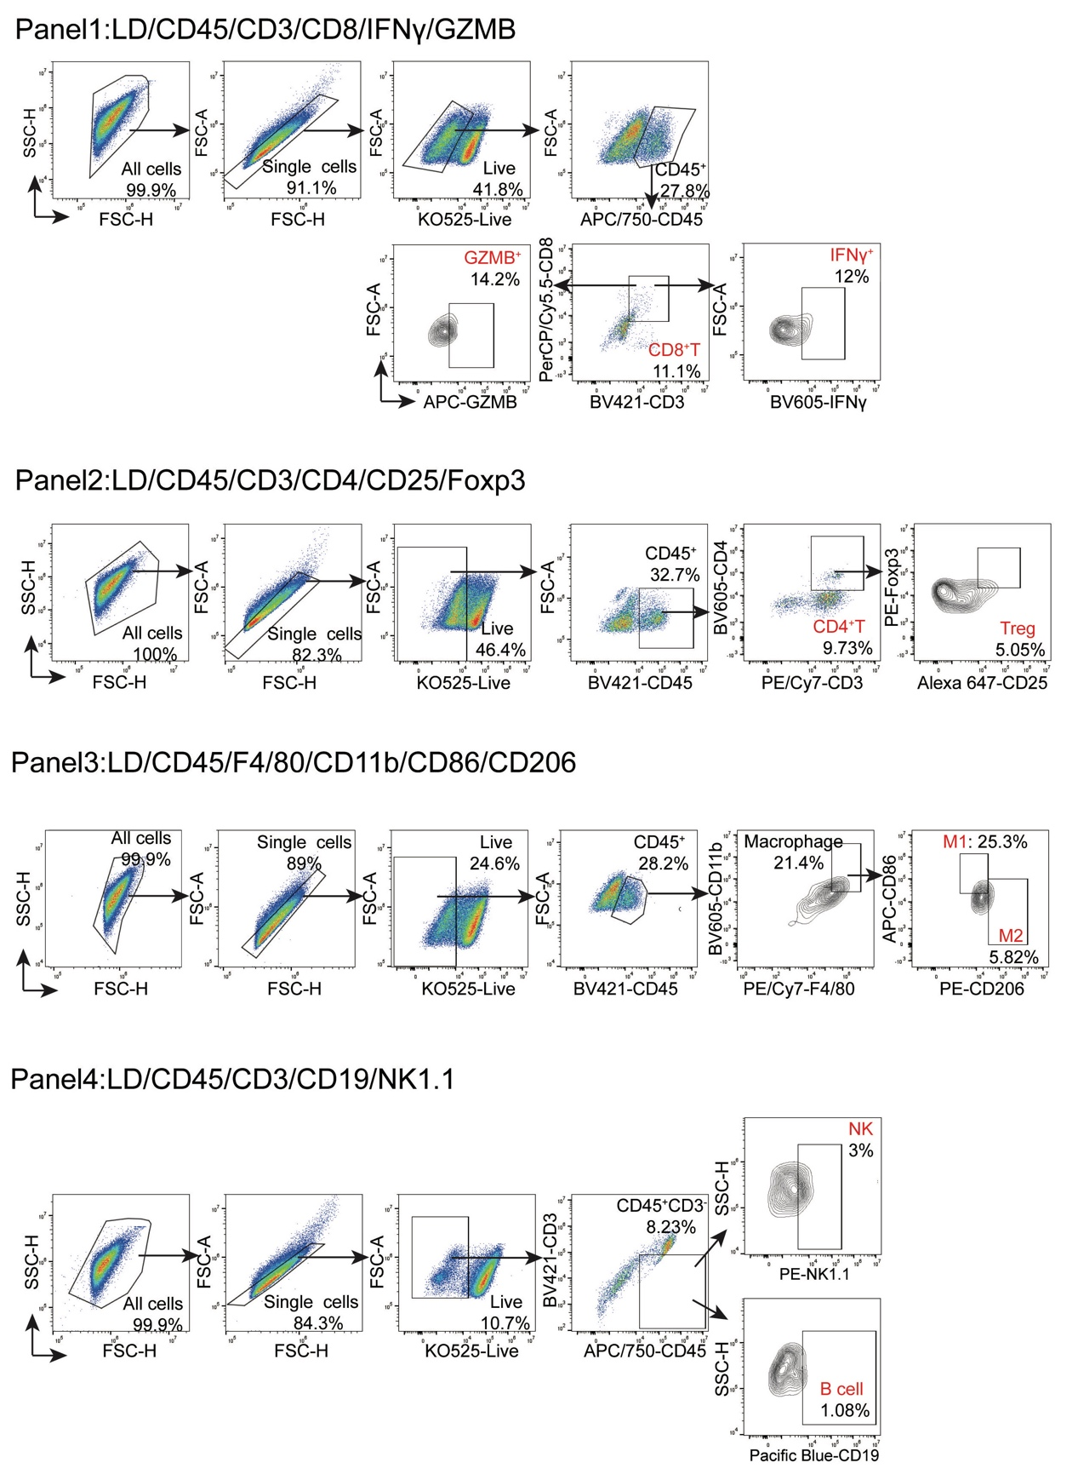
Supplementary Fig 8. Flow cytometry gating strategy for the tumor immune microenvironment in fully immunocompetent mice.

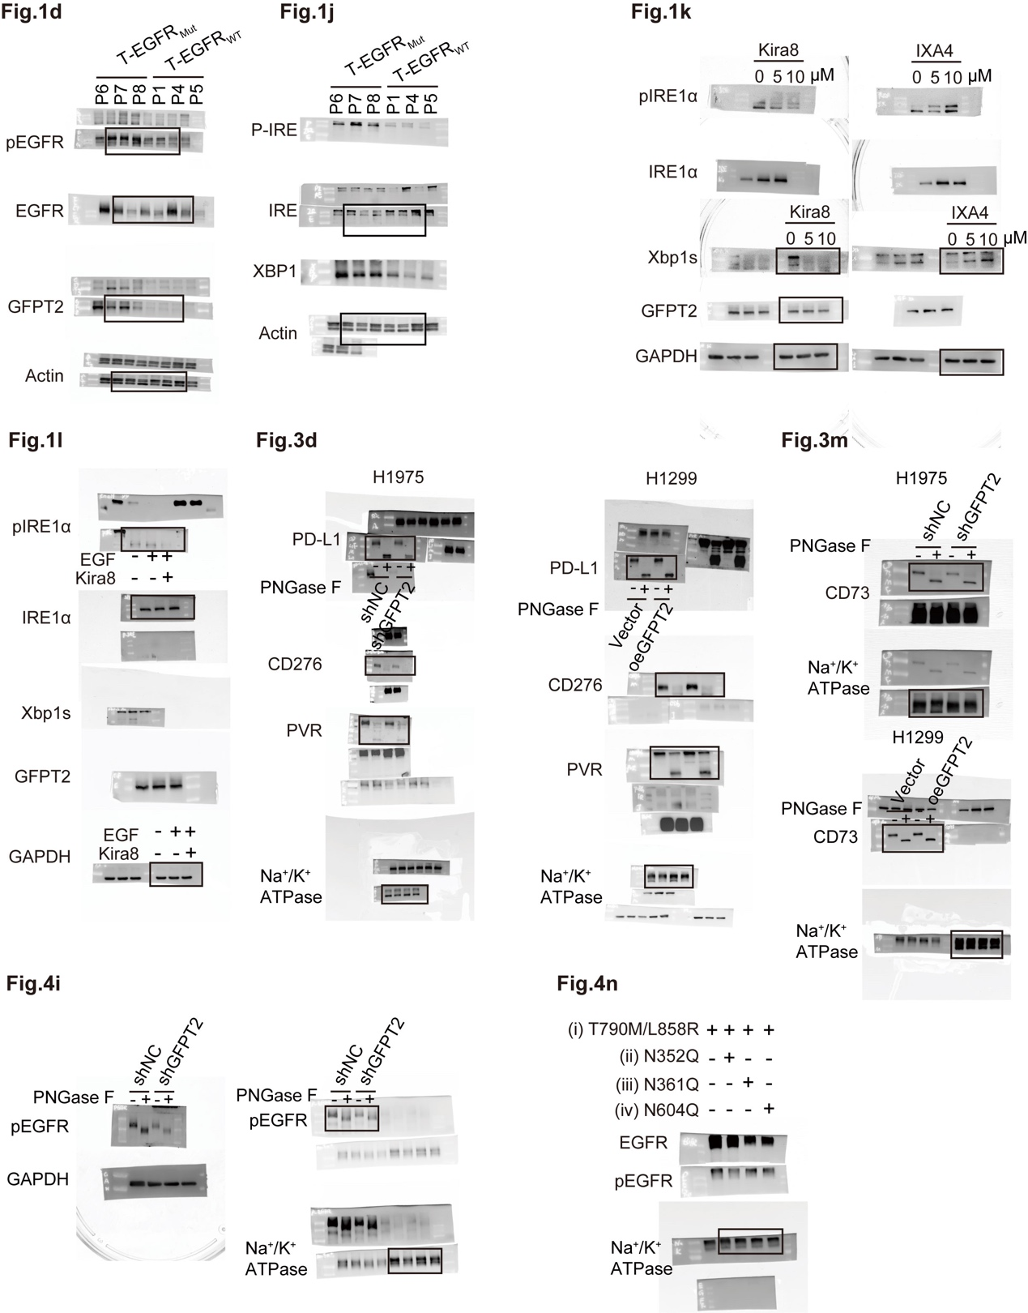
Supplementary Fig 9. Original immunoblotting data related to main figures.

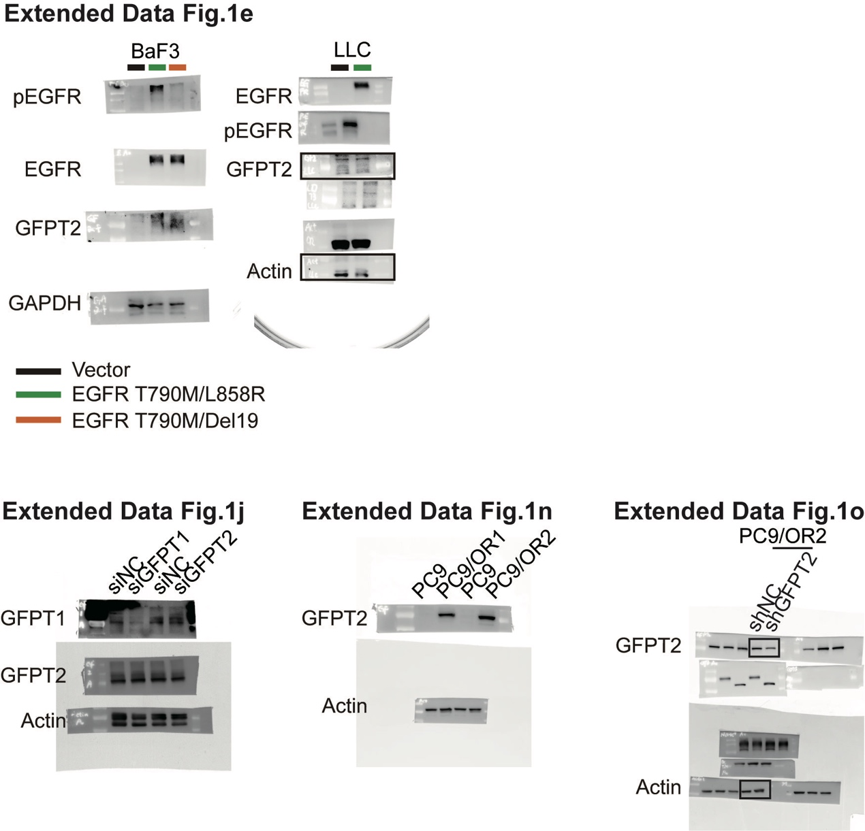
Supplementary Fig 10. Original immunoblotting data related to Extended Data Fig 1.

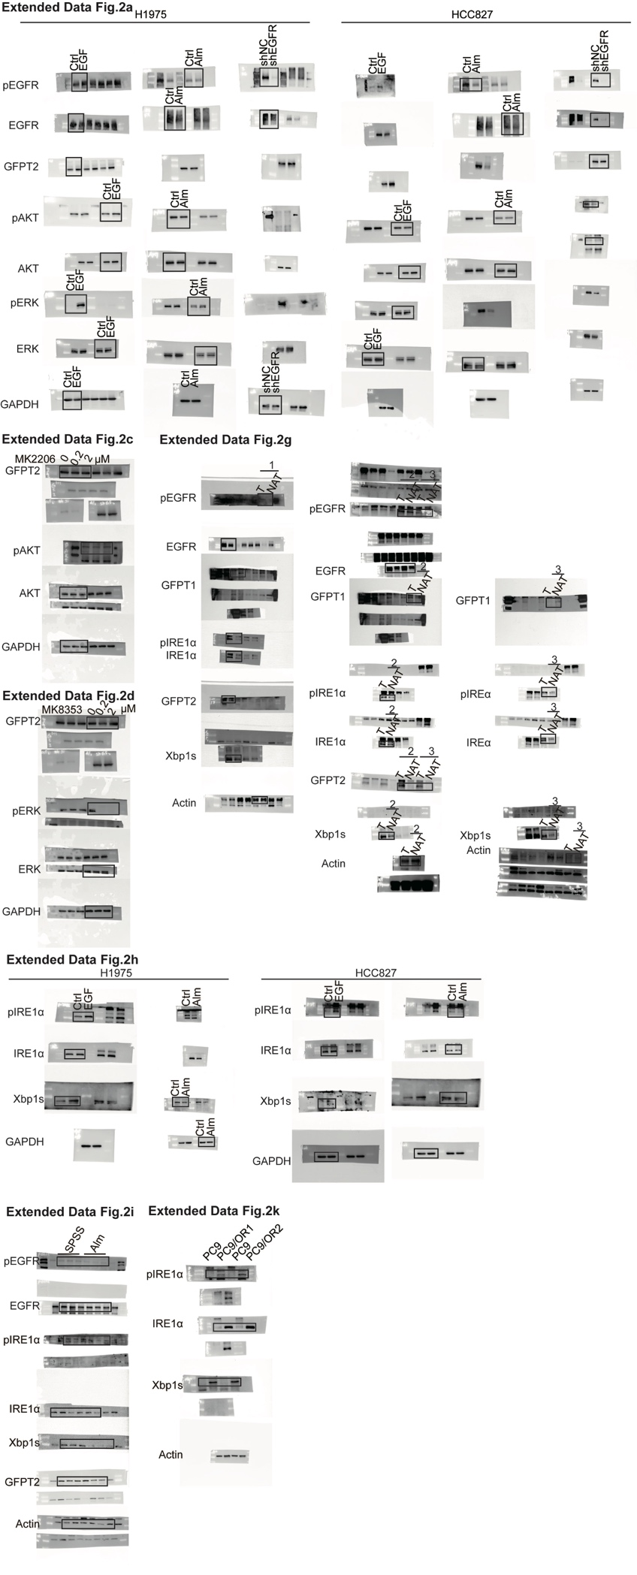
Supplementary Fig 11. Original immunoblotting data related to Extended Data Fig 2.

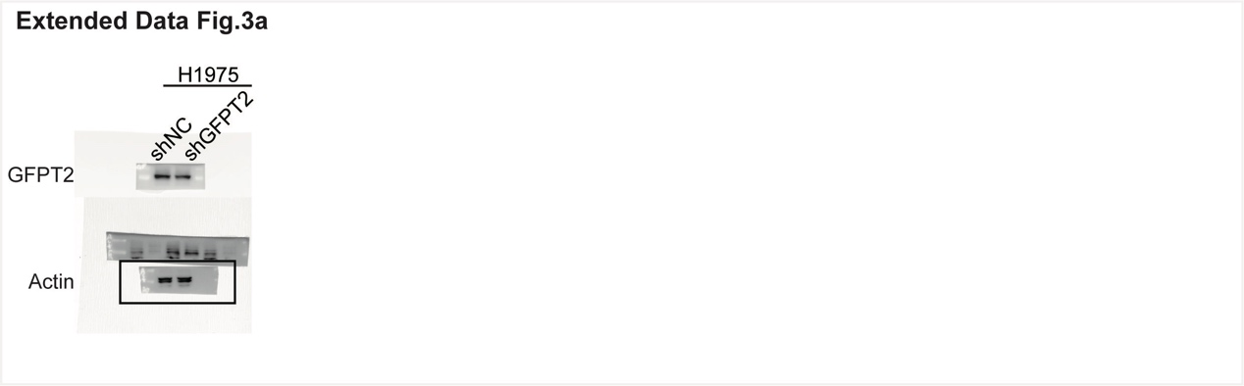
Supplementary Fig 12. Original immunoblotting data related to Extended Data Fig 3.

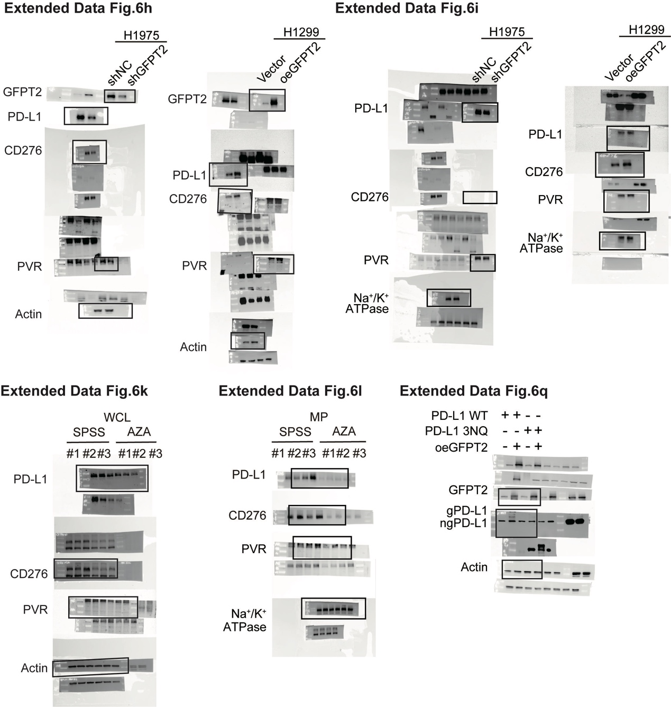
Supplementary Fig 13. Original immunoblotting data related to Extended Data Fig 6.

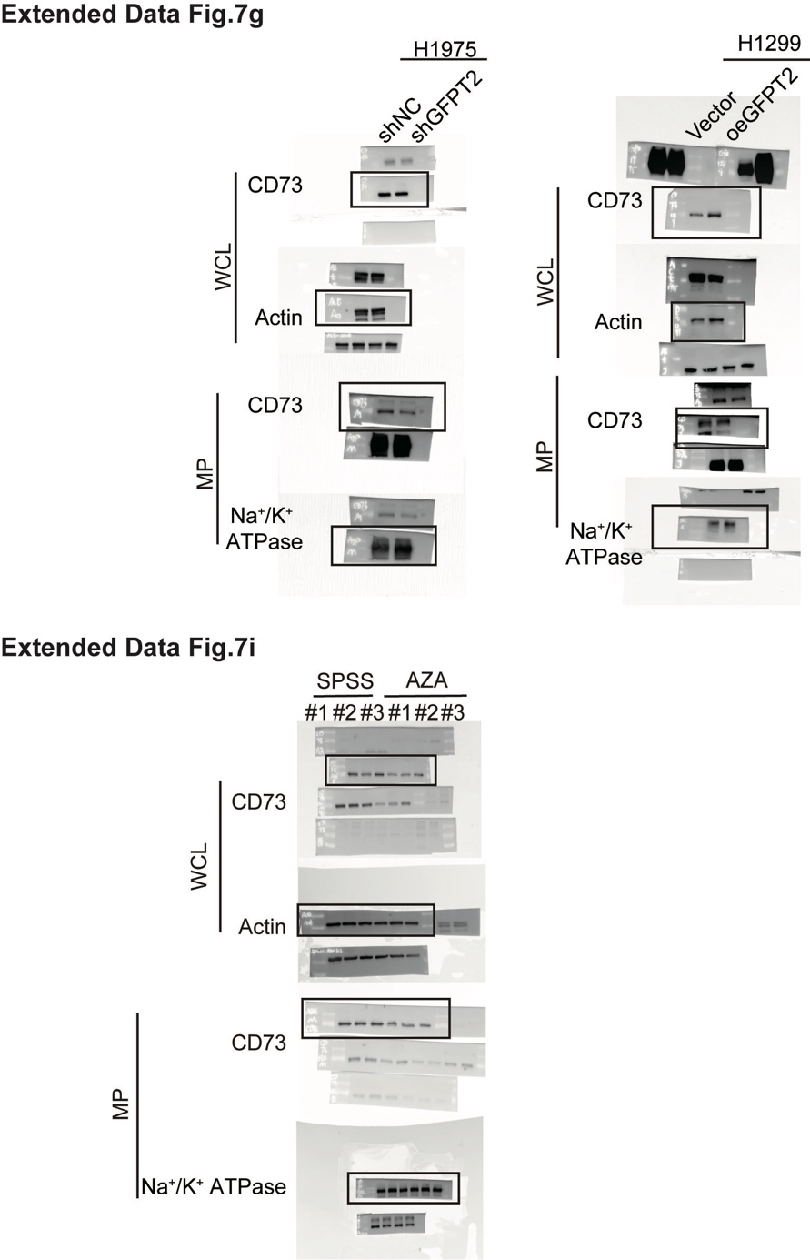
Supplementary Fig 14. Original immunoblotting data related to Extended Data Fig 7.

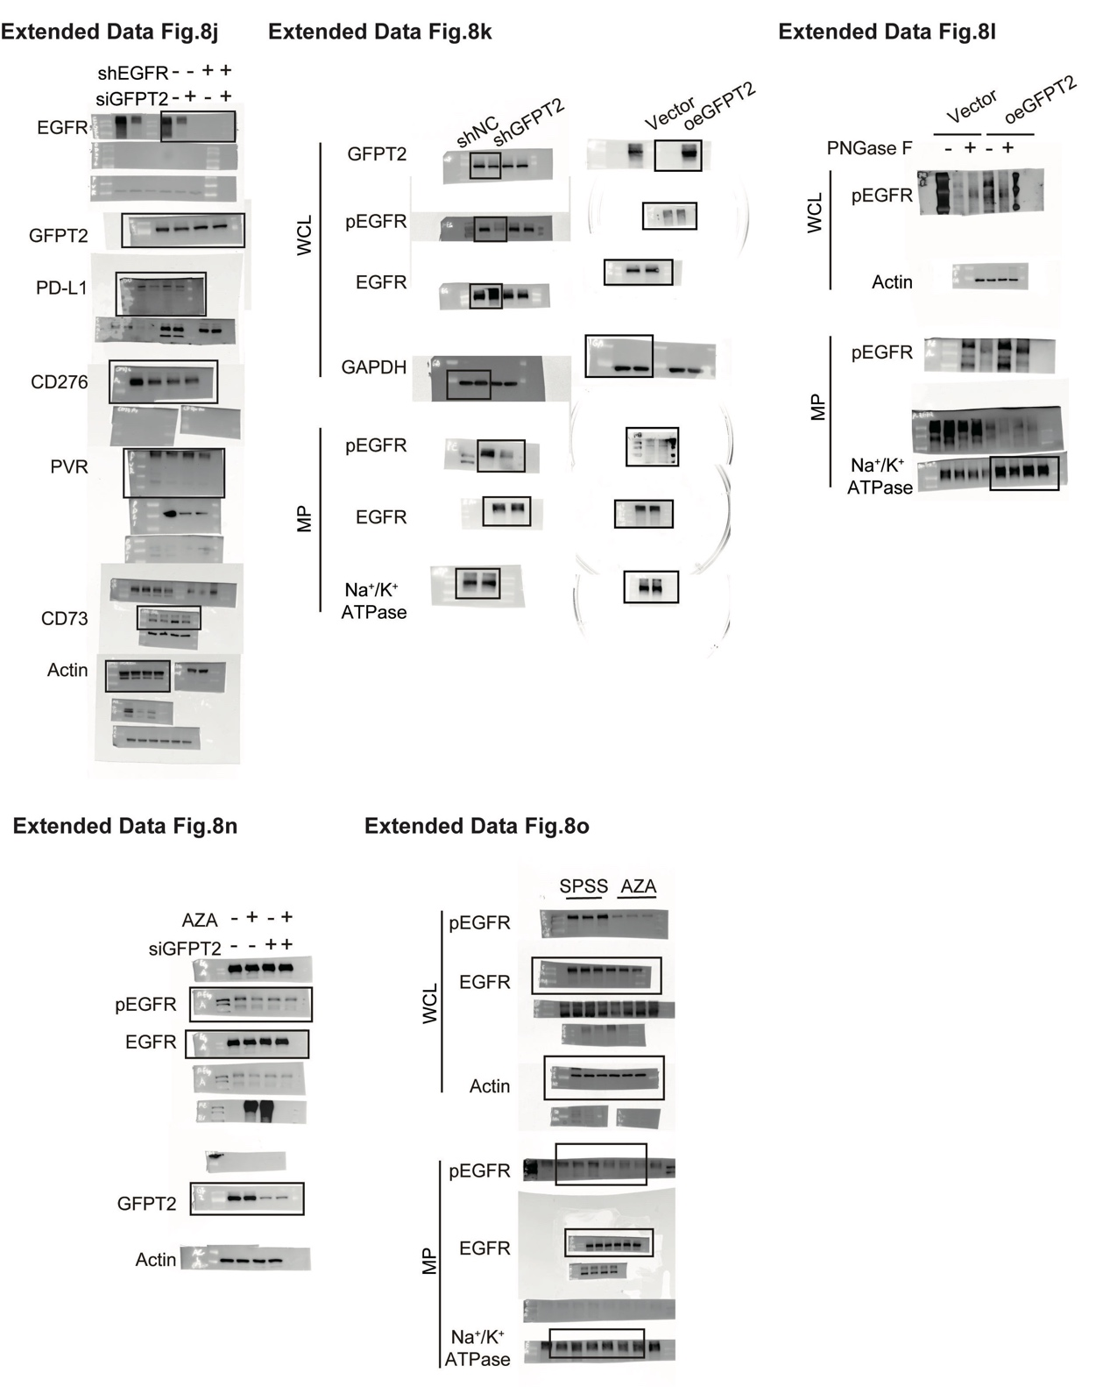
Supplementary Fig 15. Original immunoblotting data related to Extended Data Fig 8.

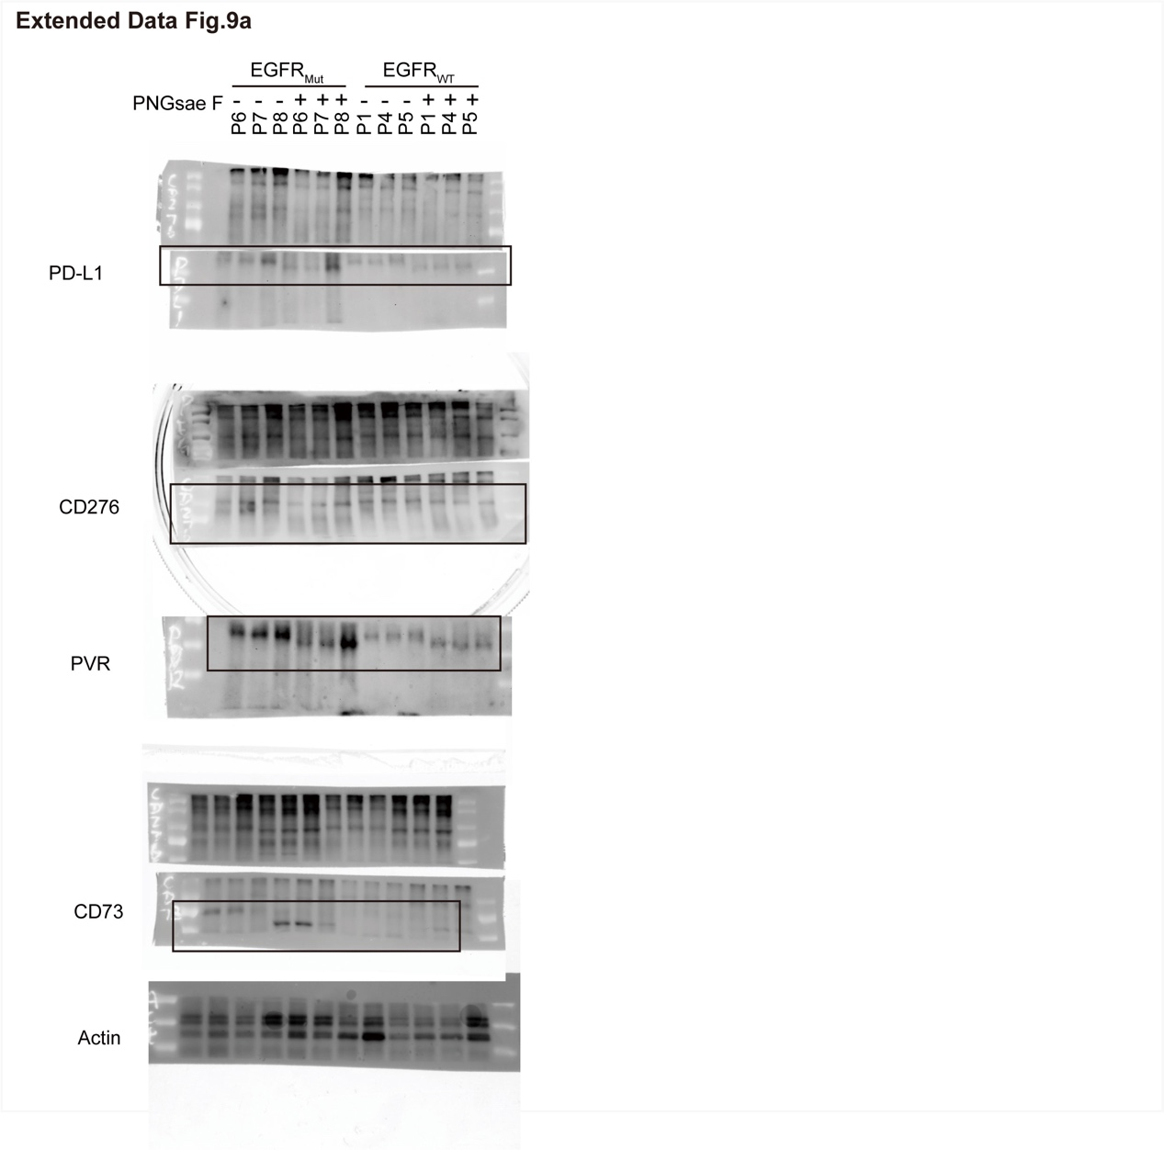
Supplementary Fig 16. Original immunoblotting data related to Extended Data Fig 9.

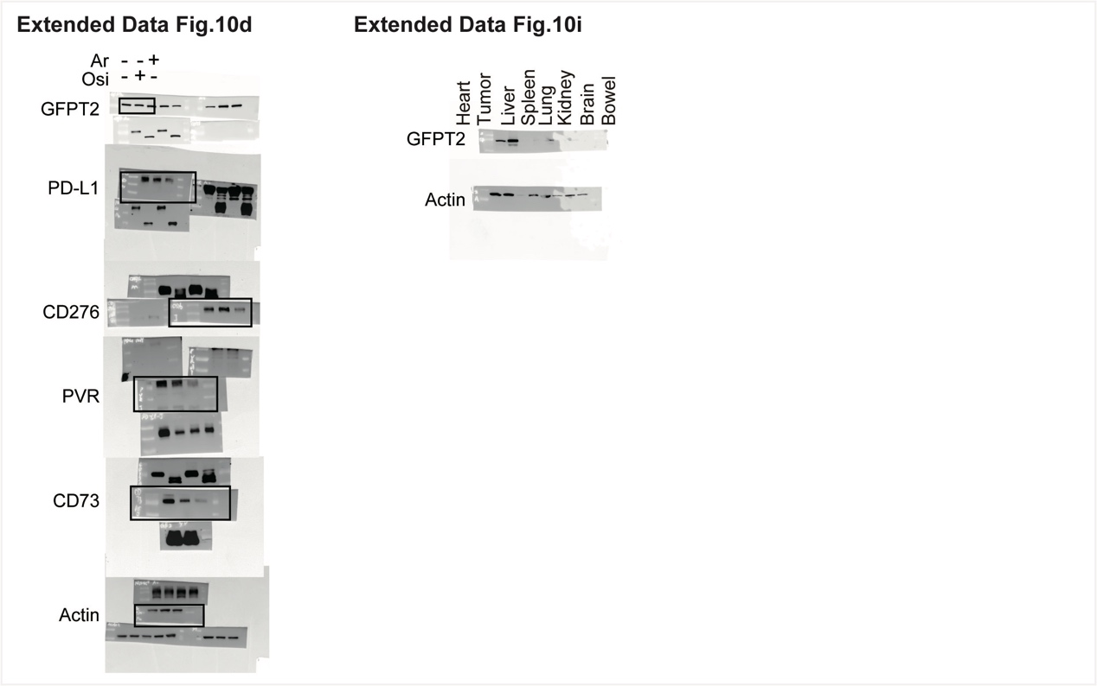
Supplementary Fig 17. Original immunoblotting data related to Extended Data Fig 10.

