Supplementary Materials for

The metabolic and physiological responses to spaceflight of a lipopeptide-producing Bacillus subtilis

Wan-Qi Qin et al.

*Corresponding author. Email: bzmu@ecust.edu.cn

This PDF file includes:

Table S1. Phenotypic and biochemical characterization of the BSG and BSS strain.
Table S2. Genomic features of the BSS and BSG strain.
Table S3. Putative gene regions that encoded for secondary metabolite in BSG and BSS.
Table S4. Differentially expressed genes in the main KEGG pathways.
Figure S1. The detecting results of thin layer chromatogram (TLC). The TLC of the biosurfactant showed orange spots under ninhydrin treatment which indicated that the biosurfactant contains lipopeptide.
Figure S2. (+) ESI Q-TOF MS spectroscopy of purified lipopeptide extract. Different homologs of surfactin molecular ion species are displayed in the ranges of m/z 900-1100. The result shows there is surfactin exists in biosurfactants produced by BSG.
Figure S3. Total ion chromatograms (TICs) and extracted ion chromatograms (EICs) from liquid chromatography-mass spectrum (LC-MS) analyses of surfactin homologs (C11-C18) produced by BSG and BSS.

Supplementary Text
Table S1. Phenotypic and biochemical characterization of the BSG and BSS strain.
No. | Characteristics |  | BSG | BSS
1 | Gram staining |  | + | +
2 | Cell morphology |  | rod | rod
3 | Motility |  | + | w
4 | Citrate utilization |  | + (R) | + (R)
5 | Catalase |  | - | -
6 | Methyl red |  | - (Y) | + (R)
7 | Starch hydrolysis |  | + | +
8 | Gelatin hydrolysis |  | + | +
9 | Growth at temperature of | 4℃ | NG | NG
10 |  | 20℃ | + | +
11 |  | 37℃ | + | +
12 |  | 50℃ | + | +
13 |  | 65℃ | w | w
14 | Growth in the NaCl concentration of | 0% | + | +
15 |  | 2% | + | +
16 |  | 5% | + | +
17 |  | 7% | + | +
18 |  | 10% | w | +
19 |  | 15% | NG | +
20 | Growth in medium pH of | 2 | NG | NG
21 |  | 4 | NG | NG
22 |  | 6 | + | +
23 |  | 8 | + | +
24 |  | 10 | NG | NG
25 |  | 12 | NG | NG
26 | Acid produced from | D-glucose | + | +
27 |  | D-xylose | - | -
28 |  | Maltose | + | +
29 | Utilization of | CH₃OH | - | -
30 |  | (NH₄)₂C₂O₄ | + | -
31 |  | CH₃COONH₄ | w | w
32 |  | NaNO₃ | + | w
33 |  | Urea | - | -
34 |  | NH₄H₂PO₄ | - | -
35 |  | L-Histidine | + | +
36 |  | L-Tyrosine | - | +
*- for negative, + for positive, NG for not grow, R for red, Y for yellow and w for weak.

Table S2. Genomic features of the BSS and BSG strain.
Feature | BSG | BSS
Genome size (bp) | 4,070,924 | 4,070,127
GC content (%) | 43.81 | 43.81
Protein-coding percentage (%) | 88.77 | 88.75
Gene number | 4236 | 4234
Gene total length (bp) | 3,613,914 | 3,612,096
sRNA | 11 | 11
rRNA | 30 | 30
tRNA | 86 | 86
KEGG alignment | 1558 | 1558
GO assignment | 5700 | 5697
COG assignment | 3836 | 3836
CAZy | 191 | 190
Secondary metabolism clusters | 14 | 14

Table S3. Putative gene regions that encoded for secondary metabolite in BSG and BSS.
Gene  Region | Type | BSG |  | BSS |  | Most similar know cluster | Similarity (%)
Gene  Region | Type | From | To | From | To | Most similar know cluster | Similarity (%)
Cluster 1 | NRPS | 349747 | 413186 | 349755 | 413194 | surfactin | 82
Cluster 2 | terpene | 1108206 | 1128719 | 1108214 | 1128727
Cluster 3 | lanthipeptide-class-i | 1682287 | 1708386 | 1682294 | 1708393
Cluster 4 | tranAT-PKS, PKS-like, T3PKS, NRPS | 1730653 | 1835889 | 1730581 | 1835817 | bacillaene | 100
Cluster 5 | NRPS, betalactone | 1908453 | 1985391 | 1908381 | 1985320 | fengycin | 100
Cluster 6 | terpene | 2056043 | 2077941 | 2055972 | 2077870
Cluster 7 | T3PKS | 2125677 | 2166774 | 2125606 | 2166703
Cluster 8 | NRPS | 3094709 | 3141845 | 3094636 | 3141772 | bacillibactin | 100
Cluster 9 | lanthipeptide-class-i | 3292715 | 3318940 | 3292643 | 3318868 | subtilin | 100
Cluster 10 | CDPS | 3437969 | 3458715 | 3437897 | 3458643
Cluster 11 | sactipeptide | 3683478 | 3705089 | 3682681 | 3704292 | subtilosin A | 100
Cluster 12 | other | 3712180 | 3753598 | 3711383 | 3752801 | baciysin | 100
Cluster 13 | RiPP-like | 3955078 | 3967809 | 3954281 | 3967012
Cluster 14 | epipeptide | 3983055 | 4004753 | 3982258 | 4003956 | thailanstatin A | 10%

Table S4. Differentially expressed genes in the main KEGG pathways.
KEGG pathway |  | Down regulated genes | Log2FC | FDR | Up regulated genes | Log2FC | FDR
Amino acid metabolism | Valine, leucine and isoleucine biosynthesis | leuA | -1.491 | 1.66E-17
Amino acid metabolism | Valine, leucine and isoleucine biosynthesis | leuB | -1.564 | 5.62E-14
Amino acid metabolism | Valine, leucine and isoleucine biosynthesis | leuC | -2.252 | 2.26E-34
Amino acid metabolism | Valine, leucine and isoleucine biosynthesis | leuD | -2.557 | 6.7E-18
Amino acid metabolism | Valine, leucine and isoleucine biosynthesis | alsS | -1.687 | 2.57E-14
Amino acid metabolism | Valine, leucine and isoleucine biosynthesis | ilvH | -1.302 | 0.00438
Amino acid metabolism | Valine, leucine and isoleucine biosynthesis | ilvC | -1.532 | 2.58E-08
Amino acid metabolism | Alanine, aspartate and glutamate metabolism | ansZ | -4.135 | 1.03E-19 | argH | 1.736 | 1.25E-11
Amino acid metabolism | Alanine, aspartate and glutamate metabolism | glsB | -2.810 | 1.98E-43 | argG | 3.098 | 1.7E-66
Amino acid metabolism | Alanine, aspartate and glutamate metabolism | nadB | -2.477 | 8.53E-16 | racX | 1.386 | 2.53E-11
Amino acid metabolism | Alanine, aspartate and glutamate metabolism | asnO | -5.926 | 1.35E-146 | gltA | 1.018 | 2.46E-11
Amino acid metabolism | Alanine, aspartate and glutamate metabolism |  |  |  | glmS | 1.544 | 1.46E-11
Amino acid metabolism | Alanine, aspartate and glutamate metabolism |  |  |  | putC | 1.390 | 2.61E-17
Carbohydrate metabolism | Glycolysis / Gluconeogenesis | adhB | -5.694 | 2.26E-78 | licH | 1.532 | 4.72E-24
Carbohydrate metabolism | Glycolysis / Gluconeogenesis |  |  |  | acoC | 2.218 | 1.42E-17
Carbohydrate metabolism | Glycolysis / Gluconeogenesis |  |  |  | acoL | 1.296 | 2.88E-11
Carbohydrate metabolism | Glycolysis / Gluconeogenesis |  |  |  | bglH | 2.145 | 1.63E-44
Carbohydrate metabolism | Glycolysis / Gluconeogenesis |  |  |  | gmuD | 1.737 | 7.33E-20
Carbohydrate metabolism | Citrate cycle (TCA cycle) | mmgD | -5.056 | 5.34E-130 | icd | 1.144 | 1.31E-15
Carbohydrate metabolism | Citrate cycle (TCA cycle) |  |  |  | citZ | 1.237 | 4.89E-15
Carbohydrate metabolism | Citrate cycle (TCA cycle) |  |  |  | citB | 1.112 | 1.5E-12
Carbohydrate metabolism | Citrate cycle (TCA cycle) |  |  |  | acoC | 2.218 | 1.42E-17
Carbohydrate metabolism | Citrate cycle (TCA cycle) |  |  |  | acoL | 1.296 | 2.88E-11
Carbohydrate metabolism | Citrate cycle (TCA cycle) |  |  |  | mdh | 1.253 | 2.51E-16
Carbohydrate metabolism | Pyruvate metabolism | leuA | -1.491 | 1.66E-17 | acoC | 2.218 | 1.42E-17
Carbohydrate metabolism | Pyruvate metabolism | lgeHB | -4.299 | 1.05E-15 | acoL | 1.296 | 2.88E-11
Carbohydrate metabolism | Pyruvate metabolism | mmgA | -6.185 | 1.56E-146 | mdh | 1.253 | 2.51E-16
Carbohydrate metabolism | Pyruvate metabolism | ldeHA | -3.572 | 7.52E-79 | ysfE | 1.194 | 0.04005
Carbohydrate metabolism | Starch and sucrose metabolism | ytdA | -4.757 | 4.45E-68 | mdxD | 2.085 | 1.86E-34
Carbohydrate metabolism | Starch and sucrose metabolism | glgD | -2.613 | 6.56E-51 | gmuE | 1.681 | 2.87E-22
Carbohydrate metabolism | Starch and sucrose metabolism | yugT | -3.571 | 1.61E-42 | licC | 1.393 | 1.45E-13
Carbohydrate metabolism | Starch and sucrose metabolism | murP | -1.126 | 4.48E-13 | licH | 1.532 | 4.72E-24
Carbohydrate metabolism | Starch and sucrose metabolism | glgC | -2.915 | 9.03E-64 | gmuB | 1.312 | 0.0000949
Carbohydrate metabolism | Starch and sucrose metabolism | glgA | -2.676 | 6.1E-56 | licA | 1.052 | 0.00796
Carbohydrate metabolism | Starch and sucrose metabolism | glgP | -3.000 | 1.51E-72 | mdxL | 1.731 | 9.3E-25
Carbohydrate metabolism | Starch and sucrose metabolism | glgB | -3.201 | 5.36E-69 | mdxM | 1.883 | 8.09E-30
Carbohydrate metabolism | Starch and sucrose metabolism | spmH | -9.335 | 2.82E-226 | bglH | 2.145 | 1.63E-44
Carbohydrate metabolism | Starch and sucrose metabolism | eglS | -4.134 | 1.06E-107 | malA | 1.299 | 2.3E-16
Carbohydrate metabolism | Starch and sucrose metabolism |  |  |  | gmuC | 1.644 | 1.67E-17
Carbohydrate metabolism | Starch and sucrose metabolism |  |  |  | gmuD | 1.737 | 7.33E-20
Carbohydrate metabolism | Starch and sucrose metabolism |  |  |  | gmuA | 1.797 | 7.86E-07
Carbohydrate metabolism | Starch and sucrose metabolism |  |  |  | licB | 1.648 | 0.0000377
Carbohydrate metabolism | Starch and sucrose metabolism |  |  |  | mdxK | 2.085 | 2.88E-38
Metabolism of terpenoids and polyketides | Nonribosomal peptide structures | srfAA | -1.342 | 7.76E-21 | racX | 1.386 | 2.53E-11
Metabolism of terpenoids and polyketides | Nonribosomal peptide structures | srfAB | -1.426 | 4.9E-21
Metabolism of terpenoids and polyketides | Nonribosomal peptide structures | srfAC | -1.481 | 1.66E-23
Metabolism of terpenoids and polyketides | Nonribosomal peptide structures | ppsB | -1.006 | 5.96E-12
Metabolism of terpenoids and polyketides | Nonribosomal peptide structures | ppsC | -1.060 | 8.52E-13
Metabolism of terpenoids and polyketides | Nonribosomal peptide structures | ppsD | -1.021 | 1.3E-12
Lipid metabolism | Fatty acid biosynthesis | ldeHA | -3.572 | 7.52E-79
Lipid metabolism | Fatty acid biosynthesis | lgeHB | -4.299 | 1.05E-15
Lipid metabolism | Synthesis and degradation of ketone bodies | scoB | -3.637 | 1.79E-37
Lipid metabolism | Synthesis and degradation of ketone bodies | scoA | -4.797 | 2.97E-29
Lipid metabolism | Synthesis and degradation of ketone bodies | mmgA | -6.185 | 1.56E-146
Lipid metabolism | Synthesis and degradation of ketone bodies | ldeG | -3.317 | 3.12E-65
Lipid metabolism | Synthesis and degradation of ketone bodies | yxjF | -3.157 | 3.58E-51
Lipid metabolism | Fatty acid degradation | mmgA | -6.185 | 1.56E-146 | fadA | 1.077 | 3.09E-12
Lipid metabolism | Fatty acid degradation | cypD | -1.715 | 6.3E-19 | fadB | 1.061 | 3.4E-12
Lipid metabolism | Fatty acid degradation | adhB | -5.694 | 2.26E-78 | fadN | 1.446 | 3.16E-17

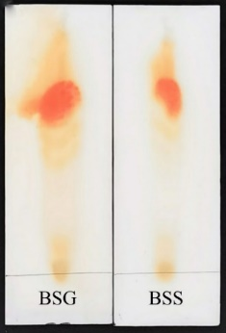
Figure. S1. The detecting results of thin layer chromatogram (TLC). The TLC of the biosurfactant showed orange spots under ninhydrin treatment which indicated that the biosurfactant contains lipopeptide.

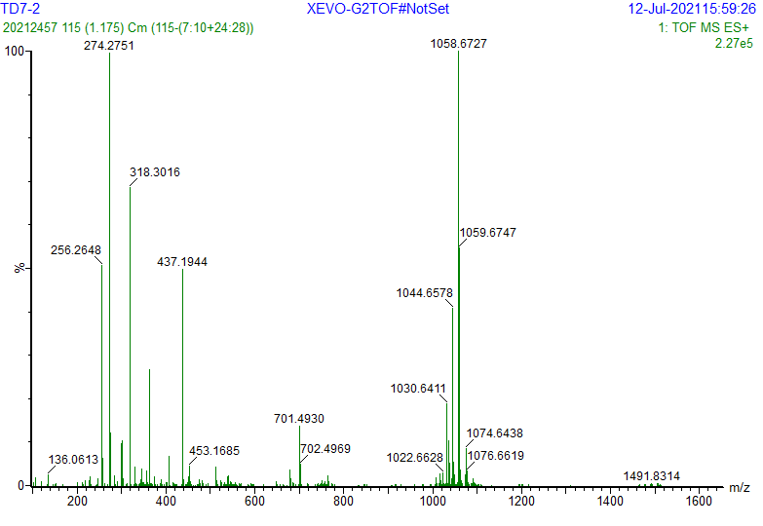
Figure. S2. (+) ESI Q-TOF MS spectroscopy of purified lipopeptide extract. Different homologs of surfactin molecular ion species are displayed in the ranges of m/z 900-1100. The result shows there is surfactin exists in biosurfactants produced by BSG.

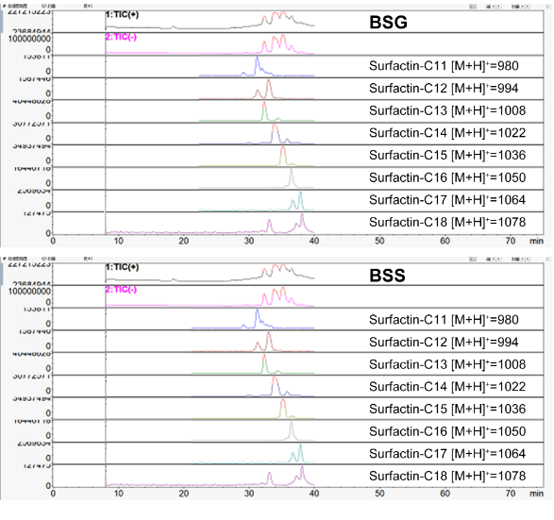
Figure. S3. Total ion chromatograms (TICs) and extracted ion chromatograms (EICs) from liquid chromatography-mass spectrum (LC-MS) analyses of surfactin homologs (C11-C18) produced by BSG and BSS.

