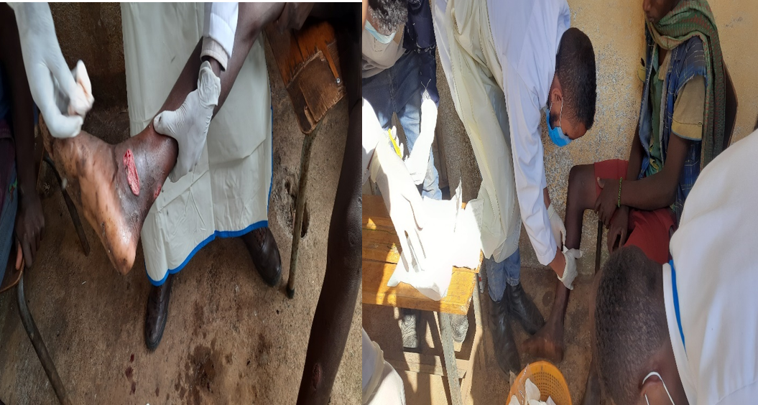
Picture 1: Wound care activities in the outbreak investigation of S. pyogenes skin infection in Andabet and Dera district of South Gondar Zone, Northwest, Ethiopia, 2023.

