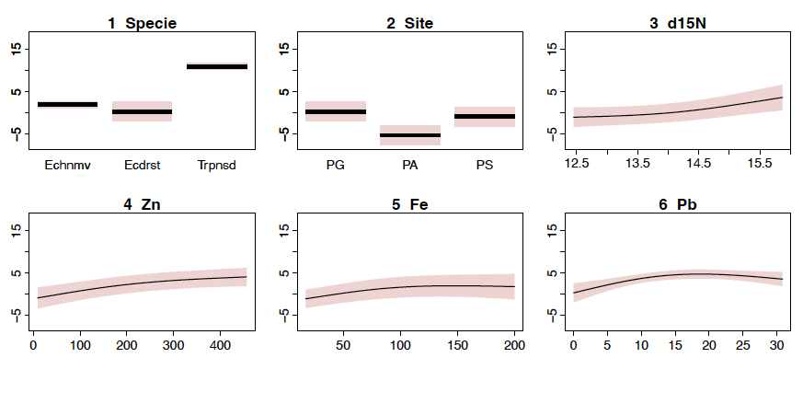
Fig. S1. Effect plots of General Additive Models (GAMs) for Cd concentrations. All plots are on the scale of linear predictor. Red contour represents two standard errors above and below the estimate of the smooths curve.

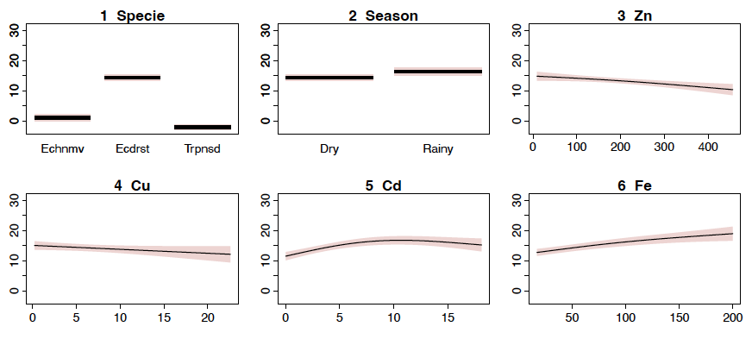
Fig. S2. Effect plots of General Additive Models (GAMs) for Pb concentrations. All plots are on the scale of linear predictor. Red contour represents two standard errors above and below the estimate of the smooths curve.

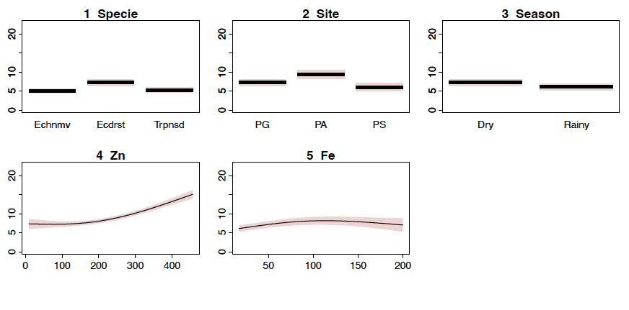
Fig. S3. Effect plots of General Additive Models (GAMs) for Cu concentrations. All plots are on the scale of linear predictor. Red contour represents two standard errors above and below the estimate of the smooths curve.

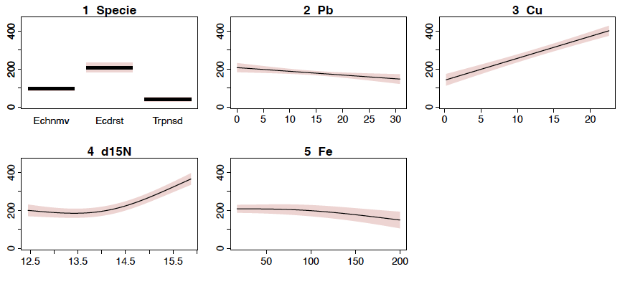
Fig. S4. Effect plots of General Additive Models (GAMs) for Zn concentrations. All plots are on the scale of linear predictor. Red contour represents two standard errors above and below the estimate of the smooths curve.

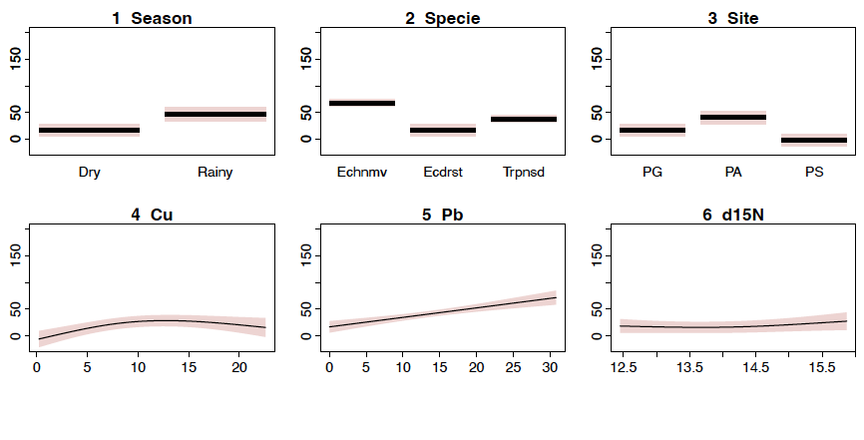
Fig. S5. Effect plots of General Additive Models (GAMs) for Fe concentrations. All plots are on the scale of linear predictor. Red contour represents two standard errors above and below the estimate of the smooths curve.

