Earth, Planet, and Space

Supporting Information for

Building the Fracture Network Model for the Okuaizu Geothermal Field Based on Microseismic Data Analysis

D. Darisma^{1,2}, Y. Mukuhira¹, K. Okamoto³, N. Aoyagi3, T. Uchide⁴, T. Ishibashi³, H. Asanuma³, T. Ito¹

¹Institute of Fluid Science, Tohoku University, Sendai, Japan
²Department of Geophysical Engineering, Universitas Syiah Kuala, Banda Aceh, Indonesia
³Fukushima Renewable Energy Institute, National Institute of Advanced Industrial Science and Technology, Koriyama, Japan
⁴Geological Survey of Japan, National Institute of Advanced Industrial and Technology, Tsukuba, Ibaraki, Japan

Content of this file
Fig. S1 to S6

Introduction
This supporting information provides the following contents.
- Relocation and clustering results of 2019, 2020, and 2021 data (Fig. S1, S2, and S3)
- Performance test of polarity picking by deep learning to March-September 2021 data (Fig. S4)
- Histogram of polarity picking by deep learning for Mw ≥ 1 to data January 2019-February 2021 (Fig. S5)
- Focal mechanism results with station plot (Fig. S6)

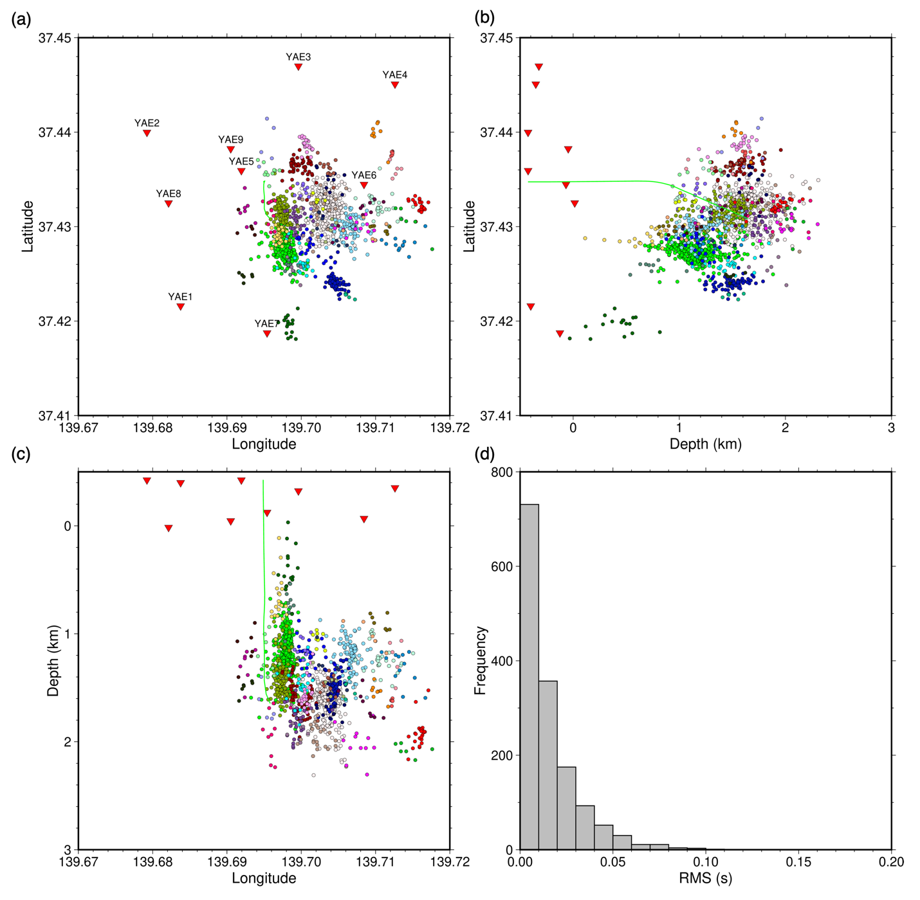
Fig. S1 Relocation and clustering result of 2019 data by Growclust (Trugman and Shearer 2017). Events are color coded by the cluster ID. (a) map view, (b) north-south cross-section, (c) east-west cross-section, and (d) RMS of travel residual (observed-predicted)

Fig. S2 Relocation and clustering result of 2020 data by Growclust (Trugman and Shearer 2017). Events are color coded by the cluster ID. (a) map view, (b) north-south cross-section, (c) east-west cross-section, and (d) RMS of travel residual (observed-predicted)

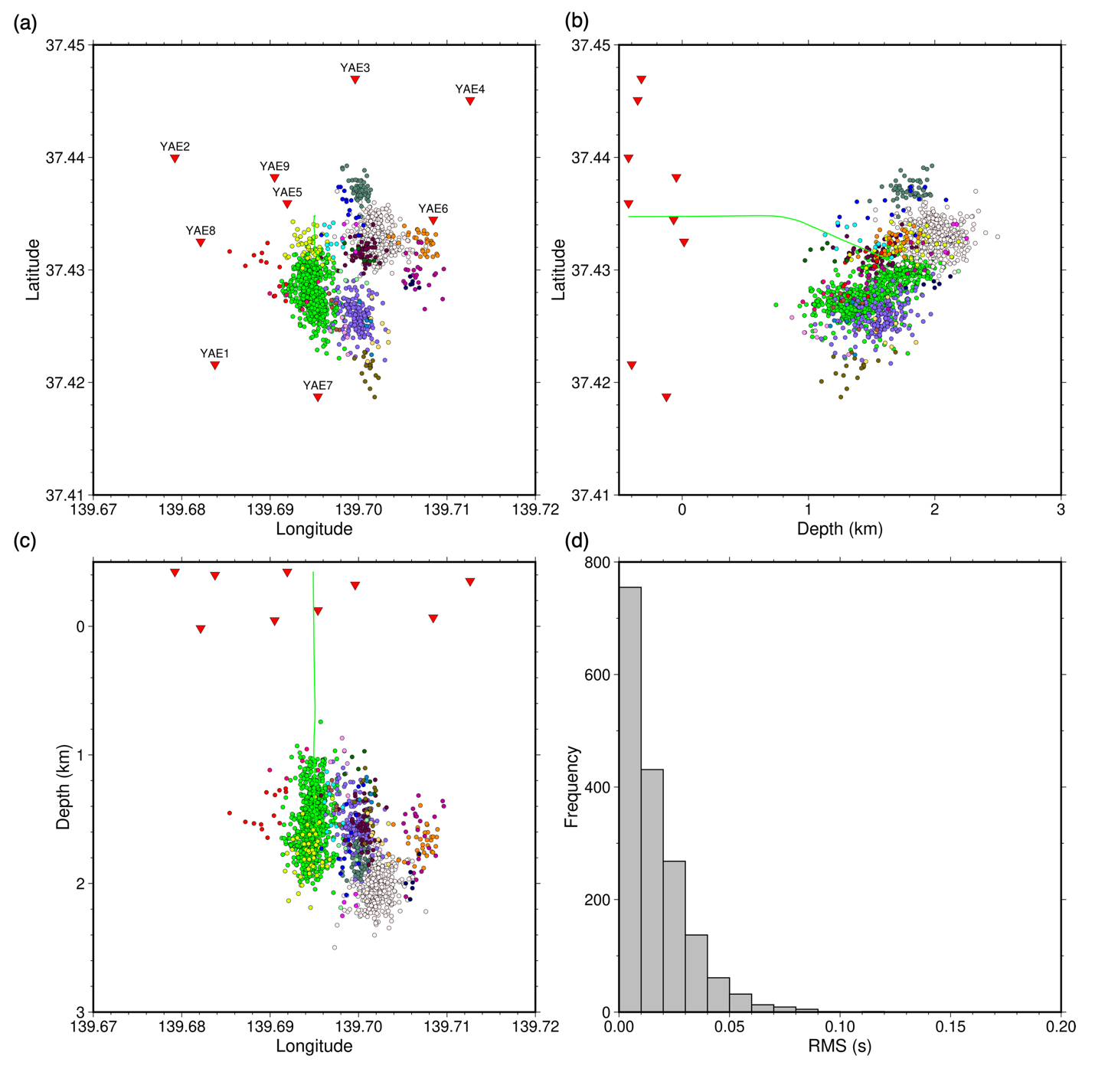
Fig. S3 Relocation and clustering result of 2021 data by Growclust (Trugman and Shearer 2017). Events are color coded by the cluster ID. (a) map view, (b) north-south cross-section, (c) east-west cross-section, and (d) RMS of travel residual (observed-predicted)

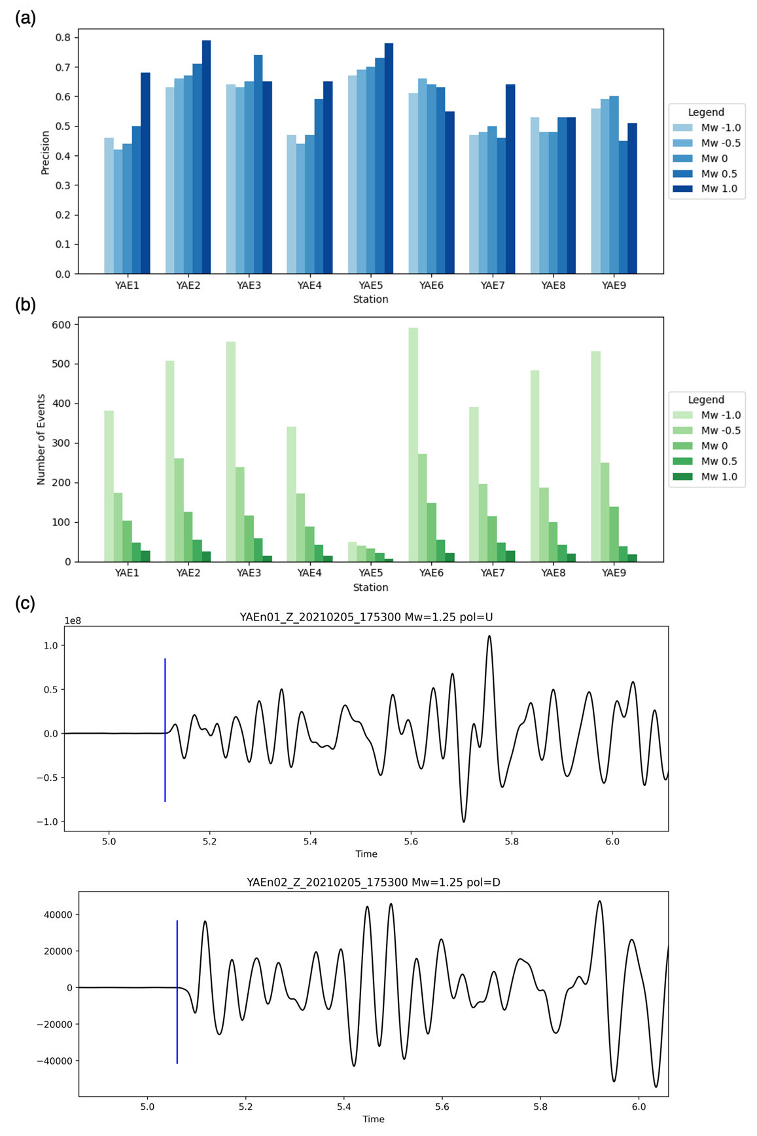
Fig. S4 Performance test of polarity picking by deep learning to March-September 2021 data. (a) precision of polarity picking with range magnitude from Mw -1 to Mw 1, (b) number of polarity detected with range magnitude from Mw -1 to Mw 1, (c) waveform example with polarity

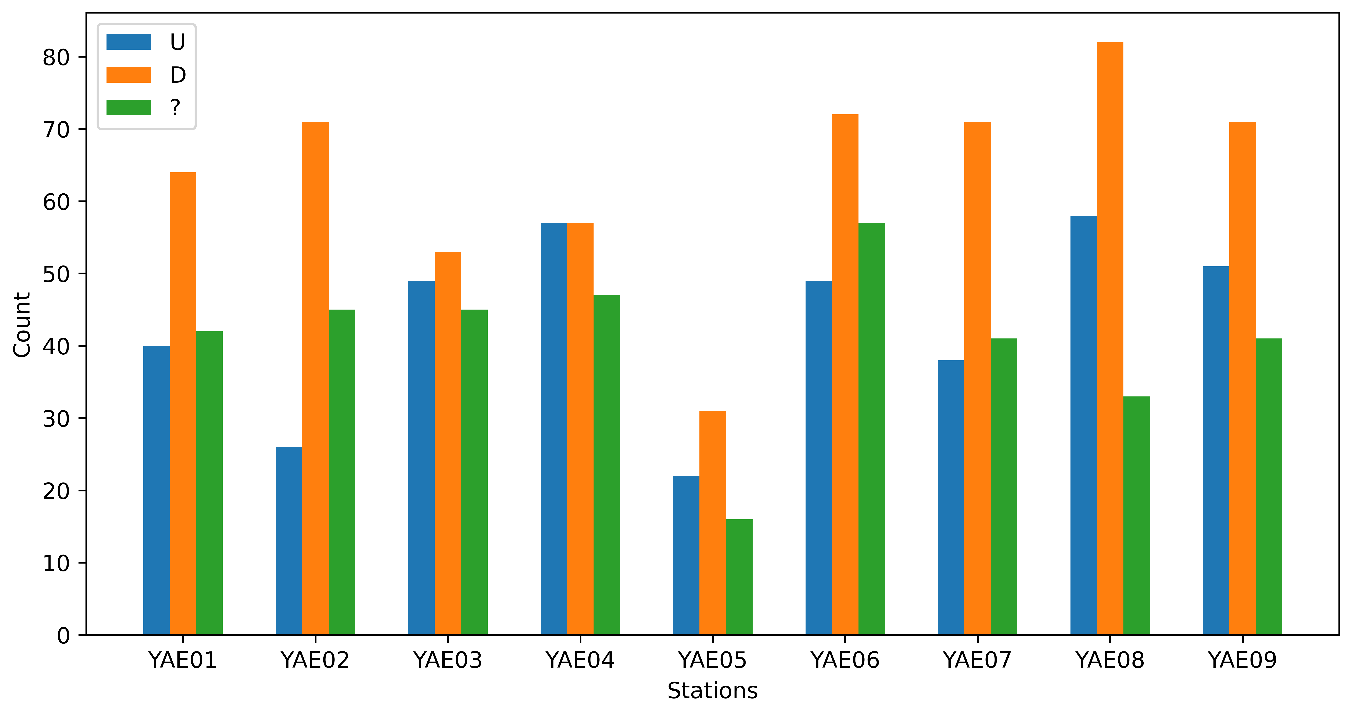
Fig. S5 Histogram of polarity picking by deep learning for Mw ≥ 1 to data January 2019-February 2021. U is for polarity up, D is for polarity down, and “?” for undetected polarity

