Appendices

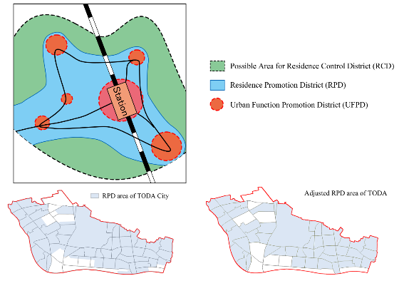
Appendix 1. Regional localization of RPD and adjusted RPD distribution by town in Toda City

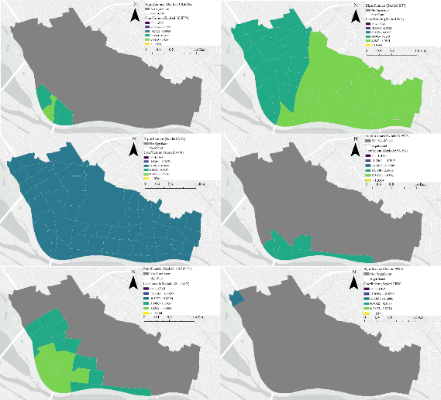
Appendix 2. Distribution characteristics of each factor in MGWR

